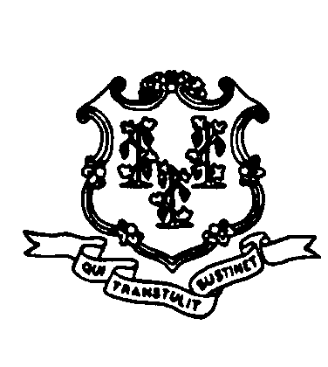
STATE OF CONNECTICUT

COUNCIL ON ENVIRONMENTAL QUALITY

Barbara C. Wagner  Chair  M. Howard Beach  Janet P. Brooks  Liz Clark  Bruce R. Fernandez  Karyl Lee Hall  Alison Hilding  Richard Sherman  Karl J. Wagener  Executive Director | July 3, 2012  Robert Stein, Chairman  Connecticut Siting Council  Ten Franklin Square  New Britain, CT 06051  RE: Docket 427, Proposed Telecommunications Facility in Branford or East Haven  Dear Chairman Stein:  In response to your request for consultation regarding Docket # 427, the Council on Environmental Quality (CEQ) has reviewed the application and offers the following comments.  If either location is approved, it will be one of a number that have been built or proposed along the coastline of Long Island Sound. Presumably there will be more. The potential negative consequences for scenic resources and migratory birds warrant special consideration in the placement of communication structures along the coast. CGS Section 16-50p (3) (B) suggests legislative concern with the magnified impact of multiple installations, as it requires consideration of “the nature of the probable environmental impact of the facility alone and cumulatively with other existing facilities including specification of every adverse effect … on and in conflict with the policies of the state concerning, the natural environment, ecological balance, … and wildlife;” [emphasis added].  Migratory Birds. As you know, tall structures can result in unintended bird mortality caused by accidental strikes. The risks to birds posed by shorter towers reportedly are less than for other types of tall structures. Nonetheless, the proposed sites are within areas of Connecticut’s coast that are unusually important to migratory birds. The risk is magnified because of the volume of birds that traverse the area both day and night. The marshes and shoreline in the New Haven area are cited by many sources as significant habitat for migratory waterfowl, shore birds, hawks, eagles and other birds. For example, the Focus Area Report of the Atlantic Coast Joint Venture¹ (of which the State of Connecticut is one of the partners) reports that “The open water areas and tidal flats in New Haven Harbor and the nearshore area south of Guilford, Branford and East Haven contain some of the largest and most important concentrations of wintering and migrating waterfowl along the Connecticut coast, especially American Black Duck, Canvasback, American Wigeon, Greater and Lesser Scaup, Common Goldeneye and three species of scoter” [emphasis added].  In 2010, a migratory bird impact evaluation was submitted for Docket # 396 in East Lyme. That evaluation referenced the same Focus Areas of the Atlantic Coast Joint Venture and included a map of the same but stated that the East Lyme site was not in one of the Focus Areas. However, the shore near the Branford and East Haven sites is within Focus Areas for waterfowl, as noted above, plus other birds.  In East Haven, the proposed location is between Farm River State Park and the East Haven Marsh Wildlife Area. The Farm River Park is identified on the website of the Department of Energy and Environmental Protection as a salt marsh that is recommended for birding activity. The East Haven Marsh Wildlife Area is a state  property that is managed to maintain wildlife populations.  The proposed East Haven tower would be about 2.5 miles up the coast from Lighthouse Point Park, a major birding area for observation of migratory species that has been designated by the National Audubon Society as an Important Bird Area (IBA). The importance of the area is founded to a large extent on the extraordinary number of migrating hawks, eagles and other birds that migrate just inland from the water’s edge. On average, more hawks and eagles migrate through that area than any location northeast of Cape May, New Jersey.²  The Branford site is similar in that it is less than a half mile from three large marshes and less than a mile from the Pawson Park Marsh Wildlife Area.  Scenic Resources. The tidal waters of Long Island Sound and its bays are public resources, and exceptional consideration should be given to the views of the shore from the water.  It is possible that the same designs that might reduce bird mortality, such as monopoles or stealth structures, might also reduce the scenic impact of the towers. The CEQ recommends consideration of special height or design requirements to protect the wildlife and scenic heritage of the coast, and suggests that the applicant be required to submit analyses and plans to address those specific considerations.  Thank you for your consideration of these comments. I will be happy to answer any questions you might have.  Sincerely,  Karl J. Wagener  Executive Director  CC: Linda Roberts, Executive Director  ¹ http://www.acjv.org/resources.htm, see northeast Focus Area descriptions.  ² http://ct.audubon.org/lighthouse-point-park

