DOCKET NO. 404 - New Cingular Wireless PCS, LLC application for a Certificate of Environmental Compatibility and Public Need for the construction, maintenance and operation of a telecommunications facility located at 28 Great Oak Lane, Redding, Connecticut. | }  }  } | Connecticut  Siting  Council  January 20, 2011

Findings of Fact

Introduction

- New Cingular Wireless PCS, LLC (AT&T), in accordance with the provisions of Connecticut General Statutes (CGS) §§ 16-50g through 16-50aa, applied to the Connecticut Siting Council (Council) on August 26, 2010 for the construction, maintenance, and operation of a 180-foot wireless telecommunications facility located at 28 Great Oak Lane in Redding, Connecticut (refer to Figure 1). (AT&T 1, p. 3)

- AT&T is a Delaware corporation with an office in Rocky Hill, Connecticut. AT&T is licensed by the Federal Communications Commission (FCC) to construct and operate a personal wireless service system in Connecticut. (AT&T 1, p. 4)

- The purpose of the proposed facility is to provide wireless service for AT&T to central Redding. (AT&T 1, pp. 6-7)

- Pursuant to CGS § 16-50m, the Council, held a public hearing on November 23, 2010, beginning at 3:00 p.m. and continuing at 7:10 p.m. at the Redding Community Center, 37 Lonetown Road, Redding, Connecticut. (Transcript 1 – 11/23/10, 3:00 p.m. [Tr. 1], Tr. 1, p. 2; Transcript 2 – 11/23/10, 7:10 p.m. [Tr. 2], p. 2)

- The Council and its staff conducted an inspection of the proposed site on November 23, 2010, beginning at 2:00 p.m. The applicant flew a four and a half foot diameter balloon at the site from 11:00 a.m. to 4:30 p.m. to simulate the height of the proposed tower. The balloon was flown at its intended height of 180 feet above ground level (agl) during the field review. (Tr. 1, pp. 25-26)

- Notice of the application was sent to all abutting property owners by certified mail and all return receipts were received. Public notice of the application was published in The Redding Pilot on July 15 and July 22, 2010. (AT&T 1, Tab 10)

- AT&T installed a four-foot by six-foot sign at the entrance to the property along Great Oak Lane on November 10, 2010. The sign presented information regarding the proposed project and Council’s public hearing. (Tr. 1, p. 25 )

- Pursuant to CGS § 16-50l(b), AT&T provided notice to all federal, state and local officials and agencies listed therein. (AT&T 1, Tab 9)

State Agency Comment

- Pursuant to CGS § 16-50j(h), on September 29, 2010 and November 24, 2010, the following State agencies were solicited to submit written comments regarding the proposed facility: Department of Environmental Protection (DEP), Department of Public Health (DPH), Council on Environmental Quality, Department of Public Utility Control, Office of Policy and Management, Department of Economic and Community Development, the Department of Transportation, Department of Emergency Management and Homeland Security and the Department of Agriculture. (Record)

- The Council received written comment from the DPH Drinking Water Section on October 5, 2010 stating that the site was within a public supply watershed and recommended that construction activities adhere to certain procedures. AT&T would comply with the recommendations. (Record; AT&T 2, Q. 5)

- With the exception of the DPH, no other state agencies submitted comments in response to the Council’s solicitation. (Record)

Municipal Consultation

- AT&T began discussions with the Town regarding installation of a telecommunications facility at the Town Highway Department property at 28 Great Oak Lane in 2004. (AT&T 1, p. 2)

- Ongoing discussions with the Town in 2009 resulted in several publicly noticed meetings and tower height simulations at both 150 feet and 180 feet, using a crane. (AT&T 1, p. 2)

- The Town concluded a 180-foot flagpole style monopole would be in the best interests of the town given that the Town found a negligible difference in aesthetics between a 150 and 180-foot structure. Additionally, the Town found that the 180-foot tower would provide more co-location opportunities for other telecommunication carriers, lessening the need for another tower in this area of Redding. (AT&T 1, p. 3; Tr. 1, pp. 14-15)

- Abutting residents preferred a flagpole style tower over a traditional monopole with platform mounted antennas. (Limited Appearance Statement by First Selectman Natalie Ketchum, Tr. 2, pp. 7-10)

- AT&T and the Town executed a lease for the site in December of 2009. (AT&T 1, p. 3)

Public Need for Service

- In 1996, the United States Congress recognized a nationwide need for high quality wireless telecommunications services, including cellular telephone service. Through the Federal Telecommunications Act of 1996, Congress seeks to promote competition, encourage technical innovations, and foster lower prices for telecommunications services. (Council Administrative Notice Item No. 7)

- In issuing cellular licenses, the Federal government has preempted the determination of public need for cellular service by the states, and has established design standards to ensure technical integrity and nationwide compatibility among all systems. (Council Administrative Notice Item No. 7)

- The Telecommunications Act of 1996 prohibits local and state entities from discriminating among providers of functionally equivalent services. (Council Administrative Notice Item No. 7)
- The Telecommunications Act of 1996, a Federal law passed by the United States Congress, prohibits any state or local entity from regulating telecommunications towers on the basis of the environmental effects of radio frequency emissions to the extent that such towers and equipment comply with FCC’s regulations concerning such emissions. This Act also blocks the Council from prohibiting or acting with the effect of prohibiting the provision of personal wireless service. (Council Administrative Notice Item No. 7)

- In an effort to ensure the benefits of wireless technologies to all Americans, Congress enacted the Wireless Communications and Public Safety Act of 1999. The purpose of this legislation was to promote public safety through the deployment of a seamless, nationwide emergency communications infrastructure that includes wireless communications services. The site would provide Enhanced 911 service to the proposed service area. (AT&T 1, pp. 7-8)

AT&T - Existing and Proposed Wireless Coverage

- AT&T proposes to operate cellular (800 MHz), personal communication service (1900 MHz [PCS]), and long-term evolution (700 MHz [LTE]) equipment at the proposed site. (AT&T 1, Tab 1; Tr. 1, pp. 12-13)

- AT&T designs and operates at the following signal-level thresholds: in-vehicle service is -82 dBm and in-building service is -74 dBm. AT&T is designing the site to the in-vehicle threshold. (AT&T 2, Q. 1, Q. 4)

- AT&T currently experiences degraded coverage along Route 53 and Route 107 in the proposed service area with signal levels ranging from -80 dBm to -110 dBm (refer to Figure 6). The area is predominately residential with some municipal facilities near the town center. (AT&T 1, Tab 1; AT&T 2, Q. 2; Tr. 1, pp. 24-25)

- Existing AT&T facilities at 4 Dittmar Road, approximately three miles north of the site, and 105 Wayside Lane, approximately 2.8 miles southwest of the site, cannot provide adequate coverage to the proposed service area. (AT&T 1, Tab 1)

- Installing antennas at 167 feet and 177 feet agl would provide reliable PCS, cellular, and LTE service to the proposed service area. The site would provide a PCS coverage footprint of approximately 3.7 square miles at -82 dBm and a cellular coverage footprint of 4.2 square miles at -82 dBm (refer to Figure 7). LTE service is similar to that of cellular. (AT&T 1, Tab 1; AT&T 2, Q. 3; Tr. 1, p. 18)

- AT&T requires a minimum tower height of 150 feet to meet coverage objectives. A 180-foot tower was requested by the Town to increase the possibility of tower sharing by other telecommunication providers. (AT&T 1, p. 10; Tr. 1, pp. 13-17)

- The internal flush mount-design of the monopole requires AT&T to use two tower heights, rather than one, to accommodate their antennas since each level has a limited antenna capacity. If an antenna platform were used, AT&T would only need one tower height. Other carriers that may wish to co-locate on the tower may also need to occupy multiple tower heights to meet their antenna and service needs. (Tr. 1, pp. 14-19)

Site Selection

- AT&T established a search ring for the proposed service area in 1999. (AT&T 2, Q. 7)

- AT&T examined the possibility of developing a facility at the Redding Police Station at 96 Hill Road, where an approximately 100-foot light-duty tower already exists. The existing tower would need to be rebuilt and extended to meet AT&T’s coverage objectives. The town opposes any extension of the tower due to visibility impacts to the adjacent Redding Center National Historic District. (AT&T 1, p. 9, Tab 2; Tr. 1, pp. 20-21)

- AT&T identified a 120-foot former windmill at a residential property 80 Lonetown Road that currently accommodates Verizon Wireless. The property owners are not interested in further co-location at this site. (AT&T 1, p. 9, Tab 2)

- AT&T examined and rejected three other locations due to insufficient coverage to the proposed service area. The three locations are: the Redding Fire Department at 186 Black Rock Turnpike, the First Church of Christ at 25 Cross Highway, and a residential property at 183 Black Rock Turnpike. (AT&T 1, Tab 2)

Facility Description

- The proposed facility is located on a 6.5-acre parcel containing three buildings that serve the town highway department. (AT&T 1, Tab 3)

- The parcel is zoned residential, R-2. (AT&T 1, Tab 3)

- The tower site is located to the rear of the parcel, adjacent to a 35-foot high wood-frame storage building (refer to Figure 2). (AT&T 1, Tab 3; Tr. 1, p. 65)

- The tower site is approximately 93 feet south of the nearest property line, (Redding Elementary School property). The nearest non town-owned property is approximately 175 feet to the east (Casazza property at 25 Lonetown Road). (AT&T 1, Tab 3)

- The nearest residence is approximately 425 feet to the west at 36 Great Oak Lane (Brundage property). (AT&T 1, Tab 3)

- There are 12 residences within 1,000 feet of the tower site. (AT&T 1, Tab 3)

- AT&T proposes to construct a 180-foot flagpole-style monopole but with no flag. The antennas would be concealed within a radio-frequency transparent casing. The monopole would have a five-foot diameter, tapering to three feet at the top. Although a wider taper at the top may be necessary to accommodate other carriers based on their equipment needs, the monopole would still taper uniformly, not having abrupt changes in diameter from top to bottom. (AT&T 1, Tab 3; Tr. 1, pp. 9-11)

- The tower would be designed to support five levels of antennas and would be constructed in accordance with the Electronic Industries Association Standard ANSI/TIA-222-F. (AT&T 1, Tab 3)

- AT&T proposes to install three dual-band panel antennas at the 177-foot level to transmit PCS and cellular service and three panel antennas at the 167-foot level for LTE service. (AT&T 1, Tab 3; Tr. 1, pp. 30-31)

- AT&T proposes to paint the tower white. (Tr. 1, p. 21)

- AT&T proposes to construct a 33-foot by 73-foot equipment compound at the base of the tower, sufficient to accommodate ground equipment for four carriers. AT&T would install a 12-foot by 20-foot equipment shelter within the compound. (AT&T 1, Tab 3)

- An eight-foot high chain link fence would enclose the compound. (AT&T 1, Tab 3)

- Access to the compound would be from existing driveways and a parking lot on the property. (AT&T 1, Tab B)

- Overhead utilities would service the compound from existing service on the property. A new pole would be installed immediately west of the compound. A diesel generator would provide emergency power to the site. (AT&T 1, Tab 3)
- Surrounding properties within a quarter-mile of the site consist of residences, a public school, the town hall, and community center, recreation areas, and emergency response facilities. (AT&T 1, Tab 3)

- The tower site is located at an elevation of 588 feet above mean sea level (amsl) at 41º 18’ 24.5” north latitude and 73º 23’ 10.7” west longitude. Surrounding terrain consists of numerous ridges and valleys ranging in elevation from 205 feet to 810 amsl. (AT&T 1, Tab 3)

- The estimated construction cost of the facility, without AT&T’s antennas and radio equipment, is:

Tower and foundation $120,000.
Site development 48,000.
Utility installation 42,000.
Construction 93,000.

Total estimated cost $303,000.
(AT&T 1, p. 17)

Environmental Concerns

- The site is not within any designated area indicating the presence of Federally threatened or endangered species or State endangered, threatened or special concern species. (AT&T 1, p. 12)

- The proposed site would be located approximately 2.2 miles from the northern edge of Devil’s Den, a 1,750-acre preserve in Redding and Wilton identified by the Connecticut Audubon Society as an Important Bird Area. (Council Administrative Notice Item # 29)

- The proposed tower would comply with recommended guidelines of the United States Fish and Wildlife Service for minimizing potential impact to bird species. The guidelines recommend that towers be less than 199 feet tall, avoid the use of aviation lighting, and avoid guy wires as tower supports. (AT&T 2, Q. 10)

- No trees or vegetation would be removed to develop the site. (AT&T 1, Tab 3)

- Development of the compound would not directly affect any wetlands or watercourses. The nearest wetland is approximately 67 feet southwest of the site, at the base of a large berm along the west property boundary and adjacent to an existing driveway. (AT&T 1, Tab 3)

- The site is not within a 100-year or 500-year floodplain. (AT&T 1, p. 14)

- Erosion and sedimentation controls and other best management practices would be established and maintained for the duration of site construction. (AT&T 1, p. 16)

- The Redding Historic District is located immediately south of the site and several historic homes not in the district are east of the site along Lonetown Road. The State Historic Preservation Office reviewed the proposal and determined that the tower, as proposed, would have no effect on these cultural resources. (AT&T 1, Tabs 5, 6, 8)

- Aircraft hazard obstruction marking or lighting of the tower is not required or proposed. (AT&T 1, pp. 13, 15)

- The cumulative worst-case maximum power density from the radio frequency emissions from the operation of the proposed AT&T antennas is calculated to be 4.3% of the standard for Maximum Permissible Exposure, as adopted by the FCC, at the base of the proposed tower. This calculation was based on methodology prescribed by the FCC Office of Engineering and Technology Bulletin No. 65E, Edition 97-01 (August 1997) that assumes all antennas would be pointed at the base of the tower and all channels would be operating simultaneously, which creates the highest possible power density levels. Under normal operation, the antennas would be oriented outward, directing radio frequency emissions away from the tower, thus resulting in significantly lower power density levels in areas around the tower base. (AT&T 1, Tab 5)

Visibility

- The proposed tower would be visible year-round from approximately 43 acres and seasonally visible from approximately 56 acres within a half-mile of the proposed site (refer to Figure 3). (AT&T 1, Tab 4)

- Visibility of the proposed tower from specific locations within a half-mile radius of the site is as follows:

Specific Location  (Corresponding Location # on Figure 3) | Visible | Approximate Portion of Tower Visible (from top) | Approx. Distance from Tower
Redding Community Center/Elementary School property (2, 3) | Yes | 150 feet – unobstructed | 0.18 mile north
Route 107, east of Great Oak Lane (4) | Yes | 60 feet – through trees | 0.3 mile south
Route 107, south of Redding Elementary School (5) | Yes | 30 feet – through trees | 0.2 mile southeast
Intersection of Route 107 and Gallows Hill Road Extension (6) | Yes | 130 feet - unobstructed | 0.35 mile northeast
Great Oak Lane at Highway Dept. Entrance (7) | Yes | 130 feet- through trees | 0.2 mile west
Great Oak Lane north of Highway Dept. Entrance (9) | Yes | 150 feet – through trees | 0.12 mile northwest
(AT&T 1, Tab 4)

- Year-round visibility of the proposed tower includes five residential properties on Route 107 immediately north and south of the facility. These residences, #’s 25, 30, 40, 50 and 55, would have views of the upper half of the facility. Other residential properties with year-round views of portions of the facility include one residence on Longwood Lane, approximately 0.6 miles to the north, and one residence on Diamond Hill Road, approximately one mile to the southwest. (AT&T 1, Tab 4; Tr. 1, pp. 21-22)

- The proposed tower would be seasonally visible from nine residential properties on Route 107 within 0.4 miles of the site and seven residential properties on Great Oak Lane, 0.1 mile west of the site. (AT&T 1, Tab 4)

- The upper 130 feet of the proposed tower would be visible year-round from the Daniel and Esther Bartlett House, an historic property owned by the Redding Historical Society, approximately 0.35 mile northeast of the site. (AT&T 1, Tab 4; Tr. 1, pp. 23-24)

- The Redding Center National Historic District, a 55-acre area encompassing portions of Lonetown Road, Hill Road, Sanford Town Road, Cross Highway and Great Oak Lane, is located 0.2 mile south of the proposed site. The tower would be seasonally visible from the northern edge of the district, an area containing several historic properties along Great Oak Lane and Lonetown Road. (AT&T 1, Tab 4, Tab 6)

- The tower would not be visible from any known hiking trails maintained by the DEP or the Connecticut Forest and Parks Association. The tower would be seasonally visible from a trailhead that serves the Lonetown Marsh preserve, located on Route 107, 0.2 mile east of the site. (AT&T 1, Tab 4; Tr. 1, pp. 32-33; Tr. 2, p. 12)

- The tower would not be visible from any scenic roads within two miles of the site. (AT&T 1, Tab 4)

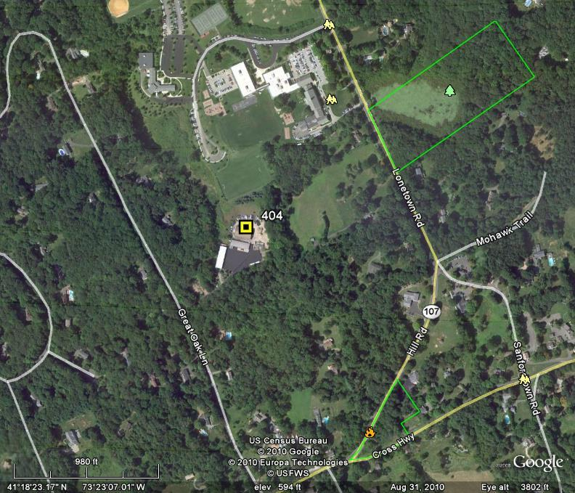


Figure 1: Location of site at 28 Great Oak Lane, Redding. (AT&T 1, Tab 3)

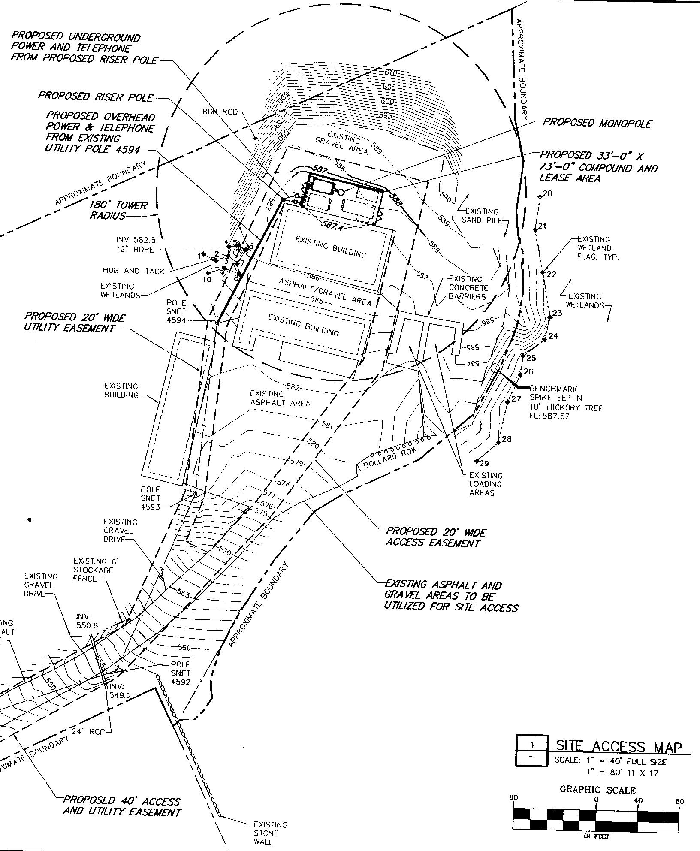
Figure 2: Site plan of proposed location at 28 Great Oak Lane. (AT&T 1, Tab 3)

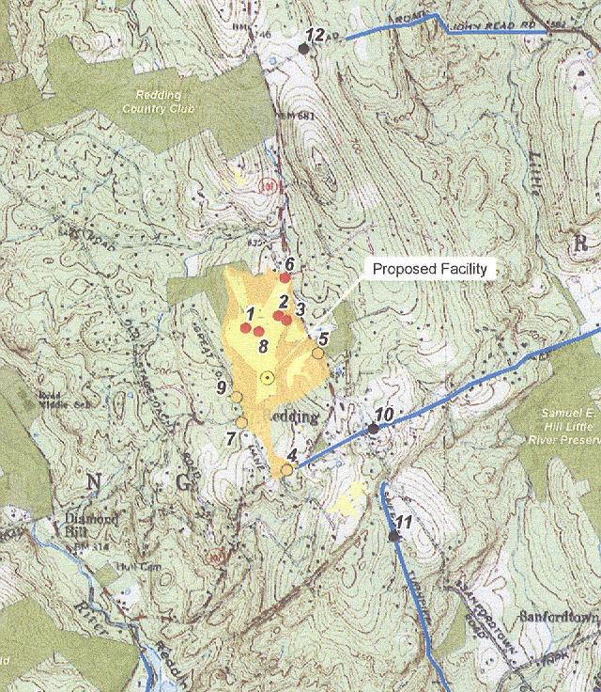
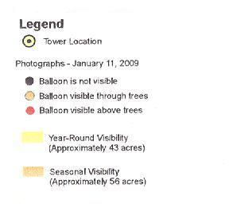

Figure 3: Projected visibility of proposed site. (AT&T 1, Tab 4)

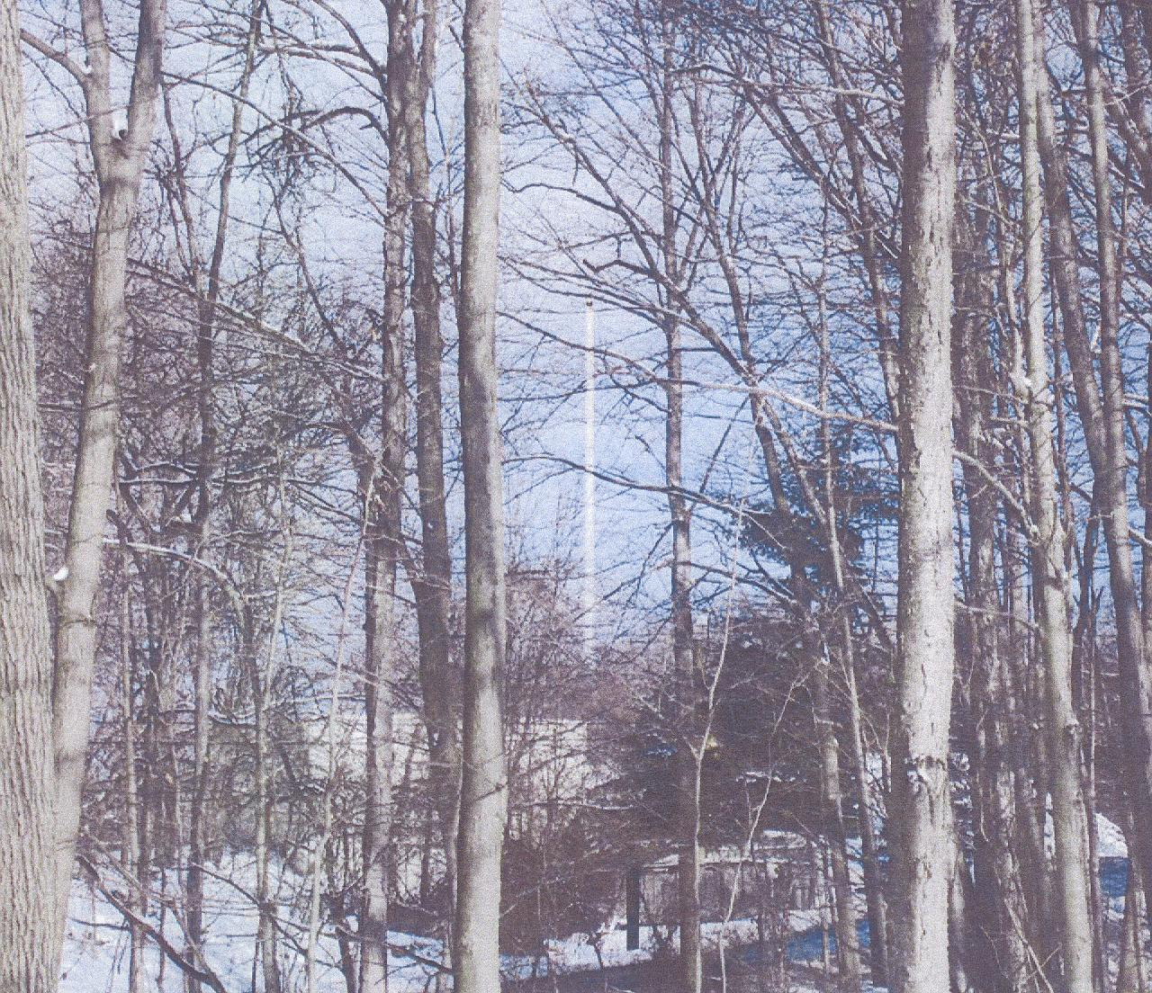
Figure 4: Photo-simulation of proposed tower from Great Oak Lane
(location 7 on Figure 3). (T-Mobile 1, Tab M)

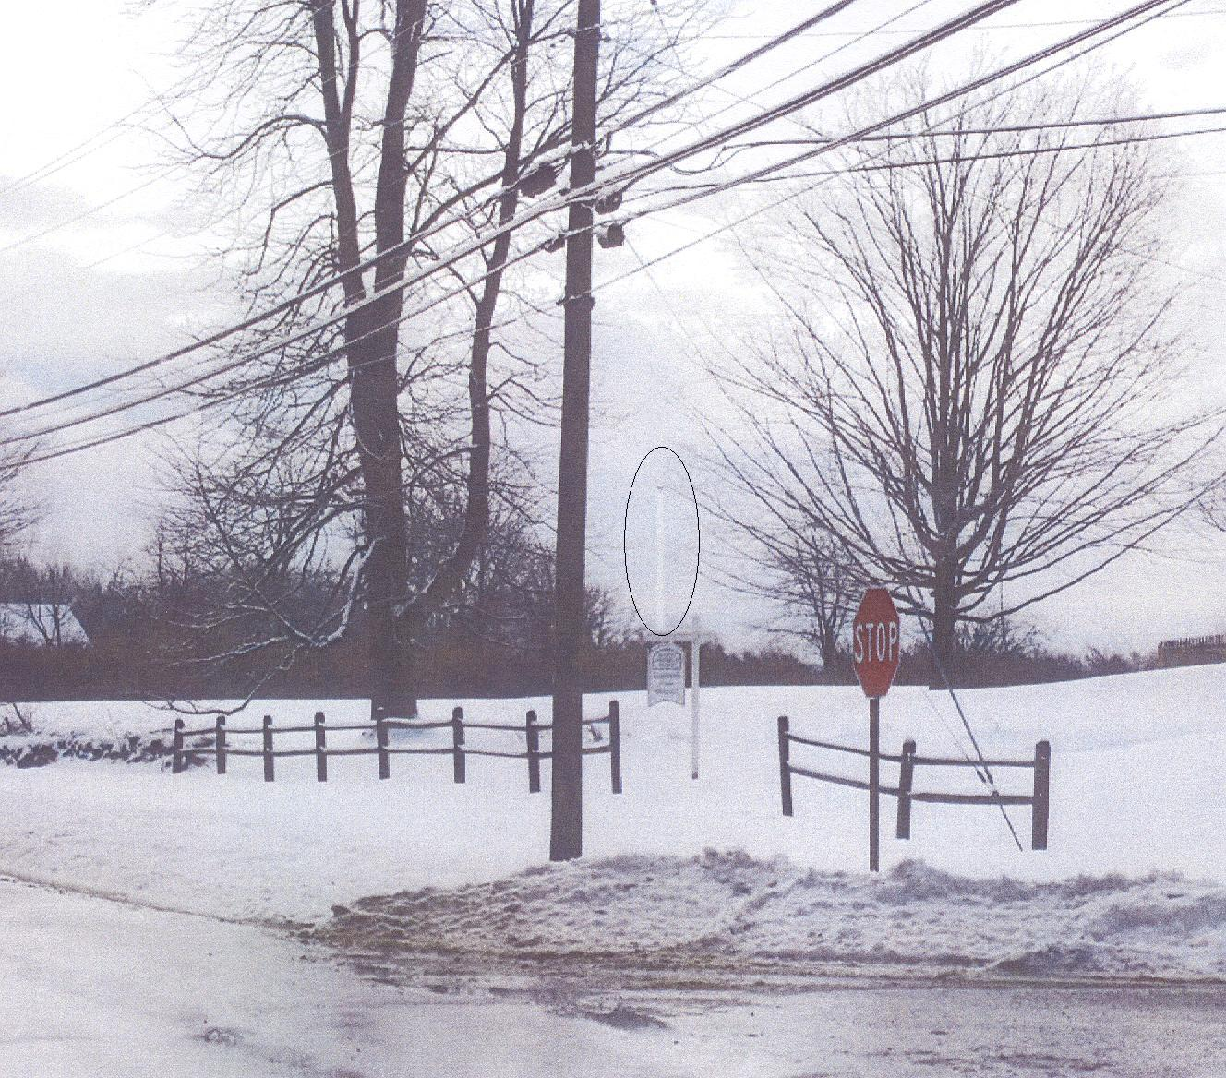
Figure 5: Photo-simulation of proposed tower from intersection of
Lonetown Road and Gallows Hill Road Ext. (location 6 on Figure 3).
(AT&T 1, Tab 4)

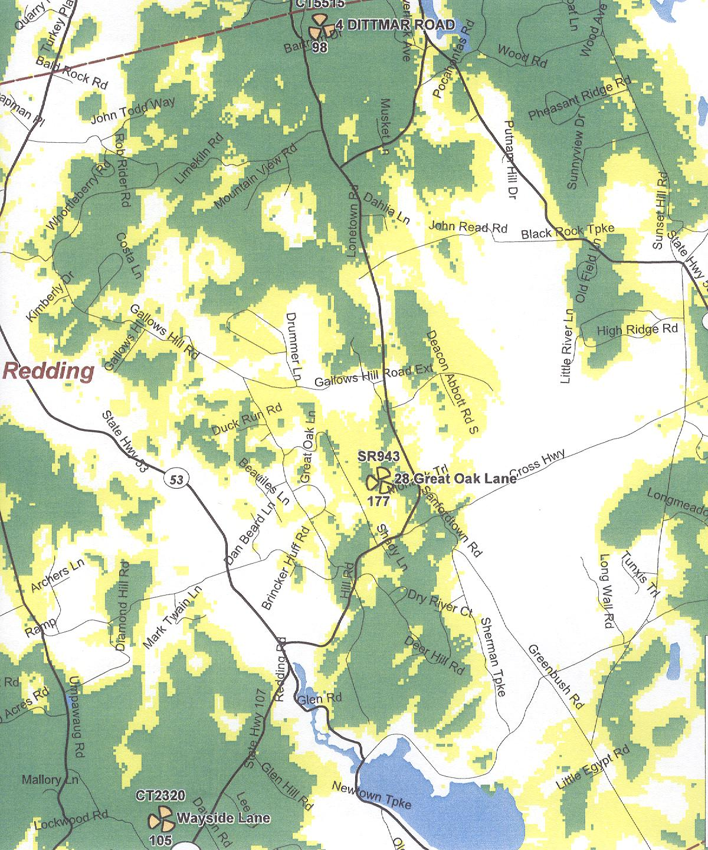
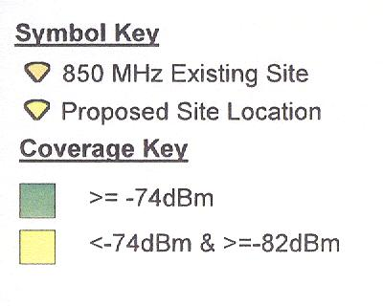
Figure 6: AT&T’s existing cellular coverage. (AT&T 1, Tab 1)
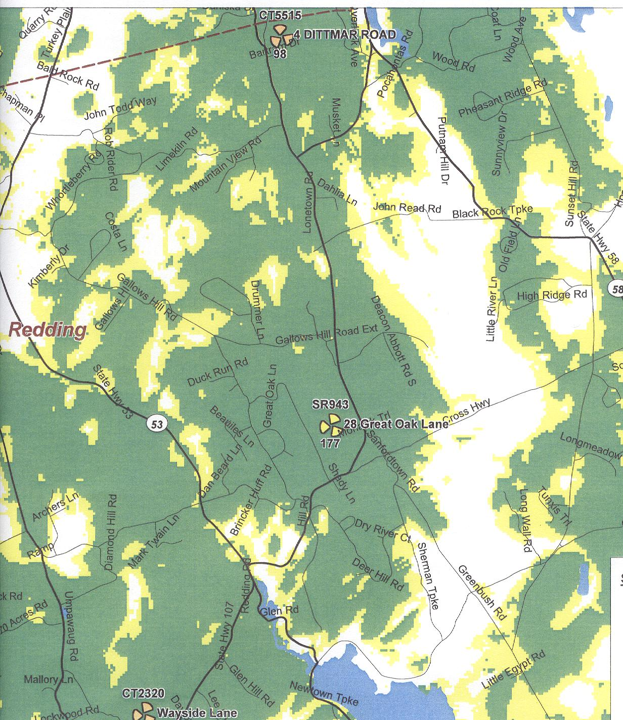
Figure 7: AT&T’s proposed cellular coverage with antennas mounted at 177 feet agl.
(AT&T 1, Tab 1)

