DOCKET NO. 400 – Cellco Partnership d/b/a Verizon Wireless application for a Certificate of Environmental Compatibility and Public Need for the construction, maintenance and operation of a telecommunications facility located at 343 Daleville Road, Willington, Connecticut. | }  }  } | Connecticut  Siting  Council  July 29, 2010

Findings of Fact

Introduction

- Cellco Partnership d/b/a Verizon Wireless (Cellco), in accordance with the provisions of Connecticut General Statutes (CGS) §§ 16-50g through 16-50aa, applied to the Connecticut Siting Council (Council) on February 5, 2010 for the construction, maintenance, and operation of a 100-foot wireless telecommunications facility located at 343 Daleville Road, Willington, Connecticut (refer to Figure 1). (Cellco 1, p. 1)

- Cellco is a Delaware corporation with an office in East Hartford, Connecticut. Cellco is licensed by the Federal Communications Commission (FCC) to construct and operate a personal wireless service system in Connecticut. (Cellco 1, pp. 4, 7)

- The purpose of the proposed facility is to provide wireless service for Cellco to the Route 44 area in the southern portion of Willington and the northern portion of Mansfield. (Cellco 1, p. 2, Tab 7)

- Pursuant to CGS § 16-50m, the Council held a public hearing on May 25, 2010, beginning at 3:00 p.m. and continuing at 7:00 p.m. at the Old Town Hall, 11 Common Road, Willington, Connecticut. (Transcript 1 – 05/25/10, 3:00 p.m. [Tr. 1], p. 2; Transcript 2 – 05/25/10, 7:00 p.m. [Tr. 2], p. 2)

- The Council and its staff conducted an inspection of the proposed site on May 25, 2010, beginning at 2:00 p.m. The applicant flew a red balloon at the site from 11:30 a.m. to 7:00 p.m. to simulate the height of the proposed tower. Weather conditions were favorable and the balloon reached its intended height of 100 feet. (Tr. 2, p. 8)

- Notice of the application was sent to all abutting property owners by certified mail. Cellco did not receive a return receipt from ING US STUDENTS NO. 7 LLC. Cellco resent notice to this abutter by regular mail. (Cellco 1, p. 6, Tab 5; Cellco 4, Q. 1)

- Public notice of the application was published in The Chronicle on February 1 and February 2, 2010. (Cellco 5)

- Cellco installed a four-foot by six-foot sign at the entrance to the property on May 7, 2010. The sign presented information regarding the project and public hearing. (Cellco 6)

- Pursuant to CGS § 16-50l(b), Cellco provided notice to all federal, state and local officials and agencies listed therein. (Cellco 1, p. 5)
State Agency Comment

- Pursuant to General Statutes § 16-50j(h), on March 15, 2010 and May 26, 2010, the following State agencies were solicited to submit written comments regarding the proposed facility: Department of Environmental Protection, Department of Public Health, Council on Environmental Quality, Department of Public Utility Control, Office of Policy and Management, Department of Economic and Community Development, the Department of Transportation (DOT) and the Department of Agriculture, and Department of Emergency Management and Homeland Security. (Record)

- The Council received a written no comment response from the DOT Bureau of Engineering and Highway Operations on April 12, 2010. (Record)

- With the exception of the DOT, no other state agencies submitted comments in response to the Council’s solicitation. (Record)

Municipal Consultation

- On December 1, 2009, Cellco met with the First Selectwoman of the Town of Willington, Christina Mailhos, and the Willington Zoning Enforcement Officer and Wetlands Agent, Susan Yorgenson, to review the project. A technical report was also submitted to Town of Mansfield officials because the project is within 2,500 feet of the town line. (Cellco 1, p. 20)

- Cellco offered the town lease-free space on the tower for municipal service antennas. The town did not respond to this offer. (Tr. 1, pp. 44-45, 56-57)

Public Need for Service

- In 1996, the United States Congress recognized a nationwide need for high quality wireless telecommunications services, including cellular telephone service. Through the Federal Telecommunications Act of 1996, Congress seeks to promote competition, encourage technical innovations, and foster lower prices for telecommunications services. (Council Administrative Notice Item No. 7)

- In issuing cellular licenses, the Federal government has preempted the determination of public need for cellular service by the states, and has established design standards to ensure technical integrity and nationwide compatibility among all systems. Cellco is licensed by the FCC to provide wireless service to Tolland County. (Council Administrative Notice Item No. 7; Cellco 1, p. 7)

- The Telecommunications Act of 1996 prohibits local and state entities from discriminating among providers of functionally equivalent services. (Council Administrative Notice Item No. 7)

- The Telecommunications Act of 1996, a Federal law passed by the United States Congress, prohibits any state or local entity from regulating telecommunications towers on the basis of environmental effects, which include human health effects, of radio frequency emissions to the extent that such towers and equipment comply with FCC’s regulations concerning such emissions. This Act also blocks the Council from prohibiting or acting with the effect of prohibiting the provision of personal wireless service. (Council Administrative Notice Item No. 7)

19. In an effort to ensure the benefits of wireless technologies to all Americans, Congress enacted the Wireless Communications and Public Safety Act of 1999. The purpose of this legislation was to promote public safety through the deployment of a seamless, nationwide emergency communications infrastructure that includes wireless communications services. (Wireless Communications and Public Safety Act of 1999)

Cellco - Existing and Proposed Wireless Coverage

- Cellco proposes to operate cellular (800 MHz), PCS (1900 MHz), and LTE (700 MHz) equipment at the proposed site. Cellular and PCS service would begin immediately. LTE service would be deployed in 2011. (Cellco 1, p. 2; Tr. 1, p. 36)

- Cellco seeks to provide coverage to the Route 44 area between existing Cellco facilities at 497 Middle Turnpike in Mansfield, 2.7 miles west of the proposed site, and 99 Knowlton Road in Ashford, 2.4 miles east of the proposed site. (Cellco 1, pp. 1-2, Tab 7)

- The existing signal level in the proposed service area ranges from -86 dBm to -101 dBm (refer to Figures 2 & 4). (Cellco 4, Q. 5)

- To maintain reliable service, Cellco designs and operates at a signal level threshold of -85 dBm for in-vehicle service and -75 dBm for in-building service. (Cellco 4, Q. 4)

- Cellco currently experiences a 1.6% drop call rate and 1.3% ineffective attempt rate within the proposed service area. Cellco is seeking to reduce the drop call and ineffective attempt rates to less than 1%. (Tr. 1, p. 57)

- Installing antennas at the proposed height of 97 feet above ground level (agl) would provide the following coverage to the proposed service area:

Coverage Type (-85 dBm) | Linear miles on Route 44 | Square miles
Cellular | 1.9 | 4.4
PCS | 1.9 | 1.9
LTE | 2.3 | 5.9
(Refer to Figures 3 & 5). (Cellco 1, p. 2)

- Installing antennas at a height of 87 feet would not meet PCS service requirements because coverage deficiencies totaling 0.4 miles on Route 44 would occur within the proposed service area. (Cellco 4, Q. 6; Tr. 1, p. 50)

Site Selection

- Cellco established a search area along Route 44 from Daleville Road to Millers Farm Road in July of 2006. (Cellco 1, Tab 9; Cellco 7)

- The search included identification of potential structures that could be used for telecommunications purposes and the examination of area properties, including municipal parcels, to identify potential telecommunications sites. (Cellco 1, Tab 9)

- The nearest Cellco facilities to the site include the 497 Middle Turnpike site and three different facilities at the University of Connecticut campus. Coverage from these sites does not extend to the proposed service area (refer to Figures 2 & 4). (Cellco 1, Tab 7, Tab 9)

- Cellco did not identify any structures in the search area that would be suitable for a telecommunications facility. (Cellco 1, Tab 9)

- After determining there were no viable structures within the search area, Cellco searched for properties suitable for tower development. Cellco investigated five different locations and selected one for tower development. The four rejected locations and reasons for their rejection are as follows:
- Boston Turnpike, Willington, Cawley Parcels, – five vacant parcels examined, landowner of the five parcels not interested in tower lease;
- Boston Turnpike, Willington, Fish Parcel– landowner did not respond to inquiries;
- 85-87 Old Turnpike Road, Mansfield – landowner did not respond to inquiries;
- 53 Old Turnpike Road, Mansfield – landowner did not respond to inquiries.
(Cellco 1, Tab 9; Cellco 4, Q. 2; Tr. 1, pp. 50-54)

Facility Description

- The proposed facility would be located in the central portion of a 22-acre parcel at 343 Daleville Road in Willington (refer to Figure 6). (Cellco 1, p. 2)

- The property is owned by Muriel Kreuscher. (Cellco 1, Tab 1)

- The property is zoned R-80, residential. (Cellco 1, p. 2)

- The property is improved with a residence, barn, small outbuildings, and several horse paddock areas. (Cellco 1, Tab 11)

- The property is immediately east of Daleville Road and 0.2 mile north of Route 44. The southern property line is also the town line between Mansfield and Willington. (Cellco 1, Tab 1)

- The tower site is located on a small knoll on the property, at an elevation of 497 feet above mean sea level (amsl). Surrounding terrain consists of rolling hills with elevations ranging from 290 feet amsl to 740 feet amsl. Tree heights in the immediate area range from 60 to 90 feet agl. (Cellco 1, Tab 1, Tab 10; Tr. 1, p. 21)

- Land use within a quarter-mile of the site includes low density residential and agricultural. An apartment complex is located immediately west of the site. (Cellco 1, Tab 1)

- The nearest property line from the tower site is 348 feet to the south (Cichowski Property). (Cellco 9, Tr. 2, p. 5)

- The nearest residence from the tower site not owned by the lessor is 680 feet to the south (Cichowski Residence). (Cellco 4, Q. 9; Cellco 9)

- There are eight residences within 1,000 feet of the tower site. (Cellco 1, p. 14)

- Cellco proposes to construct a 100-foot monopole at the site, capable of supporting four levels of platform-mounted antennas. It would be constructed in accordance with the Electronic Industries Association standard ANSI/TIA-222-F. (Cellco 1, Tab 1)

- Cellco would design the foundation and tower to support a 20-foot extension. (Tr. 1, pp. 22, 34)

- Cellco proposes to install 12 panel antennas on a platform at a centerline height of 97 feet agl. (Cellco 1, Tab 1; Tr. 1, p. 13)

- Cellco proposes to construct a 60-foot by 60-foot fenced compound within an 80-foot by 80-foot lease area at the site. An eight-foot high chain link fence would enclose the compound. (Cellco 1, Tab 1)

- A 12-foot by 30-foot equipment shelter and a 1,000-gallon propane tank to service an emergency generator would be installed within the compound. (Cellco 1, pp. 2-3)

- Access to the site would be from an existing 600-foot long driveway. From the end of the driveway, the facility access road would follow an existing dirt path 500 feet to the site. Cellco would upgrade the dirt path to a 12-foot wide gravel road. The landowner’s driveway is partially on an abutting property where it curves from east to north. Cellco would modify the turn radius of the driveway so that the entire driveway is on the landowner’s property. (Cellco 1, p. 3, Tab 1; Tr. 1, pp. 20, 33)

- Underground utilities would be installed along the new portion of access drive from an existing utility pole on the property. A utility backboard and electrical transformer would be installed adjacent to the equipment compound. (Cellco 1, p. 3, Tab 1)

- A technician would visit the site approximately once a month to service equipment. (Cellco 1, pp. 3-4)

- The estimated construction cost of the facility is:

Tower, coax, and antennas $150,000.
Radio equipment 450,000.
Power systems 20,000.
Equipment building 50,000.
Miscellaneous (site work) 115,000.

Total estimated cost $785,000.
(Cellco 1, p. 22)

Environmental Concerns

- The proposed facility would have no adverse effect on historic, architectural or archeological resources listed in or eligible for the National Register of Historic Places. (Cellco 1, p. 21)

- The site is not within any designated area indicating the presence of Federally threatened or endangered species or State endangered, threatened or special concern species. The site is near known populations of the wood turtle (Glyptemys insculpta), a Connecticut species of special concern, which occur in the Fenton River, approximately 3,500 feet east of the site. Although the property contains several small streams/swamp areas that feed into the Fenton River, there is no suitable wood turtle habitat on the subject parcel. Nevertheless, Cellco intends to develop an identification/relocation program in case any turtles are encountered during construction. (Cellco 1, pp. 15, 21, Tab 11; Tr. 1, pp. 47-49 )

- Thirty trees with a diameter of six inches or greater at breast height would be removed to develop the site. (Cellco 1, Tab 1; Tr. 1, p. 13)

- Development of the compound would not directly affect any wetlands or watercourses. The nearest wetland from the compound area is 140 feet to the south. Realignment of the curve in the existing driveway would occur adjacent to an existing drainage ditch. A new concrete drainage pipe would be installed to replace an existing pipe under the driveway that directs flow from the north side of the driveway to the drainage ditch. (Cellco 1, Tab 1, 12; Tr. 1, pp. 20, 43)

- The site would be located on the north side of a knoll and would require a net fill of 480 cubic yards. (Cellco 1, Tab 1; Cellco 4, Q. 3; Tr. 1, p. 44)

- Cellco would be willing to revise the compound site plan to reduce site grading and tree clearing. Cellco could shift the compound towards the south, onto a flatter portion of the knoll, install a smaller 44-foot by 60-foot compound and lower the compound grade by five feet to an elevation of 492 feet amsl. A 105-foot monopole would be required to compensate for the five-foot loss in elevation. The overall elevation of the tower, 597 feet amsl, would not change. (Tr. 1, pp. 42-45; Tr. 2, p. 4; Cellco late file of June 11, 2010)

- Relocating the site would result in a net cut of 470 cubic yards and save five trees. (Cellco late file of June 11, 2010)

- Erosion and sedimentation controls and other best management practices would be established and maintained for the duration of site construction. (Cellco 1, Tab 1)

- The site is within Flood Zone C, designated by the Federal Emergency Management Agency as an area with a minimal risk for flooding. (Cellco 1, Tab 12)

- Aircraft hazard obstruction marking or lighting of the tower is not required or proposed. (Cellco 1, 20-21)

- The cumulative worst-case maximum power density from the radio frequency emissions from the operation of the proposed Cellco’s antennas is calculated to be 35.4% of the standard for Maximum Permissible Exposure, as adopted by the FCC, at the base of the proposed tower. This calculation was based on methodology prescribed by the FCC Office of Engineering and Technology Bulletin No. 65E, Edition 97-01 (August 1997) that assumes all antennas would be pointed at the base of the tower and all channels would be operating simultaneously, which creates the highest possible power density levels. Under normal operation, the antennas would be oriented outward, directing radio frequency emissions away from the tower, thus resulting in significantly lower power density levels in areas around the tower base. (Cellco 4, Q. 8)

Visibility

- The proposed tower would be visible year-round from approximately seven acres within a two-mile radius of the site (refer to Figure 7). Most of the year-round visibility would be from an open hilltop on the University of Connecticut campus, approximately 1.5 miles southeast of the tower (refer to Figure 7). (Cellco 1, Tab 10)

- Limited year-round views of the upper half of the tower would be possible from portions of a tenth of a mile segment of Route 44, approximately 0.75-mile southeast of the site (refer to Figure 8). (Cellco 1, Tab 10)

- The top portion of the tower would be visible year-round from portions of the following properties: 313, 315, 325 Daleville Road, immediately north/northwest of the site, 67 Daleville Road, immediately southwest of the site, and 185 Old Turnpike Road, 0.7 mile southeast of the site. (Cellco 1, Tab 10; Cellco 4, Q. 10)

- The tower would be seasonally visible from an additional 23 acres within a two-mile radius of the site, mostly from areas within a quarter-mile of the site (refer to Figure 9). (Cellco 1, Tab 10; Tr. 1, pp. 12-13)

- Seasonal views of the upper portion of the tower would occur from three residential properties south of the site, in the area of 805A Middle Turnpike, Mansfield. (Tr. 1, pp. 26-27)

- The Nipmuck Trail, a “Blue Blazed” trail maintained by the Connecticut Forest and Park Association, is approximately 0.7 mile east of the site. The trail passes through a heavily wooded, low elevation area, and the tower would not be visible. (Cellco 1, Tab 10; Tr. 1, pp. 39-40)

- A stealth tree tower design would not be beneficial in this area due to the existing heavy vegetation that already sufficiently screens the tower. A tree design could appear out of place in winter views because it would be darker than surrounding existing vegetation, drawing attention to it rather than blending in naturally with the surrounding visual environment. (Tr. 1, pp. 24-25)

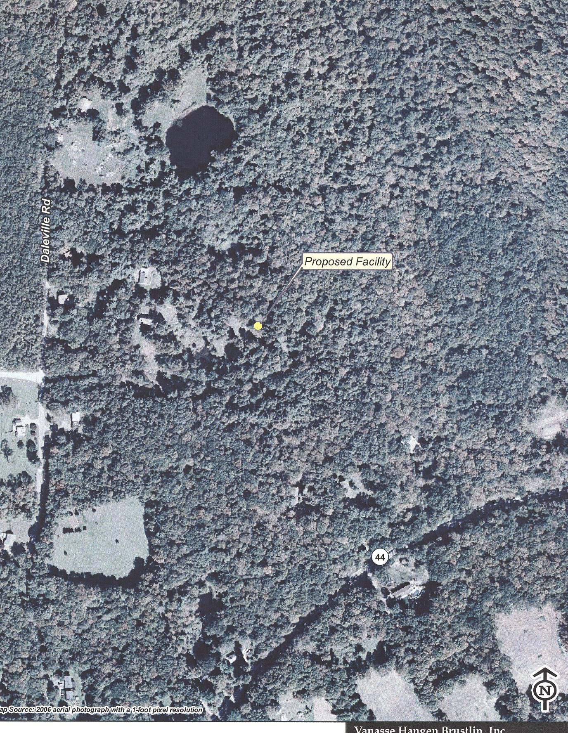
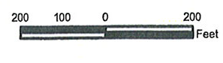
Figure 1: Aerial view of site location in Willington. (Cellco 1, p. 3)
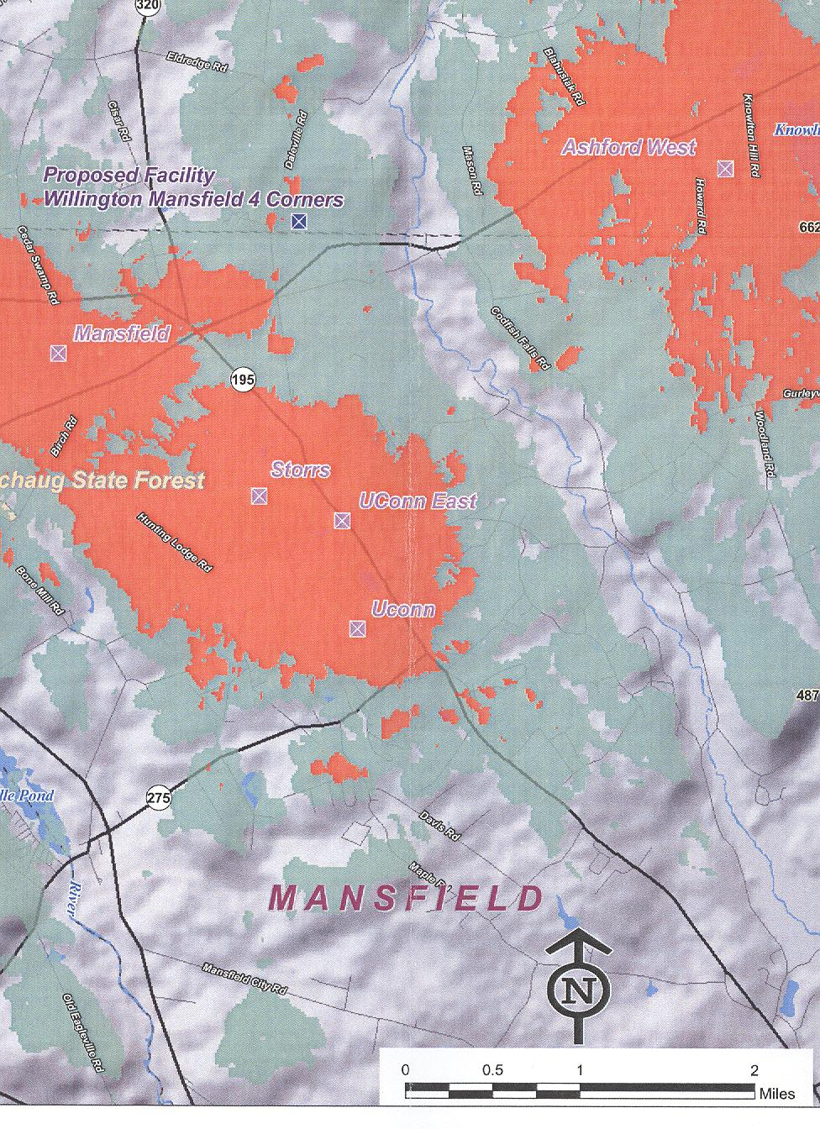

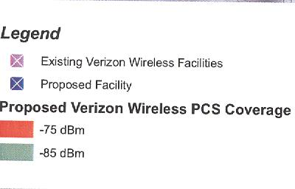

Figure 2: Existing cellular coverage. (Cellco 1, Tab 7)

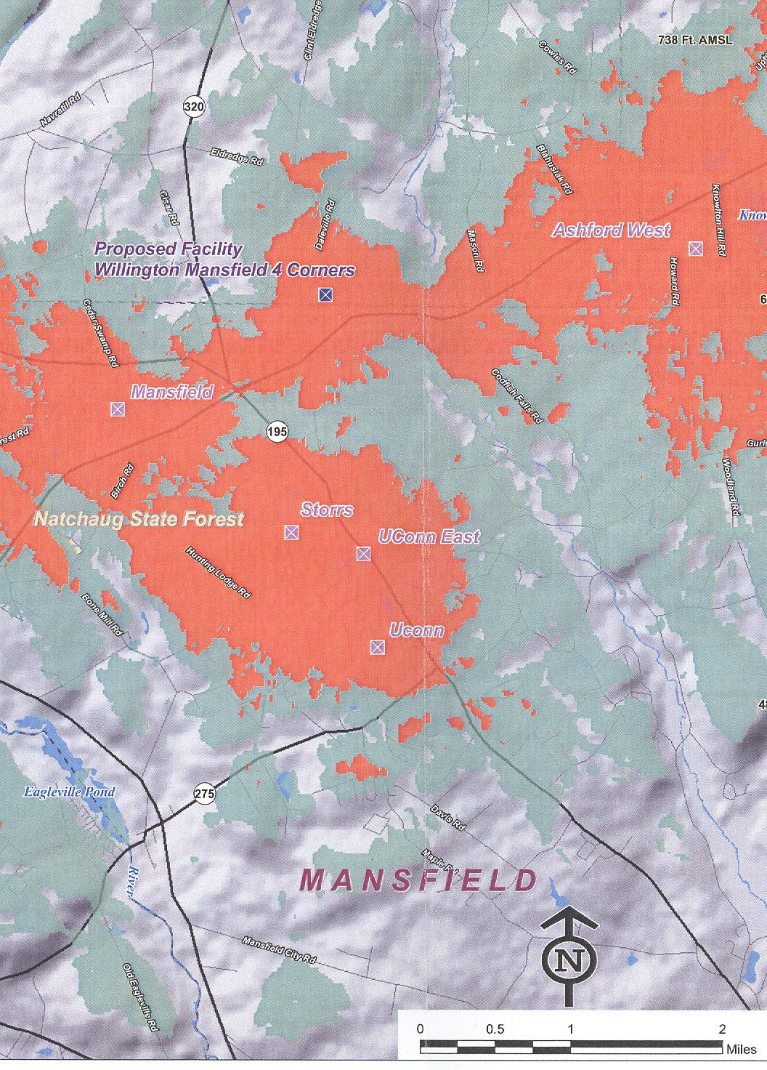

Figure 3: Existing and proposed cellular coverage. (Cellco 1, Tab 7)

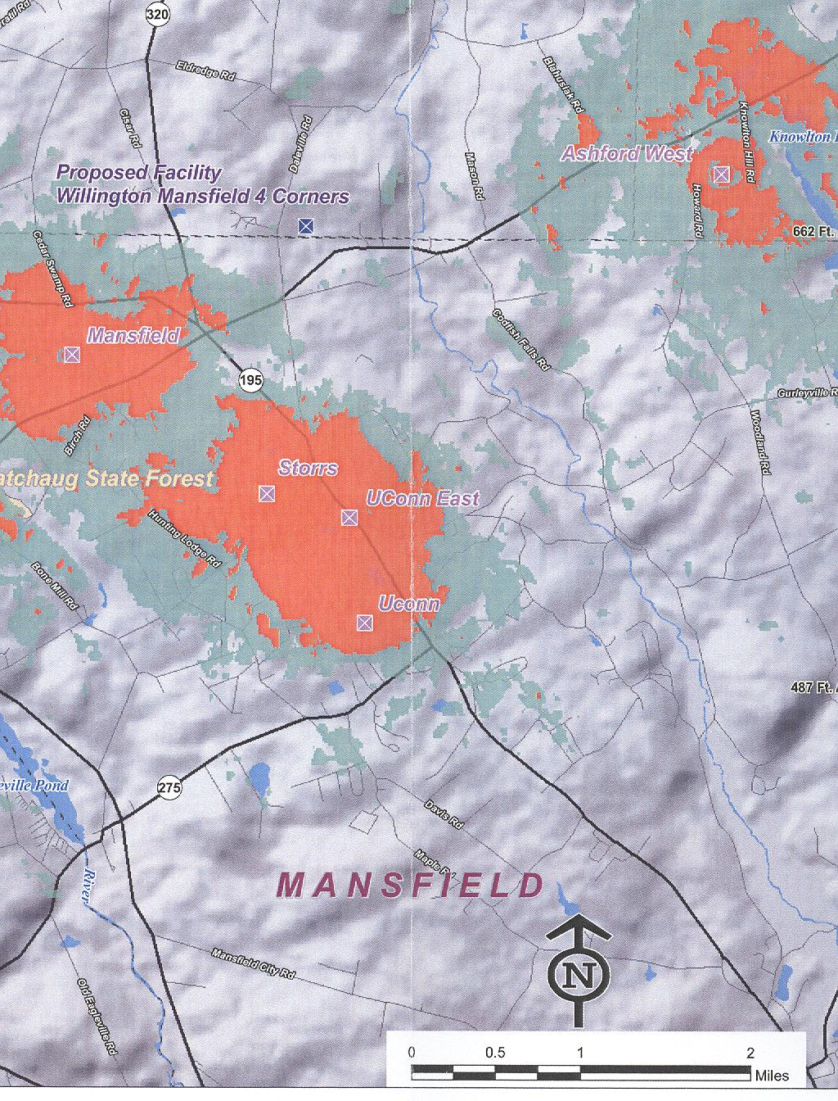

Figure 4: Existing PCS coverage. (Cellco 1, Tab 7)
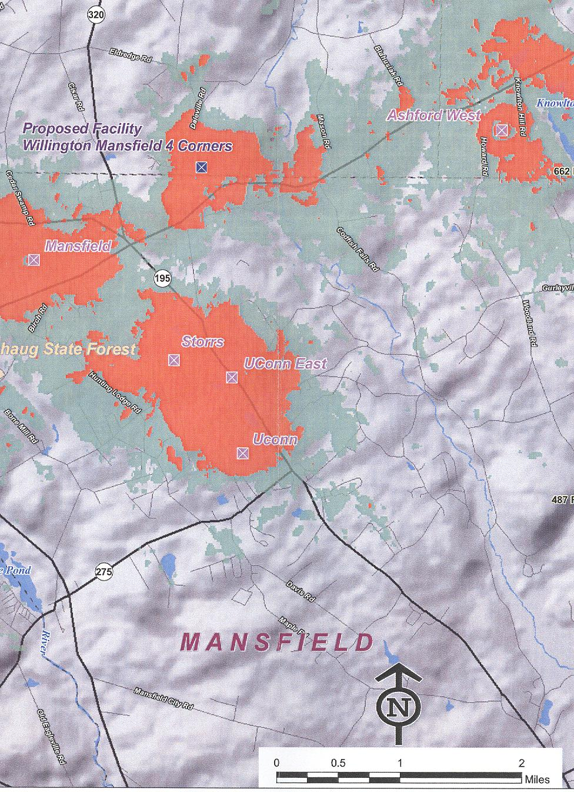
Figure 5: Existing and proposed PCS coverage. (Cellco 1, Tab 7)


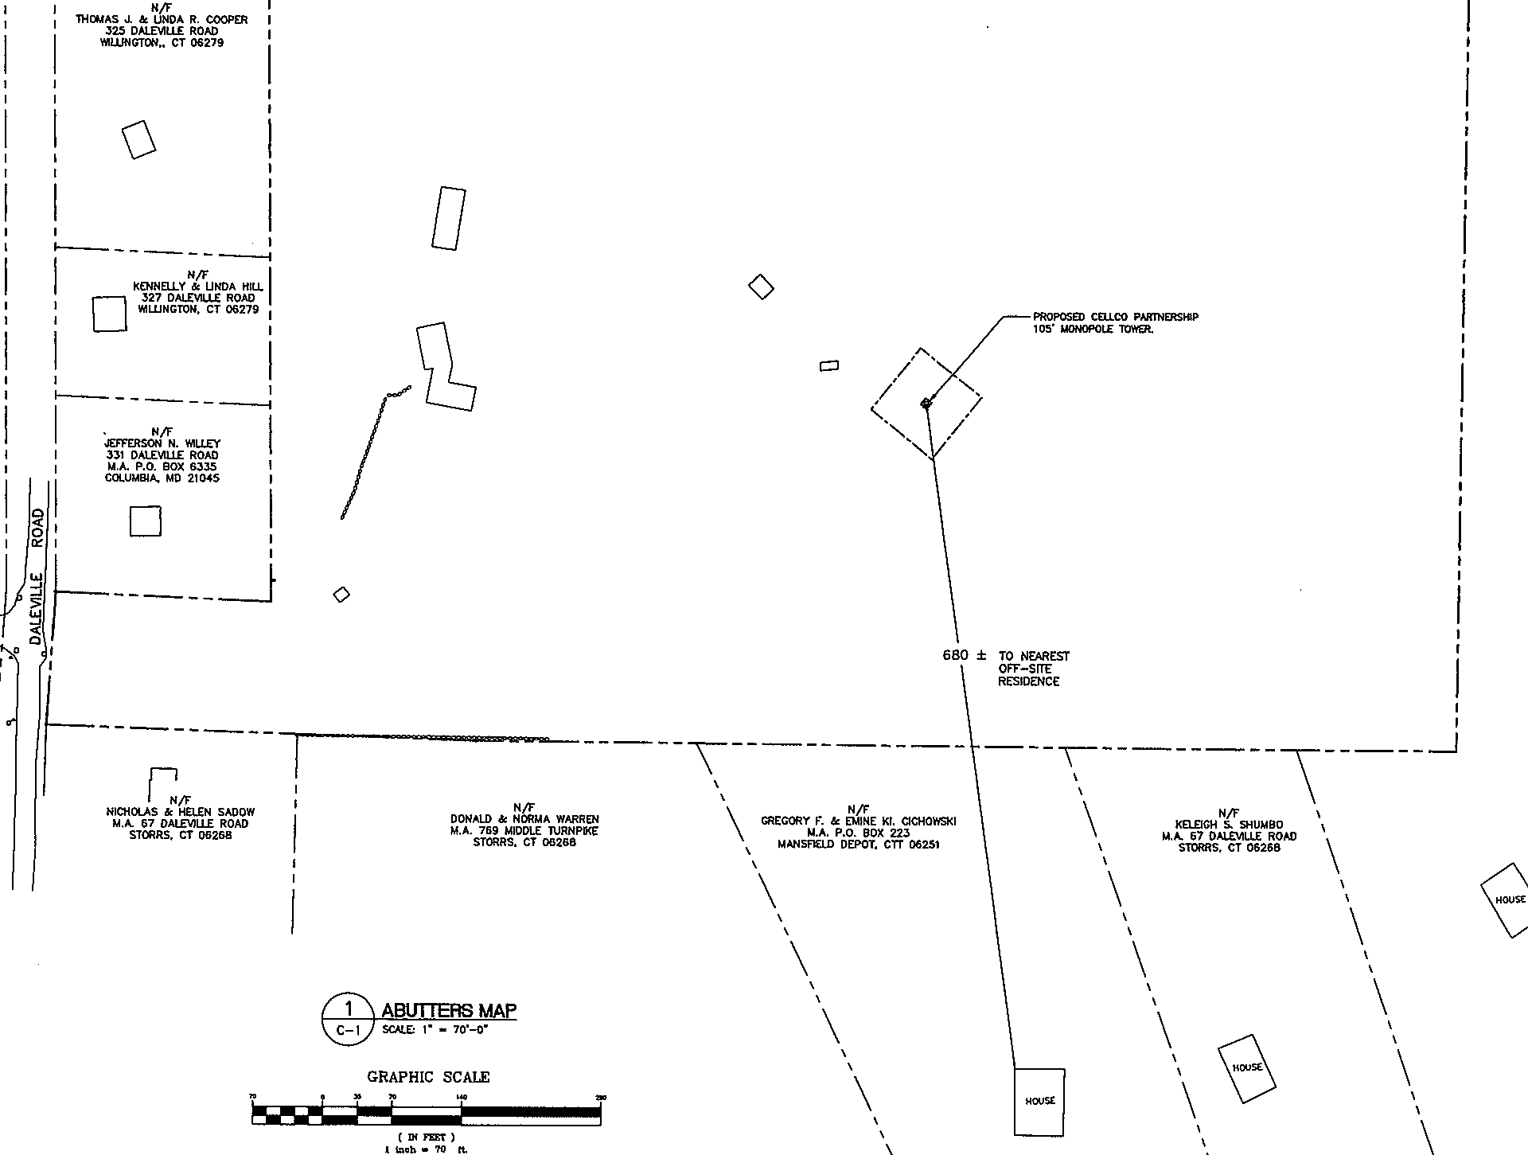

Figure 6: Site location at 343 Daleville Road. (Cellco 9)
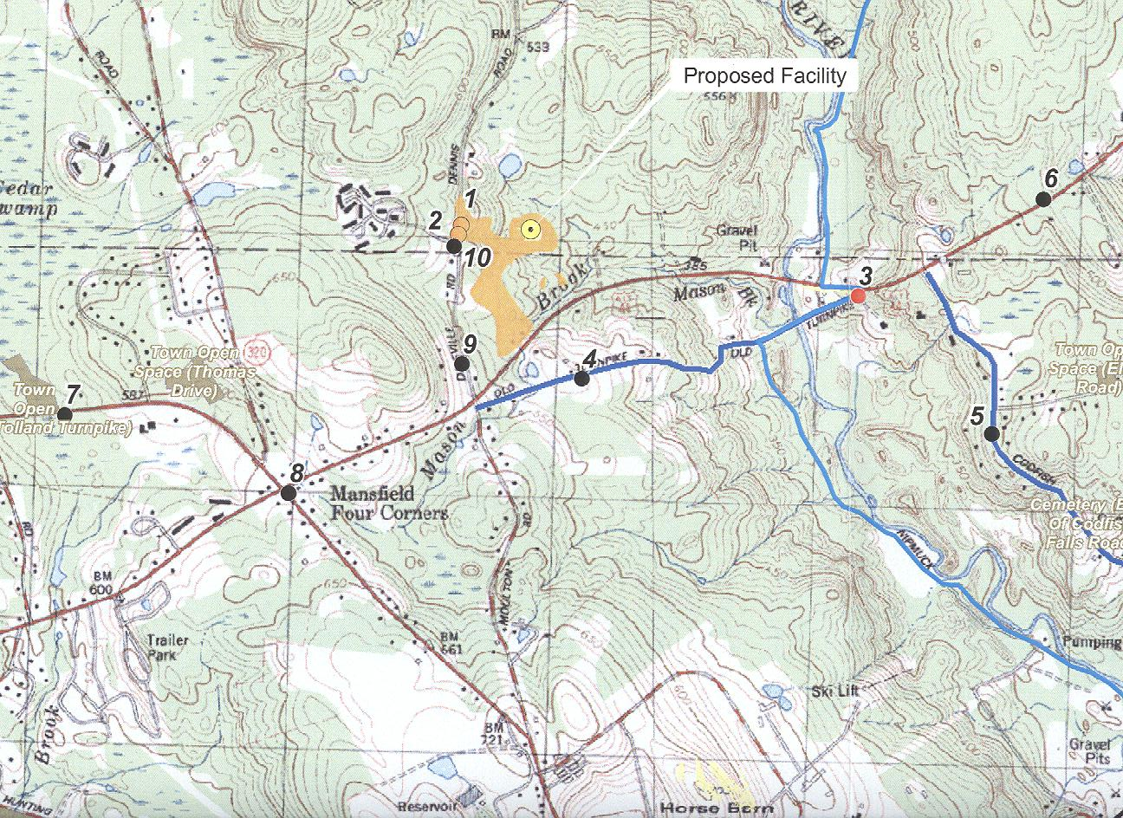
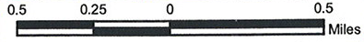
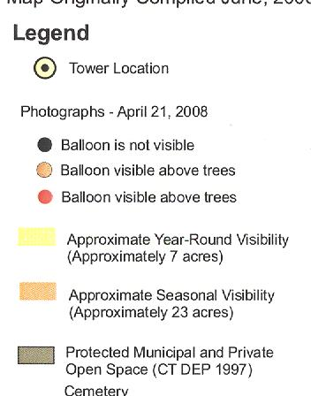
Figure 7: Visibility of proposed site. (Cellco 1, Tab 10; Tr. 1, pp. 12-13)
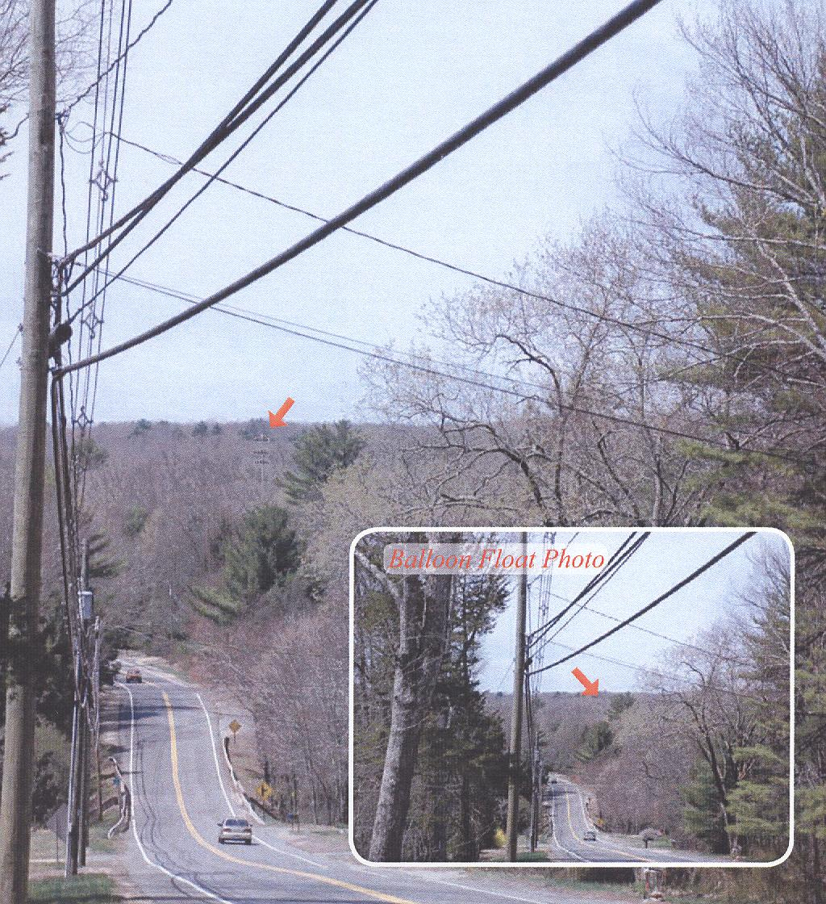

Figure 8: Year-round visibility of tower from Route 44, 0.7 mile east of site. (Cellco 1, Tab 10)

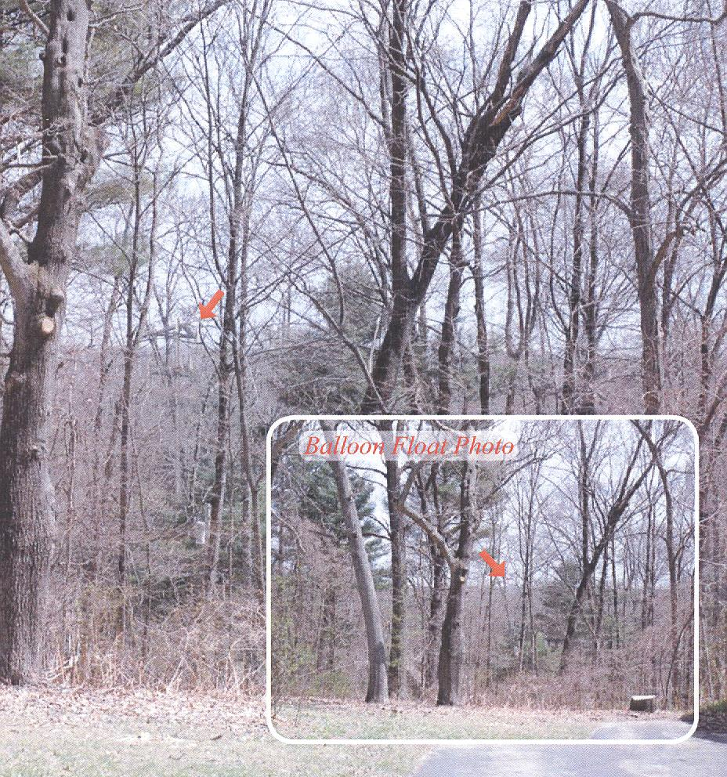

Figure 9: Seasonal visibility of tower from entrance to Willington Oaks Apts., 0.16 mile west of site. (Cellco 1, Tab 10)

