DOCKET NO. 392 - T-Mobile Northeast, LLC application for a Certificate of Environmental Compatibility and Public Need for the construction, maintenance and operation of a telecommunications facility located 387 Shore Road, Old Lyme, Connecticut. | }  }  } | Connecticut  Siting  Council  September 23, 2010

Findings of Fact

Introduction

1. Pursuant to Chapter 277a, Sections 16-50g et seq. of the Connecticut General Statutes (CGS), as amended, and Section 16-50j-1 et. Seq. of the Regulations of Connecticut State Agencies (RCSA), T-Mobile Northeast, LLC (T-Mobile) applied to the Connecticut Siting Council (Council) on October 15, 2009 for the construction, maintenance, and operation of a telecommunications facility, which would include an 80-foot monopole tower, located at 387 Shore Road in the Town of Old Lyme, Connecticut. (See Figures 1, 2, and 3) (T-Mobile 1, p. 1)

2. T-Mobile is a limited liability company, organized under the laws of Delaware, with a Connecticut office at 35 Griffin Road South, Bloomfield, Connecticut. The company and its affiliated entities are licensed by the Federal Communications Commission (FCC) to construct and operate a personal wireless services system in Connecticut. (T-Mobile 1, p. 2)

3. The parties in this proceeding are T-Mobile, the Town of Old Lyme (Town), and Mary Staley. (Transcript 3 – March 2, 2010, 11:15 a.m. [Tr. 3], p. 4)

4. T-Mobile’s proposed facility would provide coverage to Route 156, Connecticut Road, Oak Ridge Drive, Hatchetts Point Road just south of Interstate 95, and the Amtrak rail line that passes through the area. (T-Mobile 1, p. 1)

5. Pursuant to CGS § 16-50l(b), notice of the applicant’s intent to submit this application was published on July 23 and 25, 2009 in the New London Day. (T-Mobile 1, pp. 3-4 and Tab F)

6. Pursuant to CGS § 16-50l(b), T-Mobile sent notice of its intent to file an application with the Council to each person appearing of record as owner of property abutting the property on which the site is located. Notices were sent on July 21, 2009. T-Mobile received return receipts from all of the property owners to whom it sent notices. (T-Mobile 1, p. 4 and Tab G; T-Mobile 2, response 5)

7. Pursuant to CGS § 16-50l (b), T-Mobile provided a copy of its application to all federal, state, regional, and local officials and agencies listed therein. (T-Mobile 1, p. 3 and Tab E)

8. On or about January 20, 2010, T-Mobile posted a sign giving public notice of T-Mobile’s pending application for the proposed tower at 387 Shore Road and the public hearing scheduled for it. Per Council request, the sign was posted along Shore Road, on the host property, so that the public could see it more easily. (T-Mobile 4, Pre-Filed Testimony of Raymond Vergati, response 11 and Attachment A)

9. Pursuant to CGS § 16-50m, the Council, after giving due notice thereof, held a public hearing on February 4, 2010, beginning at 3:00 p.m. and continuing at 7:00 p.m. in the Old Lyme Meeting Hall, Town Hall, 52 Lyme Street, Old Lyme, Connecticut. This was a consolidated hearing for three T-Mobile tower applications in Old Lyme: Docket No. 391 – 232 Shore Road (Self-storage Site); Docket No. 392 – 387 Shore Road (Laundromat Site); and 61-1 Buttonball Road (Commercial Complex Site). The 3:00 p.m. hearing session began with Docket No. 391. The 7:00 p.m. hearing session included all three dockets. (Council's Hearing Notice dated December 23, 2009; Transcript 1 – February 4, 2010 at 3:05 p.m. [Tr. 1], pp. 3-4, 8, 13; Transcript 2 – 7:00 p.m. [Tr. 2], p. 3)

10. The Council and its staff conducted an inspection of three proposed sites on February 4, 2010, beginning at 1:00 p.m at the Laundromat Site and continuing to the Self-storage Site, and then the Commercial Complex Site. On the day of the field inspection, T-Mobile flew a black balloon up to four-feet in diameter to simulate the height of the proposed tower at the Laundromat Site beginning at approximately 7:00 a.m. and continuing to 10:00 a.m. The balloon was flown again beginning at 12:30 p.m. At approximately 2:20 p.m., T-Mobile was approached by Amtrak personnel requiring that the balloon float be abandoned because the balloon might cross Amtrak’s right of way. By approximately 2:30 p.m., the balloon was taken down. During the balloon float, the weather conditions were not favorable, due to a fairly sustained 10 miles per hour wind. The balloon briefly reached its proposed height of 80 feet above ground level (agl), but it was very fleeting due to the wind. (Council Field Review Notice dated January 27, 2010; Tr. 1, p. 4, 24-29; Tr. 3, p. 21)

11. The Council held continued hearings in New Britain on March 2, April 20, and June 23, 2010. (Transcript 3 – 11:15 a.m. [Tr. 3], p. 3; Transcript 4 – 1:15 p.m. [Tr. 4], p. 3; Transcript 5 – 1:10 p.m. [Tr. 5], p. 4)

State Agency Comments

12. Pursuant to CGS § 16-50l, the Council solicited comments on this application on December 23, 2009 from the following state departments and agencies: Department of Agriculture, Department of Environmental Protection (DEP), Department of Public Health, Council on Environmental Quality (CEQ), Department of Public Utility Control, Office of Policy and Management, Department of Economic and Community Development, and the Department of Transportation. (CSC Hearing Package dated December 23, 2009)

13. Pursuant to CGS § 16-50l, the Council solicited additional comments on this application on July 24, 2010 from the following state departments and agencies: Department of Agriculture, DEP, Department of Public Health, CEQ, Department of Public Utility Control, Office of Policy and Management, Department of Economic and Community Development, Department of Transportation, and the Department of Emergency Management and Homeland Security. (Letter to State Department Heads dated June 24, 2010)

14. The CEQ responded to the Council’s solicitation with comments. The CEQ notes that the visual impact of towers that are very close to the Long Island Sound shoreline cannot be fully assessed without a virtual simulation of their appearance from the waters of this major recreational resource. CEQ is also concerned that the proximity of multiple tall structures to preserved lands, refuges and coastal marshes raises the issues of possible impacts on resident and transient bird populations. (CEQ Comments dated January 27, 2009)

15. Except for CEQ, no state agencies submitted comments in response to the Council’s solicitation. (Record)

Municipal Consultation

16. On May 28, 2009, T-Mobile submitted a technical report on its proposed facility to Old Lyme’s First Selectman, Timothy Griswold. (T-Mobile 1, p. 17; T-Mobile 1, Tab R)

17. On June 25, 2009, T-Mobile met with the First Selectman Griswold and the Zoning and Inlands Wetlands Enforcement Officer to discuss the proposed facility. (T-Mobile 1, p. 17)

18. By letter dated October 21, 2009, First Selectman Griswold indicated that the Town had executed a lease with SBA Towers II, LLC for the development of a telecommunications facility at 14 Cross Lane, Old Lyme. The tower was proposed as 170 feet tall, and, since it would be centrally located, the Town believed T-Mobile would not need additional sites in Old Lyme; thus, a Cross Lane site would avoid the proliferation of towers in Connecticut. The Town believes that a one-site solution would be beneficial to the Town and the wireless customers who reside in or visit Old Lyme. (Town Comment Letter dated October 21, 2009)

19. In January 2010, the Cross Lane site was brought before a Town meeting and was defeated due to various citizen concerns, including the site’s proximity to a school. The Cross Lane site is no longer available for consideration. (Tr. 1, pp. 10-11)

20. At both February 4, 2010 hearing sessions, First Selectman Griswold made a statement on behalf of the Board of Selectman and residents in Old Lyme indicating an interest in improving cell reception in Old Lyme, particularly the beach area. (Tr. 1, pp. 9-11; Tr. 2, pp. 12-13)

21. First Selectman Griswold also stated that the Town requested tower space for its emergency services communications. The equipment would require approximately 160 feet of tower height on any one of the proposed towers. However, the Town has not expressed a specific interest in this tower. (Tr. 1, p. 11; Tr. 2, pp. 12-13; Tr. 3, p. 25)

22. T-Mobile would make space on its proposed tower available for the Town’s public safety communications free of charge. (T-Mobile 4, Pre-Filed Testimony of Raymond Vergati, response 10)

Federal Designation for Public Need

23. In 1996, the United States Congress recognized a nationwide need for high quality wireless telecommunications services, including cellular telephone service. Through the Federal Telecommunications Act of 1996, Congress seeks to promote competition, encourage technical innovations, and foster lower prices for telecommunications services. (Council Administrative Notice Item No. 7 – Telecommunications Act of 1996; T-Mobile 1, p. 4)

24. In issuing cellular licenses, the Federal government has preempted the determination of public need for cellular service by the states and has established design standards to ensure technical integrity and nationwide compatibility among all systems. (Council Administrative Notice Item No. 7 – Telecommunications Act of 1996)

25. The Telecommunications Act of 1996 prohibits local and state bodies from discriminating among providers of functionally equivalent services. (Council Administrative Notice No. 7 – Telecommunications Act of 1996)

26. The Telecommunications Act of 1996 prohibits any state or local agency from regulating telecommunications towers on the basis of the environmental effects, which include human health effects, of radio frequency emissions to the extent that such towers and equipment comply with FCC’s regulations concerning such emissions. This Act also blocks the Council from prohibiting or acting with the effect of prohibiting the provision of personal wireless service. (Council Administrative Notice No. 7 – Telecommunications Act of 1996; T-Mobile 1, p. 4)

27. Congress enacted the Wireless Communications and Public Safety Act of 1999 (the 911 Act) in order to promote public safety through the deployment of a seamless, nationwide emergency communications infrastructure that includes wireless communications services. (T-Mobile 1, pp. 5-6)

28. As an outgrowth of the 911 Act, the FCC has mandated that wireless carriers provide enhanced 911 services (E911) as part of their communications networks. (T-Mobile 1, p. 6)

29. The proposed facility would be an integral component of T-Mobile’s E911 network in southeastern Connecticut and would comply with FCC’s E911 requirements. (T-Mobile 1, p. 6)

Existing and Proposed Wireless Coverage

T-Mobile

30. T-Mobile experiences a coverage gap in the area around the proposed facility, specifically along the shore line and the Amtrak rail line, as well as on Route 156, Connecticut Road, Oak Ridge Drive, and Hatchetts Point Road just south of Interstate 95. (T-Mobile 1, pp. 4-5)

31. The proposed facility would provide service in the area of T-Mobile’s coverage gap. (T-Mobile 1, p. 5)

32. T-Mobile utilizes Personal Communications Services (PCS) in this area of the state through the deployment of wireless transmitting sites. Its licensed operating frequencies in the New London Basic Trading Area include 1935 to 1944.8 MHz, 1983 to 1984 MHz, and 2140 to 2145 MHz. (T-Mobile 1, p. 6 and Tab P)

33. T-Mobile’s minimum design signal strength for in-vehicle coverage is -84 dBm. For in-building coverage, it is -76 dBm. (T-Mobile 2, responses 2 and 3)

34. T-Mobile’s existing signal strengths in the area that would be covered by the proposed facility range from -84 dBm to below -100 dBm. (T-Mobile 2, response 1)

35. The lengths of the coverage gaps T-Mobile experiences on the major arteries and the lengths of the proposed coverage areas are listed in the following table.

Transportation Artery | Coverage Gap | Distance Covered at Proposed Antenna Height of 77 feet
Route 156 | 3.36 miles | 1.05 miles
Amtrak Rail Line | 4.62 miles | 1.89 miles
(T-Mobile 2, responses 14 and 15)

36. The total area T-Mobile could cover from the proposed site with antennas at a height of 77 feet would be approximately 0.96 square miles. (T-Mobile 2, response 16)

37. The lengths of T-Mobile’s coverage areas on the major arteries at lower antenna heights are listed below.

Transportation Artery | Distance Covered at Antenna Height of 67 feet | Distance Covered at Antenna Height of 57 feet
Route 156 | 0.97 miles | 0.86 miles
Amtrak Rail Line | 1.23 miles | 1.08 miles
(T-Mobile 2, response 15)

38. The total area T-Mobile could cover from the proposed site at the lower antenna heights of 67 feet and 57 feet would be 0.70 square miles and 0.54 square miles, respectively. (T-Mobile 2, response 16)

39. T-Mobile’s antennas at the proposed facility would hand off signals to the existing sites identified in the following table.

Site Address | Facility Type | Structure  Height | T-Mobile’s  Antenna  Height | Distance & Direction to proposed facility
125 Mile Creek Road, Old Lyme | Monopole | 160 feet | 160 feet | 2.11 miles SE
62-1 Boggy Hole Road, Old Lyme | Monopole | 175 feet | 175 feet | 3.13 miles SE
38 Hattchetts Hill Road, Old Lyme | Monopole | 190 feet | 187 feet | 1.60 miles S
93 Roxbury Road, Old Lyme | Self-support Tower | 160 feet | 103 feet | 3.13 miles SW
(T-Mobile 2, response 9)

Site Selection

40. T-Mobile initiated its search for a site in this vicinity on or about July 24, 2008. (T-Mobile 2, response 4)

41. T-Mobile’s site search was centered at the intersection of Old Cart Path Road and the Amtrak rail line. The radius of the search area was approximately 0.2 miles. (T-Mobile 2, response 4)

42. T-Mobile identified six telecommunications towers within approximately four miles of its proposed site. The towers are listed in the table below.

Tower Location | Height and Type  Of Tower | Tower Owner | Approx. Distance and Direction from Proposed Tower Location
93 Roxbury Road, East Lyme | 150-foot self-supporting lattice tower | Crown | 3.33 miles NE
62-1 Boggy Hole Road, Old Lyme | 175-foot monopole | Wireless Solutions | 3.04 miles NW
132 Whippoorwill Road, Old Lyme | 100-foot guyed lattice tower | Mr. & Mrs. Andrew Pfeiffer | 2.92 miles NW
30 Short Hill Road, Old Lyme | 180-foot monopole | Sprint | 1.70 miles NW
38 Hatchetts Hill Road, Old Lyme | 190-foot monopole | T-Mobile | 1.63 miles N
125 Mile Creek Road, Old Lyme | 160-foot monopole | Cellco | 2.05 miles NW
(T-Mobile 1, Exhibits I; T-Mobile 3, response 3)

43. Two of the existing telecommunications towers within a four-mile radius are too far away to meet T-Mobile’s coverage objectives. These towers are located at 132 Whippoorwill Road, Old Lyme and 30 Short Hills Road, Old Lyme. (T-Mobile 3, response 3)

44. The remaining four existing telecommunications towers within a four-mile radius already have T-Mobile co-located on them. These towers are 93 Roxbury Road, East Lyme; 62-1 Boggy Hill Road, Old Lyme; 38 Hatchetts Hill Road, Old Lyme; and 125 Mile Creek Road, Old Lyme. (T-Mobile 3, response 3)

45. There are no large areas of commercial or industrial use in or around the target coverage area. The area is heavily comprised of residential homes. Thus, T-Mobile investigated one commercial property to see if it was suitable for a tower. The site is listed below:

- Sicuranza Electric, 389 Shore Road: This parcel is only 0.60 acres and has little to no natural screening for a tower. The existing building is approximately 15 feet high, which is too low to afford adequate coverage.

46. During this proceeding, another alternative site at 14 Cross Lane, Old Lyme was explored. This is the site of a proposed SBA Towers II, LLC tower on Town property. This proposed tower would not provide adequate coverage to T-Mobile, and the site is no longer available. (T-Mobile 2, response 17)

47. An outdoor Distributed Antenna System (DAS) would not be a feasible alternative to a tower because of the following reasons:

- The unavailability of a sufficient number of existing utility poles on which to string fiber-optic cable and install DAS nodes in the coverage area;
- The existing utility poles are generally low in height;
- The existing uneven terrain and mature vegetation would prevent DAS nodes from providing reliable coverage throughout the target area;
- The unavailability of unused fiber-optic cables to serve as the backbone of the DAS network in the area; and
- There would be a need to enter into access easements, enter into pole attachment agreements, etc. which would be compounded by the large amount (roughly 45) of DAS nodes required to cover the total area to be served by the three towers proposed in Docket Nos. 391, 392, and 393.
(T-Mobile 20)

48. Repeaters, microcell transmitters, and other types of transmitting technologies are not practicable or feasible means to provide service within the coverage area that T-Mobile is seeking to serve due to significant terrain variations and tree cover, the relatively large size of the coverage area compared with the devices’ limited transmission range, and other practical considerations. (T-Mobile 1, p. 7)

Overview of Three Tower Configuration

49. If approved, this tower will not eliminate the need for the other two towers proposed as Docket Nos. 391 and 393. (Tr. 3, pp. 246-247)

50. Increasing the height of any of the proposed facilities (i.e. Docket Nos. 391 through 393) would not obviate the need for any of the facilities or allow T-Mobile to reduce the height of any of the facilities. (Tr. 3, pp. 246-247)

Facility Description

51. The proposed facility would be located at 387 Shore Road on a 2.11 acre parcel owned by Gregory Benoit (the Benoit property) and contains a laundromat. The Amtrak rail line right-of-way abuts the Benoit property to the south. (See Figures 1 and 2) (T-Mobile 1, pp. 1, 9 and Exhibits B)

52. The Benoit property is zoned Commercial (C-30). Telecommunications towers are allowed in a C-30 zoning district with a special permit. (T-Mobile 1, p. 9; T-Mobile 1b – Town of Old Lyme Zoning Regulations)

53. The proposed facility would be located in the eastern half of the host property. (T-Mobile 1, Tab B)

54. For its proposed facility, T-Mobile would lease a 2,400 square foot area (40 feet by 60 feet). The facility would include an 80-foot tall steel monopole tower within a 20-foot by 40-foot (800 square feet) compound. The compound would be enclosed by an eight-foot high chain link fence. (See Figure 3) (T-Mobile 1, p. 9 and Tab B)

55. T-Mobile could install anti-climbing weave mesh on the compound fence. T-Mobile could also install a standard chain-link fence with barbed wire if required by the Council. T-Mobile could use privacy slats on the chain-link fence or use an eight-foot stockade fence if requested by the Council. (T-Mobile 2, response 19; Tr. 3, p. 52, 55)

56. The proposed tower would be located at 41º 17’ 47.37” north latitude and 72º 15’ 35.02” west longitude. Its ground elevation would be 38 feet above mean sea level (amsl). (T-Mobile 1, Tab B)

57. The proposed tower would be designed as a monopole in accordance with the 2005 Connecticut State Building Code and the Electronic Industries Association Standard ANSI/TIA-222-F “Structural Standards for Steel Antenna Towers and Antenna Support Structures” for New London County. (T-Mobile 1, Tab B)

58. The tower would be designed for one carrier only, but could be designed for more if requested by the Council. (Tr. 1, p. 37)

59. T-Mobile would install nine panel antennas (three per sector) at a centerline height of 77-foot 9-inch AGL on T-arm mounts. (T-Mobile 1, p. 9 and Tab B; T-Mobile 2, response 10)

60. The top of T-Mobile’s antennas would be flush with the top of the tower at 80 feet. (T-Mobile 1, Tab B; Tr. 3, p. 25)

61. T-Mobile could utilize flush-mounted antennas, but that configuration would require T-Mobile to occupy two levels instead of one, with the second 10 feet higher. (T-Mobile 2, response 11)

62. T-Mobile considered alternative stealth tower designs such as evergreen tree tower, but did not think an evergreen tree tower would fit it with the existing deciduous trees. (Tr. 3, p. 27)

63. A dead tree or snag tower may be feasible, but would likely only accommodate one, possibly two carriers due to the internal antenna array. (Tr. 3, p. 27)

64. T-Mobile would install two radio equipment cabinets on a concrete pad within the fenced compound. (Tr. 3, p. 22)

65. T-Mobile would use battery backup power for its proposed facility. The battery power system could operate for 4 to 12 hours. (T-Mobile 2, response 11)

66. The equipment area would contain a service light with a motion sensor. The light would not normally be on. (Tr. 3, p. 22)

67. Construction of the proposed facility would require a total of 115 cubic yards of cut and 75 cubic yards of fill. (T-Mobile 2, response 18)

68. The facility compound cannot be easily moved closer to Shore Road due to existing mature trees, rocky outcroppings, and a sewer line slightly to the north. (Tr. 3, p. 29)

69. Vehicular access to the proposed facility would extend from Shore Road over an existing paved driveway and then across an existing gravel parking lot for a total distance of approximately 120 feet. (T-Mobile 1, p. 9; T-Mobile 1, Tab B)

70. Utility service would extend underground approximately 150 to 200 feet to reach utility poles on Shore Road. The electrical and telephone connections would be on separate poles. (T-Mobile 1, p. 9 and Tab B)

71. The tower’s setback radius would extend approximately 60 feet onto the Amtrak rail line right-of-way. (T-Mobile 1, Tab B)

72. To reduce the tower’s setback radius, T-Mobile would incorporate a yield point, or hinge point, into the design of the tower at approximately 60 feet agl. (Tr. 3, p. 24)

73. The nearest adjacent properties are the Amtrak right-of-way, which is located approximately six feet immediately to the south, and other residential properties to the north on the opposite side of Shore Road. (T-Mobile 1, Tab B)

74. There are 35 single-family residences within 1,000 feet of the proposed facility. (T-Mobile 1, Tab L; Tr. 3, p. 15)

75. The nearest single-family residence not on the host property is located 185 feet away at 2 North Road and is owned by David and Lina Tuck. (T-Mobile 1, Tabs B and L; Tr. 3, p. 14)

76. Land use in the vicinity of the proposed facility consists of existing Amtrak right-of-way, several commercial establishments along Route 156, and medium-density residential development to the south. (T-Mobile 1, Tab N)

77. The estimated cost of the proposed facility is the following:

Tower and foundation costs $ 71,000
Site development costs 73,000
Utility installation costs 41,000
Equipment cabinets 30,000
RF components e.g. antennas and cable 15,000
Total estimated costs $230,000

(T-Mobile 1, pp. 18-19; T-Mobile 3, response 1)

Environmental Considerations

78. The proposed facility would have no effect on historic, architectural, or archaeological resources listed on or eligible for the National Register of Historic Places. (T-Mobile 1, Tab O, Letter from SHPO dated June 17, 2009)

79. The proposed facility would not affect any threatened or endangered species or designated critical habitats. (T-Mobile 1, p. 13)

80. The proposed facility would not affect any of the “listed” categories of the National Environmental Policy Act (NEPA): wilderness preserves; critical habitats; National Register historic districts, sites, buildings, structures or objects; flood plains; or federal wetlands. (T-Mobile 1, p. 19; Tab Q)

81. The proposed facility is not located with the 100-year or 500-year floodplain. (T-Mobile 1, Tab Q)

82. Development of the proposed facility would require the removal of three trees with a diameter of six inches or greater at breast height. (T-Mobile 1, Tab M)

83. T-Mobile’s proposed 80-foot tower would not require notification to the Federal Aviation Administration or marking or lighting. (T-Mobile 1, Tab S)

84. The nearest wetland system is located approximately 250 feet west of the proposed facility. The proposed development is not expected to impact wetlands. (T-Mobile 1, p. 9 and Tab K)

85. T-Mobile would establish and maintain appropriate soil erosion and sedimentation control measures, in accordance with the 2002 Connecticut Guidelines for Soil Erosion and Sediment Control established by the Connecticut Council for Soil and Water Conservation, in cooperation with the Connecticut Department of Environmental Protection, throughout the construction period of the proposed facility. (T-Mobile 1, p. 16)

86. A dirt/debris pile to the west of the compound already existed at the time of T-Mobile’s environmental review of the site. (Tr. 3, pp. 21-22)

87. The cumulative worst-case maximum power density from the radio frequency emissions of the proposed T-Mobile antennas is calculated to be 21.33 percent of the standard for Maximum Permissible Exposure, as adopted by the FCC, at the base of the proposed tower. This calculation was based on methodology prescribed by the FCC Office of Engineering and Technology Bulletin No. 65E, Edition 97-01 (August 1997) that assumes all antennas would be pointed at the base of the tower and all channels would be operating simultaneously, which creates the highest possible power density levels. Under normal operation, the antennas would be oriented outward, directing radio frequency emissions away from the tower, thus resulting in significantly lower power density levels in areas around the tower. (T-Mobile 1, p. 12)

Visibility

88. The majority of the year-round visibility of the tower is over open water. Approximately 662 acres, or over 97 percent of the 679 acres of year-round visibility, is over open water on Long Island Sound to the south, at a distance of 0.55 miles to 2 miles within the study area. (T-Mobile 1, Tab N)

89. The tower would be visible year-round on land from approximately 17 acres within a two-mile radius of the site. The tower would be seasonally visible from approximately 31 acres on land within a two-mile radius of the site. (T-Mobile 1, Tab N)

90. Specific areas of year-round visibility of the tower on land include the immediate vicinity of the proposed tower site along Shore Road and the existing Amtrak right of way, extending 0.25 to 0.50 miles along the railroad corridor. Areas of limited year-round visibility also include the Point O’ Woods residential development to the south/southeast of the proposed tower site. (T-Mobile 1, Tab N)

91. Approximately 12 residences would have year-round visibility of the proposed tower, including four residences on Shore Road and roughly eight residences located within the Point O’ Woods development. (T-Mobile 1, Tab N)

92. A total of approximately 14 additional homes located on select portions of Shore Road and the Post O’ Woods development would have seasonal views of the proposed tower. (T-Mobile 1, Tab N)

93. Visibility of the proposed tower from specific locations in the surrounding area is summarized in the table below.
Location | Visible | Approx. Portion of 80’ Tower Visible (ft.) | Approx. Distance and Direction to Tower
1 – Route 156 (Shore Road) approaching proposed tower, looking northeast | Yes | 30 feet – above tree line | 0.19 miles NE
2 – Route 156 (Shore Road) at Connecticut Road, looking southwest | Yes | 20 feet – above tree line | 0.09 miles SW
3 – Walnut Road adjacent to house #2, looking northwest | Yes | 10 feet – through trees | 0.23 miles NW
4 – Hillcrest Road at Connecticut Road, looking southwest | Yes | 30 feet – through trees | 0.08 miles SW
5 – North Road at Shore Acres Road, looking northwest | Yes | 30 feet – through trees | 0.06 miles NW
6 – Tony’s Nose Overlook within Rocky Neck State Park, looking southwest | No | n/a | 0.67 miles SW
7 – Swan Avenue, looking northeast | No | n/a | 1.24 miles NE
8 – Route 156 (Shore Road), looking northeast | No | n/a | 0.30 miles NE
9 – Mile Creek Road west of Chestnut Hill Road, looking southeast | No | n/a | 0.57 miles SE
10 – Route 156 (Shore Road) at Oakridge Drive, looking southwest | No | n/a | 0.26 miles SW
(T-Mobile 1, Tab N)

Coastal Management Act

94. The tower would be located approximately 0.8 miles to the north of Long Island Sound. (T-Mobile 1, Tab N).

95. Although the proposed facility is located within the Connecticut Coastal Management Act’s (CCMA) coastal boundary, there are no coastal resources on the subject property. The nearest coastal resources are tidal wetlands associated with Threemile River, which is located approximately 500 feet southwest of the proposed tower. No coastal resources, as defined in the CCMA, would be adversely affected by the proposed tower. (T-Mobile 1, p. 14)

96. Views of the tower from Long Island Sound would be distant and rising topography to the north provides the backdrop of the view. (T-Mobile 21)

Figure 1: Location Map of Proposed Site
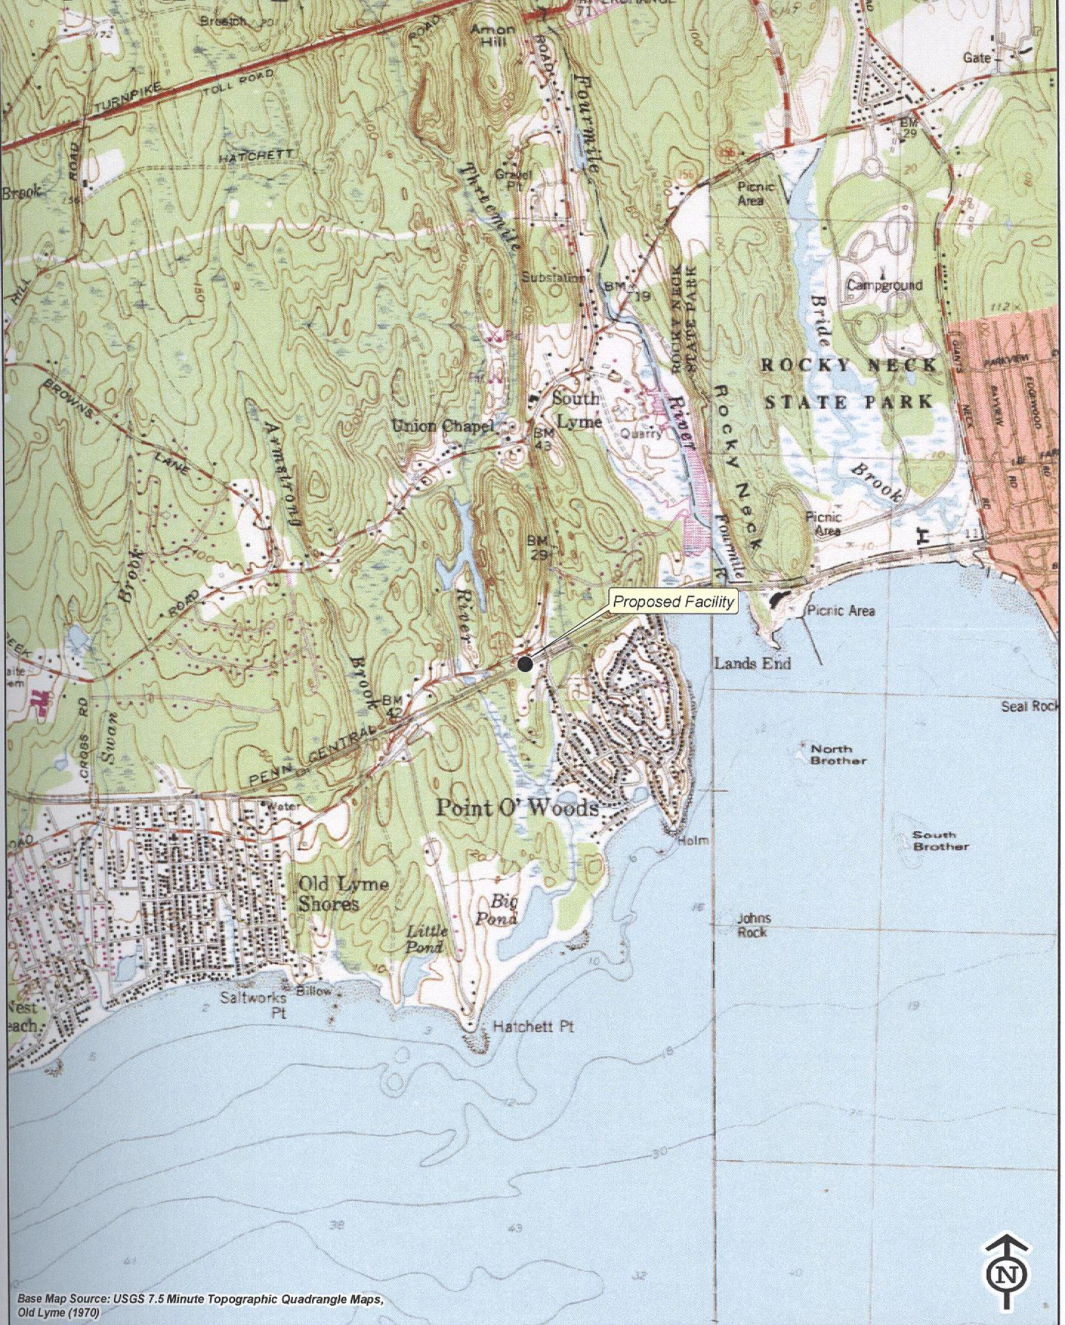
(T-Mobile 1, Tab C)

Figure 2: Aerial Photograph of Proposed Site Location
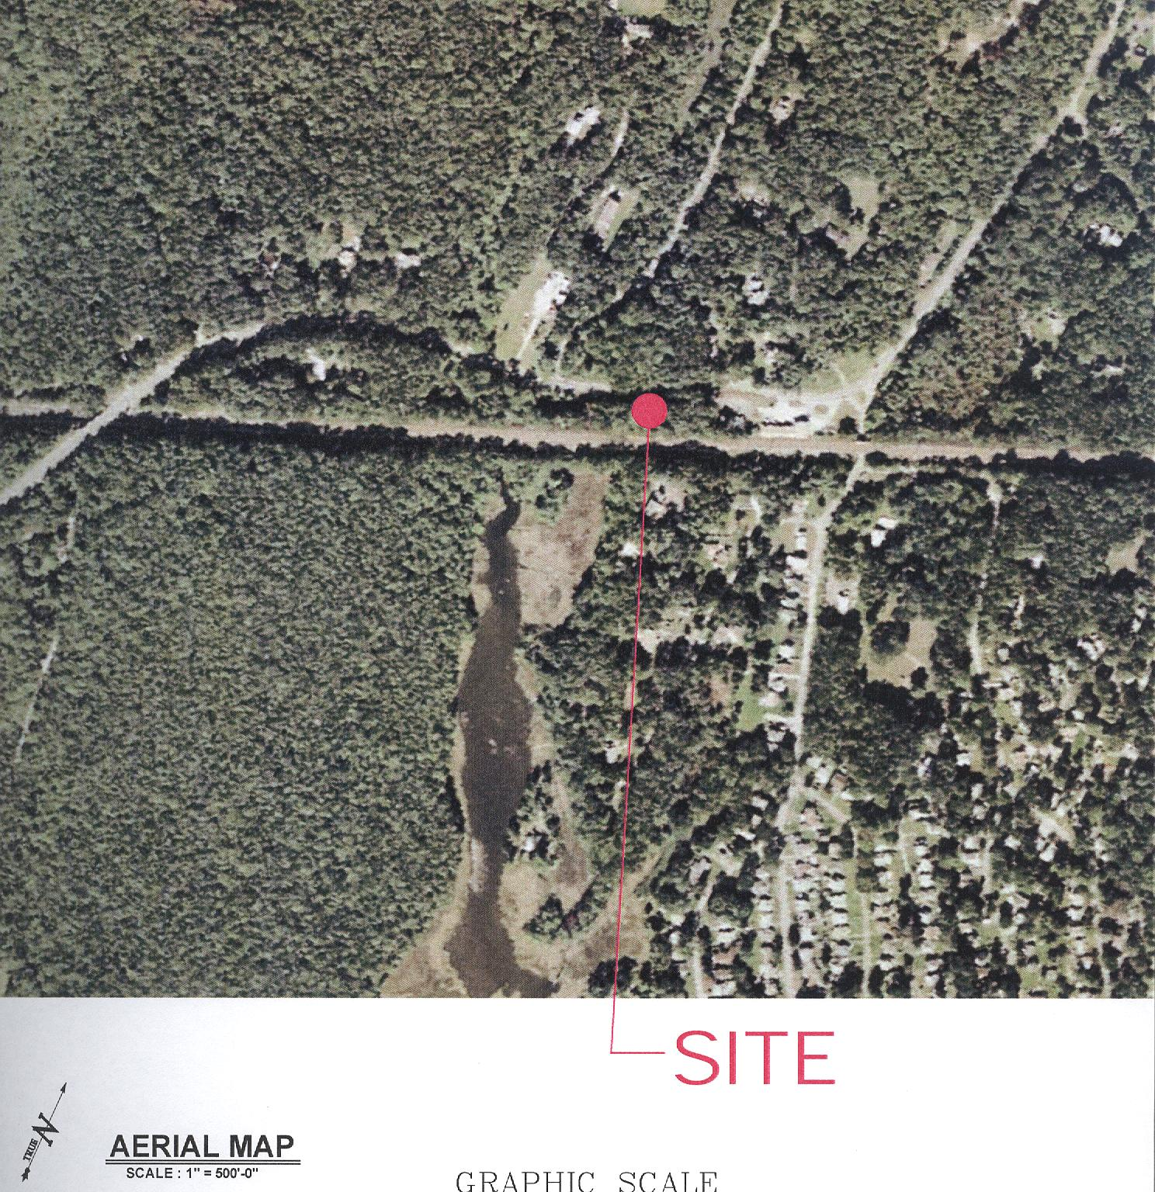
(T-Mobile 1, Tab B)

Figure 3: Proposed Facility Site Plan
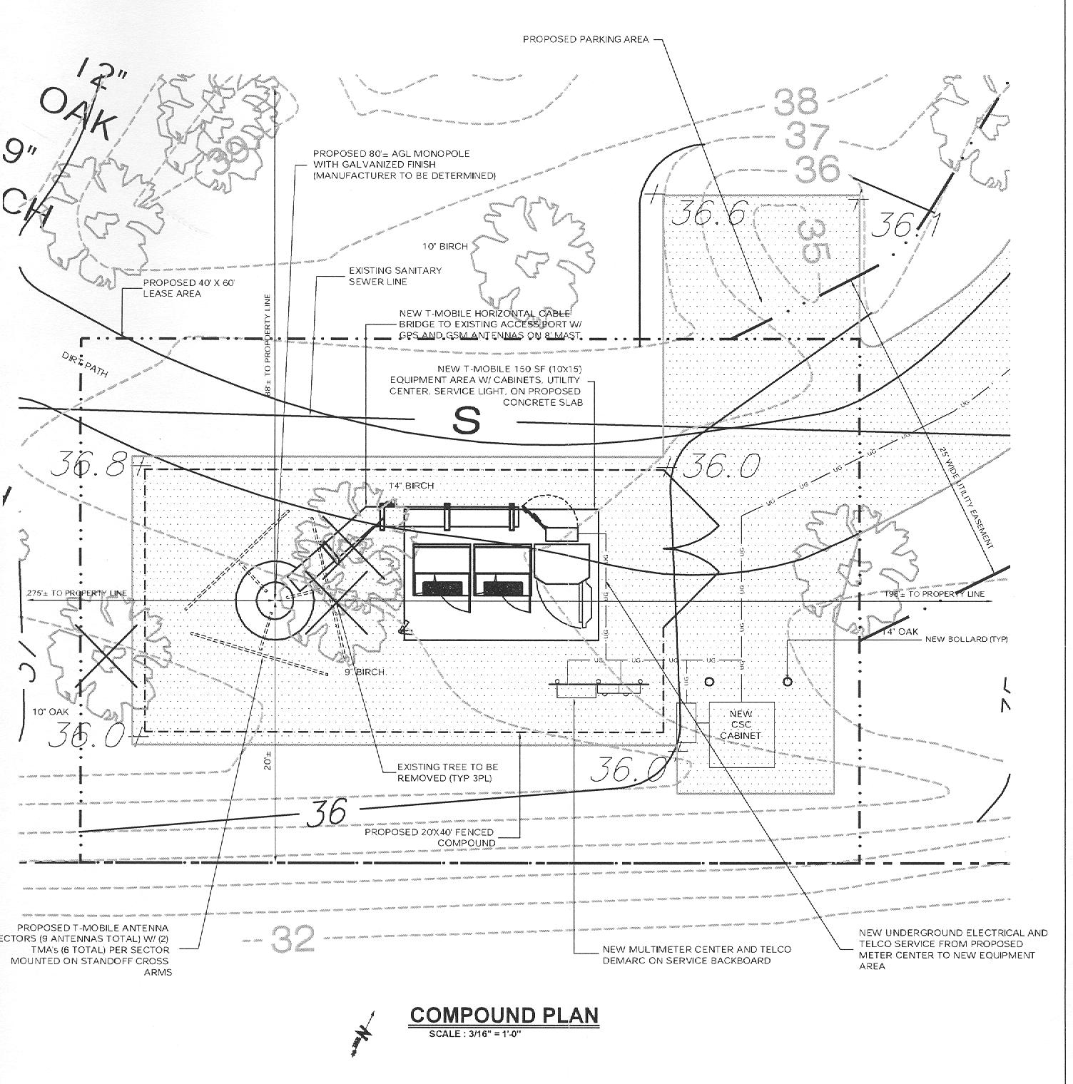
(T-Mobile 1, Tab B)

Figure 4: T-Mobile’s Existing Coverage
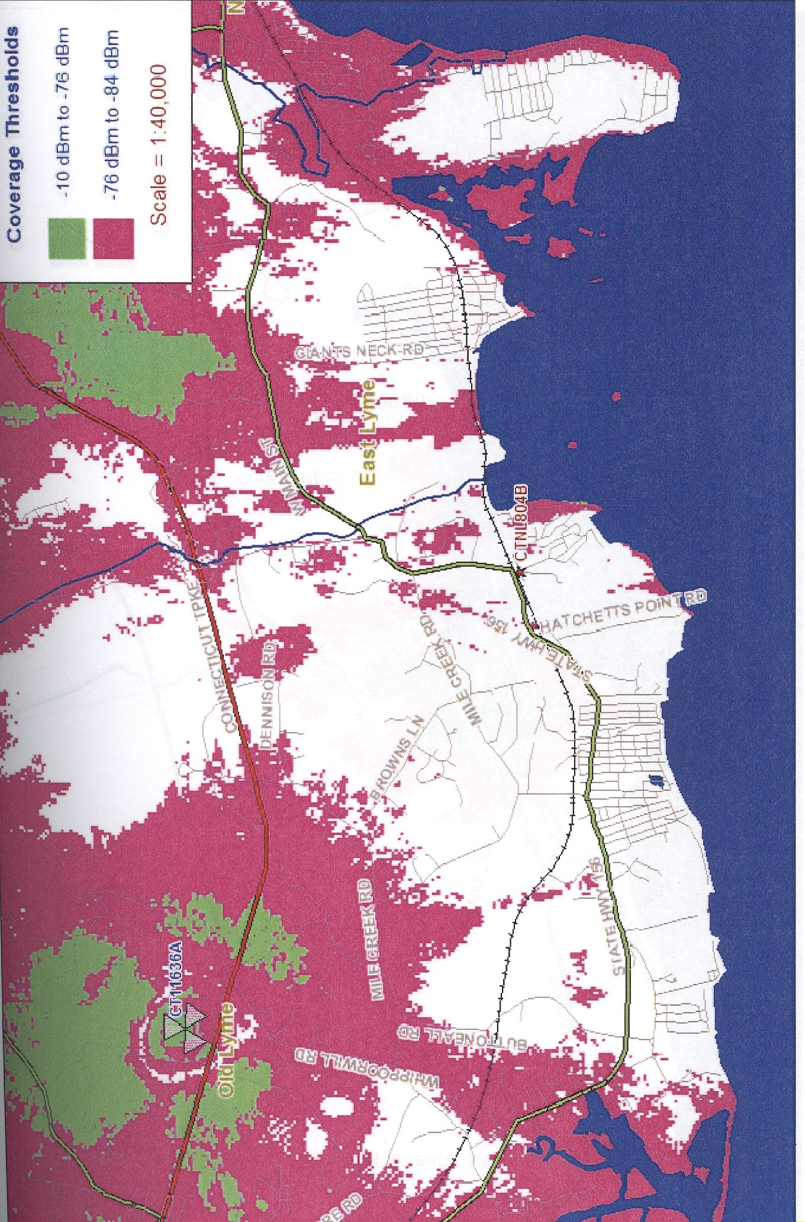
(T-Mobile 1, TabH)

Figure 5: T-Mobile’s Coverage from Proposed Site
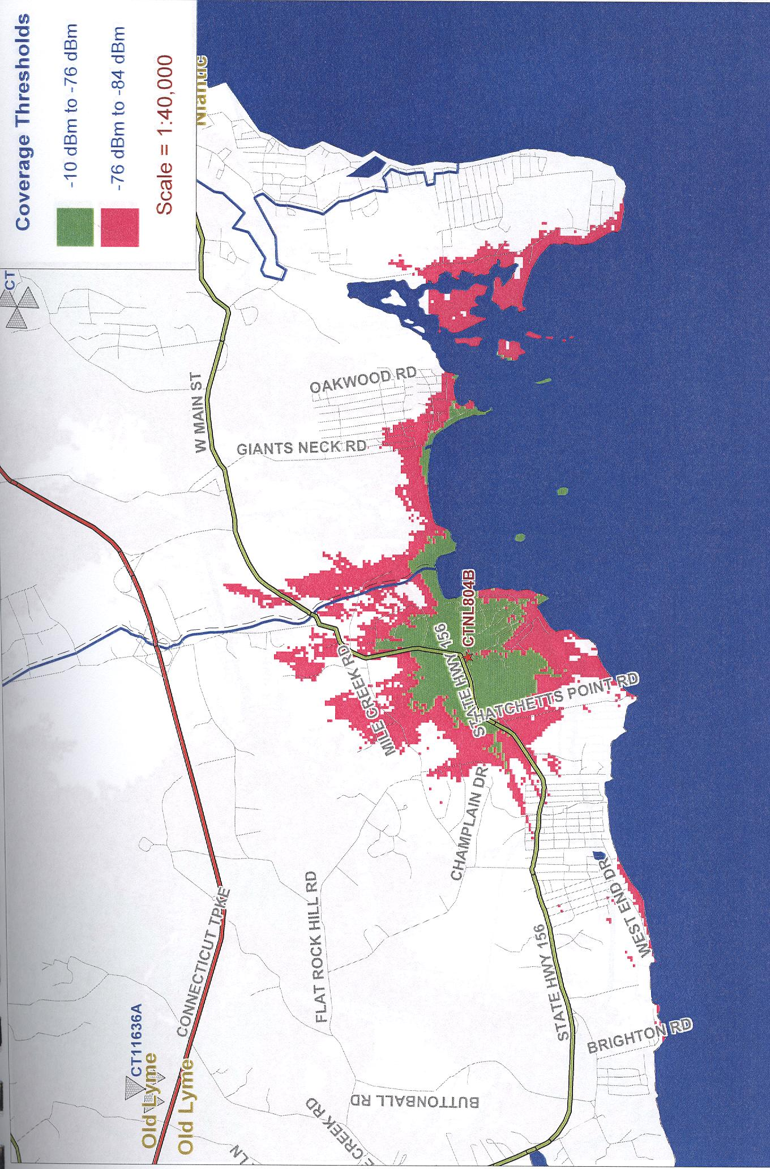
(T-Mobile 1, Tab H)

Figure 6: T-Mobile’s Existing Coverage with Proposed Site
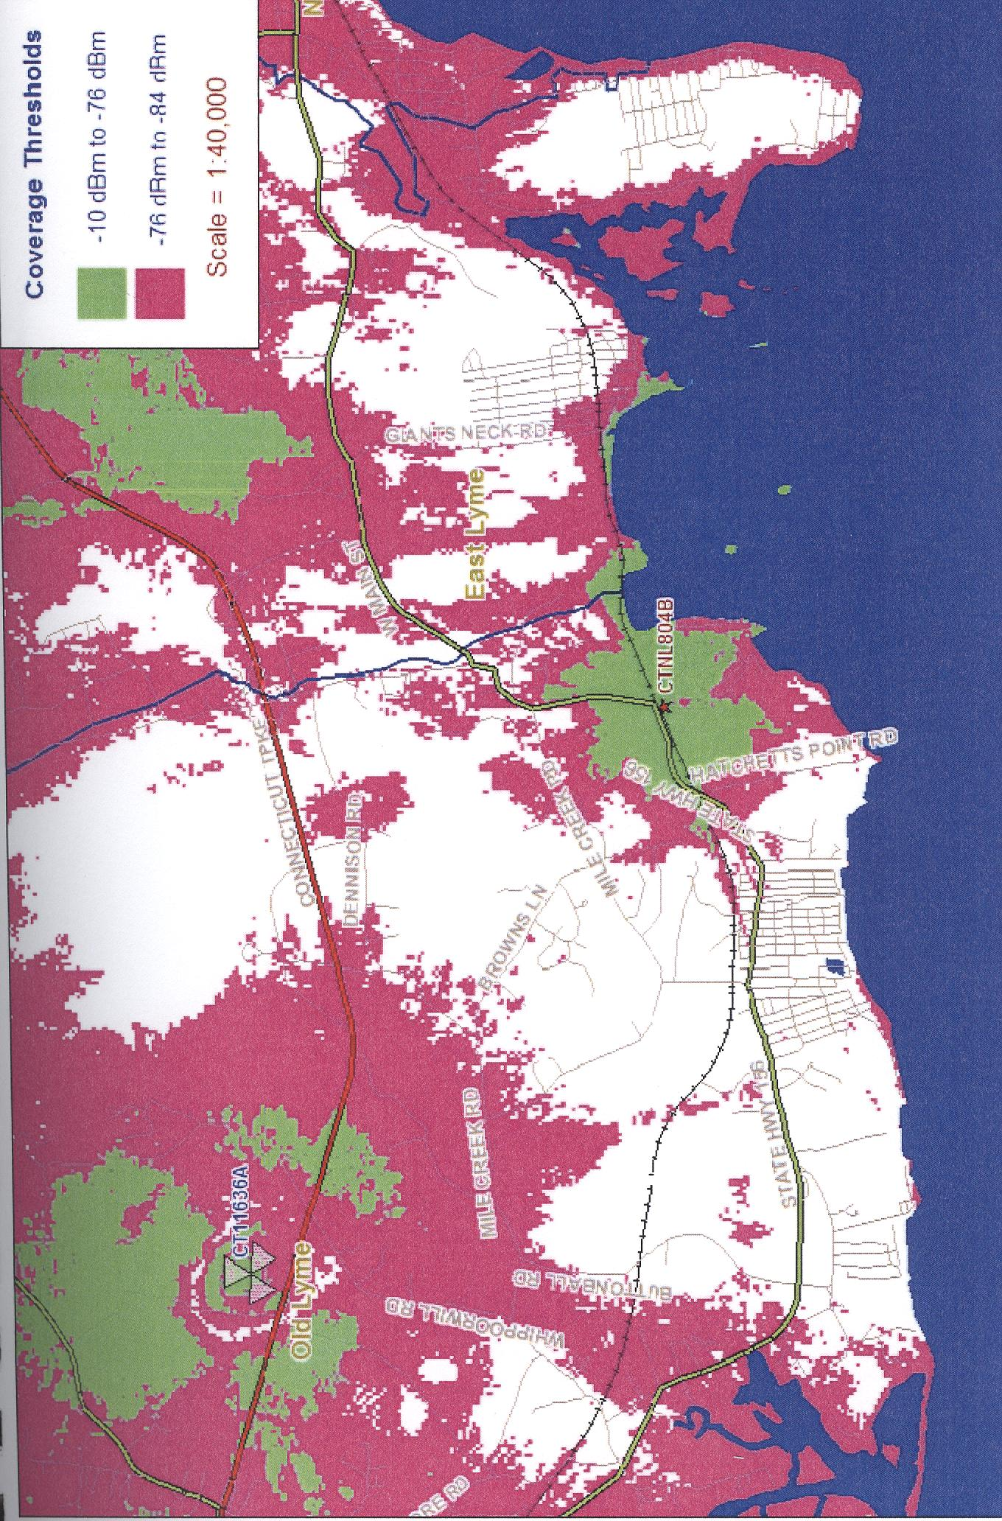
(T-Mobile 1, Tab H)

Figure 7: T-Mobile’s Existing and Proposed Coverage from all Three Towers (Dockets 391 though 393)

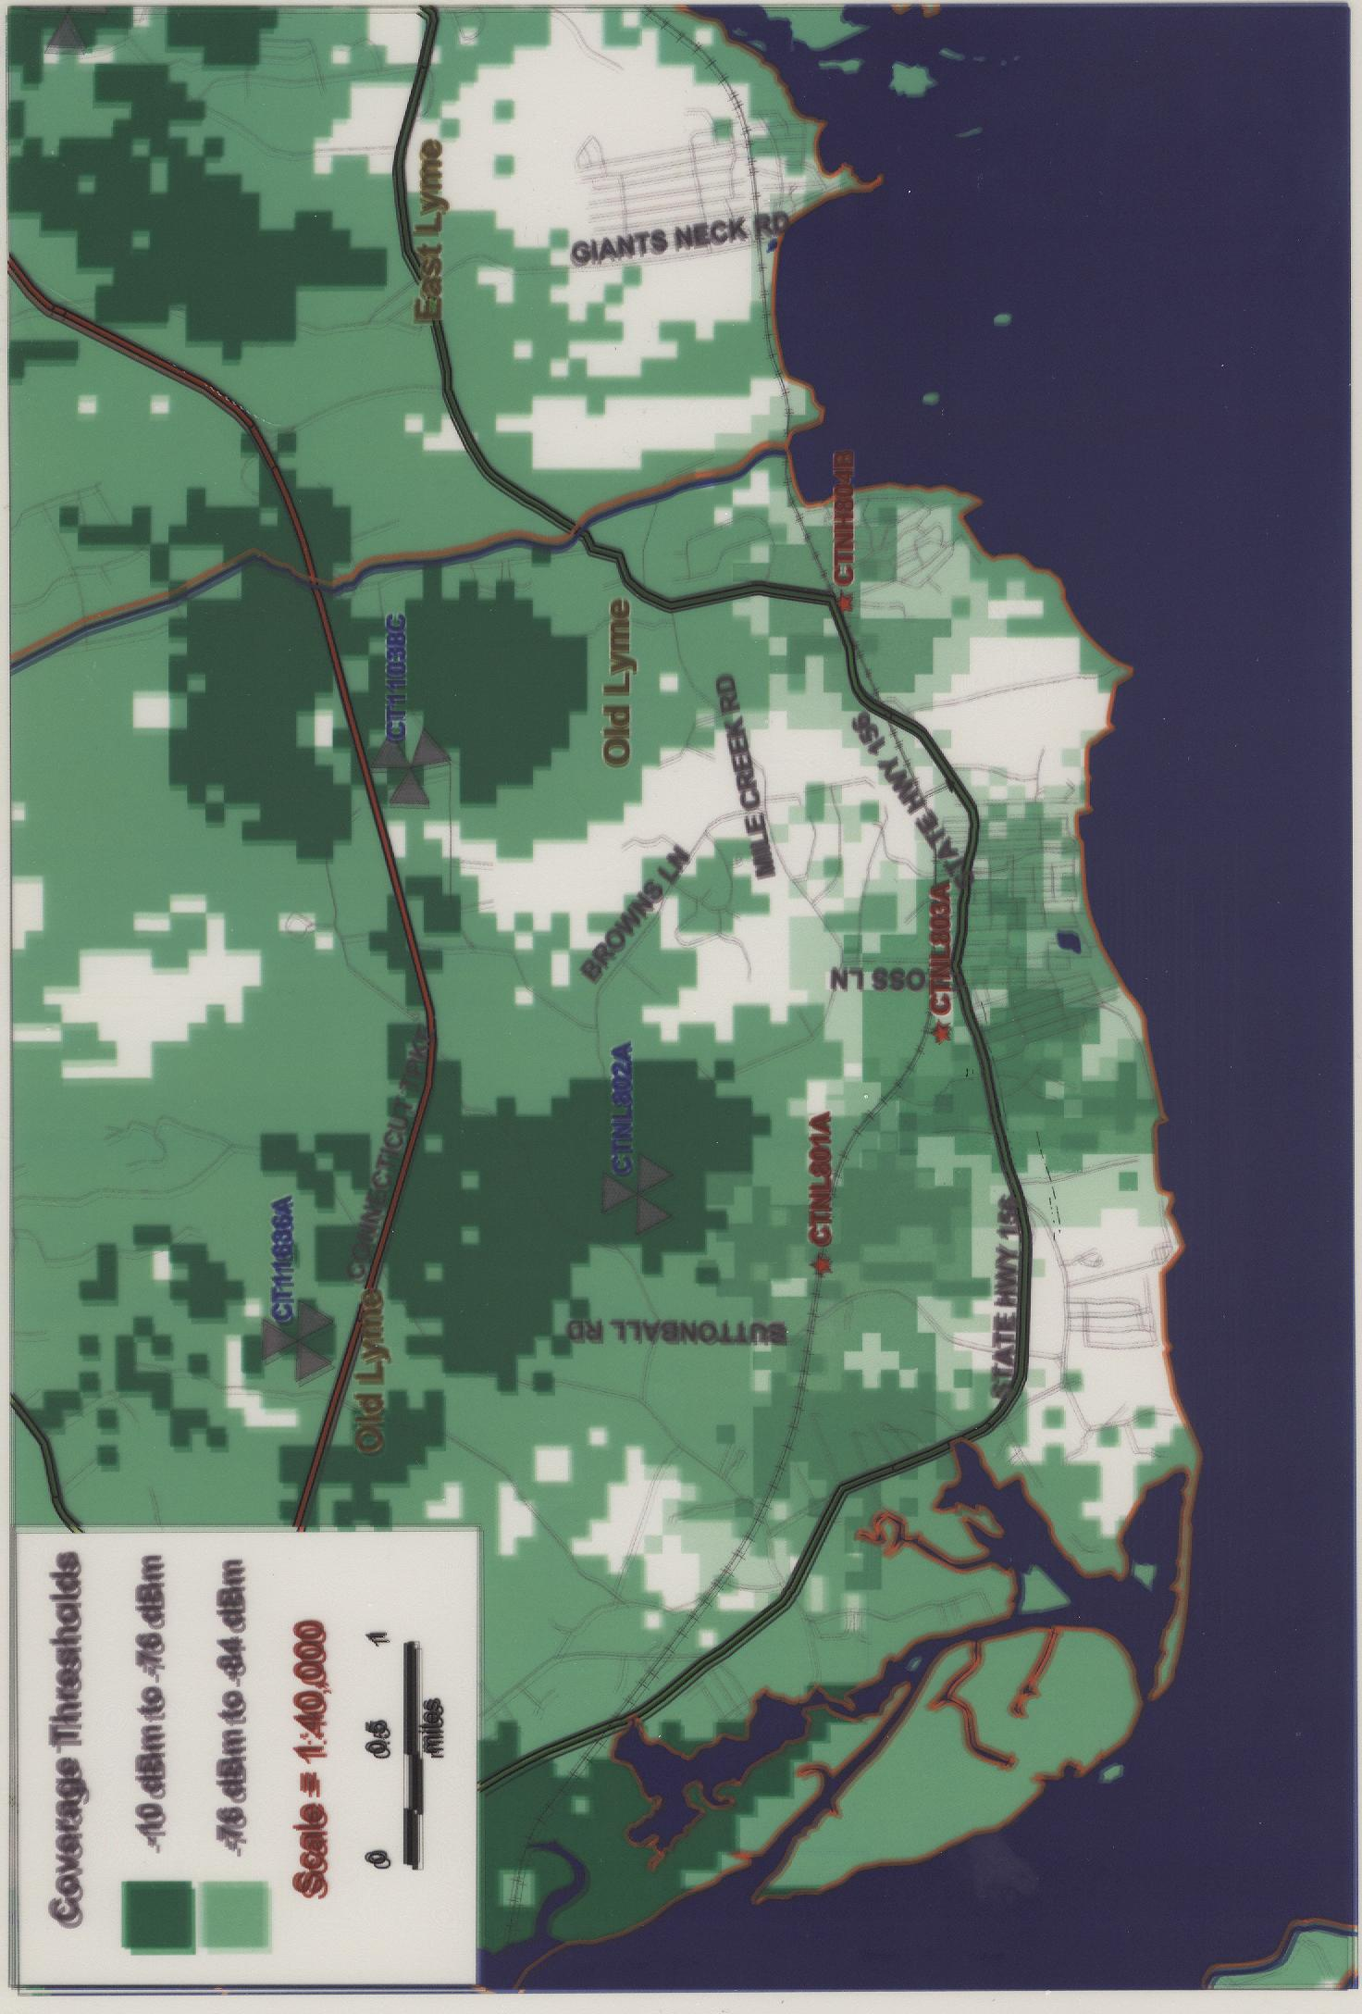

Figure 8: Viewshed Analysis
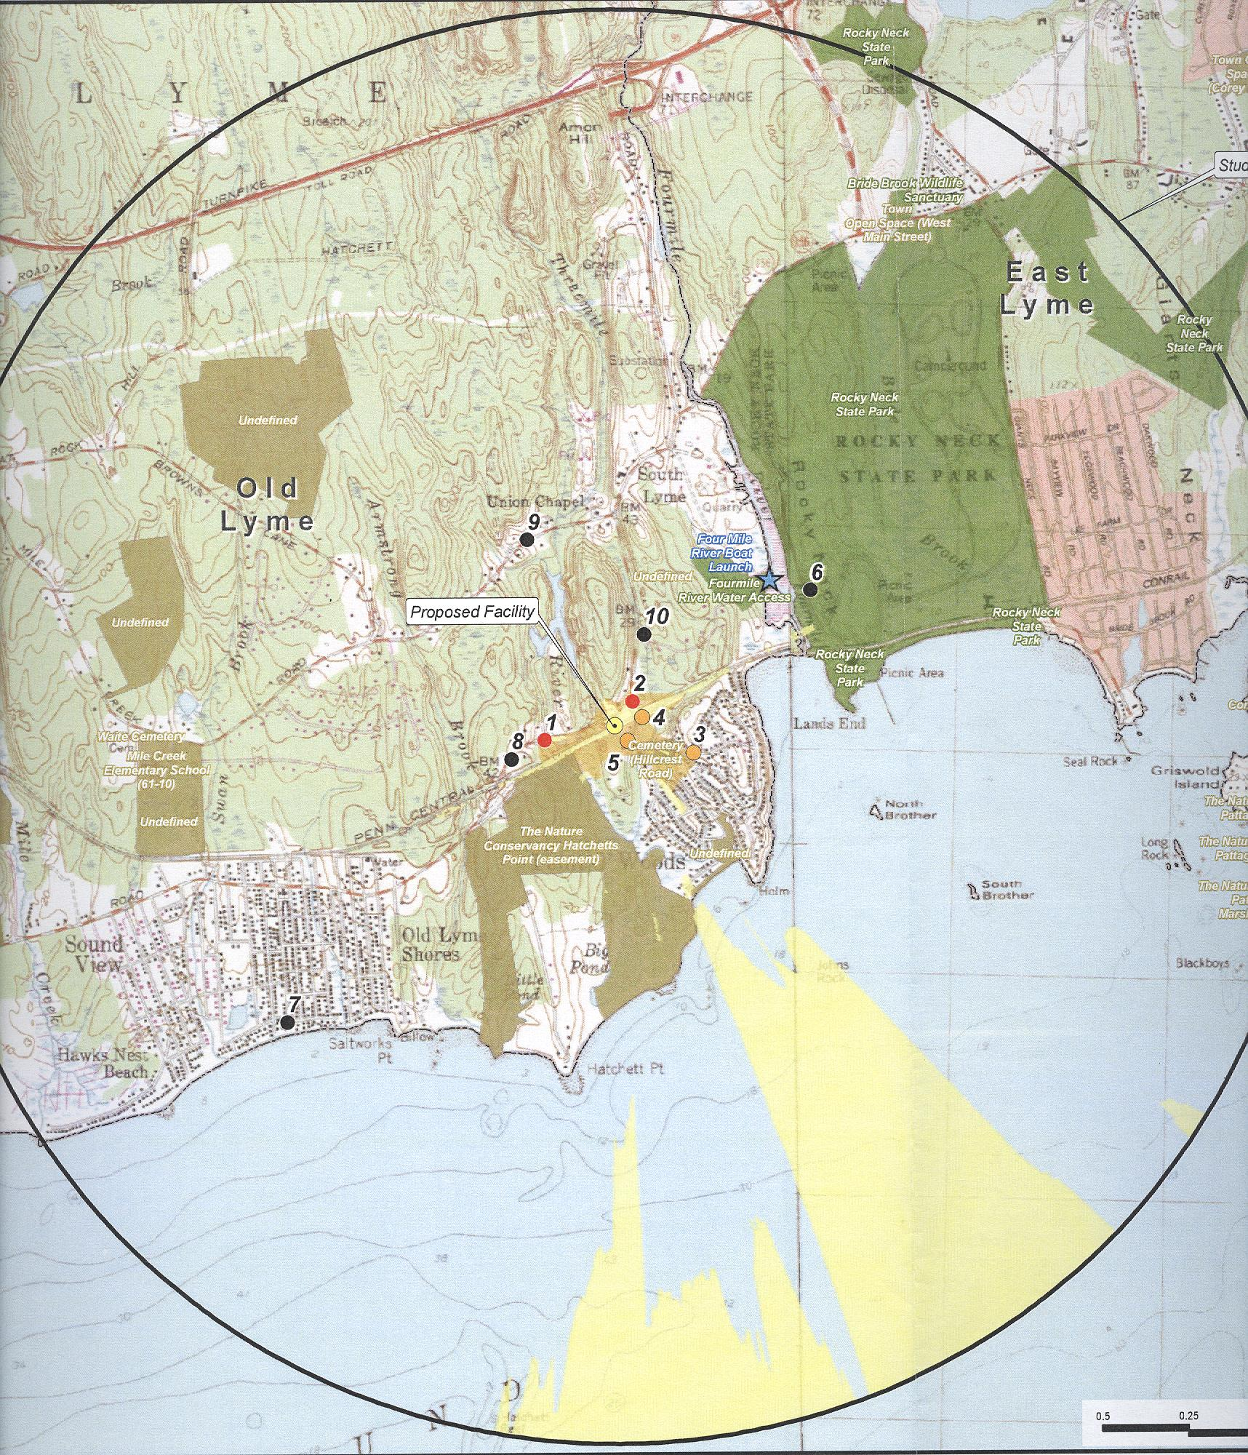
(T-Mobile 1, Tab M)

Figure 9: Viewshed Analysis Key

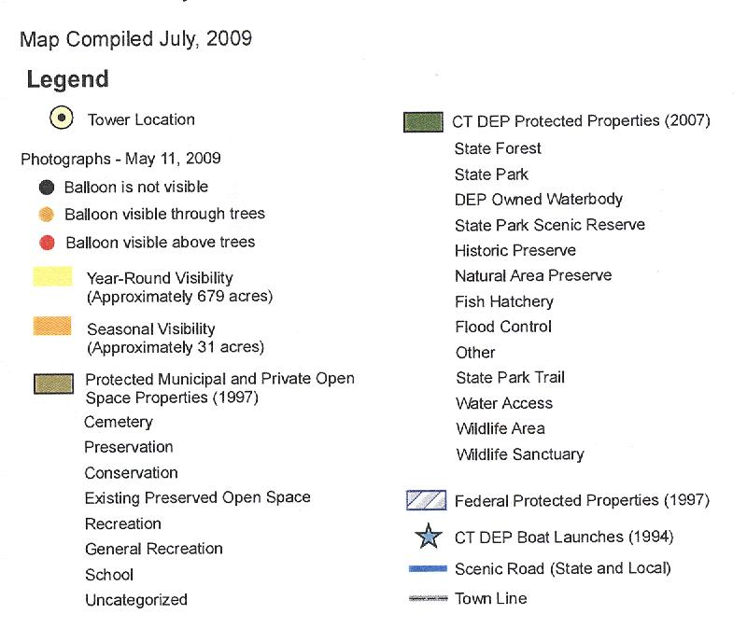
(T-Mobile 1, Tab M)

