DOCKET NO. 373A - New Cingular Wireless PCS, LLC Certificate of Environmental Compatibility and Public Need for the construction, maintenance and operation of a telecommunications facility located at the St. Matthew Lutheran Church, 224 Lovely Street, Avon, Connecticut. | }  }  } | Connecticut  Siting  Council  October 7, 2010

Findings of Fact

Introduction

- On October 8, 2009, the Connecticut Siting Council (Council) granted a Certificate of Environmental Compatibility and Public Need (Certificate) to New Cingular Wireless PCS, LLC (AT&T) for the construction of a 110-foot monopole at 224 Lovely Street in Avon, Connecticut. The approved tower site was referred to as the Option 3 site, located in the sandpit area to the rear of the church parsonage. Antennas on the monopole were limited to an exterior flush-mount design. (Record)

- As part of the Council’s Decision and Order, AT&T was ordered to discuss tower color options, site access, and compound design with the Town of Avon prior to the submission of the Development and Management Plan (D&M Plan) to the Council. (Record)

- AT&T met with Town officials at the site in late 2009 to discuss various aspects of the project. Draft site plans were submitted to the Town for their consideration. (AT&T 1)

- Based on these plans, on January 13, 2010, the Town submitted correspondence to the Council expressing concern that AT&T was relocating the Council-approved site to another area of the property, and that AT&T intended to install a pre-fabricated shelter without architectural treatment and a chain link fence with green privacy slats. Besides expressing these concerns, the Town also requested the installation of a flagpole type tower rather than the Council-approved monopole with external flush-mounted antennas. (Town 1, Ex. A)

- On May 11, 2010, AT&T submitted a D&M Plan for the facility to the Council. The D&M Plan included a new location for the tower on the church property, approximately 71 feet north of the approved tower location. AT&T stated the new location for the tower was at the request of the church to preserve some of the backyard area of the parsonage. (AT&T 1; AT&T 5, Q. 7)

- The new tower location was not consistent with the Council’s Decision and Order; therefore, on May 27, 2010, the Council, pursuant to the provisions of Connecticut General Statute § 4-181a(b), reopened the final decision rendered in this docket. The reopening would allow the Council to consider if there are changed conditions that warrant a new proposed location on the property for the facility. (Record)

- Pursuant to General Statutes § 16-50m, the Council, after giving due notice thereof, held a public hearing on June 29, 2010, beginning at 1:00 p.m. at the Council’s office, 10 Franklin Square, New Britain, Connecticut. The hearing was continued on August 19, 2010. (Transcript 1 – 06/29/10, 1:00 p.m. [Tr. 1], p. 2; Transcript 2 – 08/19/10, 1:00 p.m. [Tr. 2, p. 2])

- The parties to this proceeding are AT&T, Honorable Peter Weise, Patricia and Thomas McMahon, Sheridan and Mark Toomey, Jane Garret, William and Patricia Panetta and the Town of Avon. Intervenors to the proceeding are Juan Fernandez, David Lampert, Youghiogheny Communications-Northeast LLC (Pocket), and the group of Michael Pastore, Stuart Noyes, and Mary Ann Keenan. (Tr. 1, p. 6)

- Public notice of the hearing was published in the Hartford Courant on June 7, 2010. (Record)

- A field review of the approved and new proposed site was conducted on June 24, 2010, beginning at 2:00 p.m. AT&T flew a black balloon at the approved site and a red balloon at the new proposed site from 2:00 to 5:00 p.m. Weather conditions were variable and the balloons achieved desired heights for only some of the time. (Council's Pre-Hearing Conference memo dated June 10, 2010; Tr. 1, pp. 89-90)

- A sign describing the proposed project and public hearing was installed at the corner of Lovely Street and Greenwood Drive on June 18, 2010. (Council's Pre-Hearing Conference memo dated June 10, 2010; Tr. 1, pp. 93-94)

State Agency Comment

- Pursuant to General Statutes § 16-50j(h), on June 4 and August 23, 2010, the following State agencies were solicited to submit written comments regarding the proposed facility: Department of Environmental Protection (DEP), Department of Public Health (DPH), Council on Environmental Quality (CEQ), Department of Public Utility Control (DPUC), Department of Agriculture (DOAg), Office of Policy and Management (OPM), Department of Economic and Community Development (DECD), Department of Emergency Management and Homeland Security (DEMHS) and the Department of Transportation (DOT). (Record)

- No response was from any state agency was received. (Record)

New Proposed Site

- The new proposed tower site would be located approximately 139 feet north of the parsonage on the property and approximately 71 feet north of the Council-approved tower site. The location is just north of the sandpit area on the property (refer to Figure 1). (AT&T 8, C-3)

- The nearest property line to the new proposed tower site is approximately 55 feet to the northeast, (Panetta property). (AT&T 1)

- The nearest property line to the Council-approved tower location is 83 feet to the east (also the Panetta property). (Record)

- The nearest residence to the new proposed tower site is approximately 200 feet to the northwest (Grant residence). The Panetta residence is approximately 275 feet east of the new proposed tower site. (AT&T 1)

- The nearest residences to the Council-approved tower site are the Panetta residence and the Grant residence, both approximately 240 feet distant. (Record)

- The D&M Plan indicated AT&T would construct a 110-foot tower at the site, capable of supporting four levels of exterior flush-mounted antennas. The tower and foundation would also be designed to accommodate a 20-foot tower extension that could accommodate two more levels of exterior flush-mounted antennas. (AT&T 1)

- AT&T would install a 30-foot by 30-foot equipment compound at the site, reducing it from 50 feet by 50 feet as originally approved. An eight-foot high stockade fence would enclose the compound. (AT&T 1)

- An 11-foot by 20-foot equipment shelter would be installed within the compound. The shelter would be architecturally treated, that is, designed to resemble a wood-frame building with a pitched roof. (AT&T 1)

- Pocket would install an equipment cabinet on a concrete pad within the compound. (AT&T 1)

- A four-foot high, block style retaining wall would be constructed along portions of the west and north sides of the compound. (AT&T 1)

- AT&T would install three flush-mounted antennas at tower heights of 107 feet and 97 feet above ground level (agl). (AT&T 1)

- Pocket would install three flush-mounted antennas at a centerline height of 87 feet agl. (AT&T 1)

- Clearwire is interested in the facility but a lease has not been executed. Clearwire is depicted on the site plan as locating on the tower at a centerline height of 77 feet agl and having an equipment cabinet on a concrete pad within the compound. (AT&T 1; Tr. 1, p. 94)

- Access to the site would be from a new gravel drive extending 235 feet from the cul-de-sac on Greenwood Drive. The access drive would pass just east of the sandpit area. (AT&T 2)

Environmental Considerations

- Approximately six trees with a diameter of six-inches or greater would be removed to develop the proposed access drive and compound area. The access drive could be shifted slightly westward to preserve two 16-inch diameter oak trees (Alternative 1 driveway). (AT&T 8, Q. 1, Q. 3)

- Approximately 50 feet of the proposed access drive would be constructed along the edge of a wetland associated with Roaring Brook. The brook forms the east boundary of the church property. (AT&T 2)

- To avoid potential access drive related impacts to the adjacent wetland, AT&T could construct the access drive that extends north from the existing paved church parking lot, turn east through the rear yard of the church and behind the parsonage, then turn generally north again to the compound (Alternative 2 driveway). This route would pass between the large pines on the property and just west of the sandpit area. (AT&T 8, C-3B)

- The east edge of the compound would be approximately 15 feet from wetlands associated with Roaring Brook. (AT&T 2)

- The compound area would not significantly alter the function or value of the wetlands. (AT&T 7, Q. 3)

- The new proposed site compound occupies an area of 900 square feet. The Council-approved compound would occupy an area of 2,500 square feet. (AT&T 7, Q. 3)

- The new proposed compound location is not within a flood zone whereas the Council-approved compound site is within the 100 to 500-year flood zone. (AT&T 8)

- The access drive to the new proposed site is mostly within the 100 to 500-year flood zone, with a small portion within the 100-year flood zone. The Alternative 1 driveway is mostly within the 100 to 500-year flood zone. The Alternative 2 driveway is not within any flood zone. (AT&T 8)

- The new proposed site is within the range of the eastern box turtle (Terrapene carolina carolina), a state species of special concern. Box turtles have been observed in the surrounding neighborhood, and suitable sandy soil for nesting occurs behind the parsonage. The turtle has a limited home range and can be observed in the same locale year after year. (Record; AT&T 7; Q. 4)

- Destroyed turtle eggs, species unknown, were observed in the sandpit area on June 24, 2010 during the field review. (Record; Tr. 1, p. 86)

- The Council-approved compound location encompasses the entire sandpit area. (AT&T 3)

- All of the potential access drives (proposed drive, Alternative 1, Alternative 2) pass along the edge of the sandpit area. (AT&T 8, Q. 3, C-3B)

- Mitigation measures to avoid potential impacts to box turtles include utilization of the Alternative 2 driveway, inspection of all construction areas for individual turtles, installation of silt fencing around the perimeter of the construction area, and prohibition of construction from April through June, which is the turtle’s nesting period. (AT&T 7, Q. 6)

- Visibility of the new proposed tower and the Council approved tower is similar. The upper most portion of either tower would be visible year-round from six of the ten properties abutting the site. One other abutter (21 Greenwood Drive) would have year-round views of the lower portion of either facility, although the new proposed location would be slightly less visible. (AT&T 6; AT&T 9)

Compromise Proposal

- After the June 29, 2010 hearing, in an attempt to resolve the location and form of the facility, the Council requested that AT&T discuss potential site modifications with the Town and as many of the other parties and intervenors as possible. (Tr. 1, pp. 242-246; Tr. 2, p. 5)

- On July 27, 2010, AT&T met with Mr. Steve Kushner, Director of the Planning and Community Development for the Town of Avon, Judge Weise, and Mr. Toomey. AT&T and these stakeholders agreed upon locating the facility at the new proposed site, a design for the facility, proposed access and other site details. (Tr. 2, pp. 6-7, 31)

- After the meeting, AT&T developed site plans for the Town that incorporated the agreed-upon items. The Town shared these site plans with area neighbors. Mr. Toomey discussed the compromise proposal with Mr. Fernandez, Mr. Pastore, and Ms. Keenan, all of whom indicated support for the compromise. (Town 4; Tr. 2, pp. 6-9; Tr. 2, pp. 27-28, 34-39)

- The Town submitted the plans to the Council on August 17, 2010. (Town 4)

- The revised site plans include a 30-foot by 30-foot compound, accessed by the Alternative 2 driveway. (Town 4)

- Underground utilities would be installed within a utility easement that extends from the cul-de-sac northwards along the east portion of the property to the compound, and east of the sandpit area. (Town 4)

- An eight-foot high stockade fence would enclose the compound. AT&T would make an effort to design the associated cable tray so that it is below the height of the fence. (Town 4)

- AT&T would install an equipment shelter with architectural treatment. If other telecommunications carriers install radio equipment within the compound that is taller than the eight-foot stockade fence, the Town requests that this equipment be designed similarly. (Town 4; Tr. 2, pp. 40-43, 60)

- AT&T would construct a 110-foot monopole with interior flush mount antennas. The monopole would be installed in the northwest corner of the compound to maximize the distance to the east property line. (Town 4)

- The monopole would have a uniform diameter of 36 inches. (Town 4)

- The monopole would be constructed to accommodate five levels of interior flush-mounted antennas with three antennas on each level. The interior flush-mount design would require AT&T to use three antenna tower levels rather than two, as previously proposed, since AT&T cannot place more than three antennas on each level. AT&T requires three levels to accommodate cellular, personal communication service, and long term evolution antennas at the site. The exterior flush-mount design could allow AT&T to install more than three antennas on each level, reducing the required tower space to two levels. (Town 4; Tr. 2, pp. 22, 54)

- AT&T would install three antennas at tower centerline heights of 107 feet, 99 feet and 91 feet, leaving the 83-foot and 75-foot levels available for co-location by other carriers. (Town 4; Tr. 2, pp. 16, 54)

- The tower would not be designed to support an extension. (Tr. 2, p. 49)

- The tower would not be able to accommodate whip antennas, typically used for emergency communications services. The Town does not view the tower as an essential location for Town emergency communication services. (Tr. 2, pp. 44-46)

- The 83-foot level of the tower would be available for Pocket’s antennas. (Town 4; Tr. 2, pp. 54-55, 92-93)

- The tower would be painted a matte finish with the final color to be determined by the Town. (Town 4; Tr. 2, p. 21)

- AT&T would use a battery system instead of a diesel generator for emergency power. (Town 4)

- AT&T would submit a landscape plan to the Town for approval prior to the installation of plantings. (Town 4)

- A monopine would be able to accommodate all of AT&T’s antennas at one tower level, allowing for three additional levels of platform-mounted antennas. Whip antennas could also be accommodated. (Tr. 2, pp. 21-22)

- A monopine would fit in with the surrounding vegetation, given the relatively low height of the proposed tower and the presence of existing evergreens adjacent to the new proposed site. Most of the views of the tower from the immediate surrounding area would be of the upper portion or through vegetation during leaf-off conditions. (Tr. 1, pp. 82-83, 141-142, 147, 190-191)

- The Town, Mr. Toomey, Judge Weise and the Panettas are opposed to a monopine at the new proposed site. (Tr. 1, pp., 237-240; Tr. 2, pp. 32-33, 79-80)

- The Town does not prefer a tower with exterior flush mount antennas even if the tower diameter, excluding the antennas, was narrower that 36-inches. (Tr. 2, pp. 66-68)

- The Panetta’s do not want a tower at any location on the church property. If a tower were constructed on the new proposed site, the Panetta’s would accept the Town’s agreement with AT&T. (Tr. 2, pp. 80-82, 84)

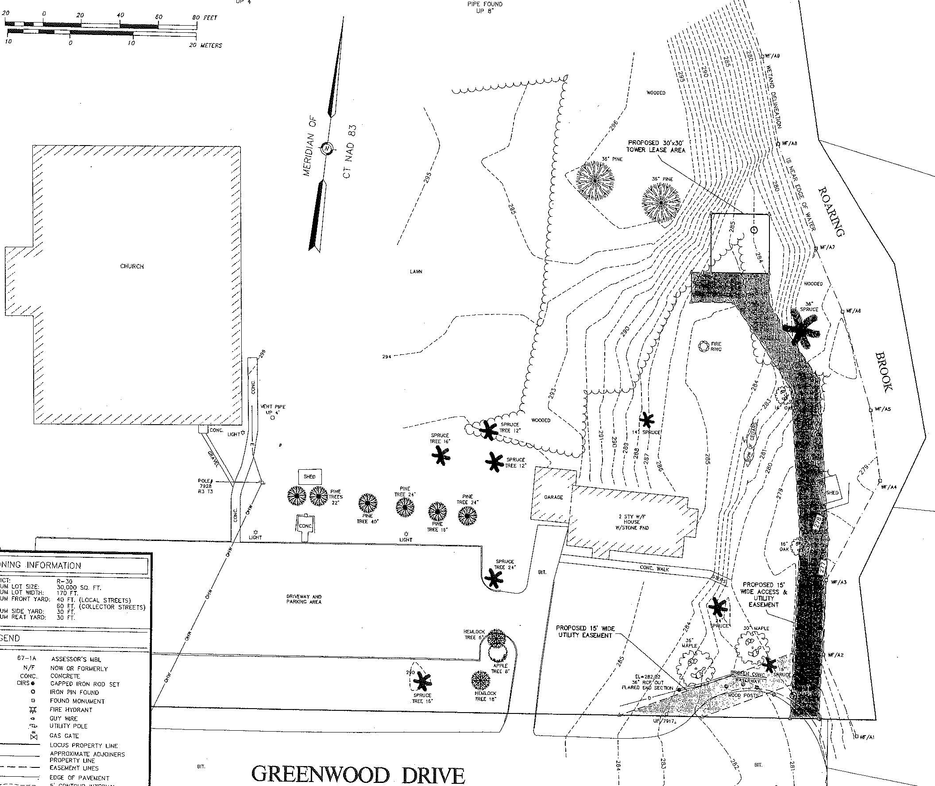

Panetta
Property

Figure 1: Location of new proposed site with access off the Greenwood Drive cul-de-sac. The approximate location of the Council approved site is demarcated with - - - - - .
(AT&T 3)

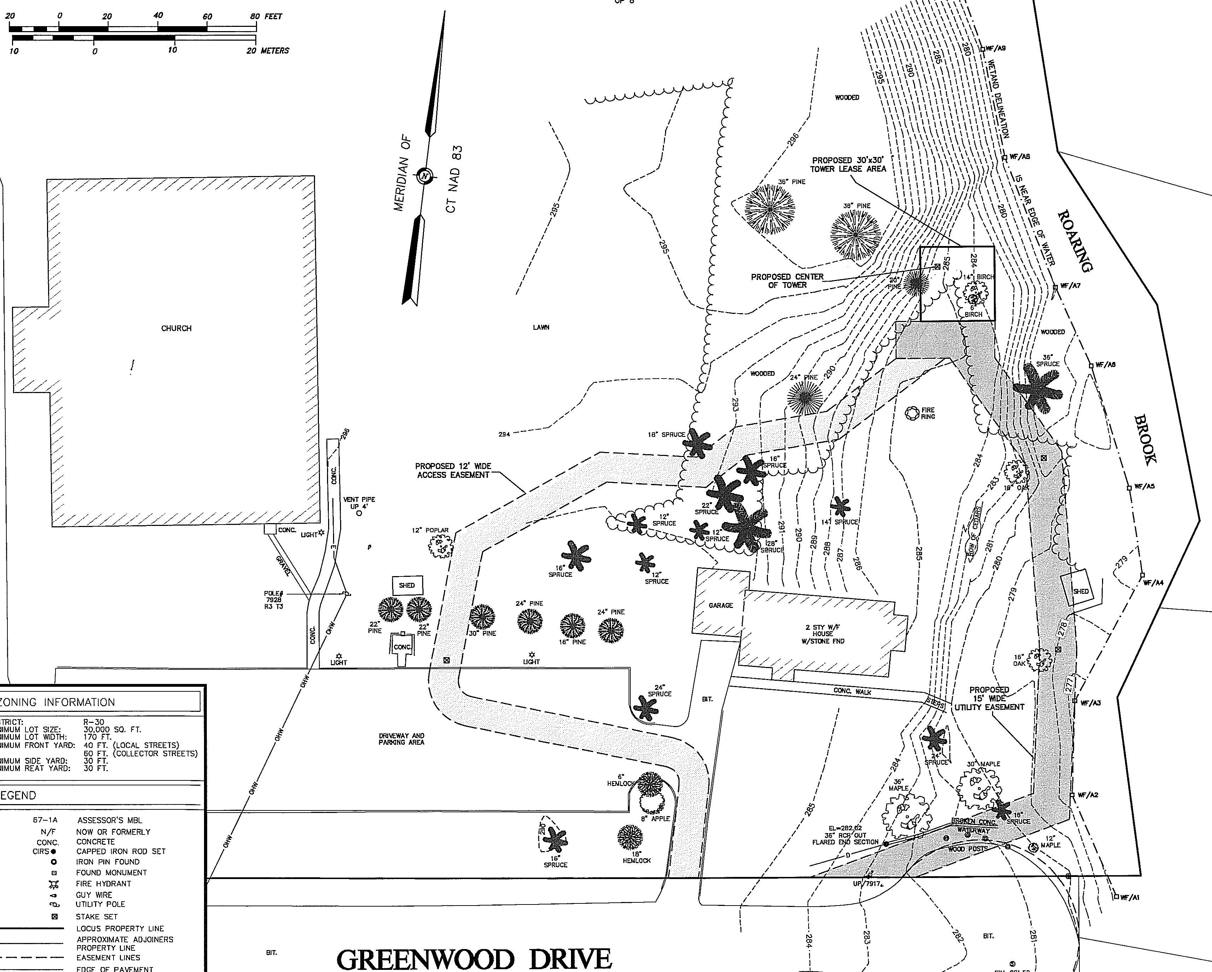

Panetta
Property

Figure 2: Site plan contained within AT&T – Town agreement. Site access is from church parking lot. Utility easement extends from cul-de-sac. The access drive, tower compound and utility line generally avoids the sandpit area.
(Town 4)

