|  |
| --- |
| Connecticut State Department of Education - Research and Data Collection |
| Restraint and Seclusion User Guide |
|  |

|  |
| --- |
| Version 7.0  7/25/2019 |

Table of Contents

Documentation Change Log 3

Objective 8

Contact List 9

Handbook / Reference Guide 10

Restraint and Seclusion Overview 10

What does “physical restraint” mean? 10

What does “seclusion” mean? 11

Collection Period 11

Due Dates: Timely and Accurate 11

Certification 12

Gaining Access and User Roles 13

Gaining Access 13

User Roles 13

Managing Student Data 14

Individualized Student R/S Data Collection 14

Who to Report 14

R/S Reporting Organization 14

Nexus District in PSIS 15

R/S Data Fields List 16

R/S Data Fields 17

Reports 26

Data Cleaning 26

Download Student-Level Data 27

Verification Reports 28

Procedures 31

How to Access the R/S System 31

How to Add an Incident 33

How to Change an Incident 38

How to View MY students reported by OTHER Organizations 40

How to Resolve a case on Injury Details 41

How to Resolve a Primary Disability Mismatch 42

How to Resolve a case on the Duplicate Records 43

How to Resolve a case on the Restraints greater than 90 Minutes  report 44

How to Resolve a case on the Seclusions greater than 90 Minutes report 45

How to Respond to Year-to-Year Comparison Report 46

How to Certify Your Organization’s Data 48

FAQs 50

Miscellaneous Questions? 50

User Roles in DM? 50

Who to Report? 51

What to report for INJURY? 52

Appendix 53

Terminology 53

References 54

CSDE's Statement of Nondiscrimination 55

# Documentation Change Log

| Version | Section / Page | Date | Description |
| --- | --- | --- | --- |
| 1.0 |  | 2/28/2013 | Published |
| 2.0 | Collection Period, p. 7 |  | Department policy requires all instances of R/S to be reported to the CSDE within 2 business days. |
|  | Individualized Student R/S Data Collection, p. 9 |  | 1. Moved from the Restraint and Seclusion Overview section to the Managing Student Data section 2. Added to do not report:  * students placed residentially, where the incident occurred as part of their residential program. * general education students (NOT in the referral process)  1. Added Who to Report section header |
|  | Incident Start Time and End Time, p.16 |  | Must be between 6 AM and 7 PM |
|  | Injury to the student, p. 6, 11, 28, 29 |  | Clarified Injury is specific to the student |
|  | Add Another Incident for students already entered in R/S, p. 28, 31 |  | The system displays the *Add New* screen with the student’s SASID and DATE OF BIRTH pre-populated |
|  | How to View MY students reported by OTHER Organizations, p. 30 |  | Added this section. |
|  | FAQ p. 31-33 |  | Added FAQS:   1. How to add multiple incidents for a student 2. Reporting incidents that occurred during a student’s Summer Program 3. Reporting restraints that occur within seconds of each other 4. Physical restraint does not include briefly holding a child in order to calm or comfort the child. Is there a specific timeframe associated with “brief” 5. What to report for INJURY when ambulance called |
|  | How to Access the R/S System, p. 24 |  | Updated Data Manager contact information for Directory Manager |
|  | Reports, p. 20-22 |  | Download Student-Level Data   * All Incidents Reported by MY Org * All My Nexus Students   Verification Reports   * [Summary Statistics: All Incidents reported by MY Org](http://sde-ap3hfdc/Districts/RestraintAndSeclusion/Reports/Reports?incid=0&rpt=SummaryStat&type=p) |
| 2.0 |  | 5/22/13 | Published |
| 3.0 | Circumstance, p. 11, 17 |  | Removed “Other” option from pull-down |
|  | Other Circumstance Details, p. 11, 17, 20 |  | Removed Other Circumstance Details field |
|  | Who to Report, p. 9 |  | Clarified do not reportstudents placed residentially, when the incident occurred outside of their educational program. |

|  |  |  |  |
| --- | --- | --- | --- |
|  | R/S Reporting Org, p. 10 |  | Added:  Contact CSDE if you need to report a restraint or seclusion incident related to a summer program in a district, RESC or APSEP that is different from the district, RESC or APSEP the student attends during the school year |
|  | Data Cleaning Reports, p. 19 |  | Added Data Cleaning Section, Primary Disability Mismatch report. |
|  | Verification Reports, p. 22 |  | Added [Summary Statistics: All My nexus students reported by All Org](http://sde-ap3hfdc/Districts/RestraintAndSeclusion/Reports/Reports?incid=0&rpt=SummaryStat&type=p)sa. My nexus students reported by OTHER Orgsb. My nexus students reported by MY Org |
|  | How to Resolve a Primary Disability Mismatch, p. 31 |  | Added this section. |
|  | How to Certify Your Organization’s Data, p. 32 |  | Added this section. |
|  | FAQ, p. 35 |  | **Do I report a Restraint or Seclusion incident that occurred during a student’s Summer Program?**  If the Summer Program is being implemented as part of the IEP and a Restraint or Seclusion occurs, then you would report that INCIDENT.  Note: PSIS Registration does not require districts to update registration records for students who attend summer programs.  You will not have a problem entering a summer program R/S incident if the student’s summer program was located at the same school the student attended during the school year (or a school within the same district or the same RESC).  ~~There will be some cases where a student attended a summer program at a different location. In order for this R/S incident to be entered in the R/S data collection, your PSIS data manager needs to contact Kendra Shakir for guidance in updating the PSIS Registration record.~~ The INCIDENT DATE will be used to determine whether the incident occurred during the academic year or during a summer program.  Important**:** Contact CSDE if you need to report a restraint or seclusion incident that occurred in a summer program in a district, RESC or APSEP that is different from the district, RESC or APSEP the student attends during the school year. |
| 3.0 |  | 12/20/13 | Published |
| 4.0 | Gaining Access and  User Roles, p. 10 | 9/23/14 | Added Section |
|  | Who to Report, p. 11 | 10/8/14 | Added more detail |
|  | Data Fields Injury and Injury Details, p. 19, How to Add an Incident, p. 30 | 6/13/16 | Added Reminder: if INJURY (to the student) = Non-serious Injury or Serious Injury, fax the injury report to the Bureau of Special Education at (860) 713-7051 |
|  | Primary Disability, p. 20 | January, 2015 | Added per state legislation   * 8A - Specific Learning Disabilities/Dyslexia |
|  | Reports, p. 21 | 6/13/16 | Replaced screenshot. Under Data Cleaning added “For detailed information see Procedures section”. |
|  | How to Resolve a case on Injury Details, p. 33 | 11/3/14 | Added this section. |
|  | How to Resolve a Primary Disability Mismatch, p. 34 | 6/13/16 | Updated Step 7 |
|  | How to Resolve a case on the Duplicate, p. 35 Records | 11/3/14 | Added this section |
|  | How to Resolve a case on Restraints greater than 90 Minutes, p. 36 | 11/3/14 | Added this section |
|  | How to Resolve a case on Seclusions greater than 90 Minutes, p. 37 | 11/3/14 | Added this section |
|  | How to Respond to Year-to-Year Comparison Report, p. 38 | 6/13/16 | Added this section |
|  | How to Certify Your Organization’s Data, p. 39 | 6/13/16 | Added What every organization should do before you Certify R/S data |
|  | FAQs, p. 41 | 9/23/14 | Added FAQs for User Roles in DM |
|  | References, p. 45 |  | Updated:   * 2015 Parental Notification of the Laws Relating to Seclusion and Restraint in the Public Schools * Model Incident Report for the Emergency Use of Seclusion * Model Incident Report for the Emergency Use of Restraint   Added:   * Understanding the Laws and Regulations Governing the Use of Restraint and Seclusion in Schools * Guidance Related to Recent Legislation Regarding Restraining and Seclusion in Schools * Recommended Procedures and Practices to Reduce the Use of Restraint and Seclusion in Schools * Public Act No. 15-141: AN ACT CONCERNING SECLUSION AND RESTRAINT IN SCHOOLS |
|  | Nondiscrimination Statement p. 46 | 3/19/14 | Updated with March 2014 version |
| 4.0 |  | 6/15/16 | Published |
| 5.0 | Injury (to the student) | 6/9/17 | Clarified   * Whether or not an injury occurred to the student as a result of the restraint or seclusion. * Injury report * Serious Injury - include any injury requiring medical attention beyond basic first aid (examples: emergency room visits, doctor visits, sutures, diagnostic x-rays to determine fractures, placement in casts, etc.) |
|  | FAQ | 6/9/2017 | Added - How do I report an incident that lasted only 40 seconds in duration?  Incidents of less than one minute should be reported as 1 minute in length (start and end times reported as one minute apart).  The department will report out these incidents with the caveat “or less” for the lowest length of time grouping (e.g., 2 minutes or less, five minutes or less, etc.). |
|  | Contact List | 11/1/2017 | Updated |
| 5.0 |  | 11/1/2017 | Published |
| 6.0 | What does “physical restraint” mean | 7/12/2018 | Updated due to changes to Statutory Restraint and Seclusion Requirements Effective July 1, 2018 |
|  | What does “seclusion” mean? | 7/12/2018 | Updated due to changes to Statutory Restraint and Seclusion Requirements Effective July 1, 2018 |
|  | Circumstance | 7/12/2018 | Removed 4 – Seclusion, as set forth in the IEP (S only) and associated Edit Checks due to changes to Statutory Restraint and Seclusion Requirements Effective July 1, 2018 |
|  | How to Access the R/S System | 7/12/2018 | Updated Step by Step Procedures |
|  | How to Respond to Year-to-Year Comparison Report | 7/12/2018 | Updated Step by Step Procedures |
|  | How to Certify Your Organization’s Data | 7/12/2018 | Updated Step by Step Procedures |
|  | References | 7/12/2018 | Updated |
| 6.0 |  | 7/23/2018 | Published |
|  | Restraint and Seclusion Overview | 9/14/2018 | Removed all instances of the seclusion via an IEP |
| 6.1 |  | 9/14/2018 | Published |
| 7.0 | Nature of Incident | 7/1/2019 | Added 3 – Restraint (Forcible Escort) |
|  | Added 6 New Fields effective 2019-20 school year | 7/1/2019 | Required if **Non-Serious Injury**   1. Injury (to the student) Verification   Required if **Serious Injury**   1. Injury Site in School 2. Cause of Injury Determination 3. Cause of Injury 4. Investigation 5. Status of Investigation |
|  | **Reminder:** if INJURY (to the student) = Non-serious Injury or Serious Injury, fax the injury report to the Bureau of Special Education at (860) 713-7051 | 7/1/2019 | Removed all instances |
|  | **Injury** (to the student) | 7/1/2019 | Removed “The CSDE does not have a model injury report. The injury report must include…”  Added Note: starting July 1, 2019 the CSDE discontinued the requirement to fax the Report of Injury and instead enhanced the R/S system to streamline the collection of information needed when an INJURY (to the student) occurs. The addition of 5 fields will streamline the CSDE requirement to report information regarding Serious Injury to the office of Disability Rights Inc. and, if appropriate, to the Office of Child Advocate. |
|  | How to Add an Incident | 7/1/2019 | Added guidance for when a student is not found in PSIS Registration  Updated Screenshots on IEP/Consent student screens **IMPORTANT** if either the school or nexus district is not correct, STOP, contact the PSIS Reporting District’s PSIS Coordinator to ensure the student is accurately reported in PSIS Registration. Once PSIS Registration is updated, enter the R/S Incident. If you need further assistance contact SDE. |
|  | How to Respond to Year-to-Year Comparison Report | 7/1/2019 | Added missing negative sign… and % Change ≥ 20% or ≤ -20% (or null)) |
| 7.0 |  | 7/25/2019 | Published |

# Objective

The purpose of this document is to provide districts with procedures and guidance for submitting data and to address questions regarding the use of this data collection.

The document is organized into four sections:

C:\Documents and Settings\Saumellr\Local Settings\Temporary Internet Files\Content.IE5\JZOM6L3F\MC900445732[1].wmf Handbook or reference guide on the purpose of this collection and definition of data collected

C:\Documents and Settings\Saumellr\Local Settings\Temporary Internet Files\Content.IE5\ZJD4FI1X\MC900014130[1].wmfC:\Documents and Settings\Saumellr\Local Settings\Temporary Internet Files\Content.IE5\IHJIXT1V\MC900434539[1].wmfC:\Documents and Settings\Saumellr\Local Settings\Temporary Internet Files\Content.IE5\KYXMKMTR\MC900014132[1].wmf Step by step procedures for use of the system

C:\Documents and Settings\Saumellr\Local Settings\Temporary Internet Files\Content.IE5\AZNQ3Q82\MC900089048[1].wmf Frequently Asked Questions (FAQs)

C:\Documents and Settings\Saumellr\Local Settings\Temporary Internet Files\Content.IE5\AZNQ3Q82\MC900412396[1].wmf Appendix of terminology and references

***Documentation Standards***

Standards used in this document include the following:

* FIELDS displayed on a screen are referenced using ALL CAPS
* Field **values** are highlighted in **bold**
* *Screens* are referenced using *italics*
* **Buttons** or **menu selections** are in **bold**
* When following procedures contained in this guide, always proceed to the next step if not directed to go to another step

Look for text in red where new information has been added or existing information has been changed.

 Represents important information related to data reporting.

Represents helpful tips and references to other sections of documentation for related topics.

 Represents reminders of information previously stated related to the current topic.

# Contact List

| **Contact** | **Name** | **E-mail** | **Phone** |
| --- | --- | --- | --- |
| Bureau of Special Education Consultant | Colleen Hayles | [Colleen](mailto:Colleen).Hayles@ct.gov | 860-713-6922 |
| Bureau of Special Education Consultant | Mary Jean Schierberl | [Maryjean.Schierberl@ct.gov](mailto:Maryjean.Schierberl@ct.gov) | 860-713-6943 |
| SDE Data Manager | Laura Guerrera | [Laura.Guerrera@ct.gov](mailto:Laura.Guerrera@ct.gov) | 860-713-6898 |
| Analyst | Diane Murphy | [Diane.Murphy@ct.gov](mailto:Diane.Murphy@ct.gov) | 860-713-6891 |

# Handbook / Reference Guide

## Restraint and Seclusion Overview

In accordance with Section 46a-153 of the Connecticut General Statutes (C.G.S.), as amended by Public Act 12-88, the department is required to collect data from each local or regional board of education, institution or facility that provides direct care, education or supervision of persons at risk. Persons at risk are defined as children receiving special education or being evaluated for eligibility. The required data include:

* all instances of the emergency use of restraint and seclusion;
* the nature of the emergency that necessitated its use;
* all instances of physical injury to the student as a result of restraint or seclusion; including serious injuries (defined as requiring attention beyond basic first aid).

The State Board of Education shall produce an annual summary report identifying the frequency of use of physical restraint or seclusion on such children and specifying whether the use of such seclusion was in accordance with an individualized education program or whether the use of such physical restraint or such seclusion was an emergency. Such report shall be submitted on an annual basis not later than December fifteenth of each year to the select committee of the General Assembly.

### What does “physical restraint” mean?

Physical restraint means any mechanical or personal restriction that immobilizes or reduces the free movement of a person’s arms, legs or head, **including, but not limited to, carrying or forcibly moving a person from one location to another.**

** Important:** Physical restraint **does not include**:

(1) briefly holding a person in order to calm or comfort the child;

(2) the minimum contact necessary to safely escort a person from one area to another;

**Note: "Escort"** means the minimum contact necessary to safely escort a person from one area to another through temporary touching or holding for the purpose of guiding or inducing a student to walk to another location.

(3) medical devices, including, but not limited to, supports prescribed by a health care provider to achieve proper body position or balance;

(4) helmets or other protective gear used to protect a person from injuries due to a fall;

(5) helmets, mitts, and similar devices used to prevent self-injury when the device is:

i. part of a documented treatment plan or individualized education program pursuant to Section 10-76d; or

ii. prescribed or recommended by a medical professional, as defined in section 38a-976, and is the least restrictive means available to prevent such self- injury; or

(6) exclusionary time out

**Note: "Exclusionary time out"** means a temporary, continuously monitored separation of a student from an ongoing activity in a non-locked setting, for the purpose of calming such student or deescalating such student's behavior (exclusionary time out becomes a reportable "seclusion" if or when the student is physically or otherwise prohibited from leaving the space).

### What does “seclusion” mean?

Seclusion means the involuntary confinement of a student in a room from which the student is physically prevented from leaving. **"Seclusion" does not include an.**

** Important:** Seclusion **does not include:**

(1) time outs in the back of the classroom or in the hallway, meant to give the student a minute to pull themselves together; or

(2) in-school suspensions; or

(3) exclusionary time out

**Note: "Exclusionary time out"** means a temporary, continuously monitored separation of a student from an ongoing activity in a non-locked setting, for the purpose of calming such student or deescalating such student's behavior (exclusionary time out becomes a reportable "seclusion" if or when the student is physically or otherwise prohibited from leaving the space).

### Collection Period

Collected on a July 1 – June 30 calendar.

* Accessible year round, 24/7
* Student records are accepted if the INCIDENT DATE falls between July 1 and June 30 of that school year

**Note:** Department policy requires all instances of R/S to be reported to the CSDE within 2 business days.

### Due Dates: Timely and Accurate

* Timely due date is typically near July 20th.
* Accurate due date is typically near August 31st.

Each collection year, the exact calendar due dates are published in the *LEA Level Determinations - Timely and Accurate Data Collection* calendar.

Timely and Accurate (SPP Indicator #20 / Principles, Procedures and Standards for the Approval of Private Special Education Programs / Connecticut General Statutes (CGS) 46a-153)

The Department will take into account whether or not district data are submitted in a timely and accurate manner in District-level Annual Performance Report (APR) Determinations, in accordance with CGS 46a-153, and 10-76b/10-76d for Approved Private Special Education Programs (APSEPs). Please work with staff to ensure data submitted to the Department are timely and accurate.

(20 U.S.C. 1416(a)(3)(B))

The Department defines *Timely and Accurate* as a holistic system analysis, thereby ensuring the determination is not about minor edits/errors…but instead is about systemic failure to report and/or follow reporting directions/guidelines.

*Timely* = 1) submission of each incident within 2 business days; 2) passed general edit checks and provided complete data. ***Timely Due Date:  July 20th***

We will use the following to examine component two of Timely:  a) district did not report placeholder data; b) there are no missing data (i.e., failure to report an entire field or non-public school, etc.) and c) the data pass all reasonability tests (no unexplained significant changes in count or percent of students within various data points).

*Accurate* = District assures all records are error free and all incidents are reported within the applicable collection year. ***Accurate Due Date:  August 31st***

Any incidents reported to the state after the accurate due date for the collection year will result in the district’s collection being considered not accurate.

All system verification reports have been reviewed and resolved.

Accuracy includes the electronic certification of the file by the accurate due date.

### Certification

Your district/organization is required to sign-off on the content of your data, which in turn locks the data against any further changes. This certification is not available until after June 30th of the collection year. For a district/organization to certify, all student records must be complete. Districts/Organizations that have no reported data, must still certify.

The CSDE is able to decertify your district’s/organization’s data after certification if changes, additions or deletions of any student records are needed. Once changes are made, the collection will need to be re-certified by your district/organization. Each time you certify, the *Certification Confirmation* report is presented with the results for your district/organization. Print this report for your records

Note: The Restraint and Seclusion data collection may be audited. A best practice for your organization is to compile all Restraint or Seclusion Incident forms in two locations: 1) the student’s file; and 2) in a central file for the corresponding collection year. This will ensure alignment of reported Restraint and Seclusion data against the Restraint or Seclusion Incident forms.

## Gaining Access and User Roles

### Gaining Access

R/S uses the state’s Directory Manager (DM) application and is accessed through the “NEW Collections” portal.  Your LEA Security Manager is responsible for assigning and maintaining R/S roles in DM.

* If an individual already has a DM account, he/she will use their existing username/password.
* If an individual is new to DM, he/she will receive one email with a unique username and a second email with a password.
* **Usernames and passwords should NOT be shared**, as each are unique to the assigned individual. This process improves accountability for any errors or changes entered into the system and allows the department to identify exactly who to contact should we have questions about a specific student record.
* The list of R/S Writers and Certifiers from DM will be used to conduct all communication about the R/S system.

Note:If you do not know who your LEA Security Manager is, click [here](https://portal.ct.gov/SDE/Performance/Data-Collection-Help-Sites/Directory-Manager-Help-Site/Documentation) for a listing of all LEA Security Managers.

### User Roles

|  |  |  |  |  |
| --- | --- | --- | --- | --- |
| **Name** | **Level** | **Required Role** | **Permissions** | **# of Users Allowed** |
| RS Certifier | District Based | Yes | * Enter R/S data * View reports * Certify data | * Only 1 per reporting organization * Must be a certified administrator |
| RS Writer | District Based | No | * Enter R/S data * View reports | * Unlimited; At the discretion of the organization * Important: be aware that all R/S Writers have access to see all R/S data reported by your district. We do not have the ability to limit reports/views to the school level. Therefore, it is important that all of your R/S Writers are aware of their responsibilities under FERPA regarding protection of student level data. |

## Managing Student Data

To prepare for use of R/S you must understand what students to report and who is responsible for reporting the incident (R/S Reporting Organization). It is helpful to understand the difference between the R/S Reporting Organization and Nexus District, and how it affects students being reported in R/S.

### Individualized Student R/S Data Collection

The Restraint and Seclusion system’s objective is to provide an automated method to collect individual student data for Restraint and Seclusion.

### Who to Report

Every student must have either an:

* active Individualized Education Program (IEP) or
* Consent to Conduct an Initial Evaluation (ED625). Incident occurs on or after the date parent signed the ED625 and prior to the Determine Eligibility PPT (if the student is found Eligible prior to the date the parent signed the IEP for initial Consent for Special Education Placement (ED626)).

Every student must be a publically funded by a Connecticut town and registered in the Public School *Information System* (PSIS).

 Important: do not report:

* general education students (NOT in the referral process);
* students placed by another state into your school;
* students unilaterally placed by their parents where the district has not accepted programmatic responsibility for the child’s education through the development and implementation of an IEP; or
* students placed residentially when the incident occurred outside of their educational program.

### R/S Reporting Organization

The R/S REPORTING ORGANIZATION is the district or APSEP in which the student is attending school on the date of the incident being reported.

For IEP students and students referred to special education with a signed consent to evaluate, their R/S REPORTING ORGANIZATION is:

* Public Schools, including students attending:
  + Public schools within your district;
  + OPEN Choice students attending schools within your district (Receiving District);
  + Out-of-state schools;
  + Students placed in “other non-public” facilities
  + Students placed in municipal detention centers;
  + Students placed in Age Appropriate Community Based Programs.
* Quasi-Public - Endowed and Incorporated Academies
* Charter Schools
* Regional Education Service Center (RESC) – both Special Education programs and Magnets
* CT Technical High School System (CTHSS)
* Department of Children and Families (USD2)
* Department of Mental Health and Addiction Services (DMHAS).
* Approved Private Special Education Programs (APSEPs)

 Important: Contact CSDE if you need to report a restraint or seclusion incident related to a summer program in a district, RESC or APSEP that is different from the district, RESC or APSEP the student attends during the school year, transportation, a school/facility not in PSIS Registration, an OPEN Choice student sent out of the OPEN Choice receiving district to another public school district (including RESC) or a general education student with consent to evaluate where nexus exists due to SEDAC-G State Agency Placement grant.

### Nexus District in PSIS

The Nexus District is the district that has the legal responsibility to identify, educate, and pay for a special education student under the Individuals with Disabilities Education Act (IDEA). Generally, nexus means the town where the student’s parent(s) reside (and pay taxes).

***Exceptions***

* Districts considered to be the NEXUS DISTRICT for students attending their schools:
  + CT Technical High School System (CTHSS)
  + Department of Corrections (USD1)
  + Department of Children and Families (USD2)
  + Department of Mental Health and Addiction Services (DMHAS)
  + OPEN Choice (Receiving District).

### R/S Data Fields List

The following is a list of all the fields and guidance for completing each student record.

**Origins of Data:**

**PSIS** - Public School Information System; the PSIS Registration module is referenced for student data.

**District/Organization** - Restraint and Seclusion Forms

Reference: A Model Incident Report for the Emergency Use of Seclusion and Model Incident Report for the Emergency Use of Restraint are available, refer to the links located in the Appendix.

|  | **Field Name** | **Notes** |
| --- | --- | --- |
|  | R/S Reporting Organization |  |
|  | Collection Year |  |
|  | SASID (State Assigned Student ID) | Numeric |
|  | Date of Birth | MMDDYYYY |
|  | Incident Date | MMDDYYYY |
|  | Special Education Status | 1 – IEP  2 – Consent for Evaluation |
|  | Name | Character allowing a dash, period, space and apostrophe |
|  | School |  |
|  | Nexus District |  |
|  | Nature of Incident | 1 – Restraint  3 – Restraint (Forcible Escort)  2 – Seclusion |
|  | Incident Start Time | HHMM Time Format |
|  | Incident End Time | HHMM Time Format |
|  | Circumstance | 1 – Immediate or Imminent risk of injury to self  2 – Immediate or Imminent risk of injury to others  3 – Immediate or Imminent risk of injury to self and others |
|  | Injury (to the student) | 1 – No injury  2 – Non-serious injury  3 – Serious injury (required medical attention beyond basic first aid) |
|  | Injury Details | Required if Injury = Non-serious injury or Serious injury |
|  | Primary Disability | Required when Special Education Status = IEP |
|  | Injury (to the student) Verification | Required if Injury = Non-serious injury |
|  | Injury Site in School | Required if Injury = Serious injury |
|  | Cause of Injury Determination | Required if Injury = Serious injury |
|  | Cause of Injury | Required if Injury = Serious injury |
|  | Investigation | Required if Injury = Serious injury |
|  | Status of Investigation | Required if Injury = Serious injury |

### R/S Data Fields

Following is a list of fields and guidance for reporting data for your students with restraint and/or seclusion.

Note: Fields are presented in the order as displayed on Restraint and Seclusion screens.

|  |  |
| --- | --- |
| **Restraint/Seclusion Reporting Organization** | The R/S REPORTING ORGANIZATION is the district or organization in which the student is attending school on the date of the incident being reported. |
| **Rules**   * Required * Organization reporting the Restraint and Seclusion   **Values**   * R/S Reporting Districts include district Public Schools (001-219), Quasi-Public - Endowed and Incorporated Academies (901-903), Charter Schools, RESC (241-253), CT Technical High School System (CTHSS – 900), Department of Children and Families (USD2 – 347), Department of Mental Health and Addiction Services (DMHAS – 337), and APSEPs.   **Source**   * District/Organization |
| **Collection Year** | Identifies which collection year the incident occurred. |
| **Rules**   * Required * The student record reported must have an INCIDENT DATE on or between July 1 and June 30 of the Collection Year.   *For example, an INCIDENT DATE of 8/1/2012 must be reported in the COLLECTION YEAR 7/1/2012 – 6/30/2013.*  **Values**   * The name of the collection is the start year and end year of that collection period. *For example, 2012-2013 for the July 01, 2012 – June 30, 2013 school year.*   **Source**   * District/Organization |
| **SASID** | The State Assigned Student Identifier (SASID) established in the PSIS Registration system for your student.  This is a unique 10-digit numeric code assigned to each student. Reporting in the field conforms to PSIS Registration rules. |
| **Rules**   * Required * SASID must be assigned in PSIS Registration before entry. * PSIS Registration   + If no match found in PSIS Registration, record will not be created   + If match found in PSIS Registration, the system will compare DATE OF BIRTH     - If no match, record will not be created   + If match found in PSIS Registration, the system will verify INCIDENT DATE is on or between DistrictEntry AND DistrictExit.     - If no match, record will not be created   **Values**   * N/A   **Source**   * Always verify displayed values coincide with PSIS and the data recorded on the Incident Report for the Emergency Use of Seclusion or Incident Report for the Emergency Use of Restraint. |
| **Date Of Birth** | Student’s date of birth. |
| **Rules**   * Required * When **SASID** provided, the DATE OF BIRTH reported must match the student’s **DATE OF BIRTH** in PSIS Registration.   + If no match, record will not be created   **Values**   * MMDDYYYY, where MM is Month, DD is Day, YYYY is Year   **Source**   * Always verify displayed values coincide with PSIS and the data recorded on the Incident Report for the Emergency Use of Seclusion or Incident Report for the Emergency Use of Restraint. |
| **Incident Date** | Date of the incident. |
| **Rules**   * Required * Cannot bea future date. * Must be on or between July 1 and June 30 of the Collection Year.   **Values**   * MMDDYYYY   **Source**   * Incident Report for the Emergency Use of Seclusion or Incident Report for the Emergency Use of Restraint. |

|  |  |
| --- | --- |
| **Special Education Status** | The student’s special education status on INCIDENT DATE. This collection includes only students with an IEP or Consent for Evaluation (district received the signed Notice and Consent to Conduct an Initial Evaluation form (ED625)). |
| **Rules**   * Required   **Values**   * 1 – IEP * 2 – Consent for Evaluation   **Source**   * IEP or Signed Notice and Consent to Conduct an Initial Evaluation form (ED625) |
| **Name** | The student’s legal last name, first name. |
| **Rules**   * N/A   **Values**   * N/A   **Source**   * Displayed from PSIS Registration * Always verify displayed values coincide with PSIS and the data recorded on the Incident Report for the Emergency Use of Seclusion or Incident Report for the Emergency Use of Restraint. |
| **School** | School attended by the student at the time of the incident. |
| **Rules**   * Required * When R/S REPORTING ORGANIZATION is not an APSEP, school will display as follows:   + Facility Code 1 where the INCIDENT DATE is on or between the PSIS Registration **FACILITY ENTRY DATE** and **FACILITY EXIT DATE**   + Facility Code 2 (will be displayed as a pull-down if reported in PSIS Registration) where the INCIDENT DATE is on or between the PSIS Registration **DISTRICT ENTRY DATE** and **DISTRICT EXIT DATE** * When R/S REPORTING ORGANIZATION is an **APSEP**, school will display as follows:   + the school equal to the Administrative Organization of the user   **Values**   * Connecticut Public School Codes - PSIS Data Table **A** at   <http://www.csde.state.ct.us/public/psis/downloads.asp#layouts>  **Source**   * Displayed from PSIS Registration * Always verify displayed values coincide with PSIS and the data recorded on the Incident Report for the Emergency Use of Seclusion or Incident Report for the Emergency Use of Restraint. |
| **Nexus District** | The Nexus District is the district that has the legal responsibility to identify, educate and pay for a student with disabilities receiving special education or related services under IDEA. Generally, *nexus* means the town where the student’s parent(s) reside (and pay taxes). |
| **Rules**   * Required * If Special Education Status is IEP   + NEXUS DISTRICT will display where the INCIDENT DATE is on or between the PSIS Registration **NEXUS DISTRICT ENTRY DATE** and **NEXUS DISTRICT EXIT DATE** * If Special Education Status is Consent to Evaluate   + Select valid Nexus District   **Values**   * Nexus Districts include districts 001-219, 336, 337, 347 and 900   **Source**   * Displayed from PSIS Registration * Always verify displayed values coincide with PSIS and the data recorded on the IEP or Notice and Consent to Conduct an Initial Evaluation form (ED625). |
| **Nature of Incident** | Indicates whether the incident was a restraint or seclusion. |
| **Rules**   * Required   **Values**   * 1 – Restraint * 3 – Restraint (Forcible Escort) * 2 – Seclusion   **Source**   * Incident Report for the Emergency Use of Seclusion or Incident Report for the Emergency Use of Restraint. |
| **Incident Start Time** | Start time of the incident. |
| **Rules**   * Required * Must be between 6 AM and 7 PM * Cannot bea future time   **Values**   * Format: HH MM AM/PM   **Source**   * Incident Report for the Emergency Use of Seclusion or Incident Report for the Emergency Use of Restraint. |
| **Incident End Time** | End time of the incident. |
| **Rules**   * Required * Must be between 6 AM and 7 PM * Cannot beon or before INCIDENT START TIME   **Values**   * Format: HH MM AM/PM   **Source**   * Incident Report for the Emergency Use of Seclusion or Incident Report for the Emergency Use of Restraint. |
| **Circumstance** | Why the incident occurred. |
| **Rules**   * Required   **Values**   * 1 – Immediate or Imminent risk of injury to self (R/S); * 2 – Immediate or Imminent risk of injury to others (R/S); * 3 – Immediate or Imminent risk of injury to self and others (R/S);   **Source**   * Incident Report for the Emergency Use of Seclusion or Incident Report for the Emergency Use of Restraint. |

|  |  |
| --- | --- |
| **Injury** (to the student) | Whether or not an injury occurred to the student as a result of the restraint or seclusion.  C:\Documents and Settings\Saumellr\Local Settings\Temporary Internet Files\Content.IE5\XXDGVTTL\MC900433838[1].png**Note:** starting July 1, 2019 the CSDE discontinued the requirement to fax the Report of Injury and instead enhanced the R/S system to streamline the collection of information needed when an INJURY (to the student) occurs**.** The addition of 5 fields will streamline the CSDE requirement to report information regarding **Serious Injury** to the office of Disability Rights Inc. and, if appropriate, to the Office of Child Advocate. ~~The CSDE does not have a model injury report. The injury report must include:~~   * ~~the name of the student;~~ * ~~the student’s date of birth;~~ * ~~the student’s race;~~ * ~~the student’s disability;~~ * ~~the date, time and location of the injury;~~ * ~~a description and cause of the injury (including the behavior displayed by the student which necessitated the seclusion or restraint);~~ * ~~an indication whether or not the student was in restraint at the time of the injury, as well as the total number of hours the student was in restraint within the previous 24 hours; and~~ * ~~any other further actions, including on-site first aid and medical intervention, or investigations taken by your facility must also be noted, along with the name and full address of the facility.~~   ~~In the event that the report contains information regarding a serious injury or death, the~~ ~~Bureau will report that information to the Office of Protection and Advocacy for Persons with Disabilities and, if appropriate, to the Office of Child Advocate.~~ |
| **Rules**   * Required   **Values**   * 1 - No injury; * 2 - Non-serious Injury   + include red marks, bruises or scrapes that require a Band-Aid or application of basic first aid. * 3 - Serious Injury   + include any injury requiring medical attention beyond basic first aid (examples: emergency room visits, doctor visits, sutures, diagnostic x-rays to determine fractures, placement in casts, etc.)   **Source**   * Incident Report for the Emergency Use of Seclusion or Incident Report for the Emergency Use of Restraint. |
| **Injury** (to the student) **Verification** | Did the injury require medical attention beyond basic first aid (examples: emergency room visits, doctor visits, sutures, diagnostic x-rays to determine fractures, placement in casts, etc)?  **Rules**   * Required if INJURY is **2 -** **Non-serious Injury** * If Injury (to the student) Verificationis **1 - Yes**, INJURY (to the student) must be **3 - Serious Injury**. * Otherwise not allowed   **Values**   * 1 - Yes * 2 - No   **Source**   * Incident Report for the Emergency Use of Seclusion or Incident Report for the Emergency Use of Restraint. |
| **Injury Details** | If an injury occurred to the student, provide details of the injury. |
| **Rules**   * Required if INJURY is **2** – **Non-serious Injury** or **3** – **Serious Injury**. * Otherwise not allowed   **Values**   * Text   **Source**   * Incident Report for the Emergency Use of Seclusion or Incident Report for the Emergency Use of Restraint. |
| **Injury Site in School** | Report the specific site/location of where the injury occurred in the school (i.e. hallway, lunchroom, time out area, etc.). |
| **Rules**   * Required if INJURY is **3** - **Serious Injury**. * Otherwise not allowed   **Values**   * Text   **Source**   * District Report of Injury |

|  |  |
| --- | --- |
| **Cause of Injury Determination** | Has the cause of the serious injury been determined? |
| **Rules**   * Required if INJURY is **3** - **Serious Injury**. * Otherwise not allowed   **Values**   * 1 - Yes * 2 - Pending   **Source**   * District Report of Injury |
| **Cause of Injury** | What was the immediate cause of the serious injury? |
| **Rules**   * Required if INJURY is **3** - **Serious Injury** and CAUSE OF INJURY DETERMINATION is **1 - Yes** * Otherwise not allowed   **Values**   * Text   **Source**   * District Report of Injury |
| **Investigation** | Is an investigation being conducted by your organization/agency? |
| **Rules**   * Required if INJURY is **3** - **Serious Injury**. * Otherwise not allowed   **Values**   * 1 - Yes * 2 - No   **Source**   * District Report of Injury |
| **Status of Investigation** | What is the status of the investigation (i.e. ongoing, reported to DCF/DDS, completed, etc.).? |
| **Rules**   * Required if INVESTIGATION is **1** - **Yes**. * Otherwise not allowed   **Values**   * Text   **Source**   * District Report of Injury |

|  |  |
| --- | --- |
| **Primary Disability** | The student’s primary disability. Use one of the disabilities eligible for special education services under IDEA or Connecticut statutes. |
| **Rules**   * Required * If SPECIAL EDUCATION STATUS is **IEP**, PRIMARY DISABILITY cannot be **18** – **General Education**. * If SPECIAL EDUCATION STATUS is **Consent for Evaluation**, default PRIMARY DISABILITY is **18** – **General Education**.   **Values**   * 01 – Intellectual Disability * 02 – Hearing Impairment * 03 – Speech / Language Impairment * 04 – Visual Impairment * 05 – Emotional Disturbance * 06 – Orthopedic Impairment * 07 – Other Health Impairment * 7A – ADD / ADHD * 08 – Specific Learning Disability * 8A – Specific Learning Disabilities/Dyslexia * 09 – Deaf-Blindness * 10 – Multiple Disabilities * 11 – Autism * 12 – Traumatic Brain Injury * 15 – Developmental Delay (3-5) * 18 – General Education *(not in pull-down)*   **Source**   * Incident Report for the Emergency Use of Seclusion or Incident Report for the Emergency Use of Restraint. |

## Reports

The data collected within this application is analyzed and displayed for each organization in a variety of reports. These reports aid the organization in the effort to complete and verify their reported data in a timely and accurate manner.

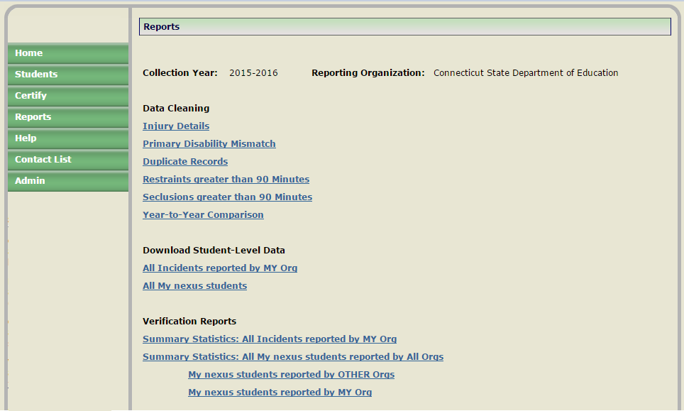

### Data Cleaning

For detailed information see Procedures section.

### Download Student-Level Data

#### All Incidents Reported by MY Org

|  |  |
| --- | --- |
| **Report Name/Link:** | ALL Incidents Reported by MY Org |
| **Sort Controls:** | Name, Incident Date, Incident Start |
| **Download Format:** | MS Excel File |
| **Purpose of Report:** | Districts may download this report for research and analysis purposes. This format provides all collected and calculated fields of a student’s reported incident. |
| **Source of Data:** | Restraint and Seclusion Data (Archived data if prior year selected) reported within your organization. |

Below are the fields (Column headers) that will be exported.

|  |  |
| --- | --- |
| 1. Collection Period 2. RS Reporting Org 3. Nexus District 4. PSIS Reporting District 5. School 6. SASID 7. Last Name 8. First Name 9. DOB 10. Spec Ed Status Type 11. Primary Disability Code | 1. Nature of Incident Type 2. Incident Date 3. Time Start 4. Time End 5. Incident Minutes 6. Circumstance Type 7. Injury Type 8. Injury Details 9. Date Created 10. Last Updated 11. Last User |

#### All My Nexus Students

|  |  |
| --- | --- |
| **Report Name/Link:** | All My Nexus Students |
| **Sort Controls:** | Name, Incident Date, Incident Start |
| **Download Format:** | MS Excel File |
| **Purpose of Report:** | Districts may download this report for research and analysis purposes. This format provides all collected and calculated fields of a student’s reported incident. |
| **Source of Data:** | Restraint and Seclusion Data (Archived data if prior year selected) reported within your organization.  Restraint and Seclusion Data (Archived data if prior year selected) reported, where Nexus District equals your organization. |

Below are the fields (Column headers) that will be exported.

|  |  |
| --- | --- |
| 1. Collection Period 2. RS Reporting Org 3. Nexus District 4. PSIS Reporting District 5. School 6. SASID 7. Last Name 8. First Name 9. DOB 10. Spec Ed Status Type 11. Primary Disability Code | 1. Nature of Incident Type 2. Incident Date 3. Time Start 4. Time End 5. Incident Minutes 6. Circumstance Type 7. Injury Type 8. Injury Details 9. Date Created 10. Last Updated 11. Last User |

### Verification Reports

Reports in this section are designed for superintendent and director of special education review purposes and allow districts to verify that students are accurately reported prior to certification. Multiple reports covering all major data elements have been designed in district level aggregate form.

#### [Summary Statistics: All Incidents reported by MY Org](http://sde-ap3hfdc/Districts/RestraintAndSeclusion/Reports/Reports?incid=0&rpt=SummaryStat&type=p)

|  |  |
| --- | --- |
| **Report Name/Link:** | Summary Statistics: ALL Incidents Reported by MY Org |
| **Download Format:** | Adobe PDF |
| **Purpose of Report:** | Superintendent and director of special education use this aggregate report to review and verify that students are accurately reported prior to certification . |
| **Source of Data:** | Restraint and Seclusion Data (Archived data if prior year selected) reported within your organization. |

|  |  |
| --- | --- |
|  |  |
|  | |

#### [Summary Statistics: All My nexus students reported by All Org](http://sde-ap3hfdc/Districts/RestraintAndSeclusion/Reports/Reports?incid=0&rpt=SummaryStat&type=p)s

##### My nexus students reported by OTHER Orgs

##### My nexus students reported by MY Org

|  |  |
| --- | --- |
| **Report Name/Link:** | Summary Statistics: All My nexus students reported by All Orgs |
| **Download Format:** | Adobe PDF |
| **Purpose of Report:** | Superintendent and director of special education use this aggregate report to review all incidents for Nexus students. |
| **Source of Data:** | Restraint and Seclusion Data (Archived data if prior year selected) reported within your organization. |

|  |
| --- |
|  |
|  |

# C:\Documents and Settings\Saumellr\Local Settings\Temporary Internet Files\Content.IE5\ZJD4FI1X\MC900014130[1].wmfC:\Documents and Settings\Saumellr\Local Settings\Temporary Internet Files\Content.IE5\IHJIXT1V\MC900434539[1].wmfC:\Documents and Settings\Saumellr\Local Settings\Temporary Internet Files\Content.IE5\KYXMKMTR\MC900014132[1].wmf Procedures

Note: While following procedures contained in this guide, always proceed to the next step if not directed to go to another step.

## How to Access the R/S System

**Step Action**

1. Using Internet Explorer, go to the <https://csde.ct.gov> website. The system displays the State of Connecticut Login screen.

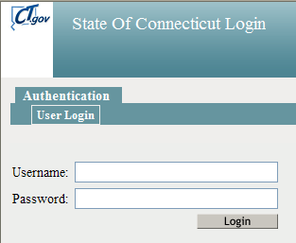

1. Enter your **Username** and **Password** and select Login.

Description: C:\Documents and Settings\Saumellr\Local Settings\Temporary Internet Files\Content.IE5\XXDGVTTL\MC900433838[1].png **Note:** If you forgot your username or password, click here <http://sdeportal.ct.gov/portaluser/>.

* + If you only have access to R/S, the system displays the *Restraint and Seclusion Data Collection* Homescreen - Go to Step 4.
  + If you have access to more than one application, the system displays the *State Department of Education Home Page*.

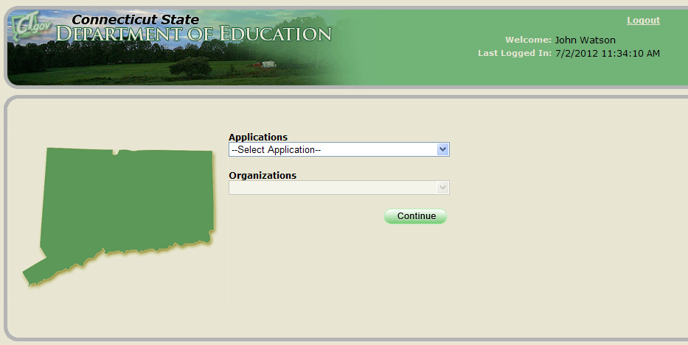

Remember: In DM usernames and passwords should NOT be shared, as each are unique to the assigned individual.

Note: If you do not have access to Restraint and Seclusion, contact your LEA Security Manager. For a list of LEA Security Managers go to the [DM Help Site](https://portal.ct.gov/SDE/Performance/Data-Collection-Help-Sites/Directory-Manager-Help-Site/Documentation). When an account is first created in DM the username and password are sent in two separate emails.

 Important:**At this time, there are no school-level permissions. Permissions are only available at the DISTRICT-level.**

1. Select **Restraint and Seclusion** from the Application drop-down menu. The system displays the *Restraint and Seclusion Data Collection* Homescreen.

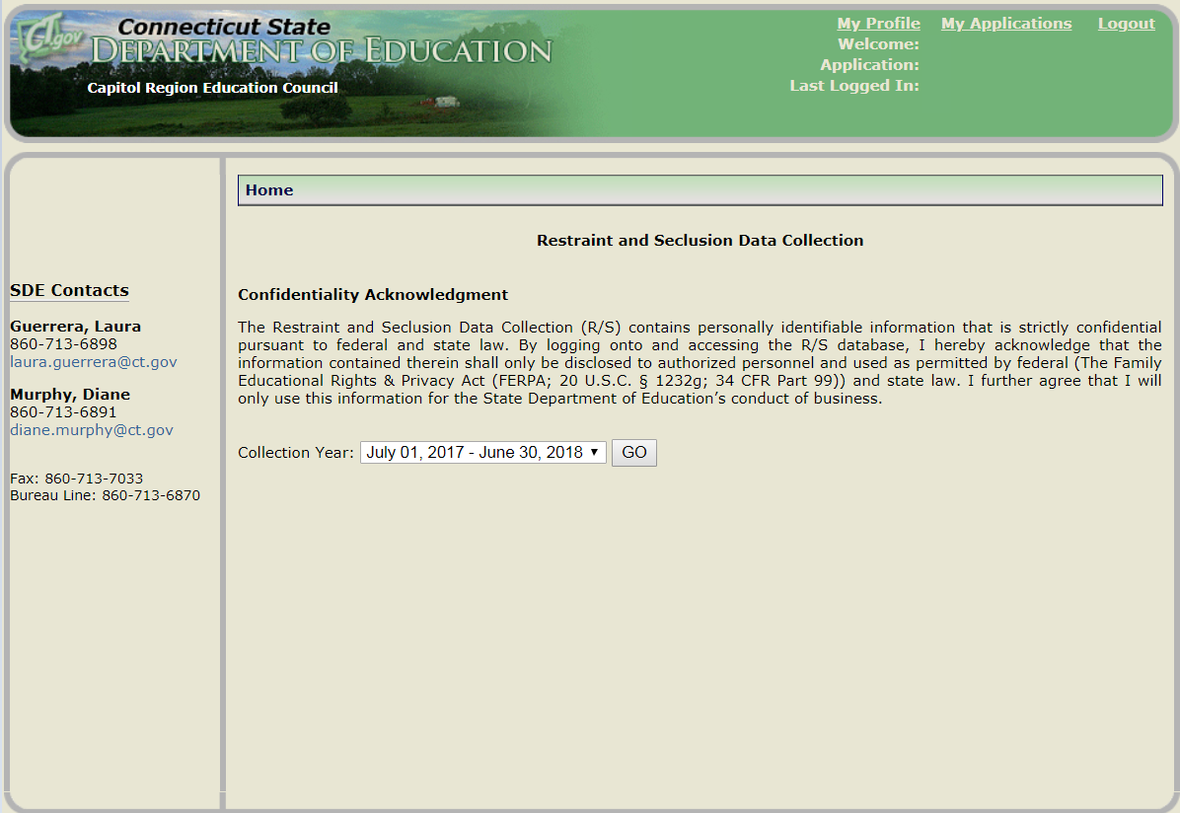

1. This procedure is complete.

## How to Add an Incident

Use this procedure to add an incident to R/S.

**Prerequisites**

* Access to the R/S system
* The collected data for entry into the system
* Your district has not yet certified the R/S Collection

**Step Action**

1. Select the Collection Year and click Go

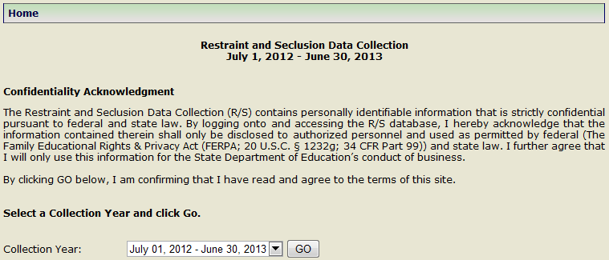

1. Using the navigation menu on the left of the screen, select the **Students Add New** menu option. The system displays the *Add New* screen.

** Reference:** Review the *Data Fields* section for descriptions of each field and the rules of entry.

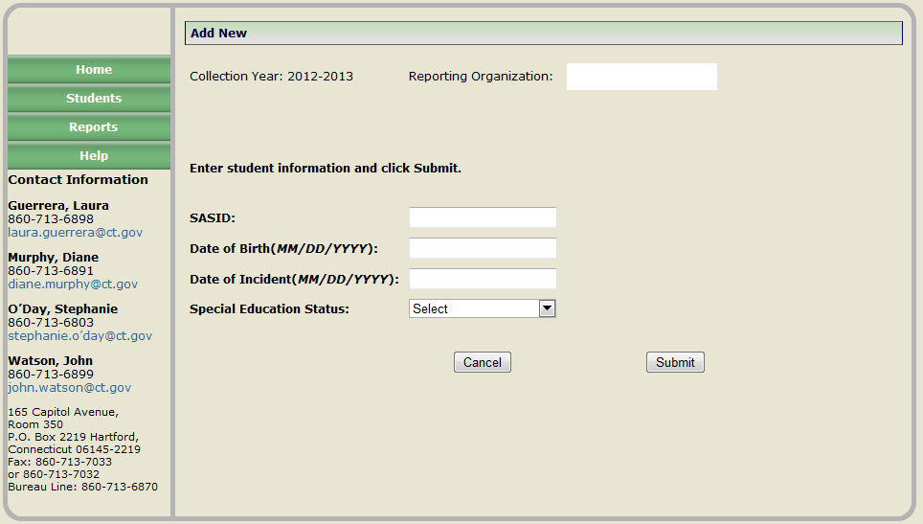

1. Enter the student’s SASID, DATE OF BIRTH, INCIDENT DATE and SPECIAL EDUCATION STATUS and select **Submit**.

** Note:** If you already entered an incident for the student on this date you will get a message “There is an existing record on this Incident Date. If you want to add another record on this Incident Date, click Submit. Otherwise, click Cancel.”

1. Was a matching student found in PSIS Registration?
   * **Yes** – The following applicable screen will be displayed. Go to Step 5.
   * **~~No~~** ~~- Contact the SDE to determine why the student is not registered in PSIS or the data you have entered does not match PSIS Registration. Return to Step 1 when errors are resolved.~~
   * **No** – Refer to the **Who to Report** section to ensure the criteria is meet to be reported.
     + If SPECIAL EDUCATION STATUS=**IEP**, the SASID and DATE OF BIRTH must match PSIS Registration and the INCIDENT DATE must fall within the Nexus Entry and Nexus Exit Dates within PSIS Registration.
     + If SPECIAL EDUCATION STATUS=**Consent to Evaluatate**, the SASID and DATE OF BIRTH must match PSIS Registration.

** Note:**  first contact the [SEDAC contacts](https://portal.ct.gov/SDE/Performance/Data-Collection-Help-Sites/SEDAC-Help-Site/Documentation) from the sending district. They work with the PSIS Coordinator the ensure the student is accurately reported in PSIS Registration.

1. Is the student registered in PSIS Registration?
2. Is the student reported with the correct Facility History (the Facility Code/Facility Code Entry/Exit Dates are accurate)?
3. if student has No Nexus District in Registration, is the student reported with the correct Nexus History (the Nexus District and Nexus District Entry/Exit Dates are accurate)?

If not resolved within 2 business days, contact the SDE.

SPECIAL EDUCATION STATUS is **IEP**

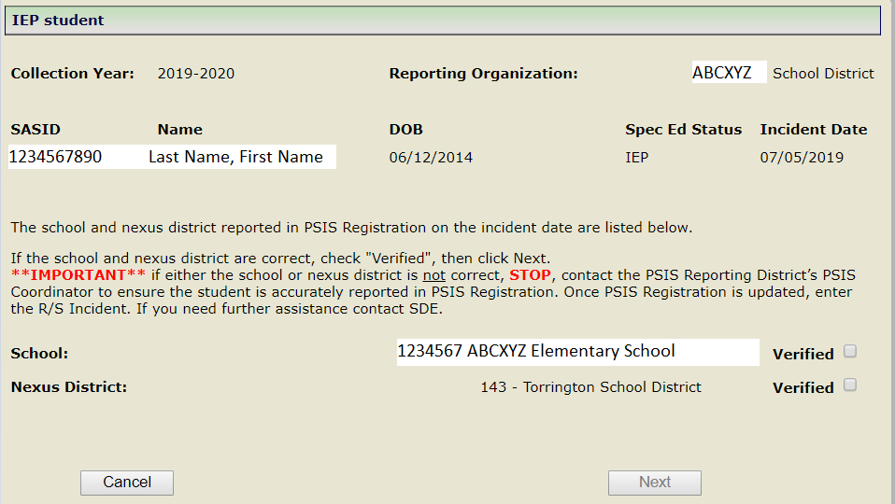

SPECIAL EDUCATION STATUS is **Consent to Evaluate**

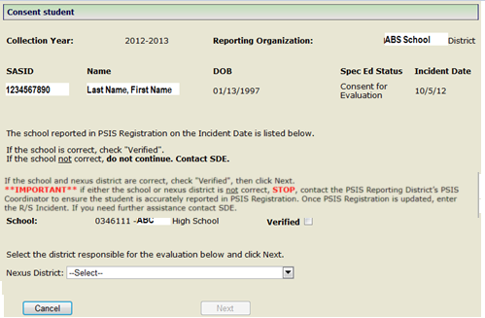

1. Is the SCHOOL where the R/S Incident occurred listed?

** Note:** if the student has Facility Code 2 reported in PSIS Registration, both facilities will appear in a drop-down. In this case, select the SCHOOL where the R/S Incident occurred.

* + **Yes** – **Check** Verified.
  + **No** - Contact the PSIS Data Manager to determine why the student is not registered in that school on the date of the incident. Return to Step 1 when errors are resolved.

1. Is the Nexus District displayed accurate based on the INCIDENT DATE?

** Note:** if SPECIAL EDUCATION STATUS is equal to **Consent to Evaluate** you will select the Nexus District.

* + **Yes** – **Check** Verified.
  + **No** - Contact the PSIS Data Manager to determine why the student is not registered in the appropriate Nexus on the date of the incident. Return to Step 1 when errors are resolved.

1. Select **Next**
2. The system displays the *Edit Record* screen.

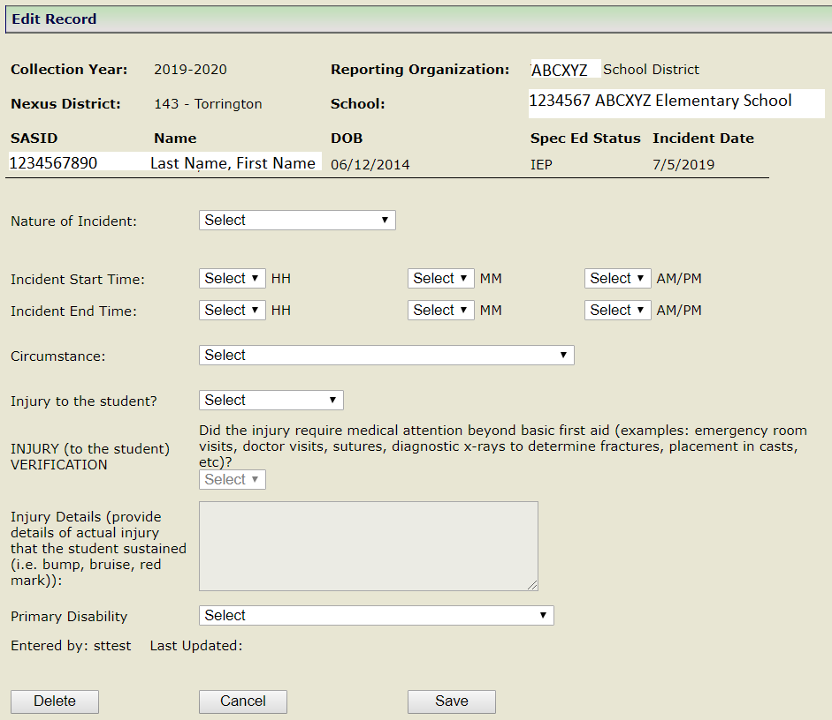

If INJURY (to the student) = Serious Injury 5 additional questions are displayed

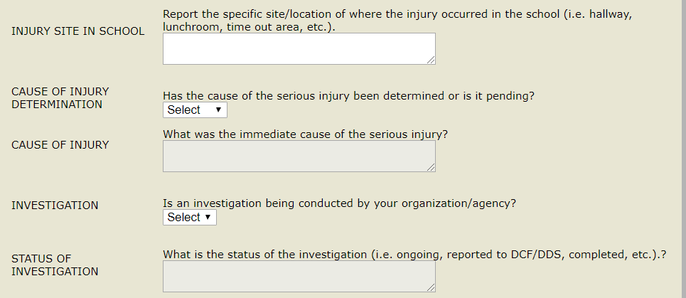

1. Enter the NATURE OF INCIDENT, INCIDENT START TIME, INCIDENT END TIME, CIRCUMSTANCE, INJURY (to the student), **Injury** (to the student) **Verification** (required when INJURY is **2- Non-serious injury**); INJURY DETAILS (required when INJURY is **2- Non-serious injury** OR **3-Serious injury**), INJURY SITE IN SCHOOL(required when INJURY is **3- Serious injury**), CAUSE OF INJURY DETERMINATION(required when INJURY is **3- Serious injury**), CAUSE OF INJURY (required when INJURY is **3- Serious injury** and CAUSE OF INJURY DETERMINATION is **1 - Yes**),INVESTIGATION (required when INJURY is **3- Serious injury**), STATUS OF INVESTIGATION (required when INJURY is **3- Serious injury** and if INVESTIGATION is **1** - **Yes**), PRIMARY DISABILITY and select **Save**

**Note:** if SPECIAL EDUCATION STATUS is **Consent to Evaluate,** PRIMARY DISABILITY will default to **18-General Education**.

1. The system displays a confirmation “Record saved successfully”.

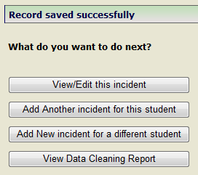

1. If you want to add another incident for **this** student, select **Add Another Incident for this student**, the system displays the *Add New* screen with the student’s SASID and DATE OF BIRTH pre-populated. Go to step 3.
2. If you want to add a incident for a different student, select **Add New Incident for a different student** the system displays the *Add New* screen. Go to step 3.
3. This procedure is complete.

## How to Change an Incident

Use this procedure to change student data.

**Prerequisites**

* Access to the R/S system
* Your district has not yet certified the R/S Collection

**Step Action**

1. Using the navigation menu on the left of the screen, select the **Students Incidents reported by MY Org** menu option. The system displays the *Incidents reported by MY Org* screen.

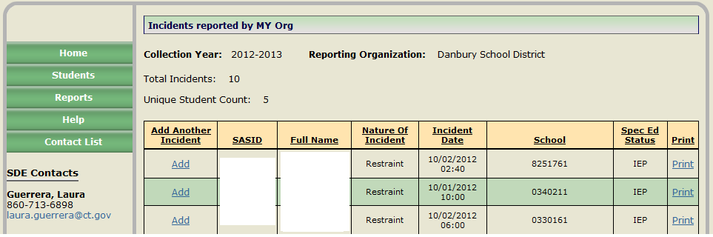

1. Select the FULL NAME link for the student record you need to change. The system displays the *Edit Record screen*.

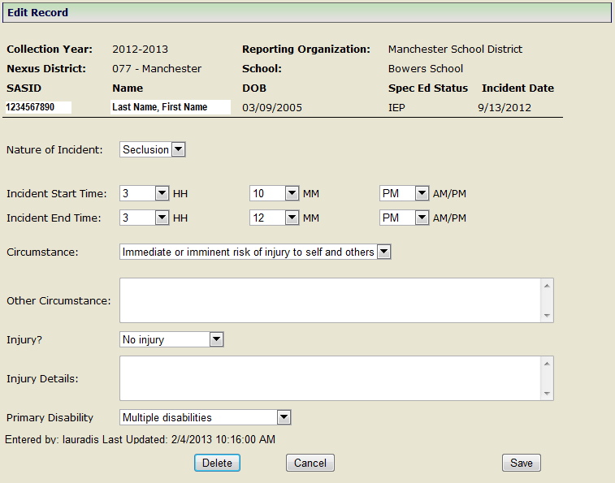

1. You have selected to change a student record. You may update the following fields: NATURE OF INCIDENT, INCIDENT START TIME, INCIDENT END TIME, CIRCUMSTANCE, INJURY (to the student), **Injury** (to the student) **Verification** (required when INJURY is **2- Non-serious injury**), INJURY DETAILS (required when INJURY is **2- Non-serious injury** OR **3-Serious injury**), INJURY SITE IN SCHOOL(required when INJURY is **3- Serious injury**), CAUSE OF INJURY DETERMINATION(required when INJURY is **3- Serious injury**), CAUSE OF INJURY (required when INJURY is **3- Serious injury** and CAUSE OF INJURY DETERMINATION is **1 - Yes**),INVESTIGATION (required when INJURY is **3- Serious injury**), STATUS OF INVESTIGATION (required when INJURY is **3- Serious injury** and if INVESTIGATION is **1** - **Yes**), PRIMARY DISABILITY and select **Save**.

** Note:** If you do not want to make changes select **Cancel**. If you want to delete the record select **Delete**.

1. The system displays a confirmation “Record saved successfully”.
2. This procedure is complete.

## How to View MY students reported by OTHER Organizations

Use this procedure to view student data reported by OTHER Organizations.

**Prerequisites**

* Access to the R/S system
* Your district has not yet certified the R/S Collection

**Step Action**

1. Using the navigation menu on the left of the screen, select the **MY students reported by OTHER Org** menu option. The system displays the *MY students reported by OTHER Org* screen.

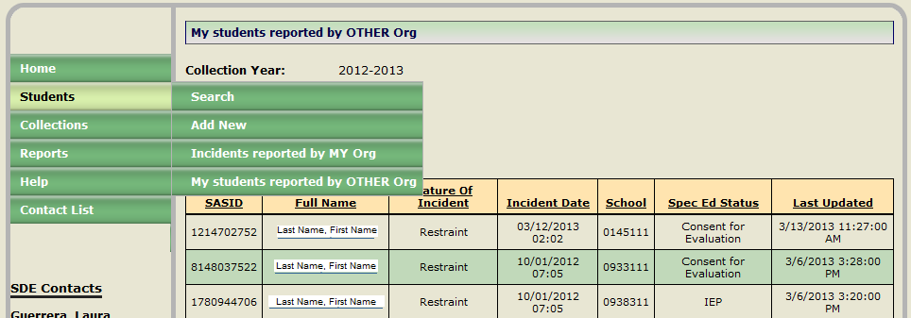

1. Select the FULL NAME link for the student record you want to view. The system displays the *Print Record screen*.

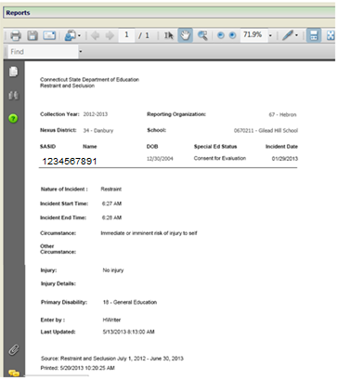

1. You may print this record for the student’s file.
2. This procedure is complete.

## How to Resolve a case on Injury Details

The SDE uses this report is to streamline monitoring of INJURY DETAILS.

1. Quick access on the *Home Page Status Dashboard* or select **Reports** from the navigation menu on the left of the screen.
2. Select INJURY DETAILS under Data Cleaning.  Records are displayed here where INJURY TYPE=**Non-serious injury or serious injury**.  If TOTAL UNRESOLVED CASES=**0 cases as of “date timestamp”**.  Go to Step 8.

* If INJURY DETAILS are reviewed by SDE, incident will come off this report.
* If INJURY is changed to **No injury**, INJURY DETAILS are removed and the incident will come off this report.

1. Review comment

* If Comment is blank, SDE has not yet reviewed the comment, go to step 4
* If you need to make changes to INJURY (TO THE STUDENT) or INJURY DETAILS, go to step 5.

1. Review INJURY (TO THE STUDENT) and INJURY DETAILS to ensure they meet R/S reporting requirements. Consider the following:
   * Only report injuries to the STUDENT being restrained or secluded (not injuries to staff or other students).
   * The injury must have been sustained during (not before or after) the restraint or seclusion.
   * Details of the injury to the student (e.g., bump, bruise, red mark) must be included.
   * An injury should only be reported once for an overlapping restraint and seclusion.
   * If the student required medical attention beyond basic first aid, the injury must be reported as SERIOUS.

* If INJURY (TO THE STUDENT) and INJURY DETAILS meets the R/S reporting requirements, wait for the SDE to review the incident.
* If you need to make changes to INJURY (TO THE STUDENT) or INJURY DETAILS, go to step 5.

1. Select the **Name** link for the student record you need to change.  The system displays the *Edit Record screen.*
2. Update INJURY and/or INJURY DETAILS accordingly and select **Save**.  The system displays a confirmation “Record saved successfully”.
3. Select *View Data Cleaning Report*.  Go to Step 2.
4. This procedure is complete.

## How to Resolve a Primary Disability Mismatch

**Step Action**

1. Quick access on the *Home Page Status Dashboard* or select **Reports** from the navigation menu on the left of the screen.
2. Select the PRIMARY DISABILITY MISMATCH under Data Cleaning.  Records are displayed here where PRIMARY DISABILITY does not MATCH across all incidents reported for a SASID.  If TOTAL UNRESOLVED CASES=**0 cases as of “date timestamp”**.  Go to Step 9.

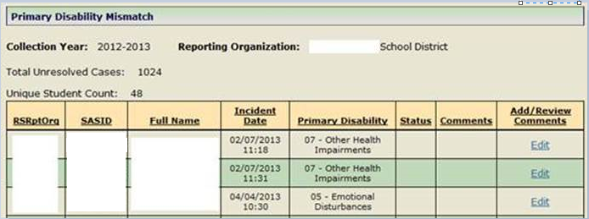

* + Once  PRIMARY DISABILITY matches across all incidents reported for a SASID the student will come off this report.

1. Is PRIMARY DISABILITY reported accurately?
   1. If no, go to step 4.
   2. If yes, go to step 7.
2. Select the **Name** link for the student record you need to change.  The system displays the *Edit Record screen*.
3. Update PRIMARY DISABILITY accordingly and select **Save**.  The system displays a confirmation “Record saved successfully”.
4. Select *View Data Cleaning Report*.  Go to Step 2.
5. The District must sent an email to [laura.guerrera@ct.gov](mailto:laura.guerrera@ct.gov) and include:

* District Name and SASID#
* the previous disability
* the date of the PPT where the disability was changed
* the new disability

1. The CSDE will verify the Primary Disability change, if verified, the student will be removed from this report.
2. This procedure is complete.

## How to Resolve a case on the Duplicate Records

**Step Action**

1. Quick access on the *Home Page Status Dashboard* or select **Reports** from the navigation menu on the left of the screen.
2. Select DUPLICATE RECORDS under Data Cleaning.  Records are displayed here where SASID, NATURE OF INCIDENT, INCIDENT DATE, INCIDENTSTART and INCIDENT END match exactly.  If TOTAL UNRESOLVED CASES=**0 cases as of “date timestamp”**.  Go to Step 6.

* Once there are no more duplicates the incident will come off this report.

1. Select the NAME link to view each of the duplicate records and review all fields.
2. Select **Delete** on the incident that is not accurate.  If all fields are an exact match DELETE either of the duplicate records.  The system displays a confirmation “Are you sure you want to delete this record?”. Select **Yes**. The system displays a confirmation “Student incident deleted successfully.”
3. Select *View Data Cleaning Report*.  Go to Step 2.
4. This procedure is complete.

## How to Resolve a case on the Restraints greater than 90 Minutes  report

***IMPORTANT REMINDER:***

When a student is restrained, released from this restraint, and then restrained again (the lapse between restraints is only a matter of seconds), this is reported as **two** separate restraints.  In these cases, the CSDE is aware that the  incident start time of the second restraint may be the same as the incident end time of the first restraint.

**Step Action**

1. Quick access on the *Home Page Status Dashboard* or select **Reports** from the navigation menu on the left of the screen.
2. Select Restraints greater than 90 Minutes under Data Cleaning.  Records are displayed here where INCIDENT MINUTES are greater than or equal to 90 minutes.  If TOTAL UNRESOLVED CASES=**0 cases as of “date timestamp”**.  Go to Step 7.

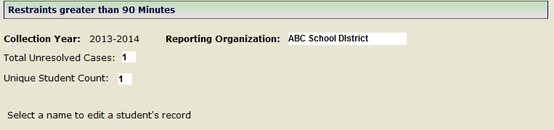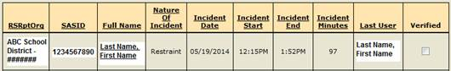

* Once a case is resolved or verified the incident will come off this report.

1. Are INCIDENT START and INCIDENT END TIMES accurate? (INCIDENT MINUTES are calculated based on INCIDENT START TIME and INCIDENT END TIME)
   1. If no, go to step 4.
   2. If yes, check Verified.  Go to step 1.
2. Select the **Name** link for the incident you need to change.  The system displays the *Edit Record screen*.
3. Update INCIDENT START TIME or INCIDENT END TIME accordingly and select **Save**.  The system displays a confirmation “Record saved successfully”.
4. Select *View Data Cleaning Report*.  Go to Step 2.
5. This procedure is complete.

## How to Resolve a case on the Seclusions greater than 90 Minutes report

**Step Action**

1. Quick access on the *Home Page Status Dashboard* or select **Reports** from the navigation menu on the left of the screen.
2. Select SECLUSIONS greater than 90 Minutes under Data Cleaning.  Records are displayed here where INCIDENT MINUTES are greater than or equal to 90 minutes.  If TOTAL UNRESOLVED CASES=**0 cases as of “date timestamp”**.  Go to Step 8.

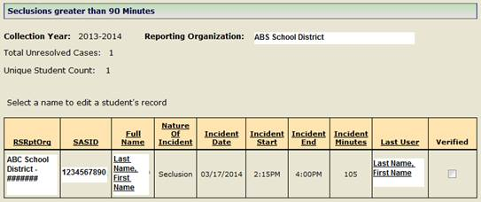

* Once a case is resolved or verified the incident will come off this report.

1. Is the incident reported accurately?
2. If the student was **prevented from leaving the area** for the ENTIRE reported duration, check Verified.  Go to step 1. Else, go to step 4.
3. Select the **Name** link for the incident you need to change.  The system displays the *Edit Record screen*.
4. If the student was **prevented from leaving the area** for ONLY A PORTION of the reported duration, Go to step 5.
5. If the student was **allowed to leave the area** for the ENTIRE reported duration, Go to step 6.
6. Update INCIDENT START TIME or INCIDENT END TIME accordingly and Select **Save**.  The system displays a confirmation “Record saved successfully”.
7. Select **Delete**.  The system displays a confirmation “Are you sure you want to delete this record?”. Select **Yes**. The system displays a confirmation “Student incident deleted successfully.”
8. Select *View Data Cleaning Report*.  Go to Step 2.
9. This procedure is complete.

## How to Respond to Year-to-Year Comparison Report

In reviewing R/S data for the current reporting period, if a substantial change (# Change ≥ 20 or ≤ -20 and % Change ≥ 20% or ≤ -20% (or null)) was noted in total R/S incidents from the previous year your organization is required to provide a response. % Change compares incidents reported from previous collection year to current collection year.

* A negative % Change indicates a reduction.
* A positive % Change indicates an increase.
* A blank % Change indicates that a % Change could not be calculated as 0 incidents were reported in the previous year. In this case, simply consider the # Change

 **Important:** The Edit link will appear under Comments if your organization is required to provide a response.

1. On the Status Dashboard located on the Home Page, select the **Edit** link above Year-to-Year Comparison. Total counts are displayed comparing incidents from the previous year to the current year.

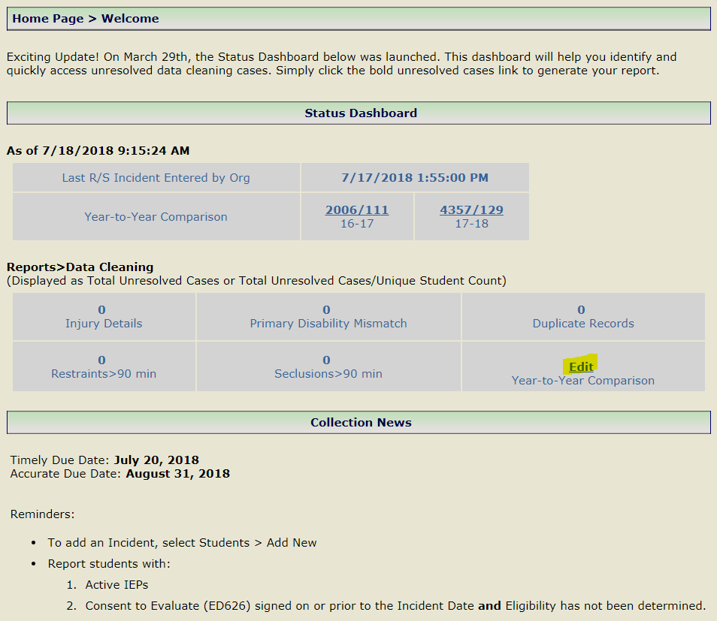

Note: The YEAR-TO-YEAR COMPARISON report is also available under the **Reports** menu.

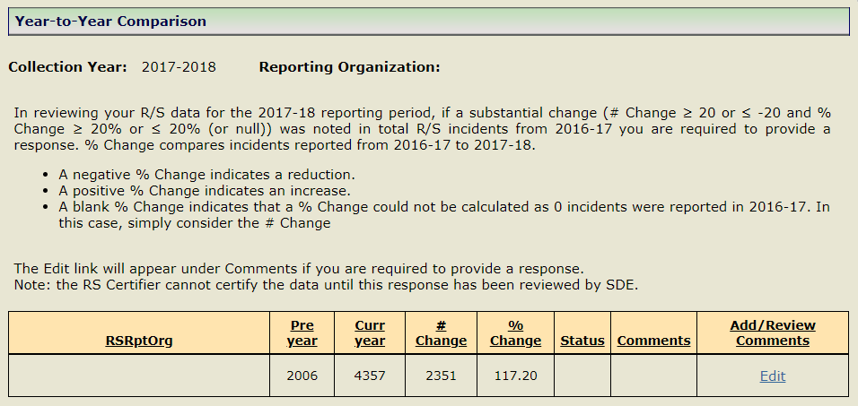

1. Select **Edit** under the Add/Review Comments column and type or paste the district’s response.

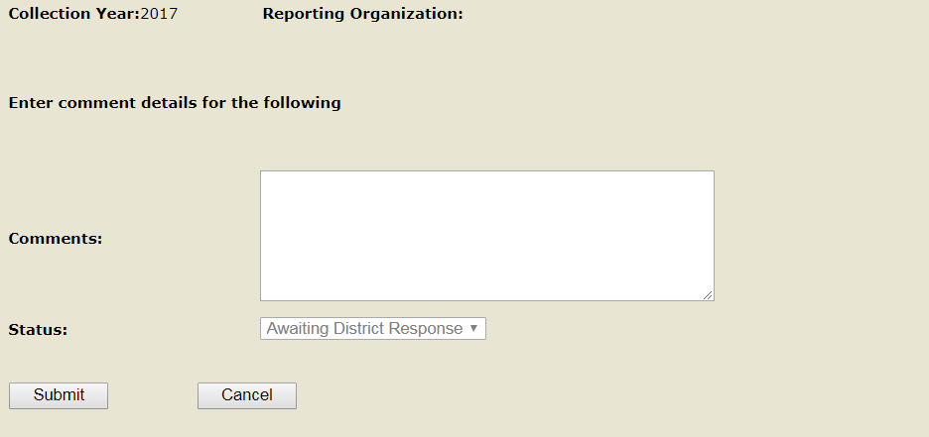

 **Note:** The response should provide an explanation for the change (e.g., a student with significant behavioral needs moved into/out of the district, the district started/ended an in-district special education program). A response such as “The data are accurate” is insufficient.

 **Note:** If your program was not in existence last year, your comment will be “Our program opened during the current school year”.

1. Select **Submit.**

 **Note:** the RS Certifier cannot certify the data until this response has been Reviewed/Closed by SDE.

1. Review Status.

* If Status is **Awaiting SDE**, SDE has not yet reviewed the comment
* If Status is **Awaiting District Response** review response, go to step 2.
* If Status is **SDE Reviewed/Closed**, go to step 5.

1. Proceed to Certify your organization’s data.

## How to Certify Your Organization’s Data

Note: Only Certified Administrators with the RS Certifier role assigned in Directory Manager have access to certify these data.

Note: Districts that have zero R/S incidents must still certify.

**What every organization should do before Certifing R/S data**

1. **Verify** ALL R/S incidents between July 1st and June 30th have been entered into the system
   * Ensure you have **received** ALL R/S Incident forms which occurred between July 1st and June 30th.

**Important:** The CSDE strongly recommends that you **send an email to each of your district’s schools/programs to verify they have sent you all R/S Incident forms.**

* + Ensure you have **entered** ALL R/S Incident forms which occurred between July 1st and June 30th.

1. **Review Verification Reports** (*Reports>Verification Reports>Summary Statistics: All Incidents Reported by MY Org*)
   * If you question reasonability of any number, please download, save, and review your student-level data. (*Reports>Download Student-Level Data>All Incidents Reported by MY Org*).

**Step Action**

1. Using the navigation menu on the left of the screen, select the **Certify** menu option. The system displays the *Certify* screen.

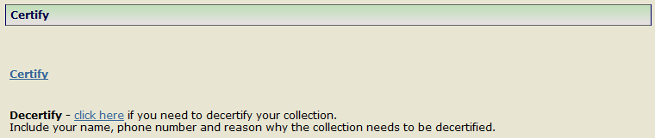

1. Select **Certify.** The system displays the *Certify* screen.

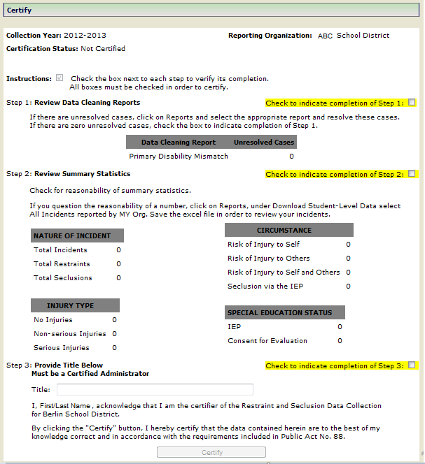

1. Step 1: Review Data Cleaning Reports. Do you have unresolved cases?
   * **Yes** – click on Reports and select the appropriate report and resolve these cases.
   * **No** – check the box to indicate completion of Step 1.
2. Step 2: Review Summary Statistics.  Do you question the reasonability of a number?
   * **Yes** – click on Reports, under Download Student-Level Data select All Incidents reported by MY Org. Save the excel file in order to review your incidents.
   * **No** – check the box to indicate completion of Step 2.
3. Step 3: **Enter your Title**.

** Note:** Must be a Certified Administrator.

1. Check the box to indicate completion of Step 3.
2. Select **Certify**.
3. The *Certification Confirmation* report is displayed; print this report for your records.

Note: The *Certification Confirmation* report is also available under the Reports menu.

1. This procedure is complete.

# C:\Documents and Settings\Saumellr\Local Settings\Temporary Internet Files\Content.IE5\AZNQ3Q82\MC900089048[1].wmfFAQs

## Miscellaneous Questions?

1. **How do we know what a student’s SASID is?**

Each student’s SASID should be located on page 1 of the IEP.

1. **Is there a way to add multiple incidents for a student without having to type their SASID and date of birth each time?**

Yes,  the system will pre-populate the student’s SASID and DATE OF BIRTH on the *Add New* screen when you select  **Add Another Incident for this student** from the *record saved successfully* screen or when you select **Add** under the *Add Another Incident* column from the *Incidents reported by MY Org* screen.

NEXUS or SCHOOL may have changed on the additional INCIDENT DATE being reported in R/S, therefore, the organization still has to verify NEXUS and SCHOOL for each incident entered.

1. **We are an APSEP, our residential program is licensed by DCF, therefore, we already report R/S to DCF. Do we also have to report to the CSDE?**

Yes, you have to report R/S incidents that occur during the school day to the CSDE, based on the criteria outlined in this handbook.

## User Roles in DM?

1. **What if I forget my User ID?**

Contact your LEA Security Manager, ask them to look-up your User ID.

1. **What if I forget my password?**

Contact your LEA Security Manager, ask them to reset your password.

1. **What should we do if a User with an R/S role no longer works in our organization?**

Contact your LEA Security Manager, ask them to inactivate the person’s account in DM.  For confidentiality and security purposes, this should be completed immediately.

1. **What should we do if a User with an R/S role is no longer responsible for inputting R/S data?**

Contact your LEA Security Manager, ask them to either unassign the R/S role for this user or inactivate the user’s account in DM.  For confidentiality and security purposes, this should be completed immediately.

* if the user has other roles in DM, the LEA Security Manager  will unassign the R/S role.
* if the user does not have other roles in DM, the LEA Security Manager  will inactivate the user’s account.

1. **What should we do if a User’s phone number or email address is not accurate?**

Contact your LEA Security Manager, ask them to update the user’s account in DM.

1. **What should we do if we have a new R/S user?**

Contact your LEA Security Manager, ask them to create/update the user’s account in DM with either the RS Certifier role (note: only one certifier should be assigned for your LEA and that person is a certified administrator) OR RS Writer role (enters R/S data).

1. **What if we do not know who our LEA Security Manager is?**

If you do not know who your LEA Security Manager is, click [here](https://portal.ct.gov/SDE/Performance/Data-Collection-Help-Sites/Directory-Manager-Help-Site/Documentation) for a listing of all LEA Security Managers.

1. **How do I report an incident that lasted only 40 seconds in duration?**

Incidents of less than one minute should be reported as 1 minute in length (start and end times reported as one minute apart). The department will report out these incidents with the caveat “or less” for the lowest length of time grouping (e.g., 2 minutes or less, five minutes or less, etc.).

## Who to Report?

1. **What should we do if Restraints or Seclusions were not used?**

Every district /organization must certify even if they had no Restraints or Seclusions to report.

1. **Should we report the use of Restraint and Seclusion where the parents rejected the District IEP and the student is parent-enrolled in a facility? The District, in order to settle (potential or pending) litigation, provides some funding to offset the parent's costs.  District has not accepted programmatic responsibility for the child’s education through the development and implementation of an IEP.**

The district has not accepted programmatic responsibility for the child’s education through the development and implementation of an IEP, therefore, would not be reported in the Restraint and Seclusion data collection.

1. **Do I report a Restraint or Seclusion that occurred during Extended Day?**

If Extended Day Services are being implemented as part of the IEP and a Restraint or Seclusion occurs, then you would report that INCIDENT.

If Extended Day Services are not part of the IEP, you would not report the INCIDENT.

1. **Do I report a Restraint or Seclusion that occurred during after school sports/athletics?**

If after school sports/athletics are being implemented as part of the IEP and a Restraint or Seclusion occurs, then you would report that INCIDENT.

If after school sports/athletics are not part of the IEP, you would not report the INCIDENT.

1. **Do I report a Restraint or Seclusion incident that occurred during a student’s Summer Program?**

If the Summer Program is being implemented as part of the IEP and a Restraint or Seclusion occurs, then you would report that INCIDENT.

Note: PSIS Registration does not require districts to update registration records for students who attend summer programs.  You will not have a problem entering a summer program R/S incident if the student’s summer program was located at the same school the student attended during the school year (or a school within the same district or the same RESC). The INCIDENT DATE will be used to determine whether the incident occurred during the academic year or during a summer program.

Important: Contact CSDE if you need to report a restraint or seclusion incident that occurred in a summer program in a district, RESC or APSEP that is different from the district, RESC or APSEP the student attends during the school year.

1. **A student is placed in seclusion, while in seclusion the student is restrained. Is this reported as two separate incidents?**

Yes, you would report one seclusion and one restraint incident. In this case, the CSDE is aware that incident start time and/or incident end time will overlap.

1. **A student is restrained. When released from this restraint, the student is restrained again. The lapse between restraints is only a matter of seconds. Is this reported as two separate restraints?**

Yes, you would report two restraints. In these cases, the CSDE is aware that the  incident start time of the second restraint may be the same as the incident end time of the first restraint.

1. **Physical restraint** **does not include briefly holding a child in order to calm or comfort the child. Is there a specific timeframe associated with “brief”?**

There is no set amount of time associated with “brief”. Apply rules of common sense. The CSDE encourages teams to consider the context in which the “brief” hold was conducted, its intent and the age of the child.  If the team determines the hold was “brief” and used to calm or comfort the child, this “brief” hold would not be reported in R/S.  If you have questions regarding a specific scenario, contact Colleen Hayles, BSE consultant ([colleen.hayles@ct.gov](mailto:colleen.hayles@ct.gov) or 860-713-6922).

## What to report for INJURY?

1. **An incident occurred where an ambulance was called, but there was NO injury to the student.  The district called for an ambulance because the student could not be calmed without additional intervention.  The student was brought to the hospital for a medical or psychiatric evaluation.  What would the district report under INJURY?**

In the above scenario, the district is clear there was NO injury to the student.  The district should note on the Incident Report that an ambulance was called because the student could not be calmed without additional intervention. On the R/S data collection INJURY would be reported as “No Injury”, since there was no physical injury to the student.

# C:\Documents and Settings\Saumellr\Local Settings\Temporary Internet Files\Content.IE5\AZNQ3Q82\MC900412396[1].wmfAppendix

## Terminology

|  |  |
| --- | --- |
| CSDE | Connecticut State Department of Education |
| DM | Directory Manager |
| IDEA | Individuals with Disabilities Education Improvement Act |
| Nexus | The Nexus District is the district that has the legal responsibility to identify, educate, and pay for a special education student under the Individuals with Disabilities Education Improvement Act (IDEA). |
| PSIS Registration | Public School Information System - This application is used for year round registration of student enrollments. |
| SASID | State Assigned Student ID |
| R/S | Restraint and Seclusion |

## References

| **Reference** | **Website** |
| --- | --- |
| Restraint and Seclusion resources are available on the Bureau of Special Education’s website. | <https://portal.ct.gov/SDE/Special-Education/Special-Education-Legal-and-Due-Process> |
| Restraint and Seclusion Data Collection Login website | <https://csde.ct.gov> |
| Connecticut State Department of Education website | <https://portal.ct.gov/SDE> |
| Performance Office website | <https://portal.ct.gov/SDE/Performance/Performance-Office-Home-Page> |
| Application Information – CSDE Data Collections   * **Agency Data Acquisition Plan** * **Timely and Accurate Calendar** – Summary of Timely/Accurate Due Dates & Freeze Dates * **Certifying Data** * **Contact Information** * **Data Collection Applications** – link to all Performance Office Data Collections; the link to log in & their Help Site (which includes Important Dates, SDE Contact Information, Documentation, Statutory References and Yearly Updates) * **FAQ** * **Logging In** – Legacy vs. Portal Applications * **Password/Username Information** * **Timely and Accurate Information** – detailed information about timely and accurate | <https://portal.ct.gov/SDE/Performance/Data-Collections-Guide> |
| Facility Codes – this data system uses the facility coding structure used in the Public School Information System (PSIS).  See PSIS Table A: Facility Codes | <http://www.csde.state.ct.us/public/psis/downloads.asp#codes>. |
| Facility Codes - this data system uses the facility coding structure used in the Public School Information System (PSIS).  See Non Public and Out of State Facility Codes | <http://www.csde.state.ct.us/public/psis/downloads.asp>   * In-State APSEP tab at the bottom of the excel document is a list of IN-STATE APPROVED PRIVATE SPECIAL EDUCATION PROGRAM FACILITY CODES. * Transition Programs tab at the bottom of the excel document is a list of AGE APPROPRIATE COMMUNITY BASED TRANSITION PROGRAM FACILITY CODES. * Out of State tab at the bottom of the excel document is a list of OUT OF STATE FACILITY CODES. (Note: Effective 7/1/17 ALL Out of State Codes will be either a Public School or Non-Public.) |

## CSDE's Statement of Nondiscrimination

The Connecticut State Department of Education is committed to a policy of equal opportunity/affirmative action for all qualified persons. The Connecticut State Department of Education does not discriminate in any employment practice, education program, or educational activity on the basis of **race, color, religious creed, sex, age, national origin, ancestry, marital status, sexual orientation, gender identity or expression, disability (including, but not limited to, intellectual disability, past or present history of mental disorder, physical disability or learning disability), genetic information, or any other basis prohibited by Connecticut state and/or federal nondiscrimination laws. The Connecticut State** **Department of Education does not unlawfully discriminate in employment and licensing against qualified persons with a prior criminal conviction.** Inquiries regarding the Connecticut State Department of Education’s nondiscrimination policies should be directed to:

Levy Gillespie

Equal Employment Opportunity Director/American with Disabilities Act Coordinator

Connecticut State Department of Education

25 Industrial Park Road

Middletown, CT 06457

860-807-2071

[Levy.Gillespie@ct.gov](mailto:Levy.Gillespie@ct.gov)