DOCKET NO. 429 - New Cingular Wireless PCS, LLC (AT&T) application for a Certificate of Environmental Compatibility and Public Need for the construction, maintenance, and operation of a telecommunications facility located at one of two sites: Willington Tax Assessor Parcel ID #M23-P62 Tolland Turnpike, Willington, Connecticut; or Willington Tax Assessor Parcel ID #M18-19 Old South Willington Road, Willington, Connecticut. | }  }  } | Connecticut  Siting  Council  February 7, 2013

Findings of Fact

Introduction

- New Cingular Wireless PCS, LLC (AT&T), in accordance with provisions of Connecticut General Statutes (CGS) § 16-50g et. seq., applied to the Connecticut Siting Council (Council) on July 24, 2012 for the construction, maintenance, and operation of a telecommunications facility at one of two proposed locations in the Town of Willington (Town), Connecticut. (AT&T 1, pp. 1)

- AT&T’s Candidate A site would be located off of Tolland Turnpike and would include a 160-foot monopole tower. AT&T’s Candidate B site would be located off of Old South Willington Road and would include a 190-foot monopole tower. (AT&T 1, p. 2)

- AT&T is a Delaware limited liability company with an office at 500 Enterprise Drive, Rocky Hill, Connecticut. AT&T is licensed by the Federal Communications Commission (FCC) to construct and operate a personal wireless services system. (AT&T 1, p. 3)

- The party in this proceeding is the applicant. Robert and Marissa Golden are intervenors. (Transcript, October 11, 2012, 3:00 p.m. [Tr. 1], pp. 4, 9)

- The purpose of the proposed facility would be to provide service along Tolland Turnpike (State Route 74), Willington Hill Road (Route 320) , Ruby Road, and surrounding areas in the Town of Willington. (AT&T 1, p. 1)

- AT&T originally submitted a Certificate application for these two locations on May 19, 2011. AT&T subsequently withdrew the application without prejudice. (AT&T 1, p. 23)

- Pursuant to CGS § 16-50l(b), AT&T published public notice of its intent to submit this application on July 17 and July 18, 2012 in the Willimantic Chronicle. (AT&T 1, p. 4, Attachment 7; AT&T 2 – Affidavit of Publication, dated September 5, 2012)

- Pursuant to CGS § 16-50l(b), AT&T sent, via certified mail, notices of its intent to file an application with the Council to each person appearing of record as owner of property abutting the properties on which the two candidate sites are located. (AT&T 1, p. 4; Attachment 7)

- Of 33 notice letters sent to abutting property owners, AT&T received 19 return receipts and confirmed the delivery of another nine letters through the U.S. Postal Service website’s Track and Confirm tool. Five notice letters were re-sent via first class mail to the abutting property owners from whom receipts were not received. (AT&T 3, A1)

- Pursuant to CGS § 16-50l (b), AT&T provided copies of its application to all federal, state and local officials and agencies listed therein. (AT&T 1, p. 4; Attachment 6)

- AT&T posted signs at each of the two candidate sites on September 28, 2012. The signs gave the date of the public hearing and contact information for the Council. (AT&T 6 – Affidavit of Sign Posting)

- The Council and its staff conducted an inspection of the proposed sites on October 11, 2012, beginning at 1:30 p.m. The applicant attempted to fly a balloon at each of the two sites to simulate the heights of the proposed towers but gusty wind conditions resulted in several lost balloons and made it difficult for the balloons to fly at the intended heights. (Tr. 1, pp. 32-33)

- Pursuant to CGS § 16-50m, the Council, after giving due notice thereof, held a public hearing on October 11, 2012, beginning at 3:00 p.m. and continuing at 7:00 p.m. in the Old Senior Center Room in the Willington Town Office Building at 40 Old Farms Road in Willington, Connecticut. (Tr. 1, p. 3 ff.)

- On November 29, 2012, the Council ruled that cross examination of late filed exhibits was not necessary and closed the evidentiary record. (Council Memorandum from Linda Roberts to Parties and Intervenors, dated November 30, 2012)

State Agency Comment

- Pursuant to CGS § 16-50j(h), on August 13, 2012, the Council solicited comments on this application from the following state agencies: Department of Agriculture, Department of Energy & Environmental Protection (DEEP), Department of Public Health, Council on Environmental Quality, Public Utilities Regulatory Authority, Office of Policy and Management, Department of Economic and Community Development, the Department of Transportation (ConnDOT), and the Department of Emergency Management and Homeland Security. (CSC Hearing Package dated August 13, 2012)

- ConnDOT submitted comments in which it stated that AT&T would need a Highway Encroachment Permit should it need to do any work within the right-of-way of Route 74 (Tolland Turnpike) for the Candidate A site. ConnDOT had no comment on the Candidate B site. (ConnDOT Comment Letter, August 24, 2012)

- The Council did not receive comments from any of the other state agencies. (Record)

Municipal Consultation

- AT&T first contacted the Town about its interest in the two candidate sites on October 4, 2010 when it submitted to the Town a Technical Report that provided details about the two sites. (AT&T 1, p. 22)

- After some discussions with AT&T, the First Selectman and Town staff indicated a preference for the proposed Candidate A Site (off of Tolland Turnpike) because the 160-foot tower at this location appeared to minimally impact the Willington Green and this location was in an existing gravel mining operation near other commercial ventures. (AT&T 1, p. 23; Docket 418 Application, p. 8)

- The Candidate B Site was less preferred by Town officials due to its proximity to residential homes and Old Willington Road, a local dirt road of rural nature. Town officials also noted that should Candidate B become the preferred site they would want AT&T to consider utilizing an alternate route across an existing driveway for access rather than building an entirely new gravel access drive. (AT&T 1, p. 23)

- AT&T contacted the Town again on May 31, 2012 to indicate that it was going to re-apply for a facility at one of the two potential sites. (AT&T 1, p. 23; Attachment 6)

- In response to AT&T’s notice of the re-submittal of its application, the Town stated that no further consultation was necessary and added that it requested that the Council add an “ultimate height” stipulation that would limit the height of the tower at its preferred Candidate A site to the proposed 160 feet. (AT&T 1, Attachment 6 – Letter of Willington First Selectman dated July 10, 2012)

- AT&T would offer space on its proposed tower for public safety users at no cost. (Transcript, October 11, 2012, 7:00 p.m. [Tr. 2], p. 27)

Public Need for Service

- In 1996, the United States Congress recognized a nationwide need for high quality wireless telecommunications services, including cellular telephone service. Through the Federal Telecommunications Act of 1996, Congress seeks to promote competition, encourage technical innovations, and foster lower prices for telecommunications services. (Council Administrative Notice Item No. 4 - Telecommunications Act of 1996; AT&T 1, p. 5)

- In issuing cellular licenses, the Federal government has preempted the determination of public need for cellular service by the states, and has established design standards to ensure technical integrity and nationwide compatibility among all systems. (Council Administrative Notice Item No. 4 - Telecommunications Act of 1996)

- The Telecommunications Act of 1996 prohibits local and state bodies from discriminating among providers of functionally equivalent services. (Council Administrative Notice Item No. 4 - Telecommunications Act of 1996)

- The Telecommunications Act of 1996 prohibits any state or local entity from regulating telecommunications towers on the basis of the environmental effects, which include human health effects, of radio frequency emissions to the extent that such towers and equipment comply with FCC’s regulations concerning such emissions. This Act also blocks the Council from prohibiting or acting with the effect of prohibiting the provision of personal wireless service. (Council Administrative Notice Item No. 4 - Telecommunications Act of 1996)

- The Wireless Communications and Public Safety Act of 1999 (911 Act) was enacted by Congress to promote and enhance public safety by making 9-1-1 the universal emergency assistance number, by furthering deployment of wireless 9-1-1 capabilities, and by encouraging construction and operation of seamless ubiquitous and reliable networks for wireless services. (Council Administrative Notice Item No. 6 - Wireless Communications and Public Safety Act of 1999, as amended)

- AT&T would provide “Enhanced 911” services from the proposed facility as required by the 911 Act. (AT&T 1, p. 9)

- The Tolland County Mutual Aid Fire Service, one of the largest regional 911 centers in the State of Connecticut, would be interested in locating antennas on the proposed tower, preferably at the Candidate A site. (Tr. 2, pp. 14-15)

- Approximately 70 percent of the 40,000 911 calls received annually by the Tolland County Mutual Aid Fire Service are made from wireless devices. (Tr. 2, p. 15)

- In December 2009, President Barack Obama recognized cell phone towers as critical infrastructure vital to the United States. The Department of Homeland Security, in collaboration with other Federal stakeholders, State, local, and tribal governments, and private sector partners, has developed the National Infrastructure Protection Plan (NIPP) to establish a framework for securing our resources and maintaining their resilience from all hazards during an event or emergency. (Council Administrative Notice Item No. 10 -Barack Obama Presidential Proclamation 8460, Critical Infrastructure Protection)

- In 2009, the U.S. Congress directed the FCC to develop a national broadband plan to ensure that every American would have access to broadband capability whether by wire or wireless. As a result of this directive, the FCC produced a plan entitled, “Connecting America: The National Broadband Plan.” The goal of this plan was to: Advance consumer welfare, civic participation, public safety and homeland security, community development, healthcare delivery, energy independence and efficiency, education, employee training, private sector investment, entrepreneurial activity, job creation and economic growth, and other national purposes. (AT&T 1, p. 6)

- Pursuant to the tower sharing policy of the State of Connecticut under C.G.S. §16-50aa, if the Council finds that a request for shared use of a facility by a municipality or other person, firm, corporation or public agency is technically, legally, environmentally and economically feasible, and the Council finds that the request for shared use of a facility meets public safety concerns, the Council shall issue an order approving such shared use to avoid the unnecessary proliferation of towers in the state. (Conn. Gen. Stat. §16-50aa)

Existing and Proposed Wireless Coverage

- Within the area to be covered from the proposed facility, AT&T is licensed to operate within the Cellular B-Band; the D-Block, E-Block, A3 Block and C1 Block at the 1900 MHz PCS frequencies; and the Lower C Block, the Lower E Block, and the Lower B Block within the 700 MHz frequency range. (AT&T 3, A9)

- AT&T’s design criteria for satisfactory coverage are -74 dBm for in-building coverage and -82 dBm for in-vehicle coverage. These criteria are the same for each of the different frequencies utilized by AT&T. (AT&T 3, A11)

- AT&T’s existing signal strengths in the area that would be covered from the proposed site(s) range from -82 dBm to less than -100 dBm. (AT&T 3, A12)

- AT&T experiences a coverage gap of 2.17 miles on Route 74 (Tolland Turnpike) and a gap of 2.6 miles on Route 320 (Willington Hill Road). (AT&T 1, Attachment 2 – Radio Frequency Analysis Report, p. 2)

- The distances that the proposed sites would allow AT&T to cover on its target roads are indicated in the following table.

Road | Distance Covered from Candidate A | Distance Covered from Candidate B
Route 74, Tolland Turnpike | 1.46 miles | 0.86 miles
Route 320, Willington Hill Road | 1.93 miles | 1.93 miles
(AT&T 3, A14)

- The Candidate A site would provide unique incremental coverage on Tolland Turnpike of approximately 0.25 miles west of State Route 320 and 0.35 miles east of State Route 320. This incremental coverage would enable AT&T to provide continuous coverage on close to 2.5 miles along Tolland Turnpike. (AT&T 1, Attachment 1, p. 4)

- AT&T could achieve a majority of its coverage objectives from Candidate B, but each of the remaining coverage gaps on Route 74 west of Route 320 and on Route 74 east of Route 320 would likely require another site to provide adequate coverage. (AT&T 1, Attachment 2 – Radio Frequency Analysis Report, p. 5)

- The incremental coverage that would result from each site is listed in the table below.

Signal Level | Sq. Mi. covered from Candidate A | Sq. Mi. covered from Candidate B
In-building (-74 dBm) | 7.49 | 6.22
In-vehicle (-82 dBm) | 6.11 | 4.88
(AT&T 3, A15; Tr. 1, p. 30-31)

- From either proposed facility, AT&T’s antennas would hand off signals to the adjacent sites identified in the table below.

Site Location | Distance and Direction  from Candidate A | Distance and Direction  From Candidate B
5 Barbara Road, Tolland | 3.6 miles, W | 3.4 miles, W
1298 Storrs Road, Mansfield | 4.3 miles, S | 3.5 miles, S
426 River Road, Willington | 1.5 miles, NW | 2.0 miles, NW
1725 Stafford Road, Mansfield | 3.4 miles, SW | 2.6 miles, SW
99 Knowlton Hill Road, Ashford | 4.0 miles, SE | 3.8 miles, SE
20 Seles Road, Ashford | 4.5 miles, E | 4.7 miles, E
497 Middle Turnpike, Mansfield | 3.5 miles, S | 2.6 miles, S

(AT&T 7, Attachments 3 and 4)

- The lowest feasible height at which AT&T could fulfill its coverage objectives from the Candidate A site is 157 feet above ground level. From the Candidate B site, it is 187 feet above ground level. (AT&T 3, A16)

- The Candidate A site would provide better coverage and is AT&T’s preferred site. (AT&T 1, p. 13)

- The Candidate B site would allow AT&T to achieve a majority of its coverage objectives, but a remaining coverage gap on Tolland Turnpike east of Route 320 would likely require an additional site. (AT&T 1, Attachment 1, p. 5)

Site Selection

- AT&T established a search ring for a site in this vicinity on December 17, 2008. The search ring was centered at 41º 51’ 59.1” north latitude and 72º 16’ 26.4” west longitude and was approximately one mile in diameter. (AT&T 3, A2)

- There are 16 existing telecommunications towers and a church steeple located within approximately four miles of AT&T’s search area. AT&T has antennas on eight of these facilities, but none of these facilities would be able to provide the service needed in the area that AT&T is seeking to cover. The existing facilities are listed in the following table.

Owner | Approx. Height | Location | AT&T  at site | Distance from Candidate A | Direction from Candidate A
Willington Hill FD | 75’ | 24 Old Farms Rd, Willington | No | .5 mi. | SE
Federated Churches of Willington | 50’ | 236 Tolland Tpk,  Willington | No | .2 mi. | E
State of CT | 75’ | Jared Sparks Road,  Willington | No | .4 mi. | NE
(table continued on next page)

Owner | Approx. Height | Location | AT&T  at site | Distance from Candidate A | Direction from Candidate A
Verizon | 140’ | Cosgrove Road, Willington | No | 1.3 mi. | N
Willington FD | 110’ | 126 River Road, Willington | Yes | 1.5 mi. | NW
Cordless Data | 170’ | Turnpike Road, Willington | Yes | 3.6 mi. | N
DPS | 120’ | Tolland Stage Rd, Tolland | No | 2.9 mi. | W
American Tower | 150’ | 5 Barbara Road, Tolland | Yes | 3.6 mi. | W
Town of Mansfield | 170’ | 1725 Stafford Rd, Mansfield | Yes | 3.4 mi. | SW
AT&T | 120’ | 497 Middle Tpk, Mansfield | Yes | 3.5 mi. | S
UConn tower farm | 80’ – 320’ | North Eagleville Road, Mansfield | Yes | 4.3 mi. | S
SBA | 150’ | Knowlton Hill Rd, Ashford | Yes | 4.0 mi. | SE
Ray Baker | 190’ | 20 Seles Road, Ashford | Yes | 4.5 mi. | E
North Atlantic Towers | 149’ | 155 Schofield Rd, Willington | No | 3.5 mi. | NW
(AT&T 1, Attachment 2 – Existing Tower/Cell Site Listing)

- AT&T investigated a total of nine properties as possible locations. These properties and the determinations of their suitability are listed below.

- Tolland Turnpike – This is the Candidate A property. It is approximately 47.7 acres.

- 180 Tolland Turnpike – This is a 128.5-acre parcel. A facility on this property would interfere with an ongoing gravel operation.

- Old South Willington Road – This is a 170-acre parcel, which is the site of the proposed Candidate B facility.

- 236 Tolland Turnpike – This is the Federated Churches of Willington property. The church steeple at this location was rejected by AT&T’s radio frequency engineers.

- 24 Old Farms Road – This is a .84-acre parcel owned by the Willington Hill Fire Department. There is an existing 75-foot tower, but it is too short for AT&T’s needs. There is limited ground space for a tower replacement, and there is less natural screening on this property. With a tower on this property, AT&T would require a second tower to achieve coverage comparable to the proposed facility sites.

- 74 Willington Hill Road - This is a 25.3-acre parcel that was rejected by AT&T’s radio frequency engineers.

- 49 Hancock Road – This is a 49.85-acre parcel that was rejected by AT&T’s radio frequency engineers.

- Luchon Road – This is a 3.26-acre parcel owned by the Town of Willington. It was rejected by AT&T’s radio frequency engineers. Furthermore, a facility on this property would likely impact on-site wetlands.

- Jared Sparks Road – This is a 20-acre parcel owned by the Town of Willington. It was rejected by AT&T’s radio frequency engineers.

(AT&T 1, Attachment 2)

- In addition to the nine sites identified in the preceding finding of fact, AT&T also reviewed a site at 343 Daleville Road in Willington, which was the subject of the Council’s Docket No. 400. AT&T’s radio frequency engineers determined that the Daleville Road site would not satisfy the coverage needs it is seeking to satisfy from the proposed sites. (AT&T 4, A1)

- Repeaters, microcell transmitters, distributed antenna systems (DAS) and other types of transmitting technologies would not be practicable or feasible means for AT&T’s provision of service in the area surrounding the proposed facility. These technologies are better suited for specifically defined areas where new coverage is necessary, such as commercial buildings, shopping malls, and tunnels. (AT&T 1, p. 11)

Facility Description

Candidate A

- The Candidate A site is located on a 47.7-acre parcel on Tolland Turnpike. It is owned by Lawrence Becker. There is an active gravel pit on the property. (AT&T 1, p. 13; Tr. 1, p. 17)

- Mr. Becker also owns the Candidate Site B. He prefers that the facility be located at the Candidate A site. (Tr. 2, pp. 8-9)

- The Candidate A property is zoned R-80, a single-family residential zoning district requiring a minimum lot size of 80,000 square feet. Wireless telecommunications facilities are permitted in R-80 zones with a Special Permit. (AT&T 1, p. 14; AT&T Bulk Filing – Zoning Regulations for the Town of Willington)

- The Candidate A site would be located in the northerly portion of the Becker property. AT&T would lease a 100-foot by 100-foot parcel, within which it would erect a 160-foot monopole tower inside a 40-foot by 80-foot equipment compound enclosed by an eight-foot high chain link fence. AT&T’s ground equipment would be installed inside a 12-foot by 20-foot equipment shelter (AT&T 1, p. 13; Attachment 3A – Drawings C01 and Compound Plan)

- For backup power, AT&T would utilize a 50 kW diesel generator. AT&T would also have a battery backup in order avoid a “re-boot” condition during the generator start-up delay period. The typical run time of the generator before it requires refueling is 48 hours. (AT&T 3, A17; Tr. 1, p. 73)

- The generator would be designed with secondary containment capable of retaining 110 percent of the oil fill. (Tr. 1, p. 32)

- The proposed tower would be located at 41º 52’ 32.4” North latitude and 72º 16’ 9.7” West longitude. Its elevation at ground level would be approximately 768 feet above mean sea level. (AT&T 1, Attachment 3 – Site A: Site Evaluation Report)

- AT&T’s proposed tower would be designed in accordance with American National Standards Institute EIA/TIA-222-G “Structural Standards for Steel Antenna Towers and Antenna Support Structures” and the 2003 International Building Code with 2005 Connecticut Amendment. The foundation design would be based on existing soil conditions. The diameter of the tower would be approximately four and one-half feet at its base and two feet at its top. (AT&T 1, Attachment 3 – Candidate A Tolland Turnpike: Facilities and Equipment Specification)

- AT&T would initially install nine multi-band antennas on a low profile platform at a centerline height of 157 feet above ground level (agl). (AT&T 1, Attachment 3 – Candidate A Tolland Turnpike: Facilities and Equipment Specification; Tr. 1, p. 14)

- The tower would be designed to accommodate three other carriers, in addition to AT&T. (AT&T 1, Attachment 3 – Candidate A Tolland Turnpike: Facilities and Equipment Specification; Tr. 1, p. 28)

- Development of the Candidate A site would require 111 cubic yards of cut and 151 cubic yards of fill. (AT&T 3, A5)

- Vehicular access to the facility would be provided over an existing drive for a distance of 331 feet and then over a new gravel access drive that would be 581 feet long and 12 feet wide. (AT&T 1, Attachment 3 – Candidate A: General Facility Description)

- Underground electric and telephone utilities would be extended to the site from an existing offsite utility pole along the edge of the access drive. (AT&T 1, Attachment 3 – Candidate A: General Facility Description; Attachment 3A – Drawing Sheet C02)

- AT&T does not anticipate the need for blasting. If ledge is encountered, mechanical means would be the preferred method of removal. (AT&T 3, A6)

- The setback radius of the proposed tower would be contained within the host property. (AT&T 1, Attachment 3A – Drawing Sheet C02)

- There are six residences within 1,000 feet of the Candidate A site. (AT&T 1, Attachment 3A)

- The nearest residence to the Candidate A site is located 445 feet to the northwest at 202 Tolland Turnpike. It is owned by Jean Paul Landry. (AT&T 1, Attachment 3A)

- Land uses within one-quarter mile of the proposed facility include a sand and gravel mining operation, a cemetery, and commercial and residential properties. (AT&T 1, Attachment 3 – Site A: Site Evaluation Report)

- The estimated cost of the proposed facility is:

Tower and foundation $ 90,000
Site development costs 45,000
Utility installation 27,360
Facility installation 93,000
Antennas and equipment 250,000
Total cost $505,360

(AT&T 1, p. 23)

Candidate B

- The Candidate B site is located on a 170-acre parcel on Old South Willington Road. It is owned by Lawrence Becker. A portion of the gravel pit on the Candidate A property spills onto this property. (AT&T 1, p. 14; Tr. 1, p. 17)

- The Candidate B property is zoned R-80, a single-family residential zoning district requiring a minimum lot size of 80,000 square feet. Wireless telecommunications facilities are permitted in R-80 zones with a Special Permit. (AT&T 1, p. 15; AT&T Bulk Filing – Zoning Regulations for the Town of Willington)

- The Candidate B site would be located in the southerly portion of this property. AT&T would lease a 100-foot by 100-foot parcel, within which it would erect a 190-foot monopole tower inside a 75-foot by 75-foot equipment compound enclosed by an eight-foot high chain link fence. AT&T’s ground equipment would be installed inside a 12-foot by 20-foot equipment shelter. (AT&T 1, p. 14; Attachment 4A – Drawings C01 and Compound Plan)

- For backup power, AT&T would utilize a 50 kW diesel generator. AT&T would also have a battery backup in order avoid a “re-boot” condition during the generator start-up delay period. The typical run time of the generator before it requires refueling is 48 hours. (AT&T 3, A17; Tr. 1, p. 73)

- The generator would be designed with secondary containment capable of retaining 110 percent of the oil fill. (Tr. 1, p. 32)

- The proposed tower would be located at 41º 51’ 48.3” North latitude and 72º 16’ 28.3” West longitude. Its elevation at ground level would be approximately 682 feet above mean sea level. (AT&T 1, Attachment 4 – Site B: Site Evaluation Report)

- AT&T’s proposed tower would be designed in accordance with American National Standards Institute EIA/TIA-222-G “Structural Standards for Steel Antenna Towers and Antenna Support Structures” and the 2003 International Building Code with 2005 Connecticut Amendment. The foundation design would be based on existing soil conditions. The diameter of the tower would be approximately four and one-half feet at its base and two feet at its top. (AT&T 1, Attachment 4 – Candidate B: Facilities and Equipment Specification)

- AT&T would initially install nine multi-band antennas on a low profile platform at a centerline height of 187 feet agl. (AT&T 1, Attachment 4 – Candidate B: Facilities and Equipment Specification; Attachment 4A – Drawing Sheet Tower Elevation; Tr. 1, p. 14)

- The tower would be designed to accommodate three other carriers, in addition to AT&T. (AT&T 1, Attachment 4 – Candidate B: Facilities and Equipment Specification; Tr. 1, p. 28)

- Development of the Candidate B site would require 590 cubic yards of cut and 286 cubic yards of fill. (AT&T 3, A5)

- Vehicular access to the Candidate B site would be over a new gravel access drive from Old South Willington Road that would be 958 feet long and 12 feet wide. (AT&T 1, Attachment 4 – Candidate B: General Facility Description)

- Underground electric and telephone utilities would be extended from a proposed riser utility pole to the Candidate B site within the easement for the access drive. (AT&T 1, Attachment 4 – Candidate B: General Facility Description; Attachment 4A – Drawing Sheets C01 and Compound Plan)

- AT&T does not anticipate the need for blasting. If ledge is encountered, mechanical means would be the preferred method of removal. (AT&T 3, A6)

- The setback radius of the proposed tower would be contained within the host property. (AT&T 1, Attachment 4A – Drawing Sheet C02B)

- There are eight residences within 1,000 feet of the Candidate B site. (AT&T 1, Attachment 4A)

- The nearest residence to the Candidate B site is located 550 feet to the southwest at 52 Old South Willington Road. It is owned by Robert and Marissa Golden. (AT&T 1, Attachment 4A)

- Land uses within one-quarter mile of the proposed facility include a sand and gravel mining operation, and commercial and residential properties. (AT&T 1, Attachment 4 – Site B: Site Evaluation Report)

- The estimated cost of the proposed facility is:

Tower and foundation $ 90,000
Site development costs 47,900
Utility installation 28,740
Facility installation 93,000
Antennas and equipment 250,000
Total cost $509,640

(AT&T 1, p. 23)

Environmental Considerations

Candidate A

- The State Historic Preservation Office (SHPO) initially expressed concerns about potentially adverse effects on visual resources of a 160-foot tower at the Candidate A site. However, this conclusion was based on an understanding that a nearby historic cemetery was located on the south side of Tolland Turnpike instead of on the north side, where it is actually located. AT&T requested SHPO to reconsider its proposal given the proximity and visibility of other existing utility infrastructure in the vicinity of the cemetery. (AT&T 1, p. 17; Attachment 3 – Candidate A Tolland Turnpike: Environmental Assessment Statement, II. Scenic, Natural, Historic & Recreational Values)

- SHPO issued a later opinion based on revisions AT&T made to its originally proposed Candidate A Site. This SHPO opinion concluded that AT&T’s revised proposal would have no adverse effect if the project were designed to be as unobtrusive as possible and, if not in use for six months, the tower and all related equipment would be removed. (Council Administrative Notice #51: SHPO letter dated November 28, 2012)

- After reviewing the viewshed analysis, the Willington Planning and Zoning Commission concluded that the tower at the Candidate A site would have a miniscule impact on the town’s historic district. (AT&T 1, Attachment 6 – Memorandum from Willington Planning and Zoning Commission, dated November 10, 2010)

- A facility at the Candidate A site would not impact any extant populations of Federal or State Endangered, Threatened or Special Concern Species. (AT&T 1, Attachment 3D – Letter from DEEP, dated July 11, 2012)

- Both proposed sites are located within the Willimantic Reservoir Public Water Supply Watershed of the Mansfield Hollow Reservoir. AT&T would adopt measures recommended by the Drinking Water Section of the Connecticut Department of Public Health to protect this water supply area. (AT&T 1, Attachment 5, Public Water Supply Assessment)

- A facility at the Candidate A site would comply with the recommended guidelines of the US Fish and Wildlife Service for minimizing the potential for telecommunications towers to impact bird species. (AT&T 3, A7)

- The Candidate A site is not located within an Important Bird Area (IBA) as designated by the National Audubon Society. The nearest IBA is located approximately 5.2 miles to the east. (AT&T 3, A8)

- There is an isolated forested wetland system on the property, the nearest point of which is located approximately 47 feet from the proposed access drive to the Candidate A site. (AT&T 1, p. 22; Attachment 5 – Wetland Investigation)

- A drainage swale on the property is 33 feet at its nearest point from the proposed access road for Candidate A. (Tr. 1, p. 29)

- AT&T would establish and maintain appropriate soil erosion and sedimentation control measures, in accordance with the 2002 Connecticut Guidelines for Soil Erosion and Sediment Control established by the Connecticut Council for Soil and Water Conservation, in cooperation with the Connecticut Department of Energy and Environmental Protection, throughout the construction period of the proposed facility. (AT&T 1, p. 22)

- With erosion controls in place, the proposed facility at the Candidate A site should have no impact on any wetlands or watercourses. (NAT 1, p. 22; Attachment 5 – Wetland Investigation)

- The development of the Candidate A site would require the clearing of 55 trees with a diameter at breast height of six inches or greater. (AT&T 3, A18)

- The proposed facility would not constitute an obstruction or hazard to air navigation and, therefore, would not require any obstruction marking or lighting. (AT&T 1, pp. 18-19; Attachment 3C)

- The cumulative worst-case maximum power density from the radio frequency emissions from the operation of AT&T’s proposed antennas at the Candidate A site would be 5.2% of the standard for Maximum Permissible Exposure, as adopted by the FCC, at the base of the proposed tower. This calculation was based on methodology prescribed by the FCC Office of Engineering and Technology Bulletin No. 65E, Edition 97-01 (August 1997) that assumes all antennas would be pointed at the base of the tower and all channels would be operating simultaneously, which creates the highest possible power density levels. Under normal operation, the antennas would be oriented outward, directing radio frequency emissions away from the tower, thus resulting in significantly lower power density levels in areas around the tower. (AT&T 1, Attachment 3C – C Squared Systems RF Power Density Calculation)

Candidate B

- According to the SHPO, the proposed facility at the Candidate B site would have no adverse effect. (AT&T 1, p. 17; Attachment 4D – Letter stamped by State Historic Preservation Office)

- A facility at the Candidate B site would not impact any extant populations of Federal or State Endangered, Threatened or Special Concern Species. (AT&T 1, Attachment 4D – Letter from DEEP, dated July 11, 2012)

- A facility at the Candidate B site would comply with the recommended guidelines of the US Fish and Wildlife Service for minimizing the potential for telecommunications towers to impact bird species. (AT&T 3, A7)

- The Candidate B site is not located within an Important Bird Area (IBA) as designated by the National Audubon Society. The nearest IBA is located approximately 5.2 miles to the east. (AT&T 3, A8)

- The access drive AT&T has proposed for the Candidate B site would pass approximately 100 feet from a wetland system. There is also a drainage culvert that is 79 feet at its nearest point to the access drive proposed for Candidate B. (AT&T 1, p. 22; Tr. 1, pp. 29-30)

- AT&T would establish and maintain appropriate soil erosion and sedimentation control measures, in accordance with the 2002 Connecticut Guidelines for Soil Erosion and Sediment Control established by the Connecticut Council for Soil and Water Conservation, in cooperation with the Connecticut Department of Energy and Environmental Protection, throughout the construction period of the proposed facility. (AT&T 1, p. 22)

- With erosion controls in place, the proposed facility at the Candidate B site should have no impact on any wetlands or watercourses. (NAT 1, p. 22; Attachment 5 – Wetland Investigation)

- The development of the Candidate B site would require the clearing of 115 trees with a diameter at breast height of six inches or greater. (AT&T 1, Attachment 4A, Tree Inventory)

- The proposed facility would not constitute an obstruction or hazard to air navigation and, therefore, would not require any obstruction marking or lighting. (AT&T 1, pp. 18-19; Attachment 4C)

- The cumulative worst-case maximum power density from the radio frequency emissions from the operation of AT&T’s proposed antennas at the Candidate B site would be 3.62% of the standard for Maximum Permissible Exposure, as adopted by the FCC, at the base of the proposed tower. This calculation was based on methodology prescribed by the FCC Office of Engineering and Technology Bulletin No. 65E, Edition 97-01 (August 1997) that assumes all antennas would be pointed at the base of the tower and all channels would be operating simultaneously, which creates the highest possible power density levels. Under normal operation, the antennas would be oriented outward, directing radio frequency emissions away from the tower, thus resulting in significantly lower power density levels in areas around the tower. (AT&T 1, Attachment 4C – C Squared Systems RF Power Density Calculation)

Visibility

Candidate A

- The proposed 160-foot tower at the Candidate A site would be visible on a year-round basis from approximately 71.7 acres within a two-mile radius of the site. (AT&T 1, Attachment 3B – Visual Analysis Report)

- From the Willington Historic District, the proposed 160-foot tower at the Candidate A site would appear to clip the treetops from the highest point on the town green and a larger portion of the tower would be visible through the trees on a seasonal basis. (Tr. 1, p. 16)

- The proposed tower would be visible year round from Willington Hill Cemetery and Old West Cemetery. (AT&T 1, Attachment 3B – Visual Analysis Report)

- The proposed tower would be visible on a seasonal basis from approximately 16.3 acres within a two-mile radius of the Candidate A site. (AT&T 1, Attachment 3B – Visual Analysis Report)

- The table below lists the distances along which the proposed tower would be visible year-round from nearby streets and the number of residences within these stretches of roadway which would have year-round views of the tower.

Name of Street | Distance Visible | Number of residential properties with potential year round views
Glass Factory Road | 1,150’ | 1
Willington Hill Road  (State Route 320) | 285’ | 0
Tolland Turnpike  (State Route 74) | 370’, 670’, 1,635’ | 10
(AT&T 1, Attachment 3B – Visual Analysis Report)

- The table below lists the distances along which the proposed tower would be seasonally visible from nearby streets and the number of residences within these stretches of roadway that would have seasonal views of the tower.

Name of Street | Distance Visible | Number of residential properties with potential year-round views
Old Farms Road | 1,500’ | 6
Jared Sparks Road | 465’ | 0
Common Road | 575’ | 0
Tolland Turnpike  (State Route 74) | 705’ | 0
(AT&T 1, Attachment 3B – Visual Analysis Report)

- The proposed tower would be seasonally visible from the Willington Common Historic District, St. Jude Church and Rectory, and two town-designated historic properties on Old Farms Road. (AT&T 1, Attachment 3B – Visual Analysis Report)

- The visibility of the proposed tower at Candidate A site from different vantage points in the surrounding vicinity is summarized in the following table. The vantage points listed are identified by their corresponding number in the Visual Analysis Report contained in Attachment 3B of AT&T’s application.

Location | Visibility | Approx. Portion of (160’) Tower Visible | Approx. Distance and Direction to Tower
1 – Willington Hill Cemetery | Year-round | 35’ | 1,410 feet, SE
2 – Old West Cemetery | Year-round | 20’ | 1,600 feet, SE
3 – Tolland Turnpike | Year-round | 75’ | 1,525 feet, SE
4 – Tolland Turnpike | Year-round | 105’ | 7,090 feet, E
(Table continued on next page)

Location | Visibility | Approx. Portion of (160’) Tower Visible | Approx. Distance and Direction to Tower
5 – Tolland Turnpike | Year-round | 80’ | 5,700 feet, E
6 – Koller Road | None | n/a | 4,060 feet, E
7 – Glass Factory Road | Year-round | 10’ | 6,990 feet, E
8 – Old Farms Road | Seasonal | 30’ | 4,550 feet, NW
9 – Green of Willington Common Historic District | Seasonal | 75’ | 1,510 feet, W
10 – Hiram Rider House (Willington Common Historic District) | Seasonal | 10’ | 1,430 feet, W
11 – Daniel Glazier Tavern (Willington Common Historic District) | Seasonal | 10’ | 1,030 feet, W
12 – Old Baptist Parsonage (Willington Common Historic District) | Seasonal | 30’ | 1,365 feet, SW
13 – Old Congregational Church (Willington Common Historic District) | Seasonal | 60’ | 1,550 feet, W
14 – Crossgrove Road | None | n/a | 5,480 feet, SW
(AT&T 1, Attachment 3B – Visual Analysis Report)

Candidate B

- The proposed 190-foot tower at the Candidate B site would be visible on a year-round basis from approximately 20 acres within a two-mile radius of the site. Most of this acreage occurs over open water on undeveloped land, part of a large wetland area south of the site, and open land located to the northeast. (AT&T 1, Attachment 4B – Visual Analysis Report)

- Approximately six residential properties, within a two-mile radius of the site, would have at least partial year-round views of the tower at this location. Two of these properties are located along Route 320. One property is along Mirtl Road. One property is located along Luchon Road. One property is located along Glass Factory Road. One property is located along Lindsey Lane. (AT&T 1, Attachment 4B – Visual Analysis Report)

- The proposed Candidate B tower would be visible on a seasonal basis from approximately 18 acres within a two-mile radius of its proposed location. (AT&T 1, Attachment 4B – Visual Analysis Report)

- Approximately three residential properties within a two-mile radius would have seasonal views of the tower at the Candidate B site. One of these properties is located along Route 320; one property is located along Luchon Road; and one property is located off of Old South Willington Road. (AT&T 1, Attachment 4B – Visual Analysis Report)

- The visibility of the proposed tower at Candidate B site from different vantage points in the surrounding vicinity is summarized in the following table. The vantage points listed are identified by their corresponding number in the Visual Analysis Report contained in Attachment 4B of AT&T’s application.

Location | Visibility | Approx. Portion of (190’) Tower Visible | Approx. Distance and Direction to Tower
1 – Intersection of Y Road and Route 320 | Year-round | 10’ | 2,640 feet, SW
2 – Tolland Turnpike | None | n/a | 5,170 feet, S
3 – Willington Town Green | None | n/a | 5,330 feet, S
4 – Willington Town Hall parking lot | None | n/a | 4,750 feet, SW
5 – Willington Center School parking lot | None | n/a | 4,700 feet, SW
6 – Lindsey Lane cul-de-sac | None | n/a | 4,700 feet, NE
7 – #4 Lindsey Lane | Year-round | 50’ | 1,850 feet, E
8 – 87 Luchon Road | None | n/a | 1,530 feet, E
9 – Willington Woods Senior Housing – Old Farms Road | None | n/a | 4,700 feet, SW
10 – Willington Hill Cemetery | None | n/a | 5,540 feet, S
(AT&T 1, Attachment 4B – Visual Analysis Report)

Figure 1: Location Map Showing Candidate Sites A and B
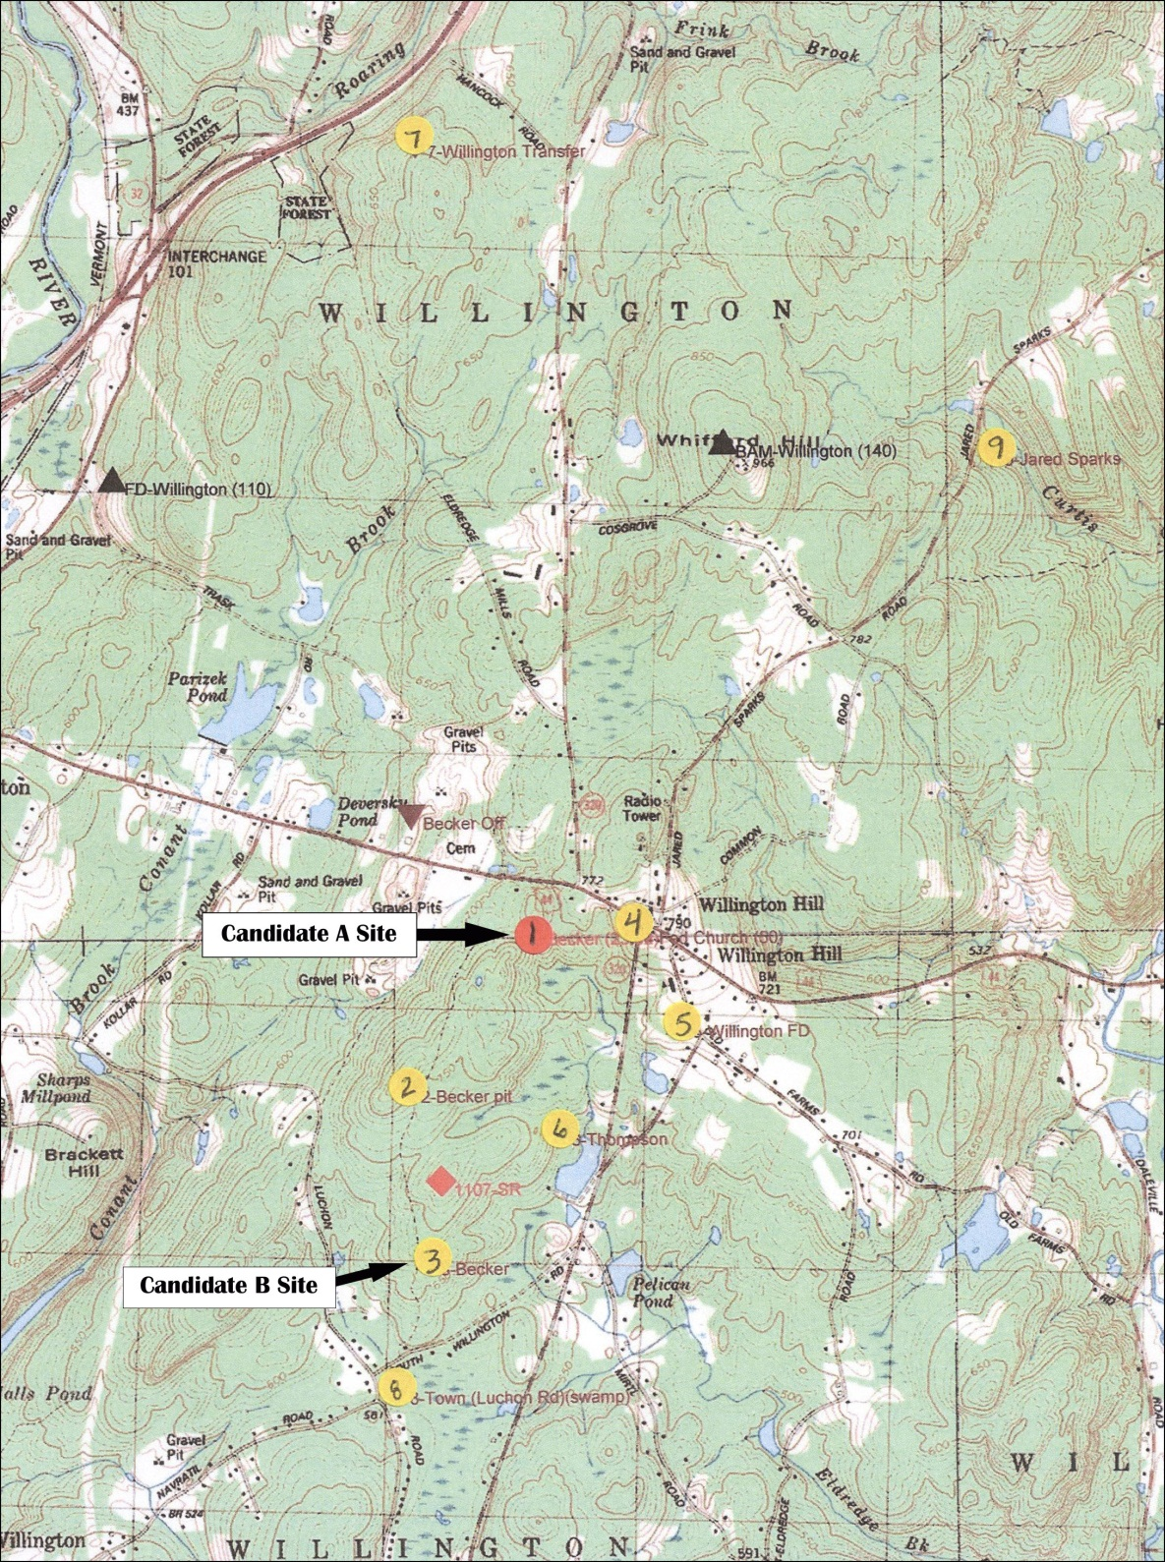
(AT&T 1, Attachment 2 – Site Search Summary)

Figure 2: Aerial Photograph of Candidate A Site
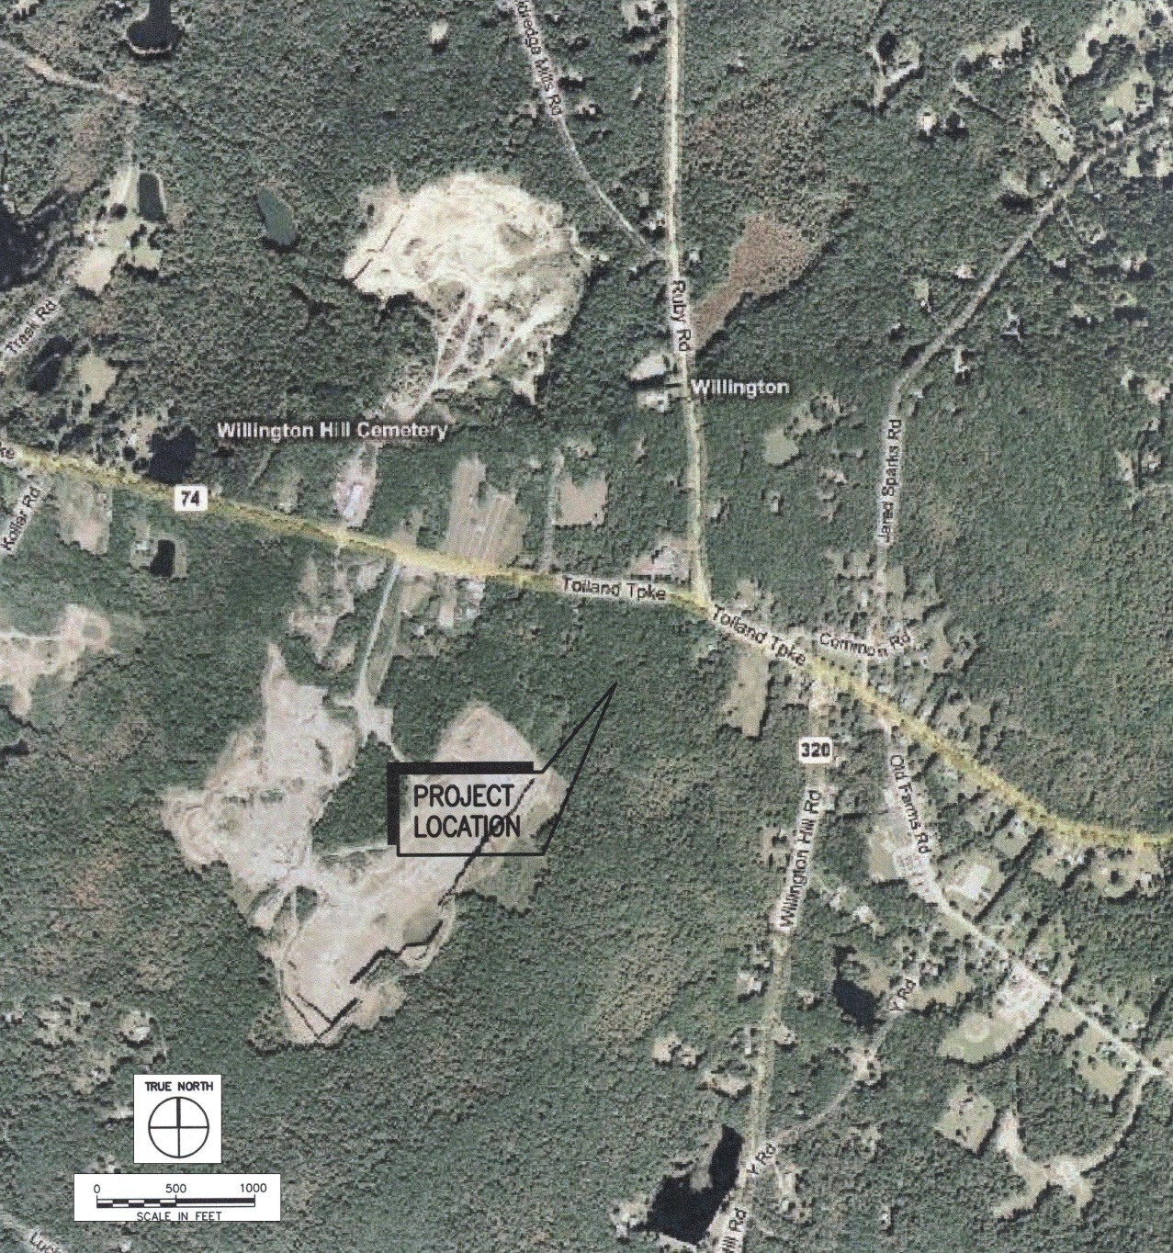
(AT&T 1, Attachment 3 – Candidate A: General Facility Description)

Figure 3: Aerial Photograph of Candidate B Site
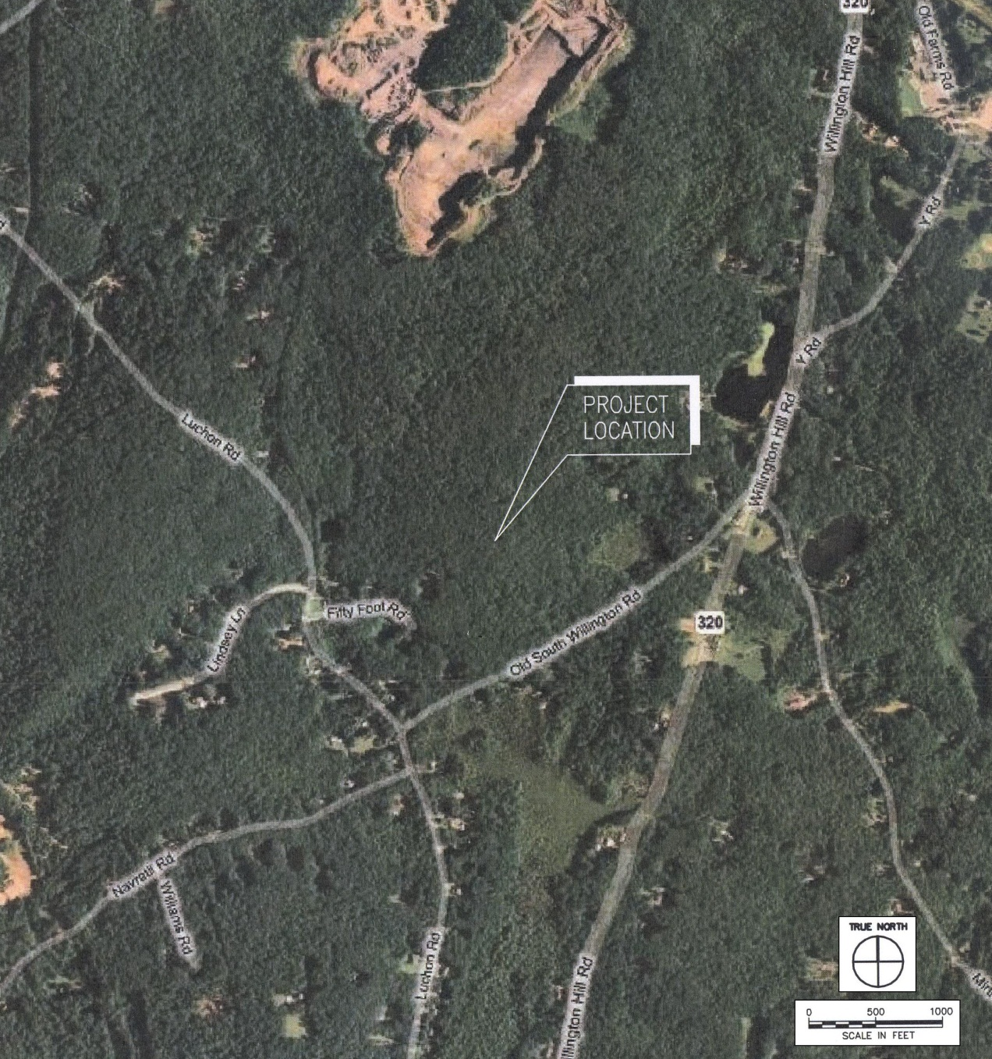
(AT&T 1, Attachment 4 – Candidate B: General Facility Description)

Figure 4: Candidate A Site Plan
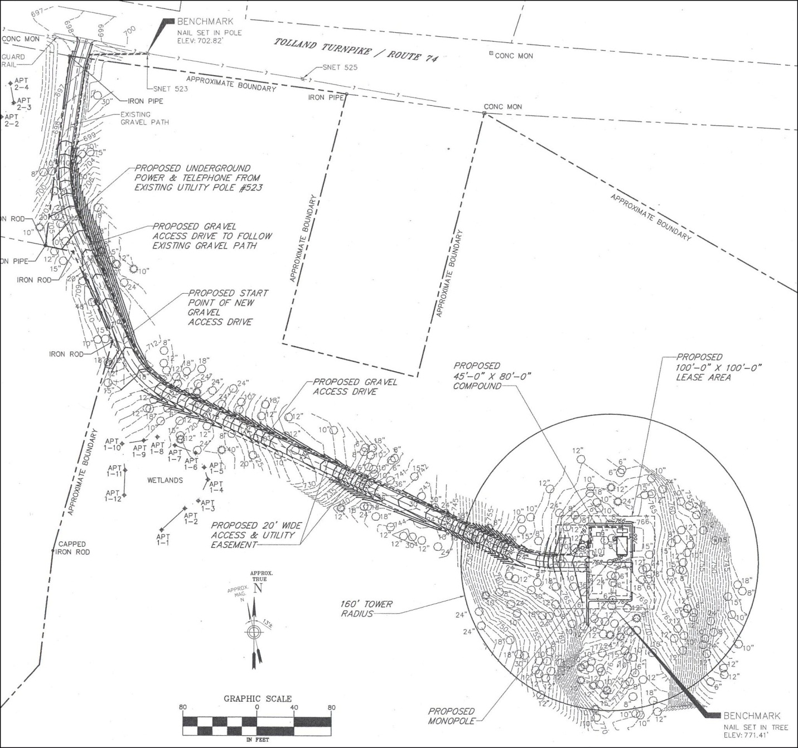
(AT&T 1, Attachment 3A, Sheet C02, Site Access Map)

Figure 5: Candidate B Site Plan
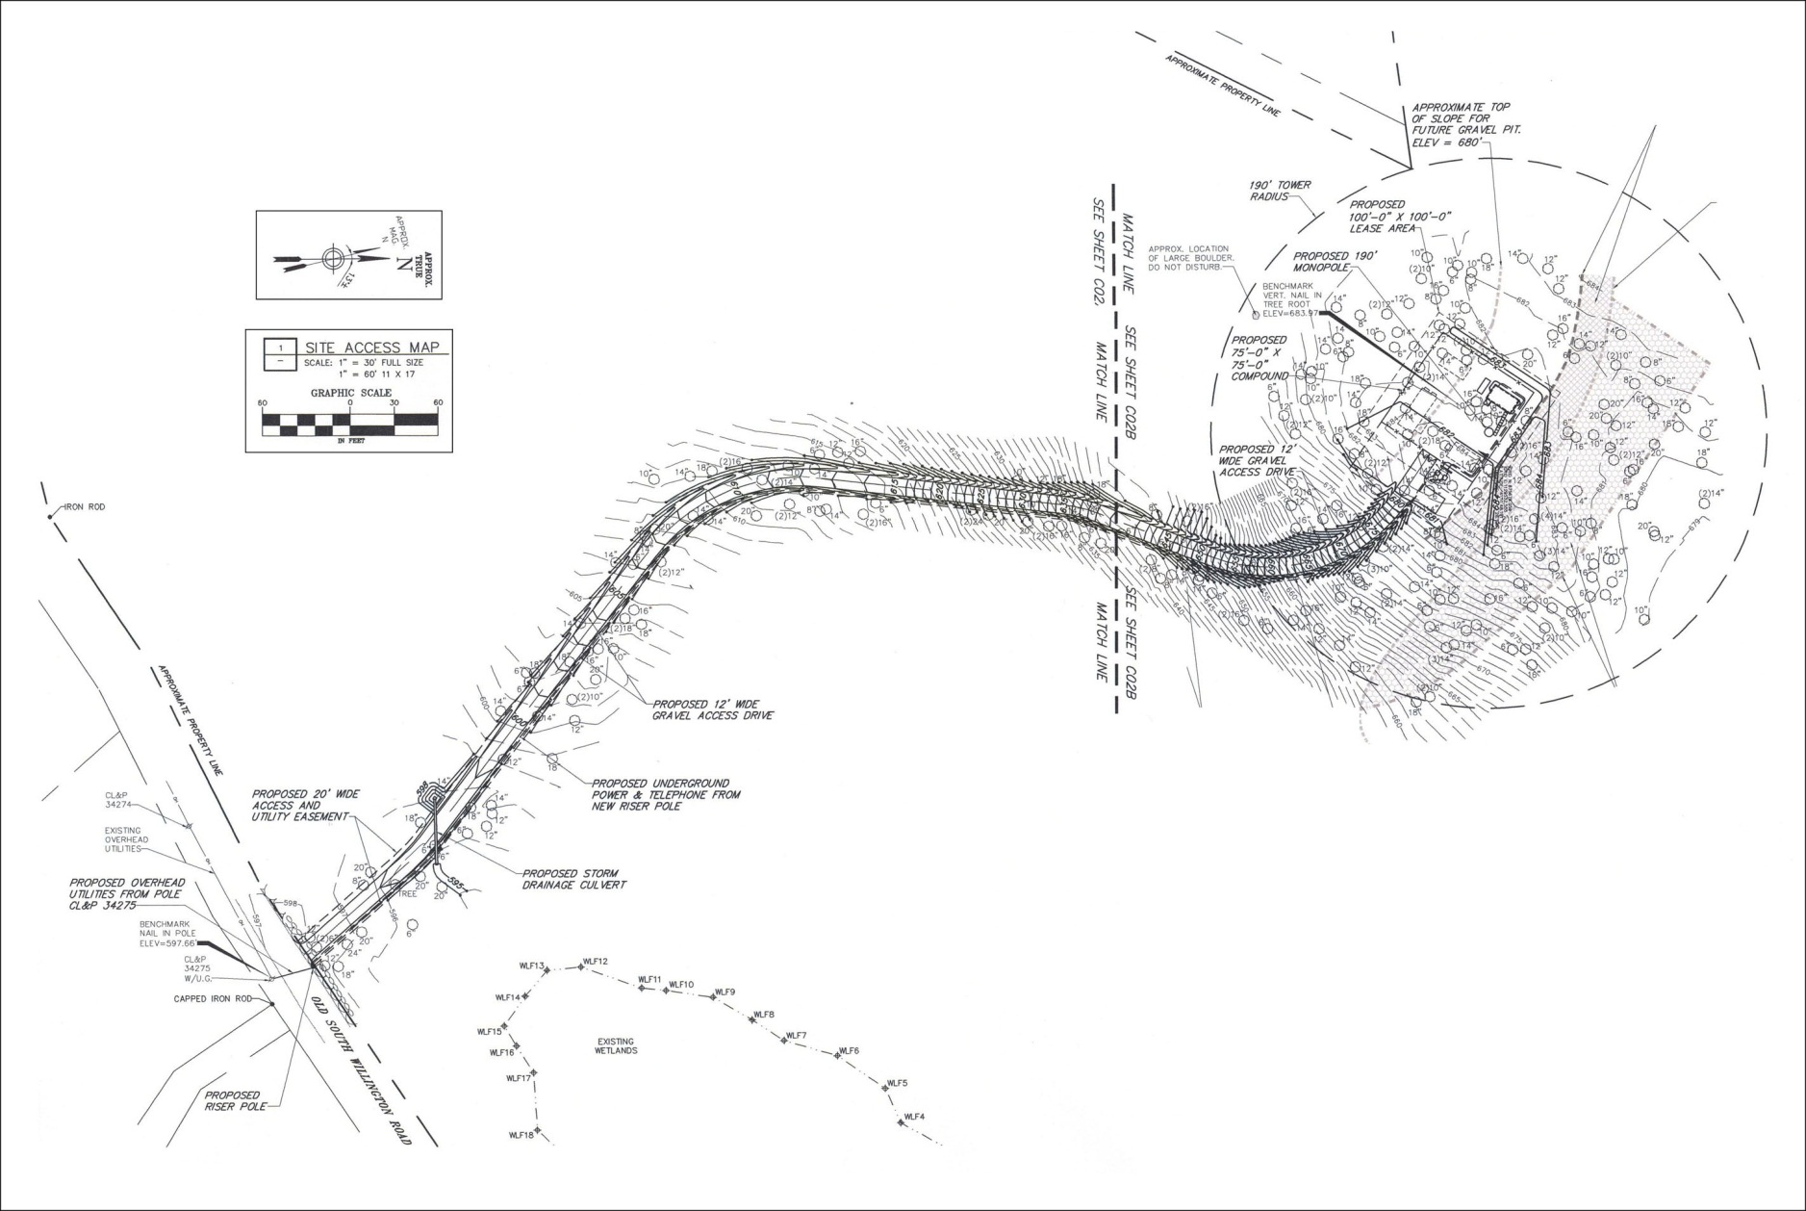
(AT&T 1, Attachment 4A – Sheets C02A and C02B)

Figure 6: AT&T Existing Coverage
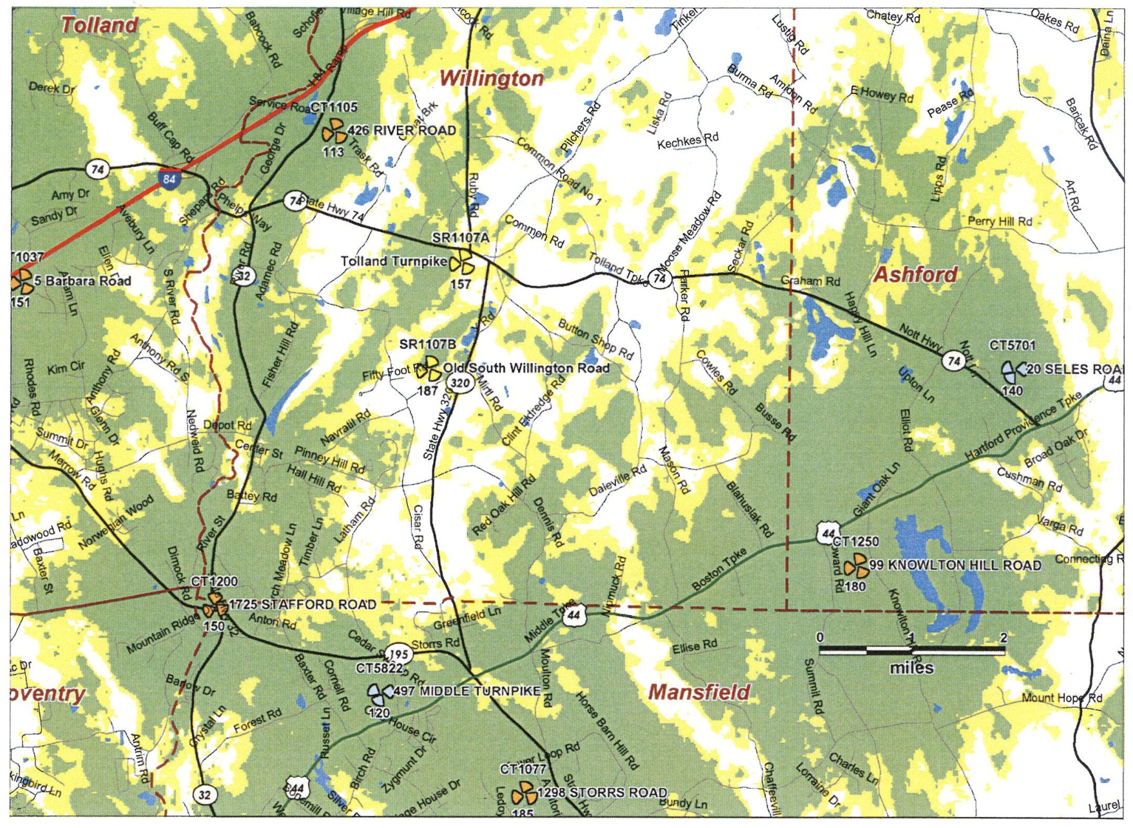
(AT&T 7, Updated RF Information – Radio Frequency Analysis Report, p. 10)

Figure 7: AT&T Coverage with Candidate A
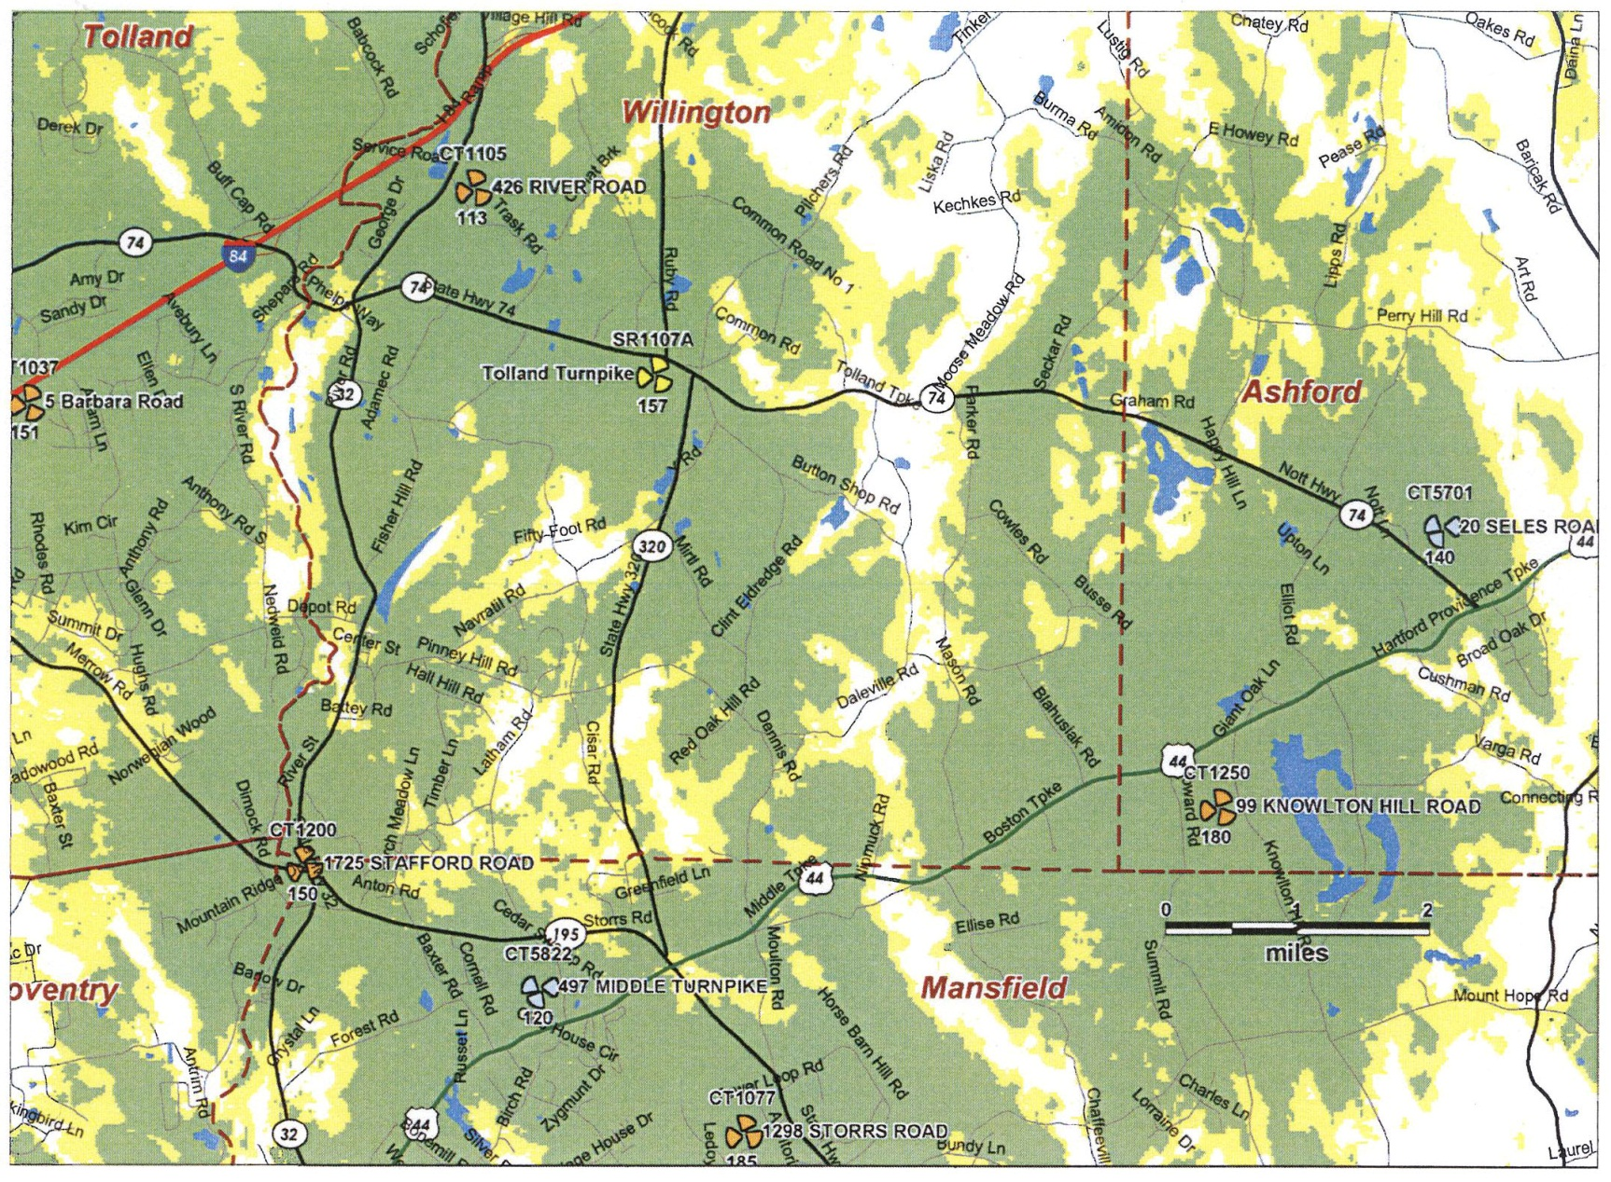
(AT&T 7, Updated RF Information – Radio Frequency Analysis Report, p. 11)

Figure 8: AT&T Coverage with Candidate B
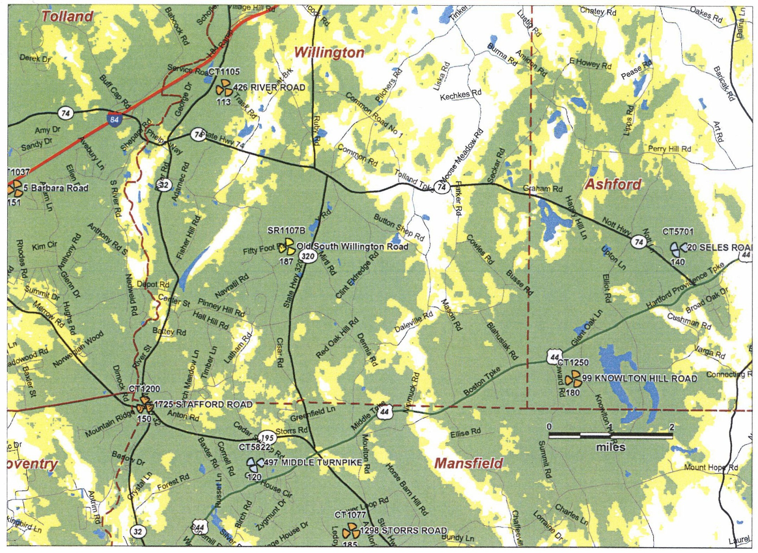
(AT&T 7, Updated RF Information – Radio Frequency Analysis Report, p. 12)

Figure 9: Candidate A 2-Mile Viewshed Analysis Map
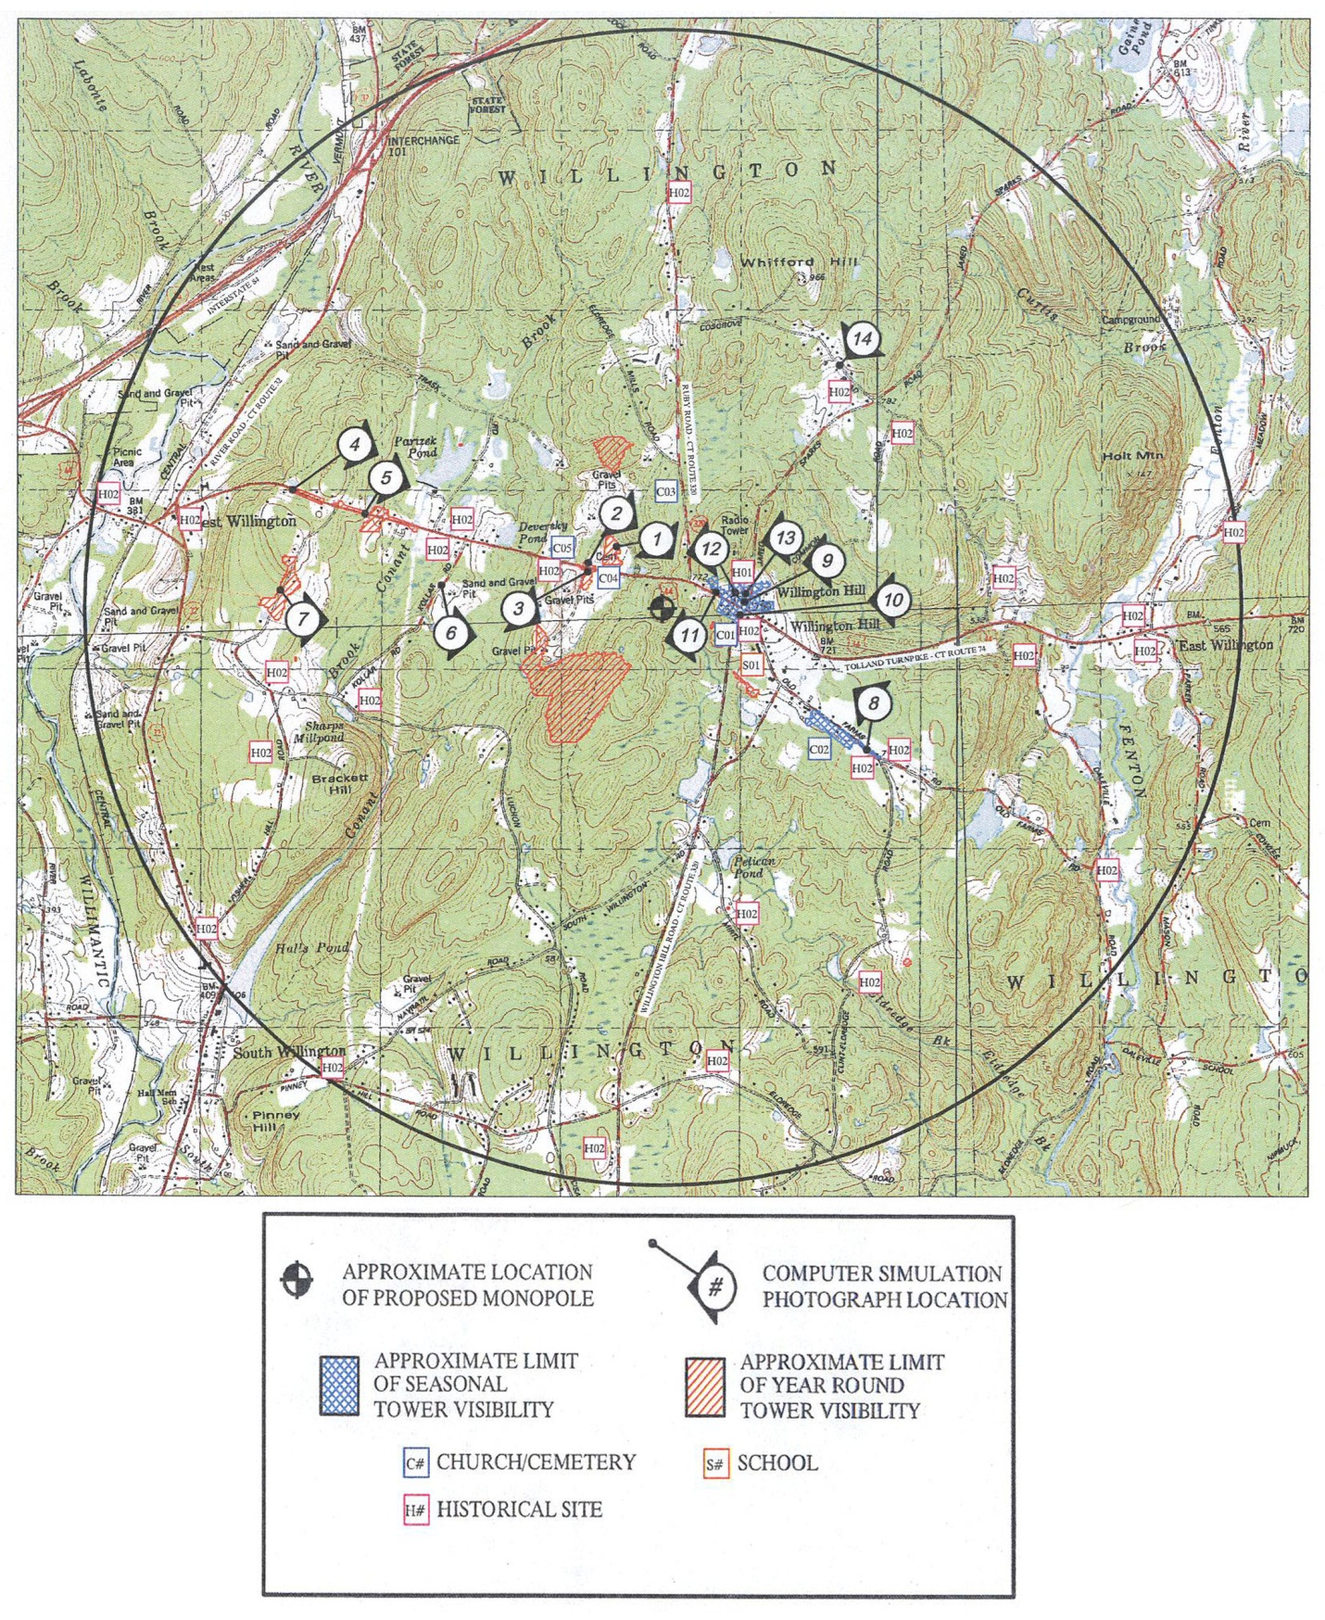
(AT&T 1, Attachment 3B – Visual Analysis Report)

Figure 10: Candidate B 2-Mile Viewshed Analysis
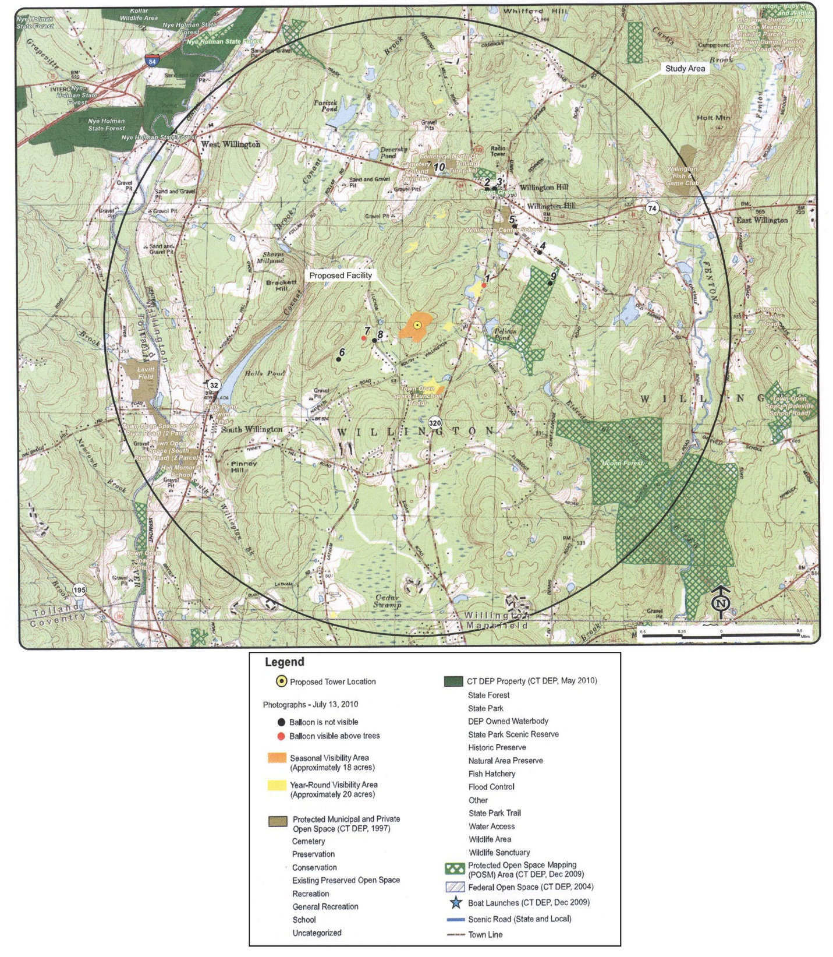
(AT&T 1, Attachment 4B, Visual Resource Evaluation Report)

