Marketing Kit for COVID-19 Vaccination Clinics

This marketing kit is intended to help you promote Mobile COVID-19 Vaccination Team clinics conducted in partnership with the Connecticut Department of Public Health and Griffin Health by providing you with templates for the production of various marketing materials.
To ensure a successful vaccination clinic, it is encouraged that you begin communicating to your community a minimum of one week prior to the scheduled clinic date. It is a best practice to follow the well-established “Marketing Rule of 7” which states an individual needs to hear a message at least seven times before taking action or making a decision, so the use of multiple methods of communication and repetition are essential. Contents include:
- Flyers
- Robocall script
- Social media posts
- Phone call script
- Email copy
- Press release
- Sign
File download instructions:
- Files are available in an online zip folder, entire folder must be downloaded
- Click this GOOGLE DRIVE LINK to preview files

- Click download button in upper right hand corner of screen

- Open folder on lower left hand side of screen
- Save zip folder to appropriate location on your computer
- Extract files to begin editing

Flyer Copy
PROTECT YOURSELF, YOUR LOVED ONES AND YOUR COMMUNITY
GET VACCINATED FOR COVID-19!
(ADD TOWN/ORG NAME)
Free Vaccination Clinic at [LOCATION] on [DATE] from [TIME].
No appointment necessary!
Vaccination is the best protection against the COVID-19 virus, and that is why everyone 5 and older is strongly encouraged to receive this truly lifesaving vaccine.
A free vaccination clinic is coming to our community to make the COVID-19 vaccine more accessible to local residents, so be on the lookout for the eye-catching yellow DPH Vaccination Van.
Downloadable Flyers
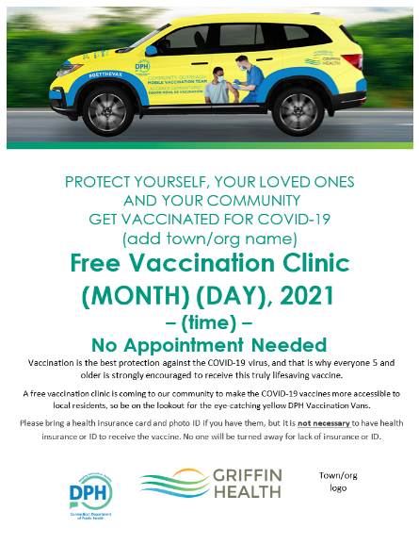
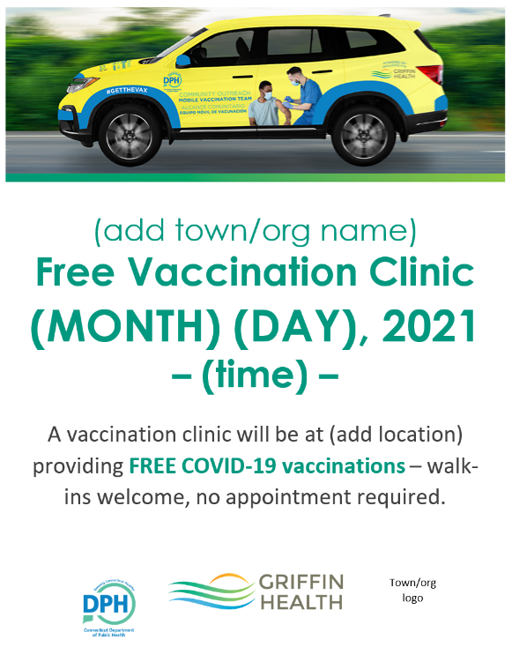

Robocall Script

Hello, this is [NAME] from [DEPARTMENT/ORGANIZATION] contacting you to inform you that there will be a free, walk-up COVID-19 Vaccination Clinic on at [LOCATION] on [DATE] from [TIME].
No appointment necessary! The Connecticut Department of Public Health in collaboration with vaccine providers are bringing this clinic to our community to make the COVID-19 vaccine more accessible, so be on the lookout for the yellow DPH Vaccination Vans at the clinic location.
The [DEPARTMENT/ORGANIZATION] strongly encourages vaccination for everyone who is eligible. This truly lifesaving vaccine is the best protection for you, your family and your community against the potentially devastating effects of the COVID-19 virus.
Once again, this free COVID-19 vaccination clinic will be [DATE] from [TIME] at [LOCATION].
Thank you for helping to protect yourself, your loved ones and your community.

Phone Call Script

Hello, I’m [NAME] from [DEPARTMENT/ORGANIZATION] contacting you to inform you that there will be a free, walk-up COVID-19 Vaccination Clinic on at [LOCATION] on [DATE] from [TIME].
No appointment is necessary! The Connecticut Department of Public Health and local providers are bringing the DPH Vaccination Vans to our community to make the COVID-19 vaccine more accessible.
Vaccination is the best protection against the COVID-19 virus, and that is why we are strongly encouraging you, your family and your neighbors to receive these truly lifesaving vaccines.
Thank you for helping to protect yourself, your loved ones and your community.

Email Copy

There will be a free, walk-up COVID-19 Vaccination Clinic at [LOCATION] from [TIME] on [DATE] specifically for our community!
No appointment necessary! The Connecticut Department of Public Health and local providers are bringing the DPH Vaccination Vans to our town to make the COVID-19 vaccine more accessible to our community, so be on the lookout for the yellow SUV when you arrive.
Vaccination is the best protection against the COVID-19 virus, and that is why we are strongly encouraging you, your family and your neighbors to receive these truly lifesaving vaccines.
Thank you for helping to protect yourself, your loved ones and your community.

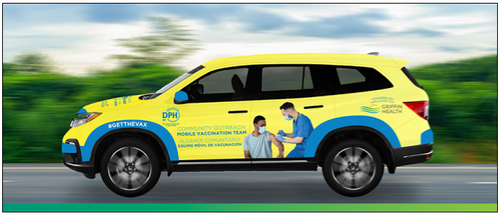
Email Header Image

Social Media Post Copy

#GETTHEVAX today! And let’s #GetVaccinatedCT!
The CT DPH and local providers will be a holding free, walk-up COVID-19 vaccination clinic at [LOCATION] from [TIME] on [DATE] specifically for our community!
No appointment needed! Vaccines are free!
Vaccination is the best protection against the COVID-19 virus, and that is why we are strongly encouraging you, your family and your neighbors to receive these truly lifesaving vaccines.
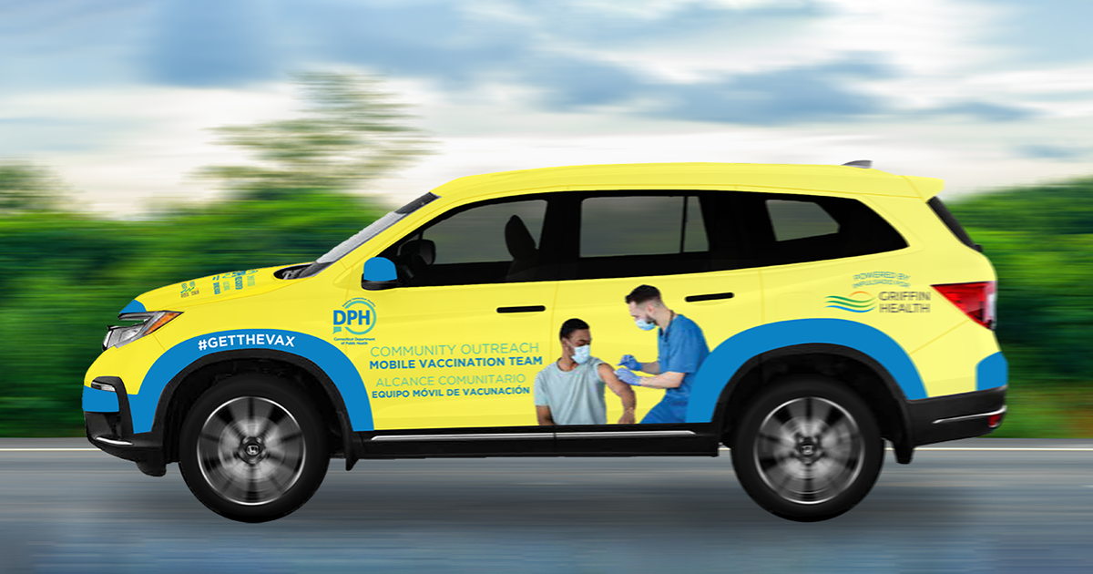
Social Media Image

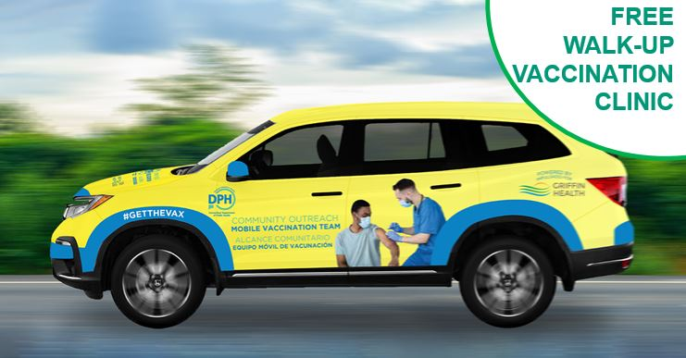
Social Media Image with Call-out

Downloadable Press Release Template

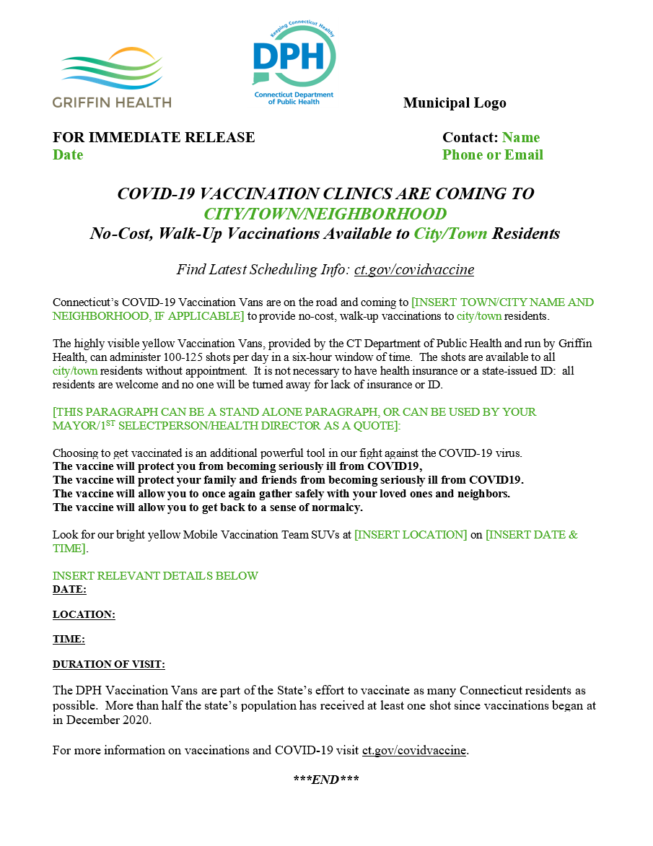

Downloadable Sign
(Dimensions can be printed as 12x18 or 24x36)
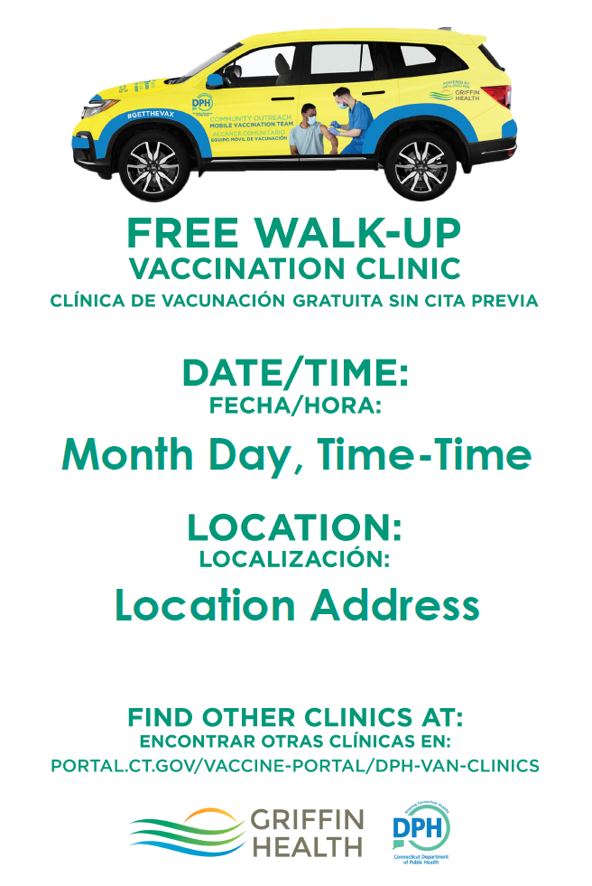

Radio Script

The DPH Vaccination Vans are on the road and coming to [LOCATION] on [DATE] from [TIME] to [TIME] make the COVID-19 vaccine more accessible. Look for the yellow DPH Vaccination Vans, and walk right in to [LOCATION] and receive your free vaccination right away. Vaccination is the best protection against the COVID-19 virus, so let’s come together to make our community a safe place. Trust science, trust the facts, and receive your free vaccine at [LOCATION] on [DATE] from [TIME] to [TIME].

