**

## **Designing for people.**

DGOE Engagement Team  
DAS-BITS

## **The CT.gov Design System: Value Through Simplicity**

Today's digital-first culture makes your website the most vital tool in your toolbelt for successful service delivery. Your customers come to your site with high expectations. And they are often visiting you to find critical information, programs, or services to help them satisfy important needs. Your website must address these needs in a quick and efficient manner without introducing additional burden. The state of CT’s new website design system simplifies the entire user journey so your customers can be more successful in their lives.

Unlike commercial websites, which are often profit-driven and use lots of flashy web designs and interactive gimmicks to grab eyeballs, a government site needs to focus on utility. It should employ simple navigability, plain language, and consumable content directly aligned to a visitor’s issue. By removing excessive design elements and disruptive hoop-jumping, you lower the cognitive load on your users. This allows them to better self-serve so they can get on with their day.

Here are some of the instant benefits you’ll receive from the new CT.gov design system:

* Higher Usability
* Improved User Experience
* Greater Search Engine Visibility
* Enhanced Accessibility
* Enterprise Support
* Easier Governance

Let’s look under the hood to see 10 ways we accomplish this.

**1. Improved User Experience**  
  
A simplified design system smooths out the user journey. It focuses on key messaging and essential functionality. There‘s none of the ”fluff” or distractions that product marketers use to keep you glued to their site, spending time and money. And this is intentional. Most people visiting a government site are not doing so because they like to. So make their experience frictionless. Without the visual noise of fancy designs, pulsing buttons, scrolling video, pop-ups, and dynamic gifs, people can get right to the information they came to find.  
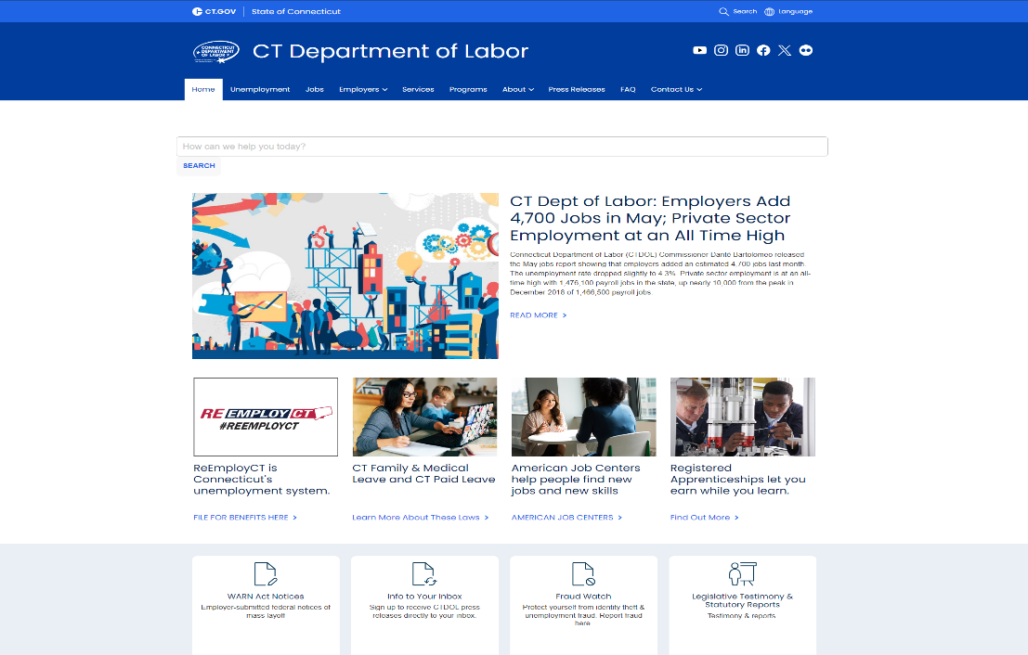

We must consider this: in government, consistency is key. It’s what builds trust. When a customer visits different agency sites and sees the exact same designs and similar language being used, they feel more confident in their decision-making and more trusting that the information they receive is authoritative.

Uniformity implies stability, and the user will see their experience on your site as part of a larger government ecosystem that implies expertise and oversight. When that “safe” space is disturbed by shiny objects, the brain gets distracted and starts scanning for meaning - and danger. This is our reptilian brain at work. And your website is not where you want to plant grains of uncertainty.

**2. Enhanced Website Accessibility**

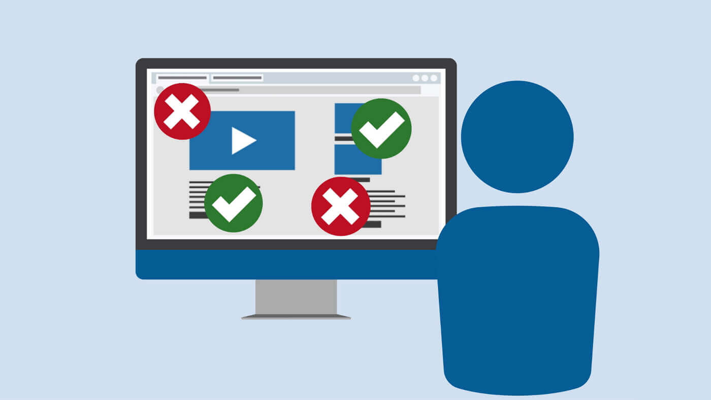Your website must be fully accessible to all visitors, regardless of ability. In fact, the State of CT is currently applying new website standards put out this year by the [Department of Justice](https://www.ada.gov/resources/2024-03-08-web-rule/). In our state, we will be going a step above and raising standards to meet the industry standard known as [WCAG 2.2 Level AA](https://www.w3.org/TR/WCAG22/).   
  
Fortunately, our CT.gov design system has this baked in. It is fast approaching 100% conformance to these standards. Which means your new content will launch fully accessible, requiring less remediation costs and resources to fix out-of-compliance designs. Most commercial websites fail miserably in this area. And they have the legal bills to prove it.

**Key accessibility features in the CT.gov design system:**

* **Keyboard Navigation**: Users can access all areas of your website using a keyboard.
* **Screen Reader Compatibility**: Standardized coding and labeling allow for the successful use of assistive reading devices.
* **Image Alt Text:** Alternative text can soon be auto-applied to images and multimedia content.
* **Accessible Colors** Accessible colors and contrasts support greater readability for users with visual impairments.

**3. Direct-Path User Journeys**  
  
A key element of a simplified design system is streamlined user journeys. This ensures that all users can find information and complete their tasks with minimal effort. For optimal customer journeys, you should make sure your users can find the information they need in ***three clicks or less***.

The CT.gov design strategy drives success with three simple principles: Create a logical information architecture, compress user touch-points, and connect the content with clearly-communicated links.

Our system also uses a wide-but-shallow infrastructure, which provides more options at the top of the customer journey so the user has less real estate to dive down through to find their content. This reduces the effect of “rabbit-holing”. Each content “category” in the agency’s website structure gets its own vertical to help the user choose exactly where they need to go. And these verticals never mix with each other. This keeps the user journey clean, navigable, and focused on outcomes.

When you organize and design your content to match customer expectations, your website’s usability will soar.   
  
  
**4. Greater Search Engine Visibility**

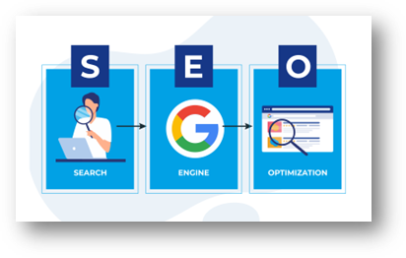  
The CT.gov design system supports powerful SEO outcomes to allow your content to be more discoverable. This includes:  
  
**Keyword Frequency**: We apply research and data to ensure your content and page headlines include terms that your customers are actually searching for. Using a strong keyword strategy allows your services to rank better on search engines like Google and Bing.   
  
**Optimized Title Tags, Meta Descriptions, and Headings:** By matching these page elements to high-volume user searches, you’ll improve your search engine rankings and click-through rates.

**Relevant High-Quality Content:** This is key. Google continually scans your site and prioritizes content that is relevant to the user’s query. The more you write in plain language and speak directly to the actual need that your customers are trying to satisfy, the higher your content will appear in search results. Not to mention, it will make your content incredibly usable for your visitors.  
  
**Reduced Technical Issues**: The CT.gov design system includes audits so you can tackle the technical issues that impact your customers most – things like broken links, orphan pages, missing metadata information, etc. Google will often penalize sites that have a lot of these issues. Find and fix issues as they appear, and you’ll stay on Google’s good side (not to mention the good side of your customers).

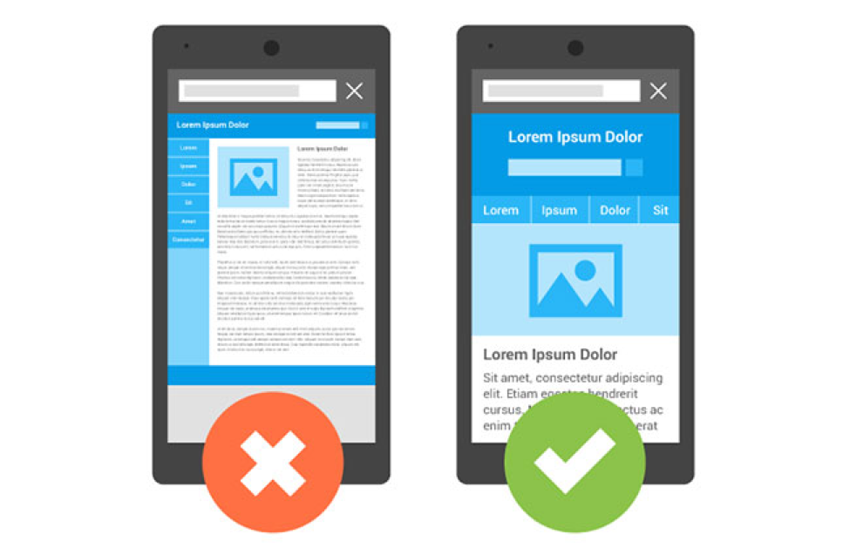

### **5. Responsive Consumable Content**

The simplified CT.gov design system fosters more successful user experiences through the use of templates, simplified page elements, and more consumable formats. The bonus is that it also changes according to the user’s device. Menus collapse, imagery compresses, and page elements are re-assembled when a visitor uses their phone to visit your site.  
  
**CT.gov: Mobile-First Design**: Our design system prioritizes mobile experiences with simplified responsive coding. Your site looks great on mobile and functions seamlessly on the major platforms of iOS and Android. On any given day, between 50-90% of your customers will visit you on a mobile device. Mobile users expect their experience to be simple without the need for a lot of scrolling or link-hunting. When it comes to your design, you should never have to worry about whether your site is failing your mobile audience.

**6. Optimal Page Speed**

With a simplified web design, your customers will also experience lower page load times. This is critical because a web page that loads slowly, particularly ones that have a lot of fancy html and media elements, can cause users to become frustrated and leave your site (and potentially resort to calling your help desk for their needs). Also, if your pages are long and contain a lot of content, page load times can take a hit. It’s worth noting that Google has recently prioritized page performance as a ranking factor for their algorithm. When your site loads quickly, it will help it stay on top of search pages, resulting in more visits and more successful interactions.

### **7. Reduced Development and Maintenance Costs**

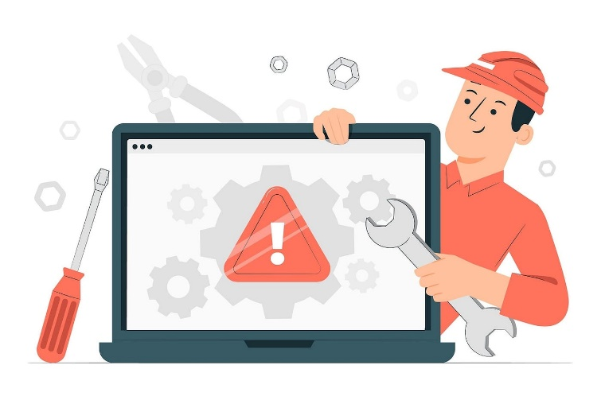A simplified design system reduces your up-front development costs. And it protects you from getting stuck in long-term maintenance contracts. Standard enterprise components make it easier to build, update, and add on to your website. This simplified design approach is great for agencies with tight budgets and limited resources. By using the CT.gov design system, you’ll minimize the need for custom development, special tools, or specialized resources, saving you time and money. You’ll then be able to focus more on what’s really important: the content and the journey.

### **8. Ease of Compatibility**

The CT.gov design system also allows for easy snap-ons of high value features offered by the State. Things like feedback widgets, surveys, support forms, low-code applications, and chatbots. These additional products - designed with compatibility in mind - work seamlessly with the State’s website platform and enhance your user experience for greater first-touch resolution.

**

### **10. Simpler Governance**

The more bloat you add to your webpage design, the more risk you assume for long-term tech debt and resource drag. Not to mention a higher probability of accessibility issues. With the State system, we’ll also have your back when it comes to support. Our Sitecore management team will assist you with technical support needs once your website is launched. It’s worth noting that if your site is full of customized out-of-network design, the State may not be able to support it.

In short, the CT.gov design system provides simple pathways to more successful customer engagements. As part of the enterprise, you’ll enjoy the consistency and reliability of the digital experiences our residents have come to expect from us. And your employees will be able to focus less on cumbersome maintenance needs and more on high-priority tasks. *Efficiency for the win!*

Thank You.

**The DGOE Engagement Team**

More questions? Reach out to [thomas.brophy@ct.gov](mailto:thomas.brophy@ct.gov)