DOCKET NO. 342 - Optasite Towers LLC and Omnipoint Communications, Inc. application for a Certificate of Environmental Compatibility and Public Need for the construction, maintenance and operation of a telecommunications facility located at 425 Litchfield Road, New Milford, Connecticut. | }  }  } | Connecticut  Siting  Council  May 22, 2008

Findings of Fact

Introduction

- Optasite Towers LLC (Optasite) and Omnipoint Communications, Inc. (T-Mobile), collectively referred to as the “Applicant”, in accordance with provisions of General Statutes §§ 16-50g through 16-50aa, applied to the Connecticut Siting Council (Council) on June 22, 2007 for the construction, operation, and maintenance of a wireless telecommunications facility at 425 Litchfield Road, New Milford, Connecticut. (Applicant 1, p. 1)

- The purpose of the proposed 140-foot tower is to provide wireless service to Route 202 in the Northville area of New Milford. (Applicant 1, p. 1)

- Optasite is a Delaware corporation with an administrative office located in Westborough, Massachusetts. Optasite would be the Certificate Holder and would construct and maintain the facility. T-Mobile is a Delaware corporation with an administrative office in Bloomfield, Connecticut. T-Mobile would be a tenant on the Optasite tower. (Applicant 1, pp. 2-3)

- Pursuant to General Statutes § 16-50m, the Council, after giving due notice thereof, held a public hearing on September 10, 2007, beginning at 4:00 p.m. and continuing at 7:00 p.m. at the New Milford High School, New Milford, Connecticut. (Council's Hearing Notice dated August 6, 2007; Transcript 1 – 09/10/07, 4:00 p.m. [Tr. 1], p. 2; Transcript 2 – 09/10/07, 7:00 p.m. [Tr. 2], p. 2)

- The Council and its staff conducted an inspection of the proposed site on September 10, 2007, beginning at 3:00 p.m. The Applicant flew a balloon from 8:00 a.m. to 6:00 p.m. at the site to simulate the height of the proposed tower. The balloon reached the desired height of 140 feet above ground level (agl). (Council's Hearing Notice dated August 6, 2007; Applicant 10)

- Notice of the application was sent to all abutting property owners by certified mail. Public notice of the application was published in the New Milford Spectrum on June 18, 2007 and The News-Times on June 18 and 20, 2007. (Applicant 2, Q. 1; Applicant 3)

- The Applicant installed a four-foot by six-foot sign at the beginning of the proposed access road on August 22, 2007 that described the proposed project and provided contact information. (Applicant 9; Tr. 2, p. 9)

- Pursuant to CGS § 16-50l (b), the Applicant provided notice to all federal, state and local officials and agencies listed therein. (Applicant 1, p. 4)

- The Council closed the hearing on September 10, 2007. (Tr. 2, p. 52)

- On December 7, 2007, Cellco Partnership d/b/a Verizon Wireless (Verizon) submitted an application (D 355) to the Council for a proposed telecommunication facility at 359 Litchfield Road in New Milford. The proposed Verizon facility would provide coverage to the Route 202 corridor in Northville area of New Milford. (Verizon 1, p. 2)

- The Verizon site is approximately 0.6 miles south of the proposed site. (Applicant 1, Tab J; Verizon 1, Tab 12)

- On December 18, 2007, the Council, pursuant to Connecticut General Statute § 16-50m(d), voted to hold a common evidentiary hearing for D 342 and D 355 to determine, in part, whether one tower could meet the mobile telecommunications needs of the area. (Council meeting minutes of December 18, 2007)

- The Council, after giving due notice thereof, held a public hearing regarding D 342 and D 355 on March 11, 2008, beginning at 3:00 p.m. and continuing at 7:00 p.m. at the New Milford High School, New Milford, Connecticut. The public hearing was continued on April 4, 2008 at the office of the Connecticut Siting Council, 10 Franklin Square, New Britain, Connecticut. (Council's Hearing Notice dated February 8, 2008; Transcript 3 – 03/11/08, 3:00 p.m. [Tr. 4], p. 3; Transcript 4 – 03/11/08, 7:00 p.m. [Tr. 4], p. 3; Transcript 5 – 04/04/08, 10:00 a.m. [Tr. 5], p. 3)

- The Council voted to reopen Docket 342 on March 11, 2008. (Tr. 3, pp. 12-14)

- The party in this proceeding is the applicant. The intervenor in this proceeding is Verizon. (Tr. 3, p. 8)

State Agency Comment

- Pursuant to General Statutes § 16-50j (h), on August 6, 2007, September 12, 2007, February 8, 2008, and April 7, 2008, the following State agencies were solicited to submit written comments regarding the proposed facility: Department of Environmental Protection (DEP), Department of Public Health (DPH), Council on Environmental Quality (CEQ), Department of Public Utility Control (DPUC), Office of Policy and Management (OPM), Department of Economic and Community Development (DECD), and the Department of Transportation (DOT). (Record)

- The Council received a written response from the DOT’s Bureau of Engineering and Highway Operations on January 17, 2007, stating that they have no comment. (Record)

- No response was received from the DEP, DPH, CEQ, DPUC, OPM, or DECD. (Record)

Municipal Consultation

- The Applicant submitted a technical report to the Town on March 16, 2007. (Applicant 1, p. 19)

- The Applicant met with the Mayor of New Milford, Patricia Murphy, on April 24, 2007 to discuss the project. Ms. Murphy had no comment regarding the tower itself but was pleased to hear the project would lead to improvement of the property. (Applicant 1, p. 19)

- The Applicant attended a New Milford Zoning Commission public hearing on August 14, 2007. After hearing comments from area residents and the Applicant, the Commission concluded the following;
  - Based on the visual analysis, the tower would have a minimal visual impact;
  - The cleanup of the property must continue and the Applicant should work with the property owner to facilitate the cleanup; and
  - The Council should review all telecommunications proposals for the Route 202 corridor to ensure the unnecessary proliferation of telecommunication facilities.
(Applicant 7)

Public Need for Service

- In 1996, the United States Congress recognized a nationwide need for high quality wireless telecommunications services, including cellular telephone service. Through the Federal Telecommunications Act of 1996, Congress seeks to promote competition, encourage technical innovations, and foster lower prices for telecommunications services. (Council Administrative Notice Item No. 7)

- In issuing cellular licenses, the Federal government has preempted the determination of public need for cellular service by the states, and has established design standards to ensure technical integrity and nationwide compatibility among all systems. (Council Administrative Notice Item No. 7)

- The Telecommunications Act of 1996 prohibits local and state entities from discriminating among providers of functionally equivalent services. (Council Administrative Notice Item No. 7)

- The Telecommunications Act of 1996 prohibits any state or local entity from regulating telecommunications towers on the basis of the environmental effects of radio frequency emissions to the extent that such towers and equipment comply with FCC’s regulations concerning such emissions. This Act also blocks the Council from prohibiting or acting with the effect of prohibiting the provision of personal wireless service. (Council Administrative Notice Item No. 7)

Site Selection

26. The Applicant established a search ring in the Northville area in February of 2006. (Applicant 1, Q. 2)

27. The nearest existing tower facility to the search ring is approximately 2.7 miles southeast of the proposed tower site at 399 Chestnut Lane in New Milford. T-Mobile is not located on this facility; however, coverage modeling concludes the site would not provide adequate coverage to the target service area. (Applicant 1, Tab G, Tab H; Applicant 8; Tr. 1, pp. 22-25, 28-33; Tr. 2, pp. 30-32)

28. T-Mobile examined potential coverage from the facility proposed in D 332, a 150-foot Verizon tower at 6 Mountain Road in New Milford. Coverage modeling indicates that if T-Mobile located at the 140-foot level of this tower, a two-mile coverage gap on Route 202 south of Northville would remain. (Applicant 11; Tr. 2, p. 28-30; Tr. 5, p. 72)

29. After determining there were no viable structures within the search area, the Applicant searched for properties suitable for tower development. The Applicant investigated seven parcels and selected one for site development. The six rejected parcels and reasons for their rejection are as follows:
- Wheaton Drive - Town parcel used as a park and within close proximity to area residences;
- Upland Road – Town parcel with development restrictions;
- 9 Little Bear Road – Insufficient site screening;
- 333 Litchfield Road – Owner decided not to pursue lease agreement.
- 387 Litchfield Road – No response from owner, insufficient site screening;
- Northville Fire Department – No response from owner. Property is under lease with Verizon and unavailable to the Applicant. Property is at a lower elevation, is smaller, and has less visual screening than the proposed site.
(Applicant 1, Tab I; Tr. 2, pp. 35-48)

Site Description

- The proposed site is located on a 28.86-acre parcel owned by the Estate of Edward J. Drazel at 425 Litchfield Road (Route 202) in New Milford. The property is on the west side of Route 202 (refer to Figure 1). (Applicant 1, p. 2)

- The property has two zoning designations: general business, B-2, along Route 202, and residential, R-40, on the hillside. The tower and compound is located in the residential portion of the property. The site access road would extend through both the business and residential zones. (Applicant 1, p. 2; Tab B, Tab J, Verizon 1 e; Tr. 5, pp. 76, 78)

- The property, which slopes upward from Route 202, consists of woodland, fields, and a cleared area along Route 202 that contains several dilapidated structures, granite slabs and abandoned vehicles and equipment. (Applicant 1, p. 17, Tab B)

- The property owner is in the process of removing all debris from the property in advance of future development plans. The removal of all visible debris should be completed by early summer of 2008. (Tr. 5, p. 92)

- The tower site is located in a comparatively level area of a hillside at an elevation of 640 feet above mean sea level (amsl). (Applicant 1, Tab B)

- The Applicant proposes to construct a 140-foot monopole at the site. It would be designed to support four levels of antennas with a 10-foot center-to-center vertical separation. (Applicant 1, p. 9)

- T-Mobile proposes to install six panel antennas on a platform at a centerline height of 137 feet agl. (Applicant 1, p. 9)

- The Applicant proposes to construct a 70-foot by 70-foot equipment compound within an 100-foot by 100-foot lease area at the base of the tower (refer to Figure 2). An eight-foot high chain link fence would enclose the compound. Within the compound, T-Mobile proposes to install equipment cabinets on a concrete pad. A battery cabinet would provide emergency power. (Applicant 1, pp. 9-10, Tab B; Tr. 1, p. 19)

- Access to the site would extend from Route 202 using an existing gravel road that merges with an old dirt logging road that ascends the hillside to the site. The old logging road would be resurfaced with gravel and cleared, as necessary. The 12-foot wide access road would be approximately 1,200 feet in length. (Applicant 1, Tab B; Tr. 1, pp. 16-17)

- A majority of the access road has an 18% grade. Drainage swales would be installed as necessary to control runoff. (Tr. 5, pp. 58, 79-80)

- Utilities would be installed underground along the access road from a new pole near the access road entrance. (Tr. 1, pp. 18-19)

- The estimated cost of construction to Optasite, not including T-Mobile’s base station equipment and antennas, is:

  - Tower and foundation 74,000.
  - Site development 66,000.
  - Utilities 28,000.

Total estimated cost $168,000.
(Applicant 1, p. 21)

- The nearest abutting property to the tower site is approximately 272 feet to the south, owned by Michael and Debra Foss. (Applicant 1, Tab B)

- There are seven residences within 1,000 feet of the site. (Applicant 2, Q. 7)

- The nearest residence to the proposed tower site is approximately 590 feet to the west, owned by John Kuck. (Applicant 1, Tab B)

- Route 202 travels through the Northville area in a southwest to northeast direction and, at its nearest point, the road is approximately 665 feet east of the proposed tower site. (Applicant 1, Tab B)

- Two other nearby roads are McNulty Drive, located approximately 1,200 feet north of the tower site, and Geiger Road, located approximately 1,470 feet west of the tower site. Both roads ascend or travel along the west ridge of the Route 202 valley. (Applicant 1, Tab B, Tab J)

- Surrounding land use is mainly residential, although some small commercial use is present. The Town Conservation and Development Plan identified Route 202 as a heavily traveled corridor. (Applicant 1, pp. 15-18)

Environmental Concerns

- The proposed facility would have no effect on historic, architectural, or archaeological resources listed on or eligible for the National Register of Historic Places. (Applicant 6)

- The proposed site contains no known existing populations of federal or State endangered, threatened or State special concern species. (Applicant 6)

- Construction of the facility would require the removal of 42 trees with a diameter of six inches or greater, primarily in the compound area. Trees along the access road would be trimmed. (Applicant 1, Tab B; Applicant 2, Q. 16; Tr. 1, p. 16)

- Construction of the compound would require a moderate amount of grading with 1,900 cubic yards of cut and 1,700 cubic yards of fill. The elevation and width of the access road would not be altered. (Tr. 5, pp. 34-35)

- Site construction would not affect any wetlands or watercourses. No wetlands were identified on the property. (Applicant 1, p. 18)

- The tower would not require aircraft hazard obstruction marking or lighting. (Applicant 6)

- The cumulative maximum power density from radio frequency emissions from T-Mobile’s proposed antennas is calculated to be 3.5 % of the standard for Maximum Permissible Exposure, as adopted by the FCC, at the base the proposed tower. This calculation was based on methodology prescribed by the FCC Office of Engineering and Technology Bulletin No. 65E, Edition 97-01 (August 1997) that assumes all antennas would be pointed at the base of the tower and all channels would be operating simultaneously. (Applicant 1, Tab L)

Visibility

- The tower would be visible year-round above the tree canopy from approximately 38 acres within a two-mile radius of the site (refer to Figure 3). The tower would be seasonally visible from an additional 18 acres. (Applicant 1, Tab J)

- The tree canopy surrounding the site is approximately 65 feet agl. (Applicant 1, Tab J)

- The tower is on an east-sloping ridge. To the west, the ridge rises steeply to an elevation of 800 feet above mean sea level (amsl) and then gradually rises to several summits. The tower would reach a height of 780 feet amsl. East of the tower, the ridge descends to Route 202 to an elevation of 500 feet amsl. East of Route 202 a ridge rises to an elevation of 900 feet amsl. (Applicant 1, Tab J)

- A majority of the tower would be visible from within a half-mile of the site, primarily from the Route 202 valley east and northeast of the site. Views from the west would be obscured by topography and vegetation except for two residences on McNulty Drive located on top of the ridgeline immediately west of the tower that may have views of the top of the tower. (Applicant 1, Tab J; Tr. 1, p. 45)

- Approximately 25 residential properties would have partial, year-round views of the tower. This includes residences on Route 202, Sandpit Road, Sandy Acres Lane, Wheaton Road, Hillendale Drive, Hearthstone Terrace, and Upland Road. An additional 10 residences in these areas may have seasonal views of the tower. (Applicant 1, Tab J)

- Two locally designated scenic roads would have views of the tower: Sandpit Road and Old Mill Road. Year-round views from Sandpit Road would be of the upper portion of the tower for approximately a tenth of a mile. Views from Old Mill Road would be seasonal for approximately a quarter of a mile. (Applicant 1, Tab J)

- The upper 25 to 45 feet of the tower would be visible year-round from a few isolated locations on Route 202 east and north of the site. (Applicant 1, Tab J)

- The tower would be seasonally visible from a 0.2 mile section of Route 202 directly east of the site. (Applicant 1, Tab J)

- The tower would be visible year-round from isolated locations on Upland Road, Sandy Acres Lane, Sandpit Road, Heathstone Terrace, Hillendale Drive, and Wheaton Road. (Applicant 1, Tab J)

- Year-round visibility of the tower from specific locations within a two-mile radius of the site is as follows:

Location | Visible | Approximate Portion of Tower Visible | Distance from Tower
Sandpit Road, adjacent to #1 | Yes | 30 feet - unobstructed | 0.2 mile south
Sandy Acres Lane | Yes | 55 feet – unobstructed. | 0.2 mile east
Hearthstone Terrace, adjacent to #3 | Yes | 25 feet – unobstructed. | 0.4 mile east
Hillendale Drive Extension, adjacent to #39 | Yes | 50 feet – unobstructed. | 0.6 mile north
Upland Road, adjacent to #109 | Yes | 25 feet – unobstructed with hillside as a backdrop. | 0.5 mile east
Upland Road, adjacent to #77 | Yes | 25 feet - unobstructed with hillside as a backdrop. | 0.5 mile east
Upland Road, adjacent to #95 | Yes | 30 feet – unobstructed with hillside as a backdrop. | 0.5 mile east
Upland Road, adjacent to #117 | Yes | 20 feet – unobstructed with hillside as a backdrop. | 0.5 mile east
Upland Road, adjacent to #21 | Yes | 20 feet – unobstructed | 0.5 mile south
Wheaton Road | Yes | 50 feet – unobstructed | 0.3 mile northeast
Wheaton Road, adjacent to #57 | Yes | 15 feet – unobstructed | 0.8 mile northeast
Route 202 at 425 Litchfield Road | Yes | 45 feet- unobstructed | 0.1 mile east
Route 202 adjacent to #469 | Yes | 25 feet – unobstructed | 0.3 mile north
(Applicant 1, Tab J)

- There are no hiking trails maintained by the DEP or the Connecticut Forest and Parks Association within a two-mile radius of the site. (Applicant 1, Tab J)

- Visual mitigation by use of a stealth tree design at the proposed site would not be effective since many views from the Route 202 corridor would not have a hillside as a backdrop. (Tr. 5, pp. 60-61)

T-Mobile - Existing and Proposed Wireless Coverage

- T-Mobile operates in the 1900 MHz frequency bands. T-Mobile’s design thresholds for this area are -84 for in-vehicle coverage and -76 dBm for in-building coverage. (Applicant 2, Q. 9, Q. 10)

- T-Mobile has no reliable, continuous coverage on Route 202 in the Northville area. Coverage from its site to the south, a facility on an electric transmission support structure, extends north to Mill Road, just south of Northville (refer to Figure 4). (Applicant 1, Tab G, Applicant 2, Q. 3)

- The proposed site with antennas at 137 feet agl would provide approximately six miles of coverage on Route 202, extending from Mill Road to approximately one mile south of New Preston village in Washington (refer to Figure 5). (Applicant 1, Tab G)

- Installing antennas at 127 feet agl would cause a 0.3-mile gap in coverage on Route 202 south of the proposed site in the Mill Road area. (Tr. 1, pp. 49-50)

- T-Mobile does not have any funded, active search rings to provide service on Route 202 northwest of the proposed site. (Tr. 5, p. 33)

- T-Mobile experiences non-reliable coverage Route 202 heading east for 16 to 18 miles until Route 202 reaches an existing T-Mobile site in Torrington. (Tr. 5, pp. 36-37, 41, 63)

- T-Mobile does not have any roaming agreements with other carriers that serve the Route 202 corridor. (Tr. 5, pp. 41-42)

- The proposed site would provide a greater coverage footprint than the proposed D 355 Verizon site, (assuming antennas were located on the Verizon tower at 140 feet), extending approximately two miles farther north along the Route 202 corridor into the Town of Washington, ending near New Preston village (refer to Figures 5 & 6). (Tr. 5, pp. 42, 52)

- Although T-Mobile does not have any active search rings north of the site, T-Mobile would examine whether the proposed site could handoff to a potential Optasite location in Warren that T-Mobile may utilize in the future. If handoff were not possible, T-Mobile would establish a search ring in the Washington area. (Tr. 5, pp. 52-55)

76. From a coverage perspective, the most effective search ring for continuous coverage to the north, would be centered approximately 1.5 miles north of the existing D 332 Verizon site in Washington. T-Mobile would also examine whether to locate on this existing Verizon site since antennas at this location would extend T-Mobile’s coverage approximately 1.2 miles to the north on Route 202, filling any remaining gap between the D 342 site currently proposed and the Optasite location in Warren. (Tr. 5, pp. 36, 44-50, 52-55, 65-66)

- If T-Mobile were to locate on the proposed Verizon D 355 site, the next search ring, from a coverage perspective, would be in the area of the existing Verizon D 332 site. (Tr. 5, pp. 38, 53-54)
FIGURE 1
LOCATION OF SITE
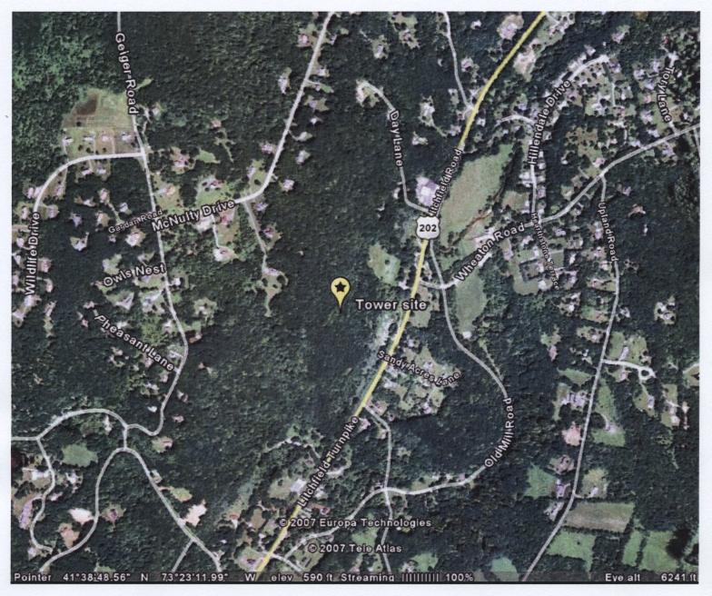(Applicant 1, Tab B)

FIGURE 2
SITE PLAN

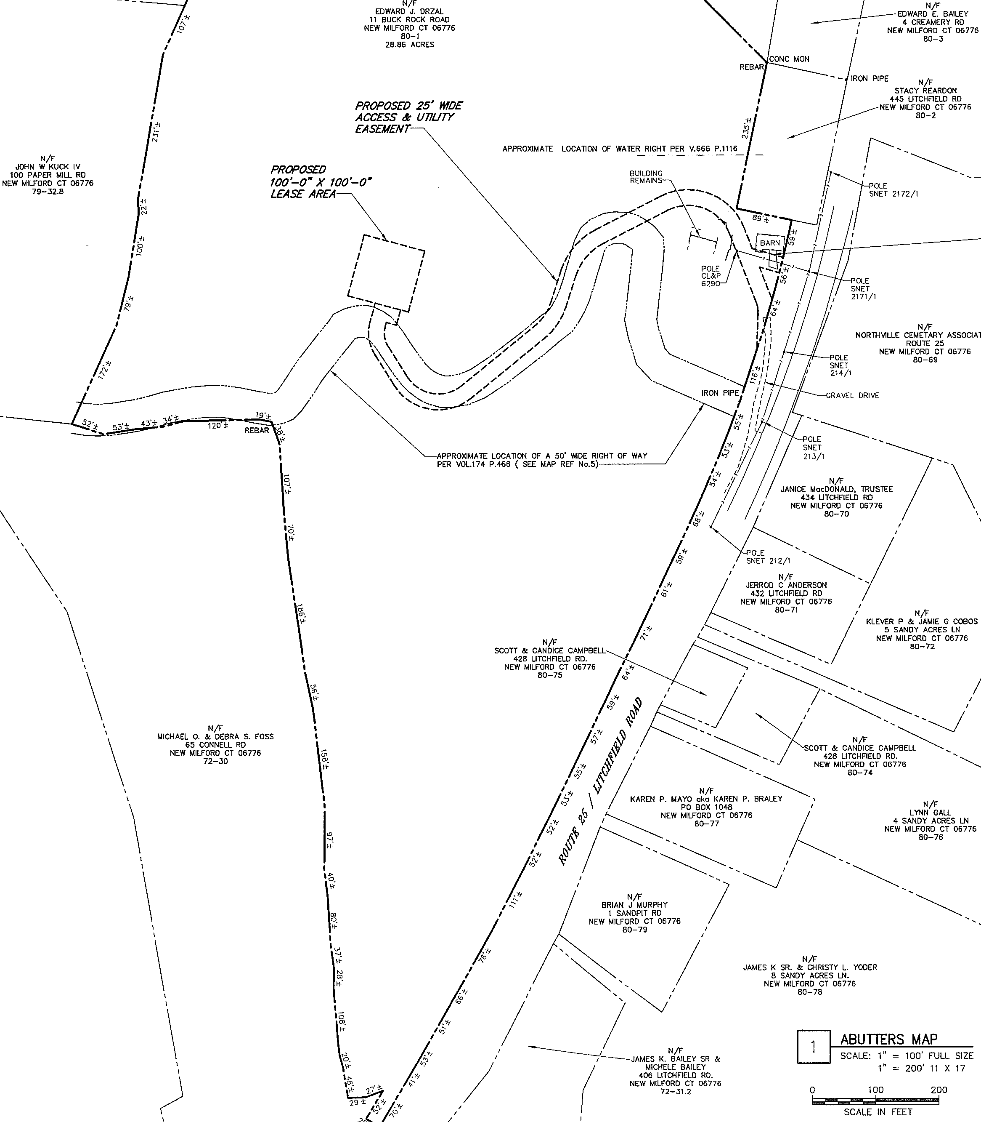
(Applicant 1, Tab B)

FIGURE 3
VISIBILITY OF SITE
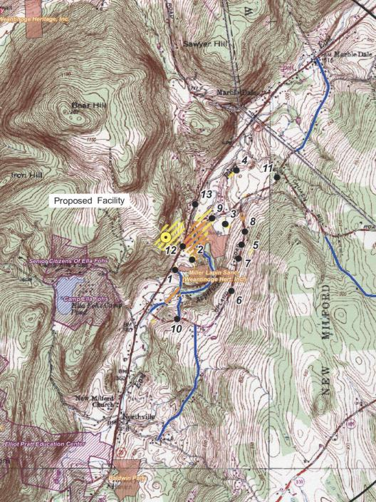
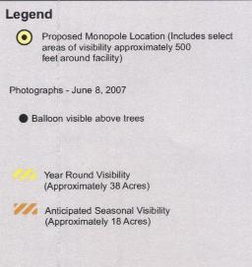 (Applicant 1, Tab J)

FIGURE 4
EXISTING T-MOBILE COVERAGE

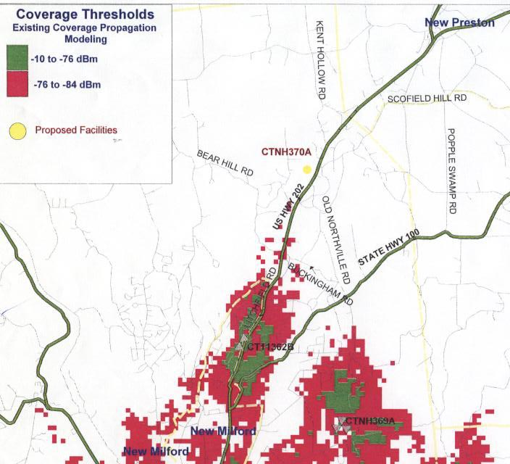

(Applicant 1, Tab G)
FIGURE 5
PROPOSED T-MOBILE COVERAGE FROM
425 LITCHFIELD ROAD @ 137 FEET AGL

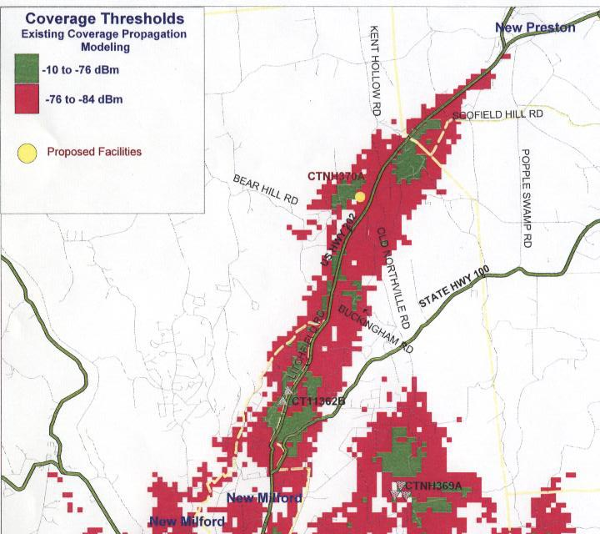

(Applicant 1, Tab G)

FIGURE 6
PROPOSED T-MOBILE COVERAGE FROM
359 LITCHFIELD ROAD AT 140 FEET AGL

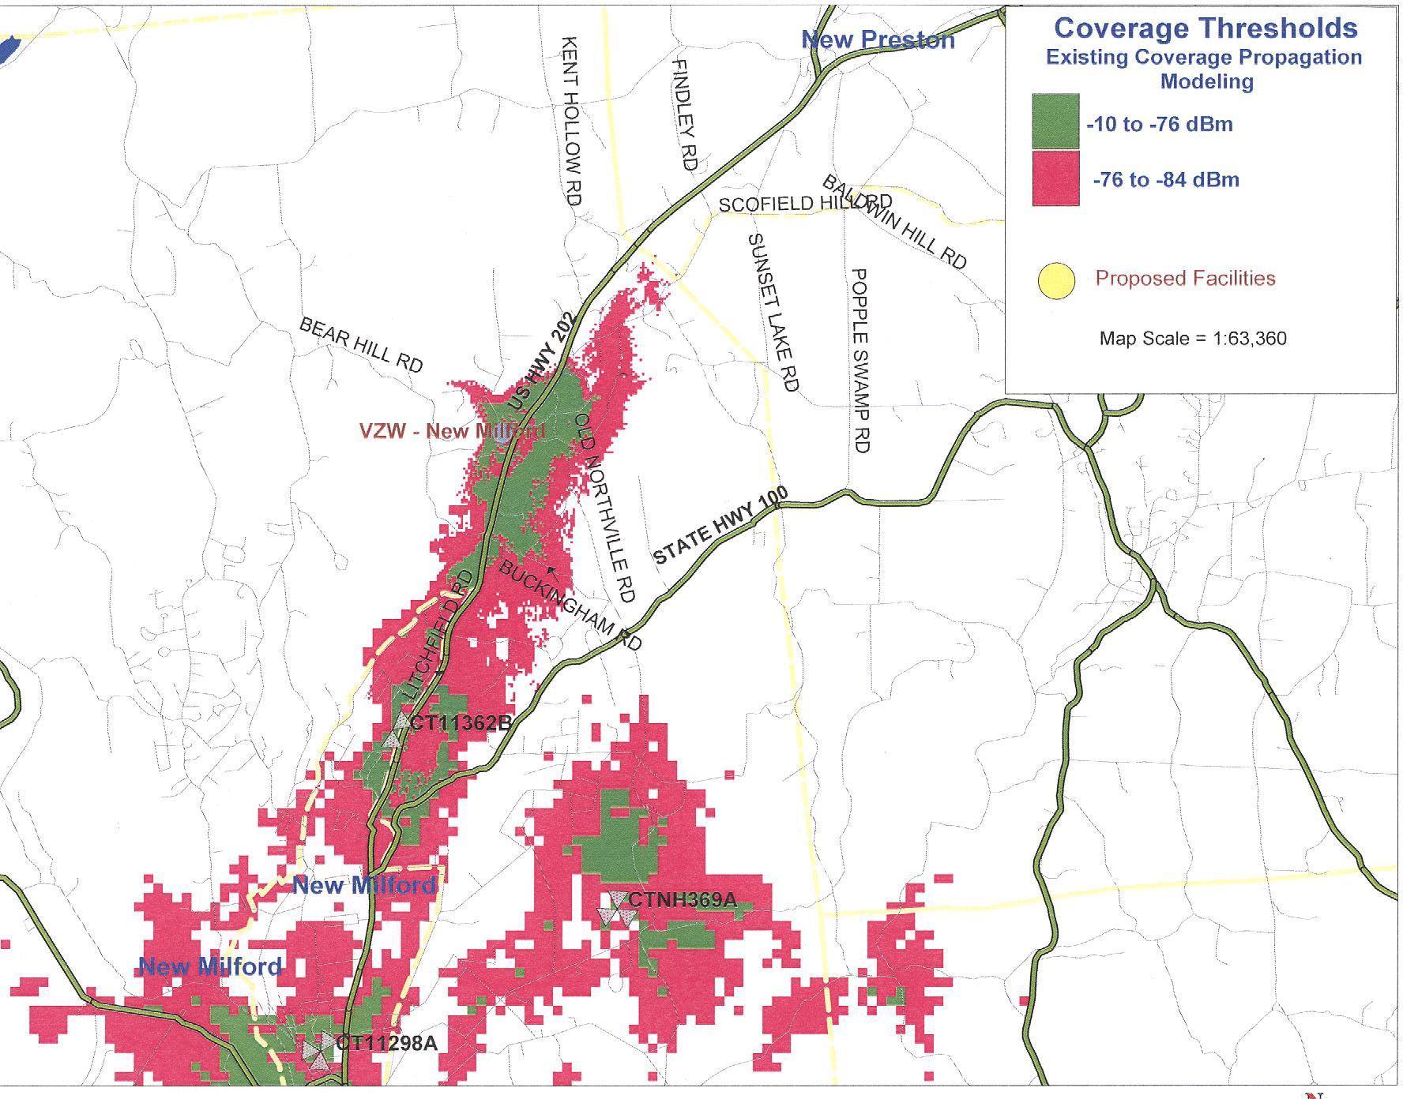
(Applicant 16, Q. 1)

