DOCKET NO. 298 - Sprint Spectrum, L.P. d/b/a Sprint PCS application for a Certificate of Environmental Compatibility and Public Need for the construction, maintenance and operation of a wireless telecommunications facility at 389 Forbes Avenue, New Haven, Connecticut. | }  }  } | Connecticut  Siting  Council  February 2, 2005

Findings of Fact

Introduction

- On April 30, 2004, Sprint Spectrum L.P., d/b/a Sprint PCS (Sprint) petitioned the Connecticut Siting Council (Council) for a declaratory ruling that no Certificate of Environmental Compatibility and Public Need would be required for the installation of a telecommunications facility at 389 Forbes Avenue, New Haven, Connecticut. The installation was necessary to replace an existing Sprint facility on an adjacent parcel at 401-411 Forbes Avenue that was condemned by the Department of Transportation (DOT) for a highway reconstruction project. The Council denied this petition (Petition No. 668) and ruled that Sprint’s proposal would require a Certificate application. (Sprint 1, p. 1; Petition 668)

- Sprint, in accordance with provisions of General Statutes §§ 16-50g through 16-50aa, applied to the Connecticut Siting Council (Council) on August 26, 2004 for the construction, operation, and maintenance of a 70-foot wireless telecommunications facility at 389 Forbes Avenue, New Haven. (Sprint 1, p. 4)

3. The party in this proceeding is the applicant. (Transcript 1- 4:00 p.m. [Tr. 1], p. 4)

4. The purpose of the proposed facility is to provide personal communication service to coverage gaps identified by Sprint on Interstate 95 and in the Townsend Avenue area of New Haven. (Sprint 1, Tab 10)

5. Pursuant to General Statutes § 16-50m, the Council, after giving due notice thereof, held a public hearing on November 8, 2004, beginning at 4:00 p.m. and continuing at 7:00 p.m. at the Nathan Hale School Auditorium, 480 Townsend Avenue, New Haven, Connecticut. (Council's Hearing Notice dated September 24, 2004; Tr. 1, p. 2; Transcript 2 – 7:00 p.m. [Tr. 2], p. 2)

6. The Council and its staff conducted an inspection of the proposed site on November 8, 2004, beginning at 3:00 p.m. During the field inspection, the applicant attempted to fly a balloon at the site to simulate the height of the proposed tower. Winds of up to 25 miles per hour prevented the balloon from reaching the intended height of 70 feet. (Council's Hearing Notice dated September 24, 2004; Tr. 1, pp. 25-26)

7. Notice of the application was provided to all abutting property owners by certified mail. All return mail receipts were received except for notification to the DOT. (Sprint 1, p. 6; Tr. 1, p. 9)

- Public notice of the application was published by the applicant in the New Haven Register on August 19 and 24, 2004, the New Haven Advocate on August 19, 2004, and the New Haven Inquirer on August 18 and 25, 2004. (Sprint 1, p. 6; Sprint 3)

- Sprint notified the City of New Haven of the proposal on June 24, 2004 by sending a technical report to the Mayor of the City of New Haven, John DeStefano, Jr., and the New Haven City Planner, Karyn Gilvarg. (Sprint 1, pp. 10-11)

- The City of New Haven did not comment on the proposal. (Sprint 1, p. 2)

- Sprint would provide space on the tower for the City of New Haven and any public safety entity for no compensation, provided any such use is compatible with the structural integrity of the tower. (Sprint 1, p. 8)

- Pursuant to General Statutes § 16-50j (h), on September 24 and November 9, 2004, the following State agencies were solicited to submit written comments regarding the proposed facility; Department of Environmental Protection (DEP), Department of Public Health (DPH), Council on Environmental Quality (CEQ), Department of Public Utility Control (DPUC), Office of Policy and Management (OPM), Department of Economic and Community Development (DECD), and the DOT. (Record)

- The following agencies did not respond with comments on the application: DPH, CEQ, DPUC, OPM, and the DECD. (Record)

Telecommunications Act

- In 1996, the United States Congress recognized a nationwide need for high quality wireless telecommunications services, including cellular telephone service. Through the Federal Telecommunications Act of 1996, Congress seeks to promote competition, encourage technical innovations, and foster lower prices for telecommunications services. (Council Administrative Notice Item No. 7, Telecom Act 1996)

- In issuing cellular licenses, the Federal government has preempted the determination of public need for cellular service by the states, and has established design standards to ensure technical integrity and nationwide compatibility among all systems. Sprint is licensed by the Federal Communications Commission (FCC) to provide personal wireless communication service in thirty-two major United States trading areas, including Connecticut. (Council Administrative Notice Item No. 7, Telecom. Act 1996; Sprint 1, p. 5)

- The Telecommunications Act of 1996 prohibits local and state entities from discriminating among providers of functionally equivalent services. (Council Administrative Notice Item No. 7, Telecom. Act 1996)

- The Telecommunications Act of 1996, a Federal law passed by the United States Congress, prohibits any state or local entity from regulating telecommunications towers on the basis of the environmental effects of radio frequency emissions to the extent that such towers and equipment comply with FCC’s regulations concerning such emissions. This Act also blocks the Council from prohibiting or acting with the effect of prohibiting the provision of personal wireless service. (Council Administrative Notice Item No. 7, Telecom. Act 1996)

Site Selection

18. Sprint installed telecommunications equipment on an existing 48-foot sign at the 401-411 Forbes Avenue property in 1999 after receiving approval from the City of New Haven. (Sprint 1, p. 1)

19. In January 2003, the DOT condemned portions of the 401-411 Forbes Avenue parcel, including the existing Sprint facility and a gas station, for an Interstate 95 reconstruction project. (Sprint 1, p. 1, Attachment 7; Petition 668)

20. The property owner of the 401-411 Forbes Avenue, Hennessey Family Partnership, offered to lease space to Sprint for a new facility on an adjacent parcel it owned at 389 Forbes Avenue. (Sprint 1, p. 4)

21. Sprint did not initiate a search ring for the 389 Forbes Avenue site since the proposed site is 120 feet from the condemned 401-411 Forbes Avenue site. (Sprint 1, p. 10)

22. Sprint contacted United Illuminating (UI) regarding potential use of a 345 kV transmission line support tower immediately north of the site. UI rejected Sprint’s inquiry stating that the power outage needed to install such a facility was excessive. In the past UI has not been responsive to telecommunication carrier requests for use of transmission line structures due to a lack of resources. UI is currently in the early stages of developing a program for such use. (Tr. 1, pp. 16-23)

Site Description

23. The proposed site is located in the southwest corner of a 0.26-acre parcel located at 389 Forbes Avenue, New Haven. The parcel and adjacent property at 401-411 Forbes Avenue is undergoing re-development as a gas station/convenience store to replace the gas station condemned by the DOT. (Sprint 1, p. 10, Attachment 7)

24. The parcel is zoned business district, BA. (Sprint 1, Attachment 7)

25. Sprint would construct a 70-foot monopole designed to support three levels of antennas with a 10-foot center-to-center vertical separation. The tower and foundation would be designed to support a 30-foot extension to accommodate future carriers, if necessary. The tower would be constructed in accordance with the American National Standards Institute TIA/EIA-222-F “Structural Standards for Steel Antenna Towers and Antenna Support Structures”. The final design of both the monopole and foundation has not been determined and would be based on specified tower loading and soil analyses for the site. (Sprint 1, p. 12, Attachment 7)

26. Sprint would install 12 panel antennas mounted on triangular platform at a centerline height of 67.5 feet above ground level (agl). (Sprint 1, p. 12)

27. A 1,298 square foot irregularly shaped rectangular compound would be established at the base of the tower. The compound would be located in a 1,705 square-foot lease area. The entire lease area would be paved. Sprint would install equipment and battery cabinets on a concrete pad within the compound. (Sprint 1, p. 13, Attachment 7)

28. The compound would be accessed from the parking lot of a convenience store/gas station under construction on the property. Underground utilities would be installed to the compound from a utility pole on Forbes Avenue. (Sprint 1, Attachment 7; Sprint 2, Q. 5)

29. The tower setback radius extends onto the Fucci property, located west of the site, by 29 feet and onto land owned by the DOT south of the site by 44 feet. A two story building on the Fucci property containing storefronts and four apartments is within the setback radius. The setback radius does not extend onto the travel lanes of Interstate 95. (Sprint 1, Attachment 7; Sprint 2, Q. 3, Q. 4; Tr. 1, pp. 11, 26)

30. The property owner is not willing to relocate the compound area to the southeast in order to reduce the amount of the tower setback radius from extending onto the Fucci property since this area will be developed with diesel pumps and any relocation of the compound would interfere with pump traffic patterns. In addition, a drainage pipe will traverse the property in a north/south direction immediately east of the proposed compound making any tower relocation to this area difficult. (Sprint late file, December 2, 2004)

31. The tower site is located at a ground elevation of 56 feet above mean sea level (amsl). The proposed tower site is six feet lower in elevation than the original facility located at 401-411 Forbes Avenue. (Sprint 1, p. 4, Attachment 7)

32. There are 188 residences within 1,000 feet of the site. The nearest residential structure to the tower site is the two-story building on the Fucci property, approximately 41 feet north of the tower site. (Sprint 2, Q. 1; Tr. 1, p. 26; Tr. 2, pp. 4-6)

33. Land use within a quarter mile of the site consists of developed residential, commercial, and industrial properties. (Sprint 1, p. 11; Tr. 2, pp. 4-6)

34. The estimated construction cost for the proposed facility is:

Site Work 20,000.
Monopole 25,000.
Electrical & Telephone 30,000.
Foundation 30,000.
Landscaping 10,000.
Site Access $10,000.

Total $125,000.
(Sprint 1, Attachment 9)

35. Although landscaping was included in the cost estimate for site construction, Sprint did not intend to install landscaping since the lease area would be paved. Sprint would be willing to install landscaping islands on the north side of the compound to provide screening from Forbes Avenue. (Sprint 1, Attachment 7, Attachment 9; Tr. 1, pp. 40-41)

Environmental Considerations

36. The proposed facility would have no effect on archaeological resources listed on or eligible for the National Register of Historic Places or upon properties of traditional cultural importance to Connecticut’s Native American community. (Sprint 1, Attachment 14)

37. The proposed site contains no known existing populations of Federal or State Endangered, Threatened or Special Concern Species. (Sprint 1, p. 19, Attachment 14)

38. The proposed site is in a cleared area of a parcel under development as a gas station/convenience store. No trees will be removed during development of the compound. (Sprint 1, Attachment 7)

39. There are no wetlands or watercourses on the site parcel. (Sprint 1, p. 17)

40. Aircraft hazard obstruction marking or lighting of the tower would not be required. (Sprint 1, p. 17, Attachment 13; Tr. 1, pp. 41-42)

41. According to methodology prescribed by the FCC Office of Engineering and Technology Bulletin No. 65E, Edition 97-01 (August 1997) that assumes all antennas would be pointed at the base of the tower and all channels would be operating simultaneously, the maximum power density at the base of the proposed tower would be 0.36 mW/cm² or 36% of the standard for Maximum Permissible Exposure (MPE) as adopted by the FCC. The conservative worst-case approximation of electromagnetic radiofrequency power density at the nearest off-site receptor, the two-story building on the Fucci property, assuming all antennas are pointed towards the building and all channels operating simultaneously, would be 0.67 mW/cm² or 67% of the MPE. (Sprint 1, Attachment 12; Tr. 1, pp. 12-16)

Visibility

42. The proposed tower and compound would be visible year-round from approximately 16 acres in the area immediately surrounding the site (refer to Figure 1). (Sprint 1, Attachment 11)

43. The upper portion of the proposed tower would be visible year-round from approximately 144 acres within a two-mile radius of the site. A majority of this area is located west of the site and includes an industrial area and portions of New Haven Harbor (refer to Figure 1). (Sprint 1, Attachment 11)

44. The tower and compound would be visible year-round from approximately 24 residences within 1,000 feet of the site. Residences include apartments within multistory building and individual condominium units. (Sprint 2, Plan C-2a; Tr. 2, pp. 4-6)

45. The upper portion of the tower would be seasonally visible from approximately 39 residences within 1,000 feet of the site. (Tr. 2, pp. 4-6)

46. Visibility of the proposed tower from specific locations within a half-mile radius of the site is presented in the table below:

Location | Visible | Approx. Portion of Tower Visible | Distance to Tower
Intersection of Forbes Avenue and Woodward Avenue | Yes | 55 feet - unobstructed | 0.1 miles southwest
Intersection of Forbes Avenue and Kendall Street | Yes | 50 feet - unobstructed | 0.1 miles southeast
Intersection of Main Street and Woodward Avenue | Yes | 35 feet - unobstructed | 0.1 miles northwest
Intersection of Forbes Avenue and Chamberlain Street | Yes | 35 feet - unobstructed | 0.2 miles southeast
Forbes Avenue | Yes | 30 feet - unobstructed | 0.1 miles west
Intersection of Alabama Street and Fulton Avenue | Yes | 50 feet - unobstructed | 0.3 miles east
(Sprint 1, Attachment 11)

47. The tower would not be visible from East Shore Park, Fort Hale Park, and Fort Wooster Park, all located within two-miles of the site. (Sprint 1, Attachment 11)

48. There are no public use hiking trails or state designated scenic roads within two miles of the site. (Sprint 1, Attachment 11)

Sprint - Existing and Proposed Wireless Coverage

49. Sprint operates in the 1950 - 1965 MHz frequency bands and at a signal level service design of -84 dBm for this area. (Sprint 1, p. 9, Attachment 10, Attachment 12)

50. The proposed site would provide approximately one mile of coverage on Interstate 95 east of the site (refer to Figures 2 and 3). Coverage to this area is currently provided by a temporary cell on wheels located on the site parcel. (Sprint 1, p. 7, Attachment 10)

51. The site would provide improved coverage (-84 dBm) to the area surrounding Route 1, Alabama Street, Townsend Street, and Woodward Avenue (refer to Figures 2 & 3). (Sprint 1, Attachment 10)

FIGURE 1
LOCATION AND VISIBILITY OF PROPOSED SITE
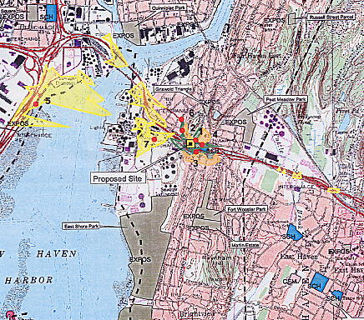

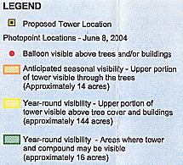
1” = 2000’
(Sprint 1, Attachment 11)
FIGURE 2
SPRINT EXISTING COVERAGE
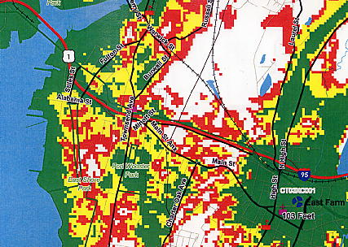

FIGURE 3
SPRINT EXISTING AND PROPOSED COVERAGE
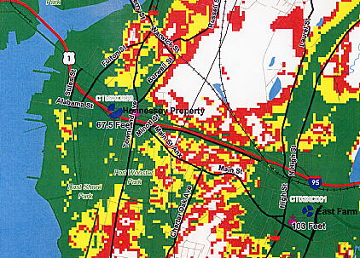

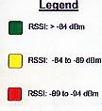 (Sprint 1, Attachment 10)

