DOCKET NO. 366 - Optasite Towers LLC and Omnipoint Communications, Inc. application for a Certificate of Environmental Compatibility and Public Need for the construction, maintenance and operation of a telecommunications facility located at 52 Stadley Rough Road in Danbury, Connecticut. | }  }  } | Connecticut  Siting  Council  April 23, 2009

Findings of Fact

Introduction

- Pursuant to Chapter 277a, Sections 16-50g et seq. of the Connecticut General Statutes (CGS), as amended, and Section 16-50j-1 et. seq. of the Regulations of Connecticut State Agencies (RCSA), Optasite Towers LLC (Optasite) and Omnipoint Communications, Inc. (T-Mobile) applied to the Connecticut Siting Council (Council) on June 30, 2008 for the construction, operation, and maintenance of a telecommunications facility that would include a 140-foot steel monopole tower. The facility would be located at 52 Stadley Rough Road in the City of Danbury, Connecticut. (Applicants 1, pp. 1-2)

- Optasite is a Delaware limited liability company with offices at One Research Drive, Suite 200C, Westborough, Massachusetts. It would construct and maintain the proposed facility. (Applicants 1, p. 3)

- T-Mobile is a Delaware corporation with a Connecticut office at 35 Griffin Road South, Bloomfield, Connecticut. The company and its affiliated entities are licensed by the Federal Communications Commission (FCC) to construct and operate a personal wireless services system in Connecticut. T-Mobile does not conduct any other business in the State of Connecticut other than the provision of wireless services under FCC rules and regulations. (Applicants 1, p. 3)

- The parties in this proceeding are Optasite, T-Mobile, and the City of Danbury. (Transcript, September 9, 2008, 3:05 p.m. [Tr. 1], p. 6)

- If the certificate application is approved, Optasite would be the certificate holder. (Transcript, October 28, 2008, 11:00 a.m. [Tr. 3], p. 140)

- Optasite has been acquired by SBA, which would succeed Optasite as the certificate holder should the application be approved. (Tr. 1, p. 67; Tr. 5, p. 117)

- The proposed Facility would provide wireless service in the northeast portion of the City of Danbury, particularly north of the I-84 junction with Route 7 in an area between Candlewood Lake, the Town of Brookfield’s municipal boundary, and Padanaram Road. (Applicants 1, p. 1)

- Pursuant to CGS § 16-50l(b), notice of the applicants’ intent to submit this application was published on June 24 and 26, 2008 in the Danbury News-Times. (Applicants 1, p. 4; News-Times Affidavit of Publication dated June 26, 2008)

- In accordance with CGS § 16-50l(b), Optasite sent notices of its intent to file an application with the Council to each person appearing of record as owner of property abutting the property on which the site is located. (Applicants 1, p. 4, Attachment 11)

- Optasite received return receipts from all of the abutting property owners to whom notices were sent. (Applicants 2, A1)

- Pursuant to CGS § 16-50l (b), Optasite provided notice to all federal, state, regional, and local officials and agencies listed therein. (Applicants 1, p. 4, Attachment 9)

- Optasite posted a sign informing the general public of its pending application with the Council on the premises of 52 Stadley Rough Road on August 24, 2008. The dimensions of the sign were four feet by six feet. The sign included the site and date of the initial hearing scheduled for this application and information about how to contact the Council. (Tr. 3, pp. 68-69)

- Pursuant to CGS § 16-50m, the Council, after giving due notice thereof, held a public hearing on September 9, 2008, beginning at 3:05 p.m. and continuing at 7:00 p.m. in the auditorium of the Broadview Middle School, 72 Hospital Avenue in Danbury, Connecticut. (Tr. 1, p. 2 ff.)

- The public hearing was continued on October 28, 2008 at the Institute of Technology and Business Development of Central Connecticut State University, 185 Main Street, New Britain, Connecticut beginning at 11:00 a.m. The hearing was adjourned at 3:00 p.m. (Tr. 3, p. 3 ff.; Tr. 3, 145)

- Another session of the public hearing was convened on December 8, 2008 beginning at 11:20 a.m. in Hearing Room One of the offices of the Council at Ten Franklin Square, New Britain. The hearing was adjourned at 4:45 p.m. (Transcript, December 8, 2008 11:20 a.m. [Tr. 4] pp. 3, 229)

- The public hearing was concluded on January 26, 2009. The concluding session was held at the Institute of Technology and Business Development of Central Connecticut State University. It began at 10:00 a.m. and ended at 5:40 p.m. (Transcript, January 26, 2009, 10:00 a.m. [Tr. 5], pp. 3, 335)

- The Council and its staff conducted an inspection of the proposed site on September 9, 2008, beginning at 2:00 p.m. On the day of the field inspection, the applicants flew a balloon beginning at approximately 7:45 a.m. Conditions for the balloon flight were difficult throughout most of the morning due to high winds and rain. One balloon was lost at approximately 11:00 a.m. Another balloon was sent aloft about 12:00 p.m. and remained aloft the rest of the afternoon. Visibility was limited due to cloud cover. (Tr. 3, p. 69)

State Agency Comments

- Pursuant to CGS § 16-50l, the Council solicited comments on Optasite’s application from the following state departments and agencies: Department of Agriculture, Department of Environmental Protection, Department of Public Health, Council on Environmental Quality, Department of Public Utility Control, Office of Policy and Management, Department of Economic and Community Development, and the Department of Transportation. The Council’s letters requesting comments were sent on July 29, 2008 and January 29, 2009. (CSC Hearing Package dated July 29, 2008; Letter to State Department Heads dated January 29, 2009)

- The Connecticut Department of Public Health responded to the Council’s solicitation with no comments. (Connecticut Department of Public Health Memorandum, dated August 26, 2008)

- The Connecticut Department of Transportation responded to the Council’s solicitation with no comments. (Connecticut Department of Transportation letter, dated September 18, 2008)

- Other than the comments received from the Connecticut Departments of Public Health and Transportation, the Council did not receive comments from any other state agencies. (Record)

Municipal Consultation

- On January 31, 2006, Optasite submitted a letter and a technical report to the City of Danbury. The technical report included specifics about the proposed site, Optasite’s plans for it, the site selection process, and the environmental effects of the proposed facility. (Applicants 1, p. 17)

- On March 21, 2006, representatives of Optasite met with Danbury’s Mayor, Corporation Counsel, and Associate Planner to discuss the proposed facility. At this meeting, Danbury officials suggested that Optasite present its plans to an information session of the Planning Commission. This session was held on May 3, 2006. Subsequent to this meeting, the Planning Commission provided written comments about the proposed facility in a memorandum dated May 17, 2006. The Planning Commission’s comments were forwarded to the applicants’ attorney in a letter from Danbury’s Corporation Counsel dated May 23, 2006. (Applicants 1, pp. 17-18)

- During its May 3, 2006 information session with Optasite, the Danbury Planning Commission considered concerns and recommendations about: the tower’s height, the tower’s proximity to an elementary school located in a nearby church, the proximity of wetlands to the proposed facility, the visual impact on the surrounding residential areas and the possible visual impact on historical properties, the proximity of the facility to residential properties, and the impact on private wells, should blasting be required for the foundation. (Applicants 1, Attachment 8)

- After the May 3, 2006 meeting, the Danbury Associate Planner prepared a memorandum for the Planning Commission summarizing the concerns raised at the meeting. The memorandum included concerns over the tower’s location in a residential district, which is the 6th least preferred location for a wireless facility, according to Danbury’s zoning regulations; the height of the tower; the potential of the facility to impact the foundation of the church; the safety of helicopters flying close to the facility; the tower posing an attractive nuisance for neighborhood children; potential impact on wetlands and wildlife habitat; and the visual impact on surrounding residences and six historic properties located within the proposed tower’s viewshed. The memorandum also listed recommendations for Optasite that included exploring alternative sites, considering a stealth treatment for the tower, and using landscaping and a stockade fence as visual buffer for the ground equipment. (Applicants 1, Attachment 8 – Memorandum to Planning Commission dated May 17, 2006)

- Following the public information session with the Planning Commission, Optasite investigated several alternative sites, including sites suggested by the city. Optasite also redesigned and relocated its proposed facility in response to the city’s comments. Revisions included moving the facility’s location 100 feet towards the southeast corner of the church property and using flush mounted antennas. Optasite also submitted a bell tower design to the church that owns the host property. After reviewing this design, the church rejected it as too visually obtrusive. (Applicants 1, p. 18; Attachment 8)

- At the September 9, 2008 public hearing, the Mayor of Danbury, Mark Boughton, expressed concern over the proposed tower’s location in a residential neighborhood and his belief that better, alternate sites were available. (Tr. 1, pp. 8-9)

- Optasite would provide space for City of Danbury emergency services antennas free of charge should the City wish to use the proposed tower. (Applicants 1, p. 9)

Public Need for Service

- The United States Congress, through adoption of the Telecommunications Act of 1996 (Act), recognized the important public need for high quality telecommunication services throughout the United States. The purpose of this Act, which was a comprehensive overhaul of the Communications Act of 1934, was to “provide for a competitive, deregulatory national policy framework designed to accelerate rapidly private sector deployment of advanced telecommunications and information technologies to all Americans.” (Applicants 1, p. 5)

- The Act prohibits local and state bodies from discriminating among providers of functionally equivalent services. (Council Administrative Notice, Telecommunications Act of 1996)

- The Act prohibits any state or local agency from regulating telecommunications towers on the basis of the environmental effects of radio frequency emissions to the extent that such towers and equipment comply with FCC’s regulations concerning such emissions. This Act also blocks the Council from prohibiting or acting with the effect of prohibiting the provision of personal wireless service. (Council Administrative Notice, Telecommunications Act of 1996)

- In an effort to ensure the benefits of wireless technologies to all Americans, Congress enacted the Wireless Communications and Public Safety Act of 1999 (the 911 Act). The purpose of this legislation was to promote public safety through the deployment of a seamless, nationwide emergency communications infrastructure that includes wireless communications services. (Applicants 1, pp. 6-7)

- The proposed facility would be an integral component of T-Mobile’s wireless network in this area of the state, where T-Mobile experiences a gap in coverage along I-84 west of the junction with Route 7 and in the area north of I-84 and south of Candlewood Lake. (Applicants 1, p. 5)

- As an outgrowth of the 911 Act, the FCC required wireless carriers to provide enhanced 911 services (E911) as part of their communications networks. These services would allow 911 public safety dispatchers to identify a wireless caller’s geographical location within several hundred feet. (Applicants 1, p. 7)

- T-Mobile has deployed network technologies implementing the FCC’s E911 requirements, and the proposed facility would be an integral component of T-Mobile’s E911 network. (Applicants 1, p. 7)

- Verizon Wireless has stated that it has a need for a facility at the applicants’ proposed location and that it would co-locate on the tower when budgets allow. (Applicants 1, Attachment 6)

- Nextel Communications of the Mid-Atlantic, Inc. (Sprint/Nextel) executed a lease agreement with Optasite to locate antennas on the proposed tower. It has reserved an antenna centerline mounting height of 127 feet. (Applicants 1, Attachment 6; Applicants 2, A10)

Site Selection

- The search for a telecommunications site in this area of Danbury was originally initiated by Sprint PCS sometime prior to the fall of 2000. Sprint applied to the Danbury Planning Commission, which had jurisdiction at the time, for approval of a site on Great Plain Road. The Planning Commission denied Sprint’s application in December, 2000. (Applicants 2, A3)

- Verizon Wireless has made efforts to find a site in this area of Danbury. (Applicants 2, A3)

- T-Mobile initiated a search ring in this area following Sprint’s denial by the Danbury Planning Commission and continued its site search efforts through early 2005. (Applicants 2, A3)

- In 2005, Optasite, through its ongoing business relationships with wireless carriers, became aware that this area of Danbury was considered a “dead zone.” (Applicants 2, A3)

- In June of 2005, Optasite received a call from the previous owner of the property at 52 Stadley Rough Road indicating that the owner was interested in leasing a portion of the property for a wireless site. (Applicants 2, A3)

- Optasite began its efforts to find a site in this area in June, 2005. Optasite used information gathered during the previous site searches by the wireless carriers to focus its own search efforts. (Applicants 2, A4)

- During its site search, Optasite contacted wireless carriers licensed to provide service in Fairfield County to ask for suggestions about potential sites. (Applicants 2, A5)

- Optasite identified 15 communications towers within approximately four miles of the proposed Stadley Rough Road site. T-Mobile has antennas on six of these towers. The towers are listed in the following table.

Tower Location | Ht. and Type of Tower | Tower Owner | Distance and Direction to Site
7 Stony Hill Road,  Bethel | 140’ utility pole | CL&P | 2.0 miles to southeast
2 Huckleberry Hill,  Brookfield | 60’ flagpole | AT&T | 1.9 miles to northeast
33 Carmen Hill Road,  Brookfield | 80’ lattice tower | Charter Communications | 4.2 miles to north
39 Carmen Hill Road,  Brookfield | 500’ guyed lattice tower | Aurora of Danbury | 3.8 miles to north
Park Ridge Road,  Brookfield | 115’ utility pole (T-Mobile on at top of pole) | CL&P | 1.5 miles to east
181 Clapboard,  Danbury | 85’ flagpole (T-Mobile on at 59’) | T-Mobile | 3.1 miles to west
39 West Street,  Danbury | 70’ building mount | SNET | 3 miles to southwest
41 Padanarum Road,  Danbury | 80’ wood pole (T-Mobile on at top) | T-Mobile | 1.8 miles to southwest
48 Newtown Road,  Danbury | 100’ monopole | Fifty Newtown Rd. | 2.1 miles to south
50 Newtown Road,  Danbury | 100’ guyed lattice tower | Fifty Newtown Rd. | 2.3 miles to south
(see next page for continuation of table)

Tower Location | Ht. and Type of Tower | Tower Owner | Distance and Direction to Site
Boxwood Lane Ext,  Danbury | 100’ lattice tower | WCSU | 3.9 miles to southwest
7 West View Drive,  Danbury | 133’ lattice tower (T-Mobile on at 50’) | Robert Kaufman | 2.6 miles to south
302 Ball Pond Road,  New Fairfield | 175’ monopole (T-Mobile on at 145’) | Town of New Fairfield | 4 miles to northwest
Dick Finn Road,  New Fairfield | 60’ lattice tower | Crown Media | 4.2 miles to north
6 Fairfield Drive,  Newtown | 163’ monopole (T-Mobile on at 160’) | Spectrasite | 3 miles to east
(Applicants 1, Attachment 3)

- During its search for a facility location, Optasite and T-Mobile investigated several locations where a new tower might be feasible. The following table lists those properties that were investigated and includes a statement about their suitability to host the proposed facility.

Property Address and Size | Owner | Suitability
52 Stadley Rough Road; 5.2 acres | Christ the Shepherd Church | Host property
40 Stadley Rough Road; 10.5 acres | Colonial Baptist Church | Owner was not interested in leasing property
85 Great Plain Road; 14.3 acres | St. Gregory the Great RC Church Corp. | Optasite lease proposal was rejected by diocese
Great Plain Road - Map J07, Lot 72; 15.37 acres | Albert Salame | Property owner has other development plans for this parcel
Great Plain Road – Map J05, Lot 101; 28.6 acres | Albert Salame | All Salame-owned parcels rejected for similar reasons
Great Meadows Road – Map J06, Lot 081; 37 acres | Albert Salame | All Salame-owned parcels rejected for similar reasons
Stadley Rough Road – Map J05, Lot 102; 7 acres | Albert Salame | All Salame-owned parcels rejected for similar reasons
73-79 Stadley Rough Road; 15.9 acres | City of Danbury | This is the site of an elementary school; city not interested in leasing here.
14 Indian Spring Road; 3.5 acres | Jose & Christina Carvalheiro | Single family home on this parcel; Optasite contacted property owner before lot was developed, owner expressed no interest
10 Stadley Rough Road; 8.8 acres | City of Danbury | This is the site of an elementary school; city not interested in leasing here.
(see next page for continuation of table)

Property Address and Size | Owner | Suitability
Sterling Woods Condominium Complex, Nabby Road | Sterling Woods Condominiums | City of Danbury leases portion of this property for an 80’ water tank; T-Mobile could not cover its target area from this site; antennas at this location would create redundancy problems; Condominium Association will not lease property for wireless telecommunications facility.
State Department of Transportation Garage, Rockwell Road | State of Connecticut | This location is too far south of target area to cover it adequately and is at base of a plateau, which would cause shadowing of radio propagation.
(Applicants 1, Attachment 3; Applicants 13, I.D.1., I.D.2.)

- Sites in the above table that Optasite investigated at the city’s suggestion include the water tank at the Sterling Woods Condominium complex on Nabby Road and the state Department of Transportation garage located on Rockwell Road. (Applicants 2, A2)

- Antennas at the Sterling Woods Condominiums water tank site that would be high enough to reach T-Mobile’s coverage objectives would also create problems with interference and redundant coverage for existing sites along I-84. (See Figure 7) (Tr. 3, pp. 78-79)

- A 140-foot tower located at the federal penitentiary would not be able to cover the area along Stadley Rough Road that would be covered from the proposed site. (Tr. 3, pp. 80-81)

- In order to approximate the coverage possible from the proposed site, a tower at the State Department of Transportation garage on Rockwell Road would have to be approximately 170 feet tall. Antennas mounted at this height would create interference problems and redundant coverage. (See Figure 6) (Tr. 3, pp. 87-88)

- Both Sprint/Nextel and T-Mobile indicated to Optasite that they would need antennas to be mounted at a minimum height of 127 feet above ground level (agl) at the proposed site in order to cover their respective target areas. Since the two carriers could not have their antennas at the same height, Optasite proposed a 140-foot high tower in order to be able to accommodate both carriers. (Applicants 2, A6)

- T-Mobile avers that repeaters, microcell transmitters, distributed antenna systems and other types of transmitting technologies are not a practicable or feasible means to provide service within the coverage gap it is seeking to cover due to significant terrain variations and tree cover in the area, as well as other practical considerations. (Applicants 1, pp. 7-8)

Distributed Antenna Systems

- Distributed antenna systems (DAS) consist of a centralized location—referred to as a radial hotel—where signal processing equipment is housed and numerous antenna nodes, which are connected to the central location by fiber optic cable. The antennas are installed at low heights—telephone poles are a good example of the types of structures on which antennas could be placed. DAS are generally used in densely populated, high-traffic areas, where extra capacity or very localized coverage footprints are required. Because antennas are mounted at relatively low heights, usually within the tree canopy, it is difficult to achieve much lateral coverage with these systems. (Tr. 5, pp. 88-89)

- T-Mobile deploys some in-building DAS and plans to use a DAS in Newton, Massachusetts, where the system is being designed in partnership with the municipality. (Tr. 5, pp. 86-88)

- T-Mobile did not consider a DAS solution to its coverage problems in its target area because of the difficult terrain in the area and because it felt the proposed tower was a more viable solution. (Tr. 5, p. 103)

- For Optasite to replicate the coverage possible from its proposed tower with a DAS, it would have to install up to several dozen utility poles to host the distributed antennas. Furthermore, approximately 20 percent of the target coverage area is served by underground utilities. In these areas Optasite would have to install up to 20 new utility poles per mile to carry the fiber optic and power cables needed for a DAS. Such an installation would be more intrusive than the proposed single tower. (Applicants’ Response to the City’s Post Hearing Filing of the “Comi Solution,” dated February 19, 2009)

Site Description

Proposed Site

- The applicants’ proposed facility is located at 52 Stadley Rough Road in Danbury in the southwest corner of a 5-acre parcel owned by Christ the Shepherd Church. (See Figures 1 and 2) (Applicants 1, p. 2; Attachment 4)

- The church property is zoned RA-40 Single Family Residential. (Applicants 1, p. 2)

- Wireless telecommunications towers are permitted in any Danbury zoning district as a special exception use. (Bulk filed exhibit: Danbury Zoning Regulations)

- The Danbury zoning regulations designate residential zoning districts as the least preferred location for wireless telecommunications towers. (Bulk filed exhibit: Danbury Zoning Regulations)

- The proposed facility would comply with the zoning regulations that pertain to wireless telecommunications facilities except for the setback requirement. Danbury’s regulations require a setback (distance from property lines) of either the required setbacks in the underlying zoning district (RA-40) or the height of the tower plus an additional 25 feet (165 feet in this case), whichever is greater. The proposed tower would be approximately 42 feet and 78 feet from the two nearest property lines. (Applicants 1, p. 15)

- On the church property, Optasite would lease a 100-foot square parcel within which it would install a 55-foot by 90-foot equipment compound and a 140-foot monopole. Antennas would be flush-mounted on the monopole tower. The compound would be enclosed by an eight-foot high chain link fence with green privacy slats. (See Figure 3) (Applicants 1, p. 2; Attachment 4)

- As an alternative to the monopole tower, Optasite designed a bell tower made of RF transparent materials. The church, however, considered this design more obtrusive than a monopole with flush-mounted antennas. (Tr. 3, pp. 135-136)

- The proposed tower would be located at 41º 25’ 59.17” north latitude and 73º 25’ 54.9” west longitude. Its ground elevation would be 545 feet above mean sea level. (Applicants 1, Attachment 4)

- Moving the location of the tower 40 to 45 feet to the north and east would preserve more of the existing vegetation between the proposed compound and the adjacent property at 14 Indian Spring Road, but such a move would directly impact the nearby wetlands and would not substantially affect the view of the tower for the neighbors at 14 Indian Spring Road. (Tr. 3, pp. 127-130)

- The proposed tower would be designed in accordance with the 2005 Connecticut State Building Code and the Electronic Industries Association Standard EIA/TIA-222-G, “Structural Standards for Steel Antenna Towers and Antenna Support Structures.” The base of the tower would be approximately five feet in diameter. The top of the tower would be approximately one and a half feet in diameter. The tower would be engineered to accommodate the antennas of up to four carriers and the antennas of the City of Danbury’s emergency services, if requested. (Applicants 1, p. 9, Attachment 4, and Attachment 5)

- Optasite would require all antennas on the tower to be flush mounted. (Tr. 5, pp. 26-27)

- Optasite would be willing to design the tower as a tree in order to mitigate concerns over its visibility. (Tr. 5, p. 29)

- If the proposed tower were to be disguised as a tree, its overall height would increase by seven feet to 147 feet above ground level in order to achieve a realistic profile with artificial tree branches at the top. (Tr. 5, pp. 27-28)

- The proposed tower would be designed with a yield point at the approximate height of 100 feet agl because of the tower’s proximity to an abutting property, the closest point of which is 42 feet from the tower’s proposed location. (Tr. 3, pp. 70-71)

- T-Mobile would initially install three antennas at a height of 137 feet agl. T-Mobile could install up to six antennas in the future. (Tr. 3, p. 74; Applicants 1, p. 9)

- T-Mobile would utilize battery back up power at the site. (Applicants 2, A13)

- Landscaping would be planted along the northern and western sides of the equipment compound to provide additional screening. (Applicants 1, Attachment 4)

- Developing this site would require 140 cubic yards of cut. No fill would be required. (Applicants 2, A11)

- Vehicular access to the proposed facility would extend from Stadley Rough Road over an existing paved driveway along the rear of the church’s premises and then along a gravel driveway that would be approximately 175 feet in length. (Applicants 1, p. 9; Attachment 4)

- Utility service for the proposed facility would be extended underground from existing service on Stadley Rough Road. The utility lines would closely parallel the access drive to the compound. (Applicants 1, pp. 9-10; Attachment 4, Sheet A02)

- No blasting is anticipated for the development of this site. (Applicants 2, A12)

- The proposed tower’s setback radius would extend approximately 98 feet onto adjacent property to the west owned by José and Christina Carvalheiro and approximately 103 feet onto property to the south owned by Colonial Hills Baptist Church. (Applicants 1, Attachment 4; Tr. 3, pp. 71-72)

- The facility’s compound would be located approximately 15 feet from the boundary of the Cavalheiro property and approximately 15 feet from the nearest point of the Baptist Church’s property. (Applicants 1, Attachment 4, Sheet A02)

- There are approximately 53 residences within 1,000 feet of the proposed tower. (Applicants 1, p. 12)

- The closest residence is located 142 feet to the northwest of the proposed compound at 14 Indian Spring Lane. It is owned by José and Christina Carvalheiro. (Applicants 1, p 12; Attachment 4)

- Land use in the area is a mix of single and multi-family residences. There are a number of institutional uses, churches and a school, in the vicinity as well. (Applicants 1, Attachment 4)

- Optasite’s estimated cost of construction for this facility, which does not include T-Mobile’s antennas and support equipment, is:

Tower and foundation $112,000
Site development 66,000
Utility installation 38,000
Total costs $216,000

(Applicants 1, p. 19)

- The cost of the equipment T-Mobile would install at this facility would be between $125,000 and $150,000. (Applicants 2, A22)

Suggested Alternate Sites

- At the public hearing of September 9, 2008, local area residents submitted to the Council a package of documents expressing reasons why they are opposed to the proposed facility. Among the documents was a list of eight locations that the residents suggested as possible alternate sites. (Exhibit No. 2 of the Exhibit List submitted by the City of Danbury, dated August 29, 2008)

- The applicants investigated the alternate locations suggested by the residents and submitted a summary of their findings to the Council. (Applicants 6 – Applicants’ Submission of Supplemental Information, dated October 10, 2008)

- The location of the Alternate 1 site identified by local residents appears to be the location of a 9 to 12 lot subdivision. The subdivision of this property would not allow sufficient space for a wireless telecommunications facility. (Applicants 6, p. 1)

- The Alternate 2 site identified by local residents appears to be the location of a 5,400 square foot residence. A viewshed analysis of this location concludes that a tower here would have a greater visual impact than the proposed tower at 52 Stadley Rough Road. (Applicants 6, p. 2; Exhibit A)

- The Alternate 3 and 4 sites are located on or near the shore of Candlewood Lake. Alternate 3 appears to be Latting Landing, a boat launching area owned by the State of Connecticut. Alternate 4 is a marina that does not have sufficient size for the placement of a wireless telecommunications facility. (Applicants 6, p. 2)

- Alternate sites 5 and 6 are in an area characterized by steep slopes and dense vegetation. Significant cut and fill and vegetation removal would be required to construct a facility at either of these locations. (Applicants 6, p. 3)

- Alternate site 7 identified by the residents appears to be the Johnson property, also suggested by the City of Danbury as an alternate site. This property is characterized by steep slopes and dense vegetation that would require significant cut and fill and clearing. In addition, the Johnson property is landlocked; the only access to it is through the adjacent Federal Correctional Institution. There is no recorded easement for the Johnson property to have access through the prison property. (Applicants 6, p. 3)

- Alternate site 8 is the Federal Correctional Institution, which is not available for other uses. (Applicants 6, p. 4)

- On October 20, 2008, Robert Kaufman, who owns property at 21 Hollandale Road in Danbury, submitted a letter in which he suggested that his property, on which a water tank is located, would be suitable as an alternative site. (City of Danbury 11: Letter from Robert Kaufman, dated October 20, 2008)

- Optasite representatives investigated the Kaufman property and determined that the water tank was approximately 40 to 45 feet in height, making it an insufficient height for mounting antennas that could provide coverage to T-Mobile’s target area. (See Figure 8) (Applicants 7: Applicants’ Supplemental Information, dated October 24, 2008; Transcript, December 8, 2008, 11:20 a.m. [Tr. 5], pp. 192-193)

- In response to a request from the City, the applicants investigated the feasibility of a city-owned property located at 35 Hayestown Road, which is the site of the Danbury Police Athletic League. (City of Danbury Third Set of Pre-Hearing Interrogatories, dated December 16, 2008; Applicants 13)

- The 35 Hayestown Road property is almost completely cleared with no trees or other vegetation to help shield a tower and its compound. The property is located adjacent to numerous single family and multifamily homes to the east and west. The property is also just south of a city park next to Candlewood Lake and just north of a city recreation area. (Applicants 13, I.A.2.)

- A tower at 35 Hayestown Road would not be able to provide coverage to its target area because signals from this location would be blocked to the north by a ridge line. A site at this location would also provide coverage redundant to existing sites. (See Figure 9) (Applicants 13, I.A.1.)

- In response to a request by the Council, the applicants investigated property located at 82 Stadley Rough Road, which is approximately 3,000 feet north of the 52 Stadley Rough Road site, and determined that the coverage possible from this site is similar to the coverage from their proposed site. It is located on the same ridge line as the proposed site and subject to similar terrain limitations. This property comprises a single family residence and an open field. It is not suitable for a tower because it is registered under the Public Act 490 program that seeks to preserve agricultural uses and open space. (See Figure 10) (Applicants 13, II.A.1. and II.A.2.)

- In response to a request by the Council, the applicants investigated a parcel east of Stadley Rough Road and just north of the Great Plain School. They determined that this property was denoted as open space on the City’s tax records. Therefore, they did not consider it as a viable alternative. (Transcript, December 8, 2008 [Tr. 5], pp. 196-197; Applicants 13, II.B.)

Multi-Site Solutions

- In response to a request by the Council, the applicants investigated a two-site solution that would consist of a lower tower (97 feet high) at the proposed site at 52 Stadley Rough Road and a tower of a similar height at one of two churches: St. Nicholas Byzantine Catholic Church at 13 Pembroke Road or Northeast Baptist Church at 101 East Pembroke Road. (Applicants 8: Information Regarding a Two Site Design)

- The two churches are located approximately 2.8 miles to the west of the proposed site. (Applicants 8: Information Regarding a Two Site Design)

- Based upon their investigation, the applicants concluded that topography in the vicinity of the target area would prevent it from being adequately covered by two 97-foot towers, one at 52 Stadley Rough and one at either of the churches. (See Figures 11 and 12) (Applicants 8: Information Regarding a Two Site Design)

- The City of Danbury proposed a multi-site solution that would consist of a monopole tower at the Police Athletic League (PAL) property at 35 Hayestown Road, antennas installed at the site of the water tower on the Kaufman property at 21 Hollandale Road, and approximately six to eight DAS nodes distributed in the northern area of Danbury. The City’s solution assumes that T-Mobile antennas would be installed at a centerline height of 147 feet agl at the PAL property and at 87 feet agl at the Kaufman property. (City of Danbury’s Submission of Supplemental Information, dated February 11, 2009)

- According to the applicants, the multi-site solution proposed by the City would produce coverage redundant with T-Mobile’s existing sites in the northwestern and southern parts of Danbury without providing sufficient coverage to the northern part of Danbury. Also, Northeast Utilities and its subsidiary companies in Connecticut do not allow the attachment of antennas at the top of distribution utility poles, which would make it difficult to deploy the DAS nodes proposed by the City. (Applicants’ Response to the City’s Post Hearing Filing of the “Comi Solution,” dated February 19, 2009)

- Approximately 20 percent of the residential areas in that part of Danbury to which T-Mobile is seeking to extend coverage do not have an above-ground utility distribution network. These areas would require the installation of new utility poles, at the rate of approximately 20 poles per mile, to support DAS nodes and their required fiber optic and power cables. (Applicants’ Response to the City’s Post Hearing Filing of the “Comi Solution,” dated February 19, 2009)

Environmental Considerations

- The proposed project would have no effect on Connecticut’s archaeological heritage. (Applicants 1, Attachment 7, Letter from State Historic Preservation Officer)

- There are no known extant populations of federal or state endangered, threatened, or special concern species at the site of the proposed facility. (Applicants 1, Attachment 7, Letter from Connecticut Department of Environmental Protection)

- Existing vegetation in the vicinity of the proposed facility consists primarily of mature, mixed deciduous hardwood species. The average tree canopy is 65 feet in height. (Applicants 1, p. 11)

- Eleven trees with diameters of six inches or greater at breast height would be removed for the proposed facility. (Applicants 1, p. 9)

- There are two small pockets of inland wetlands located close to the site of the proposed facility. The closer of these two wetlands is approximately six feet from the eastern side of the proposed compound at its nearest point. The other wetland area is approximately 39 feet from the northeast corner of the proposed compound at its nearest point. (Applicants 1, p. 17; Attachment 4)

- Two different inland wetlands delineations were made in the vicinity of the proposed tower location. The first of these delineations was prepared by URS. The second delineation, the one depicted in the site plans submitted with the application, was prepared by Kleinfelder. The wetland areas delineated by URS comprise 564 square feet. The areas delineated by Kleinfelder comprise 936 square feet. The larger of the two Kleinfelder delineated areas is located approximately six feet from the proposed location of the equipment compound at its nearest point. (Applicants 14, p. 2 and Drawing C02)

- A portion of the larger and closer wetland area (identified by Kleinfelder) is located within the 100-foot by 100-foot lease parcel. It would, however, be outside of the fenced enclosure of the 55-foot by 90-foot base compound. (Applicants 1, Exhibit 4, Drawing A02)

- The location of the proposed facility was selected to avoid disturbing these wetland areas. (Applicants 1, p. 17)

- Soil erosion control measures and other construction management practices, applied in accordance with the Connecticut Soil Erosion Control Guidelines established by the Council of Soil and Water Conservation, would be deployed before and during construction to protect the integrity of the nearby wetlands. (Applicants 1, p. 17)

- The Federal Aviation Administration determined that the proposed facility would not be a hazard to air navigation and would not require marking or lighting. (Applicants 1, Attachment 4, FAA-Determination of No Hazard to Air Navigation, issued April 24, 2008)

- The administrator of the Danbury Municipal Airport requested that an aeronautical light be installed at the top of the tower because of the amphibious aircraft and helicopters that use nearby Lake Candlewood. (Applicants 1, Attachment 8)

- The maximum power density from the radio frequency emissions of T-Mobile’s proposed antennas would be 0.0272 mW/cm² or 2.72% of the standard for Maximum Permissible Exposure, as adopted by the FCC, at the base of the proposed tower. This calculation was based on methodology prescribed by the FCC Office of Engineering and Technology Bulletin No. 65E, Edition 97-01 (August 1997) that assumes all antennas would be pointed at the base of the tower and all channels would be operating simultaneously. (Applicants 1, Attachment 4)

Visibility

Visibility of Tower Proposed at 52 Stadley Rough Road

- The proposed tower would be visible year-round above the tree canopy from approximately 25 acres. (Applicants 1, Attachment 5, p. 4)

- The proposed tower would be seasonally visible from an additional 19 acres. Most of this acreage would be located within a 0.2 mile radius of the tower location. (Applicants 1, Attachment 5, p. 4)

- Approximately 14 residences would have partial year-round views of the proposed tower. (Applicants 1, Attachment 5, p. 4)

- Approximately 10 additional residences would have seasonal views of the proposed tower. (Applicants 1, Attachment, pp. 4-5)

- The proposed tower at this location would not be visible from Candlewood Lake. (Applicants 1, Attachment 5, Viewshed Map)

- The proposed tower would not be visible from six historic properties, mentioned in a letter from Danbury’s Associate Planner, which could be eligible for the National Register of Historic Places. (Tr. 3, p. 71)

- The tower and the flush-mounted antennas would be painted brown to help reduce the tower’s visual impact. (Applicants 1, p. 12)

- The visibility of the proposed tower from different vantage points in the surrounding vicinity is summarized in the following table. (See Figure 13)

Location | Visible  Site | Approx. Portion of (140’) Tower Visible (ft.) | Approx. Distance and Direction to Tower  Site
1. – 52 Stadley Rough Road (host  property | Yes | 90’ | 520 feet; W
2. – 71 Stadley Rough Road | Yes | 90’ | 900 feet; NW
3. – 52 Stadley Rough Road (host property, from a different location) | Yes | 60’ | 740 feet; SW
4. – 122 Great Plain Road | Yes | 50’ | 3,000 feet; NE
5. – Great Plain Road at Hawley Road | Yes | 50’ | 3,060 feet; NE
6. – Indian Spring Lane | No | n/a | 690 feet; SE
7. – Corntassle Road | No | n/a | 790 feet; NE
8. – Silcam Road | No | n/a | 2,000 feet; N
9. – Monarch Road | No | n/a | 1,320 feet; SE
(Applicants 1, Attachment 5)

Visibility of Towers at Alternate Sites

- A 140-foot tower at the alternate 1 location suggested by Danbury residents would be visible year-round from approximately 971 acres, of which approximately 97% would be on or immediately adjacent to Candlewood Lake. (Applicants 6, p. 1)

- The year-round visibility of a 140-foot tower at the suggested alternate 2 location would be approximately 508 acres. A tower at this location would be visible from several residential areas, including areas within the Huckleberry School area, and from Candlewood Lake. (Applicants 6, p. 2)

- Suggested alternate sites 3 and 4 are both located on or near the shore of Candlewood Lake. A tower at either location would be visible from Candlewood Lake. (Applicants 6, p. 2)

- The visibility of a tower at suggested alternate site 5 or 6 would impact views from Candlewood Lake. (Applicants 6, p. 3)

- A tower at suggested alternate site 7, which appears to be the Johnson property also suggested by the city, would be visible year-round from approximately 391 acres and from Candlewood Lake. (Applicants 6, p. 3)

- The visual impact of the residents’ suggested alternate site 8 at the Federal Correctional Institution would be comparable to a tower located on the Johnson property. (Applicants 6, p. 4)

Existing and Proposed Wireless Coverage

- T-Mobile is now deploying antennas that can transmit both AWS (Advance Wireless Services) and PCS (Personal Communications Service) frequencies simultaneously. (Tr. 3, p. 75)

- T-Mobile acquired the right to use the AWS frequencies in a recent auction. They will be used for UMTS (Universal Mobile Telecommunications System) applications. (Tr. 3, pp. 74-75)

- T-Mobile is licensed to operate at the following frequencies in the Fairfield Basic Trading Area:

PCS Transmit: 1940 to 1949.800 MHz
PCS Receive: 1860 to 1869.5 MHz

AWS Transmit 1: 2140 to 2145 MHz
AWS Receive 1: 1740 to 1745 MHz

AWS Transmit 2: 2110 to 2120 MHz
AWS Receive 2: 1710 to 1720 MHz

(Applicants 2, A14)

- T-Mobile’s minimum design receive signal level threshold is -84 dBm, which is the lower limit at which T-Mobile can provide in-vehicle coverage to its network users. For reliable in-building coverage, T-Mobile requires a receive signal level strength of -76 dBm. (Applicants 2, A15)

- The existing signal strength in the area T-Mobile would serve from the proposed site ranges from -85 dBm to -110 dBm. (See Figure 4) (Applicants 2, A16)

- T-Mobile currently has a higher than average dropped-call rate in the area surrounding the proposed site. (Tr. 3, pp. 76-77)

- The total area T-Mobile could cover from the proposed site would be 7.4 square miles. (Applicants 2, A17)

- T-Mobile’s antennas would cover approximately two miles along Stadley Rough Road, which would achieve its coverage objective for this street. (Tr. 3, pp. 75-76)

- The sites with which T-Mobile’s antennas at the proposed site would hand off signals are identified in the following table:

Site Address | Structure Height (AGL) | T-Mobile Ant. Ht. (AGL) | Structure Type
41 Padanaram Road, Danbury | 80 feet | 80 feet | Wood pole
457 Main Street,  Danbury | 42 feet | 46 feet | Rooftop
94 Hospital Avenue,  Danbury | 134 feet | 155 feet | Rooftop
78 Federal Road  Danbury | 78 feet | 81 feet | Billboard
20 Vale Road (Tower #10247), Danbury | 115 feet | 130 feet | Utility Pole
(Applicants 2, A19)

- The minimum height at which T-Mobile’s antennas could achieve the coverage objectives is 127 feet agl. (Applicants 2, A20)

- None of the sites suggested by the Danbury residents would provide coverage to T-Mobile’s target areas that would equal the coverage possible from the proposed site. (Tr. 3, p. 86 ff.)

Figure 1: Location Map
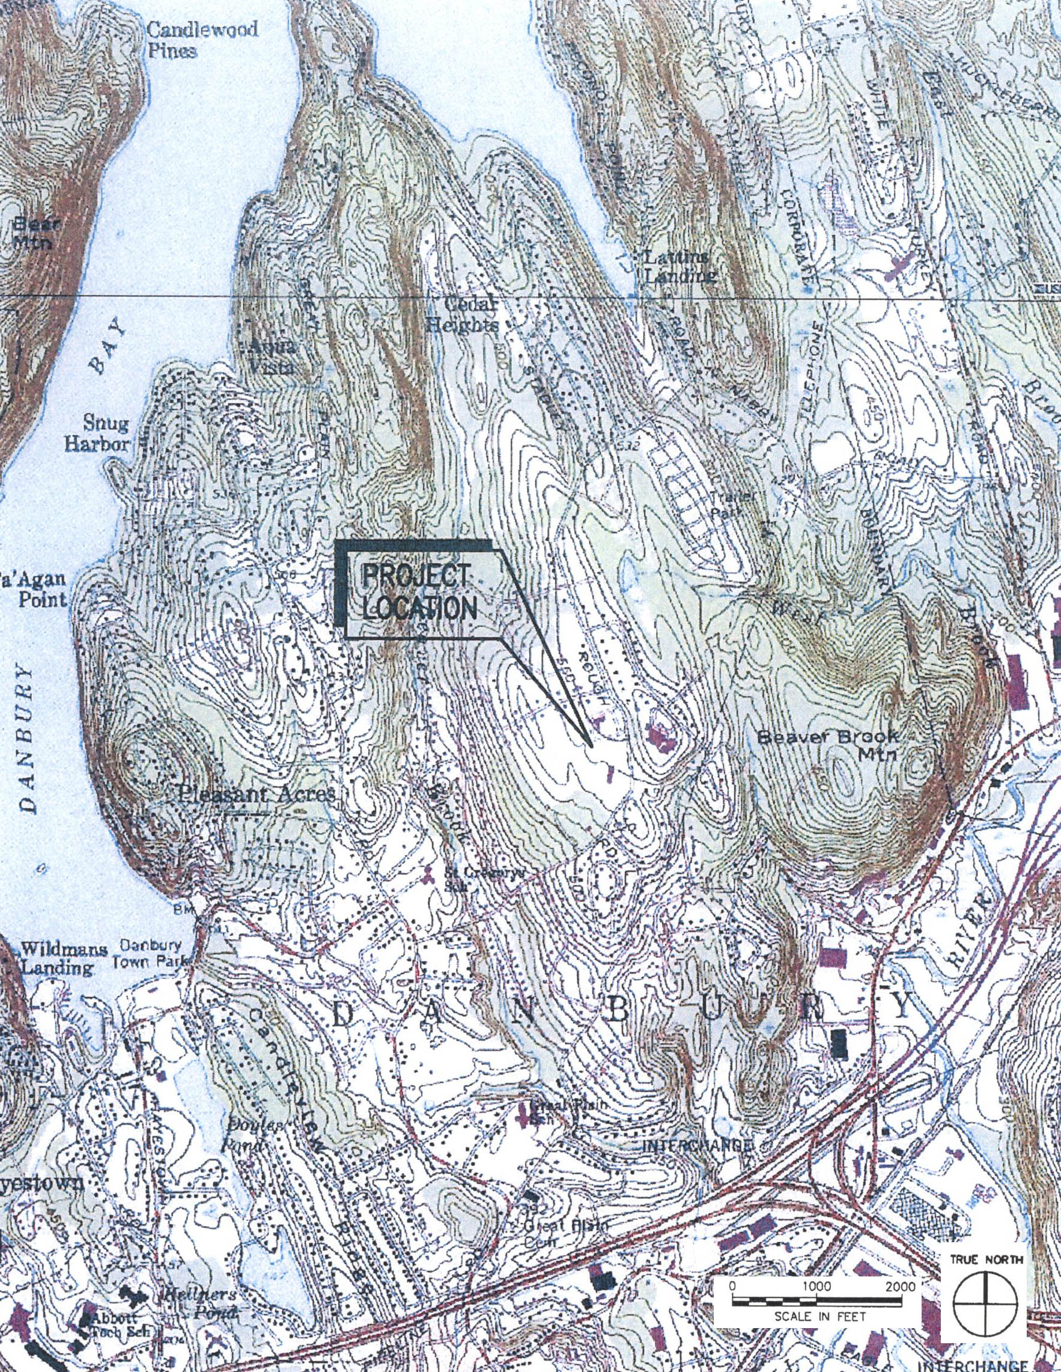
(Applicants 1, Attachment 4)

Figure 2: Aerial Photograph of Proposed Site
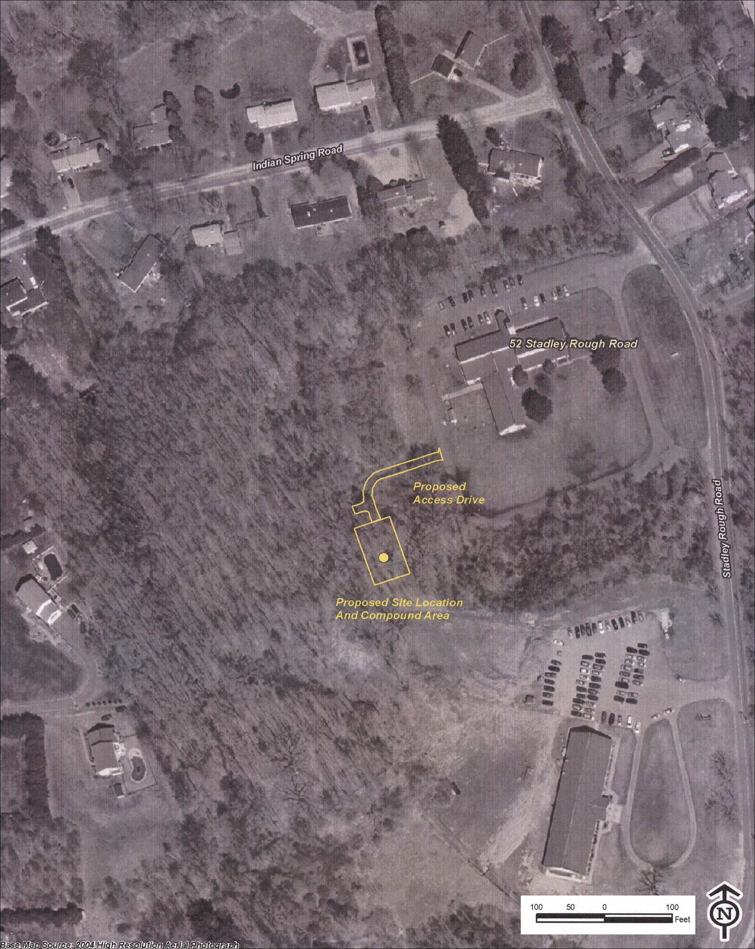
(Applicants 12, Attachment 2)

Figure 3: Site Plan for Proposed Facility
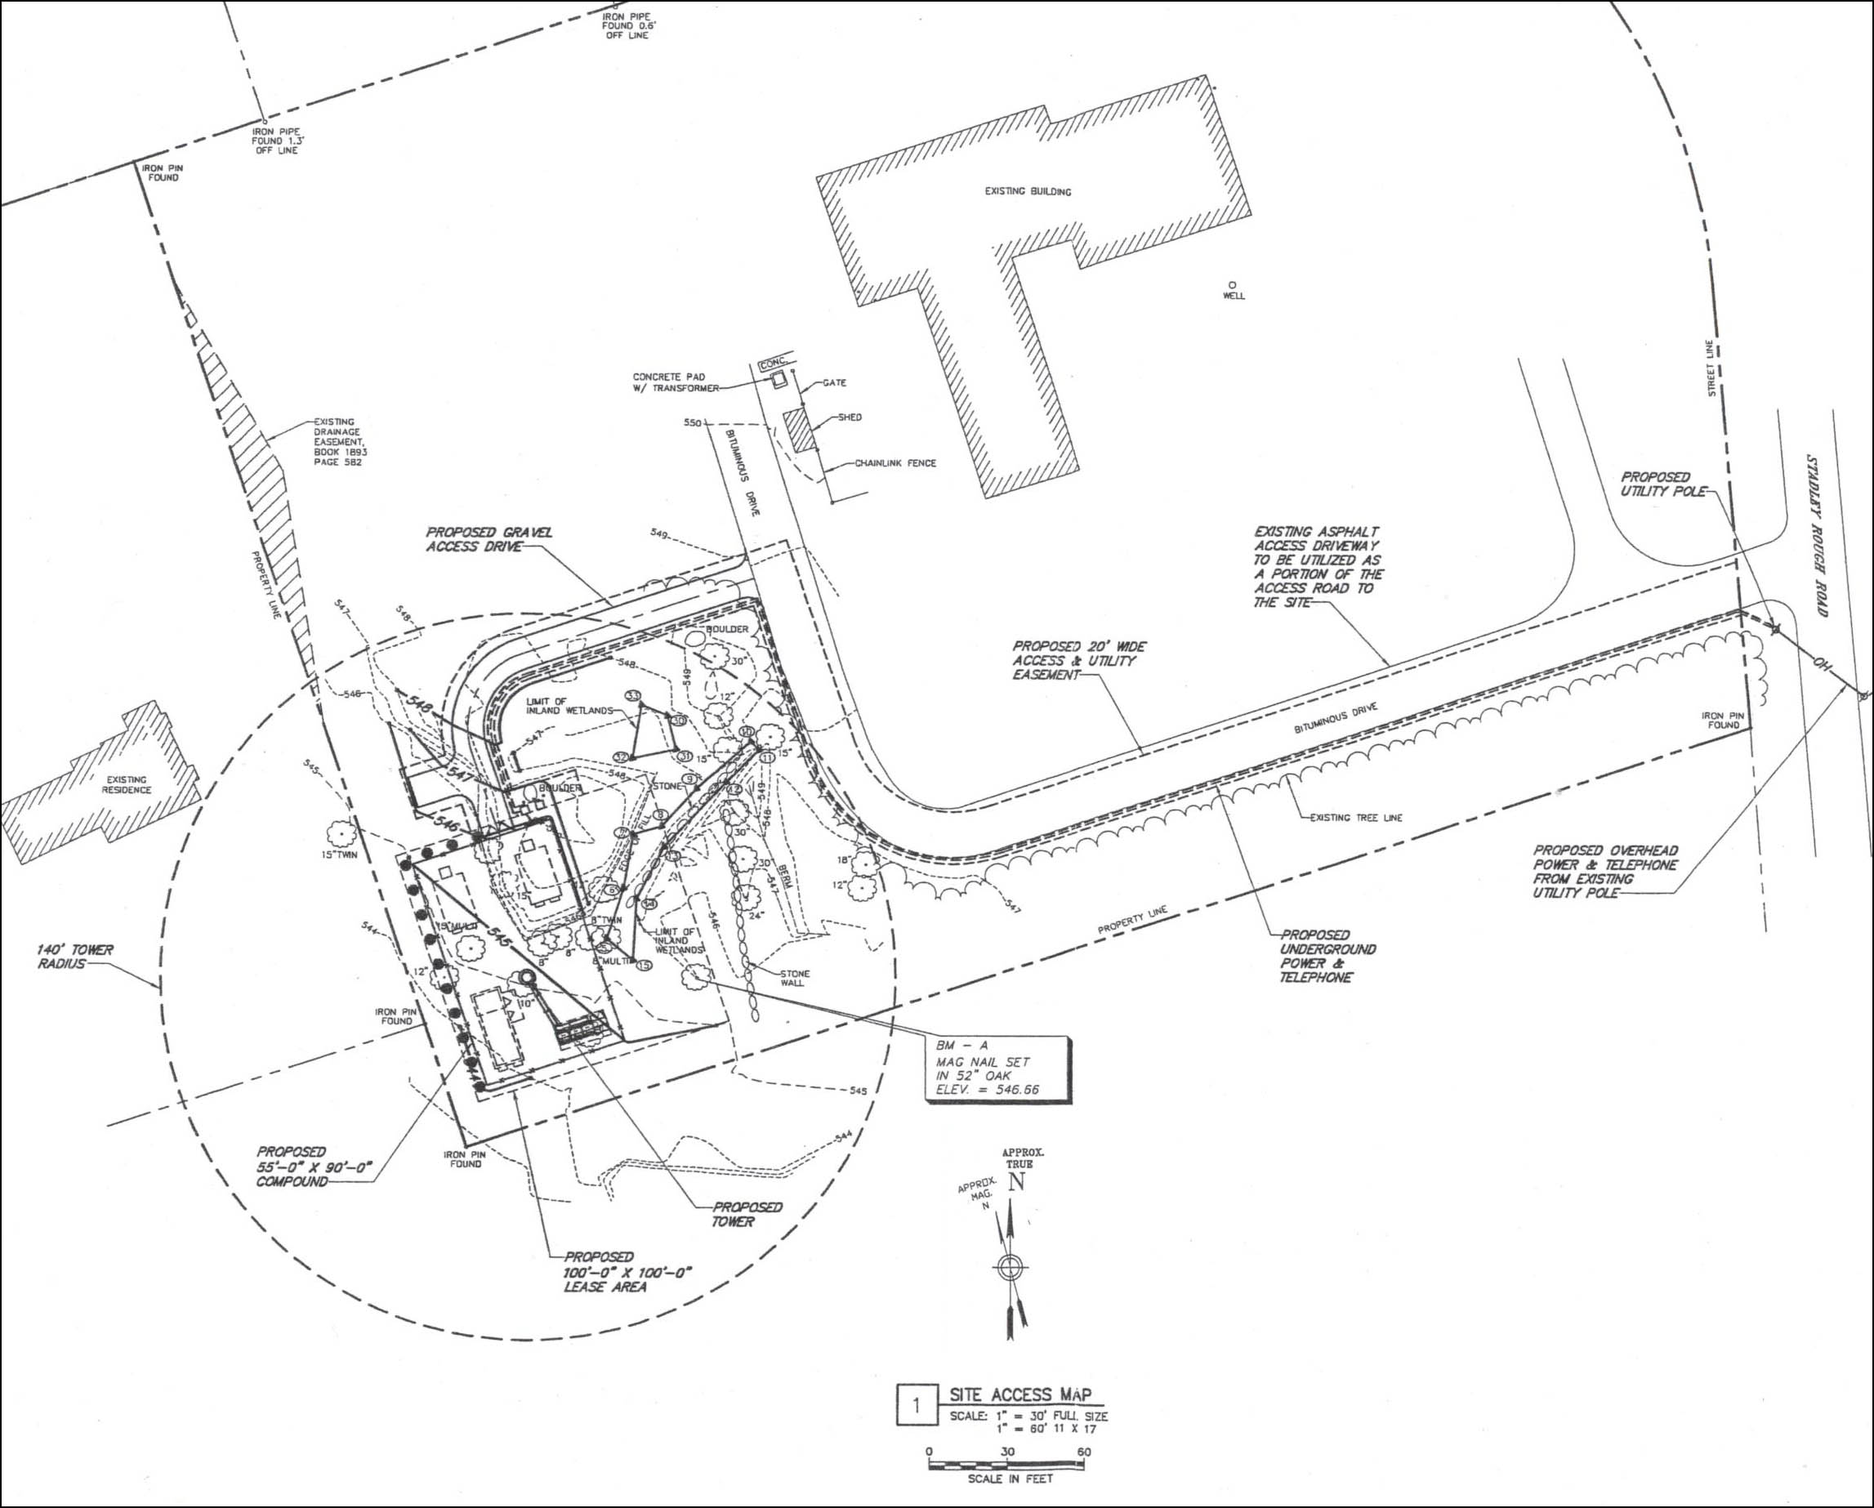
(Applicants 1, Attachment 4,Sheet Number A02)

Figure 4: T-Mobile Existing Coverage in Vicinity of Proposed Facility
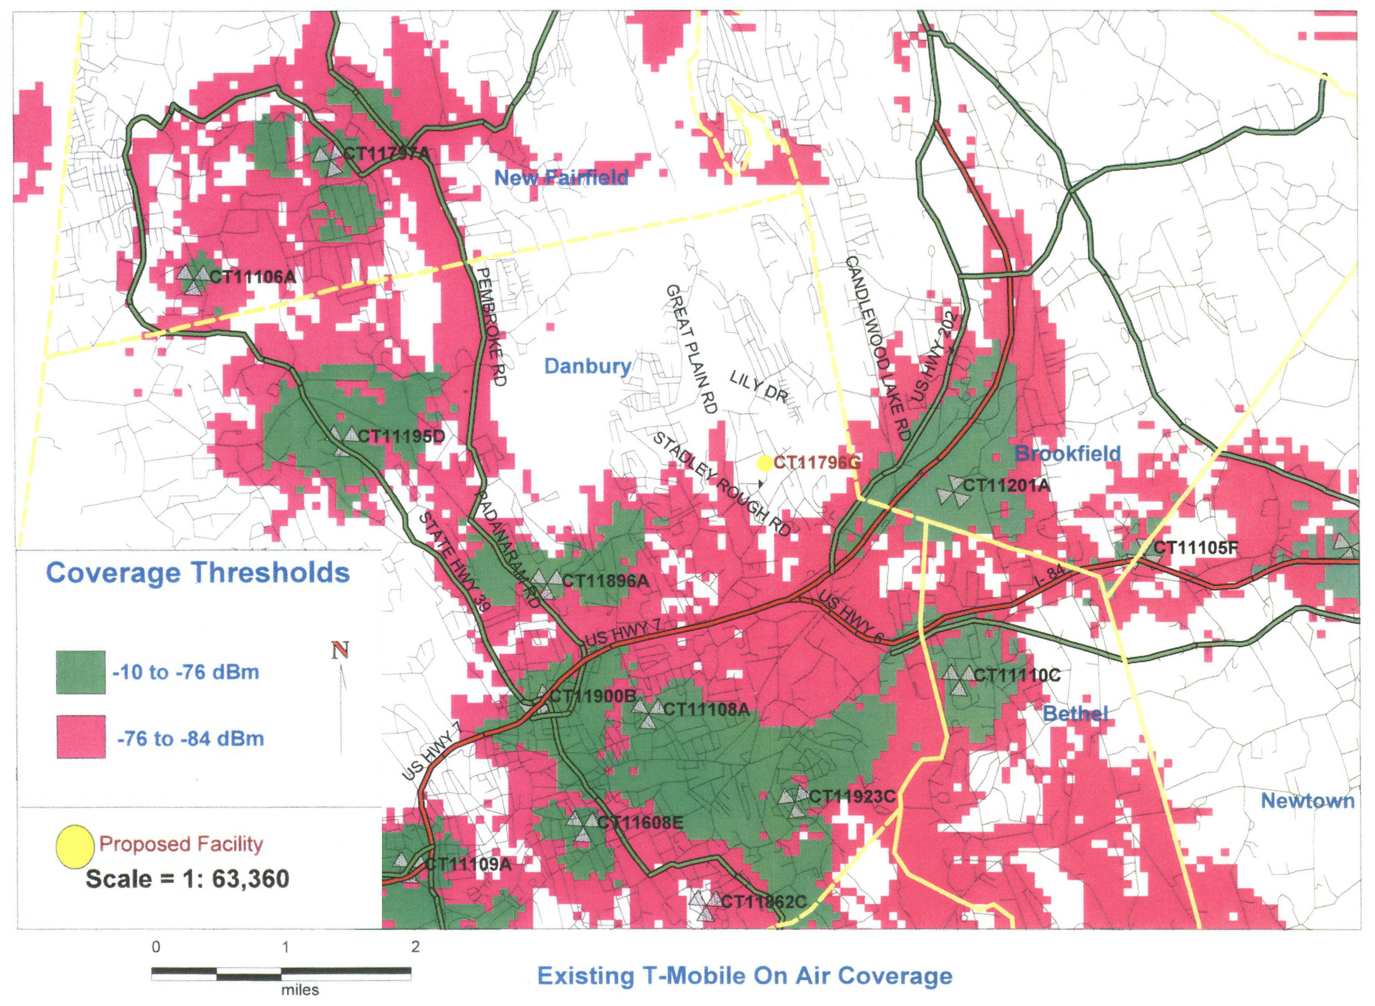
(Applicants 1, Attachment 2)

Figure 5: T-Mobile Coverage from Proposed Site @ 137’ AGL
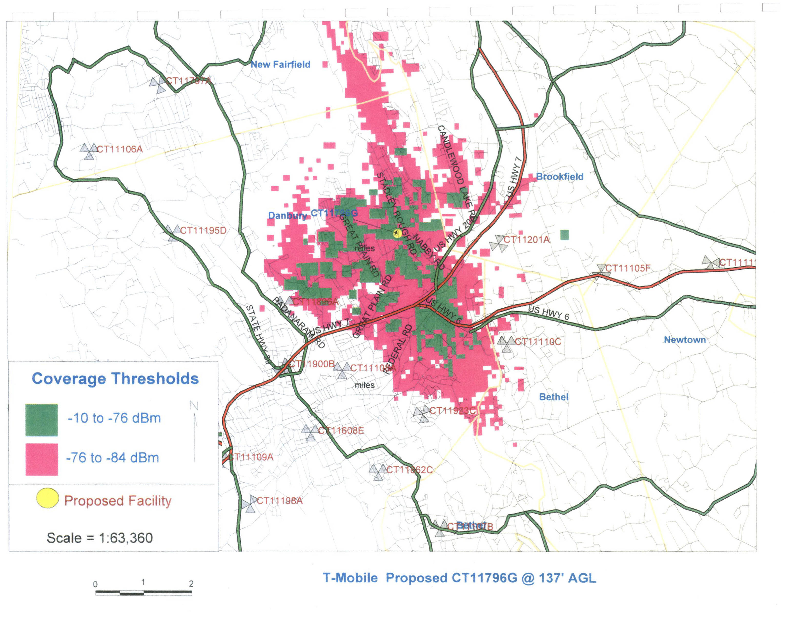
(Applicants 1, Attachment 2)

Figure 6: T-Mobile Coverage from DOT Property @ 170’ AGL
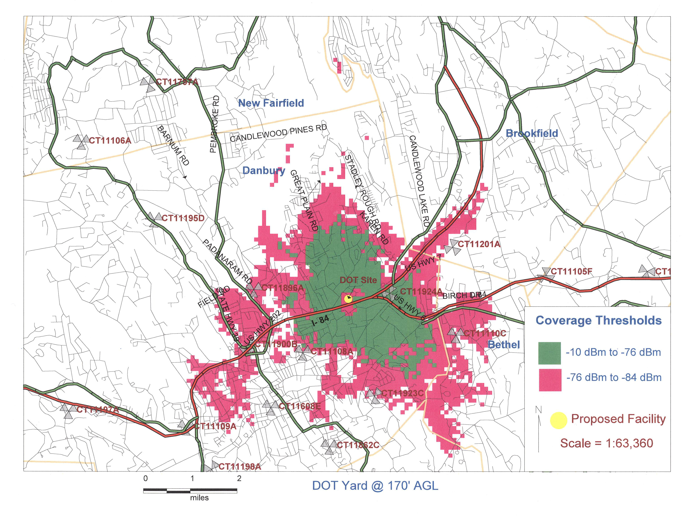
(Applicants 13, Attachment 1)

Figure 7: T-Mobile Coverage from Sterling Woods Condominium Water Tank @ 95’ AGL
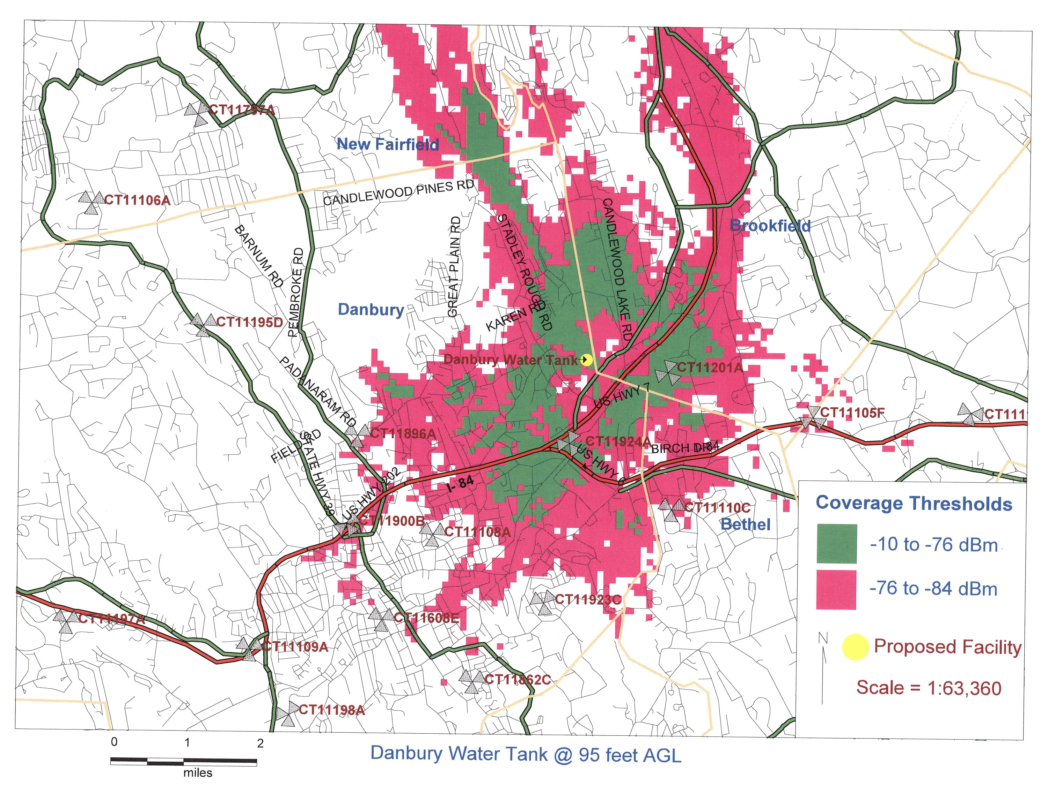
(Applicants 13, Attachment 1)

Figure 8: T-Mobile Coverage from Kaufman Property
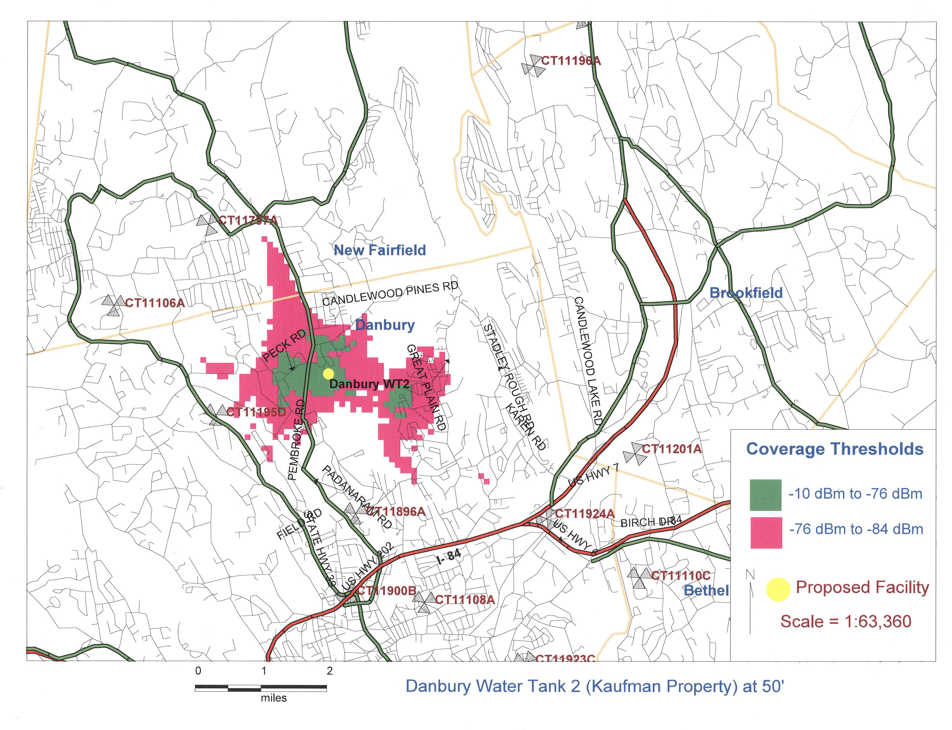
(Applicants 13, Attachment 1)

Figure 9: T-Mobile Coverage from Police Athletic League Property, 35 Hayestown Road
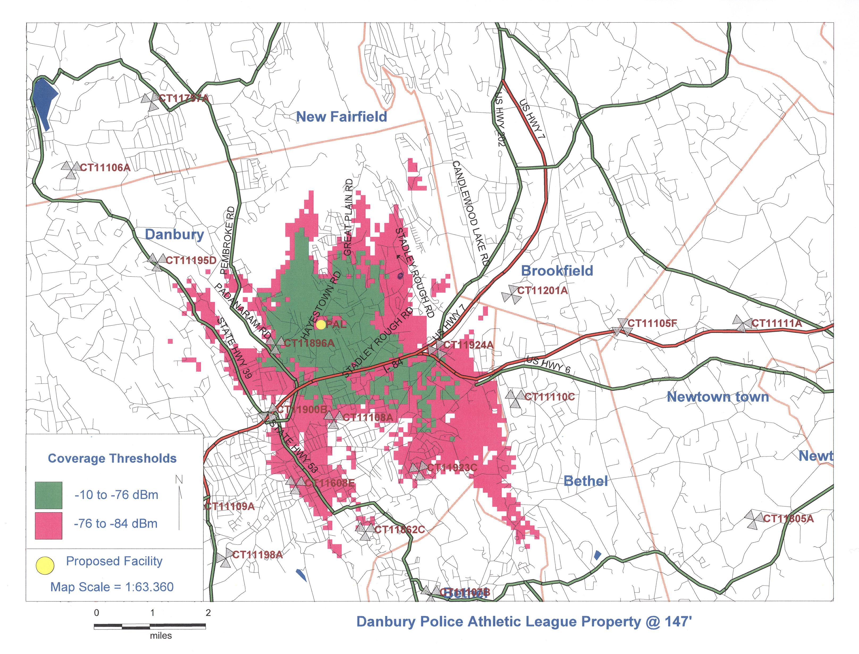
(Applicants 13, Attachment 1)

Figure 10: T-Mobile Coverage from 82 Stadley Rough Road
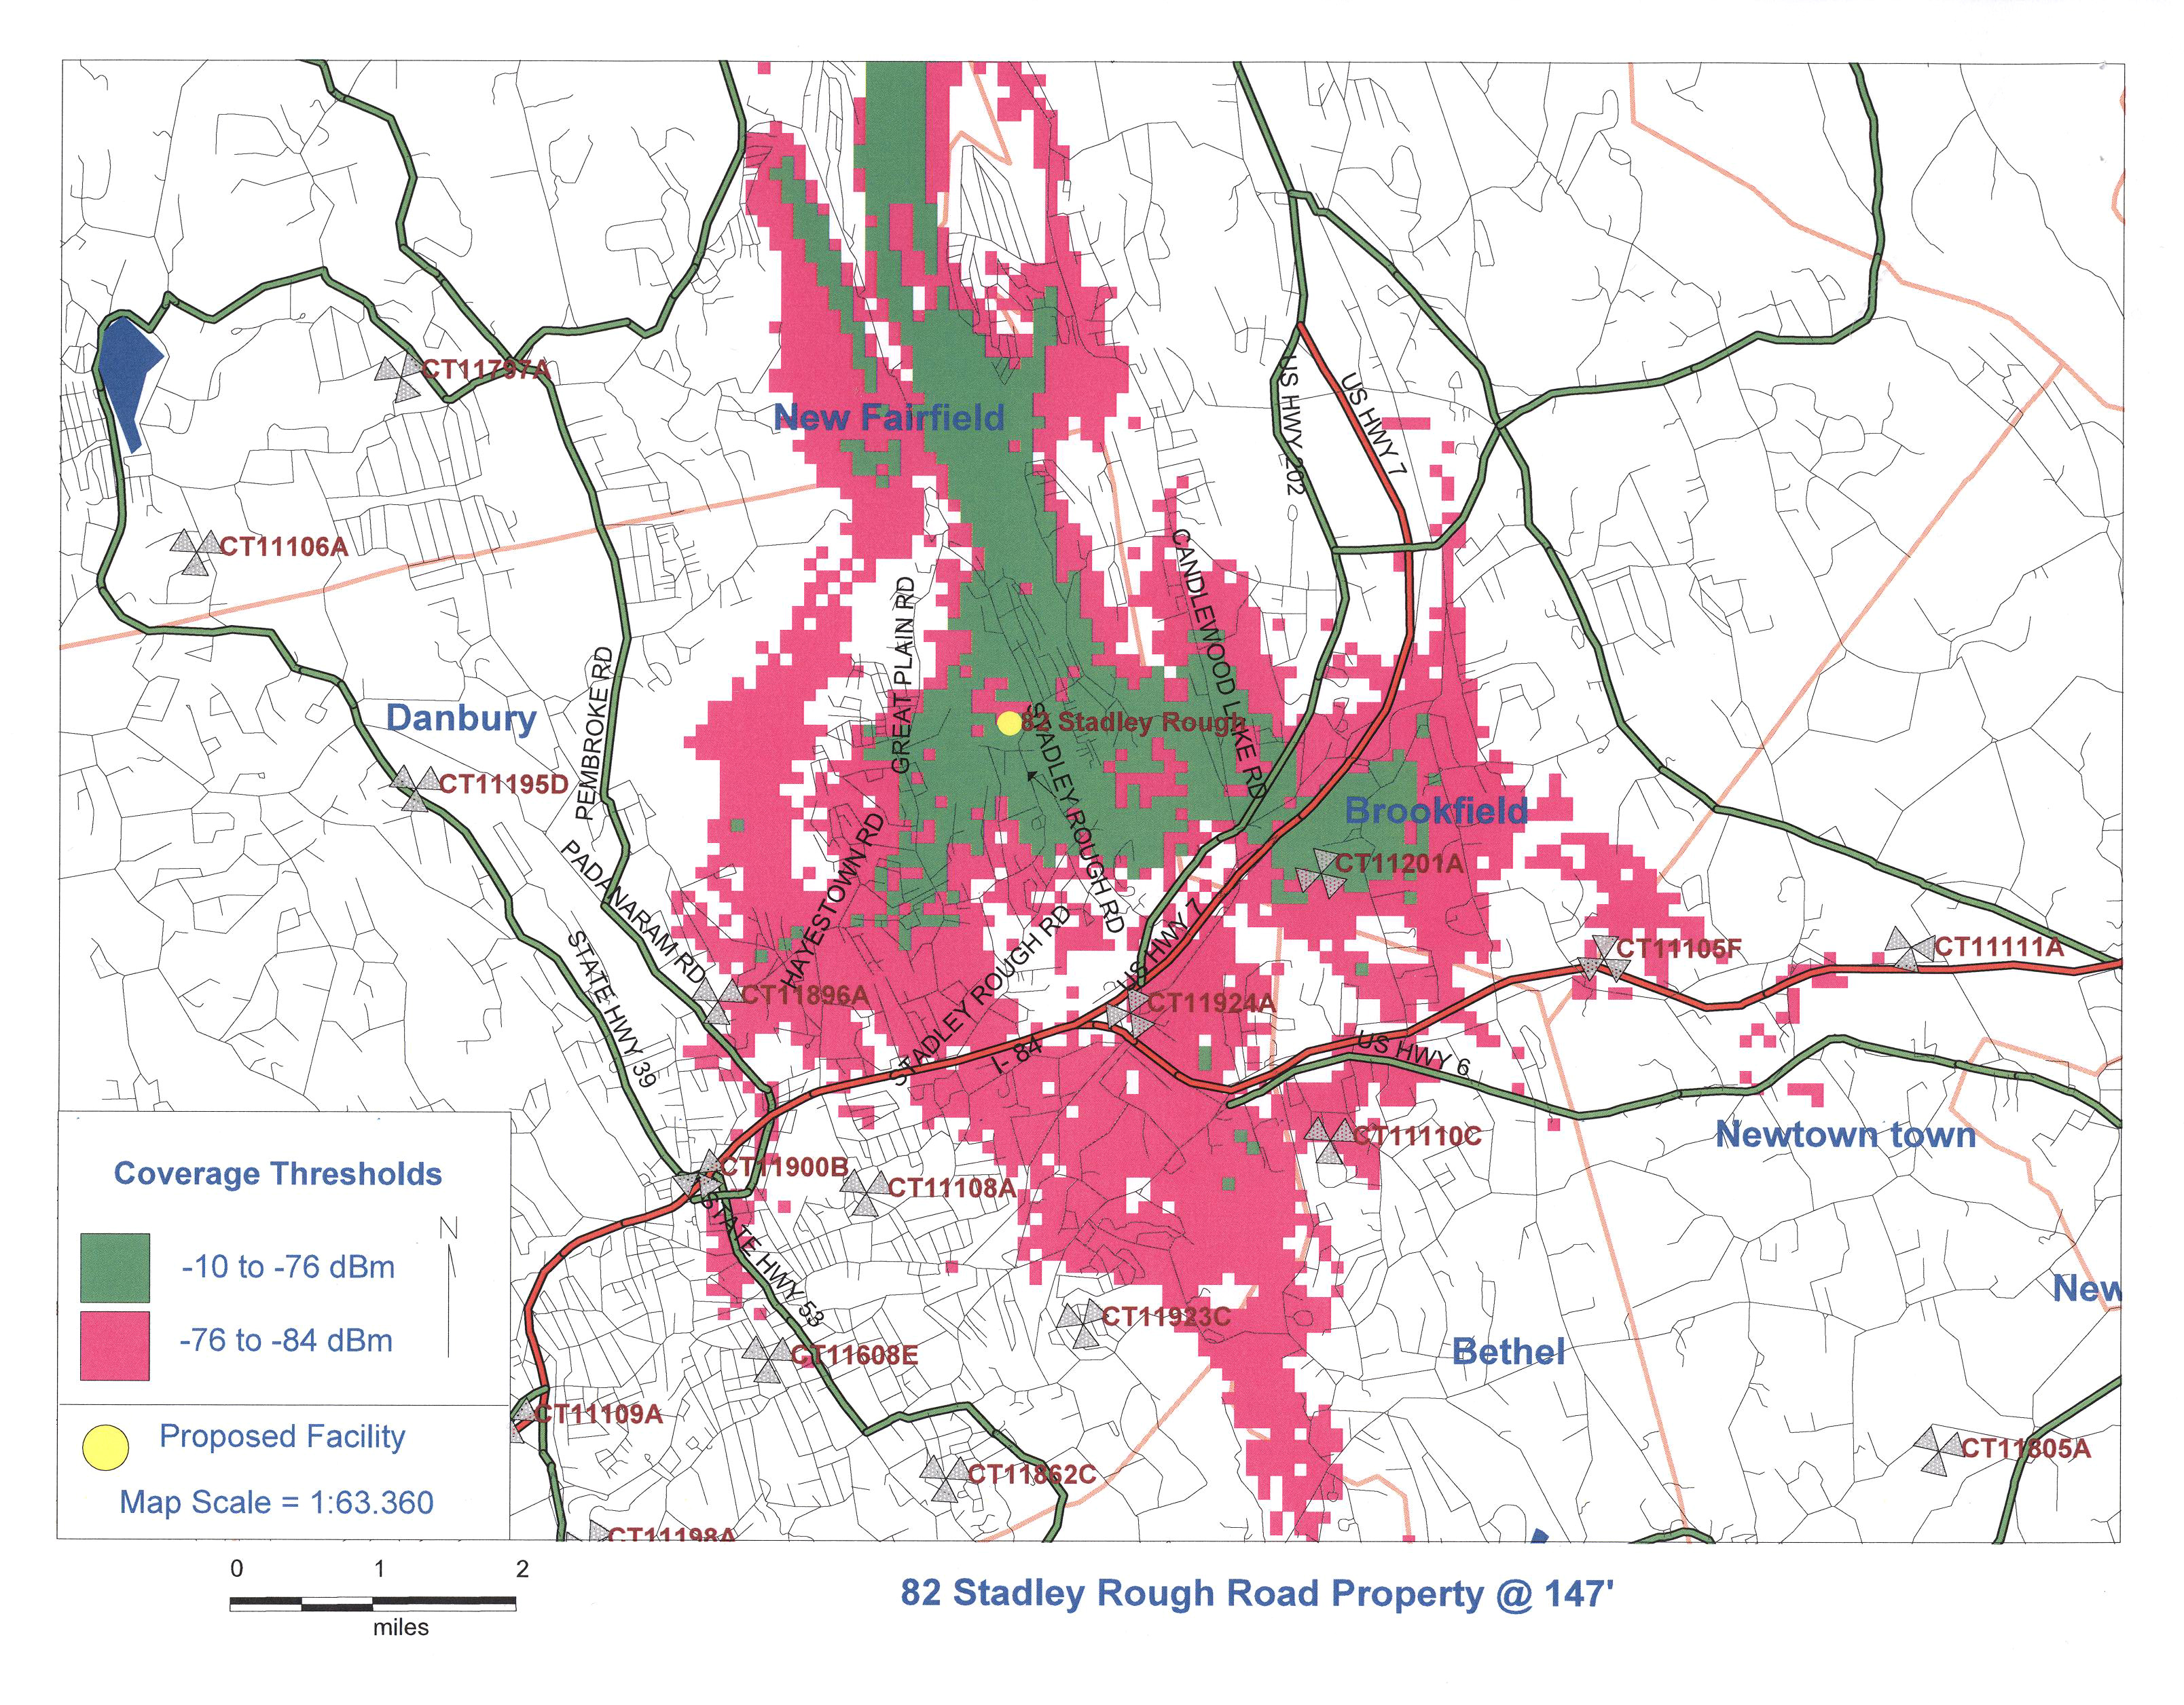
(Applicants 13, Attachment 3)

Figure 11: T-Mobile Coverage from 52 Stadley Rough Road and St. Nicholas Church
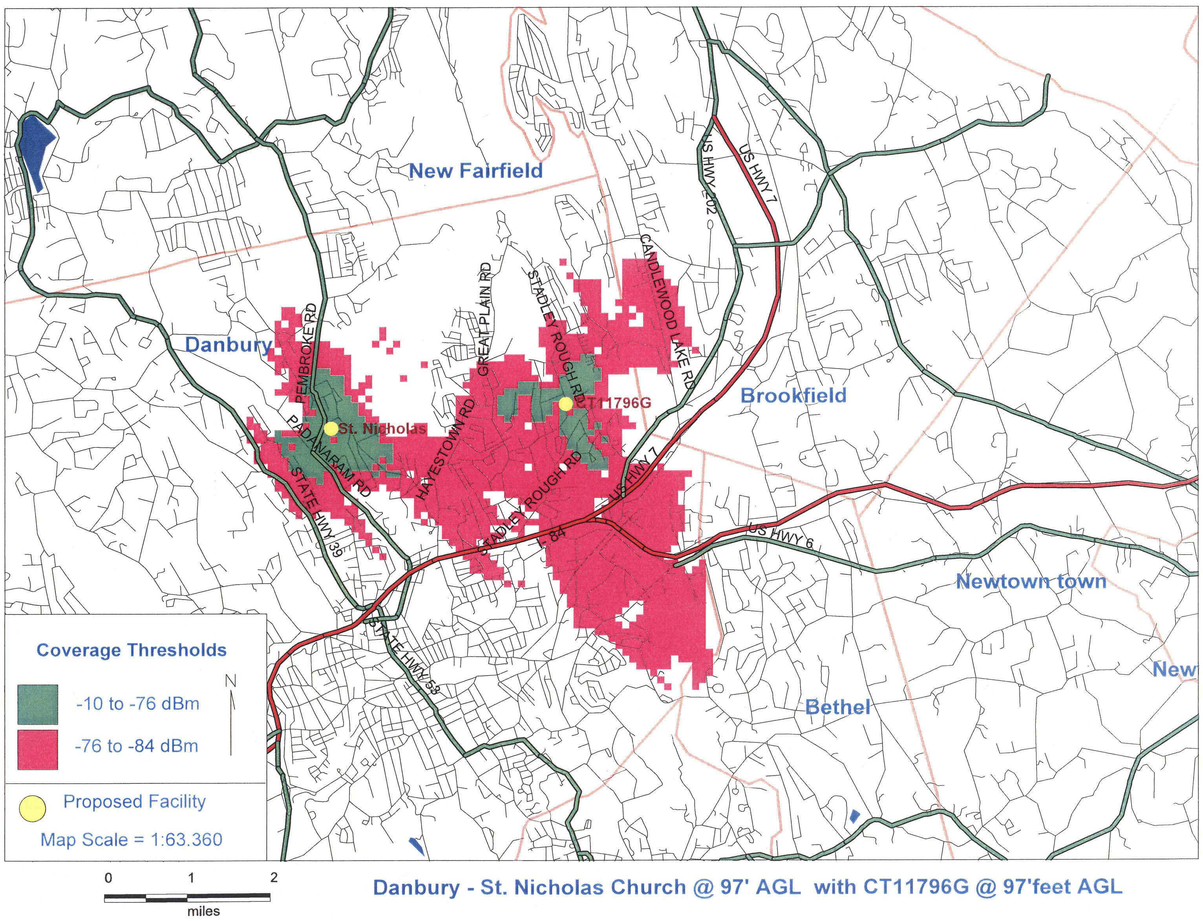
(Applicants 8, Exhibit A)

Figure 12: T-Mobile Coverage from 52 Stadley Rough Road and Northeast Baptist Church
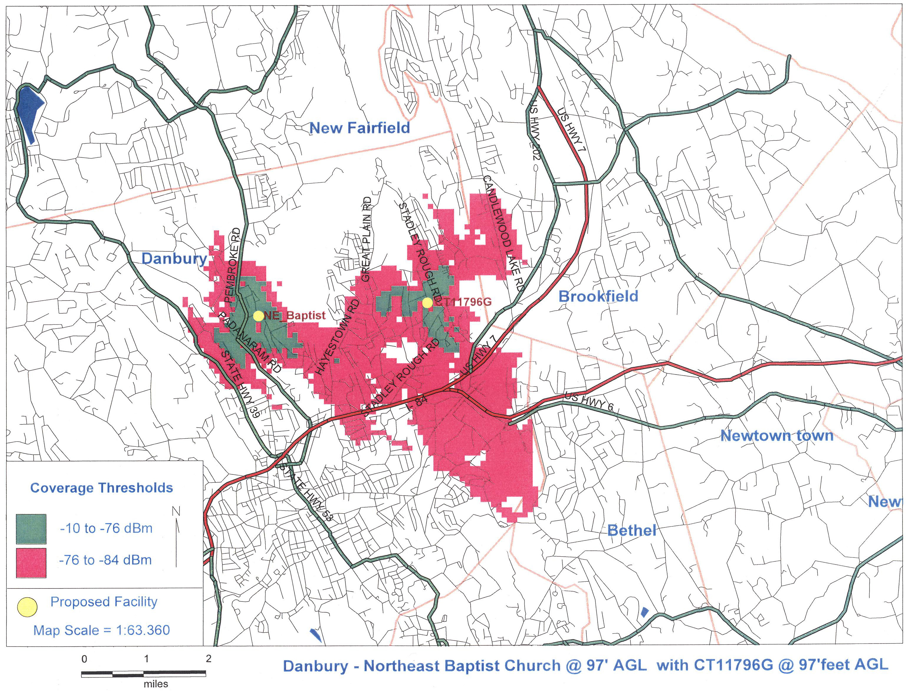
(Applicants 8, Exhibit A)

Figure 13: Visibility Map for 52 Stadley Rough Road Facility
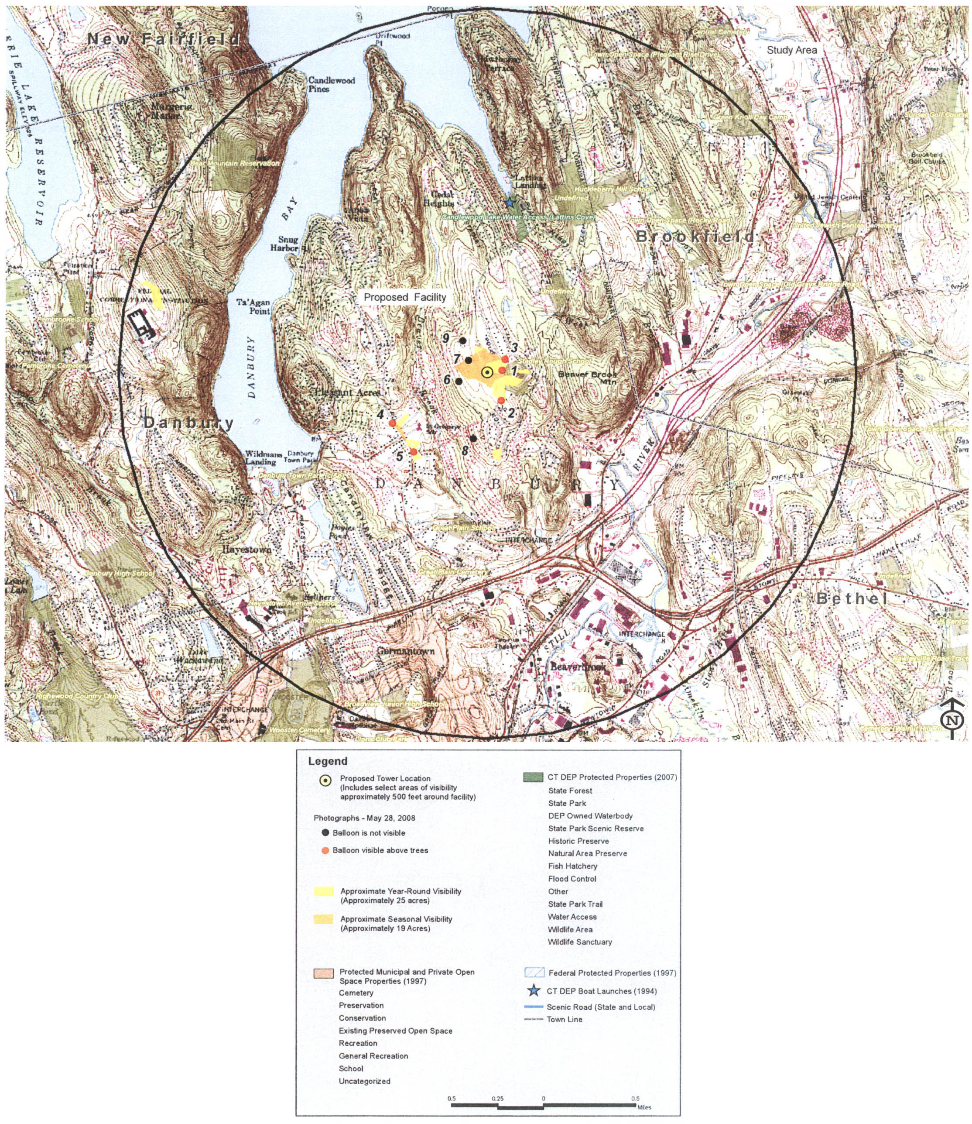
(Applicants 1, Attachment 5)

