DOCKET NO. 365 - Optasite Towers LLC and Omnipoint Communications, Inc. application for a Certificate of Environmental Compatibility and Public Need for the construction, maintenance and operation of a telecommunications facility located at 39 Maennerchor Avenue, in the Taftville section of Norwich, Connecticut. | }  }  } | Connecticut  Siting  Council  November 20, 2008

Findings of Fact

Introduction

- Pursuant to Chapter 277a, Sections 16-50g et seq. of the Connecticut General Statutes (CGS), as amended, and Section 16-50j-1 et. seq. of the Regulations of Connecticut State Agencies (RCSA), Optasite Towers LLC (Optasite) and Omnipoint Communications, Inc. (T-Mobile) applied to the Connecticut Siting Council (Council) on June 11, 2008 for the construction, operation, and maintenance of a telecommunications facility to be located at 39 Maennerchor Avenue in the Taftville section of the City of Norwich, Connecticut. (Applicants 1, p. 1)

- Optasite is a Delaware limited liability company with offices at One Research Drive, Suite 200C, Westborough, Massachusetts. It would be the Certificate holder and be responsible for constructing and maintaining the proposed facility. (Applicants 1, p. 2)

- T-Mobile is a Delaware corporation with a Connecticut office at 35 Griffin Road South, Bloomfield, Connecticut. The company and its affiliated entities are licensed by the Federal Communications Commission (FCC) to construct and operate a personal wireless services system in Connecticut. T-Mobile does not conduct any other business in the State of Connecticut other than the provision of wireless services under FCC rules and regulations. (Applicants 1, p. 3)

- The parties in this proceeding are the applicants, Optasite and T-Mobile. (Transcript, September 2, 2008, 3:00 p.m. [Tr. 1], p. 5)

- The proposed facility would provide service along State Highway 12, State Highway 97, State Highway 169, and within the Taftville section of Norwich. (Applicants 1, p. 1; Applicants 3, A21)

- Pursuant to CGS § 16-50m, the Council, after giving due notice thereof, held a public hearing on August 21, 2008, beginning at 3:00 p.m. and continuing at 7:00 p.m. in Room 335 of the Norwich City Hall, 100 Broadway, Norwich, Connecticut. (Tr. 1, p. 2 ff.)

- The Council and its staff conducted an inspection of the proposed site on August 21, 2008 beginning at 2:00 p.m. On the day of the field inspection, the applicants flew a balloon from approximately 8:00 a.m. to 6:00 p.m. to simulate the height of the proposed tower. The weather conditions were excellent for the balloon flight. (Tr. 1, pp. 15-16)

- The applicants conducted a supplemental balloon float on Tuesday, September 30, 2008. The balloon was raised at approximately 3:45 p.m. and remained continuously aloft until approximately 7:05 p.m. at the tower’s proposed height of 120 feet. (Applicants’ Affidavit Regarding Balloon Height dated October 2, 2008)

- Pursuant to CGS § 16-50l(b), notice of the applicants’ intent to submit this application was published on June 4 and 5, 2008 in the Norwich Bulletin. (Applicants 9 – Norwich Bulletin Affidavit of Publication dated June 5, 2008)

- In accordance with CGS § 16-50l(b), Optasite sent notices of its intent to file an application with the Council to each person appearing of record as owner of property abutting the property on which the site is located. (Applicants 1, pp. 4-5, Exhibit F)

- Optasite received certified mail receipts from all abutting property owners to whom notice was sent. (Applicants 2, Response 1)

- Pursuant to CGS § 16-50l (b), Optasite provided notice to all federal, state, regional, and local officials and agencies listed therein. (Applicants 1, p. 4, Exhibit D)

- On August 7, 2008, Optasite posted a sign on the 39 Maennerchor Avenue property informing the public of its pending application, including the height of the proposed tower the time, date, and location of the public hearing on the application, and contact information for the Council. (Applicants 4, Answer to Q8, Exhibit 1)

State Agency Comments

- Pursuant to CGS § 16-50l, the Council solicited comments on this application from the following state departments and agencies: Department of Environmental Protection (DEP), Department of Public Health, Council on Environmental Quality, Department of Public Utility Control, Office of Policy and Management, Department of Economic and Community Development, and the Department of Transportation. The Council’s letters requesting comments were sent on July 25, 2008 and August 22, 2008. (CSC Hearing Package dated July 25, 2008; Letter to State Department Heads dated August 22, 2008)

- The Connecticut Department of Transportation responded to the Council’s solicitation with no comments. (Letter from Connecticut Department of Transportation dated August 11, 2008)

- Other than the Department of Transportation, the Council did not receive any comments from state agencies. (Record)

Municipal Consultation

- On June 28, 2007, Optasite submitted a letter and a technical report with information about the proposed facility to the City of Norwich. (Applicants 1, p. 18)

- On August 20, 2007, Optasite representatives met with the Norwich City Council to discuss the proposed facility. The City Council requested that Optasite investigate several other alternate sites, including Mohegan Park and transmission lines in the area of the proposed facility. Optasite investigated the sites suggested by the City Council and determined that they would not provide coverage to T-Mobile’s target area. (Applicants 1, p. 18; Applicants 2, Response 6; Tr. 1, pp. 39-40 )

- Optasite representatives also contacted the Norwich City Attorney in May, 2008 as an additional follow-up. (Applicants 1, p. 18)

- The Norwich Fire Department has notified Optasite of its interest in locating antennas on the proposed tower. (Applicants 2, Response 8, Exhibit 1)

- The Norwich Police Department has expressed an interest in locating antennas on the proposed tower. (Tr. 1, p. 10)

Public Need for Service

- In 1996, the United States Congress recognized a nationwide need for high quality wireless telecommunications services, including cellular telephone service. Through the Federal Telecommunications Act of 1996, Congress seeks to promote competition, encourage technical innovations, and foster lower prices for telecommunications services. (Council Administrative Notice Item No. 7)

- In issuing cellular licenses, the Federal government has preempted the determination of public need for cellular service by the states, and has established design standards to ensure technical integrity and nationwide compatibility among all systems. (Council Administrative Notice Item No. 7)

- The Telecommunications Act of 1996 prohibits local and state bodies from discriminating among providers of functionally equivalent services. (Council Administrative Notice, Telecommunications Act of 1996)

- The Telecommunications Act of 1996 prohibits any state or local agency from regulating telecommunications towers on the basis of the environmental effects of radio frequency emissions to the extent that such towers and equipment comply with FCC’s regulations concerning such emissions. This Act also blocks the Council from prohibiting or acting with the effect of prohibiting the provision of personal wireless service. (Council Administrative Notice, Telecommunications Act of 1996)

- In an effort to ensure the benefits of wireless technologies to all Americans, Congress enacted the Wireless Communications and Public Safety Act of 1999 (the 911 Act). The purpose of this legislation was to promote public safety through the deployment of a seamless, nationwide emergency communications infrastructure that includes wireless communications services. (Applicants 1, p. 6)

- As an outgrowth of the 911 Act, the Federal Communications Commission (FCC) required wireless carriers to provide enhanced 911 (E911) services as part of the communications networks. (Applicants 1, p. 7)

- The proposed facility would be an integral component of T-Mobile’s E911 network. (Applicants 1, p. 7)

- Optasite has received an application from New Cingular Wireless PCS (AT&T) for locating antennas on the proposed tower. AT&T would locate its antennas at a centerline height of 107 feet. (Applicants 2, Response 9; Applicants 2, Exhibit 2; Tr. 1, pp. 18-19)

- Optasite would allow the City of Norwich to use the proposed tower for no charge. (Applicants 2, Response 10)

Site Selection

- T-Mobile initiated a search ring for a facility in this area on April 22, 2005. The site search area centered on the intersection of Routes 12, 97, and 169 in Norwich. The diameter of the search ring was two miles. (Applicants 3, A13, Attachment A)

- Optasite assumed site search responsibilities from T-Mobile and commenced its activities in December, 2005. (Applicants 2, Response 12)

- Optasite identified 13 communications towers, either existing or proposed, within approximately four miles of its proposed site. None of these towers would provide adequate coverage in T-Mobile’s target area. The towers are listed in the following table. Of the towers listed, T-Mobile has antennas on the towers at: 1 Chestnut Street at a centerline height of 84 feet, 50 Clinton Avenue at a centerline height of 150 feet, 2 Hinckley Hill Road at a centerline height of 150 feet, and 20 Nygren Road (26 Mell Road) at a centerline height of 195 feet. (table continued on next page)

Tower Location | Height and Type  of Tower | Tower Owner | Approx. Distance and Direction
1 Chestnut Street,  Norwich | 81’, lattice tower on building top | SNET | 2.6 miles to SW
50 Clinton Avenue,  Norwich | 150’, monopole | T-Mobile | 3.1 miles to W
2 Hinckley Hill Road, Norwich | 140’, lattice tower | Cordless Data  Transfer | 3.1 miles to S
292 Plain Hill Road,  Norwich | 180’, monopole | SBA Properties | 3.1 miles to W
1 Cuprak Road,  Norwich | 356’, guyed lattice | WICH | 1.3 miles to SW
1 Cuprak Road,  Norwich | 356’, guyed lattice | WICH | 1.3 miles to SW
1 Cuprak Road,  Norwich | 356’, guyed lattice | WICH | 1.3 miles to SW

Tower Location | Height and Type  of Tower | Tower Owner | Approx. Distance and Direction
413 Plain Hill Road, Norwich | 305’, guyed lattice | Comcast | 3.4 miles to NW
20 Nygren Road, (26 Mell Road), Lisbon | 195’, monopole | SBA | 2.8 miles to NE
21 Nygren Road, (20 Mell Road), Lisbon | 180’, monopole | SBA | 2.8 miles to NE
446 North Main Street,  Norwich | 50’, rooftop lattice | Norwich Fire Dept | 1.7 miles to S
446 Plain Hill Road,  Norwich | 100’, lattice tower | State of Connecticut | 3.6 miles to NW
442 Plain Hill Road,  Norwich | 100’, monopole | E. Wisneske | 3.6 miles to NW
(Applicants 1, Exhibit H; Applicants 2, Response 15)

- T-Mobile would have to locate antennas at 250 feet above ground level (agl) on the AM towers at 1 Cuprak Road in order to reach its target area due to the terrain between the towers and the target area. Antennas at this height would cause interference concerns with T-Mobile’s existing sites and redundant coverage along the I-395 corridor. (Applicants 3, A30)

- During its initial search for a facility location, Optasite considered several other properties in addition to the proposed site. These properties and assessments of their suitability are listed in the table below (table continued on next page):

Location Considered | Suitability
72 Jewett City Road, Norwich | Planned expansion of Bob’s Discount Furniture property precluded ability to locate facility at this location
768 Boswell Avenue (two properties), Norwich | These properties are cemeteries and owner was not interested in leasing space for cell tower
15 Bolduc Lane, Norwich | Property is only ¼ acre in size and has no natural screening on it
139 Norwich Avenue, Norwich | Not enough available ground space for facility on site
20 Norwich Avenue, Norwich | Not enough available ground space for facility on site
30 Hunters Road, Norwich | Property owners not interested in leasing space for cell tower
44 Norwich Avenue, Norwich | Property is mobile home park, and tower at this location would impact large number of residences
68 Roosevelt Avenue, Preston | Property is too far from target area to provide adequate coverage
72 Roosevelt Avenue, Preston | Property is too far from target area to provide adequate coverage

Location Considered | Suitability
Rockwell Street, Norwich | Inadequate coverage from site
197 Old Canterbury Turnpike, Norwich | Inadequate coverage from site
167 Merchants Avenue, Norwich | Inadequate coverage from site
555 Norwich Avenue, Norwich | Inadequate coverage from site
Mohegan Park Road, Norwich | Inadequate coverage from site
652 River Road, Lisbon (power mount) | Inadequate coverage from site
Utility poles in area | Inadequate coverage from site
(Applicants 1, Exhibit H)

- At the suggestion of the Norwich City Council, Optasite investigated a site in Mohegan Park in Norwich. This site was rejected by T-Mobile because it was too far to the west and signals from here would not extend over a hill to provide coverage along Routes 12, 97, and 169. (Applicants 2, Response 7; Tr. 1, p. 21)

- Optasite explored the possibility of co-locating on CL&P transmission line structures in the area or leasing property from CL&P to construct a new tower. T-Mobile rejected locating its antennas on the existing transmission line structures because they were not high enough to successfully cover the target area. Optasite was also unable to reach an agreement with CL&P to build a tower on property owned by the utility. (Applicants 2, Response 7)

- Repeaters, microcell transmitters, distributed antenna systems and other types of transmitting technologies are not a practicable or feasible means to provide service within the coverage gap T-Mobile is seeking to cover due to significant terrain variations and tree cover in the area, as well as other practical considerations. (Applicants 1, pp. 7-8)

Site Description

- Optasite’s proposed facility is located on a seven-acre property at 39 Maennerchor Avenue. The property is owned by Maennerchor Club, which has its club building on the property. The rest of the property is undeveloped. The site of the proposed facility is approximately 750 feet northwest of the intersection of Routes 12 and 97 in the Taftville section of Norwich. (Applicants 1, p. 2; Exhibit B)

- The Maennerchor Club property is located within an R-20 residential district. The City of Norwich’s zoning regulations explicitly do not regulate wireless communications towers that come under the Council’s jurisdiction. (Applicants 1, pp. 15-16)

- On the Maennerchor Club property, Optasite would lease a 70-foot by 70-foot parcel within which it would develop a 65-foot by 65-foot compound, including a 120-foot monopole tower. The compound would be enclosed by an eight-foot high chain link fence. (Applicants 1, p. 9; Exhibit B, Compound Plan)

- The tower would be located at 41º 33’ 30.5” north latitude and 72º 3’ 4.6” west longitude. Its ground elevation would be 155 feet above mean sea level. (Applicants 1, Exhibit P; Exhibit A, Sheet A02)

- Optasite’s tower would be designed in accordance with the specifications of the Electronic Industries Association Standard ANSI/TIA-222-G “Structural Standards for Steel Antenna Towers and Antenna Support Structures” in accordance with the International Building Code. The diameter of the tower at its top would be approximately 24 inches and at its base approximately 44 inches. The tower would be designed to accommodate the antennas of four wireless carriers and the antennas of the City of Norwich’s emergency services, if requested. (Applicants 1, pp. 9-10; Applicants 2, Response 2)

- Optasite would design its tower to be extendable by 30 feet, as is its customary practice. (Tr. 1, pp. 29, 79)

- T-Mobile would initially install three antennas, one per 120 degree sector at a centerline height of 117 feet agl. It could install a total of up to nine antennas (three antennas per sector) based upon future demand. (Applicants 1, p. 9; Tr. 1, p. 17)

- T-Mobile would mount its antennas on a low profile platform. (Tr. 1, p. 17)

- T-Mobile could mount antennas on T-arm mounts without affecting coverage from the site. T-arm mounts, however, would affect the site’s capacity. The same is true if T-Mobile were to flush-mount its antennas. (Tr. 1, pp. 80-81)

- Limiting antenna installations to flush-mounting could require some carriers to need two different elevations for their antennas. (Tr. 1, p. 81)

- T-Mobile would use batteries as back up power at this facility. (Applicants 3, A16)

- Site development would require approximately 236 cubic yards of cut and 122 cubic yards of fill. (Applicants 2, Response 4)

- Vehicular access to the facility would extend from Beauregard Street along a proposed gravel driveway for a distance of approximately 363 feet. (Applicants 1, p. 10)

- The access road would be laid out to avoid a small knoll that has a significant quantity of ledge visible. (Tr. 1, p. 68)

- Utility service for the facility would extend underground from Beauregard Street and would follow the access driveway to the facility compound. (Applicants 1, p. 10; Exhibit B, Sheet A02)

- Exposed ledge is visible on the host property so it is possible that ledge could be encountered during excavation for the facility. The presence of ledge would be confirmed by a geotechnical investigation. Should ledge be encountered, chipping would be preferred to blasting. (Applicants 2, Response 5)

- The tower’s setback radius would be contained within the limits of the Maennerchor Club property. (Applicants 1, Exhibit B, Sheet A02)

- There are 70 residences within 1,000 feet of the proposed tower. (Applicants 1, Exhibit B)

- The nearest residence is located 200 feet to the north of the proposed tower at 24 Beauregard Street. It is owned by Kevin C. Godaire. (Applicants 1, Exhibit B; Applicants 2, Response 3)

- Land use in the vicinity of the proposed facility consists of medium-density residential parcels with some commercial establishments along Route 12 to the east and south. (Applicants 1, Exhibit J, p. 1)

- Optasite’s estimated cost of construction for the proposed facility, not including carriers’ antennas and support equipment, is:

Tower and foundation $ 74,000
Site development 66,000
Utility installation 28,000
Total costs $168,000

(Optasite 1, p. 20)

- The approximate cost of T-Mobile’s equipment that would be installed at the proposed facility would be between $125,000 and $150,000. (Applicants 3, A29)

Environmental Considerations

- Kleinfelder East Inc., a consultant working for Optasite, conducted a Phase I Cultural Resources Reconnaissance Survey as part of a National Environmental Policy Act (NEPA) assessment of the proposed facility. The survey concluded that no impacts to cultural resources would be anticipated. The State Office of Historic Preservation reviewed the reconnaissance survey and deemed no further archaeological investigations to be necessary. (Applicants 1, Exhibit K – Phase I Cultural Resources Reconnaissance Survey Final Report, p. 10; Exhibit M - Letter from State Historic Preservation Office dated February 8, 2008)

- Optasite’s proposed site is located approximately 2,390 feet to the south of the Taftville Historic District and may be partially or seasonably visible from areas within the district. Despite this, the facility should have no adverse effect upon historic, architectural and archaeological resources associated with the National Register historic district. (Applicants 1, Exhibit M, Letter from State Historic Preservation Office dated February 8, 2008; Applicants 1, Exhibit K)

- According to the Connecticut Natural Diversity Database, there are no state or federally listed species or significant natural communities located at or in the immediate vicinity of the proposed facility. (Applicants 1, Exhibit K, p. 5)

- The proposed facility is located within a wooded, upland ecological community consisting of mixed mature second-growth hardwoods that include black cherry, sugar maple, red oak, and white oak. (Applicants 1, Exhibit L, p. 2)

- Fifteen trees with diameters of six inches or greater at breast height would have to be taken down for the proposed facility. (Applicants 1, Exhibit B-CHA Tree Removal Count)

- There are no wetlands on the Maennerchor Club property. (Applicants 1, Exhibit L, p. 3)

- Based upon an aeronautical study conducted by the Federal Aviation Administration, the proposed tower would not be a hazard to air navigation and no marking or lighting would be necessary. (Applicants 1, Exhibit P, p. 1)

- The maximum power density from the radio frequency emissions of T-Mobile’s proposed antennas was calculated to be 3.78% of the standard for Maximum Permissible Exposure, as adopted by the FCC, at the base of the proposed tower. This calculation was based on a methodology prescribed by the FCC Office of Engineering and Technology Bulletin No. 65E, Edition 97-01 (August 1997) that assumes all antennas would be pointed at the base of the tower and all channels would be operating simultaneously. (Applicants 1, Exhibit N)

Visibility

- The proposed tower would be at least partially visible year-round from approximately 175 acres within a two-mile radius study area. (Applicants 1, p. 12; Exhibit J, p. 5)

- The tower would be seasonally visible from approximately an additional 64 acres, which are generally located within a 0.25 mile radius surrounding the proposed facility. (Applicants 1, Exhibit J, p. 5)

- The visibility of the proposed tower from different vantage points in the surrounding vicinity is summarized in the following table. (See Figure 6)

Location | Visible | Approx. Portion of (120’) Tower Visible (ft.) | Approx. Distance and Direction to Tower
1 – 48 Maennerchor Avenue | Yes | 60’ | 630 feet; S
2 – 64 Maennerchor Avenue | Yes | 70’ | 630 feet; SE
3 – 9 Laporte Drive | Yes | 70’ | 1,320 feet; SE
4 – 27 Schiller Street | Yes | 15’ | 790 feet; SE
5 – 51 Hunters Road | Yes | 50’ | 580 feet; NE
6 – 815 Boswell Avenue | Yes | 25’ | 3,320 feet; N
7 – 14 McKay Street | Yes | 20’ | 2,530 feet; N
8 – 11 Hunters Road | Yes | 35’ | 790 feet; N
9 – Starrwood Food Market on Boswell Ave | Yes | 50’ | 2,640 feet; N
10 – Intersection of Norwich Ave, Hunters Rd, and Prentice St | Yes | 40’ | 1,100 feet; N
11 – Norwich Ave and Blissville Road | Yes | 20’ | 630 feet; NW
12 – Prentice Street near Norwich Ave intersection | Yes | 40’ | 950 feet; N
(table continued on next page)

Location | Visible | Approx. Portion of (120’) Tower Visible (ft.) | Approx. Distance and Direction to Tower
13 – 10 Prentice Street | Yes | 20’ | 790 feet; N
14 – Intersection of Germania Street and Maennerchor Avenue | Yes | 10’ | 1,260 feet; S
15 – 24 Maennerchor Avenue | Yes | 20’ | 1,050 feet; S
16 – 33 Bolduc Lane | Yes | 40’ | 1,100 feet; NW
17 – Bob’s Furniture Warehouse on Norwich Avenue | Yes | 15’ | 1,000 feet; W
18 – Route 12 intersection with Lower Blissville Road | Yes | 40’ | 1,850 feet; W
19 – 220 Bungy Hill Road | Yes | 10’ | 4,110 feet; SW
20 – Route 12, east of Lower Blissville Road | Yes | 50’ | 2,850 feet; W
21 – Intersection of Route 169 and Route 97 | Yes | 30’ | 3,220 feet; SW
(Applicants 1, Exhibit J)

- There are approximately 30 residences that will have at least partial year-round views of the proposed tower. (Applicants 1, Exhibit J, p. 5)

- An additional 14 residences would have seasonal views of the proposed tower. (Applicants 1, Exhibit J, p. 5)

- The visual impact of the proposed compound on neighboring properties would be minimized by the screening effect of the existing vegetation on the Maennerchor Club property. (Applicants 1, p. 12)

- Optasite would landscape the perimeter of the proposed compound to help reduce its visual impact. (Applicants 1, Exhibit B, Compound Plan)

Existing and Proposed Wireless Coverage

- T-Mobile is licensed to operate at the following frequencies in the Norwich area:

Global System for Mobile communications (GSM) Transmit: 1935 to 1945 MHz (A Band)
GSM Receive: 1855 to 1865 MHz (A Band)

and

GSM Transmit: 1983 to 1984 MHz (C Band)
GSM Receive: 1903 to 1904 MHz (C Band)

Universal Mobile Telecommunications System (UMTS) Transmit: 2140 to 2145 MHz
UMTS Receive: 1740 to 1745 MHz

(Applicants 3, A17)

- T-Mobile’s minimum design receive signal threshold is -84 dBm for in-vehicle coverage. For in-building coverage, the minimum design receive signal threshold is -76 dBm. (Applicants 3, A18)

- The existing signal strength in the area T-Mobile seeks to cover from the proposed facility ranges from -85 dBm to -110 dBm. (Applicants 3, A19)

- The coverage gaps on the state highways T-Mobile is seeking to cover from the proposed site are:

  - miles on Route 12,
  - miles on Route 97, and
  - miles on Route 169.
(Applicants 3, A22)

- The distances T-Mobile could cover from the proposed site on these state highways are:

  - miles on Route 12,
1.4 miles on Route 97, and
2.5 miles on Route 169.
(Applicants 3, A23)

- The total area T-Mobile could cover from the proposed site is approximately 3.6 square miles. (Applicants 3, A20)

- The neighboring sites with which T-Mobile’s antennas would hand off signals from the proposed site are:

Site ID | Address | Town | Facility Type | Antenna Ht. | Structure Ht.
CT11254B | 2 Hinckley Hill Road | Norwich | Lattice Tower | 150’ agl  (on pipe mast) | 140 feet
CT11151B | 114 River Road | Lisbon | Shell Gas Sign | 65’ agl | 80 feet
CT11150D | 26 Mell Road (Nygren Road) | Lisbon | Monopole | 195’ agl | 195 feet
CT11149A | 77 Reservoir Road | Norwich | Water Tank | 160’ agl | 162 feet
CT11331A | 50 Clinton Avenue | Norwich | Monopole | 150’ agl | 150 feet
CT11263A | 1 Chestnut Street | Norwich | Lattice Tower | 84’ agl  (on mast) | 81’ feet
(Applicants 3, A24)

- The minimum height at which T-Mobile’s antennas could achieve this site’s coverage objective is 117 feet agl. (Applicants 3, A25)

- T-Mobile used a software propagation prediction program to determine the area that could be covered from the proposed site. The results of the software program were confirmed through drive testing, which included having a transmitter lifted to different heights close to the proposed tower site by a crane. (Tr. 1, pp. 23-24)

Figure 1: Site Location
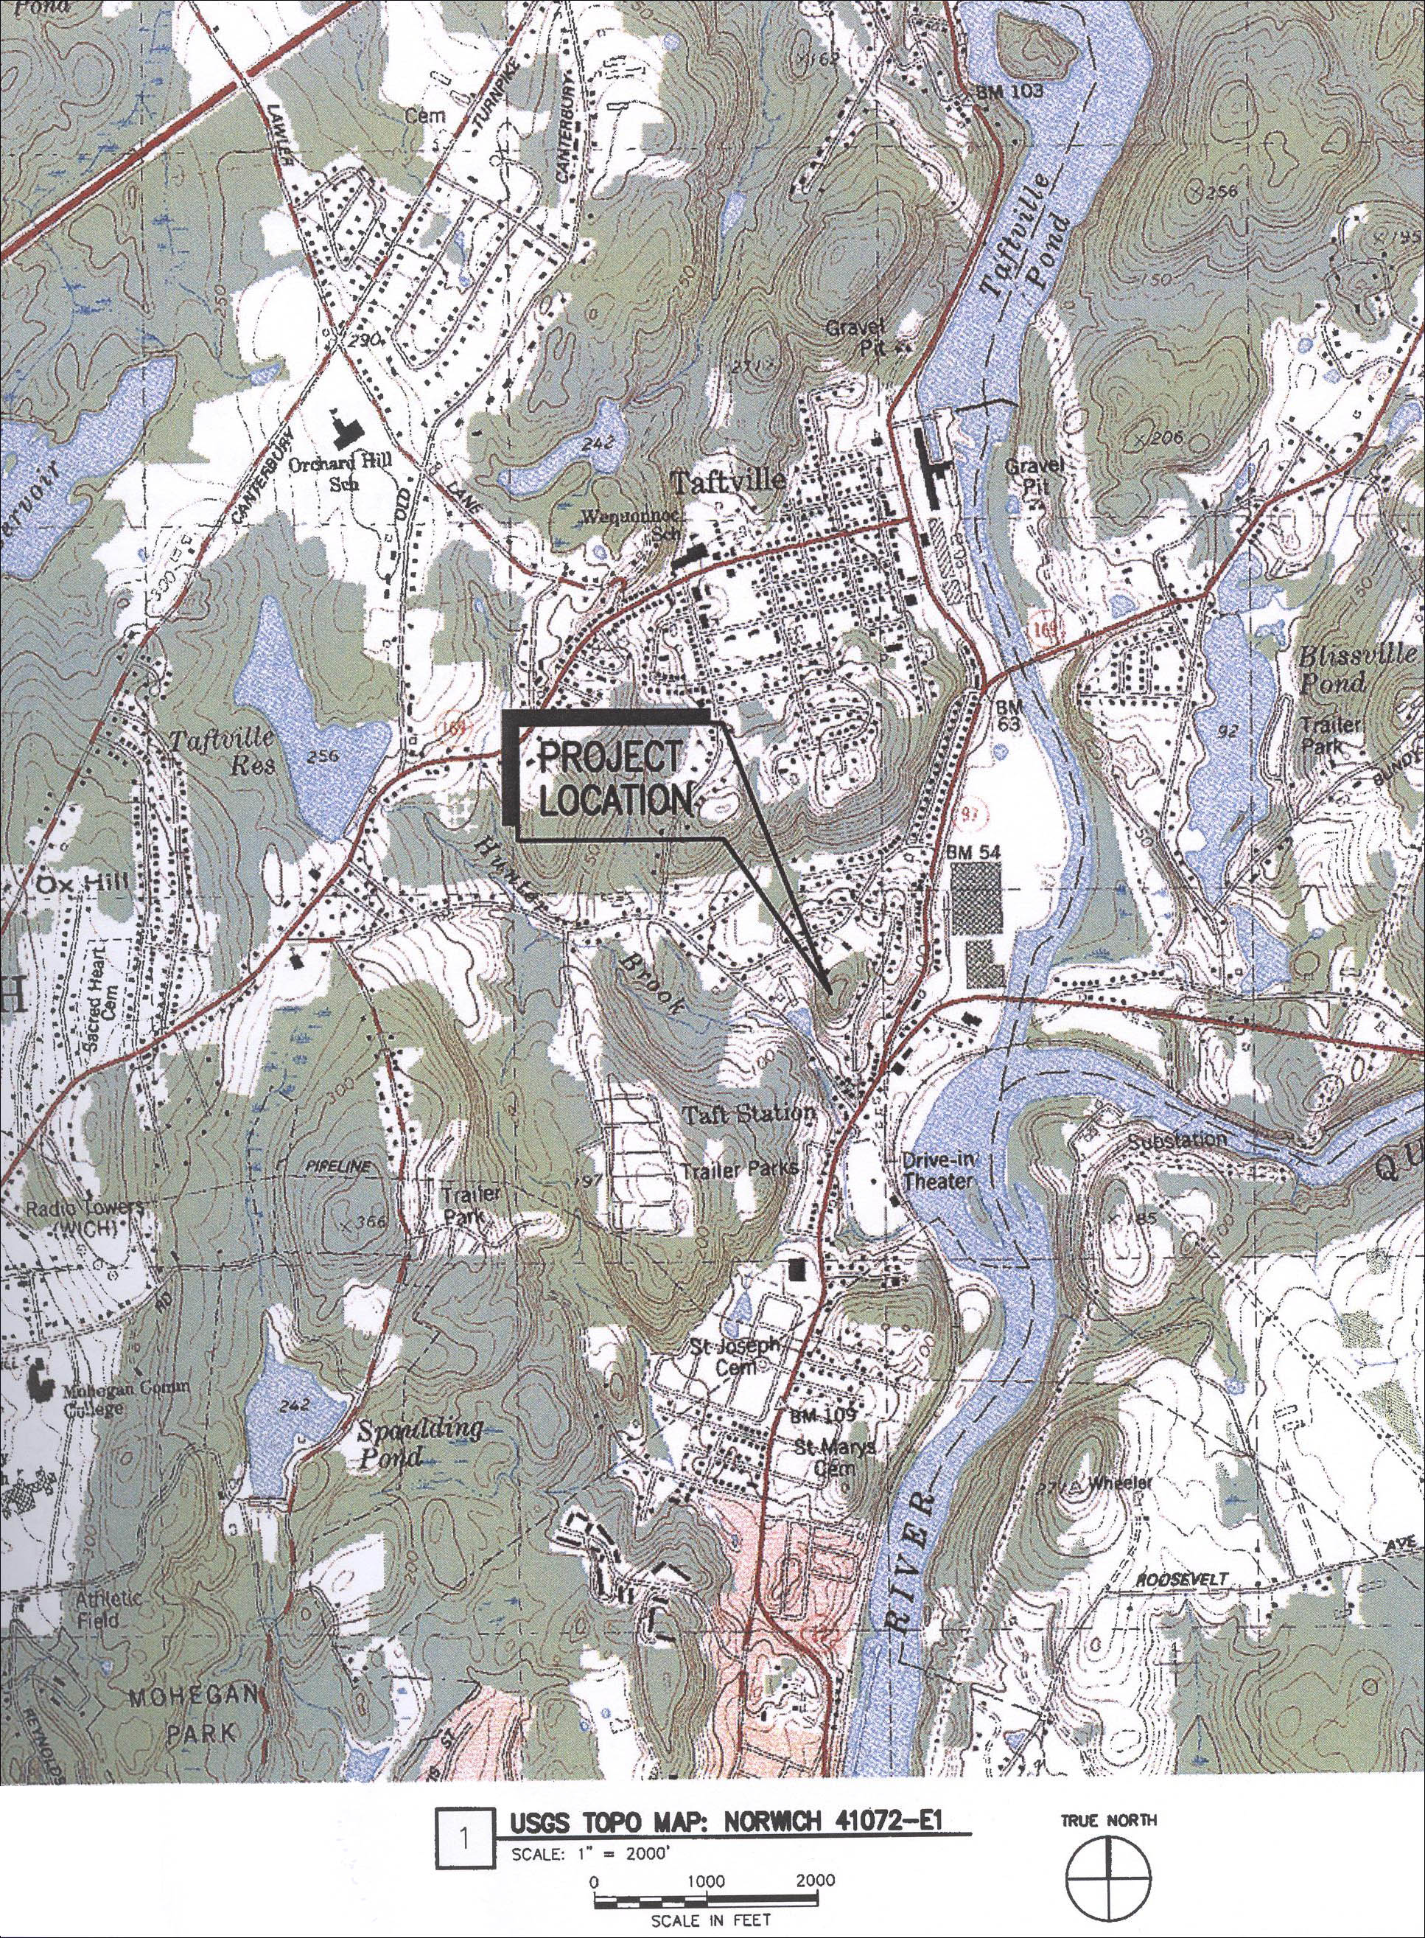
(Applicants 1, Exhibit B)

Figure 2: Aerial Photograph of Site Location
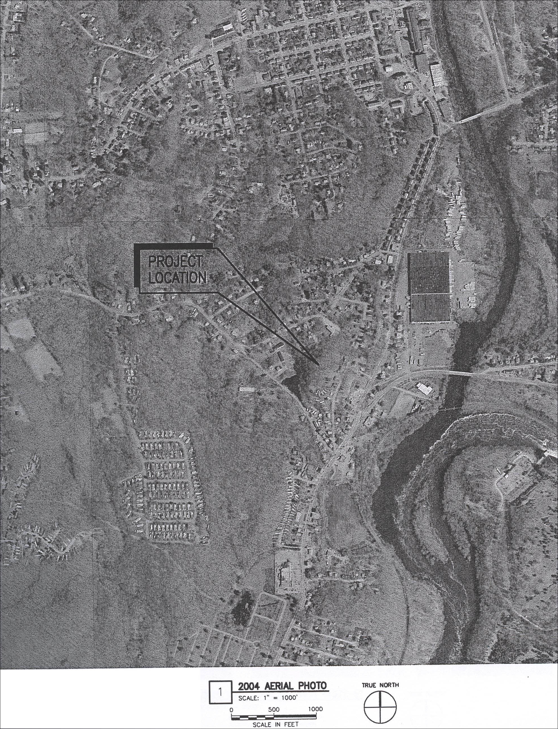
(Applicants 1, Exhibit B)

Figure 3: Facility Site Plan
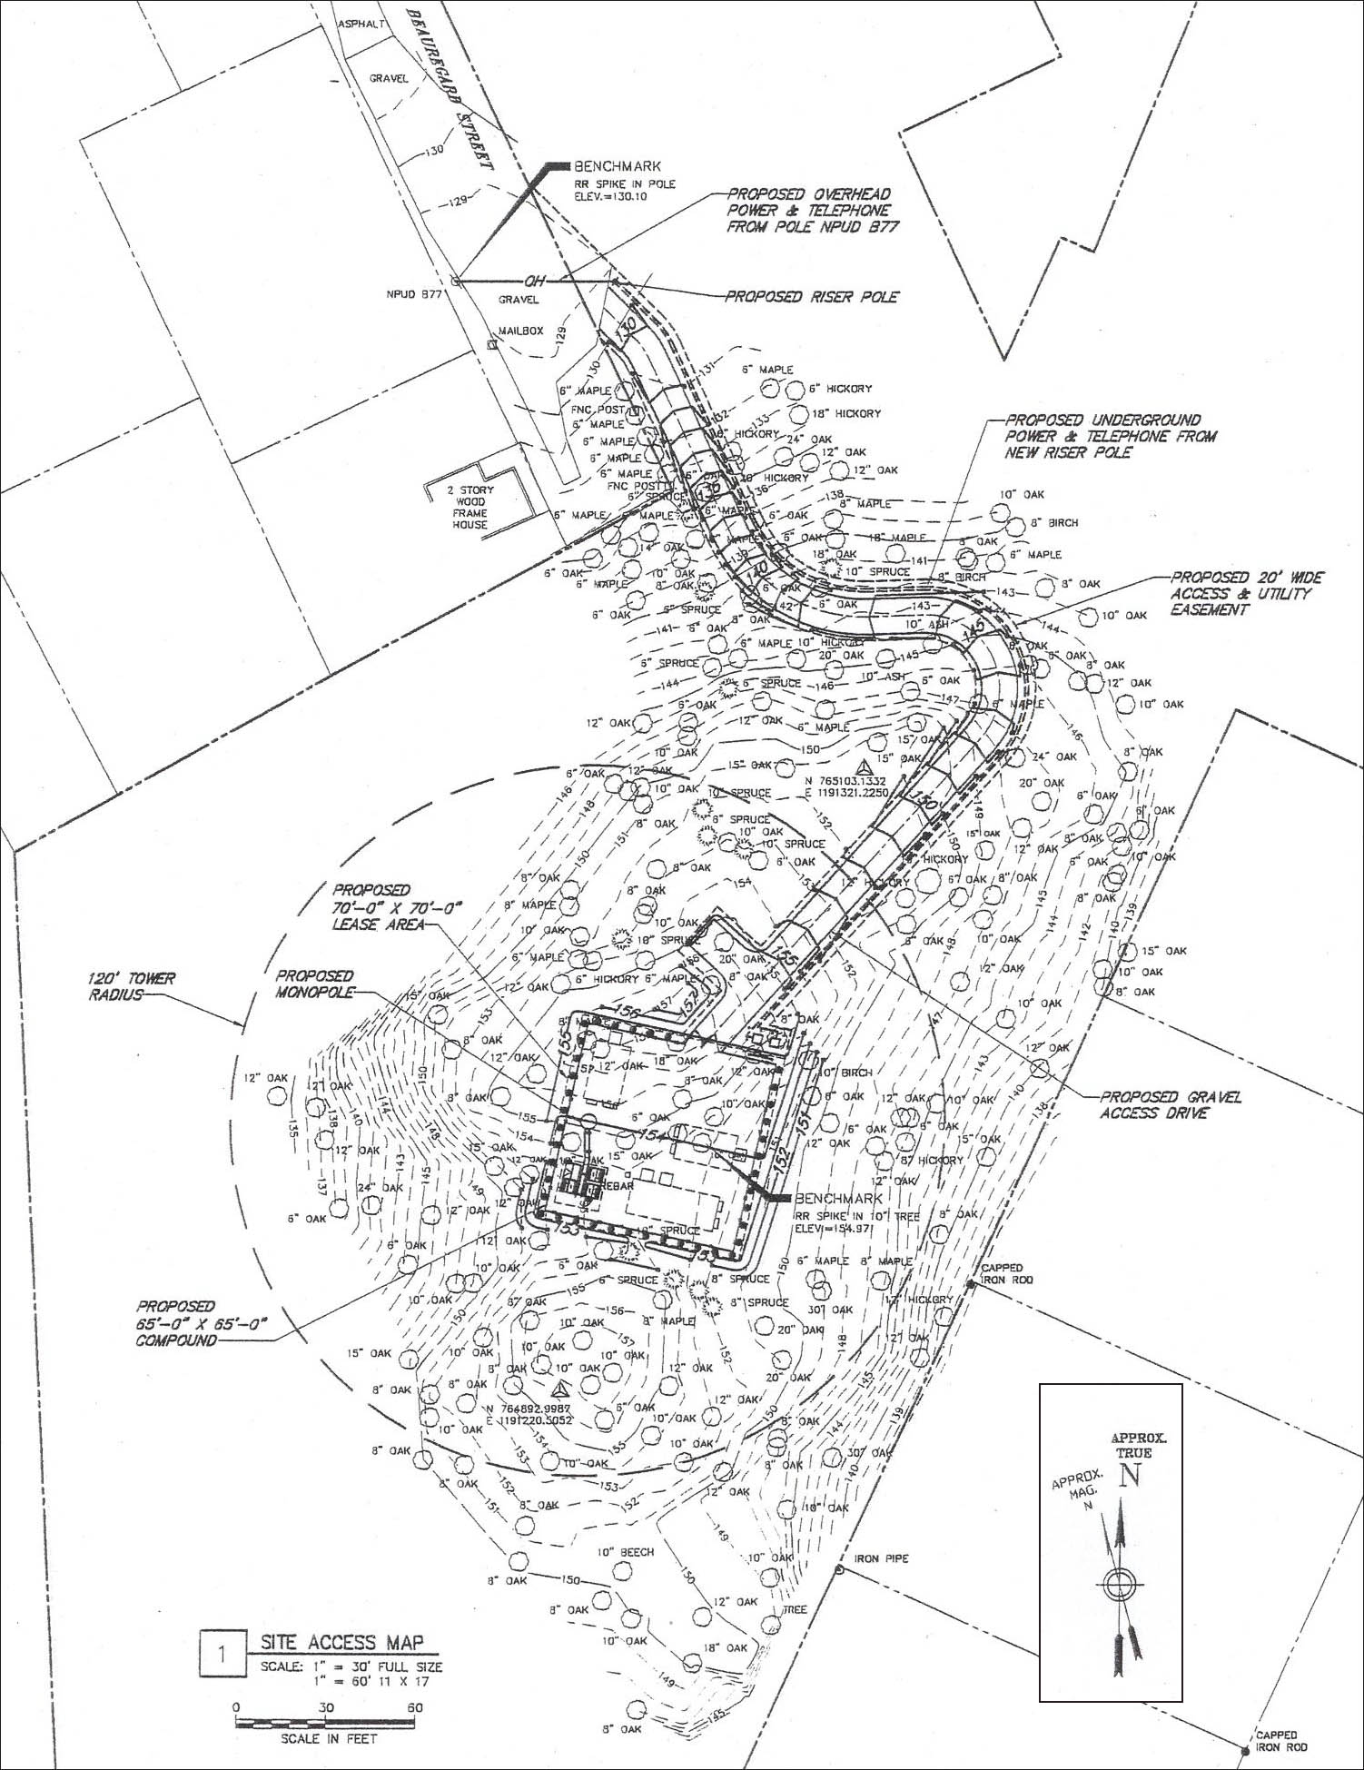
(Applicants 1, Exhibit B)

Figure 4: Existing T-Mobile Coverage
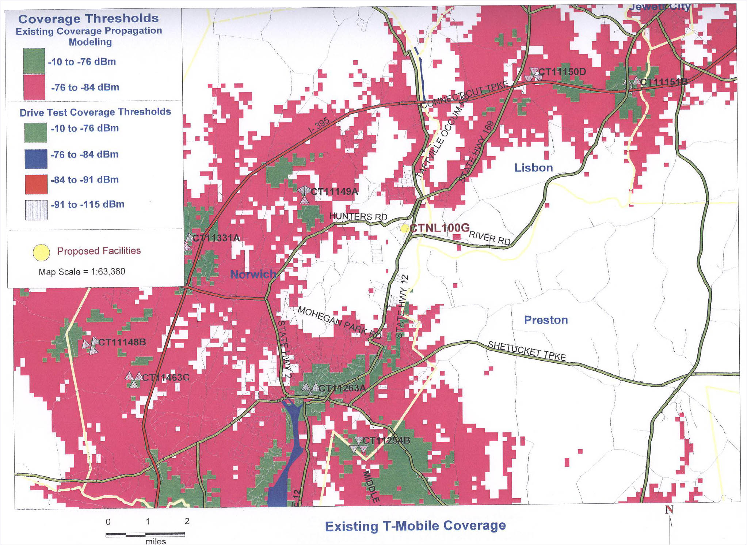
(Applicants 1, Exhibit G)

Figure 5: Drive Test Results
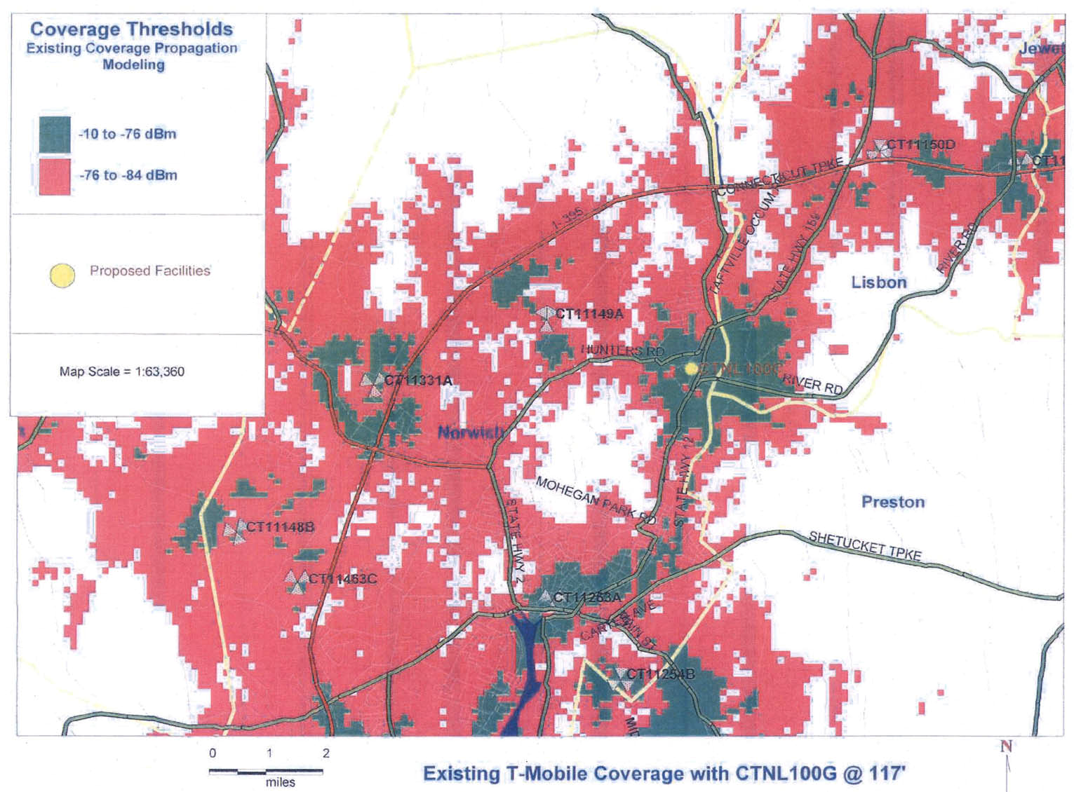

(Applicants 3, Attachment D)

Figure 6: Visibility Analysis
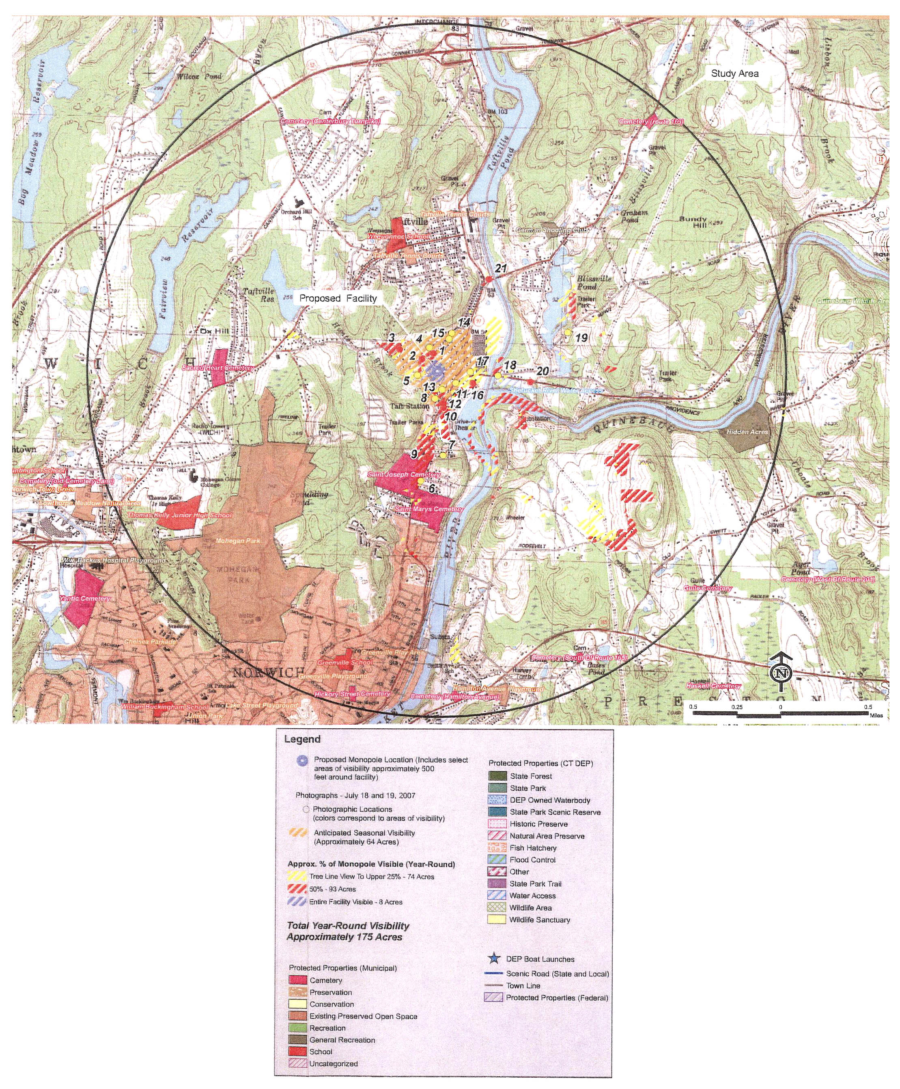
(Applicants 1, Exhibit J)

