DOCKET NO. 362 - Cellco Partnership d/b/a Verizon Wireless application for a Certificate of Environmental Compatibility and Public Need for the construction, maintenance and operation of a telecommunications facility located at 165 Elmwood Hill Road, Putnam, Connecticut. | }  }  } | Connecticut  Siting  Council  September 25, 2008

Findings of Fact

Introduction

- Cellco Partnership d/b/a Verizon Wireless (Verizon), in accordance with provisions of Connecticut General Statures (CGS) §§ 16-50g through 16-50aa, applied to the Connecticut Siting Council (Council) on May 15, 2008 for the construction, operation, and maintenance of a wireless telecommunications facility at 165 Elmwood Hill Road in Putnam, Connecticut. (Verizon 1, p. 1)

- Verizon is a Delaware Partnership with an administrative office located at 99 East River Drive in East Hartford, Connecticut. Verizon is licensed by the Federal Communication Commission (FCC) to operate wireless telecommunications services in the State of Connecticut. (Verizon 1, p. 4)

3. The party in this proceeding is the applicant. (Transcript 1 – 08/05/08, 3:27 p.m. [Tr. 1], p. 5)

4. The purpose of the proposed facility is to provide wireless service to Route 44 and local roads in northeast Putnam and southeast Thompson. (Verizon 1, pp. 1-2; Tab 7)

- Pursuant to CGS § 16-50m, the Council, after giving due notice thereof, held a public hearing on August 5, 2008, beginning at 3:30 p.m. and continuing at 7:00 p.m. at the Putnam Middle School, 35 Wicker Street, Putnam, Connecticut. (Council's Hearing Notice dated June 27, 2008; Tr. 1, p. 2; Transcript 2 – 08/05/08, 7:00 p.m. [Tr. 2], p. 2)

- The Council and its staff conducted an inspection of the proposed site on August 5, 2008, beginning at 2:00 p.m. The applicant flew a four-foot diameter balloon from 8:00 a.m. to 5:00 p.m. at the site to simulate the height of the proposed tower. The balloon reached the intended height of 150 feet above ground level (agl) during the field review. (Council's Hearing Notice dated June 27, 2008; Verizon 1, p. 2; Tr. 1, pp. 30-31)

- Notice of the application was provided to all abutting property owners by certified mail. Public notice of the application was published in the Norwich Bulletin on May 12 and May 13, 2008. (Verizon 1, p. 5, Verizon 2)

- A four-foot by six-foot sign describing the proposed project was installed on July 18, 2008 on the site property, adjacent to the access road entrance. (Verizon 6; Tr. 1, p. 30)

- Pursuant to CGS § 16-50l(b), Verizon provided notice to all federal, state and local officials and agencies listed therein. (Verizon 1, p. 5, Tab 3)

State Agency Comment

- Pursuant to General Statutes § 16-50j (h), on June 27, 2008 and August 6, 2008, the following State agencies were solicited to submit written comments regarding the proposed facility: Department of Environmental Protection (DEP), Department of Public Health (DPH), Council on Environmental Quality (CEQ), Department of Public Utility Control (DPUC), Office of Policy and Management (OPM), Department of Economic and Community Development (DECD), and the Department of Transportation (DOT). The Department of Agriculture (DOAG) was solicited on August 6, 2008. (Record)

- The Council received written responses from the DPH’s Drinking Water Division on July 22, 2008, and the DOT’s Bureau of Engineering and Highway Operations on July 28, 2008, both stating that they have no comment. (Record)

- The CEQ provided a written response on July 28, 2008 expressing concern for the degradation of scenic values from Chase Road, a locally designated scenic road, the Quaddick Reservoir, and the Five Mile River valley, a Connecticut Greenway study area. (Record)

- No response was received from the DOAG, DEP, DPUC, OPM, or DECD. (Record)

Municipal Consultation

- Verizon commenced the sixty-day municipal consultation process by meeting with the Mayor of Putnam, Robert Veins, on February 21, 2008. (Verizon 1, p. 18)

- The Town of Thompson is approximately 1,060 feet north of the site and in accordance with CGS § 16-50l(b), Verizon provided a technical report to the First Selectman of the Town of Thompson, Lawrence Groh, Jr. on February 21, 2008. (Verizon 1, p. 18)

Public Need for Service

- In 1996, the United States Congress recognized a nationwide need for high quality wireless telecommunications services, including cellular telephone service. Through the Federal Telecommunications Act of 1996, Congress seeks to promote competition, encourage technical innovations, and foster lower prices for telecommunications services. (Council Administrative Notice Item No. 7)

- In issuing cellular licenses, the Federal government has preempted the determination of public need for cellular service by the states, and has established design standards to ensure technical integrity and nationwide compatibility among all systems. Verizon holds an FCC license to provide cellular and PCS services to Windham County. (Council Administrative Notice Item No. 7; Verizon 1, p. 7)

- The Telecommunications Act of 1996 prohibits local and state entities from discriminating among providers of functionally equivalent services. (Council Administrative Notice Item No. 7)

- The Telecommunications Act of 1996, a Federal law passed by the United States Congress, prohibits any state or local entity from regulating telecommunications towers on the basis of the environmental effects of radio frequency emissions to the extent that such towers and equipment comply with FCC’s regulations concerning such emissions. This Act also blocks the Council from prohibiting or acting with the effect of prohibiting the provision of personal wireless service. (Council Administrative Notice Item No. 7)

Site Selection

20. Verizon established a search area for the site in April of 2007 that focused on the Elmwood Hill and Torry Hill areas of Putnam. (Verizon 1, Tab 9)

21. The nearest existing tower facilities to the proposed site are an SBA tower at 154 Sayle Road in Putnam and an American Tower Corporation tower at 1375 North Road in Killingly, both approximately four miles from the proposed site. Verizon is located on both of these towers and coverage from them does not serve the target service area. (Verizon 1, Tab 7, Tab 9)

22. No structures within the search area are suitable to provide coverage to the target service area. Transmission line poles (345 kV) northwest of the site were not considered since the poles would have to be replaced with taller structures, requiring a shutdown of the regional electric transmission system. Additional power outages would be required for maintenance or upgrades to the pole mounted-antennas. (Verizon 1, Tab 9; Tr. 1, pp. 41-42, 50)

23. After determining there were no viable structures within the search area, Verizon searched for properties suitable for tower development. Verizon investigated six parcels and selected one for tower development. The five rejected parcels and reasons for their rejection are as follows:
- 214 Elmwood Hill Road, Putnam – would require a 190-foot facility to achieve coverage objectives;
- 123 Elmwood Hill Road, Putnam – would require a 190-foot facility to achieve coverage objectives;
- 189 Elmwood Hill Road, Putnam – owner did not respond to inquiries;
- 203 Elmwood Hill Road, Putnam – owner did not respond to inquiries; and,
- 309 East Putnam Road, Putnam – presence of wetlands, difficult terrain, and low ground elevation.
(Verizon 1, Tab 9)

24. At the public hearing on August 5, 2008, an additional tower site was suggested at the Rawson Materials property, south of Munyan Road and west of the Munyan Road, East Putnam Road intersection. The property is 244 feet lower than the proposed 165 Elmwood Hill Road site. Due to the low elevation, a 199-foot tower would be required to achieve comparable coverage to that of the proposed site. (Verizon late file, August 14, 2008; Tr. 2, pp. 18-20)

Site Description

- The proposed facility is located on a 22.1-acre parcel owned by Lois Pray at 165 Elmwood Hill Road in Putnam. (Verizon 1, p. 2, Tab 1)

- The property contains a single-family residence fronting Elmwood Hill Road. The remaining portion of the property is wooded. Evidence of past logging is present. (Verizon 1, Tab 1; Tr. 1, pp. 35-36)

- The parcel is zoned Agricultural, AG-2. (Verizon 1, p. 2)

- The site parcel is located on the south side of Elmwood Hill Road. The tower site is near the summit of Elmwood Hill, approximately 0.8 miles north of Route 44, at an elevation of 644 feet above mean sea level. (Verizon 1, Tab 1, Tab 10)

- Verizon proposes to construct a 150-foot monopole at the site. It would be designed to support four levels of antennas with a 10-foot center-to-center vertical separation. (Verizon 1, Tab 1)

- Verizon proposes to install 12 panel antennas on a platform at a centerline height of 147 feet agl. (Verizon 1, p. 2)

- Verizon proposes to construct a 50-foot by 50-foot equipment compound within a 100-foot by 100-foot lease area at the base of the tower. An eight-foot high chain link fence topped with barbed wire would enclose the compound. (Verizon 1, Tab 1)

- Verizon proposes to install a 12-foot by 30-foot equipment shelter containing radio equipment and a diesel generator within the compound. (Verizon 1, Tab 1)

- Access to the site would be from a 12-foot wide, 1,195-foot long gravel drive extending from Elmwood Hill Road. Approximately 940 feet of the road would follow an existing logging road on the property. (Verizon 1, Tab 1)

- Development of the site would require approximately 700 cubic yards of cut and 660 cubic yards of fill. (Verizon 4, Q. 4)

- Utility service to the compound would be installed underground, alongside the access drive, from a proposed utility pole on Elmwood Hill Road. (Verizon 5; Tr. 1, p. 36)

- The road would follow the existing grade that is gently sloping for most of its length except for one 85-foot section that would have a grade of almost 20%. (Tr. 1, pp. 22-23)

- Road drainage features include four cross drainage swales and associated level spreaders. (Verizon 1, Tab 1, Verizon 5)

- The nearest abutting property from the tower site is approximately 161 feet to the south, owned by Susan B. Lowe (refer to Figure 1). (Verizon 1, Tab 1)

- The nearest residence to the proposed tower site is approximately 510 feet to the northeast, owned by Sara and Norman Seney, Jr. (Verizon 1, p. 13, Tab 1)

- There are three residences within 1,000 feet of the tower site. (Verizon 1, p. 13)

- The tower would not conform to the Town’s zoning regulations, which require a setback of 120% of the tower height from the nearest property line, or 180 feet in this case. The tower is 161 feet from the nearest property line. Verizon would be willing to shift the tower site 20 feet to the north but this relocation would decrease the distance of the tower to the abutting Seney, Jr. residence from 510 feet to 490 feet. (Verizon 1, pp. 16-17, Tab 1; Tr. 1, pp. 23-24, 43-44)

- Land use within a quarter-mile of the site consists of undeveloped land and low density residential. (Verizon 1, Tab 1)
43. The estimated construction cost of the facility is:

Cell site radio equipment 450,000.
Tower, coax, and antenna 150,000.
Utilities 20,000.
Equipment building 50,000.
Site preparation, facility installation 95,000.

Total estimated cost $765,000.
(Verizon 1, p. 20)

Environmental Concerns

- The proposed facility would have no effect on historic, architectural, or archaeological resources listed on or eligible for the National Register of Historic Places. (Verizon 1, p. 15, tab 11)

- The Narragansett Tribe reviewed the proposed project and identified several potential archaeologically sensitive areas on the site parcel. The tribe requested that these potential areas be avoided. The compound access road was shifted slightly to accommodate this request. (Verizon 5; Tr. 1, pp. 24-25; Tr. 2, pp. 16-17)

- The proposed site contains no known existing populations of federal or state endangered or threatened species or state special concern species. (Verizon 1, p. 14, Tab 11)

- Approximately 127 trees with a diameter of six inches or greater at breast height would be removed to develop the site. (Tr. 1, p. 22)

- No wetlands or watercourses would be directly impacted by site construction. The nearest wetland to any construction area is approximately 100 feet west of the proposed access drive. (Verizon 1, p. 17, Tab 12; Tr. 1, p. 54)

- The tower would not require aircraft hazard obstruction marking or lighting. The nearest landing facility to the tower is a private landing on Quaddick Reservoir for seaplane use, approximately 1.7 miles northwest of the site. Although the site could have a possible impact to this landing facility, no marking and/or lighting is required. (Verizon 1, p. 19, Tab 13; Verizon 4, Q. 8)

- The cumulative maximum power density from the radio frequency emissions of the proposed Verizon antennas is calculated to be 17.3 % of the standard for Maximum Permissible Exposure, as adopted by the FCC, at the base of the proposed tower. This calculation was based on methodology prescribed by the FCC Office of Engineering and Technology Bulletin No. 65E, Edition 97-01 (August 1997) that assumes all antennas would be pointed at the base of the tower and all channels would be operating simultaneously. (Verizon 4, Q. 7; Tr. 1, p. 13)

Visibility

- A tree canopy height of 65 feet agl was used to generate a visibility model of the proposed site. (Verizon 1, Tab 10)

- The proposed tower would be visible year-round above the tree canopy from approximately 69 acres within a two-mile radius of the site (refer to Figure 2). The tower would be seasonally visible from an additional 4 acres. (Verizon 1, Tab 10; Tr. 1, pp. 9-13)

- Approximately 38 acres of year-round visibility would occur from open water of the Quaddick Reservoir, located 1.25 miles to the northwest. The reservoir contains 335 acres of surface water. Its shoreline is developed with residences and a state park. (Verizon 1, Tab 10; Verizon late file, August 14, 2008; Tr. 1, pp. 9-13)

- Visibility from the reservoir would be confined to the open water of the southwest section of the lower pond area, and along shoreline at the base of Quaddick Mountain. (Verizon late file, August 14, 2008)

- Twelve seasonal residences, with their porches and windows facing east, are located along the west shoreline of the reservoir, at the base of Quaddick Mountain, approximately 1.5 miles from the proposed tower. Three of these homes would have year-round views of the upper 40 to 70 feet of the facility if the viewer was facing the south/southeast. (Verizon late file, August 14, 2008)

- The tower would be not be visible from Quaddick State Park or the associated boat launch, located on the east shore of the reservoir, approximately 1.7 miles northeast of the site. (Verizon 1, Tab 10; Tr. 1, pp. 44-46)

- The upper 80 feet of the proposed tower would be visible year-round from six residential properties on Hill Road, near the junction with Chase Road, approximately 1.7 miles to the northwest. An additional residential property in this area would have a seasonal view of the facility. (Verizon 1, Tab 10; Tr. 1, pp. 19-21)

- The tower would not be visible from Chase Road, a locally designated scenic road in the Town of Thompson, approximately 1.8 miles northwest of the site. Chase Road is not a state designated scenic road. (Council Administrative Notice Item 15; Verizon 1, Tab 10; Tr. 1, pp. 16-18)

- The proposed tower would be seasonally visible to the abutting residence at 171 Elmwood Hill Road, approximately 510 feet to the northeast. If the tower site was moved 20 feet to conform to the towns zoning regulations, the tower would be 490 feet from this residence. (Verizon 1, Tab 1; Tr. 1, pp. 20-24, 43-44)

- The proposed tower would not be visible year-round or seasonally to residences in the area of 75 and 95 Elmwood Hill Road due to favorable topography and dense woodland in the area. (Tr. 2, pp. 15-16)

- Projected visibility from area roads include:
a) East Putnam Road, approximately 0.7 miles east of the site, year-round views of the upper 30 feet for a tenth of a mile;
b) Munyan Road, approximately 0.9 miles east of the site, year-round spot view of the upper 70 feet;
c) Hill Road, Thompson, approximately 1.7 miles northeast of site, year-round views of the upper 80 feet for a tenth of a mile;
d) Elmwood Hill Road, adjacent to the site, seasonal views for a tenth of a mile.
(Verizon 1, Tab 10)

- The tower would not be visible from any hiking trails maintained by the DEP or the Connecticut Forest and Parks Association. (Verizon 1, Tab 10)

- The tower would not be visible from the Peck Pond Recreation Area within the Pulaksi Memorial State Forest in Rhode Island. The recreation area is approximately 0.8 miles northeast of the site. (Verizon 1, Tab 10)

- The Town of Thompson received a state grant to study its portion of the Five Mile River as a possible Connecticut Greenway. The tower, approximately 1.4 miles east of the river, may be visible from several sections of the river in Thompson and Putnam. (CEQ comments of July 23, 2008; Tr. 1, pp. 18-19)

- The tower would not be suitable for a stealth tree application since year round views are primarily distant views where the tower extends considerably above the tree line. A tree tower would have a much wider profile on the horizon than a regular monopole. (Tr. 1, pp. 46-48)

Verizon - Existing and Proposed Wireless Coverage

- Verizon proposes to operate 800 MHz (cellular) and 1900 MHz (PCS) equipment at this site. Verizon is designing the site using a signal level threshold of -85 dBm for in-vehicle coverage and -75 dBm for in-building coverage. (Verizon 1, pp. 1-2; Verizon 4, Q. 5)

- Verizon currently has no reliable, continuous cellular or PCS coverage on Route 44 east of Putnam center (refer to Figures 3 & 4). Although limited cellular coverage from Verizon’s “Putnam” and “Killingly” facilities extends along portions of Route 44, existing coverage gaps totaling 1.25 miles would remain. Reliable PCS coverage on Route 44 east of Putnam center is nonexistent. (Verizon 1, pp. 1-2, Tab 7)

- The proposed site would provide continuous cellular coverage and approximately 2.5 miles of PCS coverage on Route 44 east of Putnam (refer to Figures 5 & 6). (Verizon 1, pp. 1-2, Tab 7)

- Reducing the antenna height to 130 feet would cause a degradation of cellular coverage on Route 44 in two areas: at the intersection of Route 44 and Hill Road (less than a tenth of a mile) near the Rhode Island border (less than a tenth of a mile). PCS coverage would be reduced at the periphery of the coverage footprint and for a quarter-mile section of Route 44 near the Rhode Island border. (Verizon 4, Q. 9; Tr. 1, pp. 26-27)

- Verizon uses the PCS frequencies for both voice and data traffic. The cellular frequencies operate as a voice-only network. The PCS frequencies provide capacity offload for the cellular frequencies as demand necessitates. (Verizon 1, Q. 10)

- Verizon owns the A-band cellular license in Connecticut and the B-band cellular license in Rhode Island whereas AT&T owns the A-band cellular license in Rhode Island, and the B-band cellular license in Connecticut. To prevent interference issues between each other’s coverage close to the Connecticut-Rhode Island border, Verizon and AT&T each limit their cellular wireless service to one-half of their respective licensed cellular frequencies. This limitation means that during periods of heavy demand Verizon’s PCS network would have to handle more traffic off-loaded from its cellular network: thus, the reliability of Verizon’s PCS coverage along the Connecticut-Rhode Island border is of special concern. (Verizon 4, Q. 10; Tr. 1, pp. 27-31)

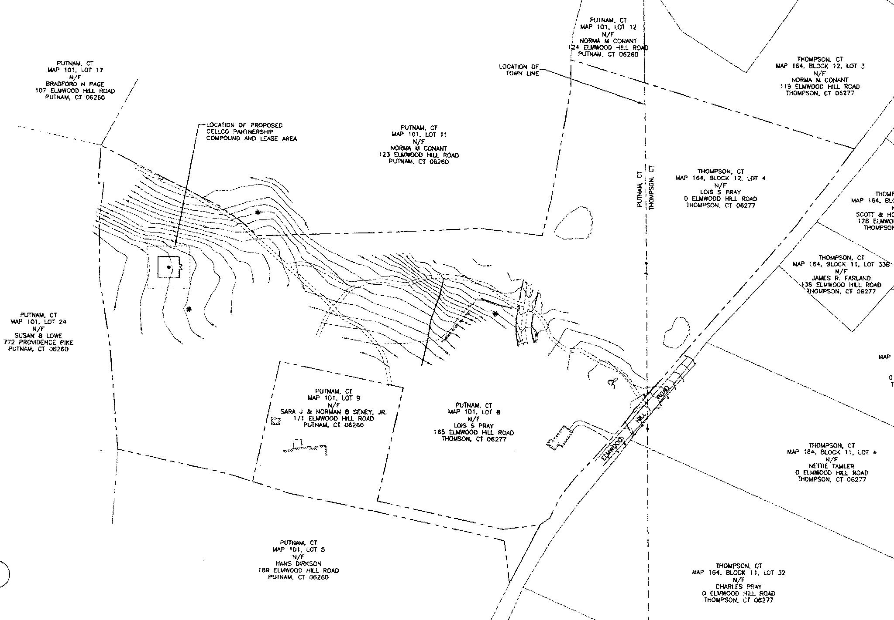

Figure 1 – Location of site, 165 Elmwood Hill Road, Putnam. (Verizon 1, Tab 1)
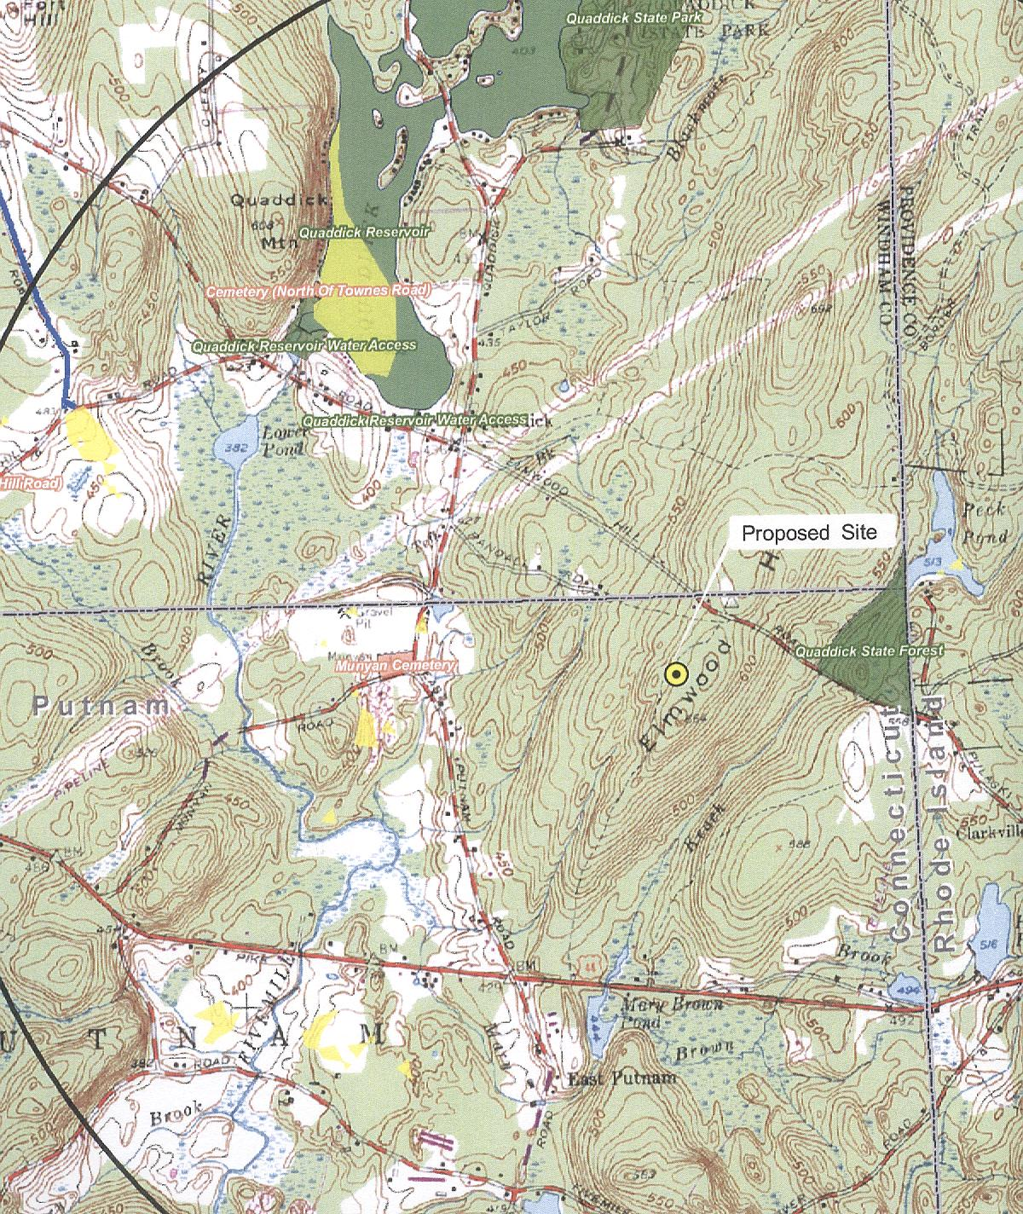
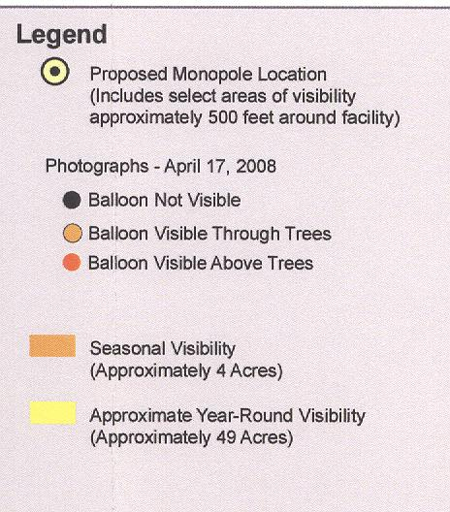
Figure 2 – Visibility of proposed site.
(Verizon 1, Bulk File D, Tab 10; Verizon late file, August 14, 2008)

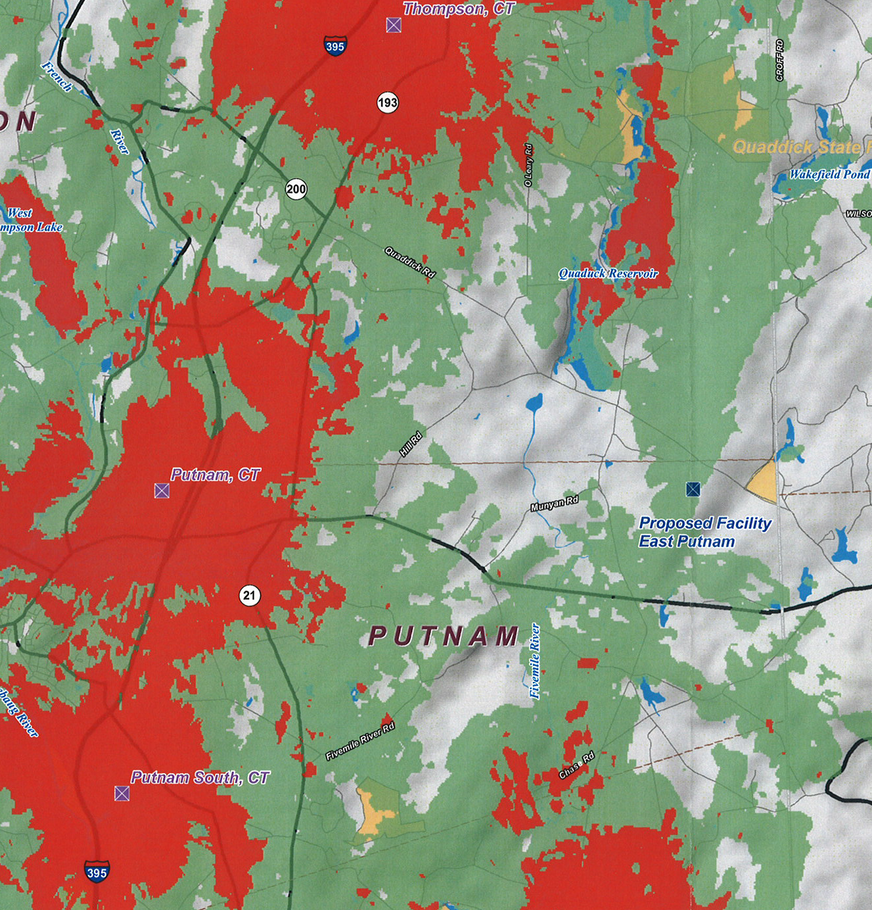
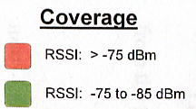

Figure 3 - Existing Verizon Cellular Coverage (Verizon 1, Tab 7)

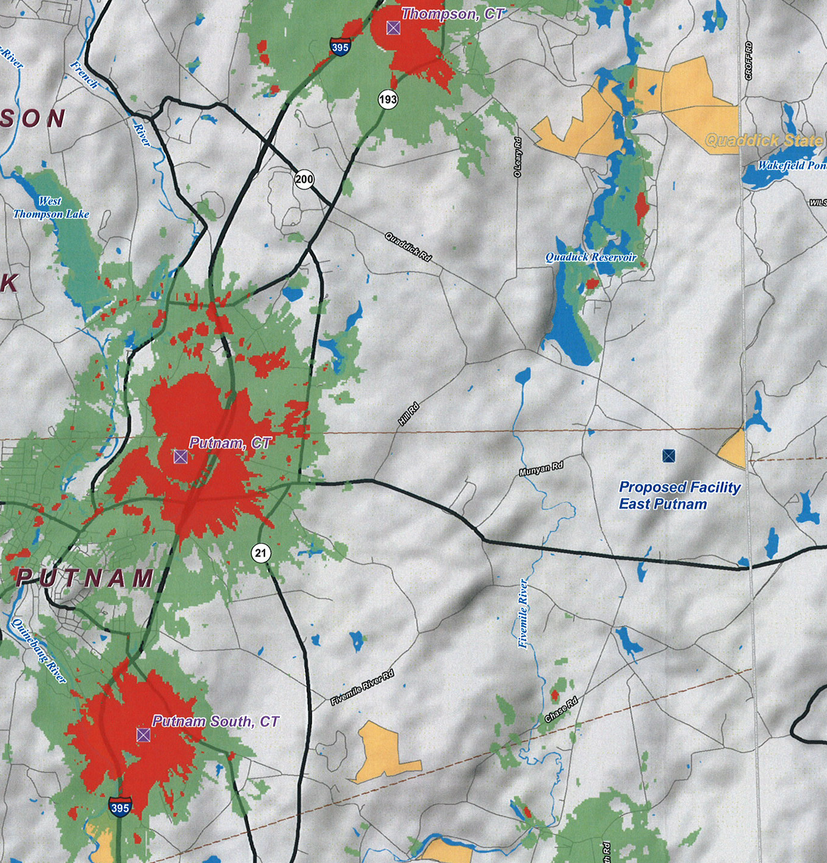

Figure 4 – Existing Verizon PCS coverage. (Verizon 1, Tab 7)

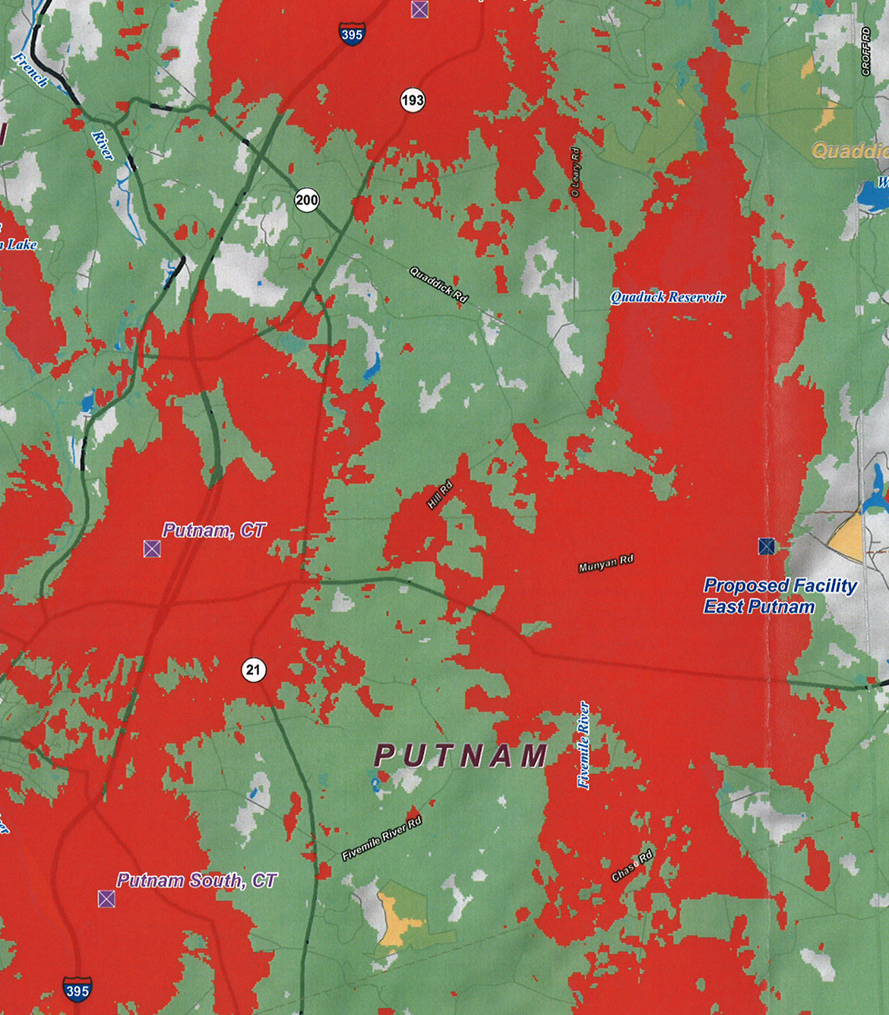
Figure 5 – Proposed Verizon cellular coverage at 147 feet. (Verizon 1, Tab 7)

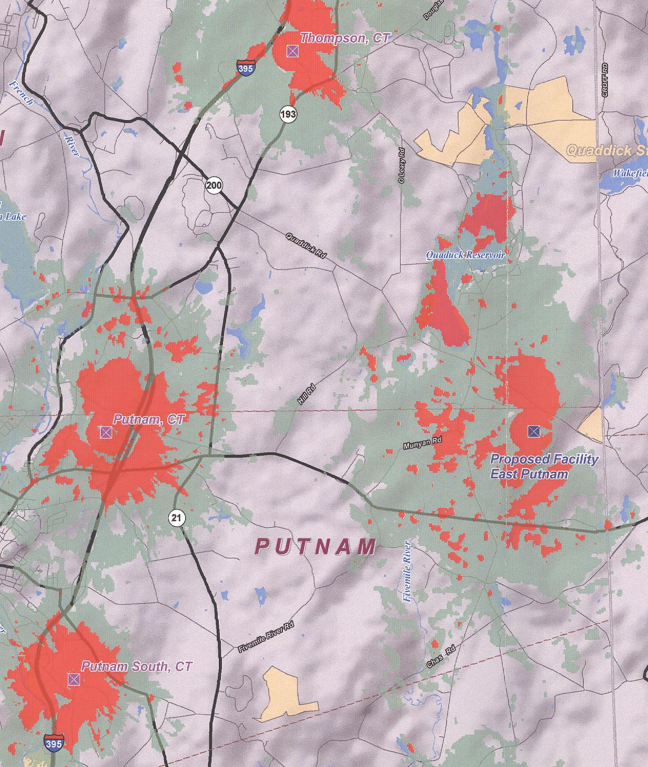

Figure 6 – Proposed Verizon PCS coverage at 147 feet. (Verizon 1, Tab 7)

