DOCKET NO. 359 - Optasite Towers LLC and Omnipoint Communications, Inc. application for a Certificate of Environmental Compatibility and Public Need for the construction, maintenance and operation of a telecommunications facility located at 58 Montano Road or 618 Neipsic Road, Glastonbury, Connecticut. | }  }  } | Connecticut  Siting  Council  September 11, 2008

Findings of Fact

Introduction

- Pursuant to Chapter 277a, Sections 16-50g et seq. of the Connecticut General Statutes (CGS), as amended, and Section 16-50j-1 et. seq. of the Regulations of Connecticut State Agencies (RCSA), Optasite Towers LLC (Optasite) and Omnipoint Communications, Inc. (T-Mobile) applied to the Connecticut Siting Council (Council) on March 18, 2008 for the construction, operation, and maintenance of a telecommunications facility to be located at 58 Montano Road (Site A) or 618 Neipsic Road (Site B) in the Town of Glastonbury, Connecticut. (Applicants 1, p. 1)

- Optasite is a Delaware limited liability company with offices at One Research Drive, Suite 200C, Westborough, Massachusetts. It would construct and maintain the proposed facility. (Applicants 1, p. 3)

- T-Mobile is a Delaware corporation with a Connecticut office at 35 Griffin Road South, Bloomfield, Connecticut. The company and its affiliated entities are licensed by the Federal Communications Commission (FCC) to construct and operate a personal wireless services system in Connecticut. T-Mobile does not conduct any other business in the State of Connecticut other than the provision of wireless services under FCC rules and regulations. (Applicants 1, p. 3)

- The parties in this proceeding are the applicants, Optasite and T-Mobile, the Town of Glastonbury, and Imtiaz Wahla, a nearby property owner. Karl Wagener, a nearby resident, was an intervenor. (Transcript, June 19, 2008, 3:25 p.m. [Tr. 1], p. 6 ff.)

- The proposed facility would provide wireless service along Route 2 as well as in adjacent residential areas. (Applicants 1, p. 1)

- Pursuant to CGS § 16-50m, the Council, after giving due notice thereof, held a public hearing on June 19, 2008, beginning at 3:00 p.m. and continuing at 7:00 p.m. in the Town Council Chambers of the Town Hall at 2155 Main Street in Glastonbury, Connecticut. (Tr. 1, p. 2 ff.)

- The Council and its staff conducted an inspection of the proposed sites on June 19, 2008, beginning at 2:00 p.m. On the day of the field inspection, the applicants flew a red balloon from approximately 7:15 a.m. at Site A and a black balloon from approximately 7:30 a.m. at Site B to approximately 5:00 p.m. to simulate the height of the proposed tower. There were light winds of between five to seven miles per hour for most of the day. Visibility was
several miles. (Tr. 1, pp. 31-32)

- Pursuant to CGS § 16-50l(b), notice of the applicants’ intent to submit this application was published on March 13 and 14, 2008 in the Hartford Courant and on March 13 and 15, 2008 in the Manchester Journal Inquirer. (Hartford Courant Affidavit of Publication dated March 17, 2008 and Manchester Journal Inquirer Affidavit of Publication dated March 24, 2008)

- In accordance with CGS § 16-50l(b), Optasite sent notices of its intent to file an application with the Council to each person appearing of record as owner of property abutting the property on which the site is located. (Applicants 1, pp. 4-5, Exhibit G)

- Optasite received return receipts from all but nine of the owners of property abutting the two proposed sites. Optasite sent a second notice to these nine owners and received return receipts from all but two of them. Optasite sent a third notice to these two property owners, but had not received a return receipt at the time of the public hearing. (Applicants 2, A1; Tr. 1, pp. 32-33)

- Pursuant to CGS § 16-50l (b), Optasite provided notice to all federal, state, regional, and local officials and agencies listed therein. (Applicants 1, p. 4, Exhibit E)

- Optasite posted a sign at each of the properties on which Sites A and B are located on June 4, 2008. The signs informed the general public of the proposed project. Information on the signs included the date and time of the scheduled hearing and how to contact the Council. (Applicants 4 - Pre-filed testimony of Charles Regulbuto, Response to Q9 and Exhibit 2)

State Agency Comments

- Pursuant to CGS § 16-50l, the Council solicited comments on Optasite’s application from the following state departments and agencies: Department of Environmental Protection (DEP), Department of Public Health, Council on Environmental Quality, Department of Public Utility Control, Office of Policy and Management, Department of Economic and Community Development, and the Department of Transportation. The Council’s letters requesting comments were sent on May 9, 2008 and June 20, 2008. (CSC Hearing Package dated May 9, 2008; Letter to State Department Heads dated June 20, 2008)

- The Connecticut Department of Transportation responded to the Council’s solicitation with no comments. (Department of Transportation letter dated June 13, 2008)

- Except for the Department of Transportation, no state agencies responded to the Council’s solicitation for comments. (Record)

Municipal Consultation

- On September 27, 2007, Optasite submitted a technical report to the Glastonbury First Selectman regarding the proposed facility. The technical report included specifics about each proposed location and addressed the public need for the facility. It described the site selection process and the environmental effects of the proposed facility. (Applicants 1, p. 19; Exhibit R)

- Optasite representatives met with Glastonbury’s town manager on October 25, 2007 to discuss the proposed facility. (Applicants 1, p. 19)

- Optasite attempted to contact Glastonbury’s chief elected official but was directed to address all correspondence to the town manager. (Tr. 2, pp. 47-48)

- The Town of Glastonbury did not undertake any hearings or informational sessions on the proposal and did not provide any comments regarding the proposal. (Applicants 1, p. 19)

- Initially, the town was interested in possibly locating a tower on town-owned property in the vicinity of the proposed sites. Subsequently, however, the town did not express a willingness to pursue this possibility any further. (Applicants 1, p. 19)

- The Town of Glastonbury requested that the Council consider the town’s policy toward the construction of new telecommunications towers included in its recently adopted Plan of Conservation & Development. The policy is to “Promote utilization of existing structures and buildings for new communication transmitting towers, with new tower facilities supported only after all other alternatives are exhausted.” (Letter from the Town of Glastonbury’s Town Manager, dated June 19, 2008)

- Optasite conducted a balloon flight at the town’s request on May 5, 2008. (Tr. 1, pp. 46 ff.; Tr. 2, pp. 29 ff.)

- The Glastonbury Volunteer Fire Department has expressed a possible interest in placing antennas on a tower at either of the proposed sites. (Applicants 4: Pre-filed testimony of Charles Regulbuto, letter from Glastonbury Volunteer Fire Department dated May 8, 2008)

Public Need for Service

- The United States Congress, through adoption of the Telecommunications Act of 1996, recognized the important public need for high quality telecommunication services throughout the United States. The purpose of this Act, which was a comprehensive overhaul of the Communications Act of 1934, was to “provide for a competitive, deregulatory national policy framework designed to accelerate rapidly private sector deployment of advanced telecommunications and information technologies to all Americans.” (Applicants 1, p. 5)

- The Telecommunications Act of 1996 prohibits local and state bodies from discriminating among providers of functionally equivalent services. (Council Administrative Notice, Telecommunications Act of 1996)

- The Telecommunications Act of 1996 prohibits any state or local agency from regulating telecommunications towers on the basis of the environmental effects of radio frequency emissions to the extent that such towers and equipment comply with FCC’s regulations concerning such emissions. This Act also blocks the Council from prohibiting or acting with the effect of prohibiting the provision of personal wireless service. (Council Administrative Notice, Telecommunications Act of 1996)

- In an effort to ensure the benefits of wireless technologies to all Americans, Congress enacted the Wireless Communications and Public Safety Act of 1999 (the 911 Act). The purpose of this legislation was to promote public safety through the deployment of a seamless, nationwide emergency communications infrastructure that includes wireless communications services. (Applicants 1, p. 6)

- The proposed facility would operate within T-Mobile’s E911 network. (Applicants 1, p. 7)

- Optasite would make space available on the tower for municipal public safety antennas at no charge. (Applicants 1, p. 10)

Site Selection

- T-Mobile initiated a site search in this vicinity in August, 2005. The site search was centered near the 58 Montano Road (Site A) property. (Applicants 2, A13 and A14)

- During its initial search for a facility location, Optasite considered several other properties in addition to the two alternative locations. These properties and assessments of their suitability are listed in the table below:

Location Considered | Suitability
4 Autumn Lane | Property located in planned area development currently being developed
3 Montano Road | Owner was not interested in leasing
1354 Neipsic Road | Property too close to an existing T-Mobile site at 366 South Three Mile Rd (approx. ½ mile distant).
990 Neipsic Road | Property too close to an existing T-Mobile site at 366 S. Three Mile Rd (approx. ½ mile distant).
Gideon Wells Middle School | School is too close to existing T-Mobile site on S. Three Mile Road
CL&P transmission structures, adjacent to Gideon Wells Middle School | Poles in this line too close to existing T-Mobile site on S. Three Mile Road; poles only 40 feet high
J.B. Williams Memorial Park, 5 Neipsic Road | Proposal rejected by town because of negative feed back from residents
472 Neipsic Road | Parcel too small for telecom facility
6F Neipsic Road | Parcel too small for telecom facility
13B Neipsic Road | Parcel too small for telecom facility
1029 Neipsic Road | Parcel too small for telecom facility
Neipsic Road property located adjacent to CL&P distribution | Parcel too small for telecom facility
13 Wickham Road | Parcel rejected because of potential residential impact
(Applicants 1, Exhibit J; Tr. 1, p. 44)

- Optasite identified 14 communications towers within approximately four miles of the proposed sites. None of these towers would provide adequate coverage in T-Mobile’s target area. The towers are listed in the following table.

Tower Location | Height of Tower | Tower Owner | Approx. Distance and Direction
1455 Forbes Street,  East Hartford | 130’ | Crown Atlantic | 3.47 miles to NW
287 Main Street,  East Hartford | 83’ | T-Mobile | 4.42 miles to NW
1616 New London Tpk,  Glastonbury | 154’ | Global Signal | .68 miles to SE
175 Dickinson Road,  Glastonbury | 180’ | SBA Properties | 3.71 miles to SE
2108 Main Street,  Glastonbury | 190’ | Town of Glastonbury | 2.26 miles to W
2380 Main Street,  Glastonbury | 100’ | Town of  Glastonbury | 2.1 miles to SE
2577 Main Street,  Glastonbury | 130’ | Nextel | 2.62 miles to NW
366 South Three Mile Street, Glastonbury | 150’ | Crown  (T-Mobile on site) | .95 miles to SE
521 Windham Road,  Glastonbury | 195’ | Francis Cathey | 4.33 miles to SE
577 Bell Street,  Glastonbury | 90’ | Greater Hartford CATV | 2.13 miles to N
575 Hillstown Road,  Manchester | 70’ | CL&P | 3.24 miles to N
52 New Britain Avenue,  Rocky Hill | 180’ | Town of Rocky Hill | 4.43 miles to SW
699 Old Main Street,  Rocky Hill | 150’ | Town of Rocky Hill | 4.48 miles to SW
44 Suffolk Drive,  East Hartford | 50’ | The Alarm Room | 3.77 miles to NW
(Applicants 1, Exhibit J)

- Repeaters, microcell transmitters, distributed antenna systems and other types of transmitting technologies are not a practicable or feasible alternative means to provide service within the area T-Mobile is seeking to cover due to significant terrain variations and tree cover. (Applicants 1, p. 7)

Site Description

Site A

- Optasite’s proposed Site A (the Shaw property) is located on a 1.3 acre property at 58 Montano Road. The property is owned by Rose Marie Shaw and is used as a residence. The rear of the Shaw property abuts the right-of-way of State Route 2, and the proposed facility would be located close to Route 2. (Applicants 1, p. 2; Exhibit A, Sheet A01)

- The Shaw property is zoned Rural Residential. (Applicants 1, p. 10)

- Transmitting and relay towers are permitted in Rural Residential zones as special exceptions. (Applicants’ Bulk Filing: Glastonbury Zoning Regulations, p. 19)

- Optasite would lease a 50-foot by 50-foot parcel within which it would develop a 50-foot by 50-foot compound that would include a 120-foot high steel monopole. The compound would be enclosed by an eight-foot tall chain link fence. (Applicants 1, p. 9; Exhibit A, Sheet A02 and Compound Plan)

- The tower at Site A would be located at 41º 41’ 58” north latitude and 72º 33’ 50.4” west longitude. Its ground elevation would be 260 feet above mean sea level. (Applicants 1, Exhibit P; Exhibit A, Sheet A02)

- Site A would require 340 +/- cubic yards of cut and 40 +/- cubic yards of fill. (Applicants 2, A6)

- Vehicular access to Site A would extend from Montano Road over a new gravel drive that would extend for a distance of approximately 334 feet. (Applicants 1, p. 10)

- Utility service to the compound would extend underground, alongside the access drive, from an existing utility pole near the front of the Shaw property. (Applicants 1, p. 10; Exhibit A, Sheet A02)

- Blasting is not expected for the development of Site A. (Applicants 2, A7)

- The setback radius of the tower at Site A would extend approximately 80 feet onto the right-of-way, but not the travel portion, of Route 2 and onto the adjacent properties on either side of the Shaw property. (Applicants 1, Exhibit A, Sheet A02)

- The proposed tower would be constructed with a pre-engineered yield point at approximately 82 feet above ground level (agl) in order to minimize the effective setback radius. (Applicants 1, p. 17; Tr. 1, p. 31)

- There are 20 homes within 1,000 feet of Site A. (Applicants 2, A5)

- The nearest residence to Site A is 58 Montano Road and is located 255 feet to the southwest. It is owned by Edward Bagot, Jr. (Applicants 1, Exhibit P, p. 4; Applicants 2, A3)

- Optasite’s estimated cost of construction for the Site A facility, not including carriers’ antennas and support equipment, is:

Tower and foundation $ 55,000
Site development 49,100
Utility installation 28,000
Total costs $132,100

(Applicants 1, p. 21)

Site B

- Optasite’s proposed Site B (the Sullivan property) is located on a 12.15 acre property located at 618 Neipsic Road, which is also known as 497A Wickham Road. The property is owned by Joanne Sullivan and used as a residence. The rear of the Sullivan property abuts the Route 2 right-of-way. Optasite’s facility would be located near the Route 2 right-of-way. (Applicants 1, p. 2; Exhibit B, Sheet A01)

- The Sullivan property lies within Rural Residential and AA Residential zoning districts. The location of Site would be within the AA Residential zone. (Applicants 1, p. 11; Optasite 2, Exhibit 2)

- Transmitting and relay towers are permitted in Rural Residential zones as special exceptions. Towers are not permitted in AA zones. (Applicants’ Bulk Filing: Glastonbury Zoning Regulations)

- Optasite would lease a 70-foot by 70-foot parcel within which it would develop a 70-foot by 70-foot compound that would include a 130-foot high steel monopole. The compound would be enclosed by an eight-foot tall chain link fence. (Applicants 1, p. 9; Exhibit B, Sheet A01 and Compound Plan)

- The tower at Site B would be located at 41º 42’ 4” north latitude and 72º 33’ 50.5” west longitude. Its ground elevation would be 216 feet above mean sea level. (Applicants 1, Exhibit Q; Exhibit B, Sheet A02)

- Site B would require 700 +/- cubic yards of cut and 430 +/- cubic yards of fill. (Applicants 2, A6)

- Vehicular access to Site B would extend from Neipsic Road (Wickham Road Extension) over a new gravel drive a distance of approximately 1,412 feet to the proposed compound. (Applicants 1, p. 11; Tr. 1, p. 21)

- Utility service would extend underground from an existing utility pole on Neipsic Road (Wickham Road Extension) to the proposed compound. The utility lines would closely parallel the new gravel drive. (Applicants 1, p. 11; Exhibit B, Sheet A02)

- Blasting is not expected for the development of Site B. (Applicants 2, A7)

- The setback radius of the tower at Site B would lie completely within the Sullivan property. (Applicants 1, Exhibit B, Sheet A02)

- There are 19 homes within 1,000 feet of Site B. (Applicants 2, A5)

- The nearest residence to Site B is located at 471 Wickham Road and is 427 feet to the northeast. It is owned by Louise C. Cote. (Applicants 2, A4)

- Optasite’s estimated cost of construction for the Site B facility, not including carriers’ antennas and support equipment, is:

Tower and foundation $ 55,000
Site development 101,800
Utility installation 112,000
Total costs $268,800

(Applicants 1, p. 21)

Common Design Features

- Optasite’s tower at either location would be designed in accordance with the specifications of the Electronic Industries Association Standard ANSI/TIA-222-G “Structural Standards for Steel Antenna Towers and Antenna Support Structures” in accordance with the International Building Code. The diameter of the tower at its top would be approximately 24 inches and at its base approximately 40 inches. (Applicants 2, A2)

- The tower would be designed to be extendable. (Tr. 1, p. 34)

- The tower at either location would be designed to accommodate four antenna placements for commercial wireless carriers and public safety antennas. (Applicants 1, p. 9)

- At either location, T-Mobile would initially install three antennas, one per sector. Eventually T-Mobile could install up to nine antennas at the top of the tower. The antennas would be mounted on a platform. (Applicants 1, p. 9; Tr. 1, pp. 33-34)

- T-Mobile would use batteries as a backup power source at either location. (Applicants 2, A15)

- Backup batteries generally provide enough power to keep a site on-air for two to three hours in the event of a power failure. (Tr. 1, p. 64)

Environmental Considerations

Site A

- The proposed facility at Site A would have no effect on historic, architectural, or archaeological resources listed on or eligible for the National Register of Historic Places. (Applicants 1, Appendix P – Letter from Deputy State Historic Preservation Officer, dated December 7, 2007)

- No extant populations of State Endangered, Threatened or State Special Concern species occur at this site. (Applicants 1, Appendix P – Letter from Connecticut Department of Environmental Protection Wildlife Division, dated August 30, 2007)

- The proposed location of Site A is within a wooded area that is dominated by sugar maple and white oak trees with some white pines. (Applicants 1, Exhibit P)

- Nine trees with diameters of six inches or greater at breast height would be cleared for the development of Site A. (Applicants 2, A11)

- There are no wetlands on the property on which Site A would be located. (Applicants 1, p. 10)

- The nearest wetland to Site A is approximately 290 feet to the northeast on the Site B property. (Applicants 2, A12)

- A TOWAIR search for Site A determined that the proposed tower at this location would not require registration with the Federal Aviation Administration (FAA) and that lighting or marking of the tower would not be required. The closest airport to this site is Brainard Field in Hartford, which is approximately five miles away. (Applicants 1, Exhibit S)

- The maximum power density from the radio frequency emissions of T-Mobile’s proposed antennas was calculated to be 3.78% of the standard for Maximum Permissible Exposure, as adopted by the FCC, at the base of the proposed tower at Site A. This calculation was based on a methodology prescribed by the FCC Office of Engineering and Technology Bulletin No. 65E, Edition 97-01 (August 1997) that assumes all antennas would be pointed at the base of the tower and all channels would be operating simultaneously. (Applicants 1, Exhibit O)

Site B

- The proposed facility at Site B would have no effect on historic, architectural, or archaeological resources listed on or eligible for the National Register of Historic Places. (Applicants 1, Appendix Q – Letter from Deputy State Historic Preservation Officer, dated November 5, 2007)

- The brown thrasher, a bird species listed as a state-species of special concern, occurs in the vicinity of Site B. Vegetation in the vicinity of Site B, however, makes it unlikely that the proposed facility would have a direct negative impact on this species. (Applicants 1, Appendix Q – Letter from DEP Wildlife Division, dated October 10, 2007)

- The habitat in which Site B is located is characterized as a mixed hardwood forest. The dominant tree species in the area are red oak, beech, yellow birch, black birch, tulip poplar, red maple, and eastern hemlock. (Applicants 1, Exhibit Q)

- Some of the trees in the immediate vicinity of the proposed facility’s site are approximately 100 to 120 feet in height. (Tr. 1, p. 34)

- Fifty-three trees with diameters of six inches or greater at breast height would be cleared for the development of Site B. (Applicants 2, A11)

- There is a forested wetland system consisting of an unnamed, shallow intermittent watercourse with associated bordering wetlands that transects the Sullivan property from north to south. Portions of this wetland system are vegetated with species such as skunk cabbage, sensitive fern, and cinnamon fern. (Applicants 1, Exhibit Q; Tr. 1, p. 18)

- The proposed facility’s access road would cross the watercourse and its bordering wetlands for a distance of 52 linear feet before reaching the facility on the west side of the riparian corridor. (Applicants 1, Exhibit L)

- The access road’s wetland crossing would include placement of fill material to create a stable road base and placement of a six-foot by six-foot by 38-foot box culvert for the stream crossing. The road crossing would require the permanent filling of 2,852 square feet of wetland. (Applicants 1, Exhibit L; Tr. 1, p. 73)

- The culvert would be designed for a 50-year storm, but it could accommodate a 100-year storm. (Tr. 1, p. 42)

- The crossing of the intermittent stream would utilize the National Stream Crossing Design Standards in that the culvert would be set a minimum of 12 inches below the bottom of the streambed and then backfilled with natural streambed material. This would allow for movement of any aquatic organisms through that stream, including any fish species. (Tr. 1, p. 25)

- The wetland impact of the access road crossing would satisfy the criteria of a Category 1 project (minimal impact and eligible without screening by reviewing agencies) under the Department of Army Programmatic General Permit. Projects that comply with Category 1 criteria could be issued a Finding of No Significant Impact under the National Environmental Policy Act (NEPA). (Applicants 1, Exhibit L)

- The nearest point of the wetland area on the Sullivan property is 22 feet from the proposed compound. (Applicants 1, p. 11)

- A TOWAIR search for Site B determined that the proposed tower at this location would not require registration with the Federal Aviation Administration and that lighting or marking of the tower would not be required. The closest airport to this site is Brainard Field in Hartford, which is approximately five miles away. (Applicants 1, Exhibit S)

- The maximum power density from the radio frequency emissions of T-Mobile’s proposed antennas was calculated to be 3.18% of the standard for Maximum Permissible Exposure, as adopted by the FCC, at the base of the proposed tower at Site B. This calculation was based on a methodology prescribed by the FCC Office of Engineering and Technology Bulletin No. 65E, Edition 97-01 (August 1997) that assumes all antennas would be pointed at the base of the tower and all channels would be operating simultaneously. (Applicants 1, Exhibit O)

Visibility

Site A

- The tower at Site A would be visible year-round from approximately 24 acres in the surrounding vicinity. (Applicants 1, Exhibit M, p. 4)

- The tower at Site A would be seasonally visible from approximately an additional 7 acres. (Applicants 1, Exhibit M, p. 5)

- It is estimated that six residences would have at least partial views of the tower at Site A year-round. Two of these residences are located on Wickham Road; two are off Montano Road; and two are located along Old Stage Road. (Applicants 1, Exhibit M, p. 5)

- An additional four residences are expected to have seasonal views of the tower at Site A. (Applicants 1, Exhibit M, p. 5)

- The visibility of the proposed tower at Site A from different vantage points in the surrounding vicinity is summarized in the following table. (See Figure 10)

Location | Visible  Site | Approx. Portion of (120’) Tower Visible (ft.) | Approx. Distance and Direction to Tower  Site
1 – Neipsic Road at Wickham Road | No | n/a | 1,700 feet; SE
2 – Neipsic Road at Oakwood Drive | No | n/a | 1,800 feet; SW
3 – Route 2 westbound | Yes | 50’ | 1,100 feet; W
4 – Wickham Road north of Neipsic Road | Yes | 30’ | 2,270 feet; SW
5 - 170 Old Stage Road | Yes | 30’ | 7,340 feet; E
6 – Hale Road | No | n/a | 1,100 feet; E
7 – Hale Road at Montano Road | No | n/a | 480 feet; NE
8 – Bidwell Street at Broadleaf Circle | No | n/a | 4,200 feet; SE
9 - 168 Lincoln Drive | No | n/a | 1,800 feet; E
10 – JB Williams Park | No | n/a | 2,000 feet; SW
11 – End of Wickham Road | No | n/a | 1,500 feet; SW
12 – Rotary Fields | No | n/a | 4,850 feet; E
(Applicants 1, Exhibit M)

Site B

- The tower at Site B would be visible year-round from approximately 19 acres in the surrounding vicinity. (Applicants 1, Exhibit M, p. 4)

- The tower at Site B would be seasonally visible from approximately an additional 10 acres. (Applicants 1, Exhibit M, p. 5)

- It is estimated that nine residences would have at least partial views of the tower at Site B year-round. Five of these residences are located on Neipsic Road; two are off Wickham Road; and two are located off Oakwood Drive. (Applicants 1, Exhibit M, p. 5)

- An additional six residences are expected to have seasonal views of the tower at Site B. (Applicants 1, Exhibit M, p. 5)

- The visibility of the proposed tower at Site B from different vantage points in the surrounding vicinity is summarized in the following table. (See Figure 10)

Location | Visible  Site | Approx. Portion of (130’) Tower Visible (ft.) | Approx. Distance and Direction to Tower  Site
1 – Neipsic Road at Wickham Road | Yes | 20’ | 1,700 feet; SE
2 – Neipsic Road at Oakwood Drive | Yes | 20’ | 1,800 feet; SW
3 – Route 2 westbound | No | n/a | 1,100 feet; W
4 – Wickham Road north of Neipsic Road | No | n/a | 2,270 feet; SW
5 - 170 Old Stage Road | No | n/a | 7,340 feet; E
6 – Hale Road | No | n/a | 1,100 feet; E
7 – Hale Road at Montano Road | No | n/a | 480 feet; NE
8 – Bidwell Street at Broadleaf Circle | No | n/a | 4,200 feet; SE
9 - 168 Lincoln Drive | No | n/a | 1,800 feet; E
10 – JB Williams Park | No | n/a | 2,000 feet; SW
11 – End of Wickham Road | No | n/a | 1,500 feet; SW
12 – Rotary Fields | No | n/a | 4,850 feet; E
(Applicants 1, Exhibit M)

Existing and Proposed Wireless Coverage

- T-Mobile is licensed to operate at the following frequencies in the Hartford Basic Trading Area:

GSM (Global System for Mobile communications) Transmit: 1935 to 1945 MHz
GSM Receive: 1855 to 1865 MHz

UMTS (Universal Mobile Telecommunications System) Transmit 1: 2140 to 2145 MHz
UMTS Receive 1: 1740 to 1745 MHz

UMTS Transmit 2: 2110 to 2120 MHz
UMTS Receive 2: 1710 to 1720 MHz

(Applicants 2, A16)

- T-Mobile’s minimum design receive signal level threshold is -84 dBm, which is the lower limit at which T-Mobile can provide in-vehicle coverage to its network users. For reliable in-building coverage, T-Mobile requires a receive signal level strength of -76 dBm. (Applicants 2, A17)

- The existing signal strength in the area T-Mobile would serve from the proposed site ranges from -85 dBm to -110 dBm. (Applicants 2, A18)

- The length of the coverage gap on Route 2 that T-Mobile is seeking to cover from the proposed sites is approximately 1.2 miles. (Applicants 2, A20)

- The distance on Route 2 that T-Mobile could cover from Site A would be 3.3 miles. The distance on Route 2 that T-Mobile could cover from Site B would be 2.4 miles. (Applicants 2, A21)

- The total area T-Mobile could cover from Site A would be 4.277 square miles. The total area T-Mobile could cover from Site B would be 4.050 square miles. (Applicants 2, A19)

- The sites with which T-Mobile’s antennas at Site A or Site B would hand off signals are identified in the following table:

Site Address | Structure Height | T-Mobile Ant. Ht. | Structure Type
62 Hebron Ave, Bldg 2  Glastonbury | 58 feet AGL | 65 feet AGL | Rooftop
2577 Main Street  Glastonbury | 130 feet AGL | 93 feet AGL | Self-Supporting Lattice
115 Birch Mountain  Glastonbury | 200 feet AGL | 177 feet AGL | Self-Supporting Lattice
366 South Three Mile Rd  Glastonbury | 150 feet AGL | 116 feet AGL | Monopole
699 Old Main Street  Rocky Hill | 150 feet AGL | 147 feet AGL | Monopole
100 Executive Square  Wethersfield | 110 feet AGL | 122 feet AGL | Rooftop
100 Great Meadow Road  Wethersfield | 90 feet AGL | 111 feet AGL | Rooftop
1441 Forbes Street  East Hartford | 110 feet AGL | 87 feet AGL | Monopole
(Applicants 2, A22)

- The minimum height at which T-Mobile could achieve its coverage objectives at Site A is 117 feet agl. At Site B, the minimum height is 127 feet agl. (Applicants 2, A23)

- The top of the 120-foot tower at Site A would be 34 feet taller than the top of the 130-foot tower at Site B due to the 44-foot difference in the ground elevations of the two sites. (Applicants 1, Exhibits A and B)

- T-Mobile could not achieve its coverage objectives at either of the proposed sites by locating its antennas higher on the existing monopole tower at 366 Three Mile Road due to terrain constraints and differences in ground elevation. In order to overcome these difficulties from the Three Mile Road site, T-Mobile would need antennas at a height of approximately 200 to 210 feet agl. Antennas at this height, however, would create interference problems with its sites toward downtown Hartford. (Applicants 2, A26)

- Locating antennas on an existing tower at 1616 New London Turnpike would not enable T-Mobile to extend coverage much farther north along Route 2 than the area already covered by its antennas located on the tower at 366 South Three Mile Road due to a ridgeline that limits possible coverage to the north. (Tr. 1, p. 35)

- Locating antennas on the tower at 1616 New London Turnpike would create a large amount of coverage that would be redundant to T-Mobile’s site at 366 South Three Mile Road. The additional coverage possible from the New London Turnpike site would be less than half a mile to the northwest. (Tr. 1, p. 37)

- By locating antennas on both the New London Turnpike and 366 South Three Mile Road sites T-Mobile would create the condition of having two sites each covering the same approximate area at the same signal strength. This would cause “leap-frogging” or “ping-ponging” as a handset would be constantly switching back and forth between sites over a very short stretch of road. Such a condition could create capacity constraints on T-Mobile’s network. (Tr. 1, pp. 35-39)

- There is no scenario in which T-Mobile would consider placing antennas on the tower at 1616 New London Turnpike because of the redundant coverage and the attendant problems that would be created. (Tr. 2, pp. 49-50)

- The CL&P transmission poles in the area are located too close to T-Mobile’s existing site at 366 South Three Mile Road and would create redundant coverage. The poles are also too short to enable T-Mobile to successfully cover its target area. (Tr. 1, pp. 60-61)

- T-Mobile could not cover its target area by utilizing Unlicensed Mobile Access (UMA or GAN) frequencies because these frequencies are intended for applications more limited in scope, such as an individual home, and because these frequencies are available for anyone to transmit over, which would create unavoidable interference problems. (Tr. 1, pp. 40-42)

- T-Mobile would prefer Site A over Site B because it could cover its target area from a lower tower height. (Tr. 1, p. 46)

Figure 1: Site Locations
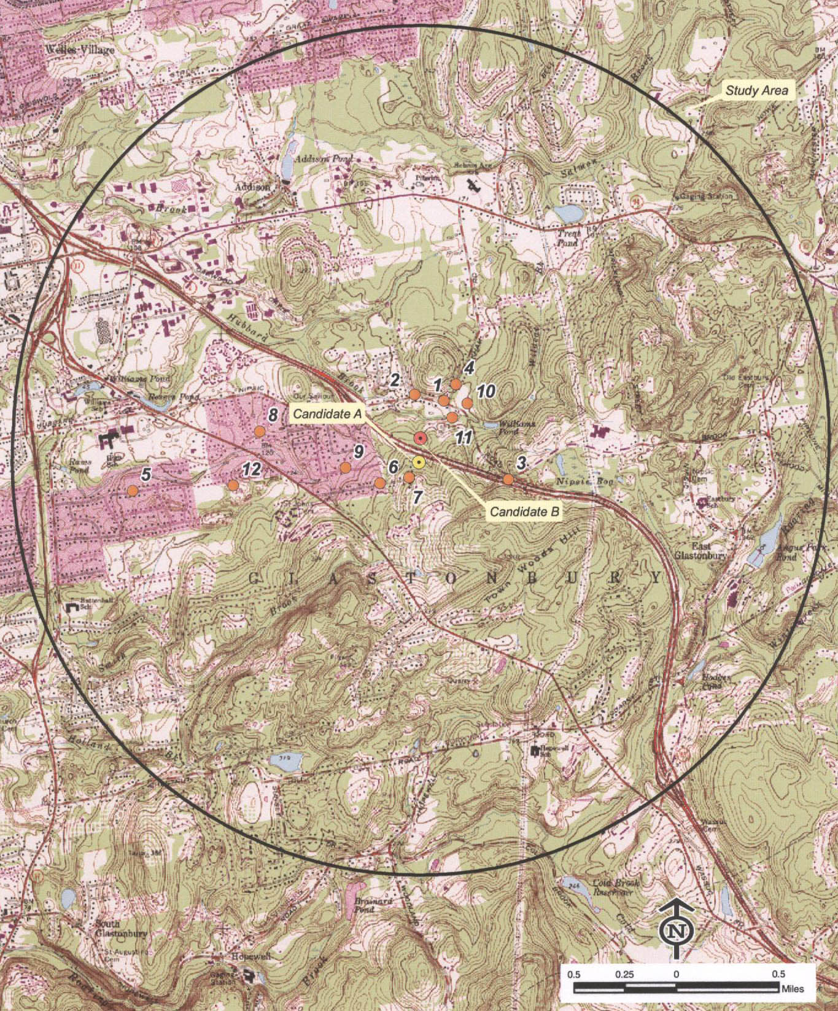
(Applicants 1, Exhibit M)

Figure 2: Aerial Photograph of Proposed Sites’ Vicinity
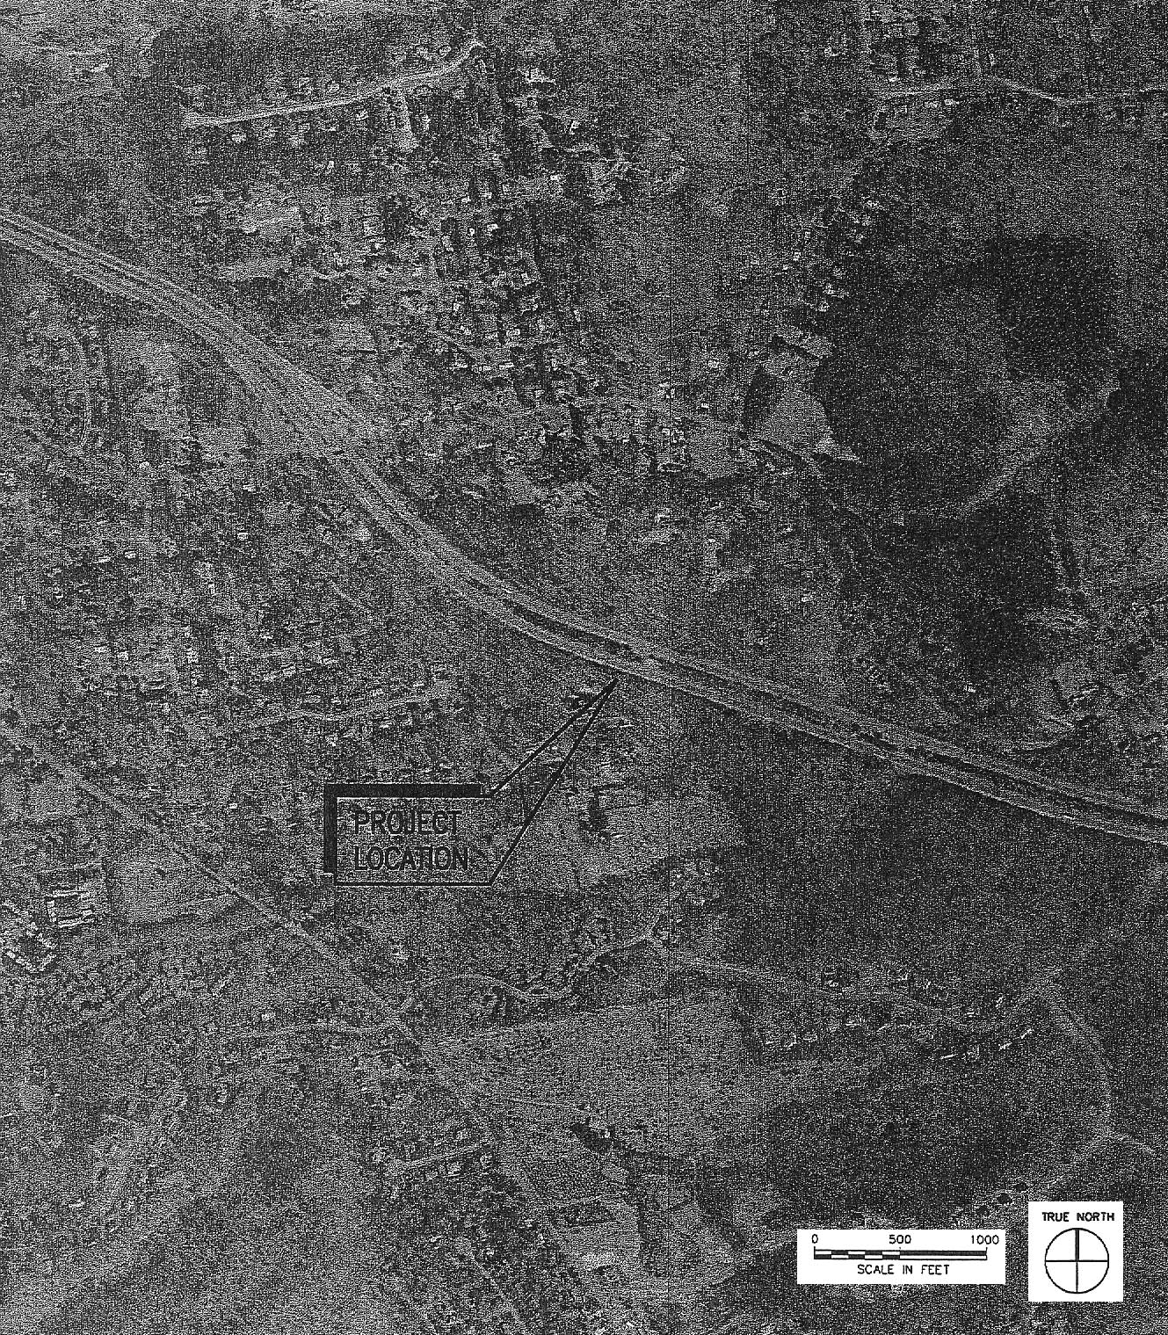
(Applicants 1, Exhibit A)

Figure 3: T-Mobile’s Existing Coverage in Project Area
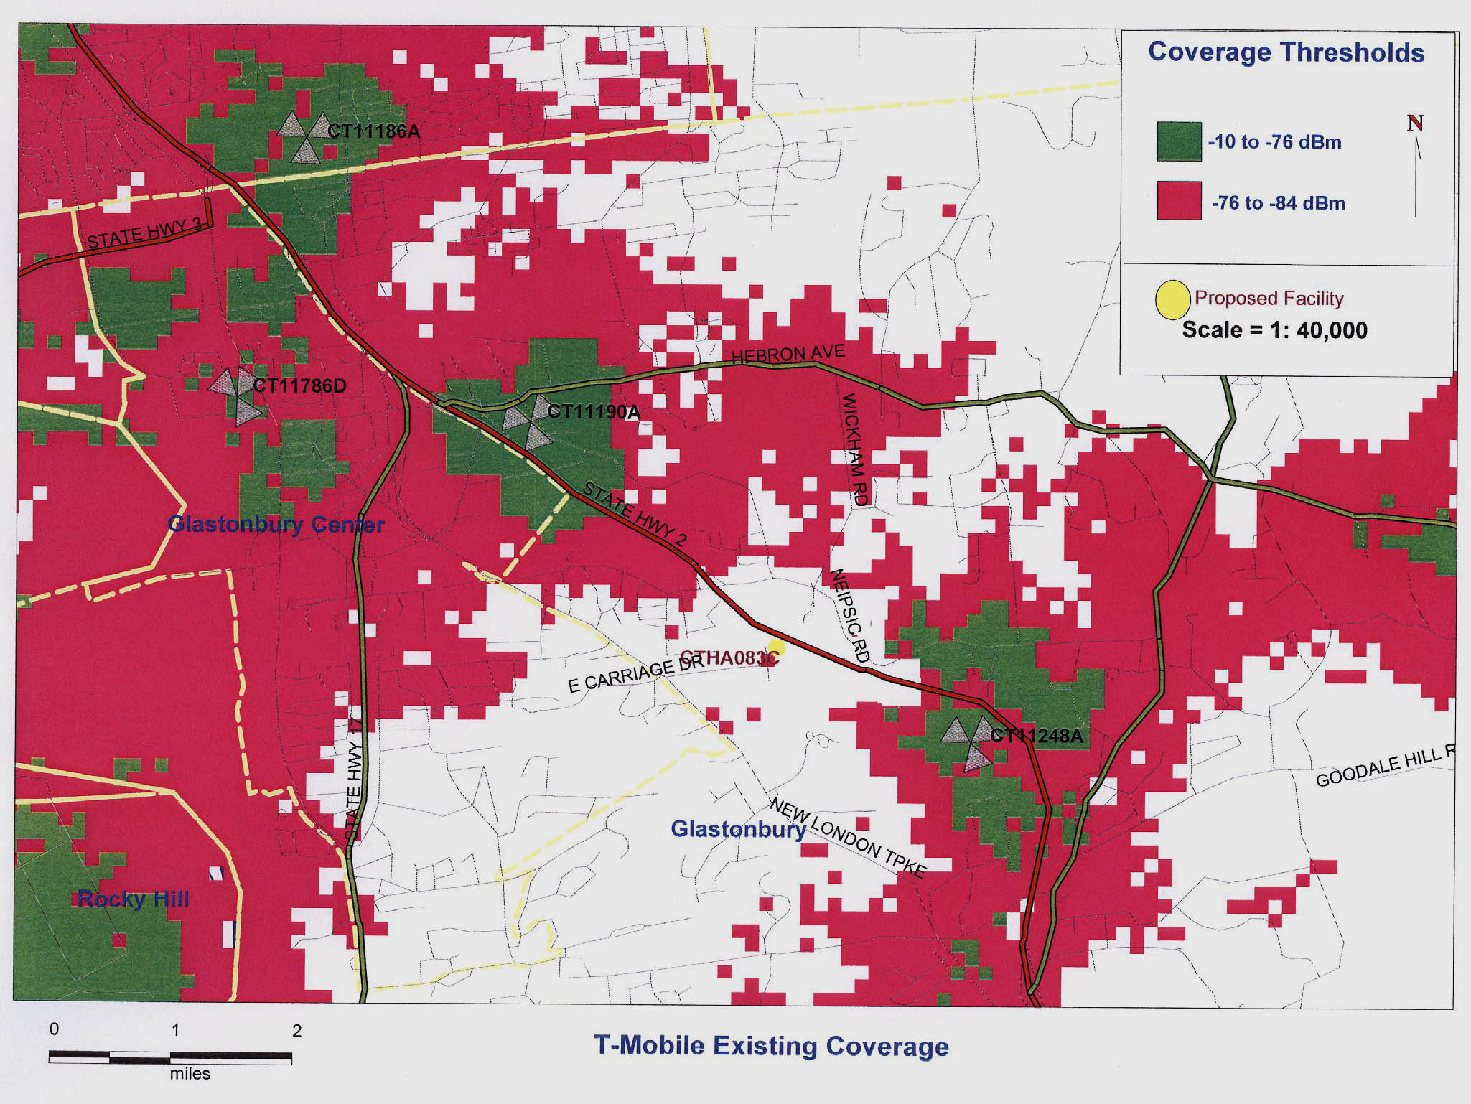
(Applicants 1, Exhibit H)

Figure 4: T-Mobile Coverage from Site A
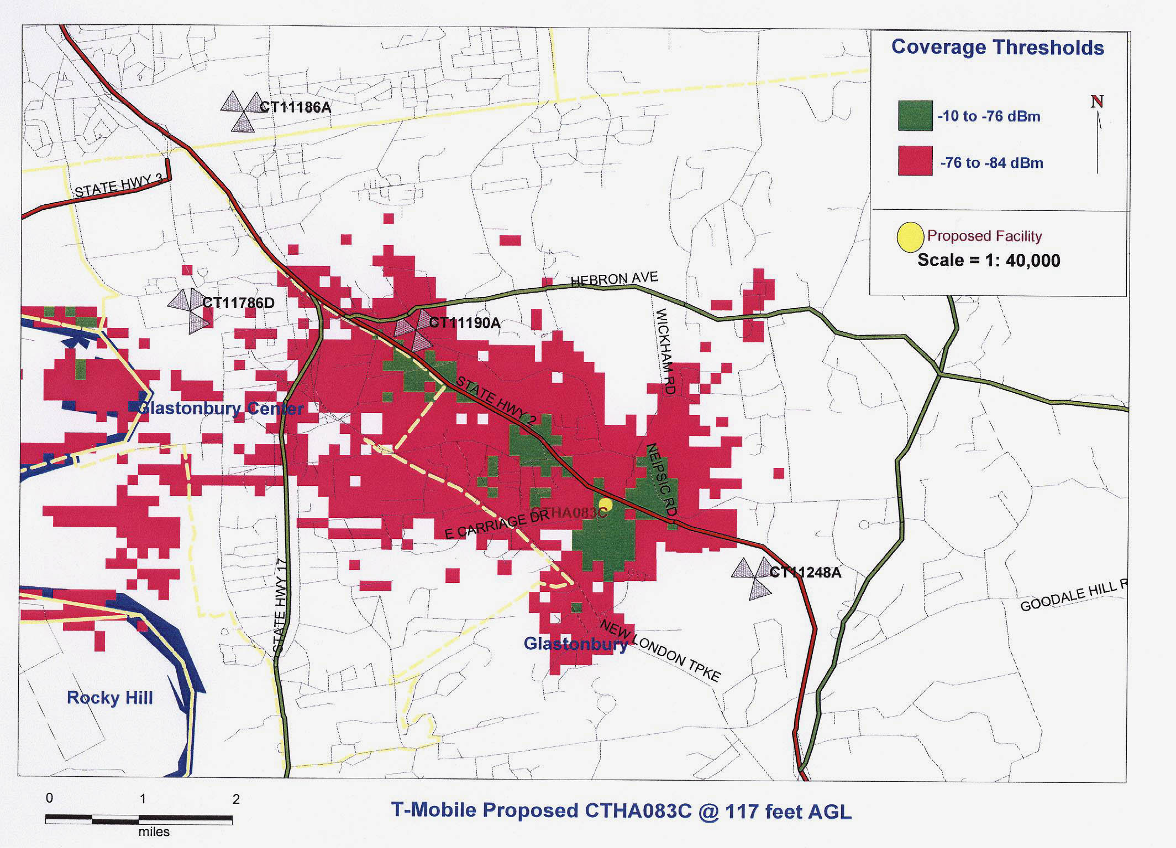
(Applicants 1, Exhibit H)

Figure 5: Existing Coverage with Site A Coverage
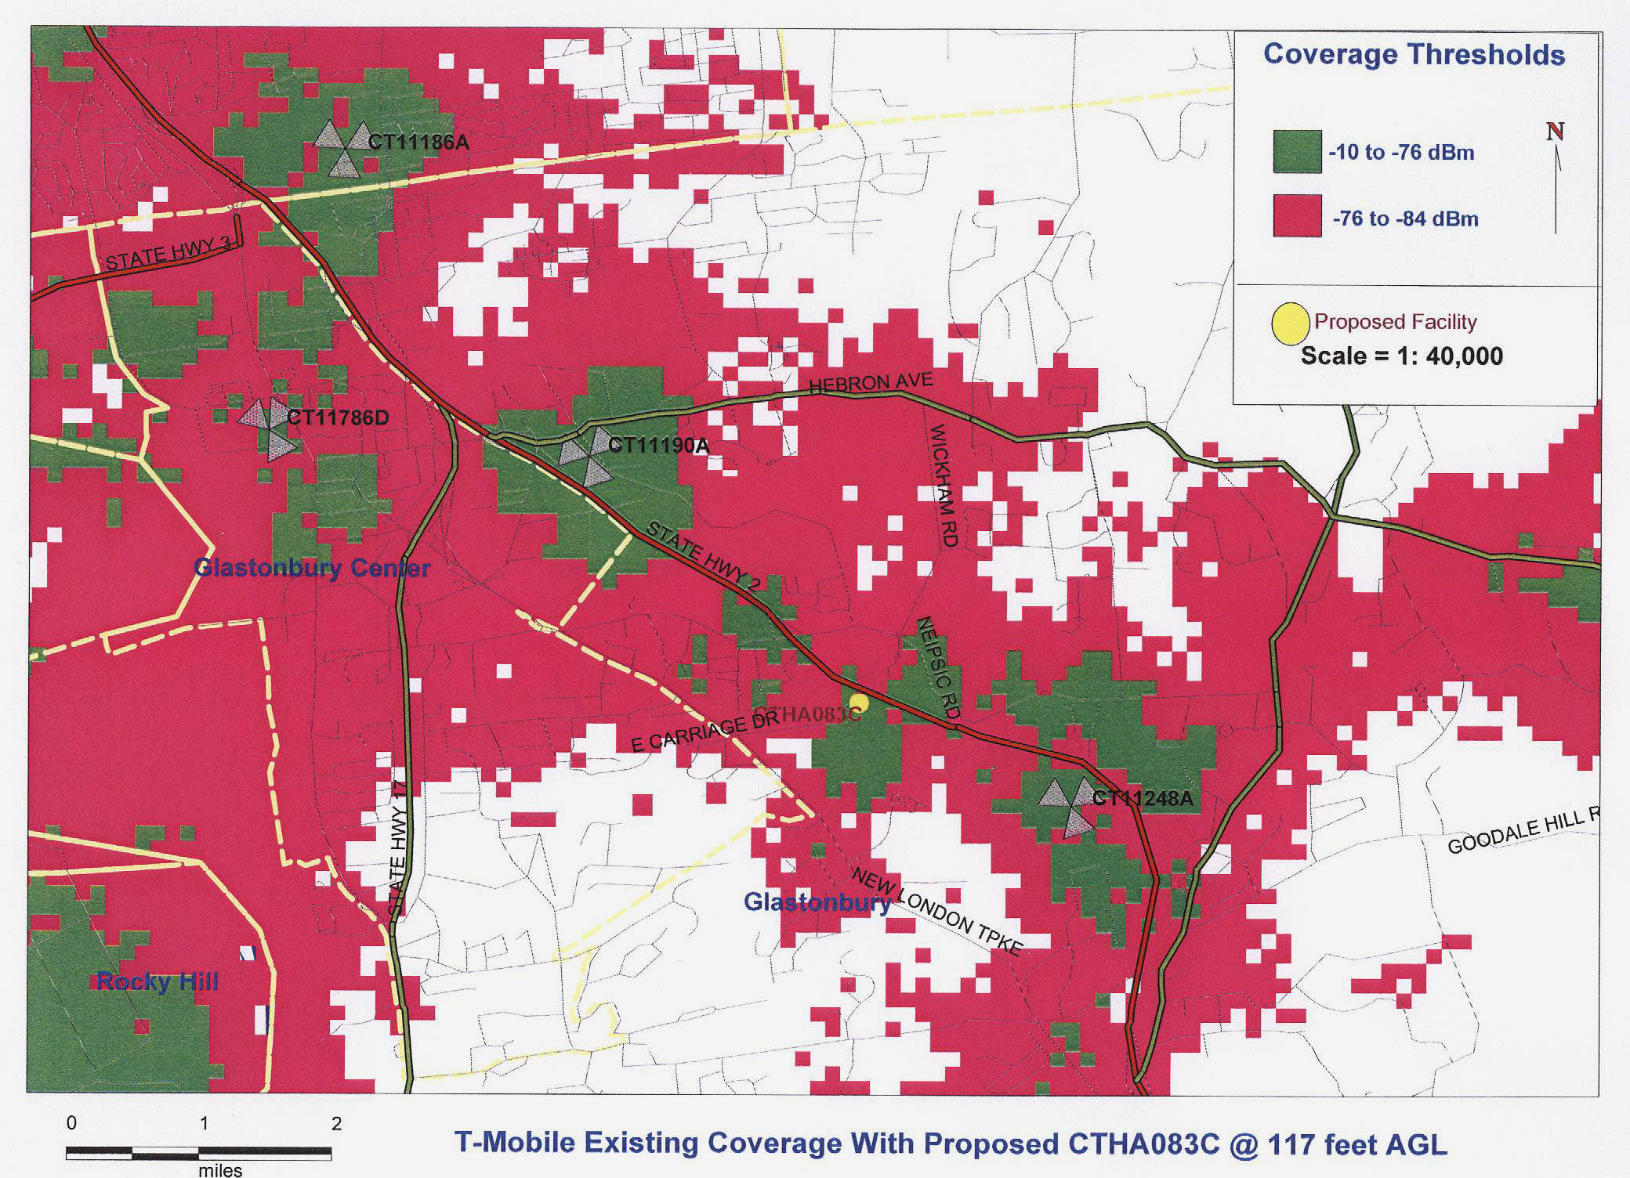
(Applicants 1, Exhibit H)

Figure 6: Site B Coverage
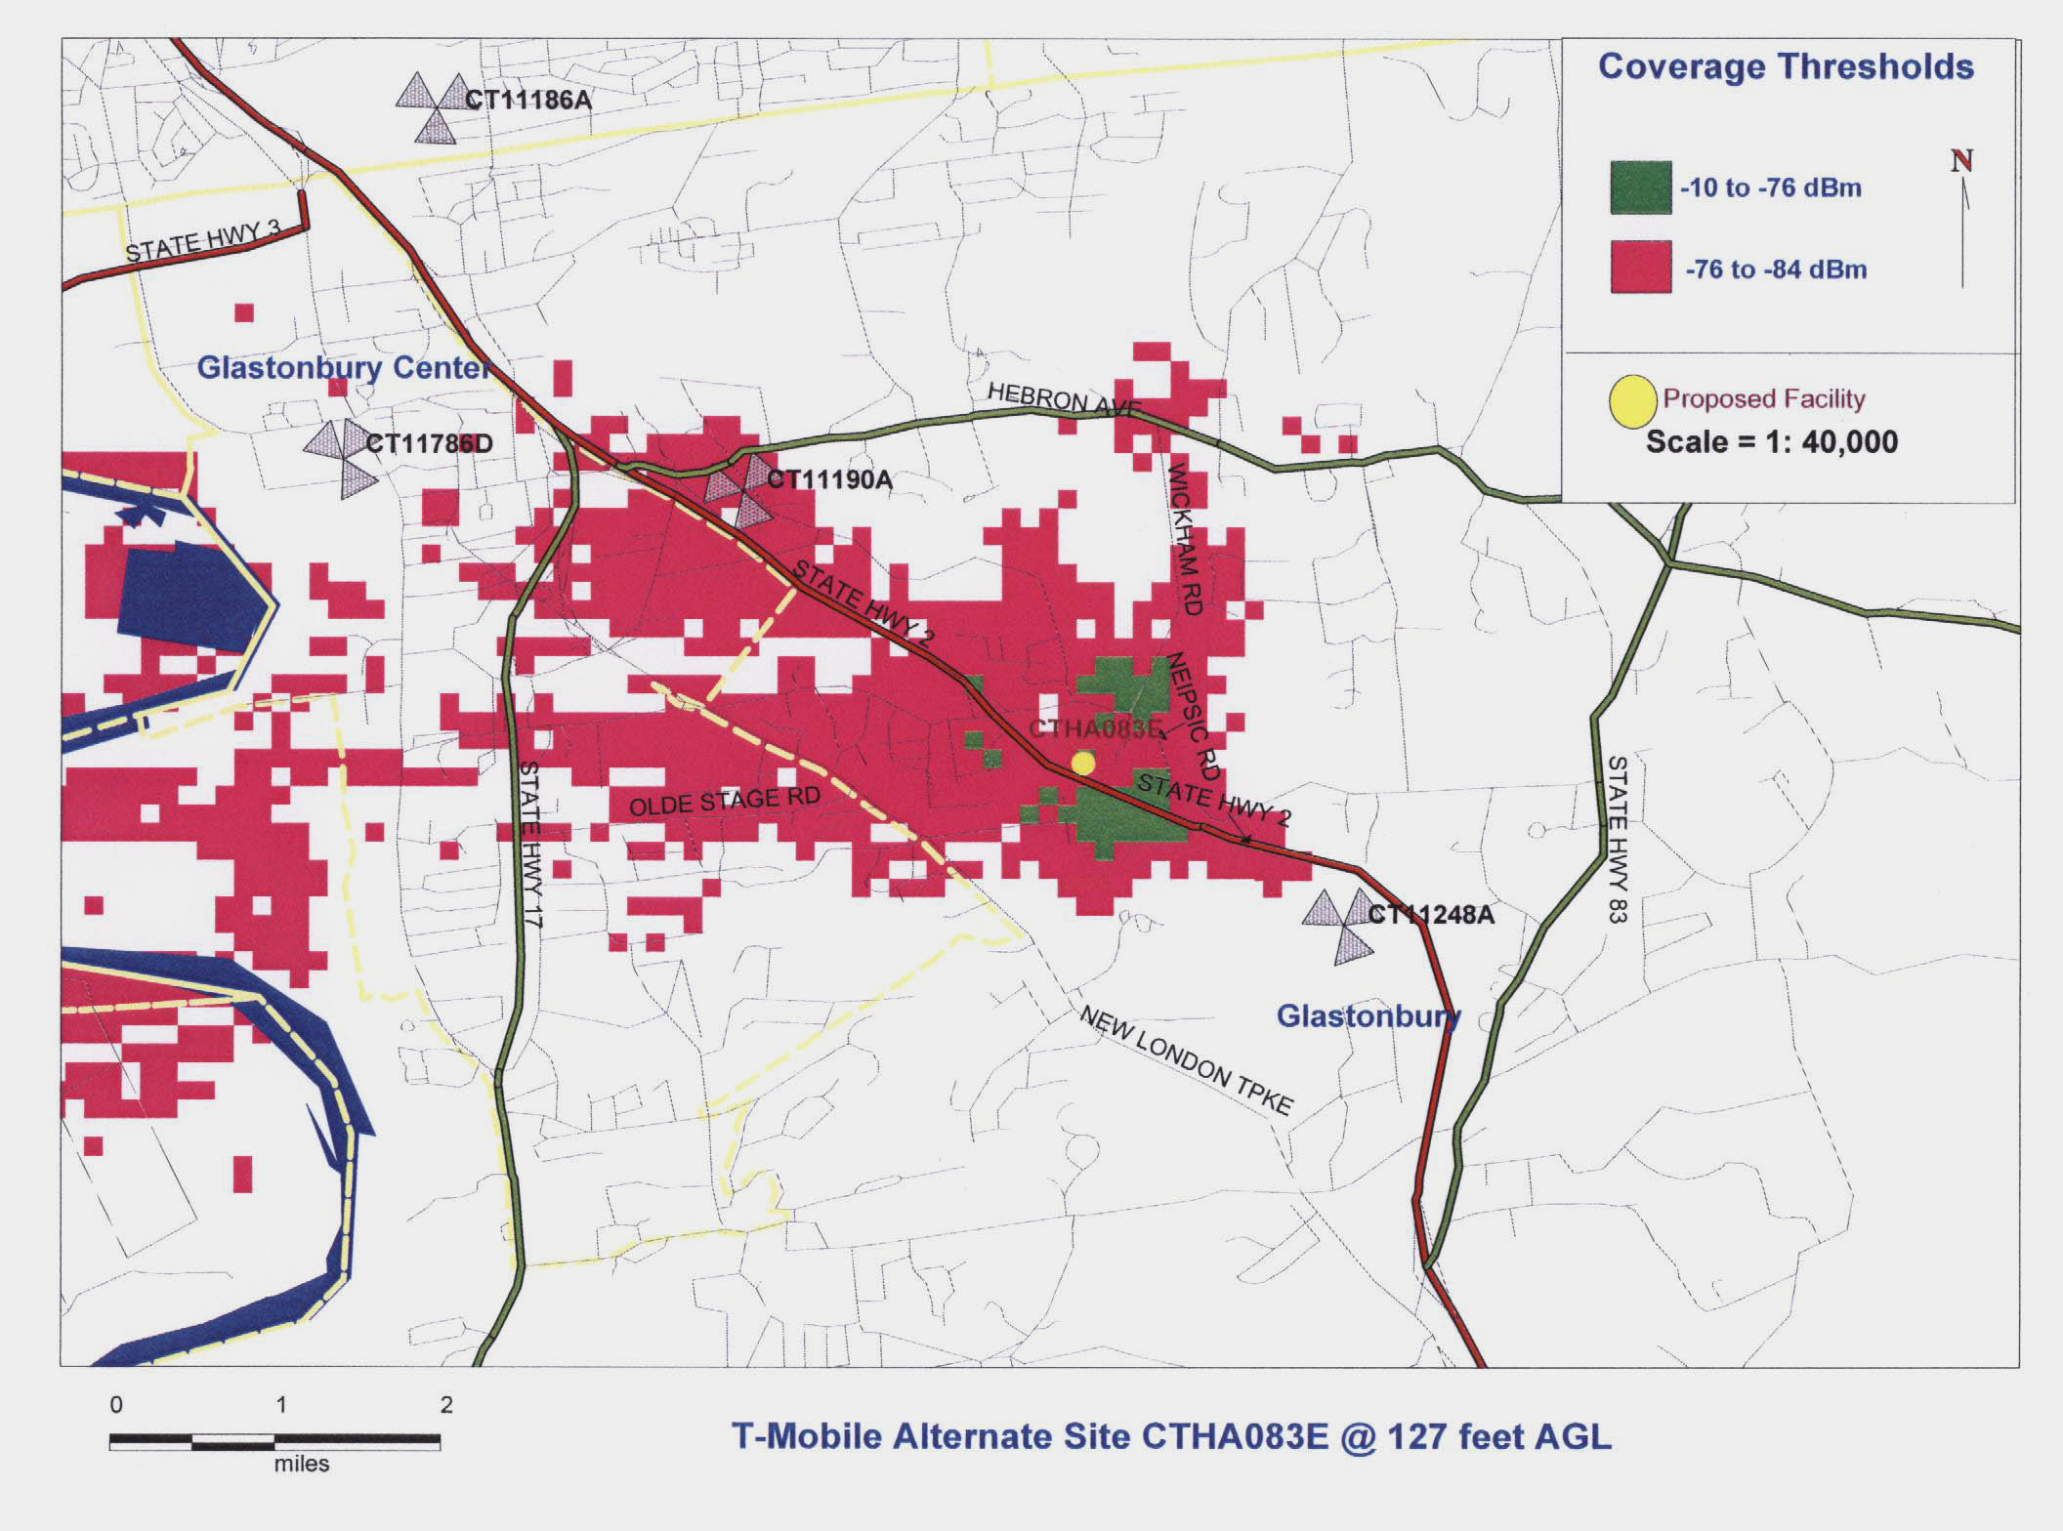
(Applicants 1, Exhibit I)

Figure 7: Existing Coverage with Site B Coverage
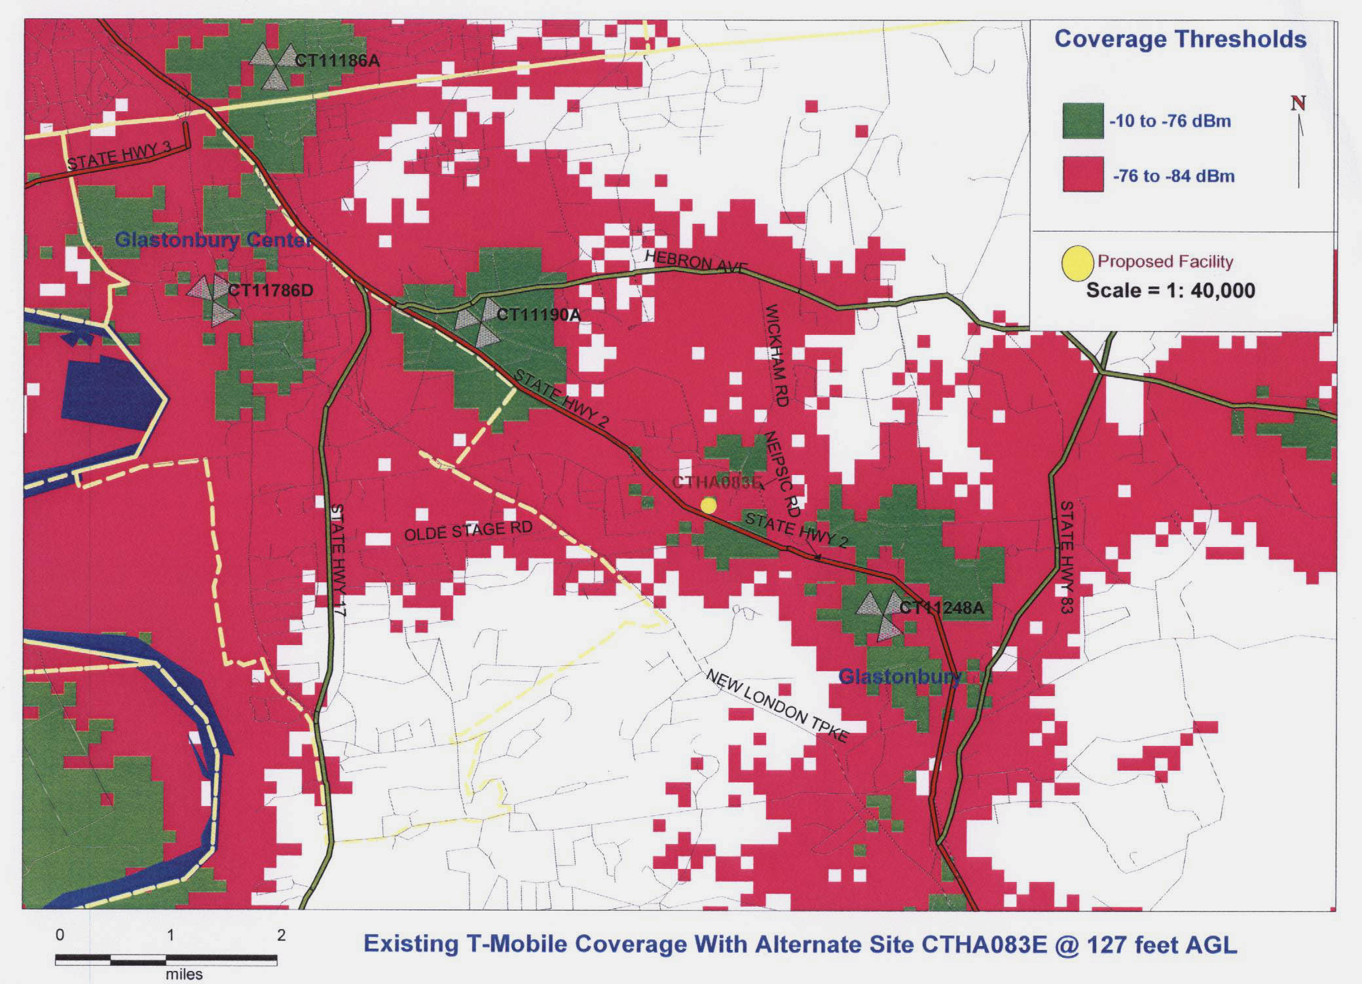
(Applicants 1, Exhibit I)

Figure 8: Plan for Site A
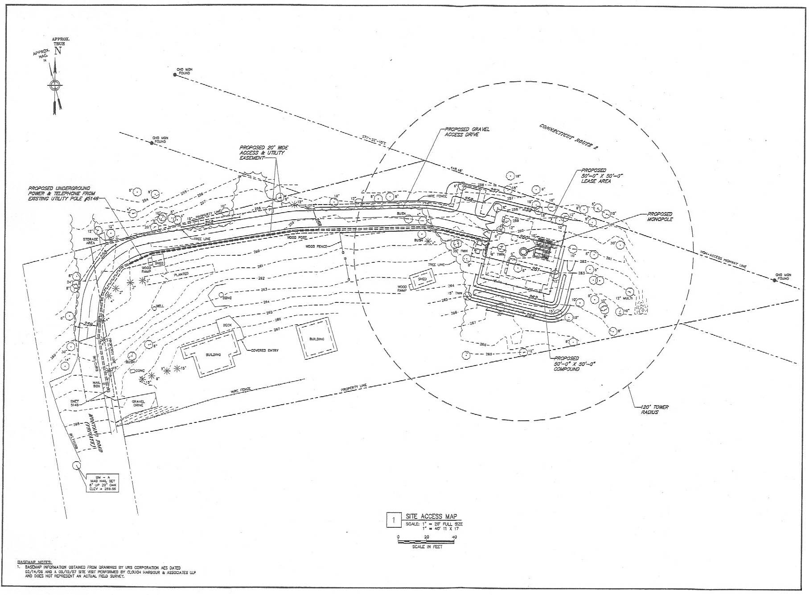
(Applicants 1, Exhibit A)

Figure 9: Plan for Site B
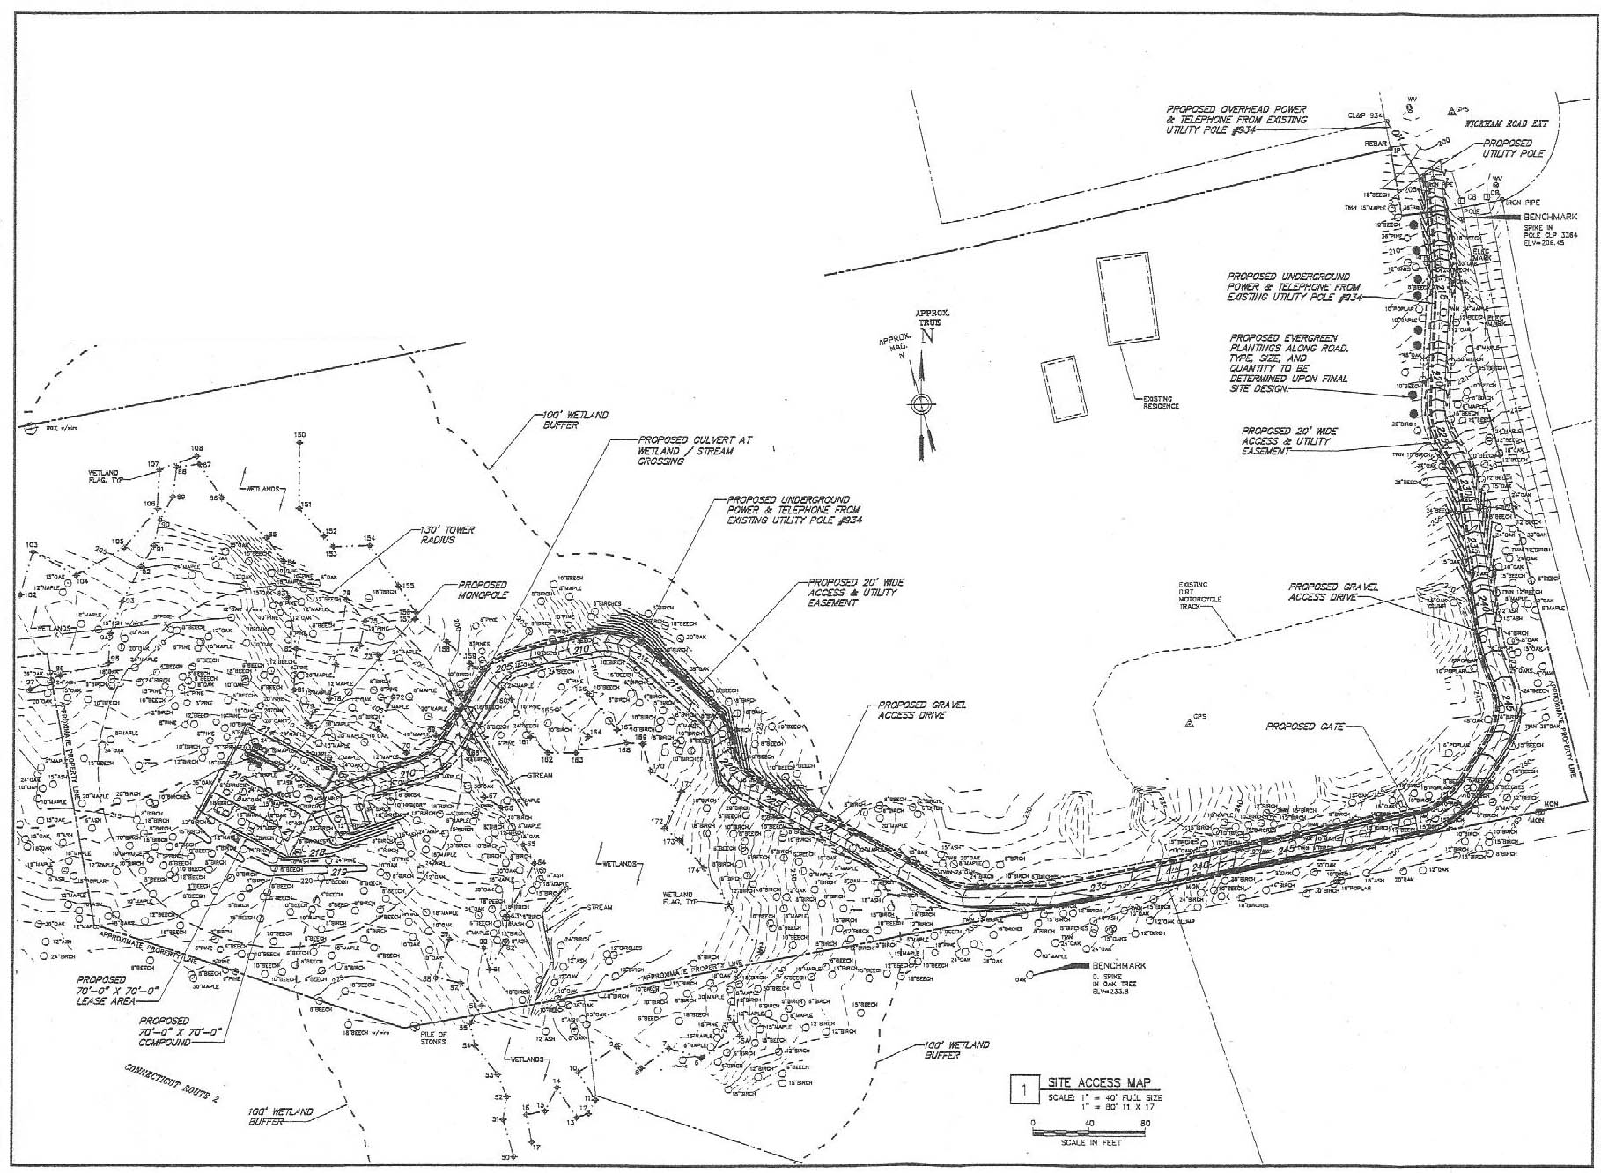
(Applicants 1, Exhibit B)

Figure 10: Visibility Map
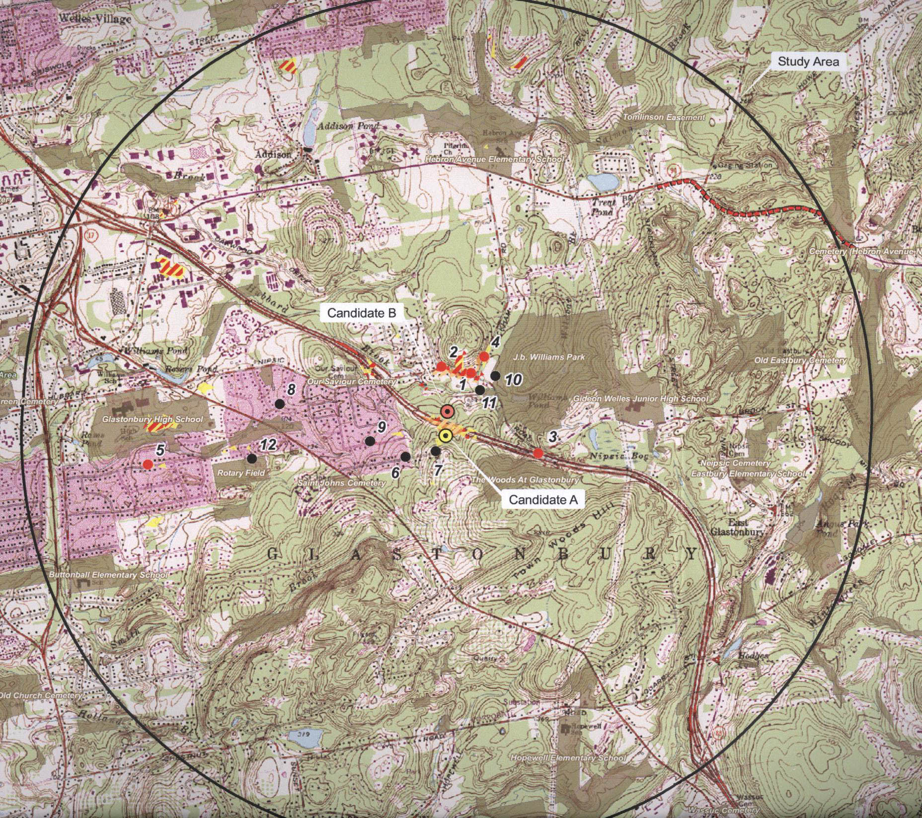
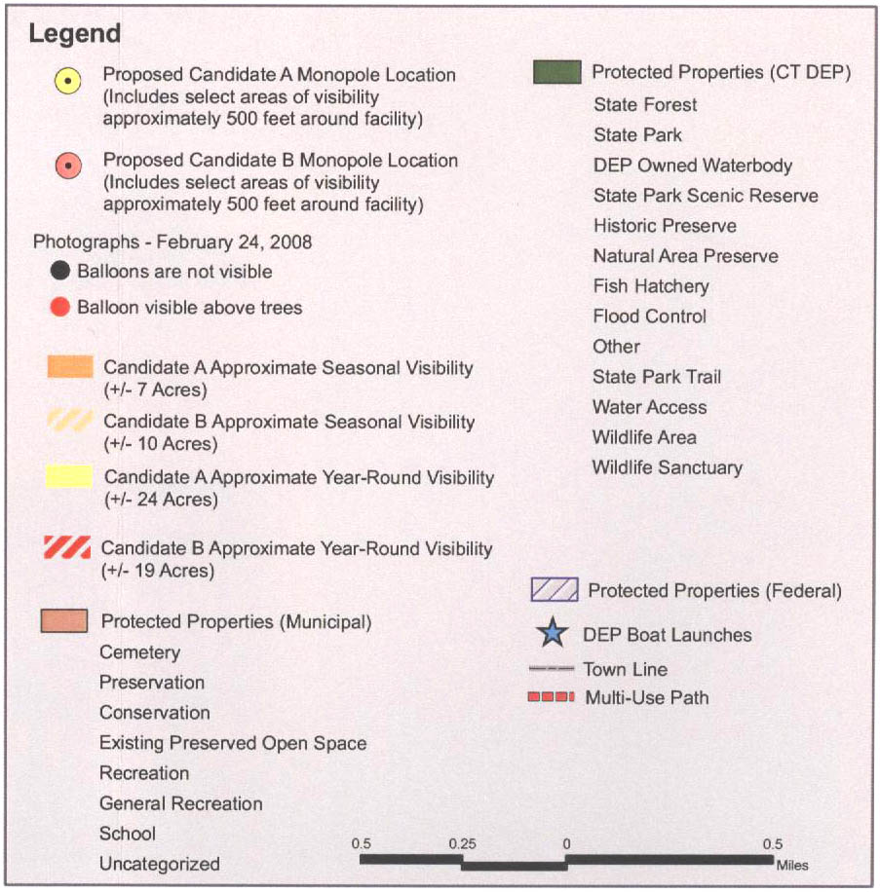
(Applicants 1, Exhibit M)

