DOCKET NO. 353 - Cellco Partnership d/b/a Verizon Wireless application for a Certificate of Environmental Compatibility and Public Need for the construction, maintenance and operation of a telecommunications facility located at 38 Maple Street, Kent, Connecticut. | }  }  } | Connecticut  Siting  Council  April 24, 2008

Findings of Fact

Introduction

- Cellco Partnership d/b/a Verizon Wireless (Cellco), in accordance with provisions of Connecticut General Statutes (CGS) § 16-50g through 16-50aa, applied to the Connecticut Siting Council (Council) on November 9, 2007 for the construction, operation, and maintenance of a wireless telecommunications facility at 38 Maple Street in Kent, Connecticut. (Cellco 1, p. 1)

- Cellco is a Delaware Partnership with an administrative office in Connecticut. Cellco is licensed by the Federal Communications Commission (FCC) to operate a wireless telecommunications system in the State of Connecticut. Operation of the wireless telecommunications systems and related activities are Cellco’s sole business in the State of Connecticut. (Cellco 1, p. 4)

- Cellco is licensed by the FCC to provide personal communications service (PCS) to Litchfield County, Connecticut. (Cellco 1, p. 7)

- The party in this proceeding is the applicant. (Transcript 1 [Tr. 1], 3:00 p.m., p. 5; Transcript 2 [Tr. 2], 7:15 p.m., p. 5)

- The purpose of the proposed facility is to provide PCS coverage along Route 7, Route 341 and local roads in the central portion of Kent. Currently, there is little or no Cellco wireless coverage in central Kent. (Cellco 1, p. 1)

- Pursuant to CGS § 16-50m, the Council, after giving due notice thereof, held a public hearing on January 31, 2008, beginning at 3:00 p.m. and continuing at 7:15 p.m. at the Kent Town Hall, First Floor Meeting Room, 41 Kent Green Boulevard, Kent, Connecticut. (Council's Hearing Notice dated January 2, 2008; Tr. 1, p. 2; Tr. 2, p. 2)

- The Council and its staff conducted an inspection of the proposed site on January 31, 2008, beginning at 2:00 p.m. During the field inspection, the applicant flew a balloon at the proposed site to simulate the height of the proposed tower. Weather conditions during the field review consisted of moderate wind within a range of 7 to 10 miles per hour; however, the balloon has primarily been aloft at the proposed height of 150 feet above ground level (agl). The balloon float occurred from 7:45 a.m. to 5:00 p.m. (Council’s Hearing Notice dated January 2, 2008; Tr. 1, p. 13)

- Cellco posted a four-foot by six-foot sign at the front of the property on January 15, 2008 to notify the public of the Council’s hearing regarding the proposed project. (Cellco 5; Tr. 1, p. 14)

- Pursuant to CGS § 16-50l (b), public notice of the application was published in Waterbury Republican-American on November 6 and 7, 2007. (Cellco 1, p. 5; Cellco 2, Affidavit of Publication)

- Pursuant to CGS § 16-50l(b), notice of the application was provided to all abutting property owners by certified mail. Return receipts were received for all adjacent landowners. (Cellco 1, p. 5, Tab 5; Cellco 4, R. 1)

- Pursuant to CGS § 16-50l (b), Cellco provided notice to all federal, state and local officials and agencies listed therein. (Cellco 1, p. 5; Tab 3)

State Agency Comment

- Pursuant to CGS § 16-50j (h), on January 2, 2008 and February 4, 2008, the following state agencies were solicited by the Council to submit written comments regarding the proposed facility; Department of Environmental Protection (DEP), Department of Public Health (DPH), Council on Environmental Quality (CEQ), Department of Public Utility Control (DPUC), Office of Policy and Management (OPM), Department of Economic and Community Development (DECD), and the Department of Transportation (DOT). (Record)

- The Council received responses from the DPH on January 18, 2008 and the DOT’s Bureau of Engineering and Highway Operations on January 22, 2008. Both agencies submitted letters that they have “no comments” on the proposed project. (DPH letter received January 18, 2008, DOT letter received January 22, 2008, Record)

- The following agencies did not respond with comment on the application: CEQ, DPUC, OPM, DEP, and the DECD. (Record)

Municipal Consultation

- Beginning in spring 2005, Cellco representatives consulted with local officials to discuss the need for a wireless facility in Kent and explore the potential use of the Town Fire Department property at 28 Maple Street in addition to the proposed site. (Cellco 1, p. 18)

- On May 1, 2007, Cellco met with the First Selectman of Kent, Ruth Epstein, to begin the municipal consultation process and deliver copies of the technical report for the proposed project. Cellco appeared before the Kent Board of Selectman, Planning and Zoning Commission and attended a Kent town meeting to discuss a lease agreement with the town to enable the installation of the proposed telecommunications facility. The proposed project has received municipal and public support at each stage of the municipal consultation process. (Cellco 1, pp. 17, 18)

- During the Council’s hearing, First Selectman Epstein spoke in support of the proposed project. (Tr. 1, p. 7)

- The Town of Kent has requested space on the proposed tower for municipal and emergency service antennas and Cellco has agreed at no cost to the town. Cellco would also make ground space in the facility compound available to the town. (Cellco 1, p. 10)

Public Need for Service

- In 1996, the United States Congress recognized a nationwide need for high quality wireless telecommunications services, including cellular telephone service. Through the Federal Telecommunications Act of 1996, Congress seeks to promote competition, encourage technical innovations, and foster lower prices for telecommunications services. (Council Administrative Notice Item No. 7)

- In issuing cellular licenses, the federal government has preempted the determination of public need for cellular service by the states, and has established design standards to ensure technical integrity and nationwide compatibility among all systems. (Council Administrative Notice Item No. 7; Cellco 1, p. 7; Tab 6)

- The Telecommunications Act of 1996 prohibits local and state entities from discriminating among providers of functionally equivalent services. (Council Administrative Notice Item No. 7)

- The Telecommunications Act of 1996, a federal law passed by the United States Congress, prohibits any state or local entity from regulating telecommunications towers on the basis of the environmental effects of radio frequency emissions to the extent that such towers and equipment comply with FCC’s regulations concerning such emissions. This Act also blocks the Council from prohibiting or acting with the effect of prohibiting the provision of personal wireless service. (Council Administrative Notice Item No. 7)

- In an effort to ensure the benefits of wireless technologies to all Americans, Congress enacted the Wireless Communications and Public Safety Act of 1999 (the 911 Act). The purpose of this legislation was to promote public safety through the deployment of a seamless, nationwide emergency communications infrastructure that includes wireless communications services. (Cellco 2, R. 2)

- Through the enhanced 911 Act of 2004 (E-911 Act), the FCC requires carriers to provide public safety facilities with information including the latitude and longitude of the caller. The development of new technologies must support E-911 services. (Cellco 4, R. 2)

- The E-911 requirements have been incorporated into all existing Cellco facilities in Connecticut and would be installed at the proposed facility. (Cellco 4, R. 2)

Site Selection

- Cellco’s search ring consists of an irregularly shaped area centered on the proposed site. The search area is approximately 1.25 miles at its longest point and approximately 0.6 miles at its widest point. (Cellco 4, R. 4)

- Prior to selecting the proposed site, Cellco identified and investigated two potential sites and an existing structure in Kent. After the Town of Kent expressed an interest in leasing its transfer station property, Cellco did not pursue the potential alternatives. The additional sites included:
    - The Kent Fire Department property at 28 Maple street for the installation of a 150-foot telecommunications facility;
    - A steeple installation at the Kent Congregational Church on Main Street; and
    - A parcel at 13 Kent Cornwall Road, north of the transfer station site.
(Cellco 1, Tab 9; Cellco 4, R. 5)

- There is one existing tower within a four-mile radius of the Kent search area. This tower is a 180-foot monopole located at Bulls Bridge Road in Kent. Cellco has antennas located at the 160-foot level of this existing tower. The existing tower would not provide the coverage or capacity needed along Route 7 and Route 341 in the central Kent area. (Cellco 1, Tab 9)

- Microcells and repeaters are not viable technological alternatives for providing coverage to the identified coverage gap due to the large size of the area that needs to be covered along Route 7 and Route 341. (Cellco 4, R. 7)

Site Description

- The proposed site is located on an approximately 10.2 acre parcel owned by the Town of Kent located at 38 Maple Street (Route 341). The property is used as the town’s Public Works Garage and Solid Waste Transfer Station. The proposed site is depicted in Figure 1 and Figure 2. (Cellco 1, p. i, Tab 1)

- The property is zoned industrial. Telecommunications towers are permitted in the Industrial zone through the issuance of a Special Permit. (Cellco 1, p. 16)

- Cellco would construct a 150-foot monopole in the central portion of the host property, to the west of the existing garage structure. The proposed tower site would be located at an elevation of approximately 393 feet above mean sea level. (Cellco 1, p. 10, Tab 1)

- Cellco would design the proposed tower to be expandable by 20 feet, if ordered by the Council. (Tr. 1, pp. 31, 32)

- The proposed monopole would be located within a 50-foot by 80-foot leased area. The tower would have a 3.5-foot diameter at the base tapering to 2.5 feet at the top. The tower would be designed to support four antenna platforms with a ten-foot center-to-center vertical separation. The tower would be designed in accordance with the Electronic Industries Association Standard EIA/TIA-222-F “Structural Standards for Steel Antenna Towers and Antenna Support Structures.” (Cellco 1, Tab 1; Cellco 4, R. 8)

- Cellco would install 12 PCS antennas on a full array platform at a centerline height of 150 feet agl. The top of the antennas would be at 153 feet agl. (Cellco 1, Tab 1; Tr. 1, p. 55)

- Cellco would install the proposed antennas on T-arms, if ordered by the Council. (Tr. 1, p. 55)

- Sprint Nextel has expressed an interest in locating antennas at the 140-foot level of the proposed tower. (Cellco 6; Tr. 1, p. 14)

- The Town of Kent would locate two 22-foot whip antennas at the top of the proposed tower, which would extend to a height of 172 feet agl. The town would also install two 12-foot whip antennas at the 110-foot level of the tower. (Cellco 6)

- A 50-foot by 80-foot equipment compound enclosed by an eight-foot chain link fence would be established at the base of the compound. The proposed equipment compound would accommodate the equipment of four carriers and the Town of Kent. Cellco would install a 12-foot by 30-foot single-story equipment shelter near the base of the proposed tower, to house Cellco’s equipment. (Cellco 1, p. 10, Tab 1)

- Cellco would install a propane-fueled back-up generator within a segregated room in the equipment shelter for use during power outages and operated periodically for maintenance purposes. The associated 1,000-gallon propane tank would be located in the southwesterly portion of the proposed compound. (Cellco 1, pp. 10, 11)

- Cellco currently does not use fuel cells as back up power supply at wireless telecommunications sites in Connecticut. Cellco is evaluating field test data for a site in New Jersey where a 12-kilowatt hydrogen fuel cell was installed, which would provide approximately 14 to 16 hours of power before refueling is required. (Cellco 4, R. 20)

- Minimal grading would be required for the construction of the tower site and compound. (Cellco 1, Tab 1)

- Access to the proposed site would extend approximately 220 feet from Maple Street (Route 341) over an existing paved driveway to the site compound. Utilities would extend underground from a utility pole adjacent to the existing access drive to the property. (Cellco 1, Tab 1; Cellco 4, R. 10)

- Development of the proposed site would not require blasting. (Cellco 4, R. 11)

- The tower setback radius would be contained within the property owned by the Town of Kent. (Cellco 4, R. 12)

- There are nine single-family residences and two multi-family residential complexes within 1,000 feet of the proposed facility. The nearest single-family residence is at 9 Maple Street Extension, owned by Bradley Gatto, which is located approximately 500 feet northeast of the proposed facility. The South Common residential complex is located approximately 400 feet south of the proposed facility. (Cellco 1, p. 13; Cellco 4, R. 14)

- Land use in the surrounding area consists of industrial zoned land to the east between Maple Street and Maple Street Extension, commercial zoned land to the north and west and residential zoned land to the south. (Cellco 1, p. 15)

- Templeton Farm Apartments, an elderly housing facility, is located on three adjacent parcels west of the proposed facility. The apartment buildings are approximately 400 feet from the proposed facility. (Tr. 2, p. 19)

- A nursing home facility, Kent Special Care Center, is located east of the proposed facility. The nearest building on the nursing home property is approximately 700 feet from the proposed facility. (Cellco 1, Tab 1; Tr. 2, p. 19)

- The estimated construction cost of the proposed facility, including radio equipment, is:

Cell site radio equipment $ 450,000
Tower, coax and antenna 150,000
Power systems 20,000
Equipment building 50,000
Misc. (incl. site preparation & installation 75,000

Total $ 745,000
(Cellco 1, p. 20)

Environmental Considerations

- The proposed facility would be partially visible from limited areas within the town center; however, it would have no effect on cultural resources listed or eligible for listing on the National Register of Historic Places. The State Historic Preservation Officer recommends a condition that if the proposed tower is not in use for six consecutive months, all antennas and equipment shall be removed by the facility owner and such removal shall occur within 90 days of the end of such six-month period. (Cellco 1, p. 14, Tab 11)

- The northern parula is a bird listed as a State Special Concern Species that occurs near the proposed project. The northern parula is strongly associated with Usnea lichens, which are used for nesting material. The decline in nesting parulas is linked to the loss of this lichen. Northern parulas may be found in deciduous or coniferous stands as long as the lichen is present. Generally, the birds prefer woodlands near water. The nesting season for this bird is May through August. (Cellco 1, Tab 11)

- Usnea lichen does not appear to be present on the host property. There is also a lack of established woodlands on the property; therefore, it is unlikely that the northern parula is present. (Cellco 1, Tab 11)

- Two federally listed, threatened species are present in Litchfield County; the bog turtle and small whorled pogonia. The property does not contain the appropriate habitat to support these two species. (Cellco 1, p. 19)

- Vegetation in the area surrounding the proposed site consists of mixed deciduous hardwood species interspersed with stands of mature evergreens. The average tree canopy height is 65 feet. (Cellco 1, Tab 10)

- No trees would be removed for the construction of the proposed facility. (Cellco 1, Tab 1; Cellco 4, R. 6)

- An intermittent watercourse was identified approximately 12 feet northeast of the proposed facility. The channel serves as an overflow from a manmade pond, known as Kent Kid’s Fishing Hole, located on the property along Route 341. (Cellco 1, Tab 12)

- Construction of the proposed site is not expected to affect the nearby watercourse since the property has been previously disturbed and no mature vegetation bordering the watercourse would be removed. (Cellco 1, Tab 12)

- The closest public airfield to the proposed site is Candlelight airfield in Sherman, Connecticut located approximately 10.5 miles from the proposed site. Obstruction marking and lighting of the proposed tower would not be required. (Cellco 1, p. 18, Tab 13; Cellco 2, R. 16)

- The maximum power density from the radio frequency emissions of Cellco’s proposed antennas and the town’s antennas would be approximately 3% of the standard for Maximum Permissible Exposure, as adopted by the FCC, at the base of the proposed tower. This calculation was based on methodology prescribed by the FCC Office of Engineering and Technology Bulletin No. 65E, Edition 97-01 (August 1997) that assumes all antennas would be pointed at the base of the tower and all channels would be operating simultaneously. (Cellco 1, Tab 1; Tr. 1, p. 47)

Visibility

- The proposed tower would be visible year-round from approximately 73 acres within a two-mile radius of the proposed site. The tower would be seasonally visible from an additional approximately 135 acres within a two-mile radius of the proposed site. A viewshed analysis of the proposed site is depicted in Figure 3 of this document. (Cellco 1, Tab 10)

- Year-round visual impact from the proposed tower predominately occurs within approximately 0.25 miles of the project area and includes portions of the host property and nearby segments of Route 341 (Maple Street) and Maple Street Extension. Additionally, year-round visibility is expected to occur over open land approximately 0.5 miles to the north and southwest with views from portions of Route 7 to the north, northwest and southwest. The proposed tower would also be visible year-round from a short stretch of Schaghticoke Road located approximately one mile southwest of the proposed site. (Cellco 1, Tab 10)

- Approximately ten residential properties would have year-round views of at least a portion of the proposed tower. The residential properties include several units within an adjacent apartment complex located approximately 0.15 miles to the northwest. (Cellco 1, Tab 10)

- Seasonal visibility of the proposed structure includes an approximately 0.40 mile segment of Route 7 south of Route 341 and an area north of the existing railroad tracks in Kent Town Center. Potential seasonal visibility of the proposed tower may occur along Schaghticoke Road to the west and southwest. (Cellco 1, Tab 10)

- Approximately six additional residential properties would have seasonal views of the proposed tower. The residential properties are located along Route 341, Maple Street Extension and adjacent to the intersection of Elizabeth Street and Meadow Street approximately 0.35 miles to the northwest. (Cellco 1, Tab 10)

- The proposed tower would not be visible year-round from the Appalachian Trail. Mount Algo is a prominent peak immediately east of the Appalachian Trail. Seasonal views may occur from the summit of Mount Algo to the west. The proposed tower would be below any prominent peaks along the Appalachian Trail and the backdrop of the tower would be a ridgeline, which would minimize the view of the structure. (Cellco 1, Tab 10; Tr. 1, p. 16)

- The proposed tower would be visible from Numeral Rock, which is located approximately 0.65 miles northwest of the site, adjacent to the Kent School Athletic fields off Skiff Mountain Road. (Cellco 1, Tab 10)

- Visibility of the proposed tower from specific locations within a two-mile radius of the site is presented in the table below:

Location | Visible | Approx. Portion of Tower Visible | Approx. Distance from Tower
- Route 341 (Maple Street) south of host property | Yes | 100 feet – above trees | 0.09 miles southeast
- Route 341(Maple Street) at host property | Yes | 120 feet – above trees | 0.05 miles northeast
- Route 341 (Maple Street) north of host property | Yes | 110 feet – above trees | 0.22 miles northeast
- Maple Street Extension | Yes | 40 feet - above trees | 0.17 miles southeast
- Maple Street Extension, adjacent to house #9 | Yes | 75 feet - above trees | 0.09 miles northeast
- Route 341 (Maple Street) adjacent to Maple Farm Apartments | Yes | 65 feet – above trees | 0.14 miles northwest
- Schaghticoke Road | Yes | 60 feet – above trees  (mountain in background) | 0.92 miles southwest
- Route 7 | Yes | 30 feet – above trees  (mountain in background) | 0.47 miles southwest
- Route 7 (Main Street) at existing railroad crossing | Yes | 30 feet – above trees (mountain in background) | 0.38 miles north
- Route 7 (Main Street) north of Route 341 | Yes | 30 feet – above trees (vegetation in background) | 0.23 miles northwest
- Route 7 (Main Street) | Yes | 10 feet – above trees (vegetation in background) | 0.19 miles northwest
- Kent Green adjacent to the Post Office | Yes | 10 feet- above trees | 0.38 miles north
- Route 7 (Main Street) | No | - | 0.27 miles northwest
- Lane Street west of Route 7 | No | - | 0.34 miles northwest
- Elizabeth Street adjacent to house #29 | No | - | 0.35 miles northwest
- Route 341 (entrance to the Kent School) north of Skiff Mountain Road | No | - | 0.5 miles northwest
(Cellco 1, Tab 10; Tr. 1, p. 30)

- The proposed tower would be visible from the Templeton Farm Apartments. The view from the apartments would be similar to Location 6 in the above table. (Cellco 1, Tab 10; Tr. 2, p. 19)

- The proposed tower would be visible from the South Common Apartments. The view from these apartments would be similar to Location 5 in the above table. (Tr. 2, p. 20)

- The town’s proposed whip antennas that would extend from the top of the proposed tower would not be visible at a distance greater than approximately 1/8 of a mile. (Tr. 1, p. 15)

Existing and Proposed Wireless Coverage – Cellco

- Cellco operates in the PCS frequency band [1970 – 1976 MHz] in this area and designs for a minimum signal level of -85 dBm. Cellco’s design standard for in-building coverage is -75 dBm. Cellco’s existing coverage near the proposed site is nearly nonexistent as depicted in Figure 4 of this document. (Cellco 1, p. 2, 7; Cellco 4, R. 23; Tr. 1, p. 21)

- The existing signal strength, in the area of the proposed site, ranges from -86 dBm to below -105 dBm. (Cellco 4, R. 22)

- At the 150-foot level, Cellco coverage from the proposed tower would consist of 2.1 miles of coverage along Route 7 and 1.8 miles along Route 341. At the 140-foot level, Cellco would provide 2.1 miles of coverage along Route 7 and 1.5 miles along Route 341. At the 130-foot level, Cellco would provide approximately 2.1 miles along Route 7 and 1.3 miles along Route 341. Existing Cellco coverage and coverage from the proposed site at 150 feet, 140 feet and 130 feet are depicted in Figures 5, 6 and 7, respectively. (Tr. 1, p. 43)

- The proposed site would provide 3.5 square miles of coverage to the surrounding area. The overall coverage footprint from the proposed site with antennas at the 140-foot level would be approximately 3.0 square miles. The overall coverage footprint from the proposed site with antennas at the 130-foot level would be approximately 2.4 square miles. (Cellco 4, R. 21; Tr. 1, p. 43)

- North of the proposed site, along Route 7, Cellco is investigating an area in Falls Village at the fire department for the potential location of a telecommunications site. The potential Falls Village site would be approximately 18 miles north of the proposed Kent site. (Tr. 1, p. 23; Tr. 2, pp. 22, 23)

- Cellco has a search area along the Cornwall/Kent boundary approximately five miles northeast of the proposed site. A site in that area would likely be approximately 120 feet agl. (Tr. 2, pp. 23, 24)

- Cellco envisions the installation of one 120 to 150-foot tower to provide adequate coverage along a 2.8-mile area between the proposed site and the existing Bulls Bridge site (“Kent South”) to the south. A site located in this area would likely be west of the existing Bulls Bridge site and would provide coverage along Route 7. (Tr. 1, pp. 25, 26)

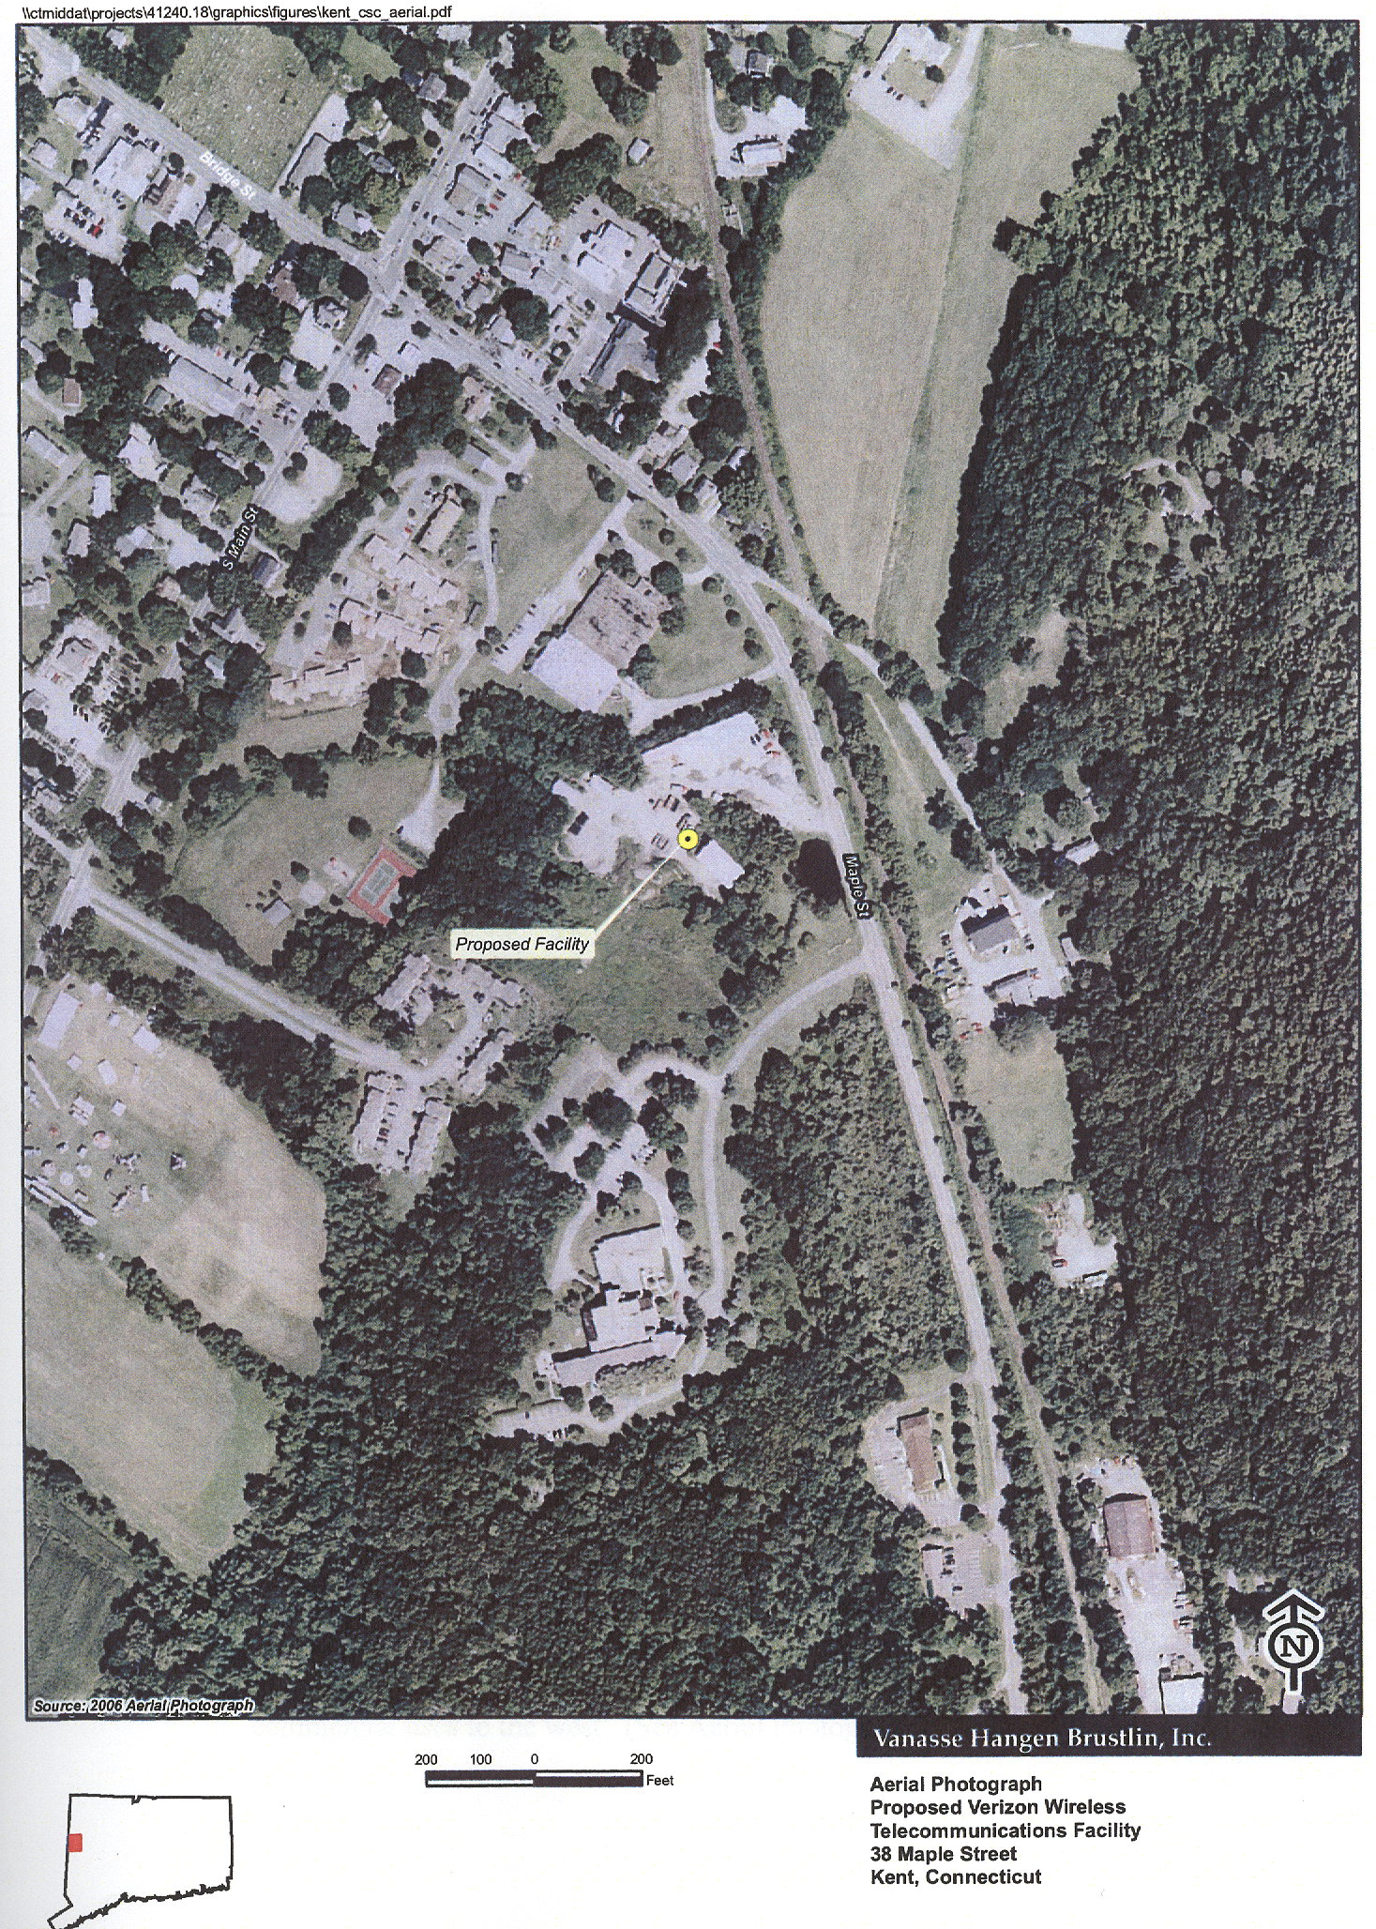
Figure 1. Aerial photograph of the proposed site and surrounding area. (Cellco 1, Tab 1)

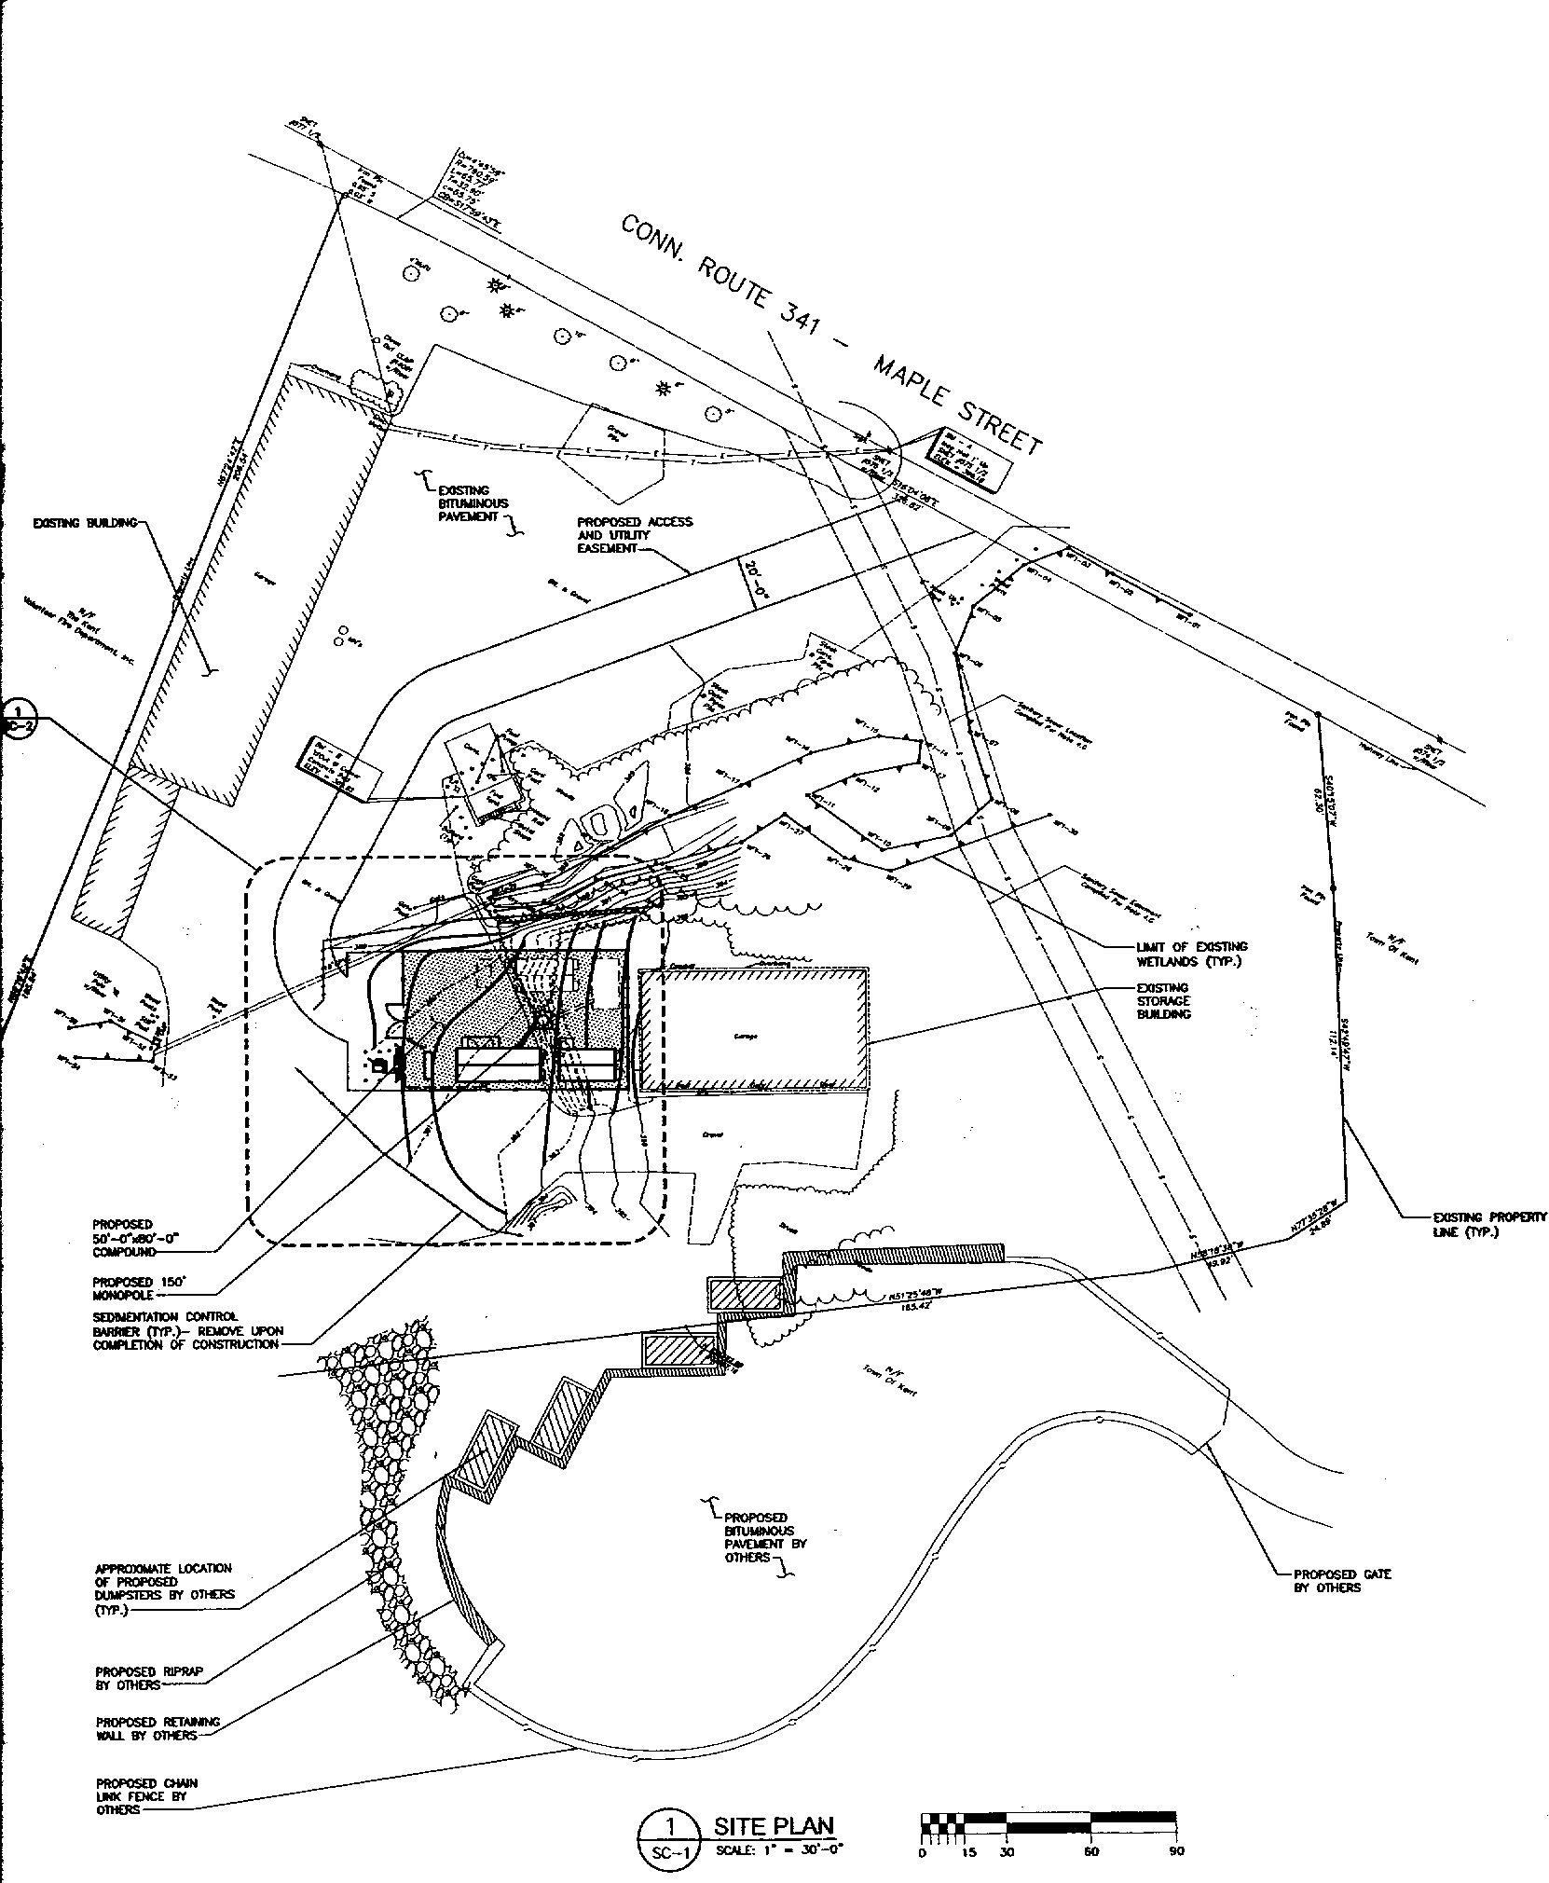
Figure 2. Site plan for the proposed site on the Town of Kent property. (Cellco 1, Tab 1)
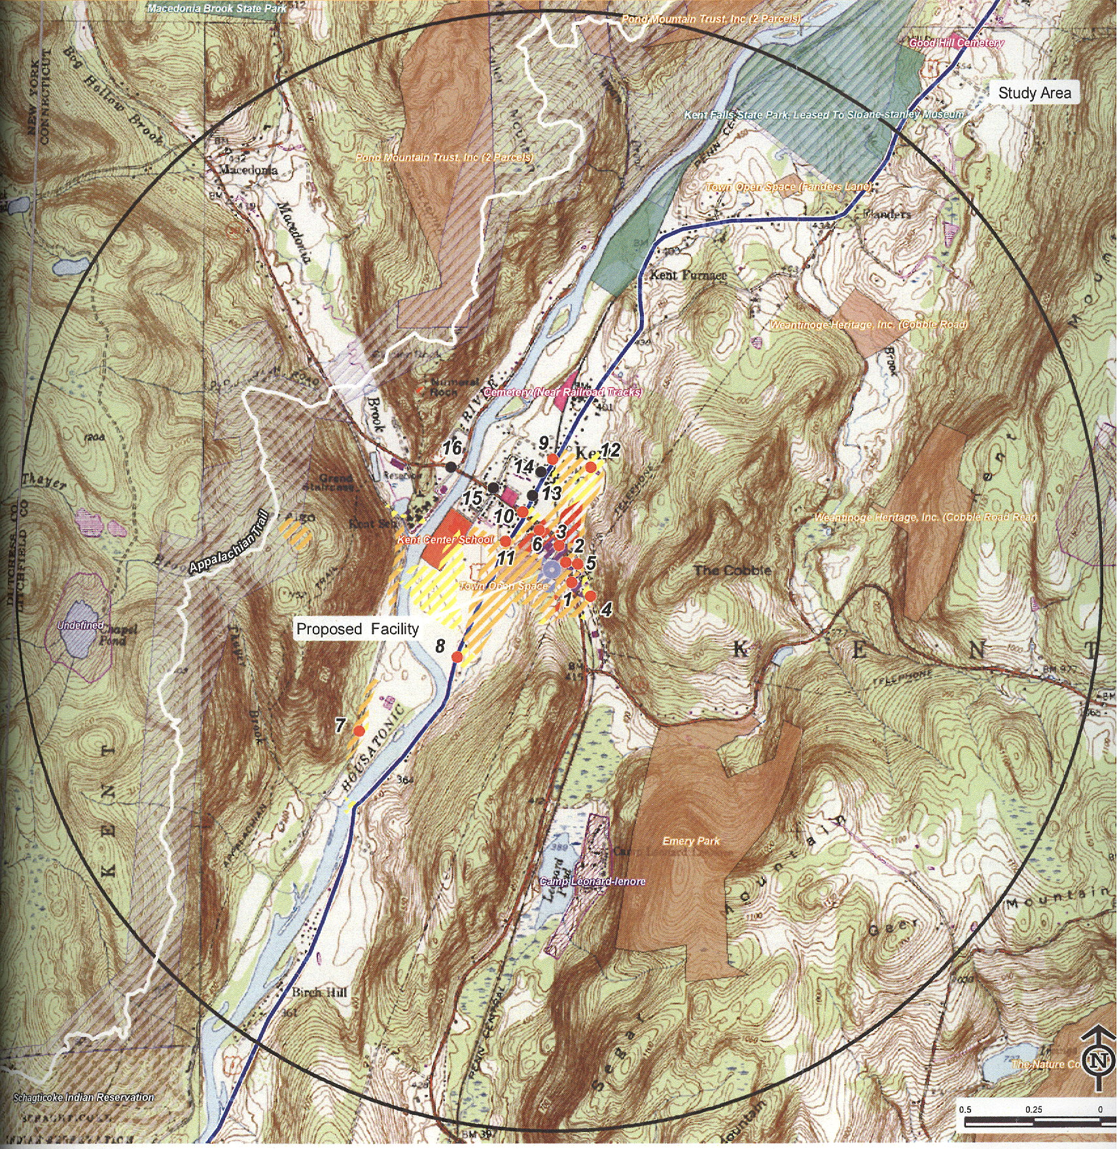
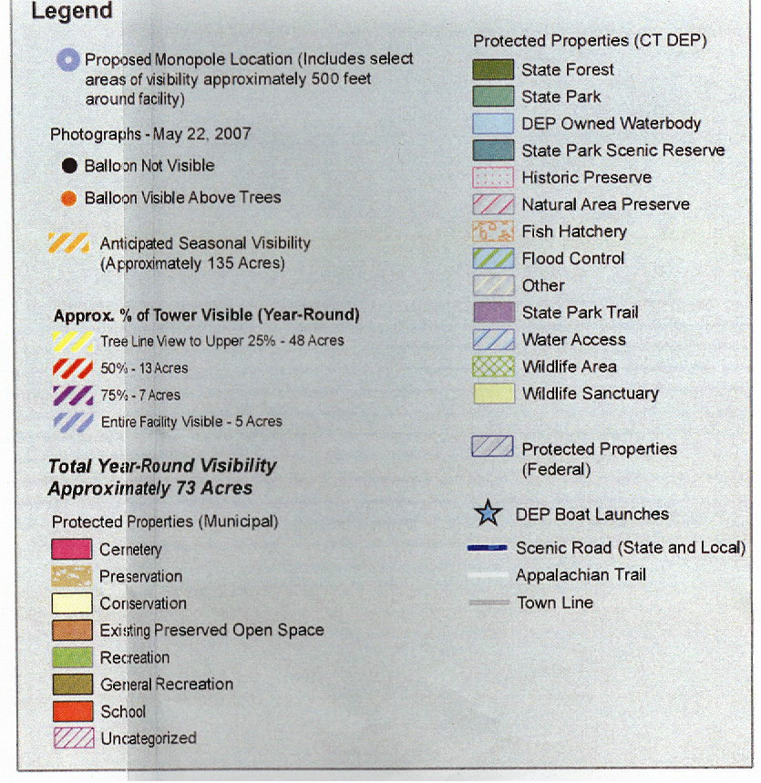
Figure 3. Viewshed analysis for the proposed facility at 150 feet agl. (Cellco 1, Tab 10)
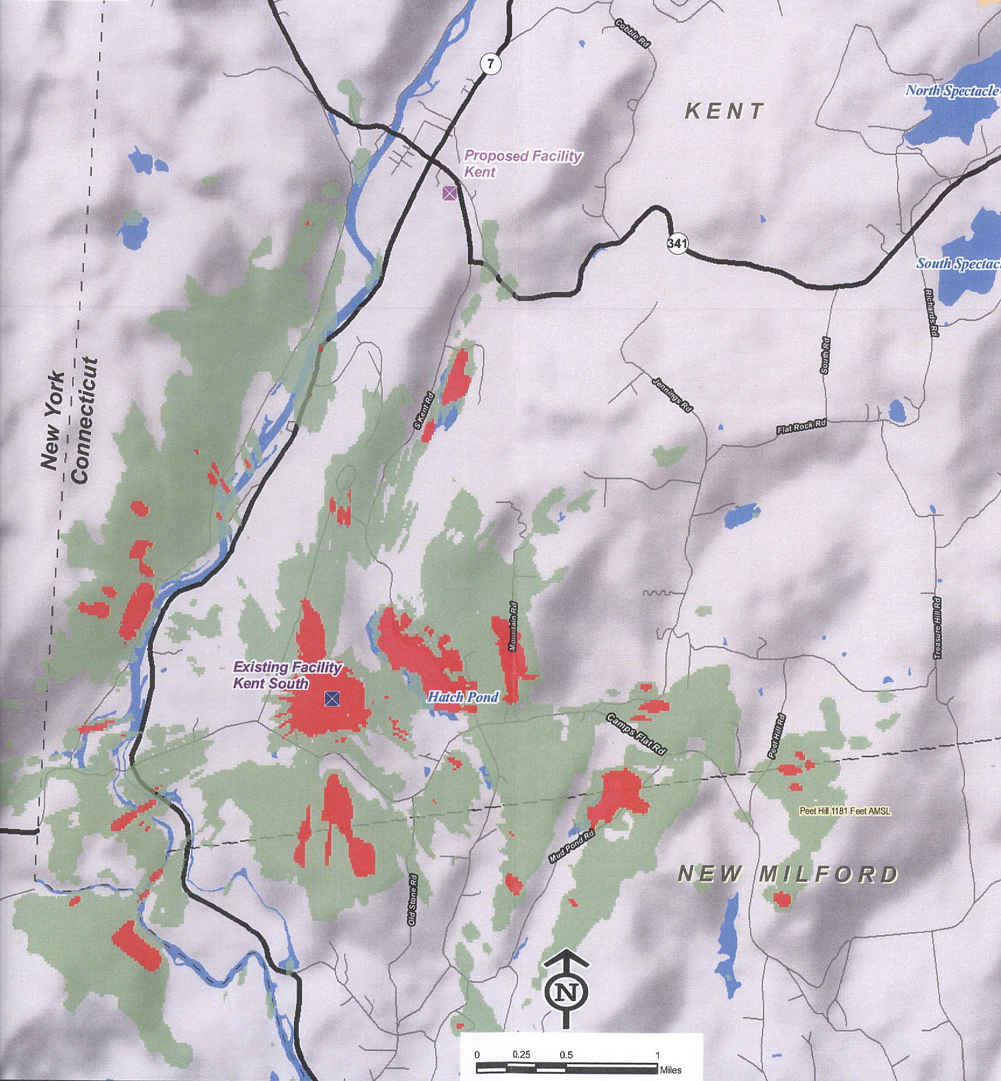
Figure 4. Existing Cellco PCS coverage near the proposed site. Red depicts -75 dBm coverage and green
depicts -85 dBm coverage. (Cellco 4, R. 23)
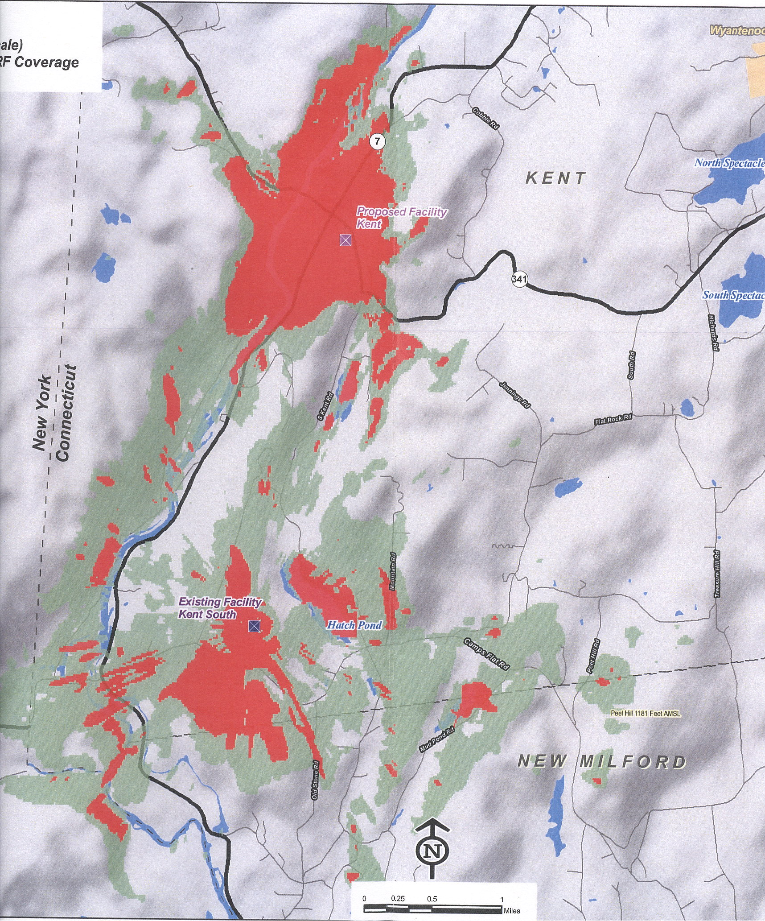
Figure 5. Cellco’s existing and proposed PCS coverage at 150 feet agl. Red depicts -75 dBm coverage and
green depicts -85 dBm coverage. (Cellco 4, R. 24 (a))
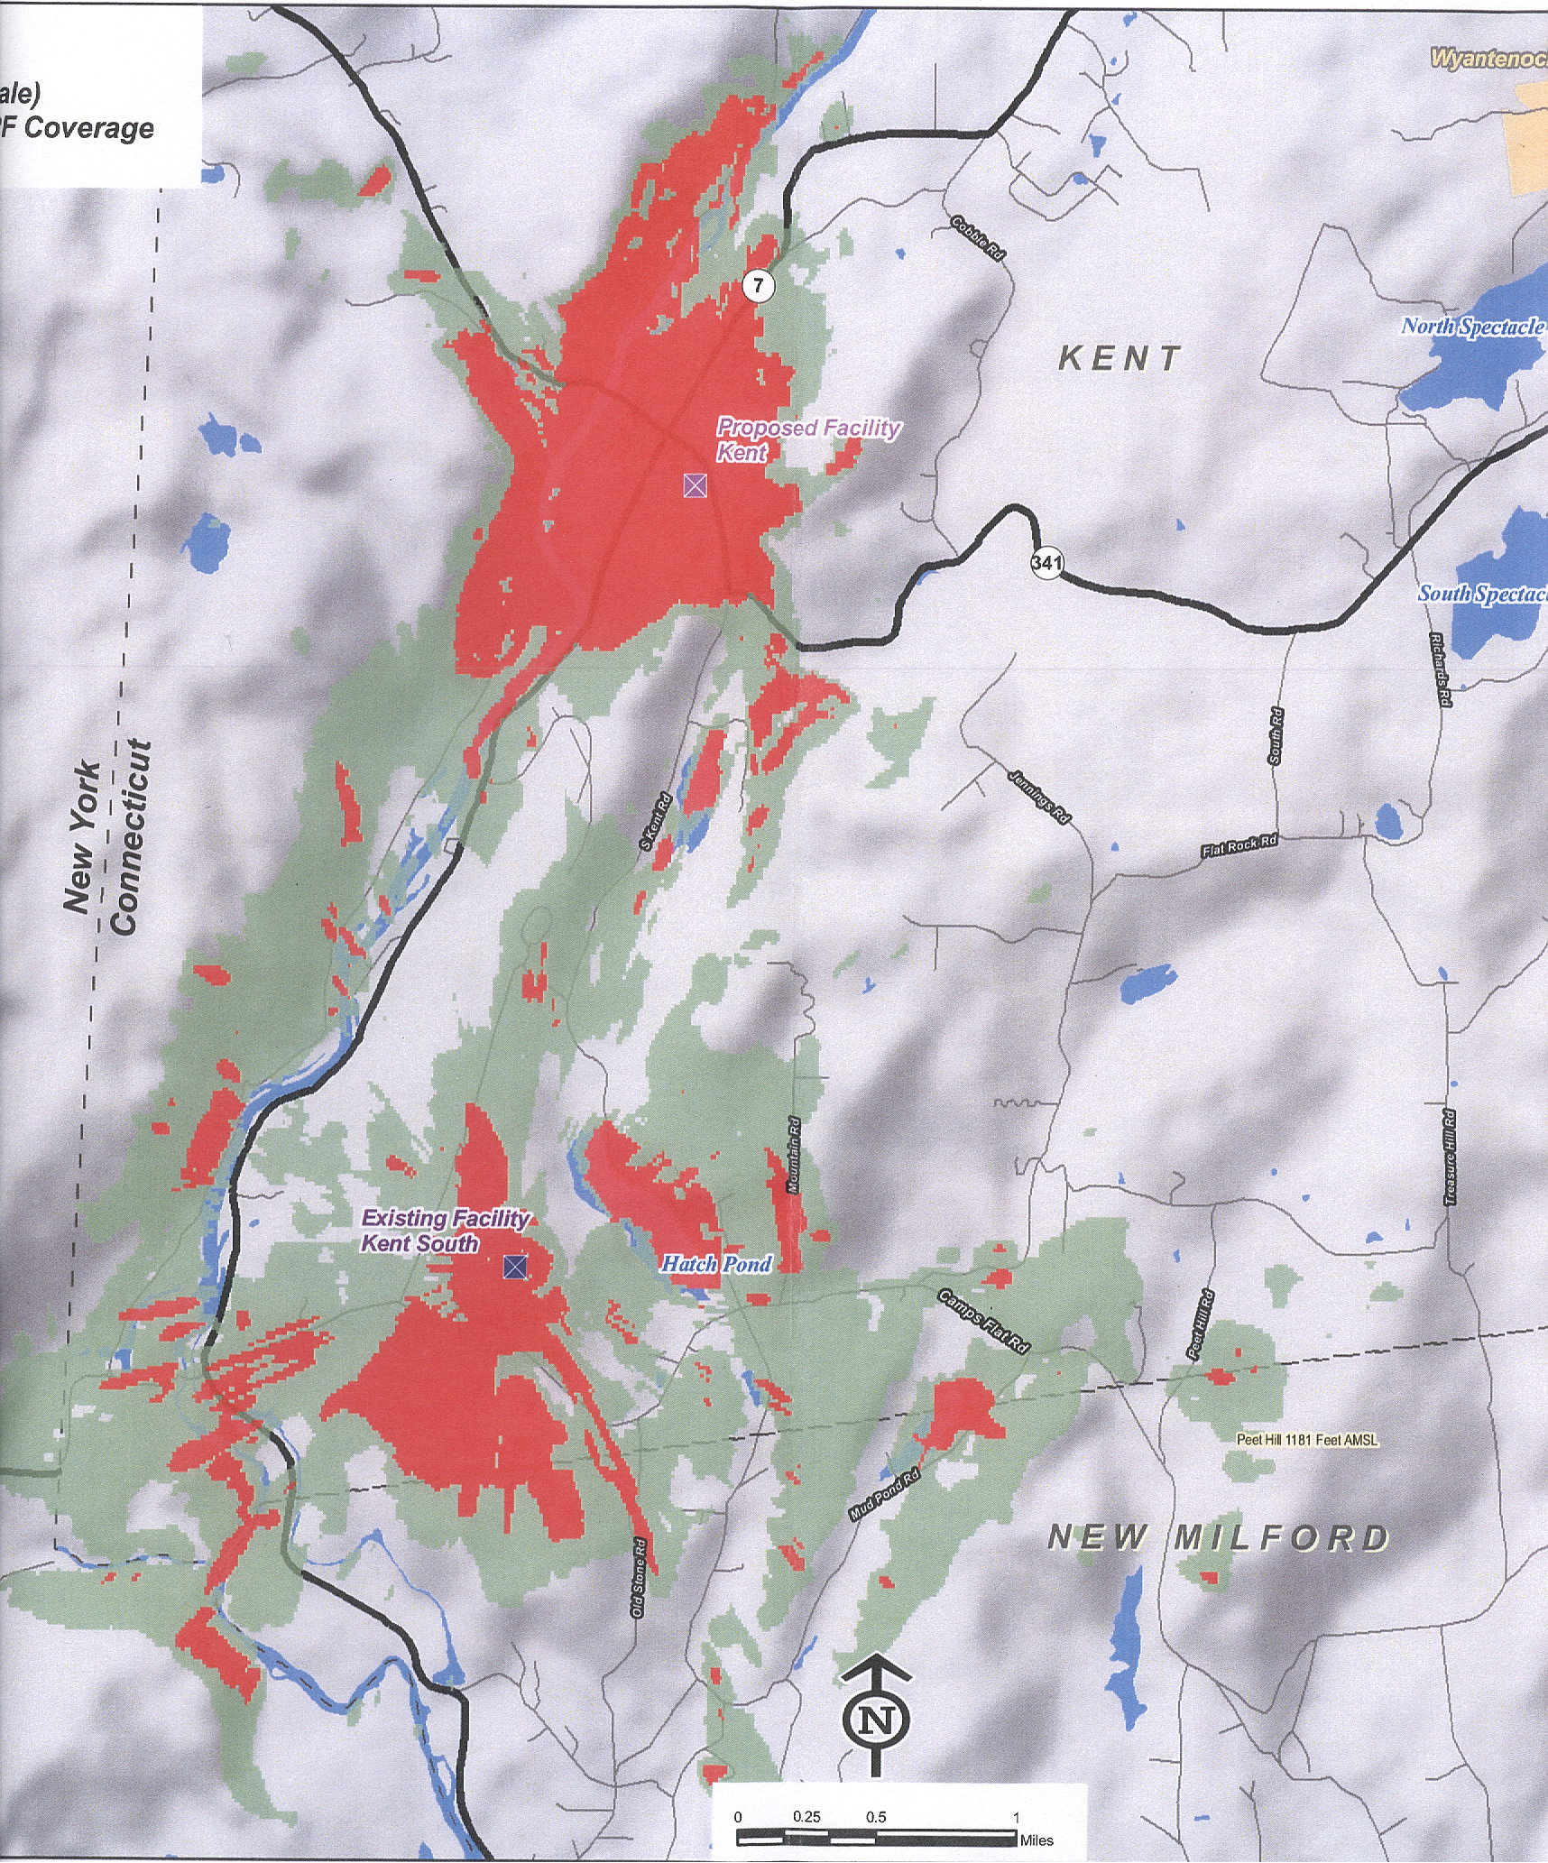
Figure 6. Cellco’s existing and proposed PCS coverage at 140 feet agl. Red depicts -75 dBm coverage and
green depicts -85 dBm coverage. (Cellco 4, R. 24 (b))
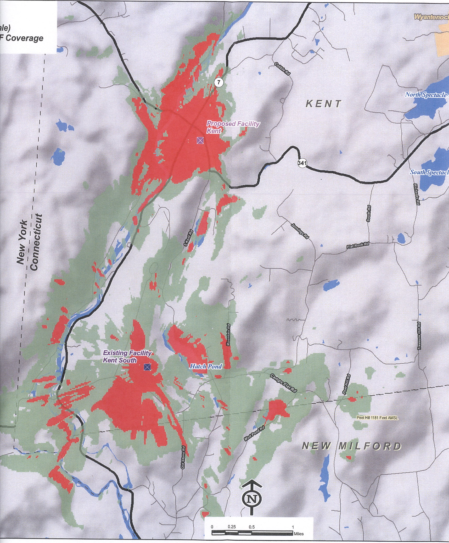
Figure 7. Cellco’s existing and proposed PCS coverage at 130 feet agl. Red depicts -75 dBm coverage and
green depicts -85 dBm coverage. (Cellco 4, R. 24 (c))

