DOCKET NO. 351 - Optasite Towers LLC and Omnipoint Communications, Inc. application for a Certificate of Environmental Compatibility and Public Need for the construction, maintenance and operation of a telecommunications facility located at 93 Lake Street, Manchester, Connecticut. | }  }  } | Connecticut  Siting  Council  May 8, 2008

Findings of Fact

Introduction

- Pursuant to Chapter 277a, Sections 16-50g et seq. of the Connecticut General Statutes (CGS), as amended, and Section 16-50j-1 et. seq. of the Regulations of Connecticut State Agencies (RCSA), Optasite Towers LLC (Optasite) and Omnipoint Communications, Inc. (T-Mobile) applied to the Connecticut Siting Council (Council) on November 2, 2007 for the construction, operation, and maintenance of a telecommunications facility that would include a steel monopole tower 110 feet tall. The facility would be located at 93 Lake Street in the Town of Manchester, Connecticut. (Optasite 1, p. 1)

- Optasite is a Delaware limited liability company with offices at One Research Drive, Suite 200C, Westborough, Massachusetts. It would construct and maintain the proposed facility. (Optasite 1, p. 3)

- T-Mobile is a Delaware corporation with a Connecticut office at 35 Griffin Road South, Bloomfield, Connecticut. The company and its affiliated entities are licensed by the Federal Communications Commission (FCC) to construct and operate a personal wireless services system in Connecticut. T-Mobile does not conduct any other business in the State of Connecticut other than the provision of wireless services under FCC rules and regulations. (Optasite 1, p. 3)

- The parties in this proceeding are the applicants, Optasite and T-Mobile. Laurie Morrone, an abutting landowner, was made a party at the public hearing. (Transcript, January 29, 2008, 3:10 p.m. [Tr. 1], pp. 5-6)

- The proposed Facility would provide service in the Town of Manchester, particularly along Route 6, Route 44 and adjacent areas. (Optasite 1, p. 1)

- Pursuant to CGS § 16-50m, the Council, after giving due notice thereof, held a public hearing on January 29, 2008, beginning at 3:10 p.m. and continuing at 7:00 p.m. at Lincoln Center, 494 Main Street in Manchester, Connecticut. (Tr. 1, p. 2 ff.)

- The Council re-opened the hearing on this application on April 4, 2008, beginning at 1:35 p.m., to consider additional testimony and evidence regarding coverage in the vicinity of the proposed tower and whether the use of existing sites might meet the coverage needs of the applicant. (Tr. 3, p. 1)

- The Council and its staff conducted an inspection of the proposed site on January 29, 2008, beginning at 2:00 p.m. On the day of the field inspection, the applicants flew a balloon from approximately 8:00 a.m. to 5:00 p.m. to simulate the height of the proposed tower. The weather conditions were overcast with little to no winds. (Tr. 1, p. 33)

- Pursuant to CGS § 16-50l(b), notice of the applicants’ intent to submit this application was published on October 27 and October 30, 2007 in the Hartford Courant and on October 26 and October 29, 2007 in the Journal Inquirer. (Optasite 1, p. 4; Hartford Courant Affidavit of Publication dated October 31, 2007 and Manchester Journal Inquirer Affidavit of Publication dated November 15, 2007)

- In accordance with CGS § 16-50l(b), Optasite sent notices of its intent to file an application with the Council to each person appearing of record as owner of property abutting the property on which the site is located. (Optasite 1, p. 4, Exhibit F)

- Optasite received return receipts from all but five abutting property owners. Optasite sent a second certified mailing to these abutters on or about December 17, 2007. Optasite received one additional return receipt from its second mailing. (Optasite 2, Response 1)

- Optasite sent a third mailing to the four abutters from whom receipts were received. It did not receive receipts from these four abutters. (Tr. 1, p. 34)

- Pursuant to CGS § 16-50l (b), Optasite provided notice to all federal, state, regional, and local officials and agencies listed therein. (Optasite 1, p. 4, Exhibit D)

- Optasite posted a four-foot by six-foot sign near the point at which the proposed tower’s access road would meet Lake Street. The sign informed passersby of Optasite’s pending application and how to contact the Council. It was installed on January 10, 2008. (Tr. 1, pp. 33-34)

State Agency Comments

- Pursuant to CGS § 16-50l, the Council solicited comments on Optasite’s application from the following state departments and agencies: Department of Environmental Protection, Department of Public Health, Council on Environmental Quality, Department of Public Utility Control, Office of Policy and Management, Department of Economic and Community Development, and the Department of Transportation. The Council’s letters requesting comments were sent on January 2, 2008 and February 4, 2008. (CSC Hearing Package dated January 2, 2008; Letter to State Department Heads dated April 7, 2008)

- The Connecticut Department of Transportation (ConnDOT) responded to the Council’s solicitation with no comments. (ConnDOT letter dated January 22, 2008)

- With the exception of ConnDOT, no comments were received from any state agencies. (Record)

Municipal Consultation

- On June 28, 2007, Optasite submitted a letter and a technical report to the Town of Manchester regarding the proposed facility. (Optasite 1, p. 19; Exhibit M)

- On July 19, 2007, representatives of Optasite met with Manchester officials Mark Pelegrini, Director of Economic Development, Jack McCoy, Chief Information Officer, and Robert Dusza, Project and Technical Support Manager, to discuss its proposed facility. (Optasite 1, p. 19)

- The Town of Manchester has indicated an interest in locating emergency service equipment on this proposed facility. (Optasite 3, Prefiled Testimony of Keith Coppins)

- Manchester’s interest in placing antennas on the proposed tower was confirmed by Jack McCoy, Manchester’s Chief Information Officer, at the public hearing. (Tr. 1, pp. 14-15)

- Optasite would provide space, for no charge, on the proposed tower to the Town of Manchester for its public safety communications antennas. (Optasite 1, p. 9)

Public Need for Service

- The United States Congress, through adoption of the Telecommunications Act of 1996 (Act), recognized the important public need for high quality telecommunication services throughout the United States. The purpose of this Act, which was a comprehensive overhaul of the Communications Act of 1934, was to “provide for a competitive, deregulatory national policy framework designed to accelerate rapidly private sector deployment of advanced telecommunications and information technologies to all Americans.” (Optasite 1, pp. 4-5)

- The Act prohibits local and state bodies from discriminating among providers of functionally equivalent services. (Council Administrative Notice, Telecommunications Act of 1996)

- The Act prohibits any state or local agency from regulating telecommunications towers on the basis of the environmental effects of radio frequency emissions to the extent that such towers and equipment comply with FCC’s regulations concerning such emissions. This Act also blocks the Council from prohibiting or acting with the effect of prohibiting the provision of personal wireless service. (Council Administrative Notice, Telecommunications Act of 1996)

- In an effort to ensure the benefits of wireless technologies to all Americans, Congress enacted the Wireless Communications and Public Safety Act of 1999 (the 911 Act). The purpose of this legislation was to promote public safety through the deployment of a seamless, nationwide emergency communications infrastructure that includes wireless communications services. (Optasite 1, p. 6)

- The proposed facility would be an integral component of T-Mobile’s E911 network. (Optasite 1, p. 7)

Site Selection

- On January 18, 2007, Optasite submitted an application to the Council for a proposed facility at 1027 Middle Turnpike East in Manchester. This application was designated as Docket 328. In response to concerns about this site raised by Manchester residents and elected officials, Optasite continued to investigate other possible locations for a facility in this area of Manchester. (Optasite 1, Exhibit I)

- Subsequent to the filing of Docket 351, Optasite notified the Council in a letter dated December 5, 2007 that it was formally withdrawing Docket 328. (Tr. 1, pp. 79 ff.)

- During its initial search for a facility location, Optasite considered several other properties in addition to the 1027 Middle Turnpike East property. These properties and assessments of their suitability are listed in the table below:

Location Considered | Suitability
Town of Manchester property, 1052 Middle Turnpike East | Reservoir related property; land use restrictions preclude towers
Town of Manchester property, 550 Lydall Street | Reservoir related property; land use restrictions preclude towers
Town of Manchester property, 199 New Bolton Road | Reservoir related property; land use restrictions preclude towers
Town of Manchester property, 226 Lake Street | Reservoir related property; land use restrictions preclude towers
Rieg Realty property, 784 Middle Turnpike East | Located next to subdivision; little to no natural screening
990 Middle Turnpike East | Part of residential subdivision; little natural screening
Capstone Builders property, 175 New Bolton Road | Property owner had other development plans
(Optasite 1, Exhibit I)

- As a result of its continued search during the time Docket 328 was pending, Optasite entered into a lease for property off Lake Street owned by Alan Rossetto, which is the host property for the facility proposed in this certificate application. (Optasite 1, Exhibit I)

- The Lake Street site would enable T-Mobile to extend its coverage farther up Lake Street towards Box Mountain at a lower height than would be possible at the Middle Turnpike East site proposed in the previous Docket 328. (Tr. 1, p. 41)

- Optasite identified 17 communications towers within approximately four miles of the proposed Lake Street site. However, none of these towers were deemed suitable for achieving T-Mobile’s coverage objectives, primarily because they would provide redundant coverage or because they could not cover the target area. These towers are listed in the following table.

Tower Location | Ht. and Type of Tower | Tower Owner | Distance and Direction to Site
130 Vernon Road,  Bolton | 280’ guyed lattice (T-Mobile on tower @ 134’) | Mountaintop Enterprises | 2.29 mi. to east
200 Boston Turnpike,  Bolton | 63’ self-supporting lattice | United Cable TV Corp | 1.03 mi. to east
230 Box Mountain,  Bolton | 200’ self-supporting lattice | Marcus Communications | 1.56 mi. to northeast
49 South Street,  Bolton | 120’ monopole | AT&T | 2.73 mi. to east
12 Carpenter Road,  Bolton | 140’ monopole (T-Mobile on tower @ 127’) | MCF Communications | 1.11 mi. to southeast
190 Olcott Street,  Manchester | 155’ utility structure | CL&P | 4.01 mi. to west
239 Middle Turnpike East, Manchester | 190’ monopole (T-Mobile on tower @ 163’) | Town of Manchester | 1.56 mi. to west
266 Center Street,  Manchester | 128’ monopole | Crown Media | 2.79 mi. to west
53 Slater Street,  Manchester | 155’ monopole (T-Mobile on tower @ 133’) | Sprint | 2.88 mi. to northwest
60 Adams Street,  Manchester | 140’ monopole | William B. Thornton | 3.73 mi. to west
Olcott Street,  Manchester | 200’ self-supporting lattice | CL&P/NU | 4.11 mi. to west
60 Industrial Park Road,  Vernon | 175’ monopole (T-Mobile on tower @ 173’) | Millenicom & G&K Beauregard | 3.51 mi. to northeast
53 Diane Drive,  Vernon | 45’ self-supporting lattice | Ali & Hajar Shakidai | 1.8 mi. to northeast
Love Lane,  Manchester | 202’ guyed lattice | Freedom Comm. Of Connecticut, Inc. | 3.96 mi. to west
640 Hilliard Street,  Manchester | 150’ monopole | Optasite | 3.56 mi. to west
269 Box Mountain Road,  Bolton | 180’ self-supporting lattice | William Stanek | 2.18 mi. to northeast
296 Box Mountain Road,  Bolton | 150’ self-supporting lattice | Eleanne Denton  Rhodes | 1.63 mi. to northeast
(Optasite 1, p. 8; Exhibit H; Optasite 2, A7; Tr. 1, pp. 63-65)

- Locating its antennas on the tower at 200 Boston Turnpike would not enable T-Mobile to achieve its coverage objectives in its target area because signals from this location would be blocked to the west by terrain. (Tr. 1, pp. 63-64; Optasite 9, A4)

- Antennas at 200 Boston Turnpike would provide coverage redundant to the site in Bolton (12 Carpenter Road) that was approved in the Council’s Docket 323. (Optasite 9, A5)

- In order to fill coverage gaps on either side of Box Mountain, T-Mobile proposes to construct sites on both sides of Box Mountain. The proposed site at Lake Street is one of the planned sites. T-Mobile is negotiating with the Town of Vernon for the use of another site. These two sites would allow T-Mobile to utilize the existing terrain to contain signals to localized footprints. The prospective site in Vernon would not be able to cover the area that would be covered from the proposed Lake Street site but would cover a separate gap that T-Mobile experiences. (Optasite 9, A6)

- Existing towers at 269 and 296 Box Mountain Drive are located at sufficiently high elevations that antennas on these towers would create interference problems for T-Mobile’s network. (Optasite 9, A7)

- Repeaters, microcell transmitters, distributed antenna systems and other types of transmitting technologies are not a practicable or feasible means to provide service within the coverage gap T-Mobile is seeking to cover due to significant terrain variations and tree cover in the area, as well as other practical considerations. (Optasite 1, pp. 7-8)

Site Description

- Optasite’s proposed facility is located at 93 Lake Street in Manchester in the west central portion of a 23.4 acre parcel used as a residence, with an associated garage and a pool, and owned by Alan Rossetto. (See Figure 1) (Optasite 1, p. 2)

- The Rossetto property is located in an RR residential zone. (Optasite 1, p. 2)

- Wireless communications towers are allowed in RR zones as a special exception. (Optasite 1, bulk filed Manchester Zoning Regulations)

- At the proposed location, Optasite would lease a 70-foot by 70-foot parcel in order to erect a 110-foot, self-supporting monopole tower within a 70-foot by 70-foot compound that would be enclosed by an eight-foot high chain link fence. (Optasite 1, p. 2; Exhibit B, Compound Plan)

- The proposed tower would be located at 41º 47’ 20.7” north latitude and 72º 28’ 55.5” west longitude. Its ground elevation would be 467 feet above mean sea level. (Optasite 1, Exhibit N and Exhibit B, Sheet A02)

- The tower would be designed to accommodate up to four antenna platforms and equipment and Manchester public safety functions. (Optasite 1, p. 9)

- The tower would be designed in accordance with the specifications of the Electronic Industries Association Standard ANSI/EIA/TIA-222-G, “Structural Standards for Steel Antenna Towers and Antenna Support Structures,” in accordance with the International Building Code. (Optasite 2, A3)

- T-Mobile would initially install six antennas on a platform at a centerline height of 107 feet. T-Mobile would eventually install up to nine antennas, three per sector on the tower. (Optasite 1, p. 9; Tr. 1, pp. 55-56)

- T-Mobile would utilize an equipment shelter, approximately 10 feet by 12 feet, to house its ground equipment. (Optasite 1, p. 9)

- T-Mobile would use battery back-up power. (Optasite 2, A9)

- Approximately 681 cubic yards of cut would be required to develop this site. No fill would be required. (Optasite 2, A5)

- Vehicular access to the proposed facility would extend from Lake Street approximately 1,133 feet over a new gravel drive. This drive would have to cross a separate parcel, also owned by Alan Rossetto, to reach the parcel on which the facility would be located. Optasite does have a lease with Mr. Rossetto that provides it with the right to traverse the other property. (See Figure 3) (Optasite 1, p. 10; Exhibit B)

- The existing driveway to the Rossetto property could not be used for access because it is not wide enough to accommodate Optasite’s needs, it crosses the Algonquin gas line, and Mr. Rossetto does not have the legal right to grant another party access to the shared right-of-way. (Tr. 1, pp. 39-40; Tr. 2, pp. 31-32)

- Utility service for the proposed facility would be extended underground from an existing utility pole on Lake Street and would run adjacent to the gravel access drive. (Optasite 1, p. 10; Exhibit Sheet A02)

- Should the presence of ledge be discovered during the geotechnical investigation, Optasite would prefer chipping over blasting. (Optasite 2, A6)

- The proposed tower’s setback radius would be contained within the Rossetto property. (Optasite 1, Exhibit B)

- There are 21 residences located within 1,000 feet of the proposed tower. (Optasite 1, Exhibit B)

- The closest residence is located 431 feet to the west of the proposed tower. It is owned by Raymond Gagnon and Jill Lavoie. (Optasite 1, Exhibit B; Optasite 2, A4)

- The Rossetto residence is located approximately 440 feet to the east of the proposed facility. (Optasite 1, Exhibit B, Drawing A01)

- Land use in the vicinity of the proposed site is generally medium density residential. (Optasite 1, Exhibit J, p. 1)

- Optasite’s estimated cost of construction for this facility, which does not include T-Mobile’s antennas and support equipment, is:

Tower and foundation $ 74,000
Site development 74,000
Utility installation 31,000
Total costs $179,000

(Optasite 1, p. 20)

Environmental Considerations

- The proposed facility would have no effect on historic, architectural, or archaeological resources listed on or eligible for the National Register of Historic Places. (Optasite 4, Appendix E – Letter from Deputy State Historic Preservation Officer, dated January 3, 2008)

- There are no state- or federally-listed species or significant natural communities known to be located in the immediate vicinity of the proposed facility. (Optasite 4, p. 5)

- There are two small ponds in the northeast corner of the Rossetto property that are over 1,000 feet from the location of the proposed tower. (Tr. 1, p. 25)

- Soil erosion control measures and other best management practices would be established and maintained throughout the construction of the proposed facility. (Optasite 1, p. 18)

- The existing vegetation in the vicinity of the proposed facility consists primarily of mature, mixed deciduous hardwood species with an average estimated height of 65 feet. (Optasite 1, p. 12)

- Ten trees with a diameter of six inches or more at breast height would be removed during the development of the proposed facility. (Optasite 1, Exhibit B)

- The Federal Aviation Administration determined that the proposed facility would not be a hazard to air navigation and would not require marking or lighting. (Optasite 1, Exhibit N)

- The maximum power density from the radio frequency emissions of T-Mobile’s proposed antennas was calculated to be 4.57% of the standard for Maximum Permissible Exposure, as adopted by the FCC, at the base of the proposed tower. This calculation was based on a methodology prescribed by the FCC Office of Engineering and Technology Bulletin No. 65E, Edition 97-01 (August 1997) that assumes all antennas would be pointed at the base of the tower and all channels would be operating simultaneously. (Optasite 1, p. 14)

Visibility

- The proposed tower would be visible year round from approximately 34 acres. Most of this acreage is located on the host property or its immediate vicinity. (Optasite 1, Exhibit J, p. 4)

- The proposed tower would be seasonally visible from an additional 39 acres. Most of this acreage is located within one-quarter mile of the tower location. (Optasite 1, Exhibit J, p. 4)

- Approximately 12 residences would have partial year round views of the proposed tower. (Optasite 1, Exhibit J, p. 4)

- Approximately eight additional residences would have seasonal views of the proposed tower. (Optasite 1, Exhibit J, p. 4)

- No views of the tower would be anticipated from the Shenipsit Trail, which passes within 1.1 miles east of the proposed site. (Optasite 1, p. 13; Exhibit J, p. 4, Viewshed Map)

- The visibility of the proposed tower from different vantage points in the surrounding vicinity is summarized in the following table. (See Figure 7)

Location | Visible  Site | Approx. Portion of (110’) Tower Visible (ft.) | Approx. Distance and Direction to Tower  Site
1 – Residence at 93 Lake Street (host  property | Yes | 80’ | 450 feet; NW
2 – Intersection of Garth Road and  Chilstone Lane | Yes | 10’ | 2200 feet; NE
(Optasite 1, Exhibit J)

Existing and Proposed Wireless Coverage

- T-Mobile is licensed to operate at the following frequencies in Manchester:

Upper 2/3 A Band
TX: 1935.00 MHz to 1945.00 MHz
RX: 1855 MHz to 1865.00 MHz

AWS 1
TX: 2140 MHz to 2145 MHz
RX: 1740 MHz to 1745 MHz

AWS 2
TX: 21210 MHz to 2120 MHz
RX: 1710 MHz to 1720 MHz

(Optasite 2, A10)

- T-Mobile’s minimum design receive signal level threshold is -84 dBm, which is the lower limit at which T-Mobile can provide in-vehicle coverage to its network users. For reliable in-building coverage, T-Mobile requires a receive signal level strength of -76 dBm. (Optasite 2, A11)

- T-Mobile’s existing signal strength in the area that would be served from the proposed site ranges from -84 dBm to -105 dBm. (See Figure 4) (Optasite 2, A12)

- T-Mobile has a coverage gap along Routes 6 and 44(Middle Turnpike East) in the area of the proposed site of approximately 1.44 miles. (Optasite 2, A 14)

- The distance on Routes 6 and 44 that T-Mobile could cover from this site would be 2.04 miles. (Optasite 2, A15)

- The total area T-Mobile would cover from the proposed site is 2.0 square miles. (Optasite 2, A13)

- The area covered from this site would be limited by the terrain in the immediate vicinity. (Tr. 3, pp. 8-10)

- From the proposed location, T-Mobile would hand off signals with the sites identified below:

Site ID | Site Location | Type of Facility | T-Mobile  Antenna Ht. | Distance and Direction to Site
CT11177B | 47 Main Street, Vernon | 118’ water tank | 116 feet above ground level (AGL) | 2.3 miles to north
CT11140J | 60 Industrial Park Rd, Vernon | 175’ monopole | 173 feet AGL | 3.5 miles to northeast
CT11180C | 130 Vernon Road, Bolton | 280’ self-supporting lattice tower | 134 feet AGL | 2.3 miles to east
CT11384D | 5 Glen Road, Manchester | 70’ smokestack | 70 feet AGL | 1.9 miles to southeast
CT11501E | 122 Route 6, Andover | 150’ monopole | 137 feet AGL | 4.9 miles to southeast
CT11365D | 239 Middle Tpk East, Manchester | 180’ monopole | 163 feet AGL | 1.6 miles to west
CT11187D | 494 Main Street, Manchester | 57’ rooftop | 45 feet AGL | 2.2 miles to west
CT11320A | 63 Elm Street, Manchester | 198’ smokestack | 196 feet AGL | 2.9 miles to west
CT11377C | 55 Slater Street, Manchester | 155’ monopole | 133 feet AGL | 2.8 miles to northwest
CTHA076D | 14-16 Carpenter Road, Bolton | 140’ monopole | 127 feet AGL | 1.1 miles to southeast
(Optasite 2, A16)

- The extent and signal strength of overlap in coverage from the proposed site and the surrounding hand-off sites varies from site to site. The table below summarizes what these overlaps are.

Site ID | Site Location | Overlap with Proposed Site
CT11177B | 47 Main Street, Vernon | No handover at -84 dBm design threshold; potential handover would be at fringe signal strengths.
CT11140J | 60 Industrial Park Rd, Vernon | No handover at -84 dBm design threshold; potential handover would be at on-street levels (fringe).
CT11180C | 130 Vernon Road, Bolton | No handover at -84 dBm design threshold; potential handover would be at on street levels (fringe). Proposed site would hand off to CTHA076D on Carpenter Road before handing off to this site.
CT11384D | 5 Glen Road, Manchester | No appreciable overlap at -84 dBm desigh threshold; potential handover would be at on street levels (fringe) just south of Middle Turnpike.
CT11501E | 122 Route 6, Andover | No handover at -84 dBm design threshold; potential handover would be at on-street levels (fringe).
CT11365D | 239 Middle Tpk East, Manchester | Approximately .75 miles coverage overlap at -84 dBm design threshold.
CT11187D | 494 Main Street, Manchester | No handovers at -84 dBm design threshold levels; proposed site would hand off calls to CT11365D (239 Middle Tpk ) before handing calls to this site.
CT11320A | 63 Elm Street, Manchester | No handover at -84 dBm design threshold; potential handover would be at fringe signal strengths.
CT11377C | 55 Slater Street, Manchester | No handover at -84 dBm design threshold; potential handover would be at fringe signal strengths.
CTHA076D | 14-16 Carpenter Road, Bolton | Approximately 0.25 miles of coverage overlap at -84 dBm design threshold signal strength.
(Optasite 9, A2)

- The minimum height at which T-Mobile could achieve its coverage objective from this proposed site is 107 feet AGL for the antennas’ centerline. (See Figures 5 and 6) (Optasite 2, A17)

- At heights below 107 feet, a gap in T-Mobile’s coverage would develop on Middle Turnpike East (Routes 6 and 44) to the east of the proposed site. (Tr. 1, p. 44; Optasite 9, A3)

Figure 1: Location Map
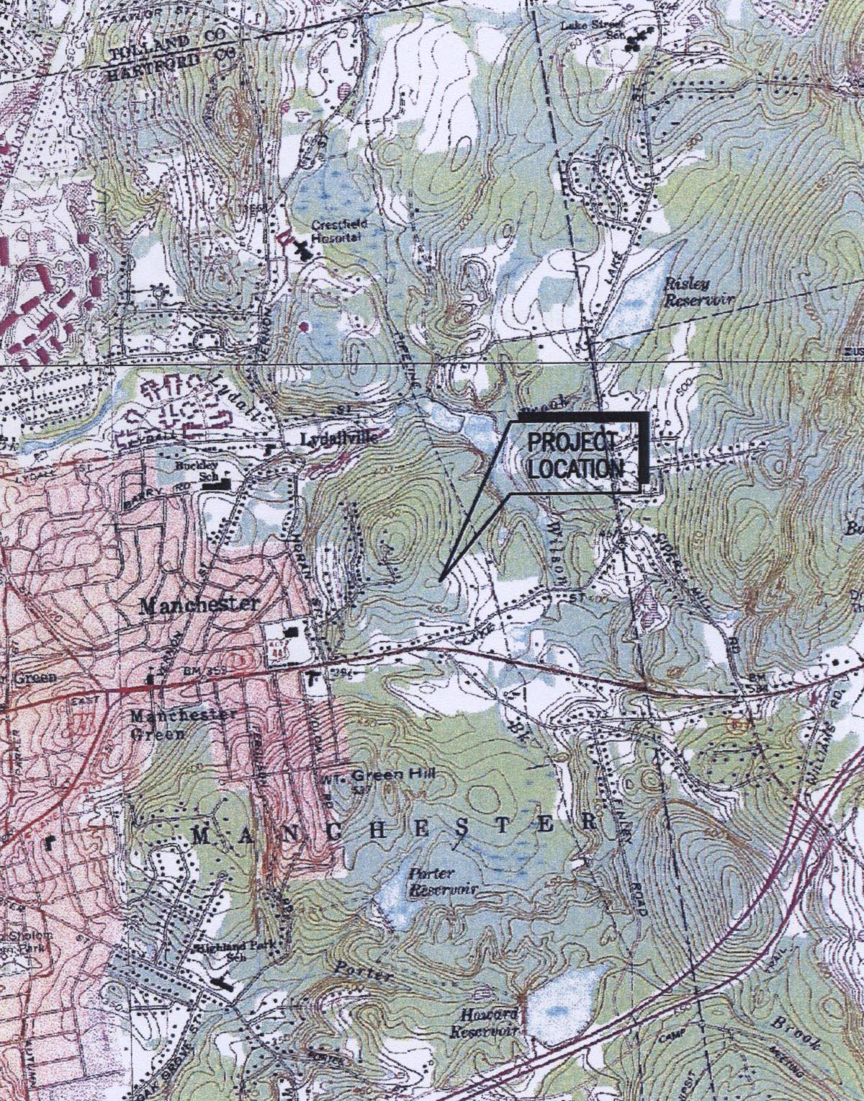
(Optasite 1, Exhibit B)

Figure 2: Aerial Photograph of Site Vicinity
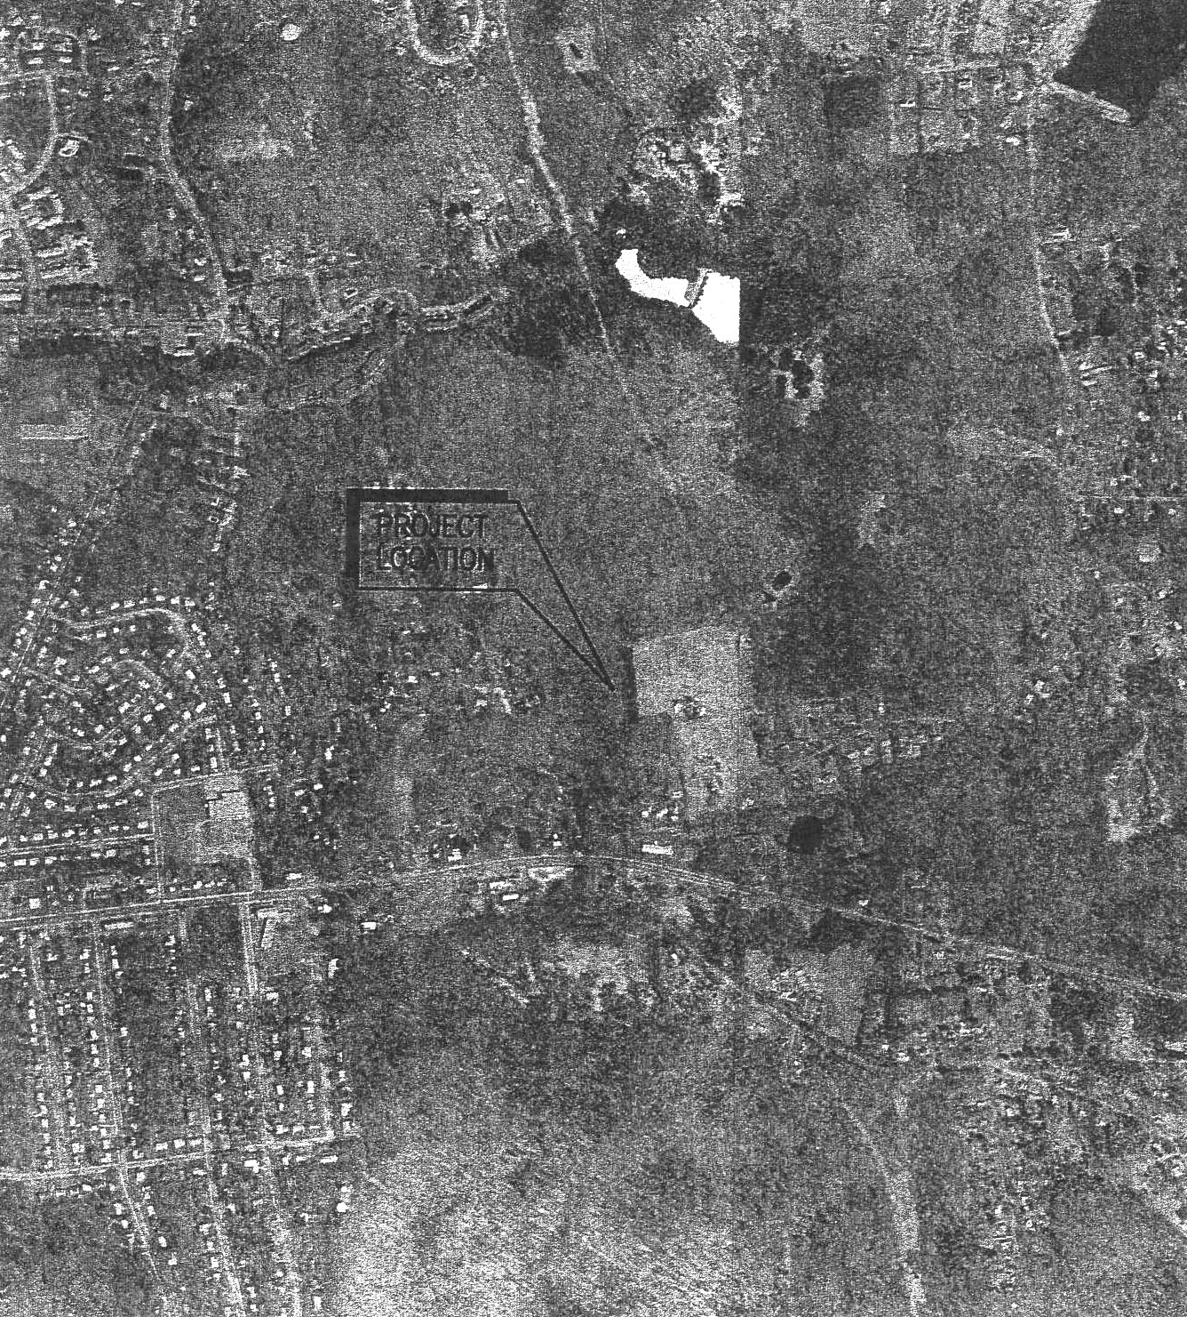
(Optasite 1, Exhibit B)

Figure 3: Facility Site Plan
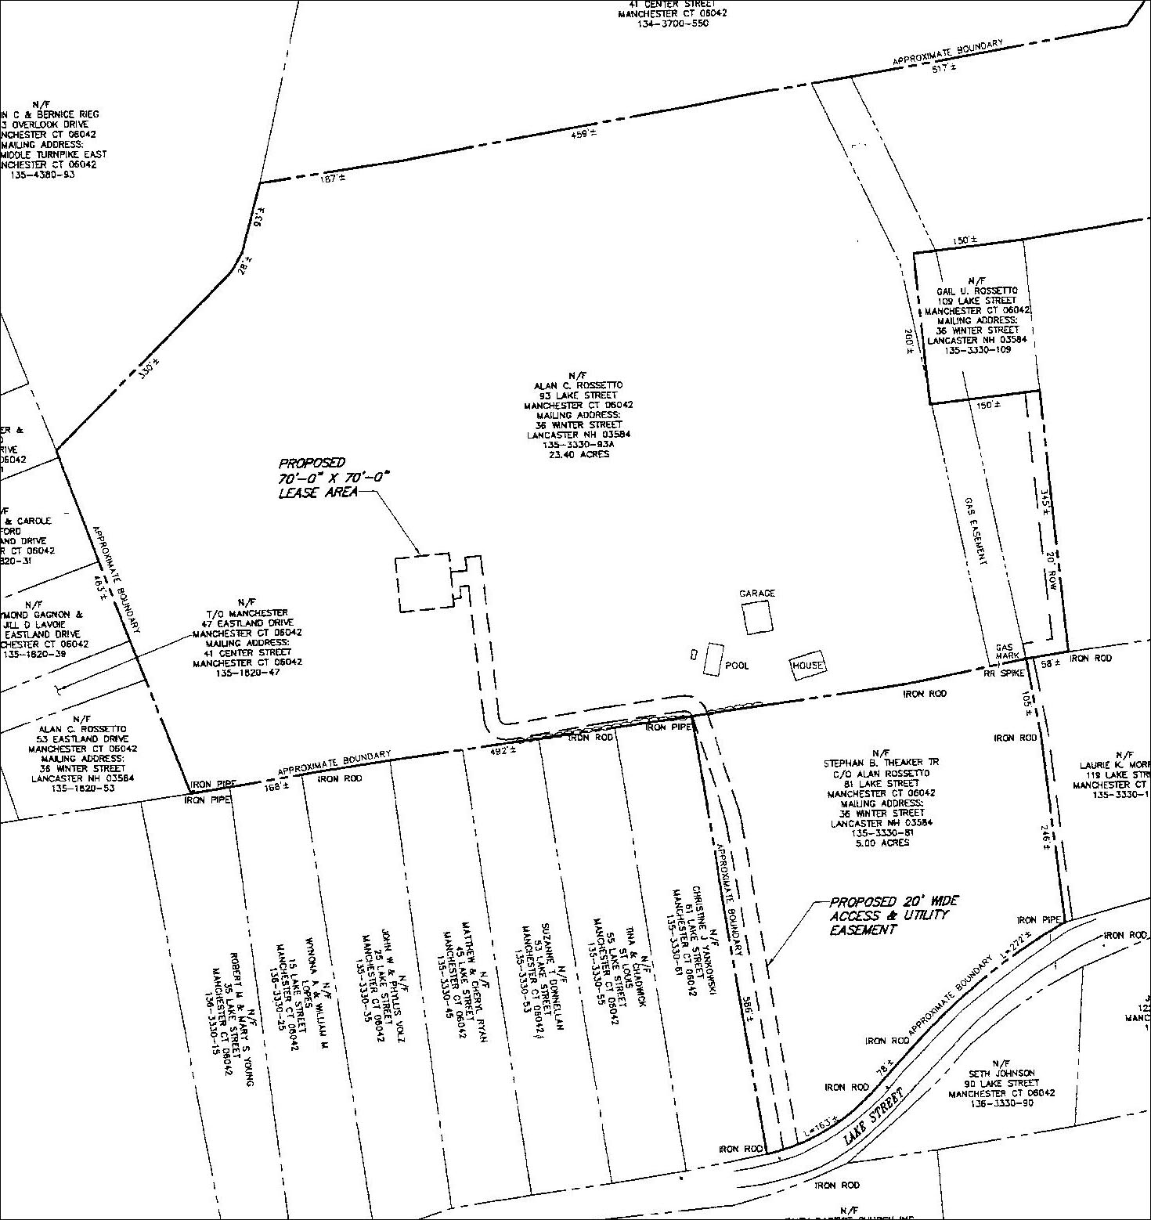
(Optasite 1, Exhibit B)

Figure 4: T-Mobile’s Existing Coverage 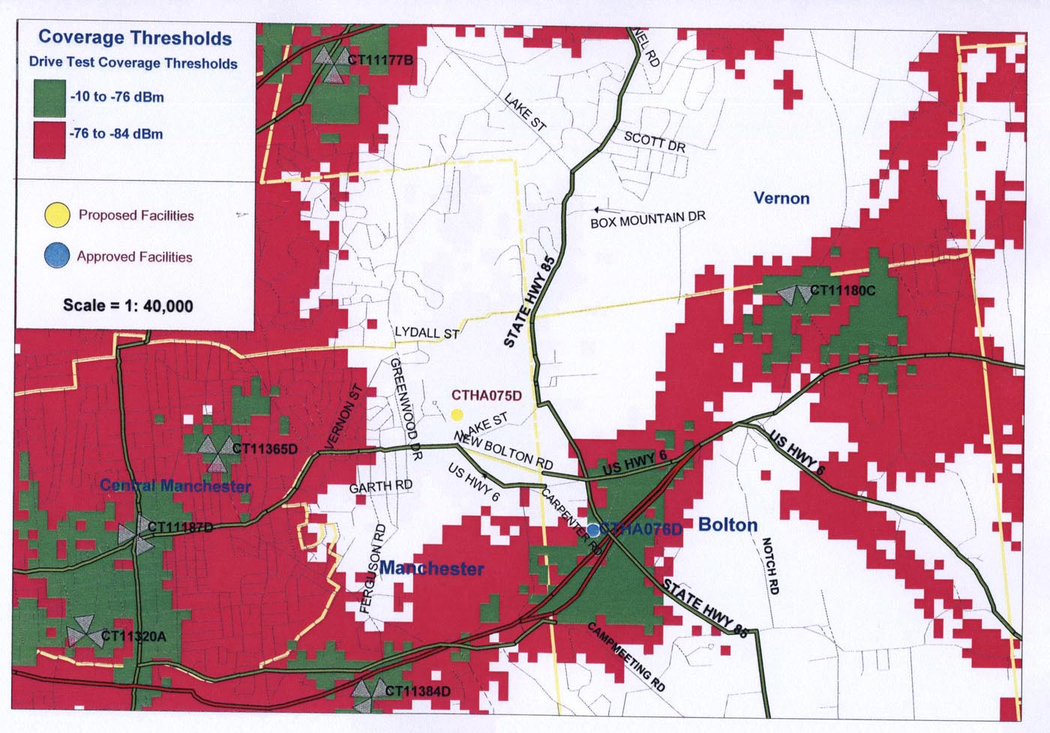
(Optasite 1, Exhibit G)

Figure 5: Coverage from Proposed Site at 107’
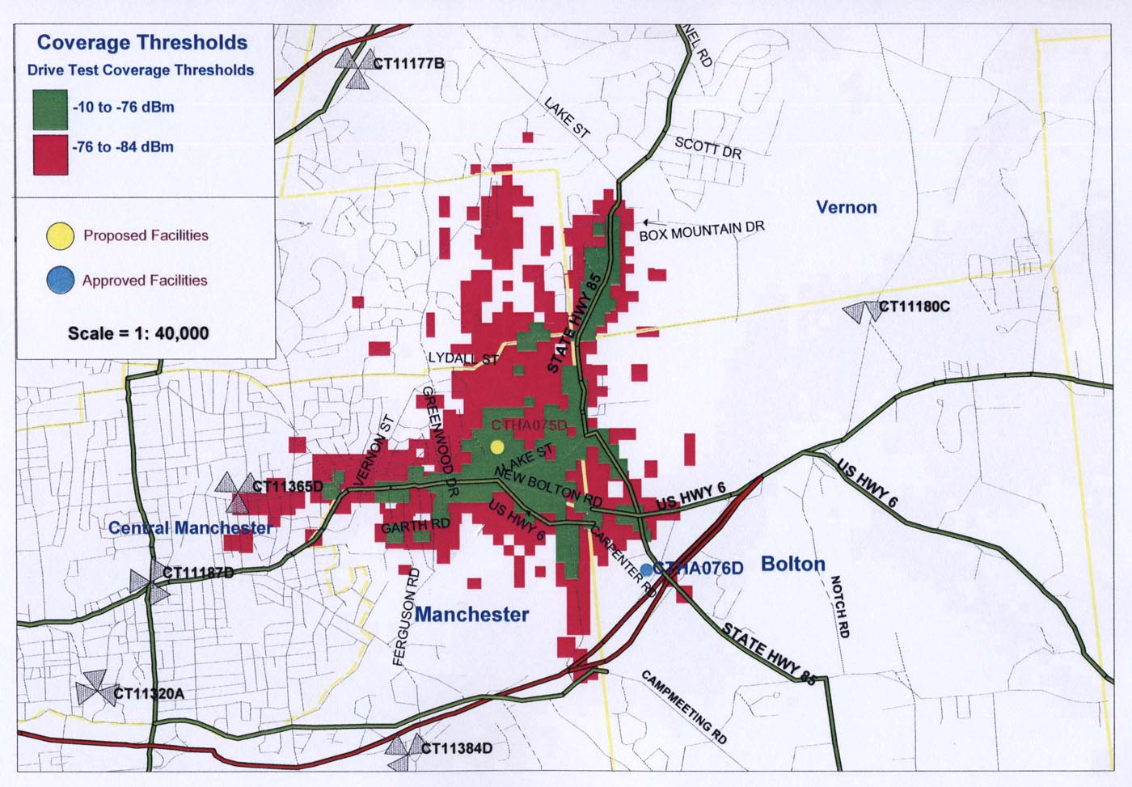
(Optasite 1, Exhibit G)

Figure 6: T-Mobile Composite Coverage with Proposed Site at 107’
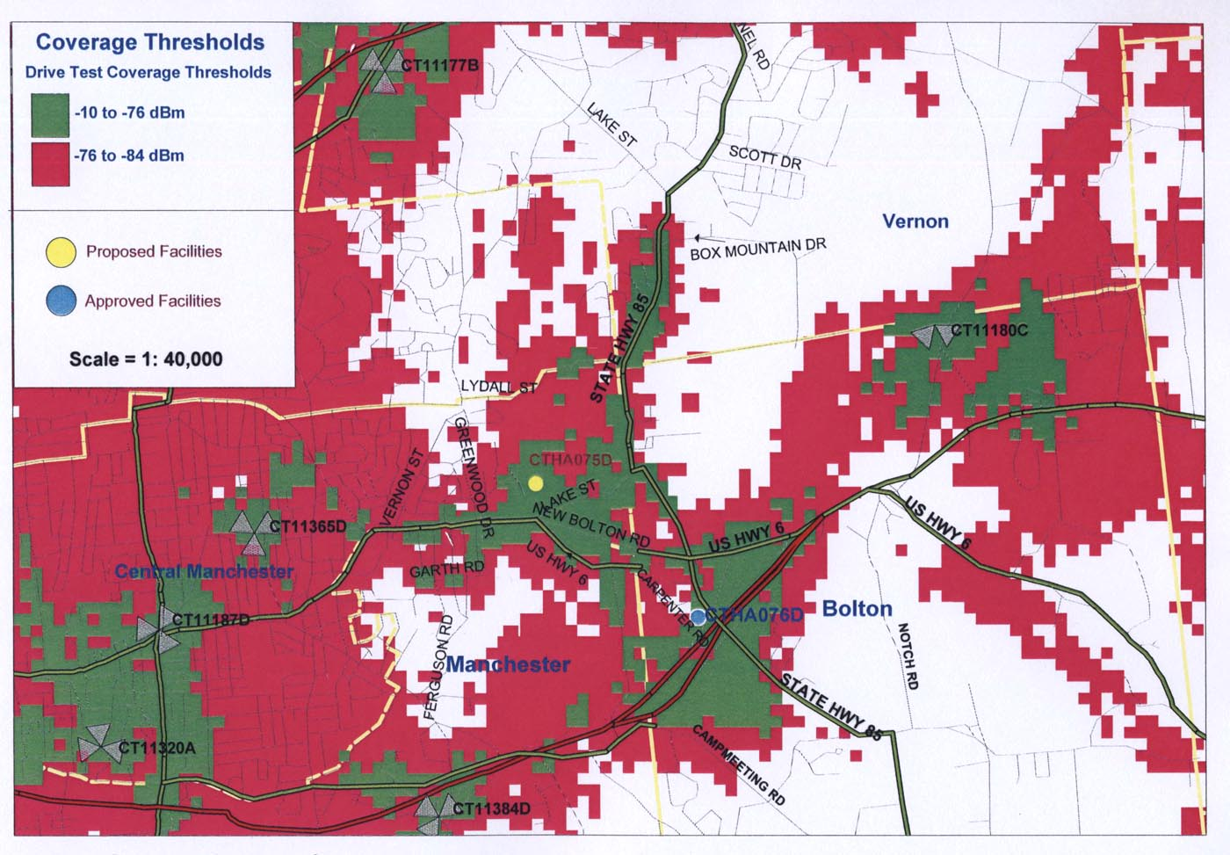
(Optasite 1, Exhibit G)

Figure 7: Visual Analysis Map
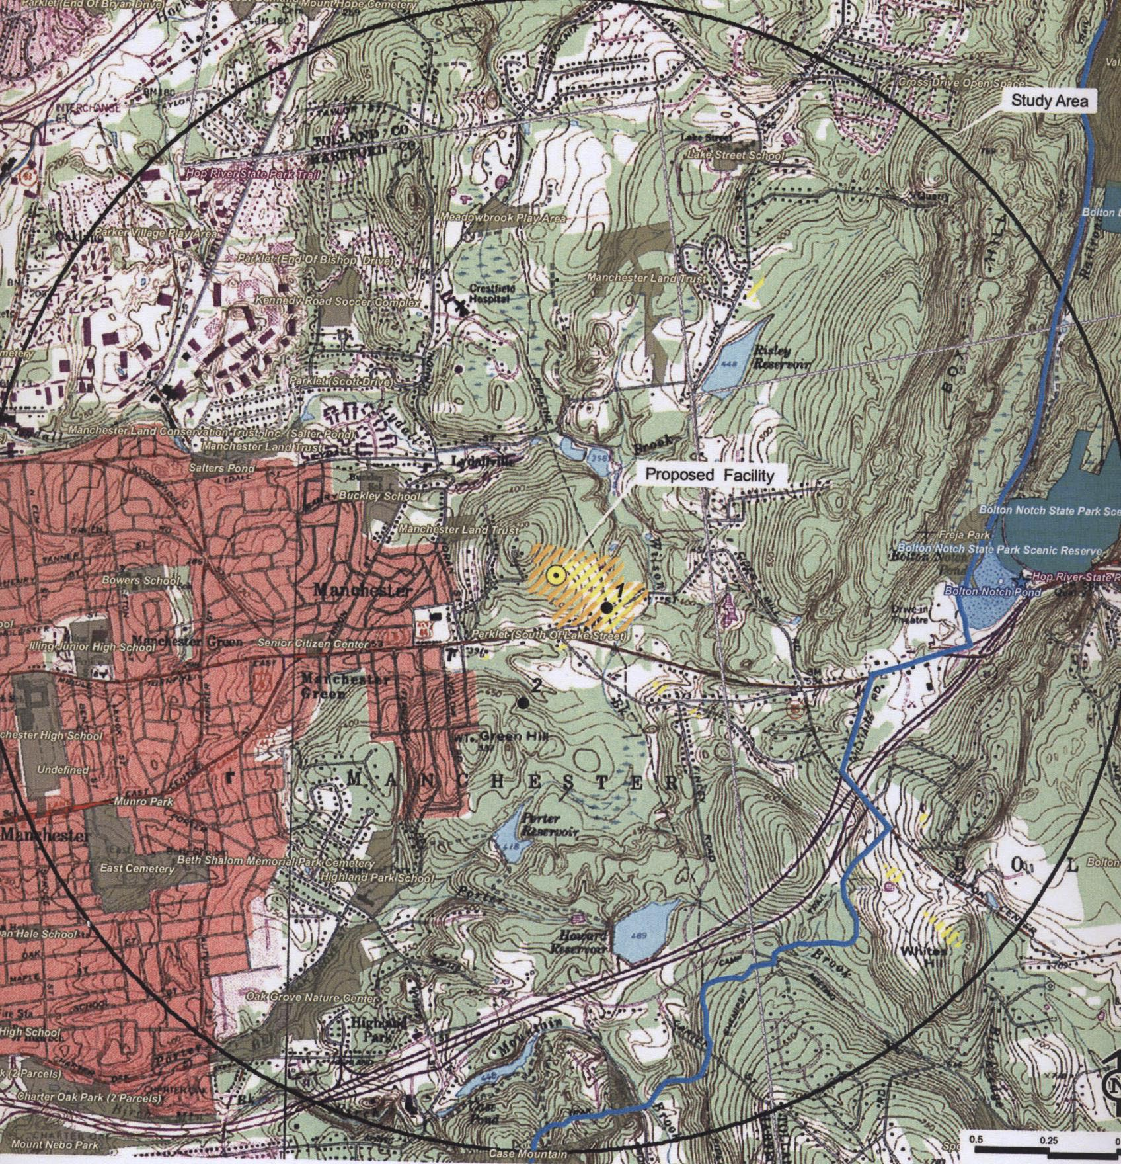
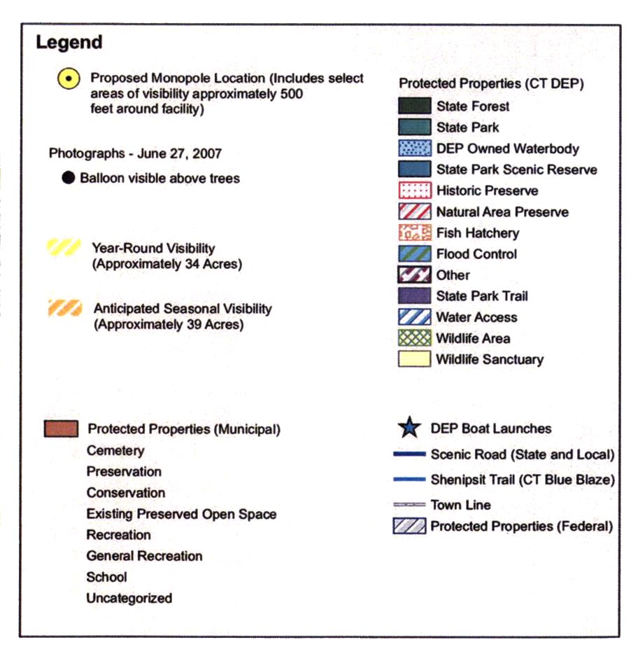
(Optasite 1, Exhibit J)

