DOCKET NO. 341 - Cellco Partnership d/b/a Verizon Wireless application for a Certificate of Environmental Compatibility and Public Need for the construction, maintenance and operation of a telecommunications facility located at 174 Ashford Center Road, Ashford, Connecticut. | }  }  } | Connecticut  Siting  Council  December 13, 2007

Findings of Fact

Introduction

- Pursuant to Chapter 277a, Sections 16-50g et seq. of the Connecticut General Statutes (CGS), as amended, and Section 16-50j-1 et seq. seq. of the Regulations of Connecticut State Agencies (RCSA), Cellco Partnership d/b/a Verizon Wireless (Cellco) applied to the Connecticut Siting Council (Council) on May 8, 2007 for the construction, operation, and maintenance of a telecommunications facility to be located at 174 Ashford Center Road, in the Town of Ashford, Connecticut. (Cellco 1, p. 1)

- Cellco is a Delaware Partnership with an administrative office located at 99 East River Drive, East Hartford, Connecticut. Cellco is licensed by the Federal Communications Commission (FCC) to operate a wireless telecommunications system in Connecticut. The operation of wireless telecommunications systems and related activities are Cellco’s sole business in Connecticut. (Cellco 1, pp. 3-4)

- The party in this proceeding is the applicant. (Transcript, September 27, 2007, 3:05 p.m. [Tr. 1], p. 4)

- The purpose of the proposed facility would be to provide coverage along Routes 44 and 89, as well as local roads in the south central portion of the Town of Ashford. (Cellco 1, p. 1)

- Pursuant to CGS § 16-50m, the Council, after giving due notice thereof, held a public hearing on September 27, 2007, beginning at 3:05 p.m. and continuing at 7:00 p.m. in Ashford, Connecticut. (Tr. 1, p. 2 ff.)

- The Council and its staff conducted an inspection of the proposed site on September 27, 2007, beginning at 2:00 p.m. The applicant flew a black balloon tethered at a height of 121 feet from 8:00 a.m. until 6:00 p.m. at the proposed site to simulate the height of the proposed tower. Weather conditions were conducive to a successful balloon flight and provided good visibility. (Tr. 1, p. 11)

- Pursuant to CGS § 16-50l(b), notice of Cellco’s intent to submit this application was published on June 4 and 5, 2007 in the Willimantic Chronicle. (Chronicle Affidavit of Publication dated June 8, 2007)

- In accordance with CGS § 16-50l(b), Cellco sent notices of its intent to file an application with the Council to each person appearing of record as owner of property abutting the property on which the site is located. (Cellco 1, p. 5; Attachment 4)

- Cellco received return receipts from all of the property owners to whom notice was sent. (Cellco 4, Response 7)

- Pursuant to CGS § 16-50l (b), Cellco provided notice to all federal, state and local officials and agencies listed therein. (Cellco 1, p. 5; Attachment 2)

- Cellco posted a sign on the host property informing the general public of its pending application and hearing. The sign was installed on September 11, 2007 next to the easterly driveway on the property. (Tr. 1, p. 12)

State Agency Comment

- Pursuant to CGS § 16-50l, the Council solicited comments on Cellco’s application from the following state departments and agencies: Department of Environmental Protection, Department of Public Health, Council on Environmental Quality, Department of Public Utility Control, Office of Policy and Management, Department of Economic and Community Development, and the Department of Transportation. The Council’s letters requesting comments were sent on September 5 and October 1, 2007. (CSC Hearing Package dated September 5, 2007; CSC Letter to State Department Heads dated October 1, 2007)

- The Connecticut Department of Transportation (ConnDOT) responded to the Council’s solicitation with no comments. (ConnDOT Letter dated September 18, 2007)

- The Connecticut Department of Public Health (DPH) responded to the Council’s solicitation with the observation that the proposed facility is within the Willimantic Reservoir Watershed Area of the Mansfield Hollow Reservoir for the Windham Water Works. DPH recommended that Cellco contact the Windham Water Works prior to construction and follow Best Management Practices during construction. (DPH Memorandum dated October 2, 2007)

- Except for ConnDOT and DPH, the Council did not receive comments from any state agency in response to its solicitation. (Record)

Municipal Consultation

- Cellco representatives met with Town of Ashford First Selectman Ralph Fletcher on March 2, 2007. At this meeting, Cellco gave First Selectman Fletcher copies of technical information summarizing the company’s plans for its telecommunications facility proposed on Ashford Center Road. (Cellco 1, p. 19)

- The Town of Ashford would like to place two antennas on a single mast at the top of Cellco’s tower. It would need a 4-foot by 4-foot area for its ground equipment. (Letter from Ashford First Selectman dated September 10, 2007)

- Cellco would make space available to the Town at no charge. (Cellco 4, Response 19)

Public Need for Service

- In its Report and Order issued May 4, 1981 in Federal Communications Commission (FCC) Docket No. 79-318, the FCC recognized the public need for technical improvement, wide-area coverage, high quality service and a degree of competition in mobile telephone service. (Cellco 1, p. 5)

- The federal Telecommunications Act of 1996 (Act) recognized a nationwide public need for high-quality wireless telecommunication services. The Act also promoted competition among wireless service providers, tried to foster lower prices for consumers, and encouraged the rapid deployment of new telecommunications technologies. (Cellco 1, p. 6)

- Cellco’s proposed Ashford facility would be part of its expanding wireless telecommunications network envisioned by the Act. (Cellco 1, p. 6)

- In issuing cellular licenses, the federal government has preempted the determination of public need for cellular service by the states and municipalities with respect to public need for the service to be provided by a proposed facility. The FCC has established design standards for wireless systems to ensure technical integrity and nationwide compatibility among all systems. (Cellco 1, p. 6)

- The Telecommunications Act of 1996 prohibits local and state bodies from discriminating among providers of functionally equivalent services. (Council Administrative Notice, Telecommunications Act of 1996)

- The Telecommunications Act of 1996, a federal law passed by the United States Congress, prohibits any state or local entity from regulating telecommunications towers on the basis of the environmental effects of radio frequency emissions to the extent that such towers and equipment comply with FCC’s regulations concerning such emissions. This Act also blocks the Council from prohibiting or acting with the effect of prohibiting the provision of personal wireless service. (Council Administrative Notice Item No. 7)

- The Wireless Communications and Public Safety Act of 1999 (E911 Act) was enacted by Congress to promote and enhance public safety by making 9-1-1 the universal emergency assistance number, by furthering deployment of wireless 9-1-1 capabilities, and by encouraging construction and operation of seamless ubiquitous and reliable networks for wireless services. (Cellco 4, Response 2)

- Cellco’s antennas at the proposed location would comply with the requirements of the E911 Act. (Cellco 4, Response 3)

Site Selection

- Cellco issued its Ashford North search ring in August 2005. The ring had a diameter of approximately 0.75 miles and was centered generally near the Ward Cemetery and the Boy Scouts of America camp. (Cellco 4, Response 16)

- Within its search ring area, Cellco did not find any suitable existing structures that could be successfully used to locate its proposed facility. (Cellco 1, p. 10)

- Cellco maintains three existing communications facilities within a four mile radius of its proposed site. These facilities are identified in the table below:

Facility Location | Owner/Operator | Facility Type | Cellco Antenna Ht.
99 Knowlton Road, Ashford | NationaloGrid Wireless | 150’ monopole | 127 feet
20 Seles Road, Ashford | Raymond Baker | 190’ guyed lattice | 190 feet
353 Pumpkin Hill Road, Ashford | Charter Communications | 300’ guyed lattice | 240 feet
(Cellco 1, Attachment 8)

- None of the Cellco facilities identified above would enable Cellco to provide the coverage or capacity relief needed in its identified problem areas. (Cellco 1, Attachment 8)

- Cellco identified and investigated four potential sites for its proposed facility. These sites and the determinations of their suitability are described below.

- Midway Restaurant: This is a two-acre site located on the south side of Route 44 and is the site of Cellco’s proposed facility.

- June Norcross Webster Scout Reservation: This is an approximately 55-acre parcel located on the north side of Route 44, north of the Midway Restaurant parcel. Repeated phone calls to the owners of this parcel were never returned.

- National Grid Wireless Facility: This is an existing tower located at 229-31 Ashford Center Road (approved in Council Docket 239). Antennas at the highest available location on this tower (157 feet) would not be able to achieve Cellco’s coverage objectives.

- James Whitehouse Property: This is an approximately 17-acre parcel located at 177 Ashford Center Road. This site was rejected because of a large wetland area on the property.

(Cellco 1, Attachment 8)

- Cellco maintains that there are no technological alternatives that would be equally effective as its proposed facility in providing coverage to its target area. (Cellco 1, p. 9)

Site Description

- Cellco’s proposed site would be located at 174 Ashford Center Road on a 1.96-acre parcel owned by P&G Realty, LLC. The Midway Restaurant is located on this parcel. (Cellco 1, pp. i, 17)

- This property is zoned Commercial. Wireless telecommunication sites are allowed in Commercial districts with a Special Permit approval. (Cellco 1, p. 2; Town of Ashford Zoning Regulations, bulk filed)

- At this location, Cellco would erect a 120-foot steel monopole tower within a 70-foot by 70-foot fenced compound. The size of Cellco’s lease area would be 100 feet by 100 feet. Cellco would install twelve panel-type antennas (six cellular antennas and six PCS antennas) on a low-profile triangular platform (four antennas per sector) at a centerline height of 120 feet. The antennas would extend three feet above the top of the tower to an overall height of 123 feet above ground level (AGL). Cellco’s ground equipment and a back-up generator would be installed within a 12-foot by 30-foot shelter. (Cellco 1, p. 2; Attachment 1, Drawing S-4)

- Cellco’s equipment shelter would be architecturally treated with siding and a peaked roof to make it more aesthetically compatible with the restaurant building that is on the same property. (Tr. 1, p. 19)

- Cellco would screen its proposed facility by planting a variety of trees around its fenced compound. (Cellco 1, Attachment 1, Drawing S-3A; Tr. 1, p. 19)

- The proposed tower would be located at 41º 52’ 5.77” North latitude and 72º 8’ 45.04” West longitude. Its ground elevation would be 588 feet above mean sea level. (Cellco 1, Attachment 1, Drawing T-1)

- Cellco’s equipment compound would be enclosed by an eight-foot chain link fence topped with three strands of barbed wire. (Cellco 1, Attachment 1, Drawing S-6)

- Cellco’s tower would be designed in accordance with the specifications of the Electronic Industries Association Standard EIA/TIA-222-F-96 “Structural Standards for Steel Antenna Towers and Antenna Support Structures.” (Cellco 1, Attachment 1, p. 6)

- The tower would be designed to accommodate four wireless carriers and Town of Ashford public safety antennas. (Cellco 4, Response 15)

- The tower would be designed to be expandable. (Tr. 1, p. 27)

- Approximately 18 cubic yards of cut and 130 cubic yards of fill would be required to develop the proposed site. (Cellco 4, Response 13)

- Cellco does not anticipate any blasting would be required to develop this site. (Cellco 4, Response 18)

- Vehicular access to the facility would be over the Midway Restaurant’s existing parking area and then over a new gravel access drive of an approximate length of 77 feet. Total distance from Route 44 to the facility would be approximately 270 feet. (Cellco 1, p. 2; Attachment 1, Drawing S-3)

- Utility service for the facility would be extended underground from an existing utility pole on Route 44. The utilities would be routed within a utility easement east of the restaurant. (Cellco 1, Attachment 1, Drawing S-1)

- The tower’s setback radius would encroach approximately 100 feet onto the adjacent property to the west. (Cellco 1, Attachment 1, Drawing S-1)

- The nearest property boundary from the proposed tower location is approximately 20 feet to the west. The adjacent property is owned by P&G Realty, LLC, the owner of the Midway Restaurant property. (Cellco 1, Attachment 1, Drawing S-2)

- There are three single family residences within 1,000 feet of the proposed facility. One of the buildings in the Birch Hill apartment complex located to the northeast of the site is also within 1,000 feet of the facility. (Cellco 1, p. 13)

- The nearest residence is located approximately 418 feet to the east of the proposed facility. It is owned by Michael L. Gardner. (Cellco 4, Response 21; Tr. 1, p. 9)

- Land use in the surrounding vicinity consists of a mixture of scattered residential and business uses. There is an automotive repair business to the north of Cellco’s site, and a commercial/retail center is planned to the west of the site. (Cellco 1, p. 17)

- The estimated cost of the facility is:

Cell site radio equipment $450,000
Tower, coax, and antennas costs 150,000
Power systems costs 20,000
Equipment building costs 50,000
Miscellaneous costs (include site prep) 75,000
Total $745,000

(Cellco 1, p. 21)

Environmental Considerations

- Cellco’s proposed facility would have no effect on historic, architectural, or archaeological resources listed on or eligible for the National Register of Historic Places. (Cellco 1, Attachment 10 - Letter from Deputy State Historic Preservation Officer dated March 14, 2007)

- There are no known extant populations of Federal or State Endangered, Threatened or Special Concern Species that occur at the proposed site. (Cellco 5 – Letter from DEP dated September 18, 2007)

- No trees with a diameter of six inches or greater at breast height would be removed to develop the proposed facility at this site. (Cellco 4, Response 12)

- The closest wetland area to the proposed facility is located approximately 250 feet to the northwest on an adjacent parcel. (Cellco 1, p. 18; Attachment 11)

- Cellco would establish and maintain erosion and sedimentation control measures consistent with the Connecticut Soil Erosion Control Guidelines established by the Council for Soil and Water Conservation throughout the construction period for this facility. (Cellco 1, p. 18)

- Cellco’s ground equipment would include a 210-gallon diesel fuel tank for its diesel generator. The generator and fuel tank would be installed in a segregated 10-foot by 12-foot room within the equipment shelter. The fuel tank would have a double wall with leak detection. The floor of the generator room would have a built-in recess capable of containing 120% of all generator fluids. (Cellco 1, pp. 3, 16)

- Cellco contracts with Clean Harbors Environmental Service to respond to any spills at its cell sites within six hours of an event. (Cellco 1, p. 16)

- An air-space analysis conducted by Cellco, pursuant to FAA standards, indicated that its proposed tower would not constitute an obstruction or hazard to air navigation and would not require obstruction marking or lighting. (Cellco 1, p. 19; Attachment 12)

- According to calculations performed by Cellco, the maximum power density from the radio frequency emissions of Cellco’s proposed antennas would be 11.34% of the standard for Maximum Permissible Exposure, as adopted by the FCC, at the base of the proposed tower. This calculation was based on a methodology prescribed by the FCC Office of Engineering and Technology Bulletin No. 65E, Edition 97-01 (August 1997) that assumes all antennas would be pointed at the base of the tower and all channels would be operating simultaneously. (Cellco 1, p. 15)

Visibility

- The proposed tower would be visible year round from approximately 12 acres. These 12 acres are confined to the immediate vicinity of Cellco’s facility and an area extending approximately 0.10 mile to the north and northeast along select portions of Route 44. (Cellco 1, Attachment 9, p. 4)

- Visibility of the tower would be limited by topography and extensive vegetative cover in the surrounding area. (Cellco 1, Attachment 9, p. 4)

- Cellco’s tower would be seasonally visible from approximately an additional 16 acres. The views would be limited to the near proximity of the facility, generally within a distance of 0.25 mile. (Cellco 1, Attachment 9, pp. 4-5)

- Three nearby residential properties would have partial year-round views of the proposed tower. (Cellco 1, Attachment 9, p. 4)

- Three additional residences could have seasonal views of the tower from portions of their properties. (Cellco 1, Attachment 9, p. 5)

- The visibility of the proposed site from different vantage points in the surrounding vicinity is summarized in the following table. The locations of the vantage points listed are identified by their corresponding number in the Visual Resource Evaluation Report contained in Attachment 9 of Cellco’s application.

Location | Site  Visible | Approx. Portion of (120’) Tower Visible (ft.) | Approx. Distance and Direction to Tower
1 – 84 Ashford Center Road | Yes | Upper 100’ | 500 feet; SW
2 – Ashford Center Road, east of Ward  Cemetery | Seasonal | Upper 60’ | 840 feet; SW
3 – 149 Ashford Center Road, entrance to  Birch Hill Apartments | Yes | Upper 100’ | 530 feet; SE
(Cellco 1, Attachment 9 – Photographic Simulations)

- The tower would have some year-round and seasonal visibility at the nearest corner of the Boy Scout Reservation on the north side of Route 44. (Cellco 1, Attachment 9, Viewshed Map)

Existing and Proposed Wireless Coverage

- Cellco holds an FCC license to provide wireless service at both cellular and PCS frequencies in Windham County. (Cellco 1, p. 7)

- Its licensed frequencies are 869 – 880 MHz in the cellular range and 1970 – 1975 in the PCS F Block. (Cellco 4, Response 1)

- Cellco designs its wireless network for a signal strength of -85 dBm for in-vehicle coverage. For in-building coverage, its design signal strength is -75 dBm. (Cellco 4, Response 8; Tr. 1, pp. 12-13)

- Cellco’s existing signal strength in the vicinity of the proposed facility ranges from -85 dBm to -105 dBm at cellular frequencies and -91 dBm to -106 dBm frequencies. Cellco used baseline drive data to make this determination. (Cellco 4, Response 9)

- Cellco experiences a 0.61 mile gap along Route 44 and a 0.75 mile gap along Route 89 at cellular frequencies. At its PCS frequencies, Cellco experiences a 2.55 mile gap along Route 44. It has no PCS coverage along Route 89 north of Route 44. (Cellco 4, Response 11)

- From the proposed facility, Cellco’s cellular antennas would provide coverage to a 3.52 mile portion of Route 44 and a 2.35 mile portion of Route 89. Its PCS antennas would cover approximately 3 miles on Route 44 and 1.9 miles on Route 89. (Cellco 1, p. 10)

- Adjacent Cellco facilities that would interact with the proposed facility are as follows:

Location | Antenna Height agl | Approximate Distance from Sites
20 Seles Road, Ashford | 190 feet on 190-foot guyed lattice tower | 2.0 miles to west
353 Pumpkin Hill Road, Ashford | 240 feet on 300-foot guyed lattice tower | 1.9 miles to south
(Cellco 4, Response 4)

- From the proposed facility, Cellco’s cellular antennas would cover a total area of approximately 8.9 square miles. Its PCS antennas would cover a total area of approximately 4.1 square miles. (Cellco 1, p. 10)

Figure 1: Location Map
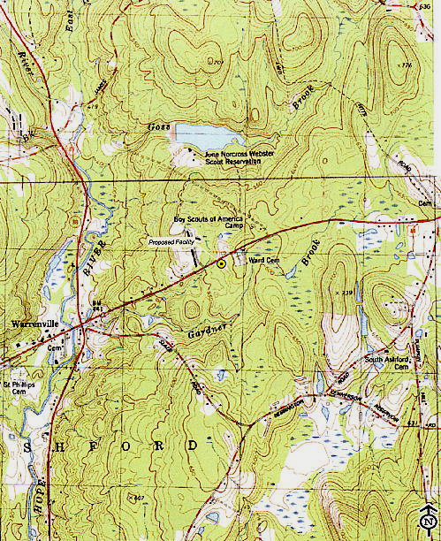
(Cellco 1, p. ii)

Figure 2: Aerial Photograph of Site Area
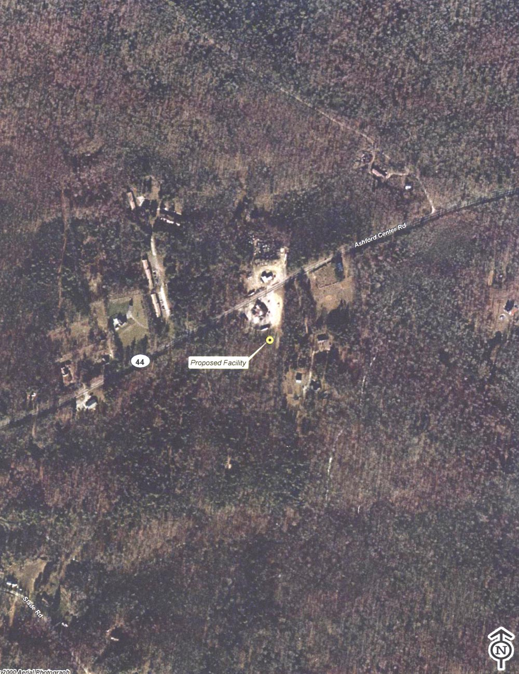
(Cellco 1, p. iii)

Figure 3: Proposed Site Plan
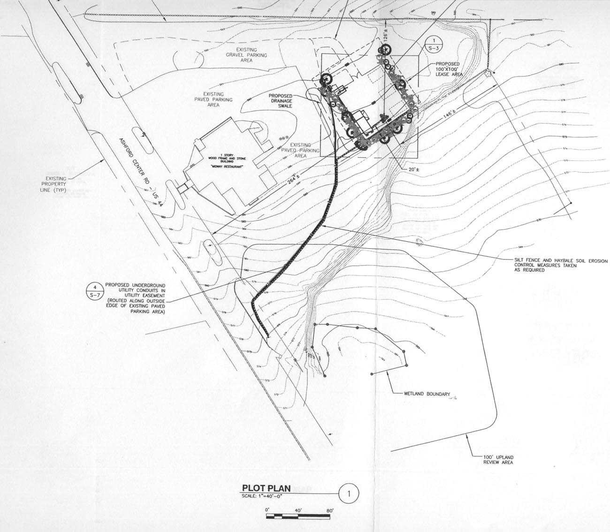
(Cellco 1, Attachment 1, Drawing S-1)

Figure 4: Cellco’s Existing Cellular Coverage
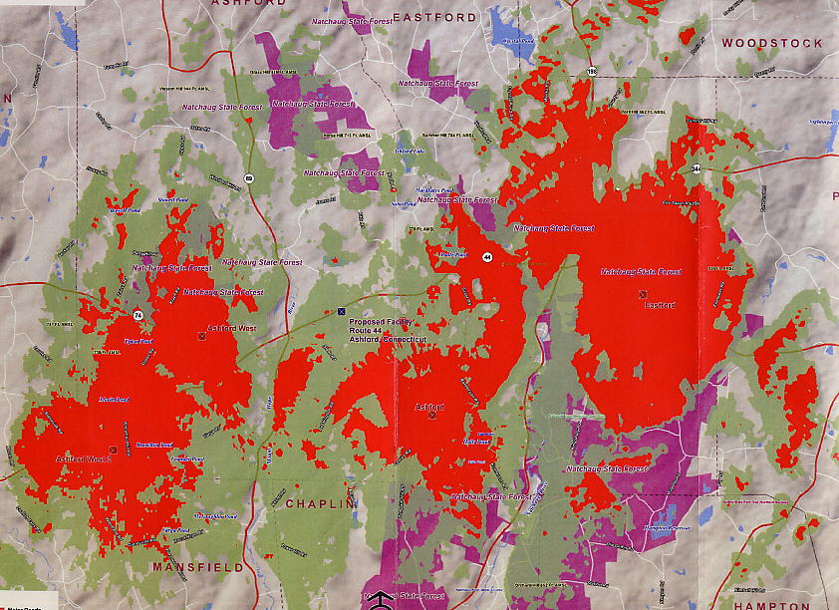
(Cellco 1, Attachment 6)

Figure 5: Cellco’s Cellular Coverage with Proposed Site
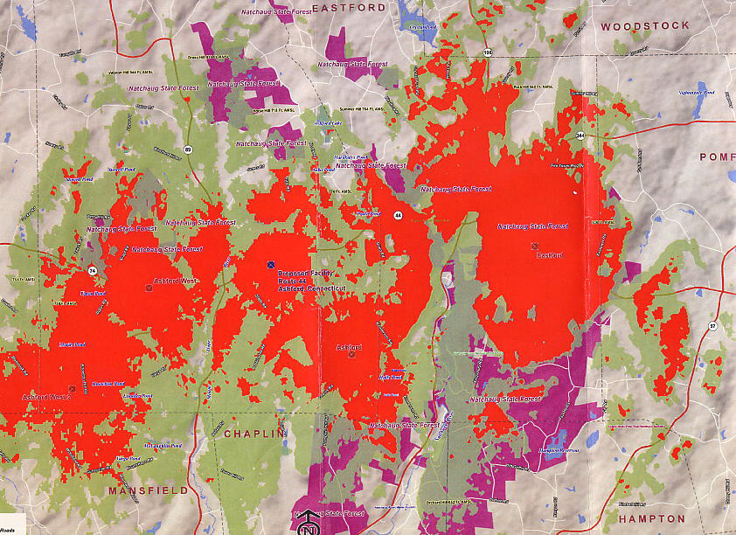
(Cellco 1, Attachment 6)

Figure 6: Cellco’s Existing PCS Coverage
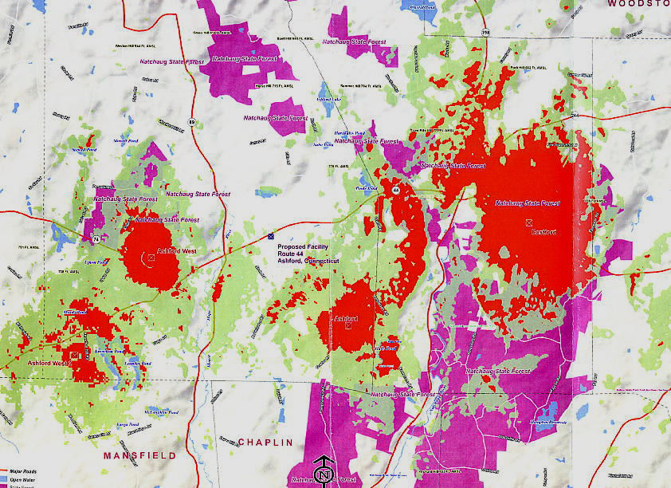
(Cellco 1, Attachment 6)

Figure 7: Cellco’s PCS Coverage with Proposed Site
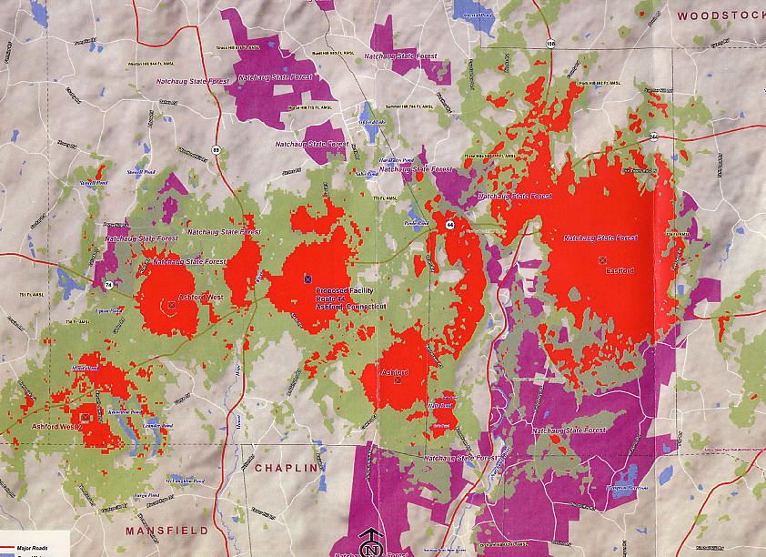
(Cellco Attachment 6)

Figure 8: Visibility Map
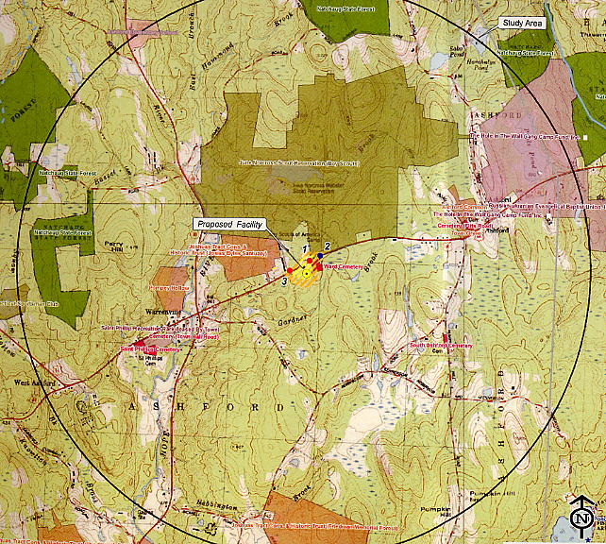
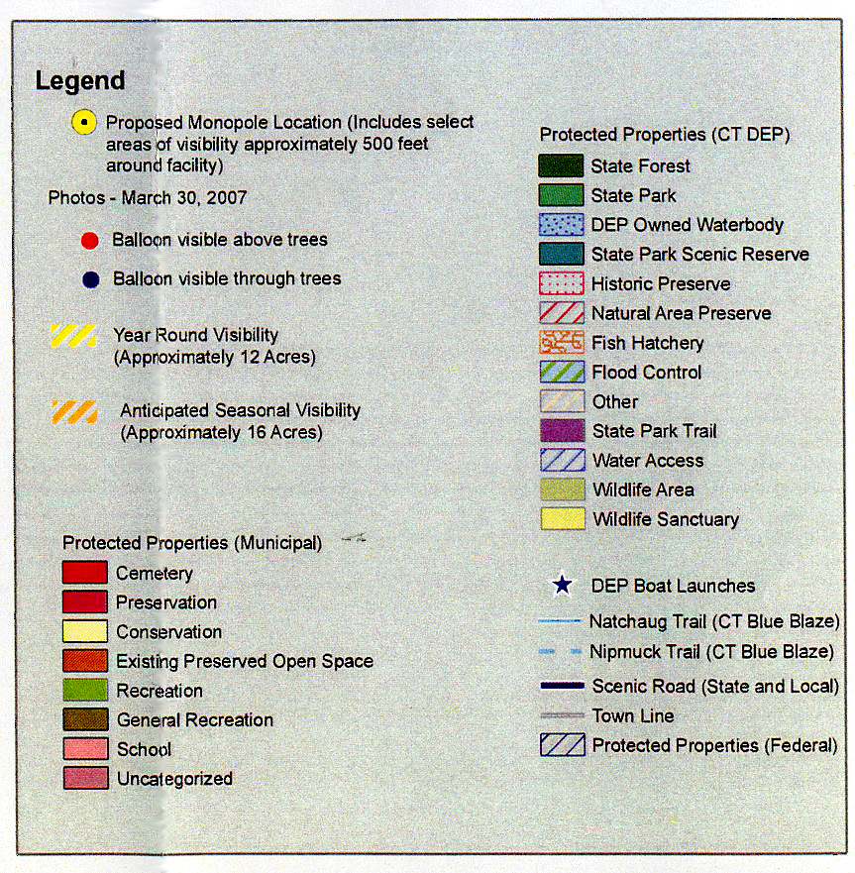
(Cellco 1, Attachment 9)

