DOCKET NO. 325 – Cellco Partnership d/b/a Verizon Wireless application for a Certificate of Environmental Compatibility and Public Need for the construction, maintenance and operation of a telecommunications facility at 111 Upper Fish Rock Road in Southbury, Connecticut. | }  }  } | Connecticut  Siting  Council  April 10, 2007

Findings of Fact

Introduction

- Pursuant to Chapter 277a, Sections 16-50g et seq. of the Connecticut General Statutes (CGS), as amended, and Section 16-50j-1 et seq. seq. of the Regulations of Connecticut State Agencies (RCSA), Cellco Partnership d/b/a Verizon Wireless (Cellco) applied to the Connecticut Siting Council (Council) on November 2, 2006 for the construction, operation, and maintenance of a telecommunications facility to be located at 111 Upper Fish Rock Road in the Town of Southbury, Connecticut. (Cellco 1, p. 1)

- Cellco is a Delaware Partnership with an administrative office located at 99 East River Drive, East Hartford, Connecticut. Cellco is licensed by the Federal Communications Commission (FCC) to operate a wireless telecommunications system in Connecticut. The operation of wireless telecommunications systems and related activities are Cellco’s sole business in Connecticut. (Cellco 1, p. 3)

- The party in this proceeding is the applicant. (Transcript, February 1, 2007, 3:00 p.m. [Tr. 1], p. 4)

- The proposed facility would provide coverage along Interstate 84 and local roads in the southerly portion of Southbury and northeasterly portion of Newtown. (Cellco 1, pp. 1-2)

- Pursuant to CGS § 16-50m, the Council, after giving due notice thereof, held a public hearing on February 1, 2007, beginning at 3:00 p.m. and continuing at 7:00 p.m. in Southbury, Connecticut. (Tr. 1, p. 2 ff.)

- The Council and its staff conducted an inspection of the proposed site on February 1, 2007, beginning at 2:00 p.m. The applicant flew a balloon from 8:00 a.m. until 5:00 p.m. at the proposed site to simulate the height of the proposed tower. Weather conditions provided good visibility for the balloon flight. (Tr. 1, p. 26)

- Pursuant to CGS § 16-50l(b), notice of Cellco’s intent to submit this application was published on October 30 and 31, 2006 in The Waterbury Republican-American. (Cellco 1, p. 4)

- In accordance with CGS § 16-50l(b), Cellco sent notices of its intent to file an application with the Council to each person appearing of record as owner of property abutting the property on which the site is located. (Cellco 1, p. 5; Attachment 5)

- Cellco sent its notice to 28 owners of abutting properties. It received return receipts from 22 of these owners. Five notice letters were returned. Three of the returned letters were resent through regular mail. One letter, to NYCONN Electric, Inc., could not be forwarded because the company had moved without leaving a forwarding address. One letter was resent to a lawyer who is representing the estate of a listed property owner. (Cellco 4, Response 7)

- Cellco posted a sign advising the general public that a certificate application was pending for the host property. The sign was approximately four feet by six feet in size. (Tr. 1, p. 26)

- Pursuant to CGS § 16-50l(b), Cellco sent copies of its application to the following municipal, regional, state, and federal agencies and officials: Connecticut Attorney General, Department of Environmental Protection (DEP), Department of Public Health, Council on Environmental Quality, Department of Public Utility Control, Office of Policy and Management, Department of Economic and Community Development, Department of Transportation, Division Director/Deputy State Historic Preservation Officer, Council of Governments of the Central Naugatuck Valley, Louis DeLuca — State Senator from the 32nd Senatorial District, Arthur O’Neill — State Representative from the 69th Assembly District, Federal Aviation Administration, Federal Communications Commission, Mark Cooper — Town of Southbury First Selectman, Virginia Salisbury — Southbury Town Clerk, William David — Southbury Planning Commission Chairman, Gary Giroux — Southbury Zoning Commission Chairman, Lemuel Johnson — Southbury Zoning Board of Appeals Chairman, DeLoris Curtis — Southbury Planning Administrator, Mark Cody — Southbury Zoning Enforcement Officer, Scott Martin — Southbury Inland Wetlands Commission Chairman, Herbert Rosenthal — Town of Newtown First Selectman, John McKinney — State Senator from the 28th Senatorial District, Julia Wasserman —State Representative from the 106th Assembly District, Cynthia Simon — Newtown Town Clerk, William O’Neill — Newtown Planning and Zoning Commission Chairman, Charles Annett — Newtown Zoning Board of Appeals Chairman, Gary Frenette — Newtown Zoning Enforcement Officer, Sally O’Neil — Newtown Inland Wetlands Commission Chairman, and Housatonic Council of Elected Officials. (Cellco 1, p. 4; Attachment 3)

State Agency Comment

- Pursuant to CGS § 16-50l, the Council solicited comments on Cellco’s application from the following state departments and agencies: Department of Environmental Protection, Department of Public Health, Council on Environmental Quality, Department of Public Utility Control, Office of Policy and Management, Department of Economic and Community Development, and the Department of Transportation. The Council’s letters requesting comments were sent on January 3 and February 5, 2007. (CSC Hearing Package dated January 3, 2007; CSC Letter to State Department Heads dated February 5, 2007)

- The Connecticut Department of Transportation (ConnDOT) responded to the Council’s solicitation with no comments on this proposal. (Letter from ConnDOT dated January 17, 2007)

- No other state agency responded to the Council’s requests for comments. (Record)

Municipal Consultation

- Cellco representatives met with the Town of Southbury’s First Selectman, Mark Cooper, and its Planning Administrator, DeLoris Curtis, to discuss its proposed facility on August 22, 2006. At this meeting, First Selectman Cooper received copies of technical information summarizing Cellco’s plans. (Cellco 1, p. 16)

- During Cellco’s meeting with Southbury officials, the First Selectman asked Cellco to consider locating its tower on a town-owned parcel north of the proposed site off Ichabod and Lakeside Roads. Cellco’s Radio Frequency engineer investigated the town parcel but could not find a suitable location on the parcel that would allow it to achieve its coverage objectives. (Cellco 1, p. 16)

- Because Cellco’s proposed site is within 2,500 feet of the Newtown municipal boundary, Cellco representatives met with Newtown’s Director of Public Works, Frederick Hurley, who was representing Newtown’s First Selectman. (Cellco 1, p. 16)

- No comments were entered into the record by any officials or boards of the Town of Newtown. (Cellco 4, Response 29)

- The Town of Southbury has an agreement with Cellco to install a 20-foot whip antenna at the top of the tower. (Tr. 1, pp. 6 ff.)

- The town’s whip antenna would be shared by the police department, fire department, EMS, and public works department. (Tr. 1, pp. 12-13)

- Cellco would make space on the tower and within the compound available to the Town of Southbury at no charge. (Cellco 1, p. 10; Cellco 4, Response 30)

Public Need for Service

- The federal Telecommunications Act of 1996 (Act) recognized a nationwide public need for high-quality wireless telecommunication services. The Act also promoted competition among wireless service providers, tried to foster lower prices for consumers, and encouraged the rapid deployment of new telecommunications technologies. (Cellco 1, p. 5)

- In issuing cellular licenses, the federal government has preempted the determination of public need for cellular service by the states, and has established design standards to ensure technical integrity and nationwide compatibility among all systems. (Council Administrative Notice Item No. 7)

- The Telecommunications Act of 1996 prohibits local and state bodies from discriminating among providers of functionally equivalent services. (Council Administrative Notice, Telecommunications Act of 1996)

- The Telecommunications Act of 1996, a Federal law passed by the United States Congress, prohibits any state or local entity from regulating telecommunications towers on the basis of the environmental effects of radio frequency emissions to the extent that such towers and equipment comply with FCC’s regulations concerning such emissions. This Act also blocks the Council from prohibiting or acting with the effect of prohibiting the provision of personal wireless service. (Council Administrative Notice Item No. 7)

- Cellco holds an FCC License to provide cellular and PCS service in New Haven County. (Cellco 1, p. 7)

- Cellco’s antennas would comply with E911 requirements at this site. (Cellco 4, Response 2)

- The Town of Southbury’s police and fire departments’ have a need for wireless coverage in the area that would be served by Cellco’s proposed facility. (Tr. 1, pp. 8 ff.)

Site Selection

- The search ring for this project was originally issued in 2000 when Cellco was relying on Crown Atlantic Company (Crown) to find and develop tower locations in accordance with a Build to Suit Agreement. This agreement has since been terminated. The original search ring was approximately ¾ of a mile in diameter. (Cellco 4, Response 18)

- Cellco maintains four existing facilities within four miles of the proposed facility. These existing facilities, however, cannot provide coverage to the areas that Cellco has identified as problems. (Cellco 1, Attachment 9, p. 1)

- In addition to its proposed site, Cellco investigated three other locations as potential sites for its facility. These sites, and the determination of their respective suitability, are described below.

Sprint/Nextel tower at 214 Russian Village Road, Southbury – existing 120-foot tower located 1.2 miles northwest of the proposed site; this site would not adequately cover the existing gap on I-84.

State police tower at 11 Lakeside Road, Southbury – existing 180-foot tower located 1.2 miles northeast of proposed site; RF signals from this site could not connect with Cellco’s Newtown facility.

Town of Southbury property – 203-acre parcel located at Ichabod Road and Lakeside Road approximately .5 miles north of proposed facility; severe topography of parcel does not enable continuous coverage between two of Cellco’s adjacent sites.
(Cellco 1, Attachment 9, p. 2)

Site Description

- Cellco’s proposed site is in the southeastern portion of a 32-acre parcel owned by Carl and Marilyn Ferencek and located at 111 Upper Fish Rock Road in the south central portion of Southbury, Connecticut. (See Figure 1) (Cellco 1, Attachment 1, p. 1)

- The site is located within a R-20 zone, a designation that allows single family homes on lots of at least 20,000 square feet. Wireless communications facilities are permitted within this zone with a Special Exception from the Zoning Board of Appeals. (Cellco 1, p. 2; Southbury Zoning Regulations bulk filed)

- At this location, Cellco would erect a 100-foot steel monopole tower within a 50-foot by 60-foot fenced compound. The compound would be within a 100-foot by 100-foot lease parcel. Cellco would house its ground equipment within a 12-foot by 30-foot equipment shelter. (Cellco 1, Attachment 1)

- The total height of Cellco’s proposed tower, including the town’s 20-foot whip antenna, would be 120 feet. (Tr. 1, p. 46)

- The tower would be located at 41° 26’ 17.80” north latitude and 73° 14’ 15.87” west longitude. Its ground elevation would be 395 feet AMSL. (Cellco 1, Attachment 1, Sheet T-1)

- The tower would be designed to accommodate up to four carriers. (Cellco 1, Attachment 1, Sheet SC-3; Cellco 4, Response 17)

- Cellco’s tower would be designed in accordance with the specifications of the Electronic Industries Association Standard EIA/TIA-222-F “Structural Standards for Steel Antenna Towers and Antenna Support Structures.” (Cellco 1, Attachment 1, p. 6; Cellco 4, Response 16)

- The tower would be engineered and built to be extendable. (Tr. 1, p. 35)

- The proposed site would require approximately seven cubic yards of fill and four and a half cubic yards of cut. (Cellco 4, Response 15)

- Cellco does not anticipate the need for blasting to develop this site. (Cellco 4, Response 22)

- Cellco would install 12 panel-type directional antennas on a triangular platform at the top of the tower. Cellco’s antennas would extend to a height of 104 feet above ground level (AGL). (Cellco 1, p. i)

- The Town of Southbury would install a 20-foot whip antenna at the top of the proposed tower. (Cellco 1, p. 10)

- Cellco’s compound would be enclosed by an eight-foot chain link fence. (Cellco 1, Attachment 1, Sheet SC-4)

- Cellco originally proposed building a new 12-foot wide gravel driveway for a distance of approximately 1,130 feet extending from Upper Fish Rock Road along the south side of the owner’s residence to provide vehicular access to its proposed facility. (Cellco 1, Attachment 1, p. 5)

- Cellco was asked by the property owners to amend its plans and relocate the access driveway to the northwesterly portion of the property near the existing driveway used for the residence. The revised route for the proposed drive would add 500 feet to its overall length. (Tr. 1, p. 20)

- It would be difficult to acquire rights to use an existing private road adjacent to the Ferencek property for access to the proposed site because of the indeterminate ownership of the road. (Tr. 1, p. 27)

- Utilities to the site would be extended from a utility pole on Upper Fish Rock Road underground following the access driveway. (Cellco 1, Attachment 1, Sheet SC-2)

- The tower’s setback radius would be contained within the Ferencek property. (Cellco 1, Attachment 1, Sheet SC-2)

- The proposed site is located in a heavily-wooded area of the Ferencek property. Land use in the vicinity of the site consists primarily of wooded land and low-density residential development. (Cellco 1, Attachment 1, p. 4)

- The closest residence to the proposed facility is 590 feet to the northwest. It is located at 155 Upper Fish Rock Road and owned by Bernice and Victoria Thomas. (Cellco 4, Response 28)

- There are 17 residences within 1,000 feet of the proposed facility. (Cellco 1, p. 12)

- Cellco would use a diesel-fueled generator for backup power. The generator would be located within the equipment shelter. It would include a 275 gallon, double-walled fuel tank with leak detection monitoring systems. (Cellco 1, p. 2)

- The estimated cost of the proposed facility is:

Cell site radio equipment $450,000
Tower, coax, and antenna costs 125,000
Power systems 20,000
Equipment building 60,000
Miscellaneous (site prep, installation) 15,000
Total $670,000

(Cellco 1, p. 18)

- The revised access drive would add approximately $20,000 to the cost of the facility. (Tr. 1, p. 50)

Environmental Considerations

- Cellco’s proposed facility would have no effect on Connecticut’s cultural heritage. (Cellco 1, Attachment 11 – Letter from State Historic Preservation Officer)

- No federally-listed or proposed, threatened or endangered species or critical habitat under the jurisdiction of the U.S. Fish and Wildlife Service are known to occur in the project area(s). (Cellco 4, Letter from the U.S. Fish and Wildlife Service dated August 24, 2006)

- Federal threatened and State Endangered Bald Eagles (haliaeetus leucocephalus) occur in the vicinity of the proposed project. (Cellco 4, Letter from the DEP Bureau of Natural Resources dated November 2, 2006)

- DEP’s Wildlife Division would recommend that no work be done on this project between February 1 and August 1 to avoid affecting the bald eagles. (Cellco, Letter from the DEP Franklin Wildlife Management Area dated November 27, 2006)

- Cellco would agree not to do any construction work during the DEP recommended time period. (Tr. 1, p. 37)

- An estimated 64 trees with diameters of six inches or greater at breast height would be removed to construct the proposed facility. (Cellco 4, Response 14)

- The revision to the access road would require the removal of an estimated 12 additional trees. (Tr. 1, p. 25)

- The closest wetland to the proposed facility is approximately 450 feet to the west of the site. (Cellco 1, p. 15)

- Cellco’s facility would not constitute a hazard to air navigation. No obstruction marking or lighting would be required for the proposed tower. (Cellco 1, p. 17)

- According to calculations performed by Cellco, the maximum power density from the radio frequency emissions of Cellco’s proposed antennas would be 29.96% of the standard for Maximum Permissible Exposure, as adopted by the FCC, at the base of the proposed tower. This calculation was based on a methodology prescribed by the FCC Office of Engineering and Technology Bulletin No. 65E, Edition 97-01 (August 1997) that assumes all antennas would be pointed at the base of the tower and all channels would be operating simultaneously. (Cellco 1, p. 14)

Visibility

- The proposed tower would be visible year-round from approximately 54 acres within a two-mile radius of the site. (See Figure 5) (Cellco 1, p. 12; Attachment 10)

- Approximately 15 residences would have year-round views of the proposed tower. (Tr. 1, p, 21)

- The proposed tower would be seasonally visible from approximately 26 acres in the surrounding vicinity. (Cellco 4, Response 23)

- Approximately 31 residential properties may have seasonal views of the proposed tower. (Tr. 1, p. 21)

- Cellco would be willing to erect a tower designed to look like a pine tree (monopine) at this location. (Tr. 1, p. 32)

- The visibility of the proposed site from different vantage points in the surrounding vicinity is summarized in the following table. The locations of the vantage points listed are identified by their corresponding number in the Visual Resource Evaluation Report contained in Attachment 10 of Cellco’s application.

Location | Site  Visible | Approx. Portion of (100’) Tower Visible (ft.) | Approx. Distance and Direction to Tower
1 – River Road , north of Berkshire Road | Yes | Upper 30’ | 3800 feet; SE
2 – River Road at I-84 overpass | Yes | Upper 40’ | 3500 feet; SE
(Cellco 1, Attachment 10)

- It is unlikely that the tower would be visible from Kettletown State Park. (Cellco 4, Response 25)

Existing and Proposed Wireless Coverage

- In the Southbury/Newtown area, Cellco is licensed to operate in the cellular band at 869-880 MHz and 890-891.5 MHz and in the PCS C3 Block at 1985-1990 MHz. Cellco would install antennas operating within both of these frequency ranges on the same platform. (Cellco 4, Response 1)

- Cellco experiences a coverage gap along I-84 of approximately 1.5 miles on its cellular frequencies and 1.8 miles on its PCS frequencies. Coverage gaps also exist along local roads in the southerly portions of Southbury and northeasterly portions of Newtown, including recreational areas along the Housatonic River. (See Figure 2) (Cellco 4, Response 31; Cellco 1, pp. 2 & 7)

- Cellco’s antennas at this site would hand off signals to Cellco sites at 133 Horse Fence Hill Road in Southbury and on Route 34 in Newtown. (Tr. 1, p. 34)

- Cellco designs its system for a signal strength of -85 dBm. (Cellco 4, Response 10)

- Cellco’s existing signal strength in the vicinity of its proposed site ranges from -86 dBm to -105 dBm. (Cellco 4, Response 11)

- On a stand-alone basis, Cellco’s cellular antennas could cover an approximately 2.9 mile portion of I-84 from this location. Its PCS antennas could cover an approximately 2.2 mile portion of I-84. (See Figures 3 and 4) (Cellco 4, Response 9)

- If this site were integrated into Cellco’s existing network, its cellular antennas would be the “best server” for an approximately 2.0 mile portion of I-84, and its PCS antennas would be the “best server” for an approximately 1.9 mile portion of I-84. (Cellco 4, Response 9)

- Cellco’s antennas would cover approximately 7.1 square miles from this location at cellular frequencies approximately 4.5 square miles at PCS frequencies. (Cellco 4, Response 8)

- The lowest height at which Cellco’s antennas could achieve its coverage objectives is 100 feet. At 90 feet, there would be gaps in Cellco’s PCS coverage along I-84 and on local roads. (Cellco 4, Response 21)

- It is unlikely that heights below 100 feet would be feasible for other carriers. (Tr. 1, p. 35)

Figure 1: Location Map
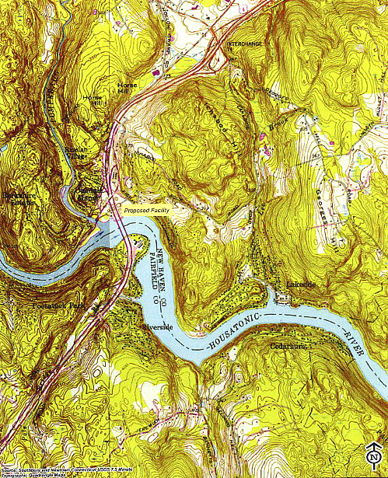
(Cellco 1, Attachment 1)

Figure 2: Existing Coverage
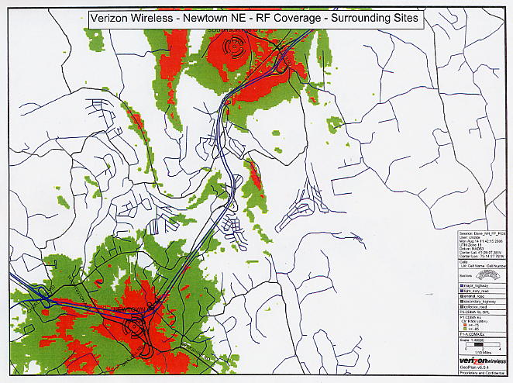
(Cellco 1, Attachment 7)

Figure 3: Coverage from Site at 800 MHz
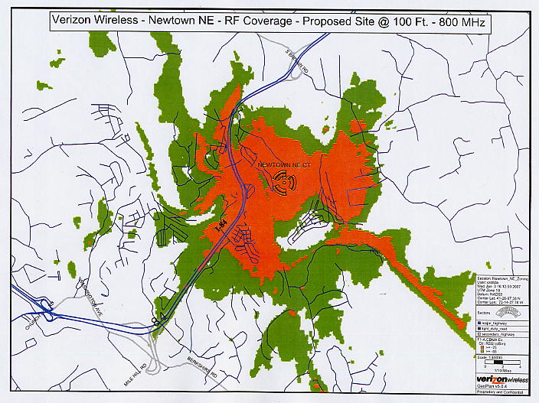
(Cellco 4, Attachment 2)

Figure 4: Coverage from Site at 1900 MHz
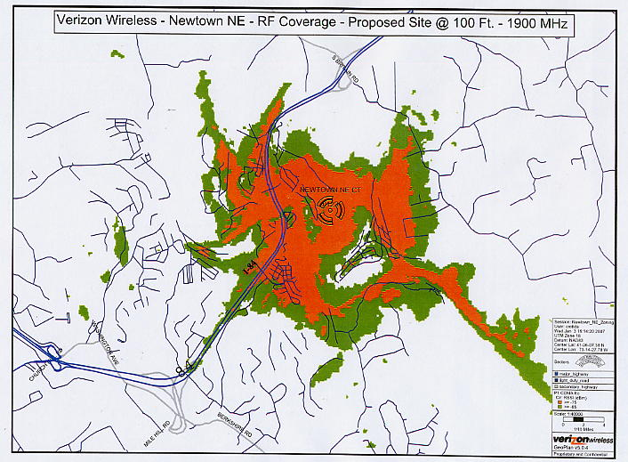
(Cellco 4, Attachment 2)

Figure 5: Combined Coverage – Existing and Proposed Sites
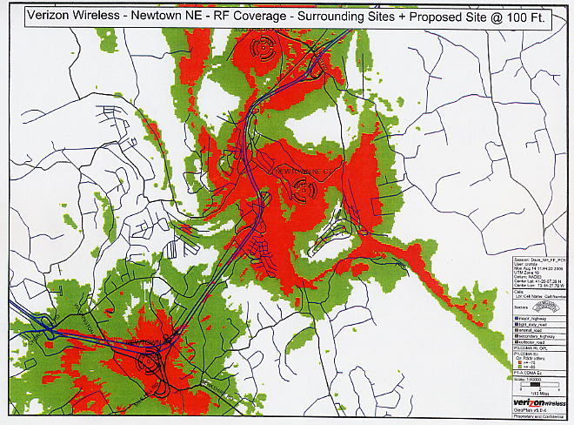
(Cellco 1, Attachment 7)

Figure 6: Visibility Map
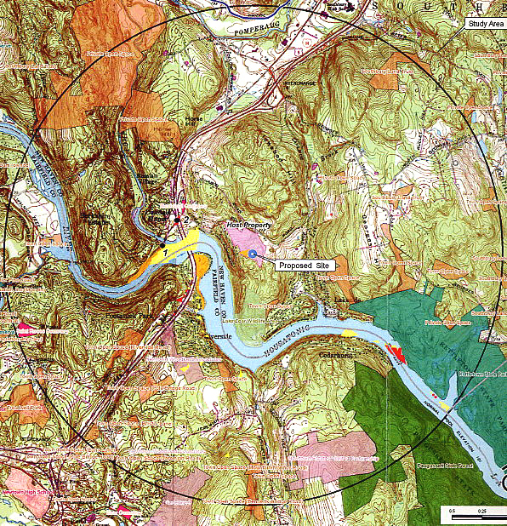
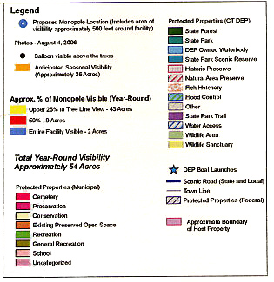
(Cellco 1, Attachment 10)

