DOCKET NO. 321 – Optasite, Inc. and Omnipoint Communications, Inc. application for a Certificate of Environmental Compatibility and Public Need for the construction, maintenance and operation of a telecommunications facility at 940 Meriden Road in Waterbury, Connecticut. | }  }  } | Connecticut  Siting  Council  February 27, 2007

Findings of Fact

Introduction

- Pursuant to Chapter 277a, Sections 16-50g et seq. of the Connecticut General Statutes (CGS), as amended, and Section 16-50j-1 et. seq. of the Regulations of Connecticut State Agencies (RCSA), Optasite, Inc. (Optasite) and Omnipoint Communications, Inc. (T-Mobile) applied to the Connecticut Siting Council (Council) on September 14, 2006 for the construction, operation, and maintenance of a telecommunications facility to be located at 940 Meriden Road in the City of Waterbury, Connecticut. (Optasite 1, p. 1)

- Optasite is a Delaware corporation with offices at One Research Drive, Suite 200C, Westborough, Massachusetts. It would construct and maintain the proposed facility. (Optasite 1, p. 3)

- T-Mobile is a Delaware corporation with a Connecticut office at 100 Filley Street, Bloomfield, Connecticut. The company and its affiliated entities are licensed by the Federal Communications Commission (FCC) to construct and operate a personal wireless services system in Connecticut. T-Mobile does not conduct any other business in the State of Connecticut other than the provision of wireless services under FCC rules and regulations. (Optasite 1, p. 3)

- The parties in this proceeding are the applicants, Optasite and T-Mobile. Sprint/Nextel Corporation (Nextel) is an intervenor. (Transcript, November 21, 2006, 3:00 p.m. [Tr. 1], pp. 5-6)

- The proposed facility would provide wireless service in the City of Waterbury and the Town of Wolcott along Interstate highway I-84 and Meriden Road, as well as in adjacent areas. (Optasite 1, p. 1)

- Pursuant to CGS § 16-50m, the Council, after giving due notice thereof, held a public hearing on November 21, 2006, beginning at 3:00 p.m. and continuing at 7:00 p.m. at Veteran’s Memorial Hall in the Waterbury City Hall in Waterbury, Connecticut. (Tr. 1, p. 3 ff.)

- The Council and its staff conducted an inspection of the proposed site on November 21, 2006, beginning at 2:00 p.m. On the day of the field inspection, the applicants flew a balloon from 7:45 a.m. to 5:00 p.m. to simulate the height of the proposed tower. The winds were mild, and visibility was unlimited. (Tr. 1, pp. 14-15)

- Pursuant to CGS § 16-50l(b), notice of the applicants’ intent to submit this application was published in two editions of the Waterbury Republican-American issued between August 22 and August 24, 2006. (Waterbury-American Affidavit of Publication dated August 30, 2006)

- In accordance with CGS § 16-50l(b), Optasite sent notices of its intent to file an application with the Council to each person appearing of record as owner of property abutting the property on which the site is located. (Optasite 1, p. 4, Exhibit E)

- Optasite sent notices by certified mail to 61 abutting property owners on August 22, 2006. Of this total, return receipts were not received from 15 abutters. A second certified mail notice was sent to these 15 abutters on September 11, 2006. Of the 15 letters re-sent, Optasite did not receive return receipts from nine abutters. Optasite sent a third notice to these nine abutters on or about November 3, 2006. (Optasite 2, Response A1)

- Pursuant to CGS § 16-50l (b), Optasite provided notice to all federal, state and local officials and agencies listed therein. (Optasite 1, p. 4, Exhibit D)

- Optasite placed a four-foot by six-foot sign at the entrance of Pine Grove Cemetery to inform the public of its pending certificate application. The sign was installed on November 8, 2006. (Tr. 1, pp. 15-16)

State Agency Comments

- Pursuant to CGS § 16-50l, the Council solicited comments on Optasite’s application from the following state departments and agencies: Department of Environmental Protection, Department of Public Health, Council on Environmental Quality, Department of Public Utility Control, Office of Policy and Management, Department of Economic and Community Development, and the Department of Transportation. The Council’s letters requesting comments were sent on October 27, 2006 and on November 22, 2006. (CSC Hearing Package dated October 27, 2006)

- The Connecticut Department of Transportation (ConnDOT) responded to the Council’s solicitation with no comments. (ConnDOT letter dated November 7, 2006)

- No other state agency submitted comments regarding this application. (Record)

Municipal Consultation

- Optasite submitted a letter and a technical report to the City of Waterbury describing its proposed facility and its intent to apply to the Council on May 31, 2006. Optasite met with Waterbury city officials on July 25, 2006 to discuss its proposed facility. Waterbury’s City Planner, James Sequin, indicated that the city did not oppose Optasite’s facility and did not intend to offer any comments regarding it. (Optasite 1, p. 19)

- Pursuant to CGS § 16-50l(b)(1), Optasite also submitted a letter and a technical report to the officials of the Town of Wolcott on May 31, 2006 because the proposed site is within 2,500 feet of the Wolcott town line. Optasite followed up on this submittal by meeting with Wolcott town officials on August 1, 2006. At this meeting, Wolcott’s mayor, Thomas Dunn, indicated that he did not have any concerns about Optasite’s proposal and that he felt it would be beneficial to the area and its residents. (Optasite 1, p. 19)

- The City of Waterbury has expressed interest in locating equipment on the proposed tower. If the city chooses to use Optasite’s facility, Optasite will provide space at no charge. (Optasite 2, Response A5)

Public Need for Service

- The United States Congress, through adoption of the Telecommunications Act of 1996, recognized the important public need for high quality telecommunication services throughout the United States. The purpose of this Act, which was a comprehensive overhaul of the Communications Act of 1934, was to “provide for a competitive, deregulatory national policy framework designed to accelerate rapidly private sector deployment of advanced telecommunications and information technologies to all Americans.” (Optasite 1, p. 5)

- The Telecommunications Act of 1996 prohibits local and state bodies from discriminating among providers of functionally equivalent services. (Council Administrative Notice, Telecommunications Act of 1996)

- The Telecommunications Act of 1996 prohibits any state or local agency from regulating telecommunications towers on the basis of the environmental effects of radio frequency emissions to the extent that such towers and equipment comply with FCC’s regulations concerning such emissions. This Act also blocks the Council from prohibiting or acting with the effect of prohibiting the provision of personal wireless service. (Council Administrative Notice, Telecommunications Act of 1996)

- In an effort to ensure the benefits of wireless technologies to all Americans, Congress enacted the Wireless Communications and Public Safety Act of 1999 (the 911 Act). The purpose of this legislation was to promote public safety through the deployment of a seamless, nationwide emergency communications infrastructure that includes wireless communications services. (Optasite 1, p. 6)

- The proposed facility would be an integral component of T-Mobile’s E911 network. (Optasite 1, p. 7)

- Nextel’s antennas would comply with E911 requirements. (Optasite 2, Response A7 for Nextel)

Site Selection

- The search for a site in this section of Waterbury was originally initiated by T-Mobile. However, T-Mobile decided that it did not want to own the tower and asked Optasite to take over the site investigation and certification process. (Tr. 1, pp. 18-19)

- Optasite began its search for a site in this area of Waterbury in December 5, 2005. (Optasite 2, Response A2)

- Optasite has a working relationship with T-Mobile to co-develop new tower facilities in Connecticut. (Optasite 2, Response A3; Tr. 1, p. 18)

- Optasite contacted other FCC-licensed wireless providers to determine their possible interest in this site. Sprint/Nextel identified a need for a facility in this area and has expressed an interest in co-locating on the proposed tower. (Optasite 2, Response A4)

- There are no existing towers or other tall structures within two miles of the proposed site that would enable T-Mobile or Nextel to adequately cover their respective target areas. (Optasite 1, p. 8)

- Optasite identified and investigated six properties as possible facility locations. These properties and an assessment of their suitability are listed below.

Location Considered | Suitability
Pine Grove Cemetery property, 940 Meriden Road | Proposed location
Pine Grove Cemetery property, 390 Meriden Road | Not enough acreage for required lease area
Wolcott Land Trust property, Celia Drive in Wolcott | Rejected by T-Mobile because it was too far from target area to provide adequate coverage
Town of Wolcott property, 10 Kenea Drive, Wolcott | Rejected by T-Mobile because it was too far from target area to provide adequate coverage
1215 Meriden Road, Waterbury | Unable to negotiate lease agreement with property owner
Tower on Rockaway Avenue property | Property surrounded by residential properties and includes extensive wetlands
(Optasite 1, Exhibit I)

- Optasite identified 17 towers within an approximate five mile radius of its search area. All of these towers are located too far from the site search area to provide adequate coverage to target areas of T-Mobile and Nextel. (Optasite 1, p. 8)

- Repeaters, microcell transmitters, distributed antenna systems and other types of transmitting technologies are not a practicable or feasible means to provide service within the coverage gaps T-Mobile and Nextel are seeking to cover. Significant terrain variations and tree cover in Waterbury and the surrounding area limit the practicality of such technologies. (Optasite 1, p. 7)

Site Description

- Optasite’s proposed facility is located in the north central portion of a 104-acre parcel owned by the Pine Grove Cemetery Association at 940 Meriden Road (also known as 850 Meriden Road) in Waterbury. Portions of cemetery property are developed for burial; however, large portions of the property remain undeveloped and wooded. (Optasite 1, p. 2)

- The Pine Grove Cemetery is located within an area zoned RL Low Density Residential. (Optasite 1, p. 2)

- Wireless communications facilities are permitted in RL districts as a special conditional use. (Optasite 1, bulk filed Waterbury Zoning Regulations)

- Optasite would lease a 60-foot by 60-foot area within which it would develop a facility that would include a 110-foot monopole. Nextel’s equipment would be housed within a 12-foot by 20-foot equipment shelter. T-Mobile’s ground equipment would consist of cabinets on a concrete pad. The entire leased area would be enclosed by an eight-foot high chain link fence. (Optasite 1, Exhibit A)

- The monopole design would enable Optasite to extend the tower’s height in the future. A flagpole design would not allow for a future tower expansion. (Tr. 1, p. 39)

- If the City of Waterbury were to mount a whip antenna on a flagpole tower, a flag could cause damage to the antenna. (Tr. 1, p. 42)

- The Pine Grove Cemetery Association did not express any preference for a particular tower design. (Tr. 1, p. 67)

- The proposed tower would be located at 41º 33’ 11.8” latitude and 72º 59’ 36.1” longitude. The elevation at the tower’s base would be 611 feet AMSL. (Optasite 1, Exhibit A)

- The tower would be designed in accordance with the specifications of the Electronic Industries Association Standard ANSI/EIA/TIA-222-G “Structural Standards for Steel Antenna Towers and Antenna Support Structures.” (Optasite 2, Response A6)

- The tower would be designed to accommodate antenna placements for up to four carriers. (Optasite 1, Exhibit A)

- T-Mobile would use batteries for back-up power. For longer outages, T-Mobile could bring a generator to the site on a temporary basis. (Optasite 2, Response A3 from T-Mobile)

- Nextel would use battery racks located within a shelter for power back-up. For prolonged outages, Nextel would bring in a portable generator. (Optasite 2, Response A9 for Nextel)

- Land use in the vicinity of the proposed tower consists of small-scale commercial development along Meriden Road and dense residential areas beyond the cemetery, abutting the commercial areas. (Optasite 1, pp.17-18)

- The nearest residence is located 770 feet to the northeast of the proposed tower. It is owned by Simeon and Leslie Arzu. (Optasite 2, Response A7)

- Fifteen residences are located within 1,000 feet of the proposed tower. (Optasite 2, Response A8)

- T-Mobile would install up to 12 antennas at a centerline of 97 feet above ground level (agl). (Optasite 1, p. 9)

- Nextel would install up to 12 antennas on the tower at a centerline height of 107 feet agl. (Optasite 1, p. 9)

- Vehicular access to the proposed facility would extend from Meriden Road over existing driveways and then over a new gravel drive that would be approximately 250 feet long. The new gravel drive was rerouted from its originally proposed location in order to avoid traveling over an existing septic system pipe. (Optasite 1, p. 10; Tr. 1, p. 12; Tr. 1, p. 26)

- Public utilities would be extended underground along the new gravel drive from existing overhead lines that follow existing driveways within the cemetery. (Optasite 1, p. 10)

- The tower’s setback radius would be contained within the Pine Grove Cemetery property. (Optasite 1, Exhibit A)

- The estimated cost of construction for this facility, not including carriers’ antennas and support equipment, is:

Tower and foundation $ 74,000
Site development 47,000
Utility installation 37,000
Total costs $158,000

(Optasite 1, p. 20)

Environmental Considerations

- The proposed project would have no effect on historic, architectural, or archaeological resources listed on or eligible for the National Register of Historic Places. (Optasite 1, Exhibit L)

- No known extant populations of Federal or State Endangered, Threatened or Special Concern Species occur at the proposed site. (Optasite 1, Exhibit L – Letter from Connecticut Department of Environmental Protection)

- No trees with a diameter of six inches or greater at breast height would be cleared for the development of the proposed site. (Optasite 1, Exhibit A)

- No wetlands or watercourses are located within 300 feet of the proposed site. (Optasite 1, p. 18)

- Developing this site would require 52 cubic yards of fill and 80 cubic yards of cuts. (Optasite 2, Response A9)

- Blasting would not be required at this site. (Optasite 2, Response A10)

- The Federal Aviation Administration determined that the proposed facility would not be a hazard to air navigation and would not require marking or lighting. (Optasite 1, Exhibit P)

- The maximum power density from the radio frequency emissions of T-Mobile’s and Nextel’s proposed antennas would be 15.457% of the standard for Maximum Permissible Exposure, as adopted by the FCC, at the base of the proposed tower. This calculation was based on a methodology prescribed by the FCC Office of Engineering and Technology Bulletin No. 65E, Edition 97-01 (August 1997) that assumes all antennas would be pointed at the base of the tower and all channels would be operating simultaneously. (Optasite 1, p. 14)

Visibility

- The proposed tower would be visible year round from approximately 33 acres. (Optasite 1, Exhibit K)

- The proposed tower would be seasonally visible from approximately 91 acres. (Optasite 1, Exhibit K)

- Eight residences in the surrounding area would have partial year-round views of the proposed facility; 36 residences would have partial seasonal views of the facility. (Optasite 1, p. 12)

- The visibility of the proposed tower from different vantage points in the surrounding vicinity is summarized in the following table.

Location | Visible  Site | Approx. Portion of (110’) Tower Visible (ft.) | Approx. Distance and Direction to Tower  Site
1 – Courtland Avenue at Beth Lane | Yes | 60’ | 2050 feet; S
2 – Meriden Road entrance to Pine Grove  Cemetery | Yes | 30’ | 1000 feet; W
3 – Meriden Road, east of Woodtick Road | Yes | 40’ | 330 feet; E
4 – Meriden Road at Woodland Avenue Rd | Yes | 50’ | 2700 feet; E
(Optasite 1, Exhibit K)

Existing and Proposed Wireless Coverage

T-Mobile

- T-Mobile’s licensed operating frequencies are:

Transmit: C Band – 1975.8 to 1989.8 MHz
Upper 2/3 A Band – 1935 to 1945 MHz
Receive: C Band – 1895.8 to 1909.8 MHz
Upper 2/3 A Band – 1855 to 1865 MHz

(Optasite 2, Response A4 from T-Mobile)

- The minimum required signal strength for T-Mobile is -84 dBm, which is the lower limit for T-Mobile to provide in-vehicle coverage. (Optasite 2, Response A5 from T-Mobile; Tr. 1, p. 33)

- T-Mobile’s lower threshold for in-building coverage is -76 dBm. (Tr. 1, p. 33)

- T-Mobile’s signal strength in the area that would be served by the proposed facility ranges from -85 to -95 dBm. (Optasite 2, Response A6 from T-Mobile)

- T-Mobile would initially install six antennas in a three sector configuration on a triangular platform at this site. (Tr. 1, p. 22)

- T-Mobile could achieve the same coverage with T-bar mounts as it could with platform mounted antennas. (Tr. 1, p. 41)

- T-Mobile’s antennas would cover a total area of 1.5 square miles from the proposed facility. (Optasite 2, Response A7 from T-Mobile)

- The proposed facility would enable T-Mobile to cover 1.4 miles along Meriden Road. It would not provide T-Mobile with additional coverage footprint along I-84. It would, however, provide necessary capacity offloading for existing T-Mobile facilities, providing coverage along I-84 in this area of Waterbury. (Optasite 2, Response A8 from T-Mobile)

- The proposed facility would hand off signals to T-Mobile sites at 25 Mulloy Road in Waterbury (CT11131A), 119 Store Avenue in Waterbury (CT11992C), 347 East Street in Wolcott (CT11414B), 1119 Summit Road in Cheshire (CT11352C), 150 Mattatuck Heights in Waterbury (CT11269B), 815 Hamilton Avenue in Waterbury (CT11130A), and 181 Garden Circle in Waterbury (CT11392B). (Optasite 2, Response A10 from T-Mobile)

- The distances and directions from the proposed site to T-Mobile’s nearest existing facilities are:

To CT11131A .68 miles, southeast
To CT11992C 1.09 miles, west
To CT11494B 2.26 miles, east
To CT11352C 2.04 miles, southeast
To CT11269B 1.07 miles, south

(Optasite 2, Response A1 from T-Mobile)

- T-Mobile could not expand its CT11131A site at 25 Mulloy Road because it is an advertising billboard and could not support any additional antennas. There is also a significant difference in the terrain between this site and T-Mobile’s target area that would limit the effectiveness of this site. (Tr. 1, p. 23)

- The minimum height at which T-Mobile could achieve its coverage objectives at this location is 97 feet AGL. (Optasite 2, Response A11)

Nextel

- Nextel is licensed to operate at 851-866 MHz and 935-940 MHz. (Optasite 2, Response A6 for Nextel)

- Nextel’s system is designed for a signal strength of -81 dBm for in-vehicle mobile coverage. (Optasite 2, Response A4 for Nextel; Tr. 1, pp. 63-64)

- Nextel requires a signal strength of -76 dBm to provide in-building coverage. (Tr. 1, p. 64)

- Nextel’s existing signal strength in the vicinity of the proposed facility ranges from some areas of -81 dBm or better to the west and south of the site to -91 dBm to the east and north of the site. (Optasite 2, Response A5 for Nextel)

- This facility would primarily fulfill a capacity need for Nextel. (Optasite 2, Response A8 for Nextel)

- Nextel would initially install three antennas per sector on a triangular platform. (Tr. 1, p. 48)

- A flagpole tower would reduce Nextel’s capability to achieve the capacity relief it is seeking to provide from this location. It might also restrict Sprint/Nextel’s ability to provide CDMA service from this site in the future. (Tr. 1, p. 49)

- Nextel’s antennas would cover approximately 2.8 square miles from this location. (Optasite 2, Response A10 for Nextel)

- Nextel’s antennas would cover approximately 1 mile along I-84 and 2.2 miles along Meriden Road from this location. (Optasite 2, Response A11 for Nextel)

- From this location, Nextel’s antennas would hand off signals to existing sites at 150 Mattatuck Heights in Waterbury (NCT1062S), 1119 Summit Road in Cheshire (NCT2529R), 1600 East Main Street in Waterbury (NCT3626R), Garden Hill Circle Extension in Waterbury (NCT10016T), and 30 Framingham Drive in Waterbury (NCT1045R). (Optasite 2, Response A12 for Nextel)

- The distances and directions from Optasite’s proposed facility to Nextel’s existing sites are:

To NCT3626R 1.2 miles, Southwest
To NCT1045R 1 mile, Northwest
To NCT1062S 1.15 miles, Southeast

(Optasite 2, Response A1 for Nextel)

- The site that would most benefit from the capacity relief provided by the proposed site is identified by Nextel as NCT1016, which is actually two sites away from the proposed site (1.7 miles to Northwest). This site currently handles 40,000 minutes a day and is considered to be at or above capacity. Because of this site’s high elevation, it causes interference problems by overshooting the nearest adjacent sites. The proposed site would reduce these interference problems in addition to providing capacity relief. (Tr. 1, pp. 51 ff.)

- The minimum height at which Nextel could achieve its coverage objectives at this location is 107 feet AGL. (Optasite 2, Response A13 for Nextel)

Site of proposed tower
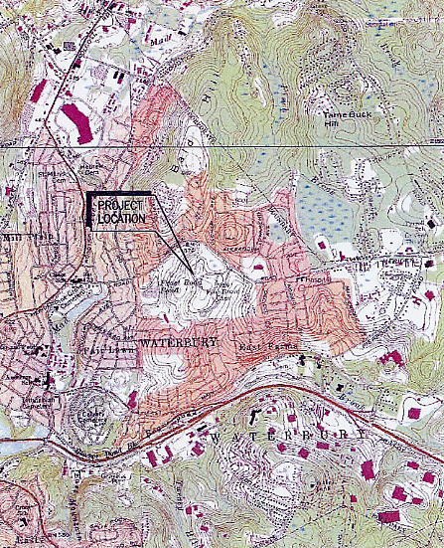
(Optasite 1, Exhibit A)

T-Mobile’s existing coverage
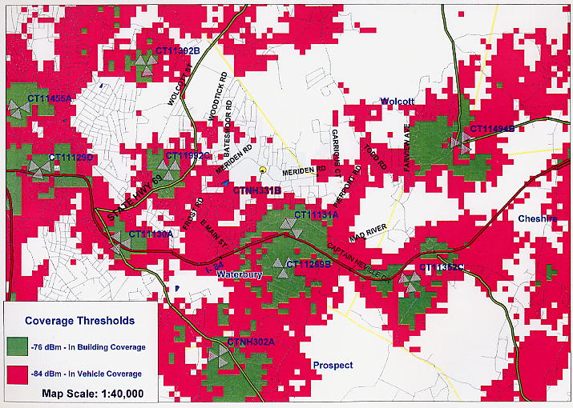
(Cellco 1, Exhibit F)

T-Mobile coverage from proposed site
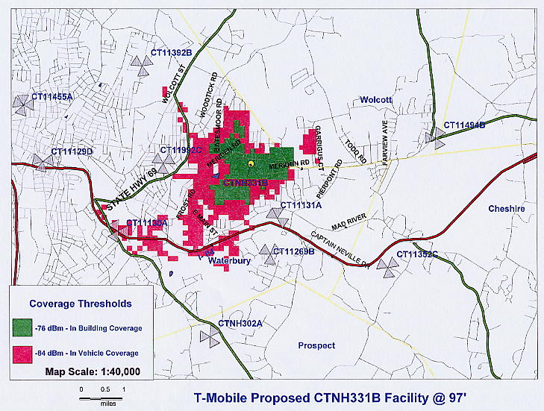
(Cellco 2, Exhibit 3)

T-Mobile coverage, existing and proposed
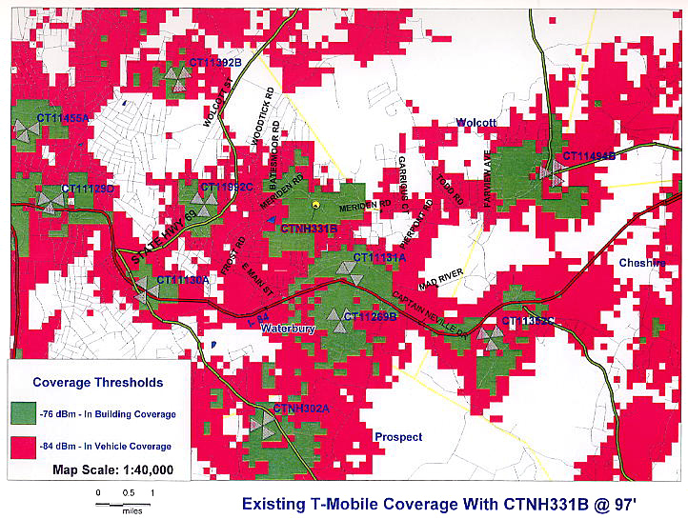
(Optasite 1, Exhibit F)

Nextel capacity analysis
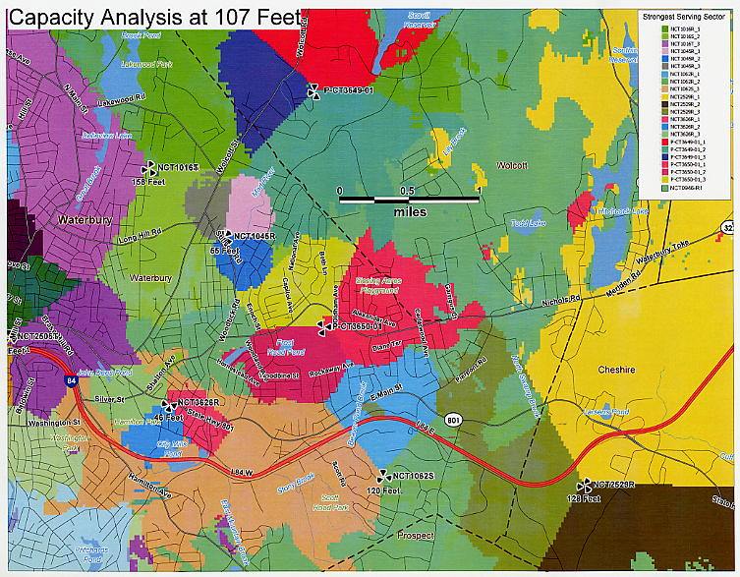
(Nextel 2)

Visibility Map
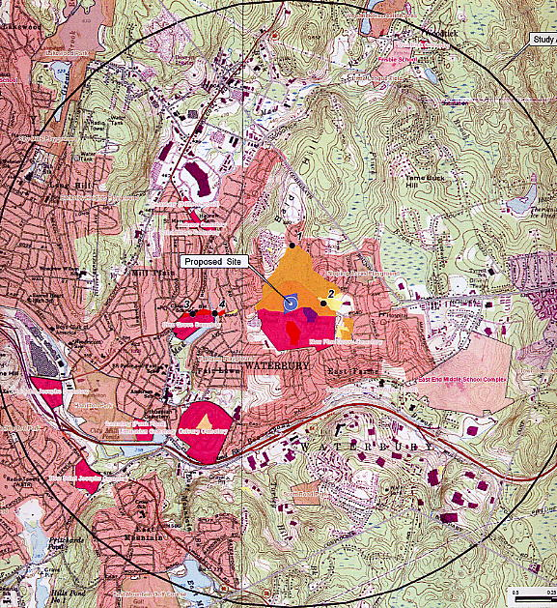
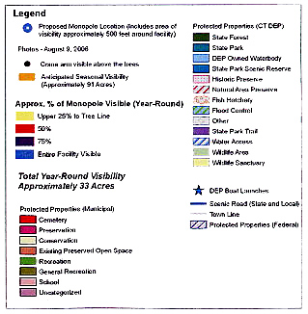
(Optasite 1, Exhibit K)

