DOCKET NO. 318 – Cellco Partnership d/b/a Verizon Wireless application for a Certificate of Environmental Compatibility and Public Need for the construction, maintenance and operation of a telecommunications facility at 1191 Terryville Avenue in Bristol, Connecticut. | }  }  } | Connecticut  Siting  Council  January 18, 2007

Findings of Fact

Introduction

- Pursuant to Chapter 277a, §16-50g et seq. of the Connecticut General Statutes (CGS), as amended, and Section 16-50j-1 et seq. seq. of the Regulations of Connecticut State Agencies (RCSA), Cellco Partnership d/b/a Verizon Wireless (Cellco) applied to the Connecticut Siting Council (Council) on July 27, 2006 for the construction, operation, and maintenance of a telecommunications facility to be located at 1191 Terryville Avenue in the City of Bristol, Connecticut. (Cellco 1, p. 1)

- The proposed facility would provide coverage along Routes 6 and 72, as well as local roads, in the westerly portion of Bristol and the easterly portion of Plymouth. (Cellco 1, p. i)

- Cellco is a Delaware Partnership with an administrative office located at 99 East River Drive, East Hartford, Connecticut. Cellco is licensed by the FCC to operate a wireless telecommunications system in Connecticut. The operation of wireless telecommunications systems and related activities are Cellco’s sole business in Connecticut. (Cellco 1, p. 3)

- The party in this proceeding is the applicant. (Transcript, October 19, 2006, 3:00 p.m. [Tr. 1], p. 4)

- Pursuant to CGS § 16-50m, the Council, after giving due notice thereof, held a public hearing October 19, 2006, beginning at 3:00 p.m. and continuing at 7:00 p.m. in Bristol, Connecticut. (Tr. 1, p. 2 ff.)

- The Council and its staff conducted an inspection of the proposed site on October 19, 2006, beginning at 2:00 p.m. The applicant flew a balloon beginning at 12:30 p.m. at the proposed site to simulate the height of the proposed tower. Weather conditions were overcast and slightly breezy, but they did allow for an accurate assessment of the proposed tower’s visibility. (Tr. 1, p. 15)

- Pursuant to CGS § 16-50l(b), notice of Cellco’s intent to submit this application was published on July 24 and 25, 2006 in The Bristol Press. (Cellco 1, p. 4)

- In accordance with CGS § 16-50l(b), Cellco sent notices of its intent to file an application with the Council to each person appearing of record as owner of property abutting the property on which the site is located. (Cellco 1, p. 5; Attachment 5)

- There are 22 abutting properties owned by 16 different individuals or entities. Of the 16 notices sent to abutting property owners, Cellco did not receive return receipts from three owners. Cellco confirmed the addresses of these owners and resent its notice via regular mail. (Cellco 4, Response 7)

- Pursuant to CGS § 16-50l(b), Cellco sent copies of its application to the following municipal, regional, state, and federal agencies and officials: Connecticut Attorney General, Department of Environmental Protection, Department of Public Health, Council on Environmental Quality, Department of Public Utility Control, Office of Policy and Management, Department of Economic and Community Development, Department of Transportation, Division Director/Deputy State Historic Preservation Officer, Central Connecticut Regional Planning Agency, Thomas Colapietro — State Senator from the 31st Senatorial District, William Hamzy — State Representative from the 78th Assembly District, Federal Aviation Administration, Federal Communications Commission, William Stortz — City of Bristol Mayor, Therese Pac — Bristol City Clerk, William Veits — Bristol City Planning Commission Chairman, Frank Johnson — Bristol City Zoning Commission Chairman, Jerald Raffaniello — Bristol Zoning Board of Appeals Chairman, Guy Morin — Bristol Zoning Enforcement Officer, William Englert — Bristol Inland Wetlands Commission Chairman, Jan Krampitz — Town of Plymouth Mayor, Barbara Rockwell — Plymouth Town Clerk, Patrick Herzing — Plymouth Planning and Zoning Commission Chairman, Martin Sandshaw — Plymouth Zoning Board of Appeals Chairman, Ronald Mormile — Plymouth Zoning/Wetlands Enforcement Officer, and Matthew Tellier — Plymouth Inland Wetlands Conservation Commission Chairman. (Cellco 1, p. 4; Attachment 3)

State Agency Comments

- Pursuant to CGS § 16-50l, the Council solicited comments on Cellco’s application from the following state departments and agencies: Department of Environmental Protection, Department of Public Health, Council on Environmental Quality, Department of Public Utility Control, Office of Policy and Management, Department of Economic and Community Development, and the Department of Transportation. Council letters requesting comments were sent on September 8 and October 20, 2006. (CSC Hearing Package dated September 8, 2006; SACADTLdo318 dated October 20, 2006)

- The Connecticut Department of Transportation (ConnDOT) responded to the Council’s solicitation with no comments. (ConnDOT letter dated October 2, 2006)

- No comments were received from the Department of Environmental Protection, Department of Public Health, Council on Environmental Quality, Department of Public Utility Control, Office of Policy and Management, and the Department of Economic and Community Development. (Record)

Municipal Consultation

- On May 26, 2006, Cellco representatives met with Bristol’s Mayor William Stortz to discuss its proposed facility. Mayor Stortz received a technical report about the facility. (Cellco 1, p. 16)

- Because the site of Cellco’s proposed facility is within 2,500 feet of the Plymouth municipal boundary, Cellco representatives met with Plymouth town planner, William Kuehn, as the designee for Mayor Jan Krampitz. Cellco provided Plymouth officials with a copy of the technical report about this facility. (Cellco 1, p. 16; Cellco 4, Response 2)

- Cellco asked both Bristol and Plymouth if they had any interest in placing antennas at the proposed site. Neither municipality expressed such an interest. (Tr. 1, p. 48-49)

Public Need for Service

- The federal Telecommunications Act of 1996 (Act) recognized a nationwide public need for high-quality wireless telecommunication services. The Act also promoted competition among wireless service providers, tried to foster lower prices for consumers, and encouraged the rapid deployment of new telecommunications technologies. (Cellco 1, p. 5)

- The Telecommunications Act of 1996 prohibits local and state bodies from discriminating among providers of functionally equivalent services. (Council Administrative Notice, Telecommunications Act of 1996)

- The Telecommunications Act of 1996, a federal law passed by the United States Congress, prohibits any state or local entity from regulating telecommunications towers on the basis of the environmental effects of radio frequency emissions to the extent that such towers and equipment comply with FCC’s regulations concerning such emissions. This Act also blocks the Council from prohibiting or acting with the effect of prohibiting the provision of personal wireless service. (Council Administrative Notice Item No. 7)

- Cellco’s antennas at this site would comply with E911 requirements. (Cellco 4, Response 5)

Site Selection

- Cellco’s search ring for this facility was issued in February, 2003. The ring is approximately one-half mile in diameter and was centered around the Pequabuck Golf Club property. (Cellco 4, Response 20)

- Cellco maintains six wireless facilities within a four mile radius of the proposed site. None of these existing facilities, however, can provide adequate coverage for Cellco’s identified problem areas. These six facilities are listed below.

a. Carpenter Realty
32 Valley Street, Bristol
rooftop facility, 88’ antenna height

b. Graziano Partners
192 Wolcott Road, Wolcott
lattice tower, 135’ antenna height

c. SBA, Inc.
297 North Adams Street, Plymouth
monopole, 165’ antenna height

d. SBA, Inc.
42 South Street, Plymouth
monopole, 169’ antenna height

e. Omnipoint
171 Town Hill Road, Plymouth
monopole, 135’ antenna height

f. Cingular
371 Terryville Avenue, Bristol
monopole, 140’ antenna height

(Cellco 1, Attachment 9)

- Cellco investigated three other sites in western Bristol. These sites and the reasons they were rejected are listed below.

a. CL&P Transmission Line Towers – Cellco investigated the use of several transmission line structures in the area. The structures that were studied in detail were located at the southern end of Clark Road, south of Terryville Road (Route 72) on Waterbury Road, and west of the intersection of Waterbury Road and Tower Road. Antennas on any of these structures would have left significant coverage gaps along Routes 6 and 72.

b. Town of Plymouth Town Hall – There is an existing 100-foot tower at the town hall. Cellco considered extending this tower to 120 feet, but even at this height its antennas would have left significant coverage gaps in the target area.

c. City of Bristol Water Department – A tower at Bristol’s Water Reservoir No. 1 property would have provided satisfactory coverage, but a taller tower than the one proposed would be required due to differences in ground elevation.

(Cellco 1, Attachment 9)

- Repeaters, microcells, or distributed antenna system technology would not be practical or feasible for providing coverage to the area Cellco seeks to serve from the proposed site. (Cellco 4, Response 14)

Site Description

- The proposed facility would be located on the 65 acre Pequabuck Golf Club at 1191 Terryville Road in Bristol between Routes 6, to the north, and 72, to the south. (Cellco 1, p. i; Attachment 1)

- The property on which the golf club is located is zoned R-40 Residential. The Bristol zoning regulations do not regulate wireless telecommunications facilities like that proposed by Cellco. (Cellco 1, p. 15; Cellco 4, Response 3)

- At this location, Cellco would construct a 120-foot telecommunications tower designed as a flagpole. Cellco would install six internally-mounted panel-type antennas on the tower—three PCS antennas at the 117-foot level of the tower and three cellular antennas at the 107-foot level. (Cellco 1, p. i)

- Cellco chose a flagpole design for its tower at the request of the landowner, the Pequabuck Golf Club. (Tr. 1, p. 30)

- Cellco’s flagpole tower would be designed to have four positions available at which antennas could be installed. It would be possible to design a flagpole that could accommodate a fifth position for antennas if needed. (Tr. 1, p. 28)

- Cellco would fly a flag from its flagpole tower. (Cellco 4, Response 30)

- Cellco would lease a 55-foot by 70-foot area within which it would fence in a 55-foot by 49-foot compound that would include a 12-foot by 30-foot equipment shelter. The compound would be located adjacent to an existing golf course maintenance building. (Cellco 1, Attachment 1)

- Cellco’s tower would be located at 41º 40’ 27.4” North latitude and 72º 59’ 17.1” West longitude. The ground elevation at its base would be approximately 638 feet AMSL. (Cellco 1, Attachment 1)

- Cellco’s tower would be designed in accordance with the specifications of the Electronic Industries Association Standard EIA/TIA-222-F-96 “Structural Standards for Steel Antenna Towers and Antenna Support Structures.” (Cellco 1, Attachment 1, p. 6; Cellco 4, Response 19)

- Cellco’s equipment compound would be enclosed with an eight-foot chain link fence topped with barbed wire. (Cellco 4, Response 18 and Tab 2)

- Cellco would plant pine trees of similar nature to existing trees in the area along the southerly fence line of its equipment compound. (Cellco 1, Attachment 1, Drawing C-2)

- Vehicular access to Cellco’s facility would be over an existing 1,100-foot paved driveway that extends from South Street to the proposed site. (Cellco 1, p. 2)

- Cellco would tap into existing utility service from a manhole located between the golf course maintenance buildings. (Cellco 4, Response 22)

- Cellco would have a propane-fueled generator within its equipment building for use during power outages and maintenance activities. A propane tank would be located in the southeasterly portion of the enclosed compound. (Cellco 1, p. 2)

- Cellco does not anticipate blasting would be required to develop this site. (Cellco 4, Response 25)

- The proposed tower’s setback radius would be contained within the golf course property. (Cellco 1, Attachment 1, Drawing C-1A)

- The nearest residence is 900 feet to the northwest from the proposed tower site. It is owned by Jeffery Stone. (Cellco 1, Attachment 1, Drawing C-1A)

- There are two residences within 1,000 feet of the proposed tower’s location. (Cellco 1, p. 12)

- Land use in the vicinity of the proposed site is generally residential with some industrial use. The area to the northwest of the golf course is primarily residential. There is some industrial development to the west of the golf course. There is a public water supply reservoir due north of the site. (Cellco 1, p. 15; Attachment 1, p. 2)

- The estimated construction cost for this facility is $670,000. The cost estimate includes:

Cell site radio equipment $450,000
Tower, coax, and antenna costs 125,000
Power system costs 20,000
Equipment building costs 60,000
Miscellaneous costs 15,000
Total $670,000

(Cellco 1, p. 18)

Environmental Considerations

- The proposed project should have no effect on historic, architectural, or archaeological resources listed on or eligible for the National Register of Historic Places. (Cellco 1, Attachment 11, letter from State Historic Preservation Officer dated May 2, 2006)

- No federally listed or proposed, threatened or endangered species or critical habitat under the jurisdiction of the U.S. Fish and Wildlife Service are known to occur in the project area. (Cellco 1, Attachment 1, letter from Fish and Wildlife Service dated May 11, 2006)

- Cellco reviewed information in the Connecticut Department of Environmental Protection’s (DEP) Natural Diversity Data Base to determine if any state endangered, threatened or special concern species are present in the vicinity of the proposed facility. Based on DEP’s criteria, Cellco’s facility would not impact any known occurrence of listed species or significant natural communities. (Cellco 4, Response 23)

- The closest wetland/watercourse area to the proposed site is associated with the Bristol Reservoir approximately 460 feet to the north. (Cellco 1, p. 15)

- Three existing trees would have to be removed to develop the proposed facility. (Cellco 4, Response 16)

- Developing this site would require 20 cubic yards of cut and 225 cubic yards of fill. (Cellco 4, Response 17)

- Cellco’s back-up generator would require an air permit from the Department of Environmental Protection. (Cellco 1, p. 17)

- During site construction, Cellco would establish soil erosion and sedimentation control measures in accordance with the Connecticut Soil Erosion Control Guidelines, as established by the Council for Soil and Water Conservation. Cellco would also employ construction management practices to avoid the discharge of pollutants to the nearest watercourses or wetland areas. (Cellco 1, p. 16)

- The proposed site would not constitute an obstruction or hazard to air navigation based on FAA standards. No marking or lighting would be required. (Cellco 1, p. 17; Attachment 12)

- According to calculations performed by Cellco, the maximum power density from the radio frequency emissions of Cellco’s proposed antennas would be 11.13% of the standard for Maximum Permissible Exposure, as adopted by the FCC, at the base of the proposed tower. This calculation was based on a methodology prescribed by the FCC Office of Engineering and Technology Bulletin No. 65E, Edition 97-01 (August 1997) that assumes all antennas would be pointed at the base of the tower and all channels would be operating simultaneously. (Cellco 1, p. 14)

Visibility

- The proposed tower would be visible year-round from approximately 69 acres within the surrounding vicinity. Of this total, the top of the tower would be visible from approximately 14 acres; the upper 25% of the tower would be visible from 25 acres; the upper 50% of the tower would be visible from 19 acres; 75% of the tower would be visible from 2 acres; and the entire tower would be visible from 9 acres. (Cellco 1, Attachment 10, Viewshed Map)

- Of the 69 acres estimated to have year-round views of the proposed tower, 18 acres are on the Pequabuck Golf Course property, 16 acres are open water of the Bristol Reservoir No. 1, four acres are on watershed/water company property, and 14 acres are on a gravel pit property located approximately 3,000 feet east of the proposed facility. (Cellco 1, p. 12; Cellco 4, Response 29)

- The tower would be visible on a seasonal basis from another 43 acres. (Cellco 1, Attachment 10, Viewshed Map)

- Approximately 12 residences would have year-round views of the proposed tower, and six residences would have seasonal views. (Cellco 4, Response 27)

- The visibility of the proposed site from different vantage points in the surrounding vicinity is summarized in the following table. The locations of the vantage points listed are identified by their corresponding number in the Visual Resource Evaluation Report contained in Attachment 10 of Cellco’s application.

Location | Visible  Site | Approx. Portion of (120’) Tower Visible (ft.) | Approx. Distance and Direction to Tower  Site
1 – Route 6 at Bristol Reservoir No. 1 | Yes | 10 | 2220 feet; S
2 – #40 Makara Street | Yes | 5 | 1700 feet; SE
3 – William Street at Kearney Street | Yes | 10 | 1900 feet; SE
4 – Route 72, west of site | Yes | 10 | 1900 feet; E
5 – Tower Road at Waterbury Road | Yes | 10 | 3000 feet; NW
6 – 503 Waterbury Road | Yes | 10 | 2430 feet; N
7 – 44 Kearney Street | Yes | 10 | 2270 feet; SE
(Cellco 1, Attachment 10)

- Based upon a balloon test that was conducted at the request of the City of Bristol, the main areas from which the proposed tower would be visible would be from Route 6 where it crosses the Bristol reservoir near the Bristol/Terryville town line and from Waterbury Road, which parallels Route 72 to the south of the Pequabuck River. Waterbury Road is considerably higher than Route 72, and there are several vantage points along this road from which the proposed tower would likely be visible. (Tr. 1, pp. 6-7)

- Bristol’s City Planner concluded from the balloon test that the proposed tower would be relatively unobtrusive compared to other towers in Bristol. (Tr. 1, p. 8)

Existing and Proposed Wireless Coverage

- Cellco is licensed to operate on cellular frequencies (869-880, 890-891.5 MHz) and PCS F Block frequencies (1970-1975 MHz). (Cellco 4, Response 5)

- At this location, Cellco would install PCS antennas at the 117 foot height and cellular antennas at the 107 foot height. (Tr. 1, p. 14)

- Most of Cellco’s new phones are tri-mode phones that work at analog 800, digital 800, as well as digital PCS frequencies. (Tr. 1, p. 16)

- Cellco designs its system for a signal strength of -85 dBm. (Cellco 4, Response 11)

- Cellco’s existing signal strength in the area that would be served by the proposed facility is below its -85 dBm threshold. (Cellco 4, Response 12)

- Cellco experiences coverage gaps of approximately 1.2 miles on Route 6 and 2.1 miles on Route 72, as well as gaps along local roads in western areas of Bristol and eastern areas of Plymouth. (Cellco 1, pp. 2,7)

- Antennas at the proposed site would hand off signals to adjacent sites located at 171 Town Hill in Plymouth, 32 Valley Street in Bristol, and 371 Terryville Avenue in Bristol. (Tr. 1, p. 29)

- At their proposed heights, Cellco’s PCS antennas would cover an additional 1.1 miles on Route 6 and 3.2 miles on Route 72. Its cellular antennas would cover an additional 0.5 miles on Route 6 and 0.8 miles on Route 72. If antenna heights were lowered ten feet, Cellco’s cellular coverage on Route 6 would remain reliable, but there would be a 0.1 mile coverage gap in PCS frequencies. Coverage on Route 72 would remain reliable for both PCS and cellular frequencies. (Cellco 4, Response 10; Tr. 1, p. 44 ff.)

- At the proposed heights of 117 feet and 107 feet respectively, Cellco’s PCS antennas would cover an area of approximately 4.95 square miles, and its cellular antennas would cover an area of approximately 6.5 square miles. If the antennas were to be installed ten feet lower, the PCS antennas would cover 3.8 square miles, and the cellular antennas would cover 6.1 square miles. (Cellco 4, Response 9)

- The proposed antenna heights are the lowest heights at which Cellco could achieve its coverage objectives at this location. (Cellco 4, Response 24)

Proposed Site Location Map
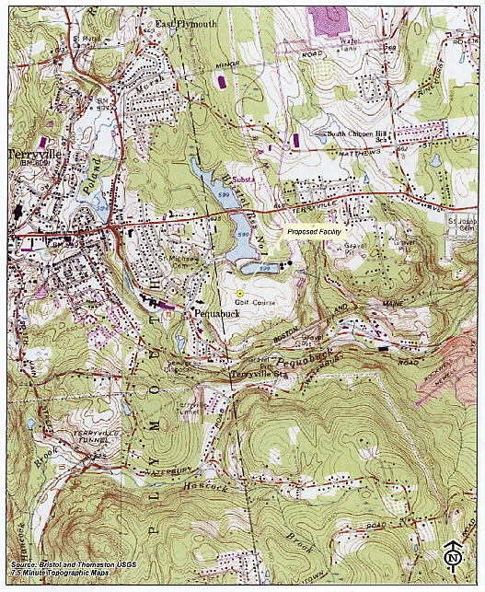
(Cellco 1, Attachment 1, p. 2)

Cellco Existing Coverage (without facility)
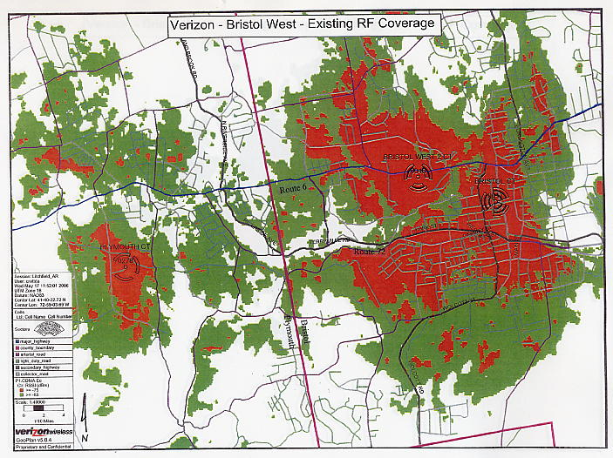
(Cellco 1, Attachment 7)

Coverage with proposed site at 120 feet
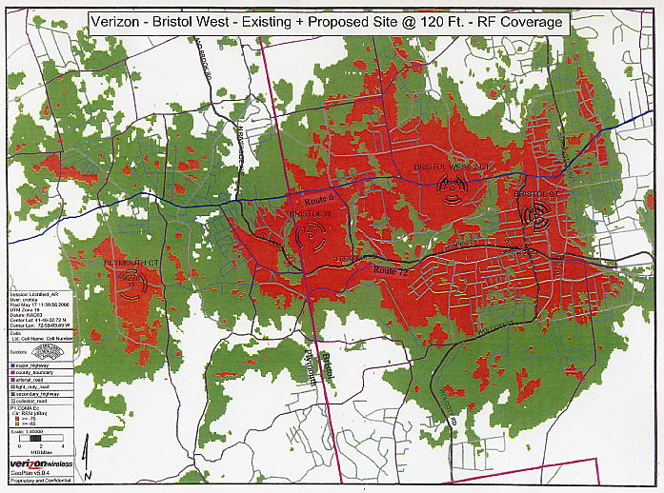
(Cellco 1, Attachment 7)

Visibility Map
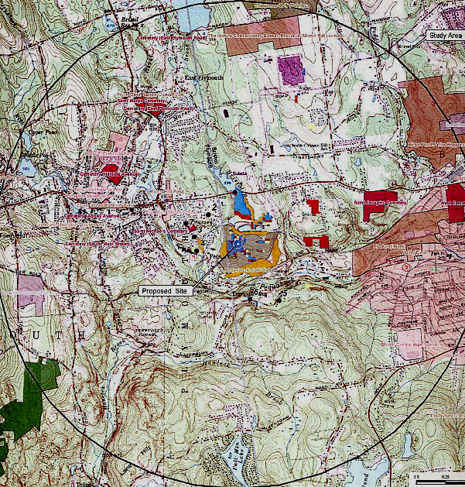
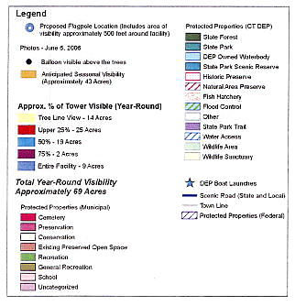
(Cellco 1, Attachment 10)

