DOCKET NO. 307 – National Grid Communications, Inc. d/b/a Gridcom application for a Certificate of Environmental Compatibility and Pubic Need for the construction, operation, and maintenance of a telecommunications facility located at one of two sites at 71 Pleasant View Road, Derby, Connecticut. | }  }  } | Connecticut  Siting  Council  April 27, 2006

Findings of Fact

Introduction

- National Grid Communications, Inc. d/b/a Gridcom, in accordance with provisions of General Statutes §§ 16-50g through 16-50aa, applied to the Connecticut Siting Council (Council) on June 30, 2005 for the construction, operation, and maintenance of a wireless telecommunications facility located at one of two sites at 71 Pleasant View Road, Derby, Connecticut. (Gridcom 1, pp. 1, 9; T-Mobile 4)

- Gridcom is the telecommunications infrastructure subsidiary of National Grid USA, which includes the following utility networks: Niagara Mohawk Power, Massachusetts Electric, Nantucket Electric, Narragansett Electric, and Granite State Electric. (Gridcom 1, Tab 1 Q. 3)

- Omnipoint Holdings, Inc. (T-Mobile) is a Federal Communications Commission (FCC) licensed carrier that has entered into a lease agreement with Gridcom to lease space on the proposed structure in Derby. (Gridcom 1, p. 5)

- The parties in this proceeding are the applicant, City of Derby, and the Pleasant View Hilltop Committee. The intervenor in this proceeding is Omnipoint Communications Inc. d/b/a T-Mobile. (Transcript 1, September 26, 2005 - 3:30 p.m. [Tr. 1], pp. 5 and 6)

- The purpose of the proposed facility is to provide service to coverage gaps identified by T-Mobile along State Routes 34, 115, and 243 and adjoining municipal roads in Derby, and extending coverage south and west toward State Routes 8 and 110 in Shelton, and south and east to State Route 121 in Orange. (Gridcom 1, Tab 1, Q. 5; Tab 9 Attachment B; Gridcom 8; Council Administrative Notice No. 10. Connecticut Official State Tourism Map, 2004-05 and No. 11 Mail-A-Map Street Map (Ansonia/Derby) 2003)

- Pursuant to General Statutes § 16-50m, the Council, after giving due notice thereof in the Hartford Courant and The Valley Gazette, held a public hearing on September 26, 2005, beginning at 3:30 p.m. and continuing at 7:00 p.m. at the Hotchkiss Hose Fire House, 200 David Humphreys Road, Derby. The Council continued the hearing on January 17, 2006 beginning at 3:00 p.m. and continuing at 7:00 p.m. at the Derby High School Auditorium, 8 Nutmeg Avenue, Derby, Connecticut. The January 17, 2006 hearing notice was published in the Connecticut Post, New Haven Register and The Valley Gazette. (Council's Hearing Notice dated July 28, and December 5, 2005; Tr. 1, p.3; Transcript September 26, 2005 – 7:00 p.m. [Tr. 2], p. 3; Transcript January 17, 2006 – 3:00 p.m. (Tr.3) p. 3; Transcript January 17, 2006 – 7:00 p.m. (Tr.4) p.3)

- The Council and its staff conducted an inspection of the proposed sites on September 26, 2005, beginning at 2:30 p.m. During the field inspection, the applicant attempted to fly a balloon at site A (next to St. Jude Church), at site B (next to driveway extending from Sentinel Hill Road on St. Jude Church property), and at the Bradley School (located north of the St. Jude church) to simulate the heights of the proposed towers. Strong winds prevented balloons from attaining the intended heights. The Council did not conduct a public field inspection on January 17, 2006; however, Gridcom did fly balloons at site A and site B. (Council's Hearing Notice dated July 28, 2006; Tr. 1, pp. 75, and 76; Tr. 2, p. 7; Tr. 3 pp. 26 and 31)

- Notice of the application was provided to all abutting property owners by certified mail. Gridcom’s notice of intent to file an application with the Council was published in The Hartford Courant on June 28 and 29, 2005, and in the Norwich Bulletin on June 28, 2005. (Gridcom 1, p. 4, Tabs 2 and 3; Gridcom 3, Q. 1)

- Gridcom incorrectly printed a notice of intent to file an application with the Council in the Norwich Bulletin which is not a publication that substantially serves to inform citizens within the City of Derby. At the conclusion of the September 26, 2005 evening hearing the Council ordered parties and intevernors to brief the Council on the issue of whether there was sufficient public notice and whether this constituted dismissal of the application. (Tr. 1, p. 19; Tr. 2, pp. 31-33)

- On November 3, 2005, the Council ruled that Gridcom’s newspaper notice did not constitute dismissal of the application and accepted the latest newspaper notice in publications that substantially serve the municipality. Therefore Gridcom initiated a notice of intent to file an application with the Council in the Valley Gazette on October 5, and 12, 2005 and The New Haven Register on October 3, and 5, 2005. (Gridcom 6, Q. 24; Tr. 3, p. 4)

- Pursuant to General Statutes § 16-50l(e) Gridcom provided a technical report of the proposal to Marc Garafalo, Mayor of Derby on March 31, 2005. (Gridcom 1, p. 2, Tab 1, Q. 6, and Tab13)

- Gridcom would provide space on the tower at no cost for municipal public safety entities. (Gridcom 1, p. 17)

- Pursuant to General Statutes § 16-50j (h), on July 28, 2005 and January 18, 2006, the following State agencies were solicited to submit written comments regarding the proposed facility: Department of Environmental Protection (DEP), Department of Public Health (DPH), Council on Environmental Quality (CEQ), Department of Public Utility Control (DPUC), Office of Policy and Management (OPM), Department of Economic and Community Development (DECD), and the Department of Transportation (DOT). (Record)

- Comments were received from the DOT on August 29, 2005. DOT has no comment on this application. (Record)

- The following agencies did not respond with comments on the application: DOT, DPH, CEQ, DPUC, OPM, and the DECD. (Record)

- New Cingular Wireless PCS LLC submitted a letter to Gridcom stating an interest to co-locate its operations on the proposed site. No schedule or details were provided. (Gridcom 3, Q. 12; Tr. p. 72)

- The City of Derby, previously under Mayor Garofalo and the present administration under Mayor Staffieri, do not want a tower located at the St. Jude Church property within a residential neighborhood. The City of Derby under Mayor Staffeiri has suggested and supports a two-tower solution with one tower at Witek Park and another tower at a location along Route 34 proximate to the gap in T-Mobile’s coverage. (Derby 1, 2, and 3; Gridcom 4; Tr. 2, p. 13; Tr. 3, pp. 29, 30, and 46)

Telecommunications Act

- In 1996, the United States Congress recognized a nationwide need for high quality wireless telecommunications services, including cellular telephone service. Through the Federal Telecommunications Act of 1996, Congress seeks to promote competition, encourage technical innovations, and foster lower prices for telecommunications services. (Gridcom 1, p. 5; Council Administrative Notice Item No. 7)

- In issuing cellular licenses, the Federal government has preempted the determination of public need for cellular service by the states, and has established design standards to ensure technical integrity and nationwide compatibility among all systems. T-Mobile is licensed by the FCC to provide personal wireless communication service (PCS) to New Haven County, Connecticut. (Council Administrative Notice Item No. 7; T-Mobile 1, p. 3)

- The Telecommunications Act of 1996 prohibits local and state entities from discriminating among providers of functionally equivalent services. (Council Administrative Notice Item No. 7)

- The Telecommunications Act of 1996, a Federal law passed by the United States Congress, prohibits any state or local entity from regulating telecommunications towers on the basis of the environmental effects of radio frequency emissions to the extent that such towers and equipment comply with FCC’s regulations concerning such emissions. This Act also blocks the Council from prohibiting or acting with the effect of prohibiting the provision of personal wireless service. (Council Administrative Notice Item No. 7)

Site Selection

- T-Mobile initially began a search for a new facility in Derby in the summer of 2003. T-Mobile identified a need for wireless service along an approximate a two mile segment of Route 34 from the Route 8 corridor east to the Orange town line and areas of east Derby (referred to as a “target area”). (Gridcom 1, pp.5-6; Tab 1 Q. 5)

- Before a new tower is considered T-Mobile investigates the feasibility of using existing structures. Eighteen existing towers within a four mile radius of the “target area” were analyzed and determined not feasible. Also no other buildings or structures with sufficient height in or near the “target area” were identified. (Gridcom 1, pp. 6-7; Tab 5; Tr. 1, p. 48; Tr. 3, pp. 33-34)

- On February 16, 2004, Tower Ventures proposed to the City of Derby a replacement of an existing guyed-lattice tower at the Hotchkiss Hose Fire Company with a monopole tower sufficient to support municipal antennae and four FCC-licensed wireless carriers. Tower Ventures did not receive a written response to its letter. (Gridcom 3, Q. 4;Tr. 1, p. 50)

- A Memorandum of License between T-Mobile and St. Jude Roman Catholic Church was completed on March 26, 2004 for a parcel of property to develop a wireless telecommunications facility. (Gridcom 3, Q. 2; Tr. 1, pp. 26-27)

- On June 21, 2004 T-Mobile transferred assignment and assumption of license to Tower Ventures II, LLC. (Gridcom 3, Q. 2; Tr. 1, pp. 26-27)

- After acquisition of Tower Ventures, Gridcom proposed a replacement of the existing guyed-lattice tower at the Hotchkiss Hose Fire Company with a monopole tower sufficient to support municipal antennae and four FCC-licensed wireless carriers in a letter dated November 2, 2004. Gridcom did not receive a written response to its letter. (Gridcom 3, Q. 4;Tr. 1, pp. 50 and 78)

- On February 24, 2005, Tower Ventures II, LLC transferred assignment and assumption of license to Gridcom. (Gridcom 3, Q. 2; Tr. 1, pp. 26-27)

- Subsequent to Gridcom filing an application with the Council, the City of Derby through Mayor Garofalo, suggested use of the Bradley School site. Consequently, the City of Derby and Gridcom met on August 16, 2005 to discuss an alternative city-owned site (Bradley School in place of the Hotchkiss Hose Fire Company site). Gridcom provided a draft lease to the City of Derby in a “good faith effort” to establish an alternate site prior to the Council’s September 26, 2005 hearing. Gridcom did not receive a written response to the draft lease agreement. (Gridcom 4; Tr, 2, pp. 13 and 37; Tr. 3, p. 29, 30, and 46)

- T-Mobile investigated and rejected the following sites:

- Hotchkiss Hose Fire Company, 200 David Humphrey Road, radio frequency approved but would require the rebuild an existing guyed-lattice tower with a 150-foot monopole. The City of Derby declined to lease said parcel.
- Bradley School, David Humphrey Road, radio frequency approved but would require construction of a new 160-foot tower at the rear of school. The City of Derby declined to lease said parcel.
- Ansonia Reservoir, Academy Hill Road, raw land, radio frequency rejected due to topography.
- Super K, Orange-Derby Shopping Plaza, Route 34, raw land, radio frequency rejected due to topography.
- Dodge Dealership, Route 34, raw land, radio frequency rejected due to topography.
- Mobile gas station Route 34, raw land, radio frequency rejected due to topography and environmental concerns.
- Valentine property, Coon Hollow Road, west Derby, radio frequency rejected as site is not in the “target area”.
- Deerfield Meat Packing, Route 34, east Derby, radio frequency rejected as site is not in the “target area”.
- St. Peter’s Cemetery Chapel Street and Route 34, east Derby, radio frequency rejected due to topography.
- Orange Cemetery, Derby-Milford Road, Orange, radio frequency rejected as site is not in the “target area”.
- Witek Park, David Humphrey Road, Derby, radio frequency rejected due to topography.

(Gridcom 1, Tab 5; Gridcom 8; Tr. 1, p. 49; Tr. 3, p. 70)

- Gridcom has proposed two sites (Site A located approximately 130 feet south of the church) and Site B located approximately 680 feet west of the church and approximately 400 feet east of Sentinel Hill Road) on an approximately 16.6-acre parcel owned by the St. Jude’s Roman Catholic Church at 71 Pleasant View Road, Derby. The parcel contains a church and rectory and associated parking areas. The parcel is south of Pleasant View Road and east of Sentinel Hill Road and is zoned Public, Semi-Public (P). The site location is depicted on Figure 1. (Gridcom 1, p. 7 and Tab 6, Tab 7, and Tab 8 sheet C-2)

Site Description – Site A

- Site A would comprise a 130-foot monopole centered within a 75-foot by 75-foot lease area in the southeast portion of the property. The site consists of a grassy area bordered by wooded vegetation. The tower location is at an elevation of 366 feet above mean sea level (amsl). (Gridcom 1,Tab 6)

- The tower would be designed to accommodate four carriers with antenna centerline elevations of 127, 117, 107, and 97 feet. The tower would be constructed in accordance with the American National Standards Institute TIA/EIA-222-F “Structural Standards for Steel Antenna Towers and Antenna Support Structures”. (Gridcom 1, pp. 7-8, Tab 6)

- T-Mobile would install three panel antennas flush-mounted at a centerline height of 127 feet above ground level (agl). The total height of the facility with antennas would be 130 feet agl. (Gridcom 1 ,p. 7 and Tab 6)

- Gridcom would install a 10-foot by 15-foot concrete pad for equipment cabinets within the compound. The compound would be enclosed by a six-foot high chain link security fence. Evergreen plantings are proposed on the west and east sides of the access drive approaching the compound. (Gridcom 1 Tab 6 and 8)

- T-Mobile would construct a new 12-foot wide, 65-foot long gravel access road extending from an existing parking lot to the site. Underground utilities would extend from a new utility pole set adjacent to the access drive behind the church. (Gridcom 1, Tab 6 and 8)

- The nearest property boundary is approximately 140 feet south. The 130-foot tower setback radius does not encompass any buildings and would remain within the church property. (Gridcom 1, Tab 8)

- There are approximately 73 residential structures within 1,000 feet of the proposed Site A. The nearest building to the tower site is the church, located approximately 130 feet northwest of the tower. The nearest residence to the tower that is not on the site parcel is located approximately 251 feet to the southwest. (Gridcom 1 p. 12, and Tab 8)

- No emergency generator is proposed; however, T-mobile uses battery back-up power during times of power outages. (T-Mobile 1, Q. 9; Tr. 1, p. 65)

- The estimated construction cost for Site A without any wireless carrier’s equipment and antennas is:

Site preparations compound, and access $20,000
Tower and foundation $40,000
Utilities $15,000
Miscellaneous (testing/permits) $20,000

Total estimated cost $95,000.

(Gridcom 1, p. 18)

- Gridcom has developed an alternative tower designed as a bell tower. Gridcom has discussed this alternative with both the property owner and T-Mobile with no objections expressed. (Gridcom 7; Tr. 1, pp. 84-85; Tr. 3, 34-36)

Site Description –Site B

- Site B would comprise of a 130-foot flag pole centered within a 75-foot by 75-foot lease area in the southwest portion of the property. The site consists of a grassy area. The tower location is at an elevation of 366 feet above mean sea level (amsl). (Gridcom 1 ,Tab 7)

- The tower would be designed to accommodate four carriers with antenna centerline elevations of 127, 117, 107, and 97 feet. The tower would be constructed in accordance with the American National Standards Institute TIA/EIA-222-F “Structural Standards for Steel Antenna Towers and Antenna Support Structures”. (Gridcom 1, pp. 7-8, Tab 7)

- T-Mobile would install three panel antennas interior-mounted at a centerline height of 127 feet above ground level (agl). The total height of the facility with antennas would be 130 feet agl. (Gridcom 1, p. 7 and Tab 7)

- Gridcom would install a 10-foot by 15-foot concrete pad for up to three equipment cabinets 6 feet high by 4 feet wide by 3 feet deep within the compound. The 75-foot by 75-foot compound would be enclosed by a six-foot high chain link security fence. Evergreen plantings are proposed on the northwest corner, and the north and east perimeters of the compound. (Gridcom 1 Tab 7 and 8; T-Mobile 1, Q. 8)

- T-Mobile would construct a new 12-foot wide by 40-foot long paved drive extending from an existing church driveway from Sentinel Hill Road. Underground utilities would extend from an existing utility pole in vicinity of the site. (Gridcom 1, Tab 6 and 8)

- The nearest property boundary to Site B is approximately 85 feet north from the tower base. (Gridcom 1, Tab 8)

- The 130-foot tower setback radius would cross the north property boundary approximately 45 feet. No buildings are within the tower radius but Gridcom could shift the tower 45 feet south to keep the tower setback radius on church property. (Gridcom 1, Tab 8; Tr.. 3, pp. 36-39)

- There are approximately 94 residential structures within 1,000 feet of the proposed Site B. The nearest building is a residence located approximately 210 feet north of the proposed tower. (Gridcom 1 p. 12, and Tab 8; Tr. 3, p. 30)

- No emergency generator is proposed; however, T-mobile uses battery back-up power during times of power outages. (T-Mobile 1, Q. 9; Tr. 1, p. 65)

- The estimated construction cost for Site B without any wireless carrier’s equipment and antennas is:

Site preparations compound, and access $10,000
Tower and foundation $65,000
Utilities $15,000
Miscellaneous (testing/permits) $20,000

Total estimated cost $110,000.

(Gridcom 1, p. 18)

Environmental Concerns

- Either facility would have no effect on historic, architectural, or archaeological resources listed on or eligible for the National Register of Historic Places or upon properties of traditional cultural importance to Connecticut’s Native American communities. (Gridcom 1, Tab 10)

- Either site contain no known existing populations of Federal or State Endangered, Threatened or Special Concern Species. (Gridcom 1, Tab 10)

- Development of Site B would not require the removal of any trees. The site is located in a cleared, grassy area. (Gridcom 1, Tab 7)

- Development of Site A would require the removal of two trees with a diameter of six inches or greater at breast height. (Tr. 1, p. 29)

- The nearest wetlands to Site A would be approximately 10 feet east of an existing paved drive that would serve as part of a longer access way to this site. Also, a wetland is located 50 feet east of Site A. (Gridcom 1, p. 10 and Tab 8)

- No wetlands or watercourses were identified in proximity to Site B. (Gridcom 1, p. 10 and Tab 8)

- Aircraft hazard obstruction marking or lighting of either tower would not be required. Towers exceeding heights of 200 feet typically require some form of lighting or marking. (Gridcom 1, Tab12; Tr. 4, p. 64)

- The 75-foot by 75-foot fenced compound could be reduced to 40-feet by 40-feet to minimize the size of the site and visual impact. (Tr. 3, p. 22)

- According to methodology prescribed by the FCC Office of Engineering and Technology Bulletin No. 65E, Edition 97-01 (August 1997), assuming all T-Mobile antennas would be pointed at the base of the tower and all channels would be operating simultaneously, the maximum power density at the base of either proposed tower would be 0.02262 mW/cm² or 2.262% of the standard for Maximum Permissible Exposure as adopted by the FCC. (Gridcom 1, Tab11)
Visibility

- Visibility of the proposed 130-foot tower at Site A from specific locations within a one and one-half-mile radius of the site is as follows:

Locations are Derby unless otherwise stated | Visible | Approximate Portion of Tower Visible | Distance from Tower
Sentinel Hill Road and Turner Avenue opposite church driveway | Yes | Top two-thirds of tower | 0.34 miles east
Pleasant View Road at entrance to St Jude Church | Yes | Top two-thirds of tower | 0.13 miles southeast
Pleasant View Road south of David Humphreys Road | Yes | Intermittent views of Top third of tower. | 0.26 miles southeast
Pleasant view Avenue at Prairier Avenue | No | Trees obstruct view | 0.19 miles southeast
Davis Humphreys Road at front of Bradley School | Yes | Top two-thirds visible ¼ mile east and west of this location | 0.27 miles south
Sunset Drive at house #94 | Yes | Top 10 feet | 0.56 miles west
Commodore Hull Drive | Yes | Top ten feet through trees leaves off | 0.15 miles northwest
General Wooster Drive at house #9 | Yes | Unobstructed views of top third of tower from two homes | 0.22 miles west
End of Lombardi Drive | Yes | Top half through trees with no leaves | 0.11 mile northeast
Lombardi Drive at house #14 | No | Not visible | 0.15 miles northwest
Grandview Avenue and Garfield Avenue | No | Not visible | 0.34 miles northeast
Sherwood Avenue | No | Not visible | 0.31 miles southeast
Route 34 West at Baldwin Road, Orange | Yes | Unobstructed views of the top of the tower | 1.21 miles northwest
Route 34 West at Orange-Derby Shopping Center | Yes | Top half | 0.50 miles northwest
Rainbow Trail at Willard Road | Yes | Top third | 0.64 miles north
Willard Road at house #1011 | Yes | Top half through trees with no leaves | 0.57 miles northwest
Route 110 north of Gordon Avenue, Shelton | Yes | Top third | 1.49 miles northeast
Ladas Place at house #46, Shelton | Yes | Limited views of top third | 1.19 miles northeast
Route 110 at house #120 | Yes | Top third | 1.02 miles northeast
End of Jenyfer Court, Shelton | Yes | Top third | 1.09 miles northeast
Route 110 north of Route 8 underpass, Shelton | Yes | Top half | 1.37 miles east
(Gridcom 1, Tab 9, Photo simulations; Tr. 1, p. 17)

- Visibility of the proposed 130-foot tower at Site B from specific locations within a one and one-half-mile radius of the site is as follows:

Location are Derby unless otherwise stated | Visible | Approximate Portion of Tower Visible | Distance from Tower
Sentinel Hill Road and Turner Avenue | Yes | Entire structure and compound | 375 feet east
Pleasant View Road at entrance to St Jude Church | Yes | Intermittent views of top half of tower | 0.13 miles southeast
Pleasant View Road south of David Humphreys Road | No | Trees obstruct view. | 0.49 miles south
Pleasant view Avenue at Prairier Avenue | Yes | Top half | 0.16 miles south
Davis Humphreys Road at front of Bradley School | Yes | 90 feet - unobstructed | 0.35 miles south
Sunset Drive at house #94 | No | Trees obstruct view | 0.69 miles south
Commodore Hull Drive at house #23 | No | Trees without leaves obstruct view | 0.26 miles west-northwest
General Wooster Drive at house #9 | No | Not visible | 0.45 miles west
End of Lombardi Drive | No | Not visible | 0.12 miles northwest
Lombardi Drive at house #14 | Yes | Top half | 0.05 miles north
Grandview Avenue and Garfield Avenue | Yes | Top ten feet | 0.18 miles northeast
Sherwood Avenue at house #13 | Yes | Top ten feet through trees with no leaves between tow homes | 0.31 miles south
Route 34 West at Baldwin Road, Orange | Yes | Unobstructed views of the top of the tower | 1.21 miles northwest
Route 34 West at Orange-Derby Shopping Center | Yes | Top half | 0.57 miles northwest
Rainbow Trail at Willard Road | Yes | Direct line of sight of top third | 0.61 miles north
Willard Road at house #1011 | Yes | Clear view of top half and other views through trees with no leaves | 0.56 miles northwest
Route 110 north of Gordon Avenue, Shelton | Yes | Top third with some views along a ½ mile segment and some obstructed by trees. | 1.49 miles northeast
Ladas Place at house #46, Shelton | No | Not visible | 1.06 miles northeast
Route 110 at house #120 | Yes | Top third | 0.92 miles northeast
End of Jenyfer Court, Shelton | Yes | Top third | 0.99 miles northeast
Route 110 north of Route 8 underpass, Shelton | Yes | Top half | 1.26 miles east
(Gridcom 1, Tab 9; Photo simulations)

- Approximately 70 residences would have year-round visibility of either Site A or B. An additional 40 residences would have views of either Site A or B during the winter when no leaves are on the trees. (Gridcom 1, Tab 9, p. 8)

- Site A and Site B would be visible above tree canopy comprising approximately 200 acres and 207 acres respectively. Leaf-off conditions would add an approximate 80 acres for either site. (Gridcom 1, Tab 9, p.8)

- Land use surrounding the proposed site is medium density residential parcels. Land use one-quarter mile west of the proposed site along Route 34 is commercial. (Gridcom 1, Tab 9, p.8)

T-Mobile - Existing and Proposed Wireless Coverage

- T-Mobile operates in the 1935-1945 MHz frequency bands. T-Mobile’s existing signal strength in vicinity of the proposed site ranges from -90dBm to -110dBm. The systems signal level of service is designed for -84dBm to provide reliable in-vehicle coverage and -76 dBm for reliable in-building coverage. (Gridcom 1, Tab 11; Gridcom 8; T-Mobile 1, Qs. 14 and 15)

- The following are existing T-Mobile sites that would hand-off to the proposed Derby facility:

T-Mobile Site and location | Structure type and height | Antenna height
CT11210B, Ansonia | church steeple, unknown | 69 feet
CT111208A, Derby | church steeple, 154 feet | 115 feet
CT11206A, Shelton | flagpole, 120 feet | 117.5 feet
CT11084B. Orange | Monopole, 160 feet | 125

Shifting antennas within the church steeples and flagpole is not possible to maximize coverage in Derby. (T-Mobile 1, Q. 23; Gridcom 1, Tab 11)

- T-Mobile proposes to fulfill a coverage need rather than capacity need. A threshold of two percent of dropped calls would trigger further analysis for resolving a capacity issue. The Orange site sectors A and B have a 2.12 and 3.35 percent dropped calls, respectively. (Gridcom 1, Tab 11; Tr. 3 pp. 85-86)

- Currently T-Mobile experiences a gap in coverage along Route 34 from the Route 8 corridor east to the Orange town line, an approximate a two mile area without wireless coverage, and areas of east Derby (refer to Figure 2). Route 8 has no gaps in coverage in the Derby area. (Gridcom 1, Tab 11; Tr. 3 pp. 83-86)

- T-Mobile initially modeled an antenna height of 130 feet. Coverage from Site A is slightly better than Site B. (Gridcom 1, Tab 11; Tr. 4, pp.69- 70)

- T-Mobile modeled an antenna centerline height of 117 feet agl that could provide coverage to the target service area and to provide sufficient hand-off to four other adjacent sites. A single radio frequency propagation plot (With Derby Zsite) represents optimum coverage from either Site A or Site B (refer to Figure 3). (Gridcom 8, With Derby ZSite; Tr. 4, pp. 29-30)

- Radio frequency coverage would not differ from the flush mount antenna array or an interior mount in a flagpole. (Gridcom 8; Tr. 4, p. 32)

- An antenna centerline height of 107 feet agl would provide coverage to the target service area at a signal strength level of -84 dBm (in-vehicle coverage) except for a small gap in coverage of about 350 feet in vicinity of Route 34 and Old New Haven Road. The in-building coverage at signal level -76 dBm would be diminished resulting in higher probability of dropped calls, inability to initiate calls, and impair call quality. (Gridcom 8, paragraphs 7 and 11; T-Mobile 1, Q. 6; Tr. 4, p.67; Council Administrative Notice 12)

- T-Mobile modeled an antenna height of 197 feet agl for the following sites: Valentine, Deerfield Meat Packing, St. Peter’s Cemetery, Orange Cemetery, Super K, Dodge dealership, Mobile gas station, Witek Park. Coverage from a single site or a combination of two sites would still have an approximate one-half (0.5) mile gap of coverage along Route 34 at the Sodom Lane area near the Derby-Orange town line. (Gridcom 8; Tr. 3, p. 74)

- T-Mobile modeled a two-site configuration for Witek Park and St. Peter’s Cemetery at 90- and 197-foot antenna heights. More than a half-mile gap in coverage would exist along Route 34 west of the Sodom Lane area. (T-Mobile 3)

- Coverage from the proposed site is limited by the topography. The proposed site is atop a hill at approximately 366 feet amsl and the target area (Route 34) is at approximately 150 feet amsl along the base of the hill. Any potential site north of St. Jude property would in effect increase the antenna and tower height to adjust for the edge of the hill and maintain a sightline to the target area. (Tr. 1, p. 50; Tr. 4, pp. 63-64)

- T-Mobile did not conduct a “drive test” within the target area. (T-Mobile 1, Q. 22)

- The following table quantifies the total area of radio frequency coverage from the following sites:

Site and tower height | Total area covered at -84 dBm (Sq. miles)
St. Jude Church at 120 feet | 16.73
Hotchkiss Hose Fire Company at 150 feet | 8.19
Gas station at 199 feet | 9.32
Super K at 199 feet | 7.03
Dodge Dealership at 199 feet | 8.85

(T-Mobile 1, Q. 17)

Figure 1.

St. Judes A1 is Site A
St. Judes A2 is Site B

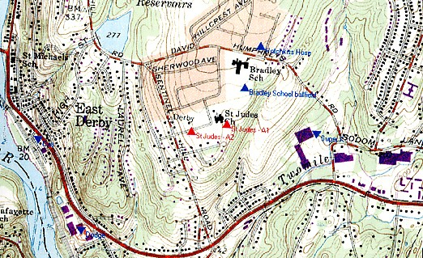

(Gridcom 1, Tab 5 [North is top of map and scale is 1:24,000 USGS 7.5 minute map))

Figure 2

Existing T-Mobile Coverage

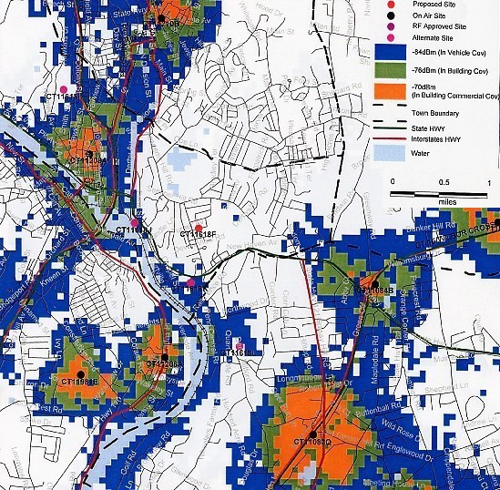

(Gridcom 8, Without Derby ZSite)

Figure 3

T-Mobile Coverage from either Site A or Site B (CT11618F)
With antennas at a centerline height of 117 feet agl.

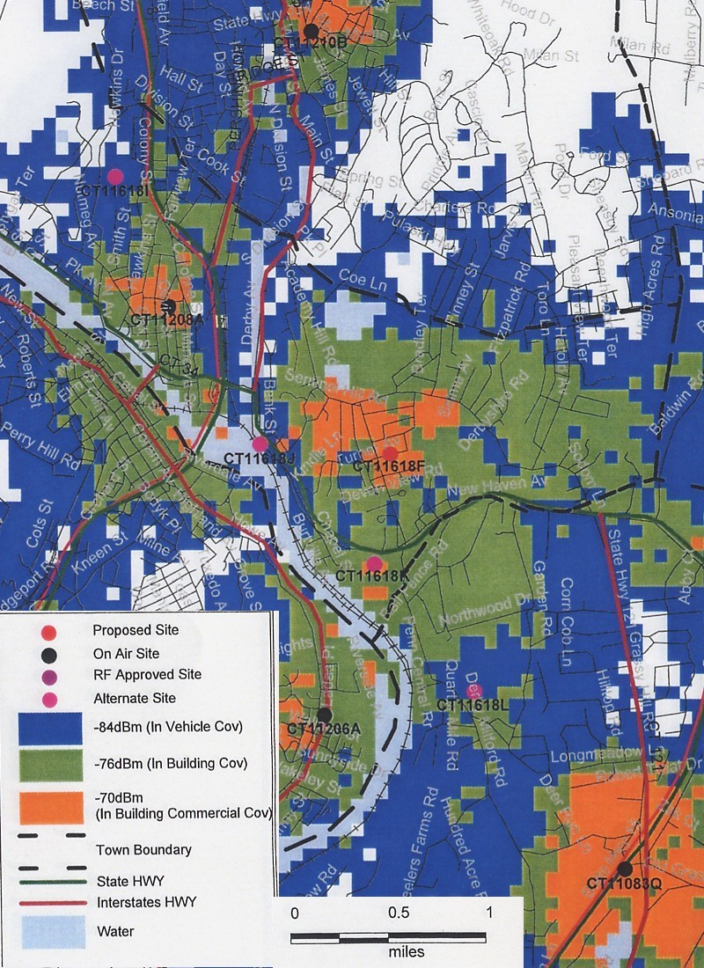
(Gridcom 8, With Derby ZSite)

