DOCKET NO. 324 – Sprint Nextel Corporation application for a Certificate of Environmental Compatibility and Public Need for the construction, maintenance and operation of a wireless telecommunications facility at 150 Willow Street, Hamden, Connecticut. | }  }  } | Connecticut  Siting  Council  May 1, 2007

Findings of Fact

Introduction

1. Sprint Nextel Corporation (Sprint) in accordance with provisions of Connecticut General Statutes (CGS) § 16-50g through 16-50aa, applied to the Connecticut Siting Council (Council) on October 27, 2006 for the construction, operation, and maintenance of a wireless telecommunications facility at 150 Willow Street, Hamden, Connecticut. (Sprint 1, p.4)

2. Sprint Nextel Corporation is a Delaware corporation. Sprint’s principal business offices are located in Mahwah, New Jersey. Sprint is licensed by the Federal Communications Commission (FCC) in many major trading areas in the United States, including Connecticut. (Sprint 1, p. 4)

3. The party in this proceeding is the applicant. (Transcript 1, March 8, 2007, 3:00 p.m. [Tr. 1], p. 4)

4. The purpose of the proposed facility is to provide service to coverage gaps identified by Sprint on Route 10 and surrounding areas in Cheshire and Hamden. (Sprint 1, pp. 3, 6)

5. Pursuant to General Statutes § 16-50m, the Council, after giving due notice thereof, held a public hearing on March 8, 2007, beginning at 3:00 p.m. and continuing at 7:00 p.m. at the Miller Library Complex, Thornton Wilder Hall, 2901 Dixwell Avenue, Hamden, Connecticut. (Council's Hearing Notice dated January 25, 2007; Tr. 1, p. 2; Transcript 2, March 8, 2007, 7:00 p.m. [Tr. 2], p. 2)

6. The Council and its staff conducted an inspection of the proposed site on March 8, 2007, beginning at 2:00 p.m. During the field inspection, the applicant flew a red balloon at the proposed site to simulate the height of the proposed tower. Weather conditions included winds of 15 to 20 miles per hour and were not conducive to a proper balloon flight. Sprint lost three balloons between approximately 12:30 pm and 2:10 pm. The balloon reached its proposed height of 160 feet above ground level for approximately two minutes during the Council’s inspection. (Council’s Hearing Notice dated January 25, 2007; Tr. 1, pp. 12-13)

7. Pursuant to CGS § 16-50l (b), public notice of the application was published in The New Haven Register on October 17 and 19, 2006. (Sprint 1, p. 5)

8. Pursuant to General Statute § 16-50l(b), notice of the application was provided to all abutting property owners by certified mail. Notice was unclaimed by four abutters: George L. Parente, Linus L. Darley, John Candella and Salvatore Hoo, and the State of Connecticut Nature Preserve. Sprint re-sent letters to these four abutters by first class mail. The first class letter to the State of Connecticut Nature Preserve was returned and then re-sent a final time to a different address. (Sprint 1, p. 5; Tr. 1, pp. 13-14)

9. Pursuant to CGS § 16-50l (b), Sprint provided notice to all federal, state and local officials and agencies listed therein. (Sprint 1, Tab 5)

State Agency Comment

10. Pursuant to General Statutes § 16-50j (h), on January 25, 2007 and March 9, 2007, the following State agencies were solicited by the Council to submit written comments regarding the proposed facility; Department of Environmental Protection (DEP), Department of Public Health (DPH), Council on Environmental Quality (CEQ), Department of Public Utility Control (DPUC), Office of Policy and Management (OPM), Department of Economic and Community Development (DECD), and the Department of Transportation (DOT). (Record)

11. The Council received a response from the DOT’s Bureau of Engineering and Highway Operations on March 1, 2007 with no comments on this proposal. (DOT Comments dated March 1, 2007)

12. DPH responded with comments that are reflected in Finding of Fact #61. (DPH Comments dated March 26, 2007 and March 29, 2007)

13. The following agencies did not respond with comment on the application: DEP, CEQ, DPUC, OPM, and the DECD. (Record)

Municipal Consultation

14. Sprint notified the Town of Hamden (Town) of the proposal on July 27, 2006 by sending a technical report to the Mayor, Craig Henrici. Sprint contacted the Town by telephone on several occasions to discuss the proposal and to inquire as to whether the Town wanted to set up a meeting or provide comments on the proposal. The Town did not respond to Sprint’s offer and did not provide Sprint with any comments. (Sprint 1, p. 10)

15. Due to the proposed tower site’s close proximity to the Cheshire town line, Sprint also notified the Town of Cheshire of the proposal on July 27, 2006 by sending a technical report to the Chairman of the Cheshire Town Council, Matt Hall. The Cheshire Town Planner, William S. Voelker, contacted Sprint to indicate that the Town of Cheshire did not have any comments on Sprint’s notice. (Sprint 1, p. 10)

16. By letter dated August 2, 2007, the Hamden Town Planner submitted a letter to the Council recommending that the tower be disguised as a silo. (Administrative Notice Item No. 16)

17. Sprint would provide space on the tower for the Town and any emergency response system for no compensation. The Hamden Police Department expressed an interest in co-locating at the top of the tower in the future. (Sprint 1, p. 7; Tr. 1, p. 65)

Public Need for Service

18. In 1996, the United States Congress recognized a nationwide need for high quality wireless telecommunications services, including cellular telephone service. Through the Federal Telecommunications Act of 1996, Congress seeks to promote competition, encourage technical innovations, and foster lower prices for telecommunications services. (Council Administrative Notice Item No. 7)

19. In issuing cellular licenses, the Federal government has preempted the determination of public need for cellular service by the states, and has established design standards to ensure technical integrity and nationwide compatibility among all systems. Sprint is licensed by the Federal Communications Commission (FCC) to provide personal wireless communication service to New Haven County, Connecticut. (Council Administrative Notice Item No. 7; Sprint 1, p. 4)

20. The Telecommunications Act of 1996 prohibits local and state entities from discriminating among providers of functionally equivalent services. (Council Administrative Notice Item No. 7)

21. The Telecommunications Act of 1996, a Federal law passed by the United States Congress, prohibits any state or local entity from regulating telecommunications towers on the basis of the environmental effects of radio frequency emissions to the extent that such towers and equipment comply with FCC’s regulations concerning such emissions. This Act also blocks the Council from prohibiting or acting with the effect of prohibiting the provision of personal wireless service. (Council Administrative Notice Item No. 7)

22. In an effort to ensure the benefits of wireless technologies to all Americans, Congress enacted the Wireless Communications and Public Safety Act of 1999 (the 911 Act). The purpose of this legislation was to promote public safety through the deployment of a seamless, nationwide emergency communications infrastructure that includes wireless communications services. (Sprint 1, p. 7)

23. Sprint’s facility would be in compliance with the requirements of the 911 Act. (Sprint 1, p. 7)

Site Selection

24. Sprint established a search ring in northern Hamden roughly centered on CL&P’s easement and located to the east of Route 10. The search ring consisted of a six-sided area, approximately 0.5 miles wide at the widest point. The area is mostly residential with rolling hills that range in elevation from approximately 150 feet above mean sea level (amsl) to over 700 feet amsl. (Sprint 1, Tab 7; Sprint 1, p. 11)

25. Prior to selecting the proposed site, Sprint considered 15 existing structures in the Hamden, Cheshire, and Wallingford area. The sites consisted of electric transmission structures, a silo, a building, a flagpole tower, and one existing tower. All of the sites were rejected due to inadequate coverage to the target service area. (Sprint 1, p. 9)

26. Twelve existing towers are located within two miles of the search area. Sprint is not located on any of these twelve existing towers. None of these sites met Sprint’s coverage objectives. The locations of the twelve existing towers are as follows:
a) NU Power Mount at 150 Willow Street, Hamden
b) NU Power Mount #2466 at 450 Tuttle Avenue, Hamden
c) NU Power Mount #2465 at 450 Tuttle Avenue, Hamden
d) NU Pole at Old Lane Road, Cheshire
e) Fire Department Whip at King Road, Cheshire
f) NU Pole #1 at Brooksvale Avenue, Hamden
g)NU Pole #3 at Cook Hill Road, Cheshire
h)NU Pole #4 at Mansion Road, Wallingford
i) Golf Range Pole at Brooksvale Avenue, Hamden
j) NU Pole #5 at Turte Avenue, Wallingford
k) Quinnipiac University Building at Hogan Road, Hamden
l) Cingular Flagpole at Quinnipiac University at New Road, Hamden
(Sprint 1, pp. 9-10; Sprint 1, Tab 6)

27. The 120-foot CL&P transmission structure #5215 was also considered by Sprint, but structurally, it can only support two carriers. New Cingular Wireless and T-Mobile already plan to locate on the pole. (Sprint 2, response 16)

28. Sprint also considered utilizing the existing CL&P structures on the subject property with height extensions in order to meet its coverage objectives. However, CL&P’s right of way in this area does not permit the installation of telephone and telecommunications equipment within the easement area. (Tr. 1, pp. 24-25)

29. Microcells and repeaters are not viable technological alternatives for providing coverage to the identified coverage gap. Microcells and repeaters are low power sites that are limited in coverage and capacity. The coverage gap in the Hamden area is significant. Therefore, technologies such as repeaters and microcells are not viable options to cover the portions of Route 10 and the surrounding areas of Hamden and Cheshire that Sprint seeks to cover. (Sprint 1, pp. 8-9)

Site Description

30. The proposed site is located on an 87-acre parcel at 150 Willow Street in Hamden. The parcel, owned by Hamden Fish and Game Protective Association, Inc., contains mainly undeveloped, forested land with a firing range. The proposed site is depicted on Figure 1. (Sprint 1, p. 11; Tr. 1, p. 14)

31. The property is zoned residential, R-1. The Town’s zoning regulations permit telecommunication towers in R-1 Zone districts, subject to issuance of a Special Permit and Site Plan Approval. (Sprint 1a, Town of Hamden Zoning Regulations)

32. Land use in the surrounding area is medium-density residential development, undeveloped forested lands, and overhead electric utility infrastructure and associated rights of way. (Sprint 1, p. 11)

33. The tower site is located in the western half of the property just north of CL&P’s easement, at an elevation of approximately 126 feet amsl. The wooded site is dominated by sugar maple, Norway maple, black oak, and red cedar. (Sprint 1, p. 19; Sprint 3, drawings Z2 and Z3A)

34. The proposed facility would consist of a 160-foot monopole within a 100-foot by 100-foot leased area. The tower would be designed to support a total of five levels of antennas with a 10-foot vertical separation between antenna centers. The tower would be constructed of galvanized steel that would weather to a non-reflective gray finish. (Sprint 1, pp. 3, 12, 18-19; Sprint 1, Tab 9, drawing Z5 )

35. Sprint would install twelve antennas on a triangular platform at a centerline height of 157 feet agl. The total height of the facility with antennas would be 160 feet agl. (Sprint 1, p. 12; Sprint 1, Tab 9, drawing Z5)

36. The tower would be designed and constructed in accordance with the American National Standards Institute TIA/EIA-222-F “Structural Standards for Steel Antenna Towers and Antenna Support Structures”. (Sprint 1, p. 12)

37. A silo tower design is feasible from both a structural and RF standpoint, but visually may be a large, cumbersome structure. (Tr. 1, pp. 17-19)

38. A monopine design is possible, but visually may not blend in effectively due to the existing utility corridor. (Tr. 1, pp. 21-22)

39. A narrow “stick” tower design is possible, but the sector orientation would have to be changed in order for the antennas to fit, thereby resulting in more dropped calls. (Tr. 1, p. 37)

40. A “one-antenna-per-sector” configuration would degrade coverage similar to a decrease in height. (Tr. 1, p. 66)

41. It would be difficult for Sprint to flush-mount its antennas because the cluster of antennas is already very close together due to the sector orientation. (Tr. 1, pp. 16, 39-41)

42. T-bars could be used to mount the antennas. (Tr. 1, pp. 38-39)

43. Cellco Partnership d/b/a Verizon Wireless did not participate in this proceeding, but informed the Council of its interest in co-locating at this facility in the future by letter dated March 16, 2007. No other carriers have expressed an interest in co-locating at this facility at this time. (Cellco Letter dated March 20, 2007; Tr. 1, p. 14)

44. A 50-foot by 50-foot equipment compound enclosed by a six-foot high chain link fence would be established at the base of the tower. Sprint would install an equipment cabinet and a battery backup cabinet on a concrete pad within the compound. (Sprint 1, pp. 12-13; Sprint 1, Tab 9, drawing Z3)

45. Development of the site would require approximately 500 cubic yards of cut and 400 cubic yards of fill. (Sprint 2, response 12)

46. Access to the tower site begins at Willow Street and follows the existing access for approximately 180 feet. The access would turn to the northeast and continue along an abandoned access way for approximately 500 feet to the compound. This access way would be improved to a width of 12 feet and covered with gravel. (Sprint 3, drawings Z2 and Z3A; Tr. 1, pp. 19-20)

47. The new access could be shifted an additional 20 feet to save several large white pines. (Tr. 1, p 20)

48. Utilities would be installed underground and leave the compound in a southeasterly direction to reach an existing pole on the property. (Sprint 3, drawing Z2)

49. Development of the site would not require blasting. (Sprint 2, response 13)

50. The tower setback radius would not extend beyond the boundaries of the Hamden Fish and Game Protective Association, Inc. property but would overlap CL&P’s easement by 27.5 feet. (Sprint 2, response 15; Sprint 3, drawing Z2)

51. Sprint is willing to engineer a break point on the monopole so that the tower setback radius would stay outside of the CL&P easement. Alternatively, Sprint could shift the monopole and lease area slightly north to keep the tower setback radius off of the CL&P easement. However, Sprint would prefer the break point method rather than shifting the monopole and lease area. (Sprint 2, response 15)

52. The nearest property boundary from the proposed tower is approximately 340 feet to the north (Rubin/Corrine property). The tower setback radius would not extend onto the Rubin/Corrine property. (Sprint 3, drawing Z2)

53. There are 27 residences within 1,000 feet of the proposed tower site. The nearest residence is approximately 406 feet north of the tower site (Rubin/Corrine residence). (Sprint 2, responses 10 and 11)

54. The estimated construction cost of the proposed facility is:

Site Work $ 30,500
Monopole $ 30,000
Electrical & Telephone $ 17,500
Foundation $ 31,800
Landscaping $ 3,000
Road $ 4,000
Total $116,800 (Sprint 1, Tab 10)

Environmental Considerations

55. The proposed facility would have no effect upon historic, architectural, or archaeological resources listed on or eligible for the National Register of Historic Places or upon properties of traditional cultural importance to Connecticut’s Native American community. (Sprint 1, Tab 14)

56. There are no known existing populations of federal or state endangered or threatened species or state special concern species occurring at the proposed site, based on a review of the Connecticut Department of Environmental Protection Natural Diversity Database. (Sprint 1, Tab 14)

57. Vegetation at the site consists of sugar maple, Norway maple, black oak, and red cedar ranging in size from 6 to 12 inches diameter at breast height (dbh). Approximately 15 trees six inches dbh or greater would be removed to develop the site. (Sprint 1, p. 19; Sprint 2, response 9; Tr. 1, p. 20)

58. Wetlands are located to the east of the pavilion, approximately 200 feet from the proposed compound. Wetland vegetation consists of red maple, green ash, spicebush, skunk cabbage, and sensitive fern. Wetland vegetation inside the CL&P right of way consists of multiflora rose, brambles, grape, silky dogwood, and goldenrod. (Sprint 1, Tab 14)

59. No work would be conducted within wetland resource areas. Some construction activities associated with the underground utility trench would be located within the Town’s 200-foot upland review area. These activities would be located within existing disturbed areas and are not expected to adversely impact the nearby wetlands. (Tr. 1, p. 15)

60. There are no airports within two nautical miles of the site. Lighting of the tower would not be required. (Sprint 1, Tabs 12 and 14)

61. The proposed construction is located within the Watershed Area for the Mill River System and the Level A Aquifer Protection Area of the North Sleeping Giant Well Field, sources of drinking water for the South Central Connecticut Regional Water Authority (RWA). The DPH Drinking Water Section recommends that the RWA be contacted prior to any construction and that the following Best Management Practices be followed to ensure the safety of the drinking water supply:

- Coordinate any construction activities with the RWA.

- Write an emergency response plan for actions to be taken in the event of an accidental fuel or chemical spill that may occur during construction.

- Have spill response equipment available on-site at all times along with personnel trained in the proper use of such equipment.

- Designate a person or persons for emergency response coordination on a 24/7 basis.

- Contact the RWA immediately in the event of an accidental spill.

- Avoid the cleaning of equipment on the locations of construction due to possible contamination from equipment chemicals.

- Avoid any storage of fuel or refueling within the watershed and acquifer protection areas.

- Designate one area (off of the source areas) for auto parking, vehicle refueling and routine equipment maintenance. This area should be well away from exposed surfaces or storm drains.

- Perform all major equipment repairs off site.

- Keep pollutants off of exposed surfaces.

- Do not bury stumps or construction debris on the job site.

- Place sediment fences and hay bales strategically and inspect and maintain them to prevent sedimentation and erosion.

- Inspect and maintain temporary storm water ponds and basins routinely.

- Have additional sediment fences and hay bales available for use as needed to prevent runoff in the event that unexpected conditions occur.

- Protect exposed stockpiles of soil to prevent runoff.

- Use as little water as possible for dust control.

- Clean up leaks, drips and other spills immediately to prevent or minimize soil contamination.

- Never hose down “dirty” pavement or surfaces where materials have spilled. Use dry cleanup methods whenever possible.

- Perform any blasting only with careful consideration to impacts to the area, including possible effects to ground water which could affect drinking water quality and quantity.

- Remove paints, paint products and other hazardous materials from the site during non-work hours or otherwise store these materials in a secure area to prevent vandalism.

- Place covered trashcans and recycling receptacles around the site. Cover and maintain dumpsters, check frequently for leaks, and never clean a dumpster by hosing it down on site.

- Avoid development of slopes at 15 percent or greater. If they cannot be avoided in this project, a separate environmental consultant should be on site to ensure proper erosion and sedimentation controls are in place. This consultant would be responsible to report to the RWA so water quality issues are avoided. (DPH Comments dated March 23 and 26, 2007)

62. The maximum power density from the radio frequency emissions of Sprint’s proposed antennas would be 0.0482 mW/cm², or 4.82% of the standard for Maximum Permissible Exposure, as adopted by the FCC, at the base of the proposed tower. This calculation was based on methodology prescribed by the FCC Office of Engineering and Technology Bulletin No. 65E, Edition 97-01 (August 1997) that assumes all antennas would be pointed at the base of the tower and all channels would be operating simultaneously. (Sprint 1, p. 23)

Visibility

63. The proposed tower would be visible year-round from approximately 59 acres within a two-mile radius of the site (refer to Figure 6). The tower would be seasonally visible from approximately 97 acres within a two-mile radius of the site. (Sprint 1, Tab 12, pp. 4-5; Tr. 1, pp. 45-46)

64. Visibility of the proposed tower from roads within a two-mile radius of the site is presented in the table below:

Road | Length of Road Visibility (Seasonal) | Length of Road Visibility  (Year-round) | Nearest Distance with Visibility to Site A
Route 10 | 0.1 miles | 0.2 miles | 0.3 miles  west
Bittersweet Lane | 0.1 miles | - | 0.3 miles northwest
Still Hill Road | 0.3 miles | - | 0.6 miles southwest
Brooksvale Avenue | 0.1 miles | 0.1 miles | 0.6 miles southwest
Knoll Drive | 0.1 miles | - | 0.1 miles north
Willow Street | 0.1 miles | 0.03 miles | 0.1 miles  southwest
(Sprint 1, Tab 12)

65. Visibility of the proposed tower from specific locations within a two-mile radius of the site is presented in the table below:

Location | Visible | Approx. Portion of Tower Visible | Approx. Distance to Tower
Route 10 – north of Brooksvalle Avenue | Yes | 20 feet – above trees | 0.6 miles northeast
Knoll Drive – Adjacent to house #162 | Yes | 15 feet – above trees | 0.3 miles south
Brooksvale Avenue – at existing utility right of way | Yes | 20 feet – above trees | 0.6 miles northeast
Route 10 – at existing utility right of way | Yes | 25 feet – above trees | 0.3 miles northeast
Willow Street – at existing utility right of way | Yes | 30 feet – obstructed through trees | 0.1 miles northeast
(Sprint, Tab 12)

66. A significant amount of the total visibility of the proposed facility falls on the host property and the existing utility right of way that traverses the study area. Other areas of visibility include a roadside commercial development along Route 10 located within the general vicinity, an adjacent open field located to the southwest of the site, and portions of Knoll Drive approximately 1,000 feet to the northeast. (Sprint 1, p. 21)

67. The proposed site would be visible year-round from four residences along Knoll Drive and two residences along Route 10. There are also several small areas of potential visibility located over one mile to the northwest and approximately 900 feet northeast of the proposed facility. These areas on are private property and the views could not be verified by Sprint’s visual resource consultant. However, views from these areas are expected to be limited to tree-line views and/or views of the upper 25 percent of the proposed facility. (Sprint 1, p. 22)

68. The proposed site would be seasonally visible from five properties along Knoll Drive and three properties along Willow Street. (Sprint 1, p. 22)

69. The nearest state or local recreational area is the Sleeping Giant State Park, which is approximately 0.3 miles east of the tower site at its closest point. The proposed tower may be visible from the Naugutuck Trail in Sleeping Giant State Park, but the viewer would have to pick it out from the existing trees and utility infrastructure. The proposed tower may be visible from other trails in the Sleeping Giant State Park, but the viewer would be looking down on the tower and the view would be largely lost because it would blend in with the valley. (Sprint 1, Tab 12; Tr. 1, pp. 30-32)

70. The proposed tower is not expected to be visible from the Quinnipiac Trail. (Sprint 1, Tab 12)

71. The proposed tower would be seasonally visible from a 0.2 mile long section of the Farmington Canal Linear State Park Trail, which is located approximately 0.5 miles to the west of the proposed site at its nearest point. (Sprint 1, Tab 12)

72. The proposed tower may be visible from the Naugatuck State Forest but the view would be limited to a tree-top view and would also be mitigated by the distance of roughly two miles. (Tr. 1, pp. 33-34)

73. The proposed tower is not expected to be visible from Brooksvale Recreation Park. (Tr. 2, pp. 13-14; Sprint 1, Tab 12)

74. There are no state or local scenic roads within two miles of the proposed tower site. (Tr. 1, p. 15)

75. There are no historic districts within a two-mile radius of the proposed site. (Sprint 1, Tab 12)

Existing and Proposed Wireless Coverage

76. Sprint transmits in the 1950 - 1965 MHz frequency bands and has a signal-level service design of -92 dBm for this area, sufficient for in-vehicle coverage. The signal-level threshold for in-building coverage is -87 dBm. (Sprint 2, response 4; Sprint 1, Tab 7)

77. Sprint’s existing signal strength in the majority of the area to be covered by this proposed facility is below -92 dBm. (Sprint 2, response 3)

78. Sprint’s customers are currently experiencing a high number of dropped calls (over 2 percent) in the area to be covered by the proposed facility. (Sprint 1, p. 6)

79. Sprint’s existing coverage gap along Route 10 is approximately 2.8 miles. The proposed site would fill this gap. Refer to Figure 2. (Sprint 2, response 8)

80. Sprint’s minimum height to meet coverage design objectives is 157 feet. Refer to Figure 3. (Sprint 1, response 2)

81. Installing the antennas at lower heights, such as 147 feet or 137 feet, would cause the coverage gap on Route 10 north of Cook Hill Road to increase in size. Refer to Figures 4 and 5. (Tr. 1, pp. 50-51)

82. The proposed tower would provide approximately 4.5 square miles of improved coverage. (Sprint 2, response 7)

Figure 1: Location Map
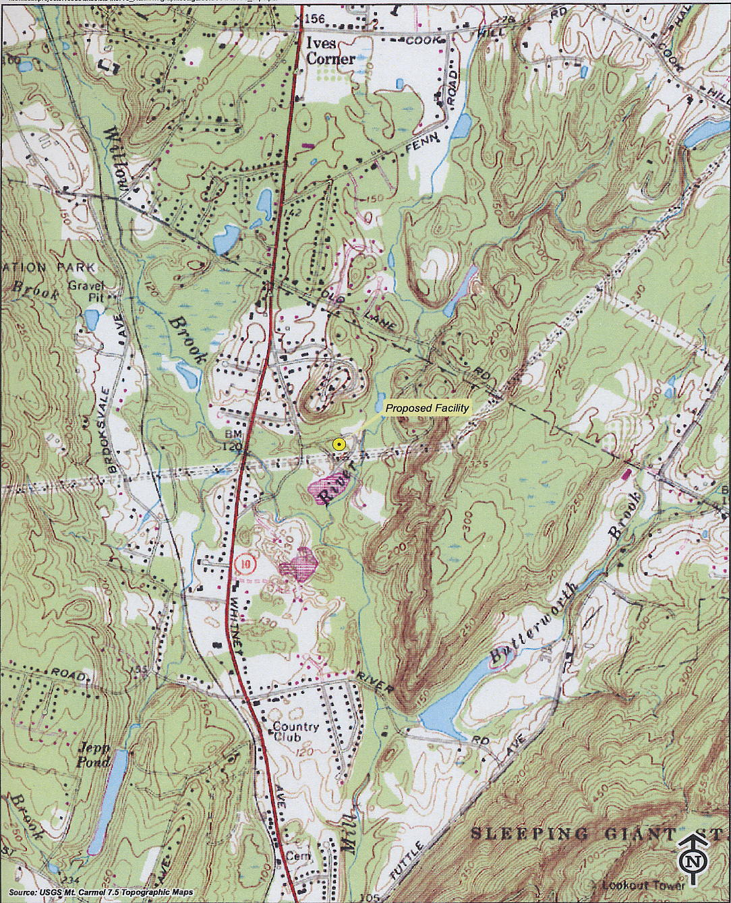 (Sprint 1, p. Tab 1)

Figure 2: Existing Coverage
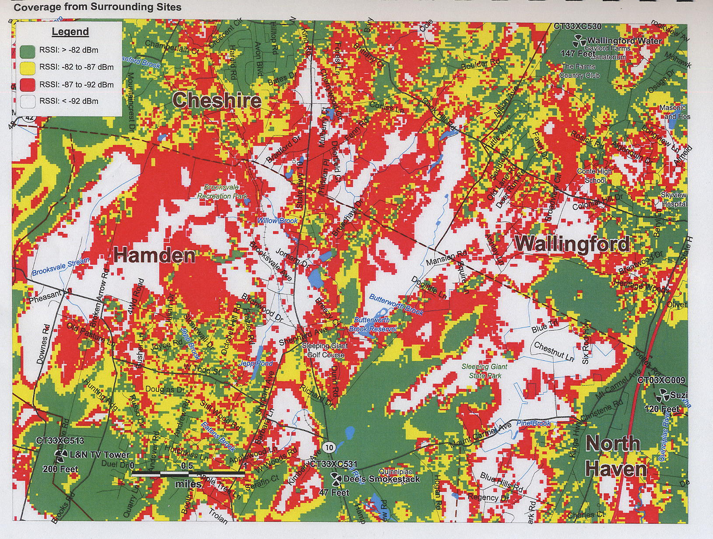
(Sprint 1, Tab 11)

Figure 3: Coverage with Proposed Antennas at 157 feet
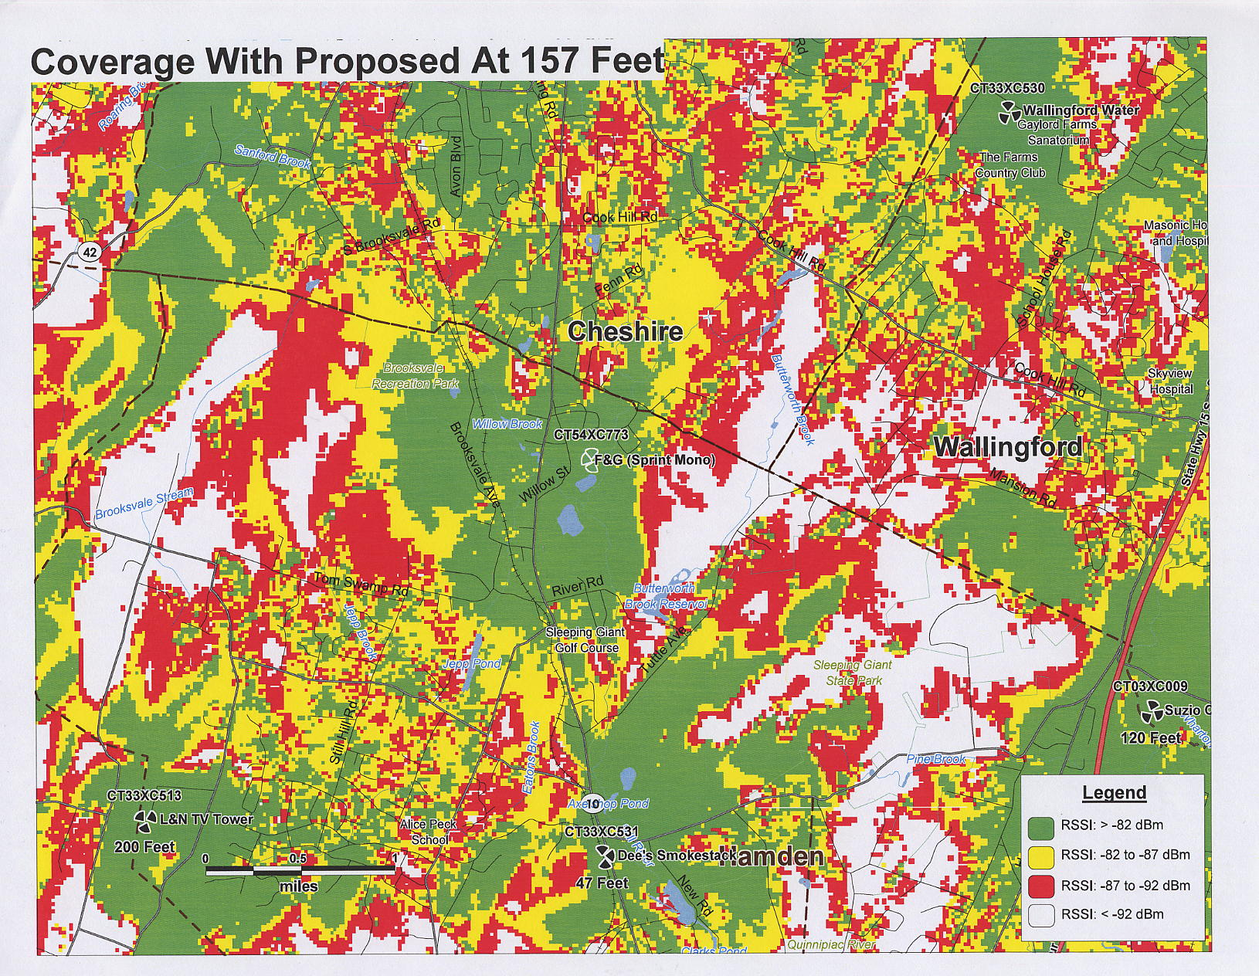
(Sprint 2, response 1)

Figure 4: Coverage with Proposed Antennas at 147 feet
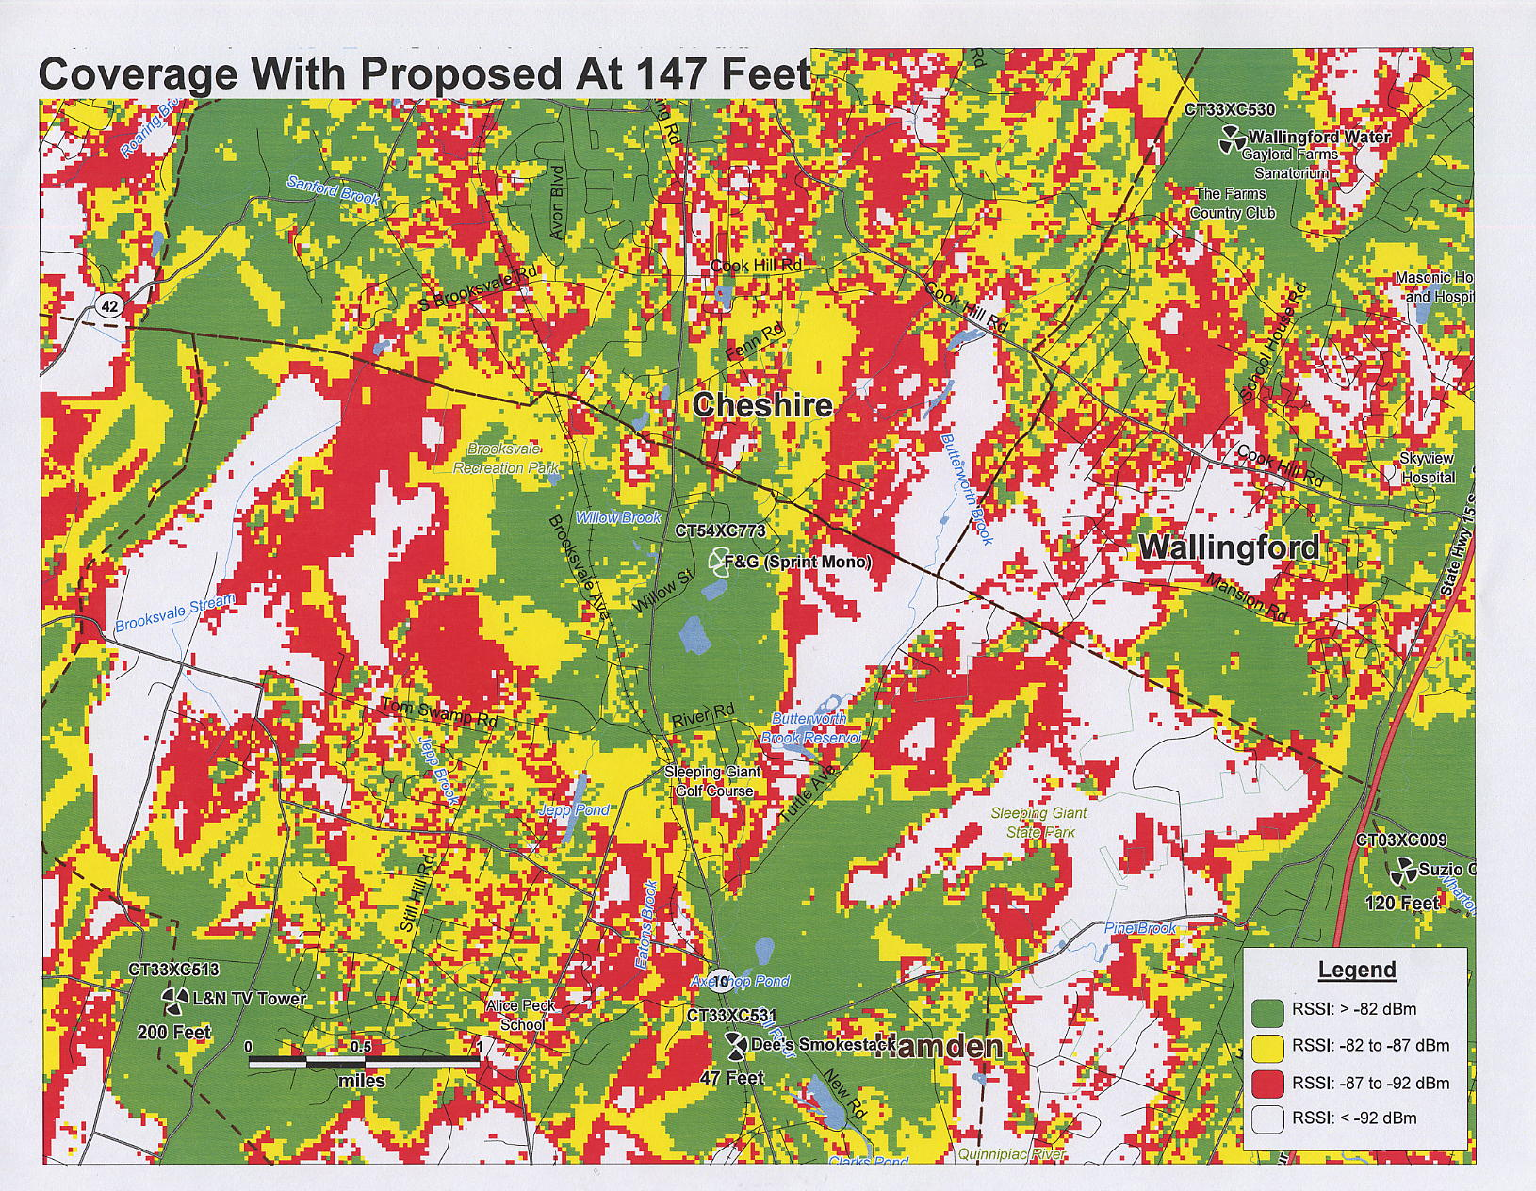
(Sprint 2, response 1)

Figure 5: Coverage with Proposed Antennas at 137 feet
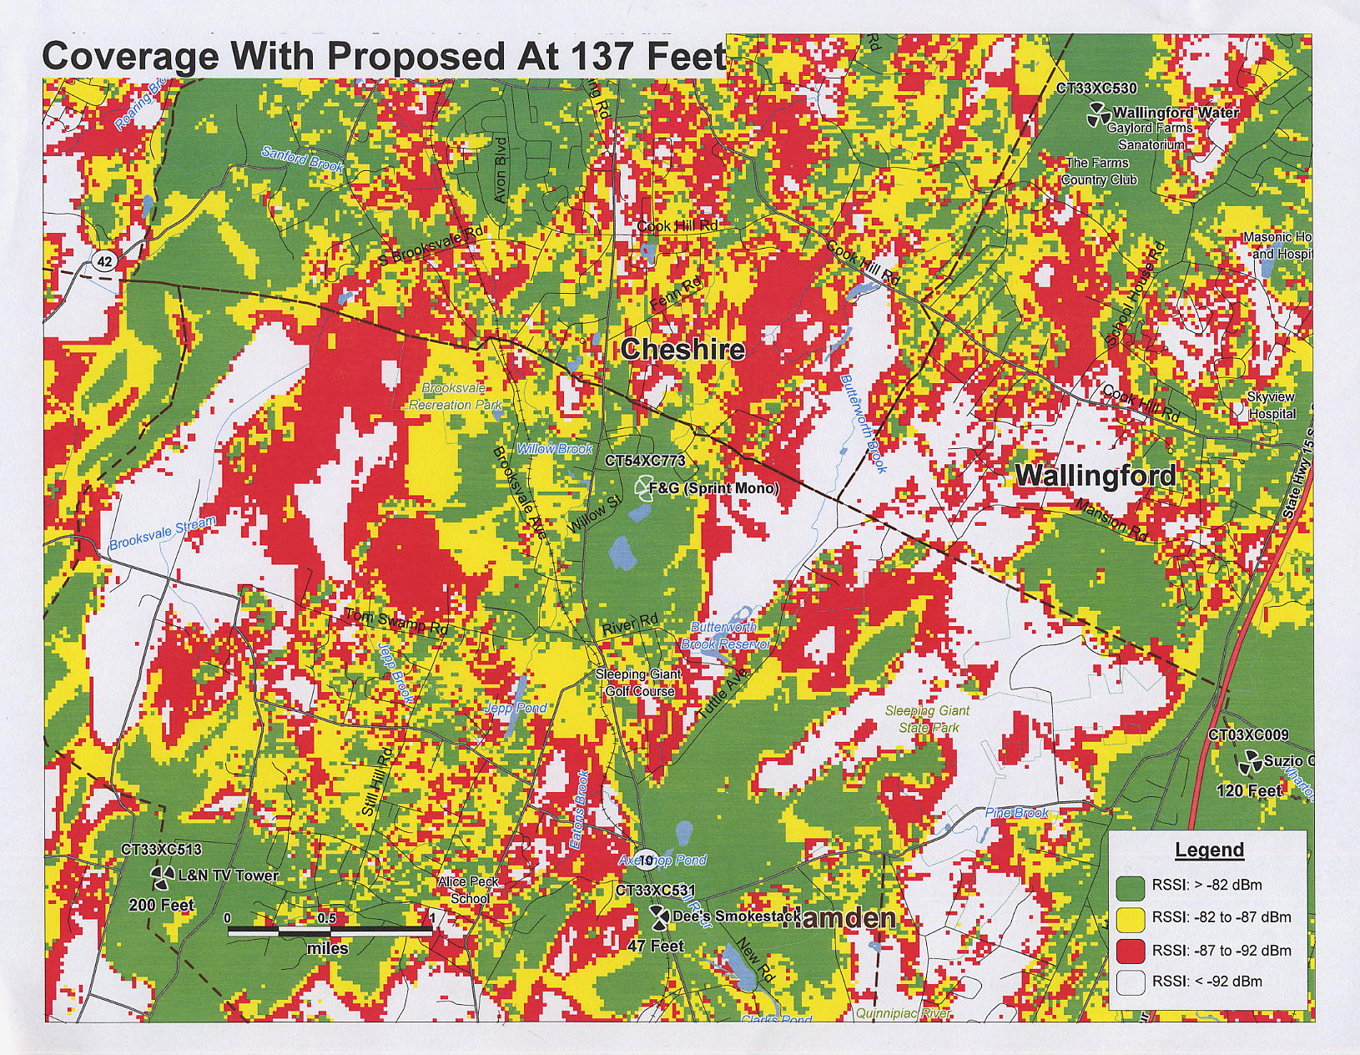
(Sprint 2, response 1)

Figure 6: Viewshed Map
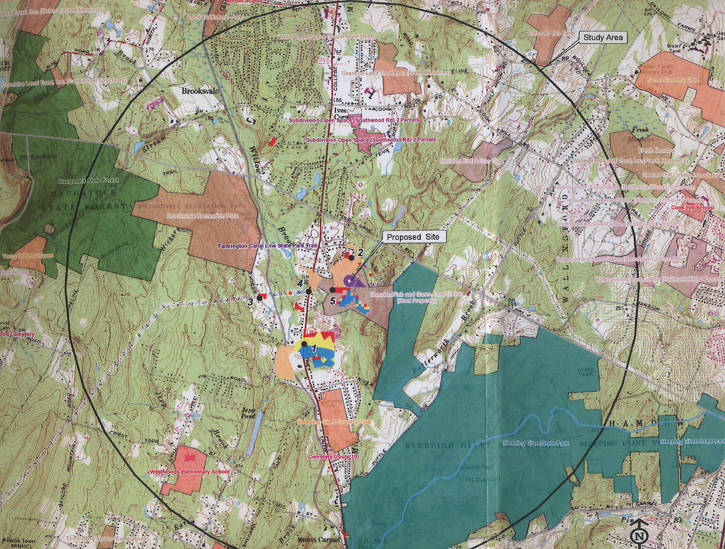
(Sprint 1, Tab 12)

Figure 6: Viewshed Map Legend
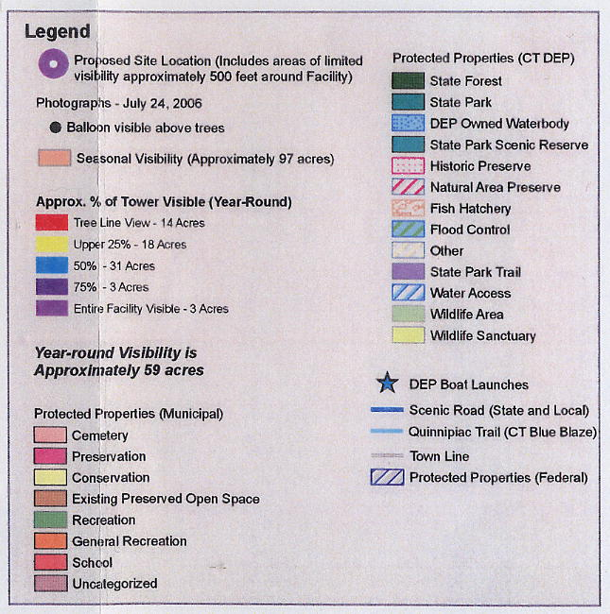
(Sprint 1, Tab 12)

