DOCKET NO. 302 – Northeast Utilities Service Company, on behalf of The Connecticut Light and Power Company (CL&P) application for a Certificate of Environmental Compatibility and Public Need for the construction, maintenance and operation of the proposed Killingly 2G Substation at 193 Tracy Road and 227-257 Park Road in the Towns of Killingly and Putnam, and the proposed connections to the existing #347 345-kV line and the existing #1607 and #1505 115-kV lines. | }  }  }  } | Connecticut  Siting  Council  May 11, 2005

Findings of Fact

Introduction

- Pursuant to Chapter 277a, Sections 16-50g et seq. of the Connecticut General Statutes (CGS), as amended, and Section 16-50j-1 et seq. of the Regulations of Connecticut State Agencies (RCSA), Northeast Utilities Service Company, acting on behalf of the Connecticut Light and Power Company (CL&P), applied to the Connecticut Siting Council (Council) on November 29, 2004 for the construction of a new substation to be located on CL&P’s 33.2 acre property located in the Towns of Putnam and Killingly, Connecticut, with the substation to be constructed in Killingly and accessed from Putnam, and for protection system and equipment upgrades to existing substations (e.g. Tracy, Lake Road, Sherman Road, Tunnel and possibly Fry Brook, Brooklyn and Exeter) and the installation of an additional 345-kV circuit breaker at the Card Street Substation in Lebanon, Connecticut. (CL&P 1, Vol. 1, pp. A-2, F-1, and F-2; CL&P 5, response 3)

- The party in this proceeding is the applicant. (Public hearing transcript [Tr. 1], pp. 4-5)

- Public notice of the application was published in the Norwich Bulletin and the Hartford Courant on November 16, 18, and 21, 2004, as well as in the Putnam Town Crier on November 19 and 26, 2004. (CL&P 1, Vol. 2, Tab 20)

- On or about November 29, 2004, acting pursuant to CGS § 16-50l(b), CL&P sent copies of its application to the following municipal, regional, state, and federal agencies and officials: Connecticut Attorney General, Department of Environmental Protection, Department of Public Health, Council on Environmental Quality, Department of Public Utility Control, Office of Policy and Management, Department of Economic and Community Development, Department of Transportation, Northeastern Connecticut Council of Governments, Donald E. Williams, Jr. – State Senator from the 29th Senatorial District, Shawn Johnston – State Representative from the 51st Assembly District, Michael Caron – State Representative from the 44th Assembly District, Killingly Town Council Chairman, Killingly Town Manager, Mayor of the Town of Putnam, Killingly Planning and Development, Killingly Planning and Zoning Commission, Putnam Planning Commission, Putnam Zoning Commission, Killingly Inland Wetlands Commission, Killingly Conservation Commission, Putnam Inland Wetlands and Conservation Commission, Robert Simmons – U. S. Representative from the 2nd Congressional District and ISO-New England. (CL&P 1, Vol. 2, Tab 19)

- In accordance with CGS § 16-50l(b), CL&P notified owners of property abutting its proposed site of its intent to file an application with the Council. CL&P’s letter of notification was sent via certified mail on or about November 15, 2004. CL&P received the certified mail receipts from six of the eight abutting property owners. (CL&P 1, Vol. 2, Tab 21; CL&P 3; CL&P 5, response 2)

- The initial notice sent to the Providence and Worcester Railroad (Railroad) was returned. CL&P sent a second notice on November 30, 2004 and received a certified mail receipt. By letter dated January 4, 2005, the Railroad advised CL&P that it had no objection to the proposed project. (CL&P 5, response 2)

- Although a return receipt was not received from Fairways Edge LLC, the United States Postal Service confirmed delivery to Fairways Edge LLC on November 17, 2004 at 2:13 pm. (CL&P 5, response 2)

- Since a return receipt was not received from the Tracy Estate, CL&P took steps to verify the address through the Killingly Tax Assessor and Tax Collector. Additionally, the Killingly Probate Court was contacted. The clerk identified the counsel for the Tracy family. Through the counsel, CL&P obtained a telephone number for Douglas Tracy. Several telephone messages were left for Mr. Tracy, but a return call to CL&P was not received. (CL&P 5, response 2)

- Pursuant to CGS § 16-50l, the Council solicited comments on CL&P’s application from the following state departments and agencies: Department of Environmental Protection (DEP), Department of Public Health, Council on Environmental Quality, Department of Public Utility Control, Office of Policy and Management, Department of Economic and Community Development, and the Department of Transportation. The Council’s letter requesting comments was sent on January 5, 2005. (CSC Hearing Package dated January 5, 2005)

- The Connecticut Department of Transportation (ConnDOT) responded to the Council’s solicitation, but did not have any comments. (ConnDOT letter dated February 9, 2005)

- The Department of Public Health (DPH) provided comments dated January 12, 2005. In those comments, DPH indicated that three active sand and gravel wells in the Park Street Wellfield are located approximately 0.8 miles north of the proposed substation site; three active bedrock wells owned and operated by the Westview Nursing Care and Rehabilitation Center are located approximately 1 mile east of the proposed substation site; and one active bedrock well and one dug well owned and operated by the R&R Trailer Park are located approximately 0.9 miles southeast of the proposed substation site. DPH also recommended construction and post-construction best management practices to help prevent or mitigate possible groundwater contamination. (DPH Letter dated January 12, 2005)

- The following state agencies did not respond to the Council’s request for comments: DEP, Council on Environmental Quality, Department of Public Utility Control, and the Office of Policy and Management. (Record)

- The proposed substation received 18.4 project approval from ISO-New England on January 18, 2005. (CL&P 7; CL&P 9, R. Orlowski, p. 11)

- Pursuant to General Statutes § 16-50m, the Council, after giving due notice thereof, held a public hearing on March 1, 2005, beginning at 3:00 p.m. and continued at 7:00 p.m. at the Killingly Town Hall in Danielson, Connecticut. (Tr. 1, p. 3)

- The Council and its staff made an inspection of the proposed substation site on March 1, 2005. (Council Hearing Notice of January 5, 2005)

Need

- CL&P, as a transmission provider, must maintain a system that meets the Northeast Power Coordinating Council (NPCC), New England Power Pool (NEPOOL) and ISO-New England reliability standards and criteria. These criteria are created under the purview of the North American Reliability Council, which establishes electric power transmission standards for all of North America. (CL&P 1, Vol. 1, p. G-1)

- The proposed substation is needed to alleviate transmission capacity constraints and improve system reliability in the eastern Connecticut service area. CL&P’s analysis show that many normal planning criteria contingencies would result in overloaded transmission lines (i.e. loaded beyond the long term emergency ratings) and unacceptable low voltages, including the potential for voltage collapse. (CL&P 1, Vol. 1, p. G-1 and G-2; CL&P 1, Vol. 2, Tab 3, pp. 11, 14, and 16)

- As early as 2006, these overloads in the eastern Connecticut area could result in transmission lines being tripped, which would subsequently result in voltage collapse unless significant load is shed. (The eastern Connecticut geographic area extends from the Rhode Island border in a westerly direction for 20 to 25 miles, and runs from Long Island Sound north to the Massachusetts border.) (CL&P 1, Vol. 1, p. G-2; CL&P 1, Vol. 2, Tab 3, p. 6)

- A number of factors contribute to present transmission limitations, including limitations of the existing transmission infrastructure, load growth, and generation availability. CL&P anticipates that potential problems would continue to emerge and worsen, unless changes to the existing system configuration are implemented in the near future. (CL&P 1, Vol. 1, p. G-2)

- The major concern with the eastern Connecticut 115-kV transmission system is that it is not capable of transferring sufficient power from the supply sources at the Montville and Card substations to the load pockets in the vicinity of and north of the Tunnel Substation. (CL&P 1, Vol. 2, Tab 3, page 15)

- The proposed substation would alleviate these criteria deficiencies by increasing transmission capacity at a point on the system that requires reinforcement. (CL&P 1, Vol. 1, p. G-2)

- The proposed substation would make a new supply connection between the high capacity 345-kV network passing near the existing Tracy Substation and the 115-kV lines between Tunnel and Tracy Substations. (CL&P 1, Vol. 2, p. 16)

- The proposed project would result in contingency power flows falling below emergency operating limits. The proposed project would also correct low transmission voltage conditions at several substations under contingency conditions. The proposed project would also bring the eastern Connecticut transmission system into compliance with NPCC, NEPOOL, and CL&P planning criteria and would transform the network into a more robust system. (CL&P 1, Vol. 2, Tab 3, p. 16)

- With the proposed project, the Lake Road generating units would not have to be tripped for the loss of the #330 line from the Lake Road Substation to the Card Street Substation. This would improve the availability of these units to serve Connecticut load. (CL&P 1, Vol. 2, Tab 3, p. 16)

- It is not feasible for CL&P to rely on additional distributed generation resources to resolve the transmission capacity issue in Connecticut. (CL&P 1, Vol. 2, Tab 3, p. 20)

- The addition of a 200-MW power plant in eastern Connecticut would solve the problem in the area. However, this unit must always be available during peak demand periods. For practical purposes, two generating units would be required to ensure that one is always available. At this time, no generating facilities are under development in eastern Connecticut or are pending in the interconnection queue in ISO-New England. (CL&P 1, Vol. 2, Tab 3, p. 21)

- Unified Power Flow Controllers (UPFCs), a newer generation of devices which combine a static condenser or compensator with a thyristor controlled series element to provide both dynamic voltage regulation and dynamic flow regulation, are not a viable option for eastern Connecticut because it would add excessive operational complexity and is better suited for stability problems, which are not evident in eastern Connecticut. (CL&P 1, Vol. 2, Tab 3, pp. 22-23)

- Demand response alone is not sufficient to resolve the reliability issues in eastern Connecticut. (CL&P 1, Vol. 2, Tab 3, p. 24)

- Several transmission line alternatives were considered, but ultimately rejected due to either: the cost being higher than the proposed project; inability to solve the reliability problem; and/or a longer construction time frame would result. (CL&P 1, Vol. 2, Tab 3, p. 26)

- Two alternate locations for an autotransformer were considered by CL&P: Lake Road 27E Substation and Brooklyn 30Y Substation. However, the Lake Road site was not considered further due to limited real estate and required line extensions. The Brooklyn site would require capacitors, at higher cost and would require a 345-kV line extension. The Brooklyn site would also result in less reliability than the proposed project. (CL&P 1, Vol. 2, Tab 3, p. 26)

Municipal Consultation

- The Municipal Consultation Filing (MCF) was delivered to the towns of Putnam and Killingly on September 27 and 29, 2004, respectively, beginning the 60 day consultation process. CL&P also consulted with the Mayor of Putnam and the Town Manager of Killingly prior to the submission of the MCF. CL&P also consulted with the following municipal commissions to seek input from the local government representatives and the public: Town of Killingly Inland Wetlands and Watercourses Commission; Town of Putnam Inland Wetlands Commission; Town of Killingly Planning and Zoning Commission; and Town of Putnam Zoning Commission. (CL&P 1, Vol. 1, p. O-1)

- By letter dated November 8, 2004, the Town of Killingly Town Manager indicated that the Town of Killingly has no objection to CL&P proceeding with its proposed substation. (CL&P 1, Vol. 2, Tab 22)

- By letter dated November 9, 2004, the Mayor of Putnam indicated that the Town of Putnam has no objection to CL&P proceeding with its proposed substation. (CL&P 1, Vol. 2, Tab 22)

- By letter dated November 24, 2004, the Town of Putnam Inland Wetland Agency granted its approval of the proposed project with the conditions that erosion and sedimentation controls be installed in accordance with submitted drawings and anti-tracking be installed (to mitigate mud/debris) at the access road entrance. The letter also indicated that the Town of Putnam Zoning Commission granted its approved to the proposed project as presented. (CL&P 1, Vol. 2, Tab 5; CL&P 4, p. 1)

- The Town of Killingly Inland Wetlands and Watercourses Commission granted its approval for the proposed project with the condition that erosion and sedimentation controls (E&S) for the project be installed prior to any disturbance, and that the E&S controls are maintained until all areas are stabilized. (CL&P 1, Vol. 2, Tab 14)

- CL&P’s response to the conditions of the Town of Killingly Inland Wetlands and Watercourses Commission is that E&S best management practices will conform to the 2002 Connecticut Guidelines for Soil Erosion and Sediment Control. Also, E&S controls will be maintained until all areas are stabilized. (CL&P 4, p. 2)

Description of Proposed Project

- The proposed Killingly 2G Substation would be located on property owned by CL&P that is composed of three separate and abutting parcels (Property) in the Town of Killingly (193 Tracy Road) and in the Town of Putnam (227-257 Park Road). (CL&P 1, Vol. 1, p. A-2)

- The Property is located in a mixed industrial, commercial and residential area. The Property is zoned for industrial uses in the Towns of Killingly and Putnam. (CL&P 1, Vol. 1, p. H-1; CL&P 9, R. Orlowski, p. 6)

- The Property is bounded by a truck service facility and a small business to the north, an active rail line to the west, a Staples warehouse distribution center to the south, and Park/Tracy Roads and two residential properties to the east. Interstate 395 extends in a north/south direction approximately 800 feet to the west of the Property. (CL&P 1, Vol. 1, p. H-1)

- The Killingly 2G Substation would be located on the southern portion of the Property entirely in the Town of Killingly, with access from Park Road in Putnam. The location of the proposed substation is within an existing utility corridor, currently occupied by one 345-kV overhead transmission line and two 115-kV overhead transmission lines. (CL&P 9, R. Orlowski, p. 5)

- CL&P would not have to purchase any additional property, transmission line rights of way, or site access in order to construct and operate the proposed substation. (CL&P 1, Vol. 2, p. 1)

- The active 115-kV Tracy 14M Substation, as well as the site of a former peaking generating unit is located on the northern portion of the Property. (CL&P 1, Vol. 1, p. A-2)

- Access to the proposed substation would be through an existing entrance along Park Road, which would be incorporated into a new, approximately 1,200 foot long driveway that would extend southwest to the site. The access drive would be 20 feet wide and have three and one-half foot soft shoulders. (CL&P 9, R. Orlowski, p. 6; CL&P 1, Vol. 1, p. F-2)

- The dimensions of the proposed Killingly 2G Substation would be 400 feet by 600 feet. (CL&P 9, R. Orlowski, p. 6)

- The Killingly 2G Substation would connect to the existing 345-kV #347 line which presently traverses the site and interconnects the existing Sherman Road Substation in Burrillville, Rhode Island and the Lake Road Substation in Killingly. (CL&P 1, Vol. 2, Tab 2, p. 1)

- The 345-kV terminal structures would be installed between the existing 345-kV wood pole structures (#9267 & #9268) and directly underneath and in-line with the existing #347 line. (CL&P 1, Vol. 2, Tab 2, p. 1)

- The 345-kV terminal structures would be located within the fenced boundary of the Killingly 2G Substation and would be 78 feet high to the line conductor attachment point and 103 feet high to the static wire attachment point. A 7 foot lightning rod would be installed at the top of the structure. (CL&P 1, Vol. 2, Tab 2, pp. 1-2)

- Two new steel pole structures would replace the existing 345-kV H-frame wood structures #9267 and #9268. These new steel structures would be 60 feet high to the line conductor attachment point and 87 feet high to the static wire attachment point. (CL&P 1, Vol. 2, Tab 2, p. 2)

- The Killingly 2G Substation would also connect into the existing 115-kV #1505 overhead transmission line which presently traverses the site. (CL&P 1, Vol. 2, Tab 2, p. 2)

- The 115-kV terminal structures would be located within the fenced boundary of the Killingly 2G Substation and would be 50 feet high to the line conductor attachment point and 65 feet high to the static wire attachment point. A 10 foot lightning rod would be installed at the top of each 115-kV terminal structure. (CL&P 1, Vol. 2, Tab 2, pp. 2 and 3)

- A new transmission structure would replace the existing #1607 overhead transmission line 115-kV H-frame wood structure #7360. The new structure would be 45 feet high to the line conductor attachment point and 60 feet high to the static wire attachment point. (CL&P 1, Vol. 2, Tab 2, p. 3)

- Three existing single phase wood poles of the #1607 overhead transmission structure #7362 would be replaced with three new single phase steel poles. The new poles would be 55 feet high to the line conductor attachment point and 70 feet high to the static wire attachment point. (CL&P 1, Vol. 2, Tab 2, p. 3)

- The Killingly 2G Substation would also connect into the existing 115-kV #1607 overhead transmission line which traverses the site. (CL&P 1, Vol. 2, Tab 2, pp. 2-3)

- The 115-kV terminal structures would be installed between the existing wood H-frame structures #7360 and #7361. These structures would split the existing #1607 line into the #1607 line westbound to the Tunnel and Fry Brook Substations and the #1621 line to the Tracy 14M Substation. (CL&P 1, Vol. 2, Tab 2, p. 3)

- The 115-kV terminal structures would be located within the fenced area of the proposed substation and would be 50 feet high to the line conductor attachment point and 65 feet high to the static wire attachment point. A 10 foot lightning rod would be installed at the top of each terminal structure. (CL&P 1, Vol. 2, Tab 2, pp. 3 and 4)

- A new transmission structure would replace the existing #1505 overhead transmission line 115-kV wood H-frame structure #7360. The structure would be 45 feet high to the line conductor attachment point and 60 feet high to the static wire attachment point. The 115-kV wood structures #7361 would be removed. (CL&P 1, Vol. 2, Tab 2, p. 3; CL&P 1, Vol. 2, Tab 2, p. 4)

- Three existing 115-kV single phase wood poles of the #1505 overhead transmission structure #7362 would be replaced with steel poles. The steel poles would be located within the Property limits and would be 55 feet to the line conductor attachment point and 70 feet high to the static wire attachment point. (CL&P 1, Vol. 2, Tab 2, p. 4)

- For the safe and proper operation of the Killingly 2G Substation, protection system and equipment upgrades would be required at existing substations (e.g. Tracy, Lake Road, Sherman Road, Tunnel and possibly Fry Brook, Brooklyn and Exeter). Also, fiber optic cables must be installed from Lake Road to Killingly and Killingly to Tracy Substations and an additional 345-kV circuit breaker is required at the Card Street Substation. (CL&P 9, R. Orlowski, p. 5)

- The 345-kV portion of the Killingly 2G Substation would include the following equipment: two circuit breakers, three motor operated line and transformer disconnect switches, fifteen coupling capacitor voltage transformers, one line trap, six surge arresters, and three single phase 345-kV/115-kV autotransformers, each with a forced cooled rating of 200 MVA arranged in a three phase bank. (CL&P 1, Vol. 2, Tab 2, p. 4; CL&P 9, R. Orlowski, p. 10 and 12)

- The application originally proposed one 345-kV circuit breaker, but an additional breaker was added to the proposal to further enhance the reliability of the system. (CL&P 9, R. Orlowski, p. 7)

- The 345-kV equipment would be arranged to facilitate a “loop through” configuration. When a line is looped though a substation, it creates two independent sources or transmission lines. If one of the transmission lines were to fault, only that transmission line is interrupted, thereby allowing the other transmission line to remain energized providing the necessary power to the substation and thus improving transmission system reliability. (CL&P 1, Vol. 2, Tab 2, p. 4; CL&P 9, R. Orlowski, p. 11)

- The initial design would consider the future build out to a six position ring bus with provisions for two future incoming 345-kV overhead transmission lines and one future autotransformer bank. (CL&P 1, Vol. 2, Tab 2, p. 5)

- The 115-kV portion of the proposed substation would include the following equipment: eight circuit breakers, four motor operated line and transformer disconnect switches, sixteen manually operated circuit breaker maintenance disconnect switches, one manually operated bypass switch, 27 coupling capacitor voltage transformers, two line traps, and twelve surge arresters. The 115-kV equipment would be arranged in a two bay breaker and a half configuration to facilitate “loop through” configurations. (CL&P 1, Vol. 2, Tab 2, p. 5)

- The initial design would consider the future build out to a three bay breaker and a half configuration with provisions for one future incoming 115-kV line, one future outgoing 115-kV line, and connection to a future autotransformer bank. (CL&P 1, Vol. 2, Tab 2, p. 5)

- The 345-kV and 115-kV portions of the proposed substation would share a common electrical control house measuring approximately 30’ wide by 70’ long with an 11’ high wall sloping up to 13’6” peak height. (CL&P 1, Vol. 2, Tab 2, p. 5)

- The control house would contain the control, relaying, and metering systems, as well as the alternating current and direct current station service systems, and other facilities. A seven-foot chain link fence with an additional foot of barbed wire on top would surround the substation. (CL&P 1, Vol. 2, Tab 2, p. 6; CL&P 1, Vol. 1, p. J-2; CL&P 9, R. Orlowski, p. 16)

- The Killingly 2G Substation would be a low profile air insulated substation (AIS). Although the sulfur hexafluoride gas-insulated substation (GIS) was considered, the construction costs are significantly higher than the AIS design. The GIS is more appropriate where there are severe weather concerns, contaminated atmospheres or location and/or physical constraints. Those limitations do not exist on the Property. (Tr. 1, p. 31; CL&P 1, Vol. 1, p. F-3)

- The service life of the proposed substation equipment would be approximately 50 years. (CL&P 1, Vol. 2, Tab 2, p. 8)

- Barring an unexpected increase in load, changed generation patterns due to a new unit or substantial change in the planned system configuration, a second autotransformer is not expected to be required for at least a decade. (CL&P 5, response 14)

- If approved, the construction would last approximately one year and the Killingly 2G Substation would have a tentative in-service date of December 31, 2006. (CL&P 9, R. Orlowski, p. 8)

- The cost of the proposed substation would be approximately $27.8 million and is categorized as follows:

Equipment/materials $14.0 million
Construction $6.5 million
Siting, Engineering, Design and Overheads $7.3 million
Total Cost $27.8 million
(CL&P 6, response 3)

Site Alternatives

- To ensure Killingly 2G location was a viable site, CL&P reviewed and evaluated a total of four sites. (CL&P 1, Vol. 1, p. I-1)

- In its site evaluations, CL&P used the following criteria to judge a particular location’s viability: proximity to customer load; proximity to the existing overhead 345-kV transmission line east of the Lake Road Substation; proximity to the existing overhead 115-kV transmission lines or Tracy 14M Substation; environmental effects; zoning and present land use; and earthwork requirements based on existing topography. (CL&P 1, Vol. 1, p. I-1)

- The four sites evaluated were: the proposed Killingly 2G Substation site; south of Park Road in the area of the former peaking station (Location 2); south of the existing Tracy Substation (Location 3); and north of Park Road – Map 119, Lot 2 (Location 4). (CL&P 1, Vol. 1, p. I-6)

- CL&P determined that the proposed site would allow the Killingly 2G substation to easily connect into the existing 345-kV and 115-kV transmission lines via a simple loop through design. Also, the connections to the lines could be made with no changes to the line profile beyond the limits of the Property and without any modifications to the existing utility transmission corridor limits. The proposed site would allow construction of the substation with no effects to existing inland wetlands; minimal visibility to residents; and minimal disturbance to the existing topography. However, at the proposed site, the Killingly 2G Substation would be visible to motorists on Interstate 395. (CL&P 1, Vol. 1, p. I-2)

- CL&P determined that Location 2, located south of Park Road and adjacent to the former peaking station, was unsuitable because the substation would have environmental effects by encroaching into existing wetlands and also would be highly visible to existing residential neighbors as well as motorists on Park Road. Location 2 also does not have the necessary area available for the proposed project. Also, a short 345-kV overhead and underground connection along with the construction of two new 115-kV lines to connect to the Tracy 14M Substation would be required. (CL&P 1, Vol. 1, p. I-4)

- CL&P determined that Location 3, located south of the Tracy Substation, was unsuitable because the substation would have significant environmental effects at this location. It would encroach on upon at least two existing inland wetlands and require extensive filling and grading. The connection to the 345-kV line would be more complicated due to the need to underground a portion of the connection. (CL&P 1, Vol. 1, p. I-5)

- CL&P determined that Location 4, located north of Park Road – Map 119, Lot 2, was unsuitable because this location would require two new 115-kV overhead transmission lines to be constructed over Park Road to connect to the 115-kV transmission system. This location would also have significant environmental effects, requiring extensive vegetation and tree removal. In addition, development in this location would also encroach upon the existing inland wetlands across the street. Extensive grading and fill would be required at this location, and the site would be highly visible to existing residential neighbors and motorists on Park Road. (CL&P 1, Vol. 1, p. I-6)

Environmental Concerns

- The tallest existing structures are the 345-kV transmission structures which are 83.5 feet tall. The tallest objects in the proposed project would be the 345-kV terminal structures, which would have a total height of 110’, including the 7’ high lightning rod. (CL&P 6, response 9; Tr. 1, pp. 23 and 24)

- The levels of noise that would be generated by the Killingly 2G substation are projected to be below the Class A residential zone standards (51 dBA night time level and 61 dBA day time level) and below the Class B commercial zone standards (66 dBA night time and daytime level) allowed by the DEP. (CL&P 1, Vol. 2, Tab 9, p. 8)

- Impulse noise, though rare, would be generated from switching and circuit breaker opening and closing. The impulse noise levels would not exceed the levels permitted at the property line by DEP’s noise control regulations. (CL&P 5, response 7)

- The new breaker at the Card Street Substation would be installed in the same bay as an existing breaker and would have minimal visual impact. The breaker would not add noise to the typical operation of the substation. Impulse noise due to the breaker is rare and would still meet DEP noise control regulations. (CL&P 5, response 3)

- The protection system and equipment upgrades to existing substations (e.g. Tracy, Lake Road, Sherman Road, Tunnel and possibly Fry Brook, Brooklyn and Exeter) would all take place within the existing fence lines of the respective substations. (CL&P 9, R. Orlowski, p.24)

- The proposed substation would have low level lighting for security purposes and to accommodate security cameras. Additional lighting capability would exist throughout the facility to allow for work at night under abnormal or emergency conditions. The Staples distribution warehouse is a 24 hour operation with extensive lighting throughout the entire grounds. As such, the proposed substation, being adjacent to the Staples warehouse, is not expected to have significantly increased visibility at night due to its lighting. (CL&P 1, Vol. 1, p. K-8; CL&P 5, response 10)

- The site of the proposed substation lies within a state-designated Preliminary Aquifer Protection Zone. The Property is also classified by DEP as a GA (suitable for drinking) groundwater area. (CL&P 1, Vol. 1, pp. H-5 and H-6)

- CL&P would incorporate measures to protect the aquifer in the construction and operation designs in accordance with CL&P’s standard practices and written procedures. As such, the project is not expected to have an adverse effect on the aquifer. (CL&P 9, M. Libertine, p. 10)

- Each single phase transformer would have its own secondary containment, consisting of an underlying and surrounding polyvinyl-line sump, capable of holding 110% of the transformer’s insulating oil capacity. The transformer’s insulating oil would contain less than one part per million of PCBs. (CL&P 9, M. Libertine, p. 10; CL&P 6, response 4)

- No State or local scenic roads are located in the vicinity of the Property. The nearest scenic road is a portion of Route 97 and is over four miles away. (CL&P 1, Vol. 1, p. H-7)

- CL&P had a Phase I Cultural Resources Reconnaissance Survey performed at the proposed site, which identified a single archaeological site and one historic structure. However, based on the results of the Phase I Survey, the State Historic Preservation Commission concluded that no further archaeological investigations appeared warranted and the proposed undertaking would have no effect upon the state’s cultural heritage. (CL&P 1, Vol.. 2, Tabs 8 and 11)

- There are no flood hazard areas or seismic areas on the on the Property. (CL&P 1, Vol. 1, p. H-9; CL&P 1, Vol. 1, p. H-9)

- There are no recreational areas close to the property. The nearest recreational area is the Airline State Park Trail, which is approximately 1.5 miles to the east. (CL&P 1, Vol. 1, p. H-9)

- CL&P has no present plans to store fuels or hazardous materials at the proposed substation or any equipment, supplies, or materials. However, if regional reliability requirements change and CL&P is required to install an emergency generator at the substation, a propane fueled unit would probably be installed. (CL&P 5, response 4; CL&P 5, response 6)

- The access drive would be stabilized with stone during the construction phase, and consistent with the 2002 Connecticut Guidelines for Soil Erosion and Sediment Control (DEP Bulletin 34), CL&P would install and maintain a stone pad underlaid with geotextile matting (filter fabric) where construction traffic accesses Park Road in Putnam. These measures would help protect against the tracking of mud onto Park Road. (CL&P 6, response 7)

- CL&P would install and maintain hay bales and/or geotextile silt fence to the limits of the grading contours to temporarily control sedimentation runoff during the construction. All disturbed areas and stockpiled materials would be provided with silt fence or equivalent erosion control measures. Permanent erosion controls would be used after completion of construction. All controls would conform to the 2002 Connecticut Guidelines for Soil Erosion and Sediment Control. (CL&P 9, R. Orlowski, p. 27)

- To control storm water runoff and provide adequate drainage after construction is completed, a minimum slope of 1/100 would be established within the proposed substation’s footprint, and the site would be graded to drain away from the northeast side, ultimately discharging into an existing depression at the toe of the slope in the west-central portion of the property. Disturbed areas would be covered with either riprap (for slopes greater than 2:1) or with topsoil and subsequently seeded, and several areas would also be planted with native shrubs and/or trees. (CL&P 9, R. Orlowski, p. 28)

- There would be minor direct and indirect effects expected on an existing intermittent watercourse, located in the section of the Property in Putnam. Vehicular access to the proposed site would require the alteration of the grade and orientation of the existing maintenance road. This work would include extending an existing culvert associated with the intermittent watercourse located beneath the maintenance road, resulting in approximately 35 linear feet of direct effect. Grading associated with the proposed access drive is expected to result in minimal effects to this intermittent watercourse. (CL&P 9, M. Libertine, pp. 4 and 5)

- There would be no direct effects on wetlands from the proposed driveway construction. However, limited site work would result in indirect wetland effects within 50 feet of wetlands. (Tr. 1, p. 32; CL&P 9, M. Libertine, p. 4)

- There are no wetland or watercourse areas located on the portion of the Property in Killingly. (CL&P 1, Vol. 1, p. H-2)

- Approximately 1,350 trees with a diameter at breast height of six inches or greater would be removed for the proposed project. Approximately 50 of the trees would be associated with the access drive and 1,300 trees would be associated with the substation. (CL&P 5, response 15)

- The dominant species of trees to be affected by the proposed tree removal are conifers such as the Eastern white pine and the pitch pine. There are a few deciduous species mixed amongst the pines, including black cherry, quaking aspen, northern red oak, scarlet oak and gray birch. (CL&P 9, M. Libertine, p. 12)

- CL&P expects to include landscaping features in the Development and Management Plan to mitigate the loss of the trees. (CL&P 9, M. Libertine, p. 13)

- The whip-poor-will (Caprimulgus vociferous), a species of special concern, occurs in the vicinity of the proposed project according to DEP. The whip-poor-will is a ground nesting bird that is only found in Connecticut during the late May through July breeding season. However, the whip-poor-will was not observed during field inventory activities that took place on July 13 and 15, 2004. CL&P does not anticipate any significant effect on the whip-poor-will since its customary habitats, young mixed forest and palustrine forested wetland, would not be disturbed with the proposed project. The habitats directly affected by the proposed substation are not favored by the whip-poor-will. (CL&P 1, Vol. 2, Tab 7; CL&P 1, Vol. 1, p. H-6; CL&P 9, M. Libertine, p. 6)

- The brown thrasher (Toxostoma rufum), a species of special concern, was found in the proposed project area. The brown thrasher is a shrubland specialist with a breeding season lasting from approximately mid-April though August. During this period, it is most susceptible to disturbances in its feeding or nest habitat. Although development of the proposed substation would result in some displacement of old field and low shrub habitats favored by the brown thrasher, the construction activity associated with the proposed project would affect only 16% (or less than 2.5 acres) of these cover types found on the Property. The availability of similar habitats immediately adjacent to the proposed development area allows for easy relocation of potentially displaced individuals. (CL&P 1, Vol. 2, Tab 7; CL&P 9, M. Libertine, p. 6)

- DEP notes that if construction is scheduled to occur outside the breeding season of the brown thrasher and the whip-poor-will, the potential for destruction of nests, eggs or young is reduced. (CL&P 1, Vol. 2, Tab 7)

- DEP notes that keeping as large a percentage as possible of surrounding area in early-successional stage vegetation (shrubs mixed with herbaceous growth) would minimize the impacts of the loss of approximately two acres of habitat associated with the proposed project. This concept could be incorporated into any landscape design elements and native shrubs and herbaceous plants could be used. (CL&P 1, Vol. 2, Tab 7; CL&P 9, M. Libertine, p. 7)

- CL&P indicated that the tree clearing could take place prior to April or May 2006, the respective beginnings of the breeding seasons of the brown thrasher and the whip-poor-will. CL&P also intends to conduct vegetation management techniques and long-term preservation of the brown thrasher and whip-poor-will habitat. (Tr. 1, p. 38; CL&P 1, Vol. 1, p. L-3)

- CL&P would use controlled blasting if bedrock constraints were encountered during construction and other preferred rock excavation methods were not practical. Such blasting would be subject to CL&P’s controlled blasting procedures. However, the need to blast is unlikely given the results of CL&P geotechnical testing. (CL&P 5, response 5; Tr. 1, p. 26)

- CL&P has no plans at this time to store equipment, supplies, or materials at the proposed substation. CL&P may in the future store an additional 345-kV/115-kV transformer at the proposed Killingly 2G Substation. However, if this were to occur, the spare would be placed in the future autotransformer position that would have the same spill containment design as for the active autotransformer. (Tr. 1, p. 26; CL&P 5, response 6)

- An increase in visibility of the proposed substation due to tree removal is not expected since the site is set back sufficiently from the surrounding roads and properties to allow a natural buffer to be maintained. (CL&P 9, M. Libertine, p. 13)

- Potential views of the proposed substation would be limited to motorists on I-395 traveling northbound as they pass beneath the existing 115-kV and 345-kV transmission lines. Any views by a motorist of the proposed substation from this vantage point would only last a few seconds while traveling at 60 miles per hour and would require that the motorist look at a 90 degree angle to their direction of travel. (CL&P 6, response 1)

- The nearest residence (located at 215 Tracy Road, Killingly) is approximately 1,100 feet to the east of the proposed Killingly 2G Substation footprint. There are no residences within a 1,000-foot radius of the center of the proposed substation. (CL&P 1, Vol. 1, p. H-1)

- Residences located to the east (including 215 Tracy Road) of the proposed substation would not have a view of the proposed substation due to topography and existing vegetative screening. (CL&P 6, response 2)

- Approximately seven residences located to the south/southwest of the proposed substation would have limited views of the substation on a year-round basis. These residences range from approximately 1,250 to 1,950 feet from the center of the substation and may have a partial view of the proposed substation takeoff structures. There are no residences located to the west of the proposed substation. (CL&P 6, response 2)

- A single residence to the northeast would not have a view of the proposed substation because of existing vegetative screening. (CL&P 6, response 2)

- The top 15 or 20 feet of the proposed 345-kV terminal structures would be visible from adjacent homes on Tracy Road. (Tr. 1, pp. 24 and 25)

Electric and Magnetic Field Levels

- The dominant source of electric and magnetic fields levels before and after the activation of the substation would be the existing 345-kV (#347) and 115-kV (#1505 & #1607) transmission lines. (CL&P 1, Vol. 1 p. M-1)

- The electric field would remain essentially unchanged on the site property because the proposed substation would not alter present voltages on the existing transmission lines. (CL&P 1, Vol. 1, p. M-1; CL&P 1, Vol. 2, Tab 12, pp. 1 and 2)

- The maximum magnetic field levels on site property are generated by the 345-kV transmission line. (CL&P 1, Vol. 2, Tab 12, p. 2)

- Measurements were performed to obtain existing electric and magnetic field (EMF) levels. Then, calculations were made to extrapolate to expected EMF levels to normal load and peak load conditions on the lines. (CL&P 9, R. Orlowski, p. 19)

- An advantage of locating the substation directly under three transmission lines is that new EMF exposure due to line extensions is avoided. (CL&P 9, R. Orlowski, p. 20)

- Projected lines loads (both normal and peak) after activation of the Killingly 2G Substation show some reduction in magnetic fields along the western portion of the 345-kV transmission line between the Lake Road Substation and the proposed substation. (CL&P 1, Vol. 2, Tab 12, p. 2)

- Projected line loads after the activation of the Killingly 2G Substation show a marginal increase in magnetic fields during peak load periods on the eastern portion of the 345-kV transmission line between the proposed substation and the Sherman Road Substation in Rhode Island. (CL&P 1, Vol. 2, Tab 12, p. 2)

- No increase in magnetic fields generated by the 345-kV transmission line is expected during normal load periods. (CL&P 1, Vol. 2, Tab 12, p. 2)

- Projected line loads (both normal and peak) for the 115-kV transmission lines show an increase in magnetic field levels after activation of the Killingly 2G Substation along the western portion of the line between the Tunnel Substation and the proposed substation. (CL&P 1, Vol. 2, Tab 12, p. 2)

- Projected line loadings are expected to remain the same after activation of the Killingly 2G Substation along the eastern portion of the 115-kV line between the proposed substation and the Tracy 14M Substation, resulting in the magnetic fields remaining essentially unchanged. (CL&P 1, Vol. 2, Tab 12, p. 2)

- Measurements of the electric and magnetic field profile of the 345-kV line were taken close to the location of the expected maximum EMFs under present conditions and also because this location would likely exhibit the most change with the activation of the Killingly 2G Substation. These measurements were taken perpendicular to the 345-kV transmission line. (CL&P 1, Vol. 2, Tab 12, p. 13)

- The magnetic fields produced by the proposed substation and the existing transmission lines would fall and become indistinguishable from typical home background levels in the vicinity of the nearest home to the proposed substation. The nearest home to the proposed substation (215 Tracy Road, Killingly) is approximately 1,100 feet from the proposed substation and 685 feet from the center of the existing 345-kV transmission line. (CL&P 6, Response 6; CL&P 1, Vol. 1, p. H-1)

- The proposed project does not change the existing magnetic fields at the home closest to the 345-kV transmission line. This home is 434 feet away from the center conductor. At this distance, the magnetic fields also fall to background levels. (Tr. 1, pp. 22 and 23)

- The project is consistent with the electric and magnetic field components of the (1993) Connecticut Siting Council’s Best Management Practices for Electric and Magnetic Fields. (CL&P 1, Vol. 2, Tab 12, p. 28)

- With the proposed project, the line loads are expected to increase on the two lines (#1505 and #1607) originally from Tunnel substation supplying the loads from the Tracy substation and along Northeastern Connecticut. The line loadings south of the Tunnel substation would decrease with the proposed project. (Tr. 1, pp. 40 and 41)

Safety and Reliability

- The Killingly 2G substation would incorporate a “looped though” design configuration for the existing 345-kV and 115-kV transmission lines, autotransformer protection, and redundant automatic protective relaying equipment. In the event of a 345-kV line fault or failure of the autotransformer, the circuit breaker would operate to help isolate the faulted equipment. (CL&P 1, Vol. 1, p. J-1)

- Protective relaying equipment would be provided to automatically detect abnormal system conditions (e.g. a faulted overhead transmission line) and would send a protective trip signal to the respective circuit breaker(s) to isolate the faulted section of the transmission system. The protective relaying schemes would include fully redundant primary and backup equipment so that an outage of one scheme does not require the portion of the transmission system being monitored to be removed from service. CL&P 1, Vol. 1, p. J-1 and J-2)

- The protective relaying and associated equipment, along with a Supervisory Control and Data Acquisition system for remote control and equipment monitoring by the Connecticut Valley Exchange System Operator, would be housed in the weatherproof, environmentally-controlled electrical enclosure. (CL&P 1, Vol. 1, p. J-2)

- The electrical control enclosure would have fire extinguishers installed along with smoke and heat detectors and would be remotely monitored. Other various devices would constantly monitor the substation equipment to alert CL&P of any abnormal or emergency situations. (CL&P 1, Vol. 1, p. J-2)

- The 345-kV/115-kV autotransformer would have a fire wall installed between each of the three single phase units to prevent a fire in one unit from cascading into an adjacent unit. (CL&P 1, Vol. 1, p. J-2)

Map 1
Location Map

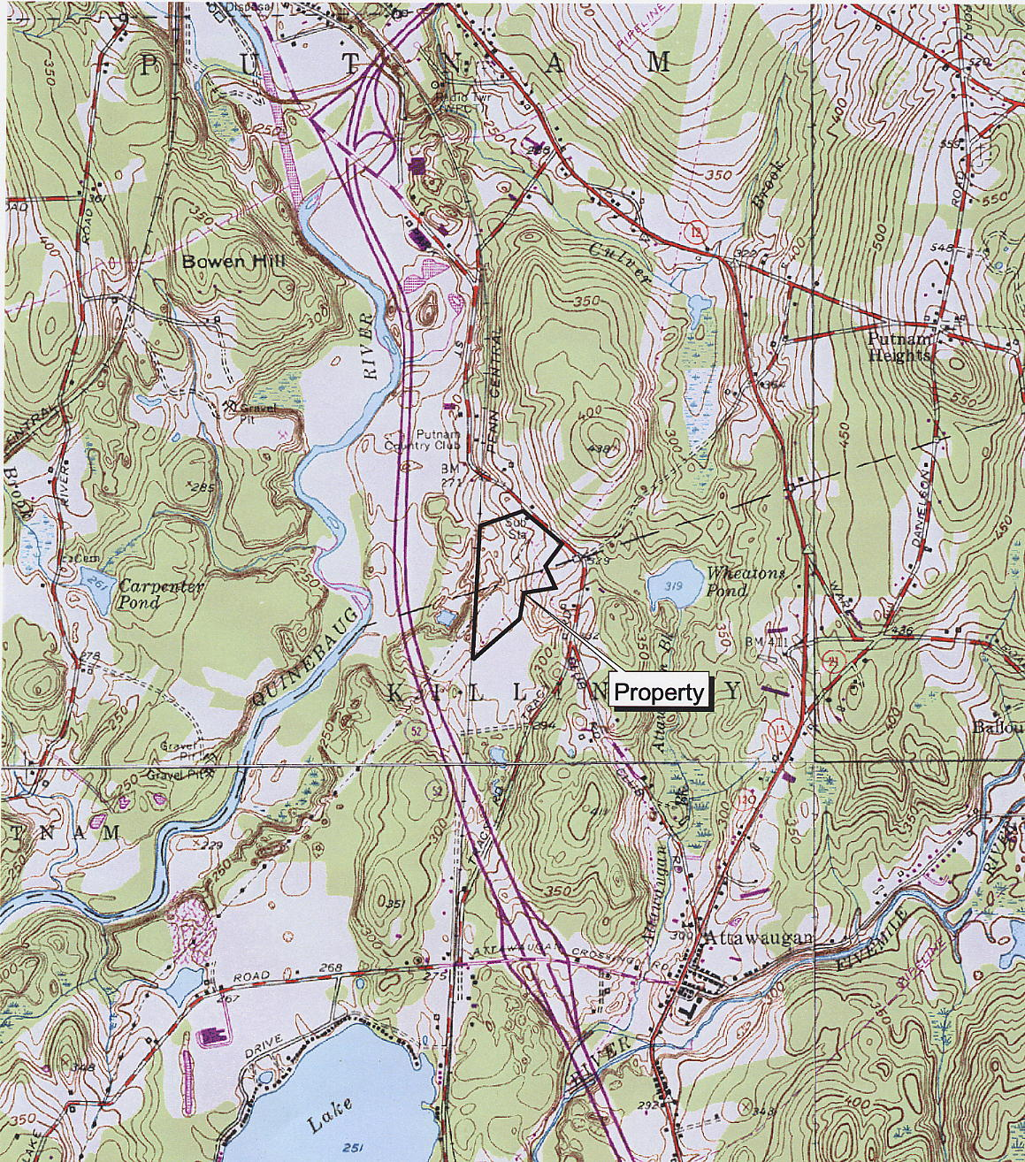
(CL&P 1, Vol. 2, Tab 6, Figure 1)

Map 2
Existing Electric Field Measurements

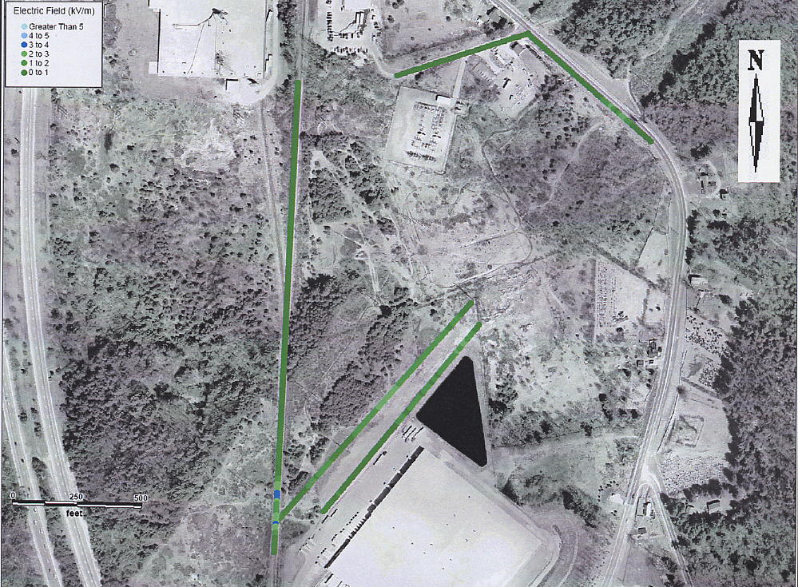
(CL&P 1, Vol. 2, Tab 12, p. 11)

Map 3
Existing Magnetic Field Measurements

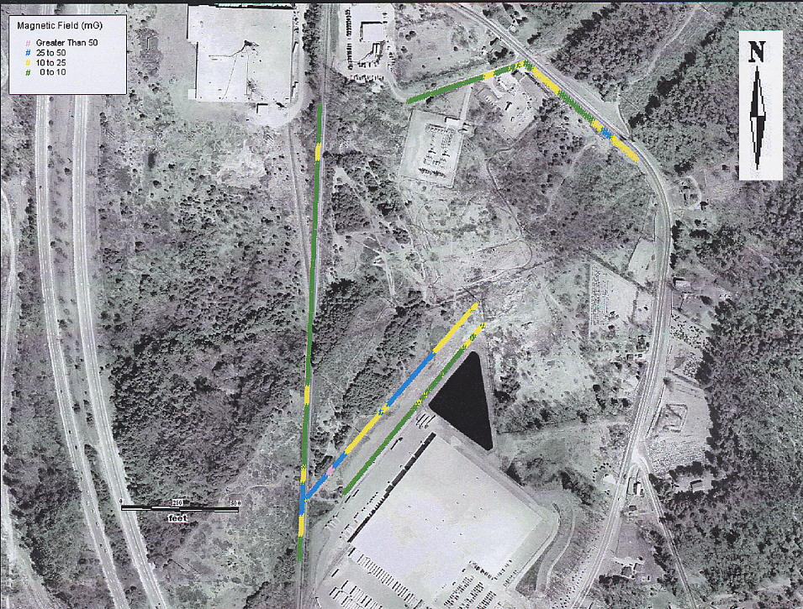
(CL&P 1, Vol. 2, Tab 12, p. 12)

Map 4
Measured Magnetic Fields Extrapolated to Expected Normal Load
Present Conditions

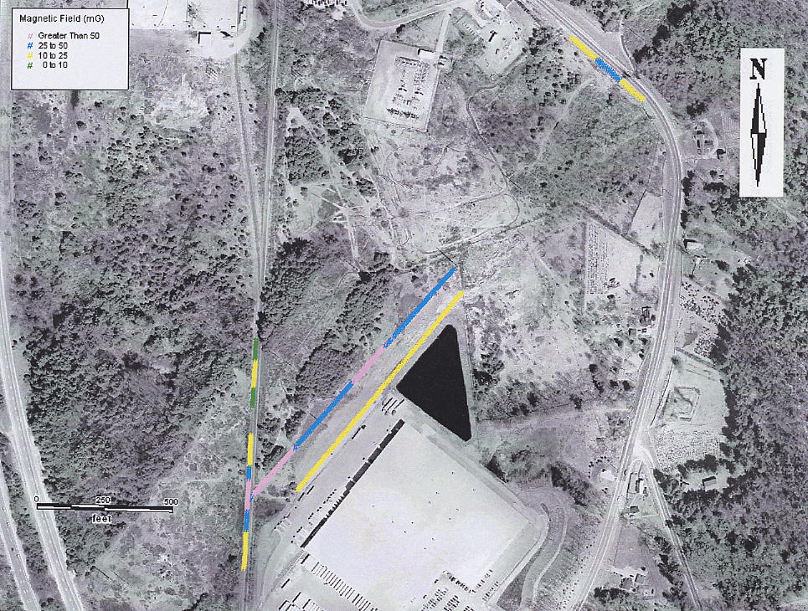
(CL&P 1, Vol. 2, Tab 12, p. 18)

Map 5
Measured Magnetic Field Extrapolated to Expected Normal Load
With Killingly 2G Substation

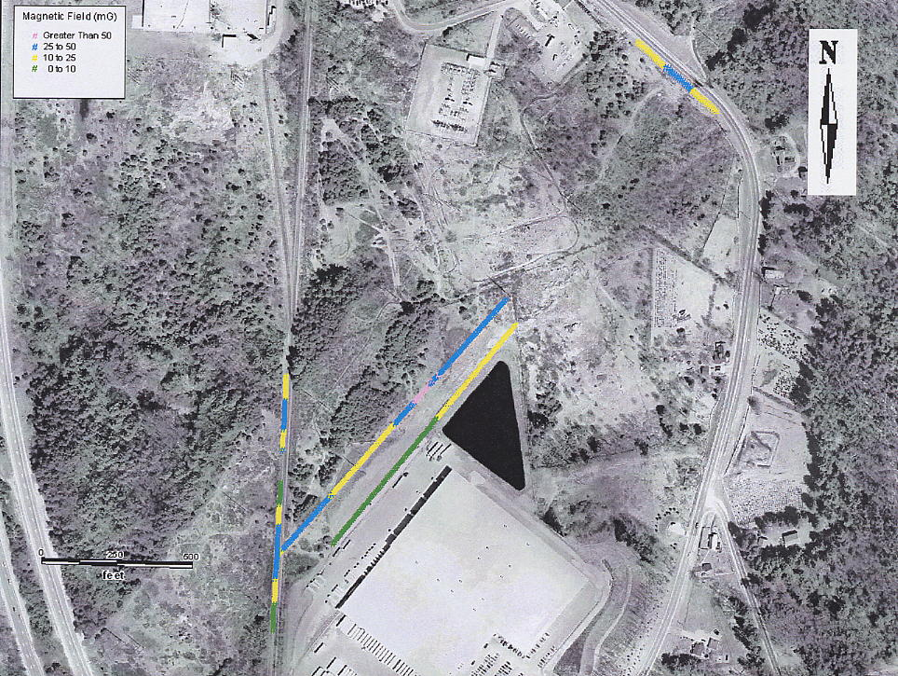
(CL&P 1, Vol. 2, Tab 12, p. 19)

Map 6
Measured Magnetic Field Extrapolated to Expected Peak Normal Load
Present Conditions

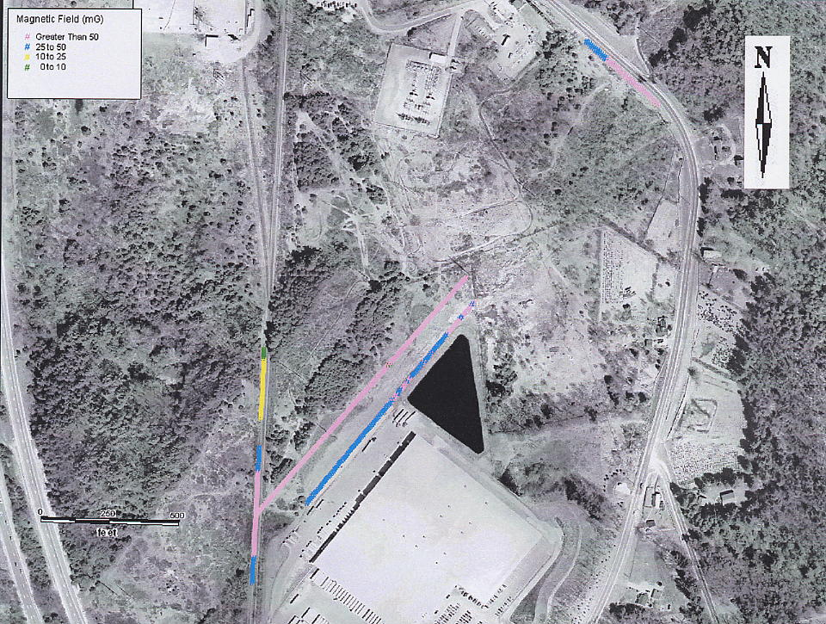
(CL&P 1, Vol. 2, Tab 12, p. 20)

Map 7
Measured Magnetic Field Extrapolated to Expected Peak Normal Load
With Killingly 2G Substation

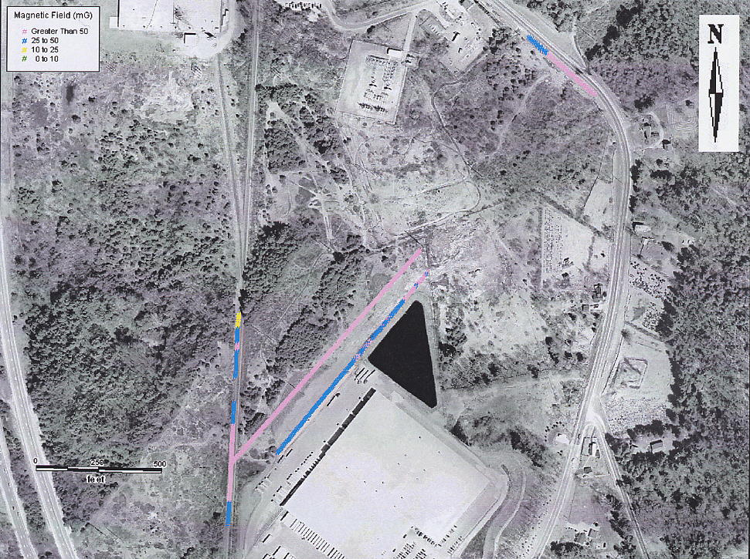
(CL&P 1, Vol. 2, Tab 12, p. 21)

Map 8
Modeled Magnetic Fields for Proposed Killingly 2G Substation
(Substation Components Only)

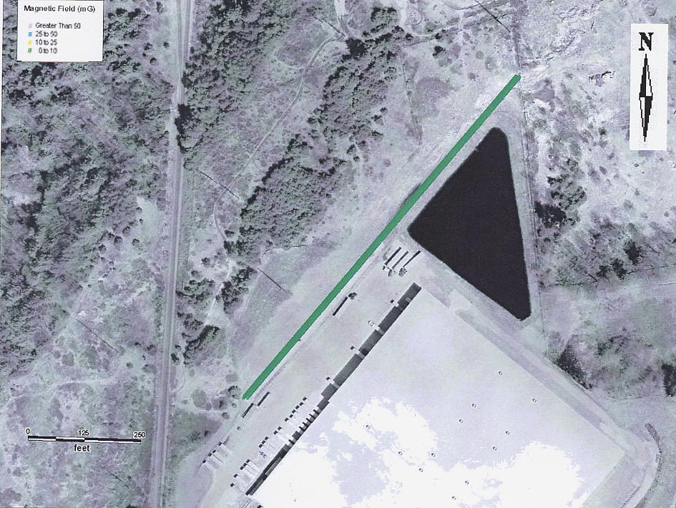
(CL&P 1, Vol. 2, Tab 12, p. 23)

