DOCKET NO. 246 – AT&T Wireless PCS, LLC d/b/a AT&T Wireless application for a Certificate of Environmental Compatibility and Public Need for the construction, maintenance and operation of a telecommunications facility at 31 Yurechko Drive, Griswold, Connecticut. | }  }  } | Connecticut  Siting  Council  July 22, 2003

Findings of Fact

Introduction

- Pursuant to Chapter 277a, Sections 16-50g et seq. of the Connecticut General Statutes (“CGS”), as amended, and Section 16-50j-1 et. seq. of the Regulations of Connecticut State Agencies (“RCSA”), AT&T Wireless PCS, LLC d/b/a AT&T Wireless (“AT&T”) applied to the Connecticut Siting Council (“Council”) on March 7, 2003 for the construction, operation, and maintenance of a telecommunications facility to be located in Griswold, Connecticut. (AT&T 1, p. 1)

- AT&T Wireless PCS, LLC d/b/a AT&T Wireless, is a Delaware limited liability company with an office at 12 Omega Drive, Stamford, Connecticut. The company’s member corporation, AT&T Wireless PCS, Inc. is licensed by the Federal Communications Commission (“FCC”) to construct and operate a personal wireless services system within the meaning of CGS Section 16-50(a)(6). (AT&T 1, p. 3)

- The FCC formally issued licenses to AT&T to provide personal communications services (“PCS”) for the New London-Norwich BTA, which includes New London County, in June of 1997. (AT&T 1, p. 5)

- The party in this proceeding is the applicant. (Transcript, May 28, 2003, 3:00 p.m. [Tr. 1], p. 4)

- Neither of the proposed sites is within 2,500 feet of the Town of Griswold’s municipal boundary. (AT&T 2, response 4)

- Pursuant to CGS § 16-50l(b), notice of AT&T’s intent to submit this application was published on four occasions in the Hartford Courant and in the Norwich Bulletin. AT&T first published notice on February 12 and 14, 2002. After this publication, AT&T delayed submission of its application. AT&T published notice again on March 6 and 7, 2003. (AT&T 1, p. 4; AT&T 2, response 1)

- In accordance with CGS § 16-50l(b), AT&T sent notices of its intent to file an application with the Council to each person appearing of record as owner of property abutting the property on which the two proposed Sites, A and B, are located. (AT&T 1, p. 4, Attachment 11)

- Return certificates of service were not received from two of the abutting owners to which AT&T mailed notices of intent to file an application. The two owners were the State of Connecticut and National Propane LP. AT&T made no additional efforts to notify these two owners. (AT&T 2, response 3)

- Pursuant to CGS § 16-50l(b), AT&T sent copies of its application to the following municipal, regional, state, and federal agencies and officials: Connecticut Attorney General, Department of Environmental Protection, Department of Public Health, Council on Environmental Quality, Department of Public Utility Control, Office of Policy and Management, Department of Economic and Community Development, Department of Transportation, Southeast Connecticut Council of Governments, Catherine W. Cook – State Senator from the 18th Senatorial District, Steve Mikutel – State Representative from the 45th Assembly District, Federal Aviation Administration, Federal Communications Commission, Paul Brycki — Town of Griswold First Selectman, F. Clyde Seaman — Griswold Planning and Zoning Commission Chairman, Theodore Faulise — Griswold Zoning Board of Appeals Chairman, Aleta DeRoy —Griswold Conservation Commission, and Inland Wetlands Commission Chairman. (AT&T 1, p. 4, Attachment 9)

- The Southeastern Connecticut Council of Governments determined that the proposed facility would not have any adverse inter-municipal impact. (April 25, 2003 letter from SECCOG)

- Pursuant to CGS § 16-50l, the Council solicited comments on AT&T’s application from the following state departments and agencies: Department of Environmental Protection, Department of Public Health, Council on Environmental Quality, Department of Public Utility Control, Office of Policy and Management, Department of Economic and Community Development, and the Department of Transportation. The Connecticut Department of Transportation was the only agency to respond to the Council’s solicitation. The Council’s letter requesting comments was sent on March 31, 2003. (CSC Hearing Package dated March 31, 2003)

- According to the Connecticut Department of Transportation, the proposed project may affect an airport. (Facisimile transmission received from ConnDOT on April 7, 2003)

- Pursuant to CGS § 16-50m, the Council, after giving due notice thereof, held a public hearing on May 28, 2003, beginning at 3:00 p.m. and continuing at 7:00 p.m. in Griswold, Connecticut. (Tr. 1, p. 2)

- During a field review of the proposed sites held on May 28, 2003 and attended by Council members and Council staff, the applicant flew balloons at a height of 170 feet, slightly above the proposed height of 160 feet, at each site. The flying conditions were excellent from 12:00 to 1:30 p.m. After that time, the wind increased and the balloons drifted between the heights of 150 and 160 feet. The balloons were raised at 12:00 p.m. and were flown until 7:00 p.m. (Tr. 1, p. 13)

Public Need for Service

- In passing the Telecommunications Act of 1996, the U.S. Congress, in part, sought to “provide for a competitive, deregulatory national policy framework designed to accelerate rapidly private sector deployment of advanced telecommunications and information technologies to all Americans.” (AT&T 1, p. 5)

- Congress enacted the Wireless Communications and Public Safety Act of 1999 (the “911 Act”). The purpose of this legislation was to promote public safety through the deployment of a seamless, nationwide emergency communications infrastructure that includes wireless communications services. In passing the 911 Act, Congress found that the establishment of a network that provided for the rapid, efficient deployment of emergency services would result in many public benefits, including faster delivery of emergency care with reduced fatalities and severity of injuries and improved service in rural areas. (AT&T 1, p. 7)

- As part of the 911 Act, the FCC mandated wireless carriers, such as AT&T, to provide enhanced 911 services (“E911”). (AT&T 1, p. 7)

- AT&T’s proposed facility would be an integral component of AT&T’s E911 services in Griswold. (AT&T 1, p. 7)

- AT&T has a coverage gap of approximately 2.5 miles on Route 138 in this vicinity and a coverage gap of approximately 2.7 miles on Route 201. AT&T’s proposed facility would cover the majority of these gaps. (AT&T 2, response 7)

PCS Service Design

- AT&T’s FCC licenses and associated FCC regulations require a timely build-out of AT&T’s network to ensure that spectrum licensed for PCS services is used effectively and is made available to as many communities as possible. (AT&T 1, p. 6)

- At the time of application, a gap existed in AT&T’s network coverage in the Town of Griswold, specifically in the area know as Pachaug, along Route 138 and adjacent areas in this portion of New London County. (AT&T 1, p. 6)

- Repeaters or microcell transmitters are not practicable or feasible means for providing coverage in this area of Griswold. These technologies are typically used for small “hole-filling” applications and are low power in nature. Filling AT&T’s existing coverage gap AT&T would require numerous microcell facilities in the place of the one facility being proposed. Repeaters require line-of-sight to on-air “donor” facilities and provide no added network capacity. (AT&T 2, response 8 )

- AT&T considers –85 dBm to be its minimum acceptable signal strength. (AT&T 2, response 13)

- AT&T’s proposed facility would hand off traffic to the following sites:

Site ID Address Owner Distance
CT-457 181A Norman Road New England Site Mgmt 1.3 mi.
Griswold

CT-480 131A Bishop Crossing Rd SBA 2.0 mi.
Griswold

CT-717 1439 Voluntown Rd Sprint Sites 2.6 mi.
Griswold

(AT&T 2, response 11)

Municipal Consultation

- Prior to applying to the Council, AT&T submitted a letter and a technical report to the First Selectman of the Town of Griswold on August 30, 2002 in accordance with CGS Sec. 16-50l(e). The letter introduced the proposed facility to town officials and invited them to discuss any comments or questions about the facility with AT&T. The technical report included specifics about each proposed location and addressed the public need for the facility, the site selection process, and the environmental effects of the proposed facility. (AT&T 1, p. 19)

- At the May 28 public hearing, the Griswold First Selectman stated that he favored the project. (Tr. 2, p. 5)

- At the May 28 public hearing, the Griswold Town Planner stated that he had no objection to the facility being proposed. (Tr. 2, p. 6)

Site Search

- The property on which the two alternative facility proposals are located was selected through a site search process that seeks to ensure the provision of high quality service in the area of coverage need and to have a minimal impact on the environment. (AT&T 1, Attachment 1, p. 2)

- In its site search, AT&T established a site search area in the vicinity of Voluntown Road (Route 138) with a radius of approximately one-half mile. It was located in the central area of a coverage gap between three surrounding towers which AT&T had targeted for shared use. (AT&T 2, response 10)

- In its site search, AT&T investigated seven potential sites within or near to its site search area. These sites, and their suitability, are identified in the table below:

Site Address | Suitability/Constraints
31 Yurechko Drive | Sites A and B
36 Old Bethel Road | Existing tower; environmental issues;  proximity to residences
Norman Road (Geer Hill) | Existing tower; too far west to cover required area
852 Voluntown Road | Owners not interested in tower lease
1061 Voluntown Road | Too far east to cover required area
1 Campbell Road | Too far east to cover required area
89 Bitgood Road | Visual impact on nearby residences
(AT&T 1, Attachment 4)

- During its site search process, AT&T found two communications towers within approximately two miles of the site search area. The two towers were:

Owner/Operator Location Height Griswold Transit Inc. 36 Old Bethel Road 70’
Griswold
New England Site Management 297 Norman Road 160’
Griswold
(AT&T 1, Attachment 4)

- The existing tower at Norman Road is located too far west to provide coverage to the Pachaug area AT&T seeks to cover with this facility. AT&T does have antennas on this tower to serve I-395. (AT&T 1, pp. 8-9)

- The existing tower at Old Bethel Road is not suitable due to ground space limitations, environmental issues, inadequate height, and proximity to residential properties. (AT&T 1, p. 9)

Project Description

- AT&T proposes to locate a wireless telecommunications facility in Griswold at one of two sites on the same property. These sites are identified as Site A and Site B. (AT&T 1, p. 2)

- The property on which the two alternative sites are proposed is located in a Rural Residential (R-80) zoning district. Wireless communications facilities are permitted in R-
80 districts as special exceptions. (AT&T 1 – Bulk file exhibit: Griswold Zoning Regulations, Sec. 11.19.4)

- At either Site, the monopole and equipment compound would be designed to accommodate up to five additional wireless carriers. (AT&T 1, p. 11)

- Site A is located in the west-central portion of a 70-acre parcel of property known as 31 Yurechko Drive. The property is owned by Philip Yurechko, Sr. and Jr. and is on the western side of Bitgood Road and Yurechko Drive. The latitude and longitude coordinates for Site A are 41° 35’ 38.7” N and 71° 55’ 59.5” W. The ground elevation at the base of the proposed tower at this site would be 200’ AMSL. (AT&T 1, p. 2, 10, Attachment 5)

- AT&T would lease a 100 foot by 100 foot area for the telecommunications facility. It would erect a 160-foot tall monopole on which AT&T would install up to 12 panel antennas. Associated equipment would be located on a concrete pad near the monopole’s base. The tower compound would measure 85 feet by 90. (AT&T 1, Attachment 5)

- The facility compound would be enclosed by an 8-foot tall security fence. (AT&T 1, p. 11)

- Vehicular access to Site A would extend from Bitgood Road over an existing improved roadway known as Yurechko Drive to its terminus and then southwesterly along a new 12-foot wide gravel driveway for a distance of approximately 1000 feet and then turn south-southeast for a distance of about 400 feet into the tower compound. (AT&T 1, Attachment 5)

- Utility services (telephone and electric) for Site A would be extended from Yurechko Drive and generally follow the access drive into the tower compound. (AT&T 1, Attachment 5)

- The closest residence to Site A is approximately 950 feet away and is the only residence within 1,000 feet of the site. (AT&T 1, p. 18)

- Estimated construction costs for Site A are as follows:
Electronic equipment costs $171,500
Tower and antenna costs $151,400
Site development costs $358,500
Total estimated costs $681,400
(AT&T 1, p. 21)

- Site B is located in the southwest portion of the Yurechko property. Its latitude and longitude coordinates are 41° 35’ 34” N and 71° 56’ 01.1” W. AT&T would lease a 100 foot by 100 foot area for the telecommunications facility. It would erect a 160-foot tall
monopole on which AT&T would install up to 12 panel antennas. Associated equipment would be located on a concrete pad near the monopole’s base. The tower compound
would measure 80 feet by 85 feet and would be large enough to accommodate equipment from other carriers who might locate on the monopole. (AT&T 1, Attachment 6)

- The Site B facility compound would be enclosed by an 8-foot tall security fence. (AT&T 1, p. 11)

- Vehicular access to Site B would extend from the northern end of Yurechko Drive along a new, 12’ wide gravel access drive located east and south for a distance of approximately 1800’ to the equipment compound. (AT&T 1, p. 11)

- Underground utility connections would extend from Yurechko Drive along the edge of the new gravel access drive. (AT&T 1, p. 11)

- There are two residences within 1,000 feet of Site B, with the closer one located approximately 600 feet from this proposed site. (AT&T 1, p. 18)

- Estimated construction costs for Site B are as follows:

Electronic equipment costs $196,300
Tower and antennas costs $150,800
Site development costs $440,300
Total estimated costs $787,400
(AT&T 1, p. 21)

- At either site, the minimum height needed by AT&T to achieve its coverage objectives is 120 feet. AT&T proposed a 160-foot tower at either site in order to provide for the possibility of tower sharing with other carriers. (Tr. 1, pp. 40-41)

- At either site, AT&T would bring in a diesel generator to provide emergency power in the event of a prolonged power outage. (Tr. 1, p. 26)

- At either site, the setback radius of the proposed tower is contained within the Yurechko property. (AT&T 1, Attachments 5 and 6, drawings SC-2B)

- At either site, the monopole would be built in accordance with the American National Standards Institute Standard TIA/EIA-222-F “Structural Standards for Steel Antenna Towers and Antenna Supporting Structures.” The foundation design would be based on soil conditions at the particular site. (AT&T 1, Attachments 5 & 6)

Environmental Considerations

- AT&T anticipates that no blasting would be required to develop either proposed site. (AT&T 2, response 23)

- There are no watercourses or wetlands located on or close to Site A or Site B. (AT&T 1, p. 19)

- Both Site A and Site B are located in a Flood Zone C, which is defined by the Federal Emergency Management Agency (“FEMA”) as an area of minimal flooding. (AT&T 1, p. 15)

- In accordance with the Connecticut Soil Erosion Control Guidelines, as established by the Council of Soil and Water Conservation, soil erosion control measures and other best management practices would be established and maintained throughout the construction of the proposed facility. (AT&T 1, p. 19)

- A total of six trees with a diameter greater than six inches at breast height would be removed during the development of the proposed access road and compound at Site A. A total of ten trees with a diameter greater than six inches at breast height would be removed during the development of the proposed access road and compound at Site B. (Tr. 1, p. 10)

- There are no town or state-designated scenic roads in Griswold. (AT&T 2, response 22)

- There are no known extant populations of Federal or State Endangered, Threatened or Special Concern Species at either of the proposed sites. (AT&T 1, Attachment 7)

- The proposed facility at Site A or Site B would have no effect on historic, architectural, or archaeological resources listed on or eligible for the National Register of Historic Places. Neither would a facility at this site have any effect upon properties of traditional cultural importance to Connecticut’s Native American communities. (AT&T 1, Attachment 7)

- AT&T conducted archaeological surveys at Site A and B at the request of the State Historic Preservation Officer. No archaeological resources were identified in AT&T’s surveys. (AT&T 1, p. 15)

- Using a methodology included in the FCC Office of Science and Technology Bulletin No. 65 (“OET Bulletin 65”), AT&T has calculated the maximum power density for its proposed facility. Based on the methodology AT&T used, the worst-case calculation of power density of AT&T’s operations at Site A would be 0.000353 mW/cm², or 0.04% of the applicable standard. For Site B, the worst-case calculation of power density for
AT&T’s operations would be 0.000353 mW/cm², or 0.04% of the applicable standard. (AT&T 1, p. 14)

- The calculated power density at Site A or B would be 0.0830 mW/cm², or 8.3% of the applicable standard, if all the facility’s antennas were pointed at the base of the tower and operating on all channels simultaneously, (AT&T 2, response 14)

- A part of Hopeville Pond State Park abuts the Yurechko property to the north. This portion of the Park, however, is undeveloped. (AT&T 2, response 24)

- The Yurechko property was formerly used as a gravel pit. After commercial gravel operations ended, the excavated land was covered with topsoil and used as a Christmas tree farm. (AT&T 2, response 19)

- There is a private landing strip located on the Yurechko property. The nearest point of the landing strip to either proposed facility is approximately 560 feet to the side of Site A and 753 feet to the side of Site B. (Tr. 1, p. 21)

- Neither proposed site would require registration with the Federal Aviation Administration. (AT&T 1, p. 20)

Visibility

- A tower at either of the proposed sites may be visible from portions of the Nehantic Trail, which is part of Connecticut’s Blue Trail system and which intersects Route 138 near Bitgood Road. (Tr. 1, p. 74)

- The proposed tower at Site A or B would be largely obscured by trees when viewed from the beaches located at Hopeville Pond State Park. (Tr. 1, p. 32)

- A tower at either proposed site would be visible for a short distance at the intersections of Edmund Road with Hemlock Drive and Leha Avenue. (Tr. 1, 33)

- Both proposed sites would be intermittently visible along Edmund Road. (Tr. 1, p. 34)

- On Voluntown Road (Route 138), the proposed sites would be visible from a point opposite the Geer Christmas Tree store and the Geer sand and gravel pit. (Tr. 1, p. 34)

- There are several residential properties on Bitgood Road from which the top of a tower at the proposed sites would be visible. A tower at Site B would have slightly greater visibility than Site A because it is located closer to Bitgood Road. (Tr. 1, p. 35)

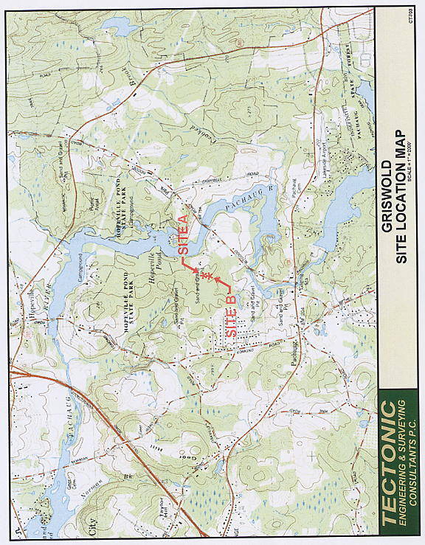

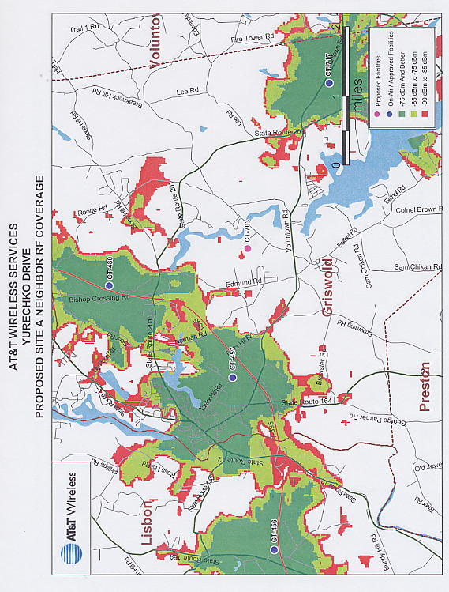

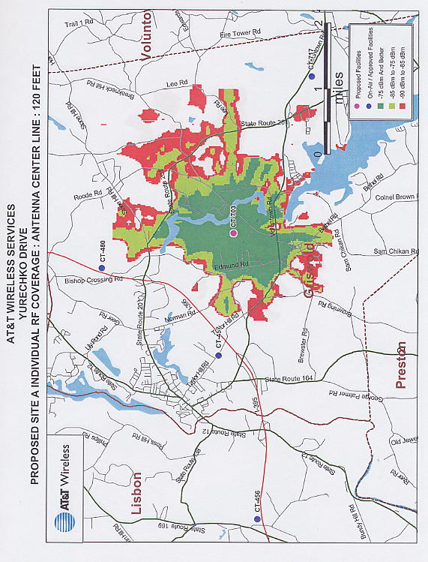S



