DOCKET NO. 218 - Crown Atlantic Company LLC and Cellco Partnership d/b/a Verizon Wireless application for a Certificate of Environmental Compatibility and Public Need for the construction, maintenance, and operation of a cellular telecommunications facility on 744 Middletown Road, Lot 65A Westchester Road, or Lot 13 Middletown Road, Colchester, Connecticut. | }  }  }  } | Connecticut  Siting  Council  May 7, 2002

Findings of Fact

Introduction

- Crown Atlantic Company, LLC (Crown) and Cellco Partnership (Cellco) d/b/a Verizon (collectively the applicant) in accordance with provisions of General Statutes §16-50g through 16-50 aa applied to the Connecticut Siting Council (Council) on November 5, 2001 for the construction, operation, and maintenance of a telecommunication facility in the Town of Colchester, Connecticut. The proposed sites are located at 744 Middletown Road, Colchester (Site No. 1), Lot 65A Westchester Road, Colchester (Site No. 2); and at Lot 13 Middletown Road, Colchester (Site No. 3)(See Appendix A). The purpose of the proposed facility is to provide cellular coverage to existing coverage gaps in the Colchester area along Route 16 and 149, and local roads, and off-load traffic from Cellco sites in Colchester, East Hampton and Salem, Connecticut. (Applicant 1, pp. 1, 2, 8, 11 Tab 1; Applicant 5, PHQ. 6, Transcript February 13, 2002, (Tr. 1, pp. 22-26, 28-33)

- Pursuant to General Statutes §16-50m, the Council, after giving due notice thereof held a public hearing on February 13, 2002, beginning at 3:00 p.m. and continuing at 7:00 p.m. in the Colchester Town Hall, 127 Norwich Avenue, Colchester, Connecticut. (Tr. 1, p. 2; Transcript, February 13, 2002, 7:00 p.m. (Tr. 2), p. 2)

- The party in this proceeding is the applicant. (Tr. 1, p.4)

- Public notice of the application was published in The Hartford Courant on October 31, 2001 and November 1, 2001. (Applicant 2)

- The Council and its staff made an inspection of the proposed sites on February 13, 2002. During the field inspection, the applicant flew a balloon at each of the proposed sites; however, due to high winds that day, the balloons did not reach heights representative of the proposed 180-foot tower. (Tr. 1, pp. 37-38)

Cellular Service Design

- In 1981 the Federal Communications Commission (FCC) recognized the public need for technical improvement, wide area coverage, high quality service and competition in mobile telephone service. Cellular system design allows for the configuration of cell sites so that the same frequencies can be used at the same time in different cells (frequency reuse) and to provide uninterrupted service throughout a service area (hand-off). (Applicant 1, p. 6, p. 9)

Public Need for Cellular Service

- In 1996, the United States Congress recognized a nationwide public need for high quality wireless telecommunications services, including cellular telephone service. Through the Federal Telecommunications Act of 1996, Congress seeks to promote competition, encourage technical innovation, and foster lower prices for wireless telecommunications services. (Federal Telecommunications Act of 1996; Applicant 1, pp. 6-7)

- In issuing cellular licenses, the federal government has pre-empted the determination of public need for cellular service by the states and municipalities, and has established technical standards to ensure the technical integrity of each system and nationwide compatibility of all systems. (Applicant 1, p. 7)

- Pursuant to FCC authorizations, Cellco has constructed and currently operates cellular service in the Fairfield, New Haven, Hartford and New London New England County Metropolitan Area (NECMAs) as the non-wireline cellular service provider. (Applicant 1, pp. 7-8)

Site Alternatives Considered by the Applicant

- Cellco investigated 7 sites in the Colchester area, three of which were selected as the proposed number one, two and three sites in this application. The remaining Colchester sites which were rejected are as follows:
- 9 Loomis Road; this 5.7 acre parcel was rejected because Crown was unable to reach an agreement with the property owner.
- 111 Loomis Road; this 4.87 acre parcel consists largely of wetlands and was therefore determined to be unsuitable.
- 119 Loomis Road; this 3.2 acre parcel was rejected by Crown because the property owner has a lease with another company.
- 752 Middletown Road, this 3.5 acre parcel was determined by Crown to be unsuitable for development. (Applicant 1, Tab 2, pp. 2-3)

- During its site selection process, Crown identified five existing telecommunications towers within approximately nine miles of the site search area. Cellco presently has antennas attached to three of the towers; the other two towers were rejected because they would not provide coverage to existing Cellco coverage gaps in the Colchester area.

Existing Towers Considered in the Colchester Area

Tower Owner/Operator | Location | Tower Height (ft) | Cellco Antennas (ft)
Sprint | 94 East High St.,  East Hampton | 120 | 105
American Tower Corp | East Haddam Rd.,  Salem | 190
Century Cable Management | Parker Rd.,  East Haddam | 300
Dept. of Public Safety | Windham Ave.,  Colchester | 320 | 220
SBA | Rt. 2, 48 Westchester St.,  Colchester | 180 | 167.5
Applicant 1, Tab 2, p. 1, Applicant 4, PHQ. 5)

- Cellco considered installing antennas within the Westchester Congregational Church, 95 Cemetery Road, Colchester, but due to height limitations, would be unable to satisfy its coverage needs. A 180-foot tower would be required to satisfy coverage requirements from this site. Use of repeater antennas at the church steeple would leave gaps in surrounding areas and could result in as many as four sites to cover gaps in the area. (Applicant 1, Tab 2, p. 2, Tr. 1, pp. 13-15)

- The applicant also investigated the use of an existing 180-foot SBA tower on Davidson Road in Colchester, subsequent to the filing of this application. The tower is approximately three miles east of the applicant’s search area and would not satisfy Cellco’s coverage requirements. A 180-foot tower at 600 Old Hartford Road was investigated, but was rejected because it is approximately five miles from the area Cellco is seeking to cover, and would not satisfy coverage needs in the area. (Tr. 1, p. 8; Applicant 6, PHQ. 13)

- The applicant was contacted by a church official regarding the possible lease of property at the intersection Route 16 and Skinner Road. The property is surrounded by residence and is lower in elevation than the other proposed sites, and would not satisfy Cellco’s coverage needs. (Tr. 1, pp. 8-9)

Municipal Consultation

- On August 7, 2001, representatives of the applicant met with the First Selectman of Colchester regarding the applicant’s plans for the development of a cell site in Colchester, and provided a Technical Report to the First Selectman. (Applicant 1, pp. 20-21)

- At the hearing on February 13, 2002, a Town of Colchester Planning Director indicated the Town’s preference would be Site No. 3. (Tr. 1 p. 69, pp. 71-72)

Proposed Site Number One

- Proposed site number one is a 7484 square foot leased area within an approximately 0.81 acre parcel of land owned by Athana Soula and Maria Sourvalis at 744 Middletown Road (Route 16) in Colchester. The proposed site is zoned General Commercial (C). The proposed site is located in the northwest quadrant of the intersection of Routes 16 and 149, in a cleared grassed portion of land next to a parking lot and north of Maria’s Pizza Palace. The proposed site is level with direct access from a parking lot. Although some scattered edges are present, no wetland functions exist on the site. (DEP Comments, 2/8/02; Applicant 1, p. 2, Tab 3, p. 1, p. 6)

- There are approximately 34 residences within a 1,000-foot radius of the proposed site the nearest of which is approximately 300 feet to the southeast of the proposed site. (Applicant 1, p. 15)

- Access to the proposed site would be from Route 16 via a 30-foot wide access and utility easement approximately 350 feet in length. (Applicant 5, PHQ. 1 Supplemental Response)

- The proposed site has an elevation of approximately 577 feet above mean sea level (AMSL). (Applicant 1, Tab 3, p. 6)

- The proposed No. 1 tower would be a 180-foot monopole on which Cellco would attach its antennas at approximately 180 feet AGL, and mount one GPS antenna at 70 feet AGL. (Applicant 1, Tab 3, p. 6, p. 8)

- The visibility of the proposed number one tower from various locations in the area is estimated as follows:

Tower Visibility

Location | Distance (feet) | Visibility
Day Pond | 3400 | Marginally visible
Route 149/Cemetery Rd. int. | 1700 | Not visible
Route 16 to east | 600 | Visible
Route 16/Rt. 149 int. | 400 | Visible
Loomis Rd. | 1000 | Not visible
Rt. 16 to south | 350 | Visible
(Applicant 1, Tab 3, pp. 13-21; DEP Comments, 2/8/02; Applicant 5 PHQ. 7, photosimulations)

- Residences with views of the proposed tower would include two homes to the east on Westchester Road, 10 homes on West Ridge Road to the north, and several homes along Route 16 to the southwest. The proposed tower would appear virtually unscreened and prominent to viewers along Route 16 facing westward to the Route 16/Route 149 intersection. (DEP Comments, 2/8/02)

- The proposed number one tower would be visible from the Henry Champion House, a site listed on the National Register of Historic Places, at distance of approximately 1100 feet. (Applicant 5, PHQ. 7, photosimulations)

- The approximate cost of construction and materials for the proposed number one site is estimated as follows:

Cell site radio equipment | $650,000.
Tower and antennas | 100,000.
Power systems | 45,000.
Building costs | 65,000.
Miscellaneous (including site preparation  and installation) | 150,000.
Total | $1,010,000.
(Applicant 1, p. 22)

- The tower radius of the proposed 180-foot tower would extend onto undeveloped portions of adjacent parcels to the north, west and east. (Applicant 5, PHQ. 1, Supplemental Response)

- No trees with a diameter breast height (dbh) of greater than six inches would be removed for the proposed access road or tower compound. (Applicant 4, PHQ. 2)

Proposed Site Number Two

- The proposed number two site is a 100-foot by 100-foot leased area within an approximately 1.6 acre parcel of land owned by Frank and Pat Adams at Lot 65A Westchester Road (Rt. 149) Colchester. The proposed site is zoned C, and is within a wooded lot approximately 200 feet northwest of proposed site No. 1. The proposed site is level with black birch and Grey birch 2-4 inches dbh and red cedar as tree cover. Both the proposed site and access route are wooded and would require clearing if developed. (Applicant 1, p. 2; Tab 4, p. 1; DEP Comments, 2/8/02)

- There are approximately 39 residences within a 1000-foot radius of proposed site No. 2, the nearest of which is approximately 210 feet to the northwest of the proposed site (Applicant 1, p. 15, Tr. 1, pp. 9-10)

- Access to the site would be from Westchester Road along an access and utility easement for a distance of approximately 475 feet. (Applicant 1, p. 2, Tab 4, pp. 1, 4, 7)

- The proposed number two site has an elevation of approximately 579 feet AMSL. (Applicant 1, Tab 4, p. 6)

- The proposed No. 2 site tower would be a 180-foot monopole on which Cellco would attach its antennas at approximately 180 feet AGL, and mount one GPS antenna at 70 feet AGL. (Applicant 1, Tab 4, p. 6, p. 8)

- The visibility of the proposed number two tower from various locations in the area is estimated as follows:

Tower Visibility

Location | Distance (feet) | Visibility
Day Pond | 3200 | Marginally visible
Peck Lane/Cemetery Rd. int. | 1600 | Not visible
Route 16/Rt. 149 int. | 650 | Visible
Route 16 to east | 800 | Visible
Loomis Road | 1300 | Not visible
Route 16 to south | 600 | Visible
(Applicant 1, Tab 4, pp. 11-21; DEP Comments, 2/8/02)

- The proposed site number two tower would appear virtually unscreened and prominent to viewers along Route 16 facing westward to the Route 16/Route 149 intersection. (DEP Comments, 2/8/02)

- The proposed number two tower would be visible from the Henry Champion House at a distance of approximately 1300 feet. (Applicant 5, PHQ. 7, photo simulations)
- The approximate cost of construction and materials for the proposed number two site is estimated
as follows:

Cell site radio equipment | $650,000.
Tower and antennas | 100,000.
Power systems | 45,000.
Building costs | 65,000.
Miscellaneous (including site preparation  and installation) | 170,000.
Total | $1,030,000.
(Applicant 1, p. 23)

- The tower radius for the proposed number two tower would include adjacent properties to the north, west and south. (Applicant 4, PHQ. 1, Map)

- Approximately 33 trees with a dbh of greater than six inches would be removed for the construction of the access road and no trees with a dbh of greater than six inches would be removed for the construction of the tower compound. (Applicant 4, PHQ. 2)

Proposed Site Number Three

- The proposed number three site is a 100-foot by 100-foot leased area within an approximately 63-acre parcel of land owned by Lorraine M. Leone at Lot 13 Middletown Road, Colchester. The proposed site is zoned Rural Residential (R-60), and is approximately 0.8 miles west of proposed sites number one and two, and north of Route 16 within a cleared area surrounded by mature forest. The proposed site is well drained, level to gently sloping and contains herbaceous growth and some pioneering shrubs. (Applicant 1, Tab 5, p. 1, p. 6; DEP Comments, 2/8/02)

- There are no residences within a 1000-foot radius of proposed site number three. The closest residence is approximately 1050 feet to the southwest of the proposed site on an adjacent property owned by the lessor. (Tr. 1, p. 10; Applicant, p. 15)

- Access to proposed site number three would be from Route 16 over an existing logging road which would need only minor improvement a distance of approximately 1950 feet. The proposed tower site is in the northwesterly portion of the leased parcel. (Applicant 1, Tab 5, p. 1, p. 3; DEP Comments 2/8/02)

- The proposed number three site has an elevation of approximately 564 feet AMSL. (Applicant 1, Tab 5, p.6)

- The proposed number three site tower would be a 180-foot monopole on which Cellco would attach its antennas at approximately 180 feet AGL and mount one GPS antenna at 70 feet AGL. (Applicant 1, Tab 5, p. 6, pp. 8-9)

The visibility of the proposed number three tower from various locations in the area is estimated as follows:

Tower Visibility

Location | Distance (feet) | Visibility
Day Pond | 2300 | Not visible
Rt. 149 (to east) | 3600 | Visible
Route 16 (to south) | 4500 | Not visible
Rt. 16/ Rt. 149 int. | 4200 | Not visible
Mary Lane | 3200 | Not visible
Route 16 (to west) | 3700 | Partially visible
Old Comstock Bridge | 6000 | Not visible
Victoria Drive | 1600 | Visible
(Applicant 1, Tab 5 pp. 11-19; Applicant 5, PHQ. 7, photo simulations and location map; Tr. 1, p. 45, pp. 66-67)

- The proposed number three site tower would not be visible from Air Line State Trail at a distance of approximately two miles to the northwest. The proposed site is within 400 feet of a boundary of the Salmon River State Forest. A portion of the Salmon River Trail is located approximately 1200 feet north/northeast of proposed site three. (Tr. 1 p. 11, p. 45; DEP Comments, 2/8/02; Connecticut Walk Book, p. 165 map; Applicant 6, PHQ. 9)

- The construction of the proposed number three tower would not alter the rural setting of the Comstock Bridge, which is listed on the National Register of Historic Places. The proposed number three tower would not be visible from the Henry Champion House, at a distance of approximately 4800 feet. (Applicant 5, PHQ. 7, photo simulations; Applicant 7, letter of 11/19/01 from Connecticut Historical Commission)

- The approximate cost of construction and materials for the proposed number three site is estimated as follows:

Cell site radio equipment | $650,000.
Tower and antennas | 100,000.
Power systems | 45,000.
Building costs | 65,000.
Miscellaneous (including site preparation  and installation) | 300,000.
Total | $1,116,000.
(Applicant 1, p. 23)

- The tower radius for the proposed number three tower would be contained entirely within the lessor’s property. (Applicant 4, PHQ. 1, Map)

- An estimated two trees with a dbh greater than six inches would be removed to construct the proposed access road, and no trees of six inches dbh or greater would be removed to construct the tower site compound. (Applicant 4, PHQ. 2)

Associated Equipment

- The proposed number one, two or three cell site would be a 56-foot by 62-foot fenced compound with a 12-foot by 30-foot Cellco equipment building. Three 12-foot by 20-foot concrete pads would be installed to hold future shelters. The surface of the tower compound yard would consist of crushed stone. An emergency diesel back-up generator pad would be installed inside Cellco’s tower compound. (Applicant 1, Tab 3, p. 5; Tab 4, p. 5; Tab 5, p. 5)

Environmental Concerns

- There are no town or state designated scenic roads in Colchester. The nearest scenic road is a portion of Route 154 in Haddam, approximately seven miles from the proposed sites. (Applicant 6, PHQ. 10)
- Phase I Archaeological Surveys were conducted for proposed sites one, two and three. No prehistoric artifacts were recovered, and the State Historic Preservation Office (SHPO) determined no further archaeological investigations were warranted, and the construction of the proposed towers would have no effect on the State’s archaeological heritage. (Applicant 1, Tab 6, SHPO letter of 6/21/01; Applicant 8, SHPO letter of 1/10/02)

- The DEP Natural Diversity Database indicated that two species of special concern, the eastern hognose snake (Heterodon platyrhinos) and the wood turtle (Clemmys insculpta) may occur in the vicinity of proposed sites one and two, and that the eastern hognose snake occurs in close proximity to proposed site number three. The eastern hognose snake occurs to the north of the proposed project area, and the wood turtle to the east of the proposed project area and neither should be impacted by construction at any of the proposed sites. (Applicant 1, Tab 6, DEP Letters of 8/12/00, 8/30/00, 10/24/01, and 10/25/01)

- There are no wetlands on the properties or on the routes of proposed access roads of the proposed number one, two or three sites. (Applicant 1, Tab 3, p. 10, Tab 4, p. 10, Tab 5, p. 10; Applicant 1, p. 20)

- The applicant performed a FAA Aviations Systems area study which considers the locations of the nearest airports to the proposed sites, and determined none of the proposed 180-foot towers in this application would be required to be obstruction marked and lighted. The nearest public use or military airfield to the search area is the Salmon River Airfield, 16,512 feet from the center point of the applicant’s search area. A private airport is located off Chestnut Hill Road, approximately five miles from the intersection of Route 16 and Route 149. (Tr. 1, pp. 46-47, p. 68; Applicant 1, p. 21)

56. The total electromagnetic radiofrequency (RF) power density, calculated using FCC Office of Engineering Bulletin 65 using conservative worst-case exposures at the base of the three proposed 180-foot towers would not exceed the American National Standards Institute Standards (ANSI) and is estimated as 0.210 MW/cm² , or 3.6 percent of the standard. (Applicant 1, p. 17)
Coverage Propagations

57. Existing Cellco coverage and gaps defined on areas receiving <-90dbm coverage or state routes 16 and 149 in Colchester are as follows

Route | Gaps  (approx miles)  <-90dbm
16 | 1.75
149 | 0.1
1.85
miles total gaps

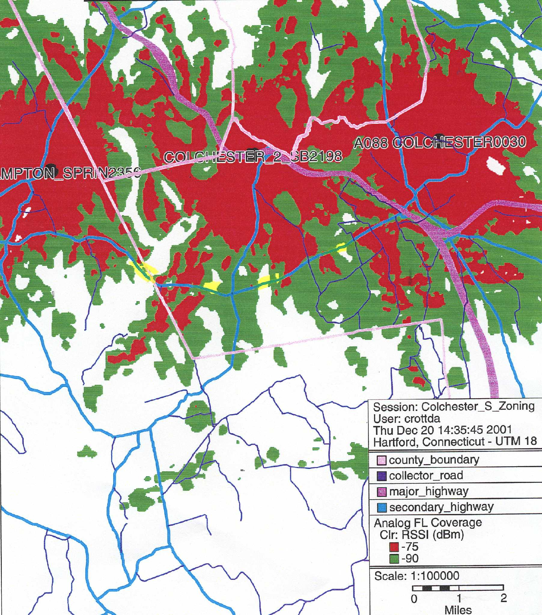
(Applicant 5, PHQ. 6 coverage maps; Tr. 1, pp. 24-25)

58. Placing Cellco antennas on the proposed site number one or number two tower at a height of 180 feet above ground level (AGL) combined with existing Cellco coverage would leave the following coverage gaps on state routes 16 and 149 in Colchester:

Route | Gaps  (approx miles)  <-90dbm
16 | 0.2
149 | 0
0.2
miles total gaps

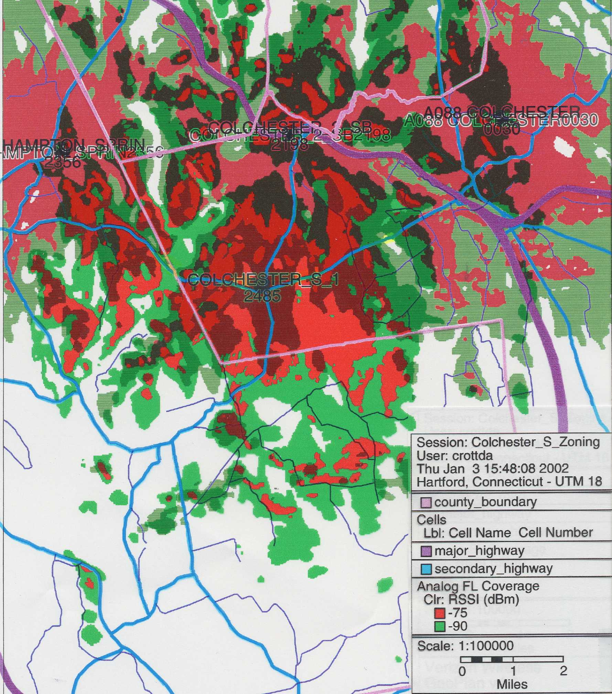
(Applicant 5, PHQ. 6, coverage maps)
59. Placing Cellco antennas on the proposed site number three tower at a height of 180 feet AGL combined with existing Cellco coverage would leave the following coverage gaps on state routes 16 and 149 in Colchester.

Route | Gaps  (approx miles)  <-90dbm
16 | 0.3
149 | 0
0.3
miles total gaps

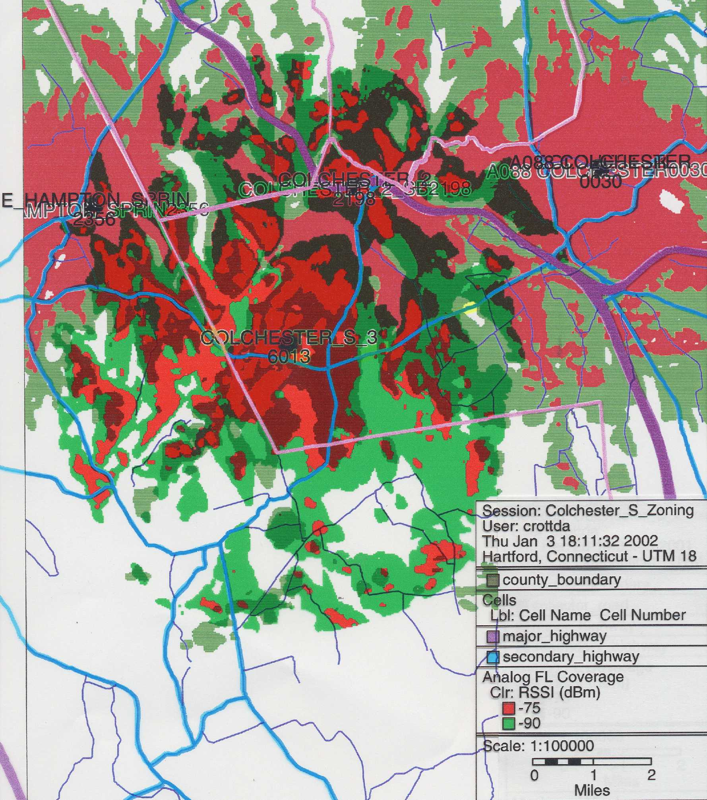
(Applicant 5, PHQ. 6, coverage maps)
60. Placing Cellco antennas on the proposed site number three tower at a height of 150 feet AGL combined with existing Cellco coverage would leave the following coverage gaps on state routes 16 and 149 in Colchester:

Route | Gaps  (approx miles)  <-90dbm
16 | 0.6
149 | 0
0.6
miles total gaps

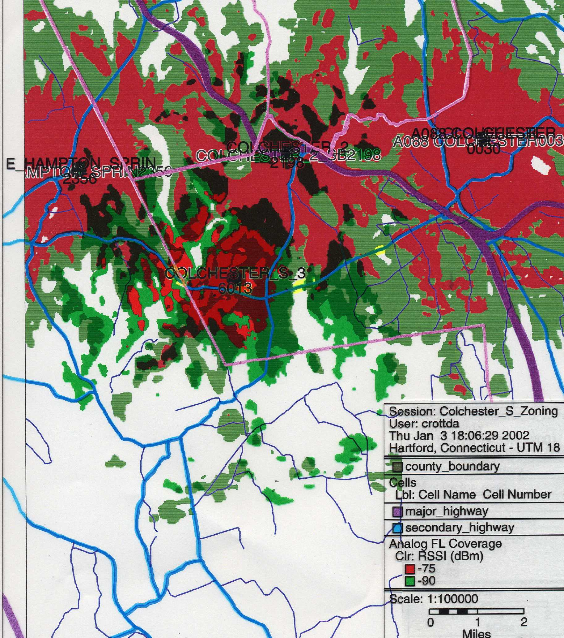
(Applicant 5, PHQ. 6, coverage maps)
61. Placing Cellco antennas on the proposed site number three tower at a height of 110 feet AGL combined with existing Cellco coverage would leave the following coverage gaps on state routes 16 and 149 in Colchester:

Route | Gaps  (approx miles)  <-90dbm
16 | 0.7
149 | 0
0.7
miles total gaps

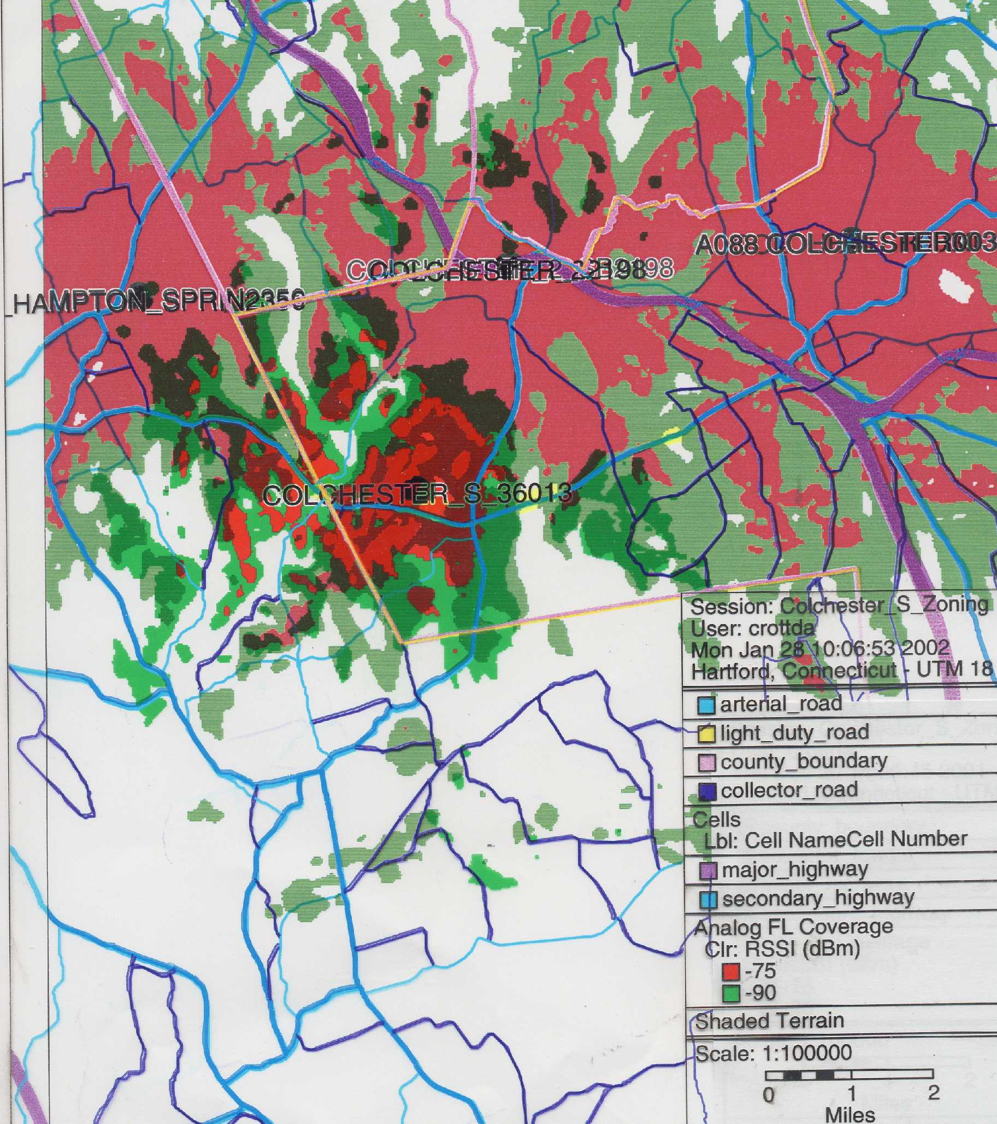
(Applicant 6, PHQ. 11, coverage maps)
62. The applicant provided information regarding proposed Colchester sites number one, two and three to Sprint Spectrum L.P. d/b/a Sprint PCS and Nextel Communications, Inc. but neither indicated an interest in any of the proposed Colchester sites. The applicant has no firm commitments from other carriers for any of the proposed Colchester towers. (Tr. 1, pp. 27-28)

63. The Town of Colchester was offered use of the proposed Colchester tower, but did not respond. (Tr. 1, p. 33)

APPENDIX A

Map of Proposed Sites

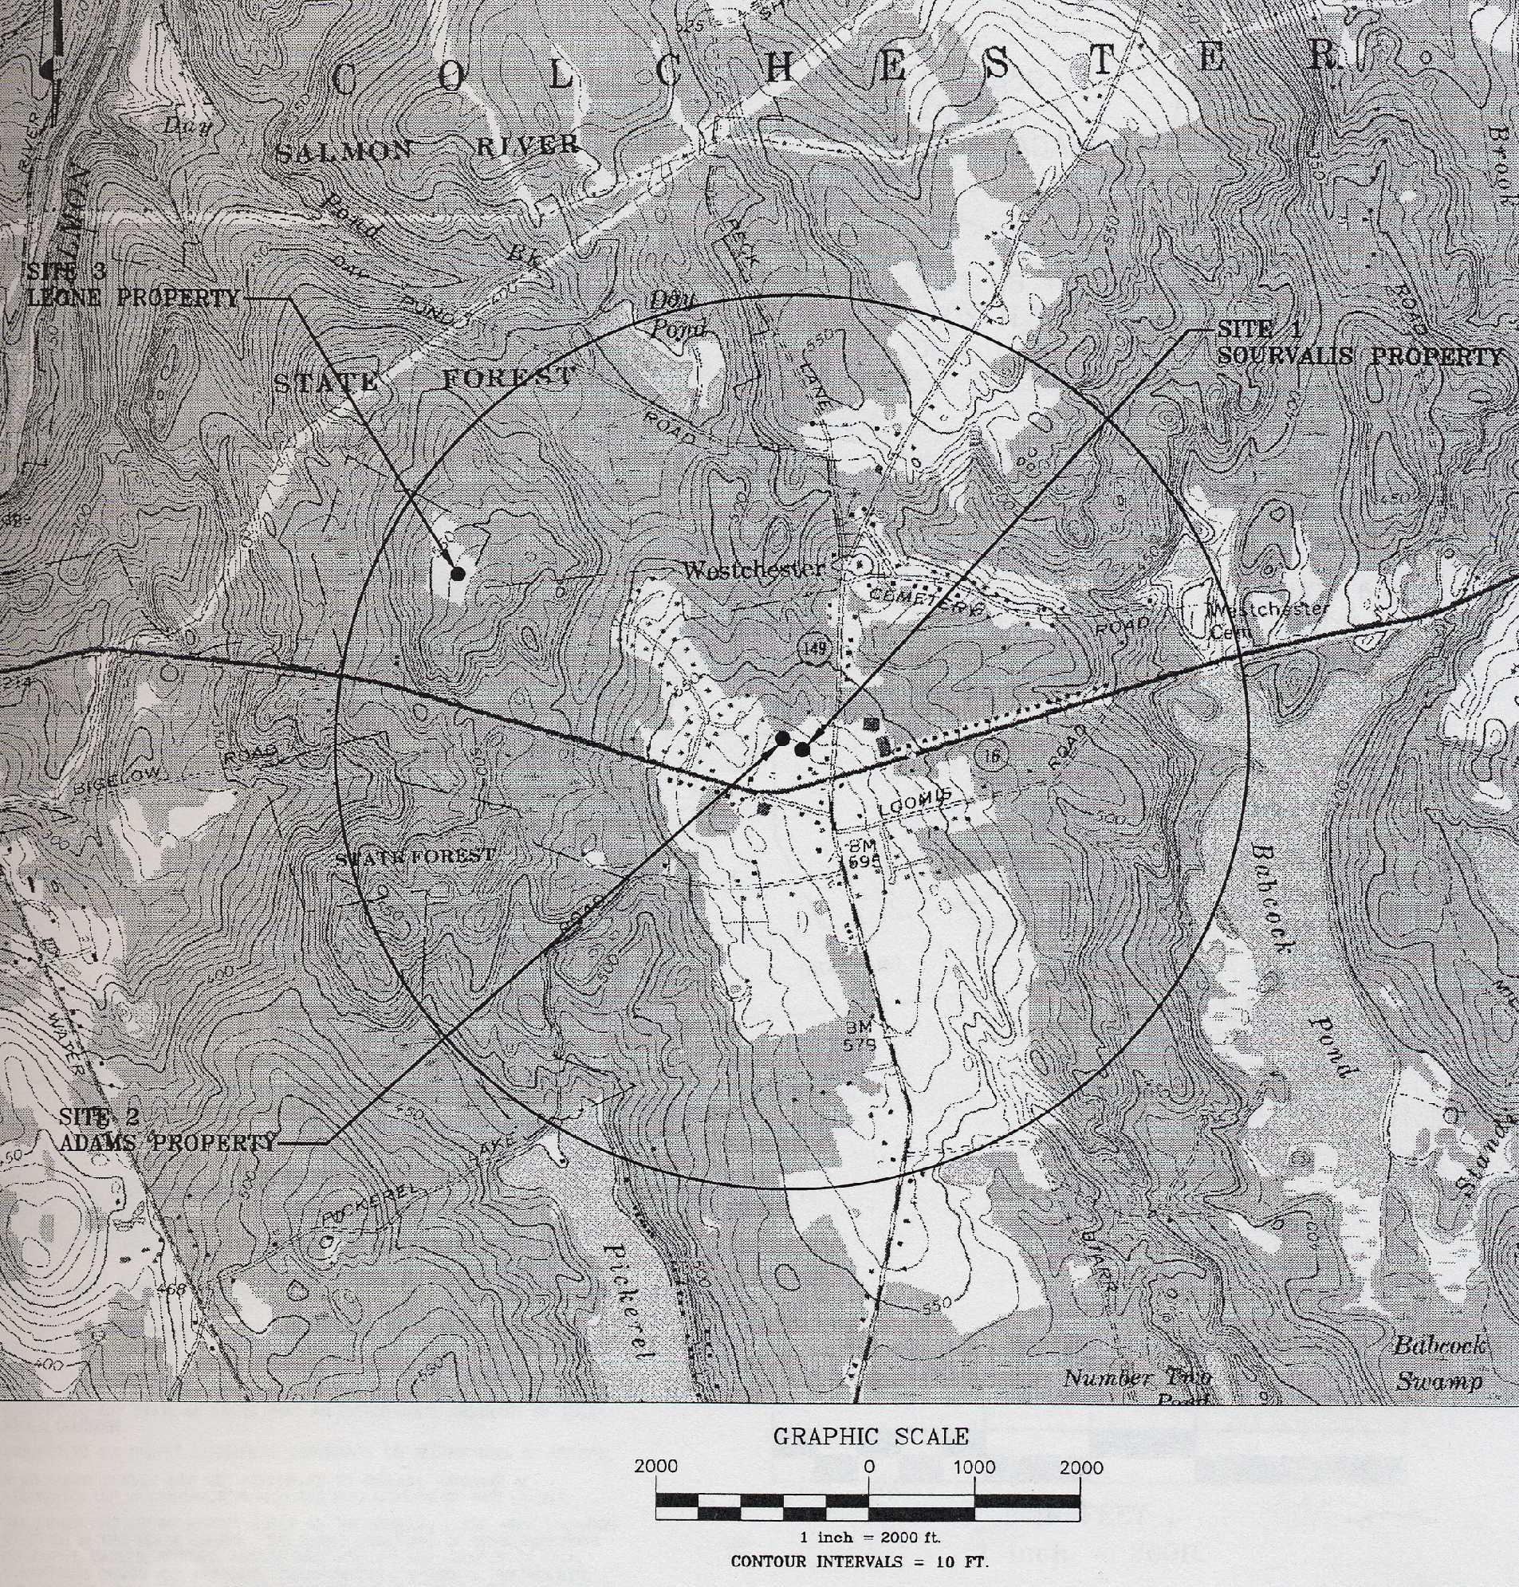
(Applicant 1, Tab 4, pg. 2)

