DOCKET NO. 211 - Crown Atlantic Company LLC and Cellco Partnership d/b/a Verizon Wireless application for a Certificate of Environmental Compatibility and Public Need for the construction, maintenance, and operation of a cellular telecommunications facility at 31 Ridge Road (Lot 57) or at Lot 54 Palmer Road, Chaplin, Connecticut. | }  }  }  } | Connecticut  Siting  Council  February 14, 2002

Findings of Fact
Introduction

- Crown Atlantic Company LLC (Crown) and Cellco Partnership (Cellco) d/b/a Verizon (collectively, the applicant) in accordance with provisions of General Statutes §§ 16-50g through 16-50aa applied to the Connecticut Siting Council (Council) on August 24, 2001 for the construction, operation, and maintenance of a telecommunications facility in the Town of Chaplin, Connecticut. The proposed sites are located at 31 Ridge Road (Lot 57) and at Lot 54 Palmer Road Chaplin, Connecticut. The purpose of the proposed facility is to provide cellular coverage to existing coverage gaps in the Chaplin area along Routes 6 and 198, and local roads, and off-load traffic from existing Cellco facilities in Ashford, Hampton and Willimantic to meet demand beyond the capacity of existing facilities. (Applicant 1, p. 2, p. 8; Transcript, November 14, 2001, pp. 19-20; Applicant 1, Section 3, p. 3)

- Pursuant to General Statutes § 16-50m, the Council, after giving due notice thereof, held a public hearing on November 14, 2001, beginning at 4:00 p.m. and continued at 7:00 p.m. in the Chaplin Elementary School gymnasium, 240 Palmer Road, Chaplin, Connecticut. (Transcript, November 14, 2001, 4:00 p.m. (Tr.1), p. 3, 7:00 p.m. (Tr. 2), p. 3)

- The party in this proceeding is the applicant. Sprint Spectrum L.P. d/b/a Sprint PCS is an intervenor in this proceeding. (Tr.1, p. 5)

- Public notice of the application was published in the Willimantic Chronicle on August 21 and 22, 2001. (Applicant Ex. 2)

- The Council and its staff made an inspection of the proposed sites on November 14, 2001. During the field inspection, the applicant flew a balloon at both of the proposed sites to simulate the height of each proposed 180-foot tower. (Tr. 2, pp. 27-29)

Cellular Service Design

- In 1981 the Federal Communications Commission (FCC) recognized the public need for technical improvement, wide area coverage, high quality service and competition in mobile telephone service. Cellular system design allows for the configuration of cell sites so that the same frequencies can be used at the same time in different cells (frequency reuse) and to provide uninterrupted service throughout a service area (hand-off). (Applicant 1, p. 6, p. 9)

Public Need for Cellular Service

- In 1996, the United States Congress recognized a nationwide public need for high quality wireless telecommunications services, including cellular telephone service. Through the Federal Telecommunications Act of 1996, Congress seeks to promote competition, encourage technical innovation, and foster lower prices for wireless telecommunications services. (Federal Telecommunications Act of 1996; Applicant 1, pp. 6-7)

- In issuing cellular licenses, the federal government has pre-empted the determination of public need for cellular service by the states and municipalities, and has established technical standards to ensure the technical integrity of each system and nationwide compatibility of all systems. (Applicant 1, p. 7)

- Pursuant to FCC authorizations, Cellco has constructed and currently operates cellular service in the Fairfield, New Haven, Hartford and New London New England County Metropolitan Area (NECMAs) as the non-wireline cellular service provider. (Applicant 1, pp. 6-7)

Site Alternatives Considered by the Applicant

- Cellco investigated a total of four potential sites in the Chaplin area, of which two were selected as the proposed number one and number two Chaplin sites. The remaining sites which were rejected are as follows:

- 100 Bedlam Road, Chaplin; this 29 acre parcel was not chosen because it failed Cellco’s radio frequency threshold requirements.
- 48 Bedlam Road, Chaplin; this 44 acre parcel was not chosen because Crown was unable to reach an agreement with the property owners. (Applicant 1, Section 2, pp. 1-2)

- In its site selection process, Crown identified three existing communications towers in the Chaplin area, and Cellco currently has antennas mounted on each of these towers. A 300-foot tower owned by Charter Communications is located at 353 Pumpkin Hill Road in Ashford. Cellco currently has antennas mounted at 220 feet above ground level (AGL) on this tower. A 160-foot tower owned by American Tower Management, Inc. is located at 185 Fisk Road in Hampton, on which Cellco has antennas mounted 140 feet AGL. A 195-foot tower owned by Nutmeg Broadcasting is located at 349R Mountain Street, Willimantic, on which Cellco has antennas mounted 180 feet AGL. (Applicant 1, Section 2, p. 1; Applicant 5, PHQ 7)

Municipal Consultation

- On June 22, 2001, Crown representatives met with the First Selectman of Chaplin to discuss the applicant's plans to develop a cell site in Chaplin. At this meeting, the First Selectman asked if the applicant had considered sharing an SBA tower off of Davis Road in Chaplin as an alternative to constructing a new tower in Chaplin. On July 13, 2001, the applicant notified the First selectman that the SBA tower would not meet Cellco coverage needs in the Chaplin area. (Applicant 1, p. 19; Applicant 3, p. 2)
Proposed Site Number One

- Proposed site number one is a 10,000 square foot leased area within an approximately 35-acre parcel owned by Kenneth Landon at 31 Ridge Road in Chaplin, Connecticut. The proposed site is zoned Rural Agricultural Residence (RA). The proposed site is level and within an area of reverting forest consisting primarily of oak, birch and red maple trees. One home is visible at the bottom of a slope through trees from the proposed site, along with the lessor’s house from portions of the lease area. The nearest residence is approximately 250 feet to the northeast of the proposed tower on the lessor's property, and eleven residences exist within a 1000-foot radius. (Applicant 1, p. 2, p. 14, section 3, p. 1, p. 6; DEP Comments of 11/08/01)

- Access to the proposed site would be from Ridge Road along the property owner’s existing driveway approximately 500 feet, then continue along an access and utility easement for approximately an additional 280 feet. (Applicant 1, p. 2, section 3, p. 7)

- The proposed site has an elevation of approximately 508 feet AMSL, and is approximately 675 feet from Ridge Road. (Applicant 1, section 3, p. 6; Applicant 5, PHQ 2, map)

- The proposed tower would be a 180-foot monopole, approximately six feet in diameter at the base, tapering to three feet at the top. The monopole would have a gray galvanized finish and support 12 Cellco panel antennas mounted 150 feet AGL and one global positioning system (GPS) antenna 70 feet AGL. (Applicant 1, Section 3, p. 8, p. 9)

- An estimated ten trees greater or equal to six inches diameter breast height (dbh) would be removed to construct the proposed site compound and access road. (Applicant 5, PHQ 4)

- The total electromagnetic radio-frequency (RF) power density, calculated using FCC Office of Engineering Bulletin 65, using conservative worst-case exposures at the base of the proposed tower would not exceed the American National Standards Institute (ANSI) standard, and is estimated as 0.0303 mW/cm² or 5.2% of the ANSI standard. (Applicant 1, p. 16)

- The visibility of the proposed prime tower from various locations in the area is estimated as follows:

Tower Visibility

Location | Distance (feet) | Visibility
Ridge Road | 800 | visible
Palmer/England Rd. int. | 3000 | obscured
England Road | 2000 | obscured
Bedlam Road (cemetery) | 5300 | visible
Route 198 | 1000 | visible
Palmer Road | 4000 | obscured

(Applicant 1, Section 3, pp. 11-20)

- The Chaplin Historic District is located along Chaplin Street, west of Route 198. The proposed site one tower would not be visible from the Chaplin Historic District. (Tr. 2, p. 26; Applicant 11, photo-simulations for site one, HSL 1, 2, 3)

- The approximate cost of construction and materials for the proposed site is estimated as follows:

Radio equipment $650,000.
Tower and antennas 100,000.
Power systems 45,000.
Building costs 65,000.
Miscellaneous (including site preparation and
installation 150,000.

Total $1,010,000.

(Applicant 1, p. 21)

- The proposed tower would be approximately 3.59 miles from the Windham Airport. The applicant has filed with the Federal Aviation Administration (FAA) and the State Department of Transportation, but has not yet received a response. (Tr. 2, p. 39, pp. 41-42)

Proposed Site Number Two

- The proposed number two site is a 10,000 square foot leased area within an approximately 44-acre parcel at Lot 54, Palmer Road in Chaplin, Connecticut. The proposed site is zoned RA, and is owned by Donald and Janet Bessette, 147 Palmer Road. Trees consist of oaks with white pine the secondary forest species. No homes are visible from this site, with one residence existing within a 1000-foot radius, approximately 700 feet to the north of the proposed tower. (Applicant 1, p. 15; DEP Comments of 11/08/01; Tr. 2, pp. 17-20)

- Access to the proposed site would be from Palmer Road along portions of an existing logging road, a distance of approximately 2200 feet. (Applicant 1, p. 2, section 4, p. 7)

- The proposed site has an elevation of approximately 511 feet AMSL, and is approximately 1950 feet from Palmer Road. (Applicant 1, Section 4, pp.6-7; Applicant 5, PHQ 2, map)

- The proposed tower would be a 180-foot monopole, approximately six feet in diameter at the base, tapering to three feet at the top. The monopole would support 12 Cellco panel antennas mounted 150 feet AGL and one GPS antenna 70 feet AGL. (Applicant 1, Section 4, p. 8)

- An estimated 18 trees greater or equal to 6 inches dbh would be removed to construct the proposed site and access road (Applicant 5, PHQ 4)

- The total electromagnetic RF power density, calculated using FCC Office of Engineering Bulletin 65 using conservative worst-case exposures, at the base of the proposed tower would not exceed the ANSI standard and is estimated as 0.0303 mW/cm², or 5.2% of the ANSI standard. (Applicant 1, Section 4, p. 11)

- The visibility of the proposed tower from various locations in the area is estimated as follows:

Tower Visibility

Location | Distance (feet) | Visibility
Ridge Rd./Palmer Rd. int. | 2400 | obscured
Bedlam Road | 4200 | visible
Bedlam Rd/Rt 198 int. | 2300 | obscured
England Rd/Rt 198 | 3000 | obscured
Palmer Road | 3800 | obscured
Palmer Rd/England Rd int. | 4000 | obscured

(Applicant 1, Section 4, pp. 11-19)

- The proposed site number two tower would not be visible from the Chaplin Historic District. (Tr. 2, p. 26; Applicant 11, photo-simulations for site tower, HSL 1, 2, 3)

- The approximate cost of construction and materials for the proposed number two site is estimated as follows:

Radio equipment $650,000.
Tower and antennas 100,000.
Power systems 45,000.
Building costs 65,000.
Miscellaneous costs (including site preparation 275,000.
and installation)

Total $1,135,000.

(Applicant 1, p. 21)

Associated Equipment

- The proposed number one or number two tower site would contain a 56-foot by 62-foot fenced compound with a 12-foot by 30-foot Cellco equipment building. Three 12-foot by 20-foot concrete pads would be installed to hold future shelters. The surface of the tower compound yard would consist of crushed stone. An emergency diesel back-up generator would be installed inside Cellco's equipment building for use during power outages and periodically for maintenance purposes. (Applicant 1, p. 2, Section 3, p. 5; Applicant 1, Section 4, p. 5)

Environmental Concerns

- Construction of the proposed number one or number two tower sites would have no effect on historic, architectural, or archaeological sites listed on or eligible for the National Register of Historic Places, and no effect on properties of traditional cultural importance to the Connecticut Native American Community. (Applicant 1, Section 5)

- There are no known existing populations of federal or state endangered, threatened or special concern species occurring at the proposed number one or number two tower sites. (Applicant 1, Section 5, DEP letters of 6/27/00)

Coverage Propagations

- Existing Cellco coverage and gaps, defined as areas receiving < -90 dbm coverage, on state routes within approximately a four-mile radius of the intersection of Route 6 and Route 198 in Chaplin are as follows:
Gaps
(approximate miles)
Route <-90 dbm

198 3.2
6 2.8
203 0.2
- 3.6
195 1.6
11.4 miles total gaps

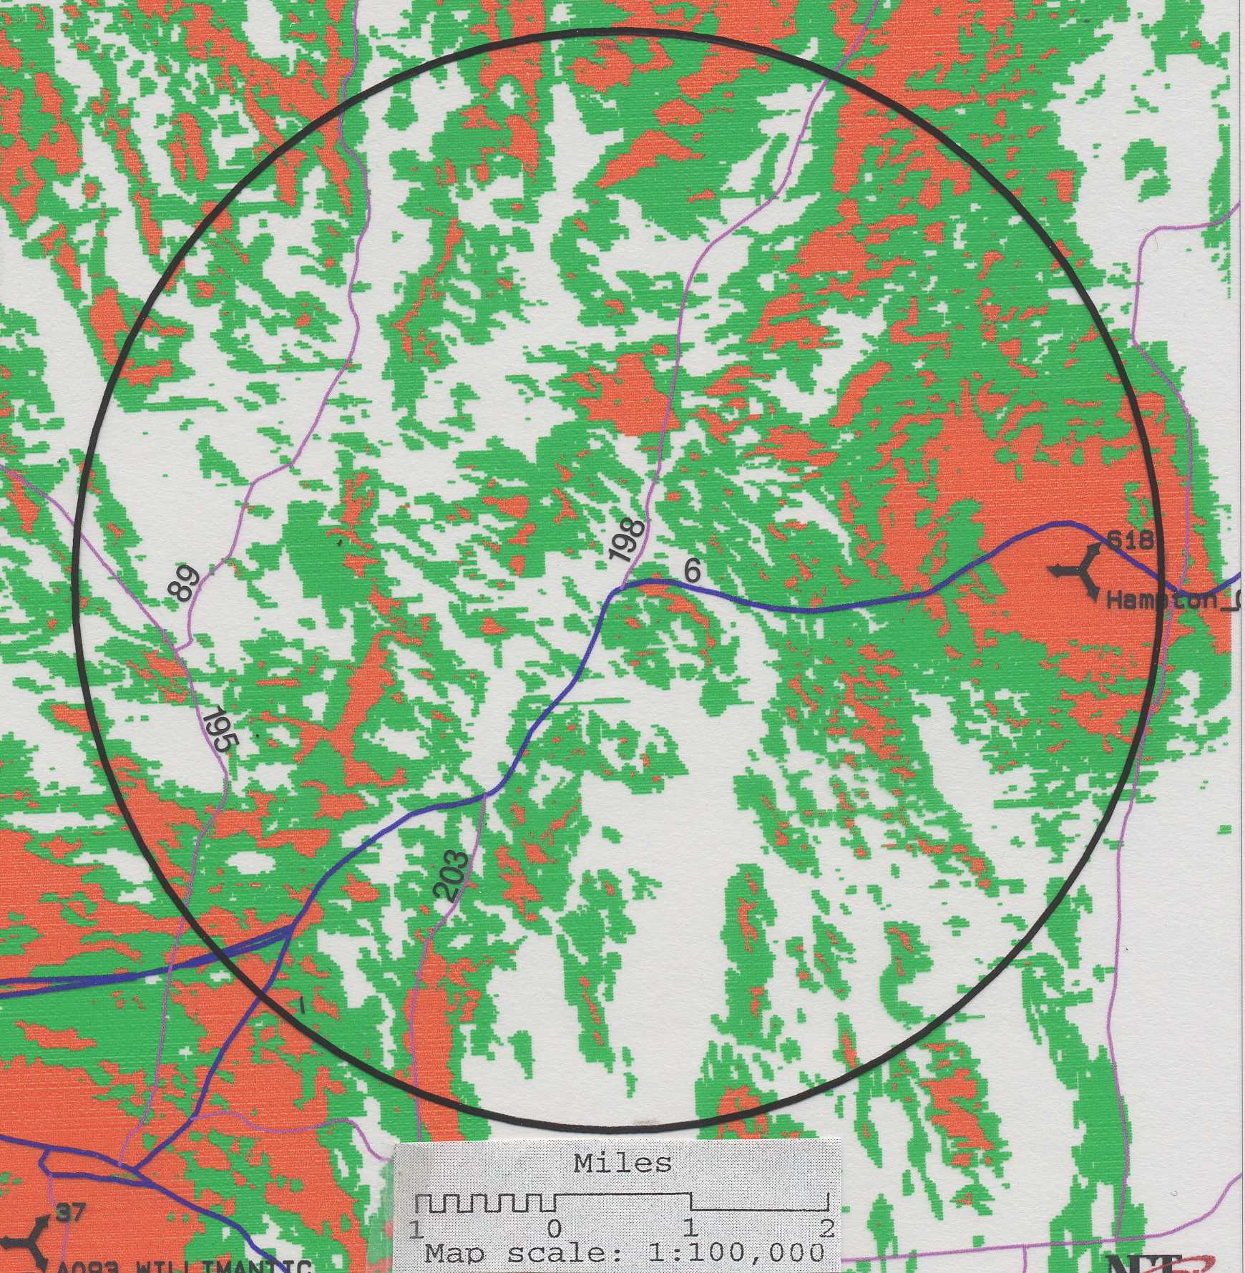
(Applicant 5, PHQ 6, map)

- Placing Cellco antennas on the proposed site number one tower at a height of 150 feet above ground level (AGL) combined with existing Cellco coverage would leave the following coverage gaps within approximately a four-mile radius of the intersection of Route 6 and Route 198 in Chaplin:
Gaps
(approximate miles)
Route <-90 dbm

198 0.0
6 0.3
203 0.2
89 3.4
195 0.5
4.4 miles total gaps

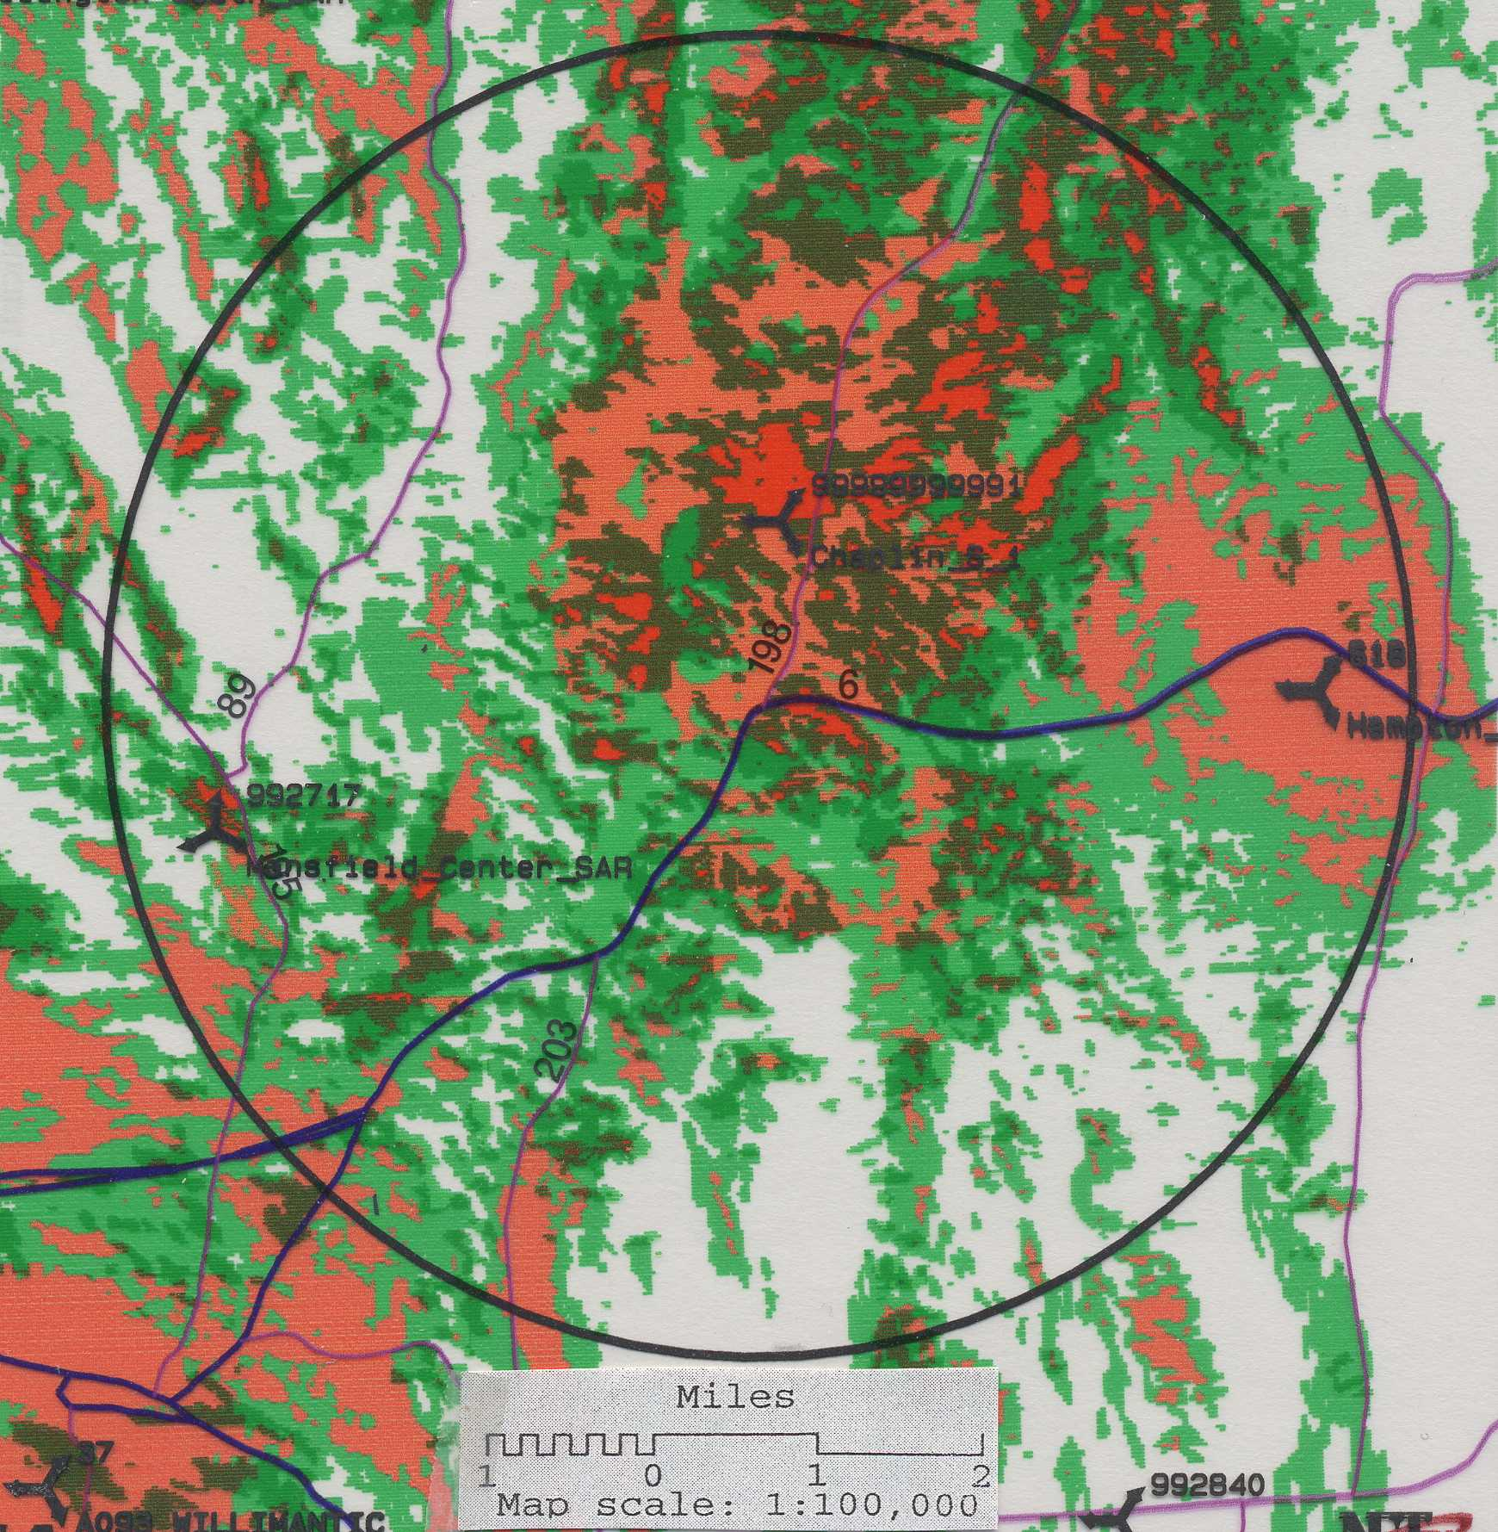
(Applicant 5, PHQ 6, map)

- Placing Cellco antennas on the proposed site number two tower at a height of 150 feet AGL, combined with existing Cellco coverage would leave the following coverage gaps within approximately a four-mile radius of the intersection of Route 6 and Route 198 in Chaplin.
Gaps
(approximate miles)
Route <-90 dbm

198 0.0
6 0.3
203 0.2
89 2.8
195 0.5
3.8 miles total gaps

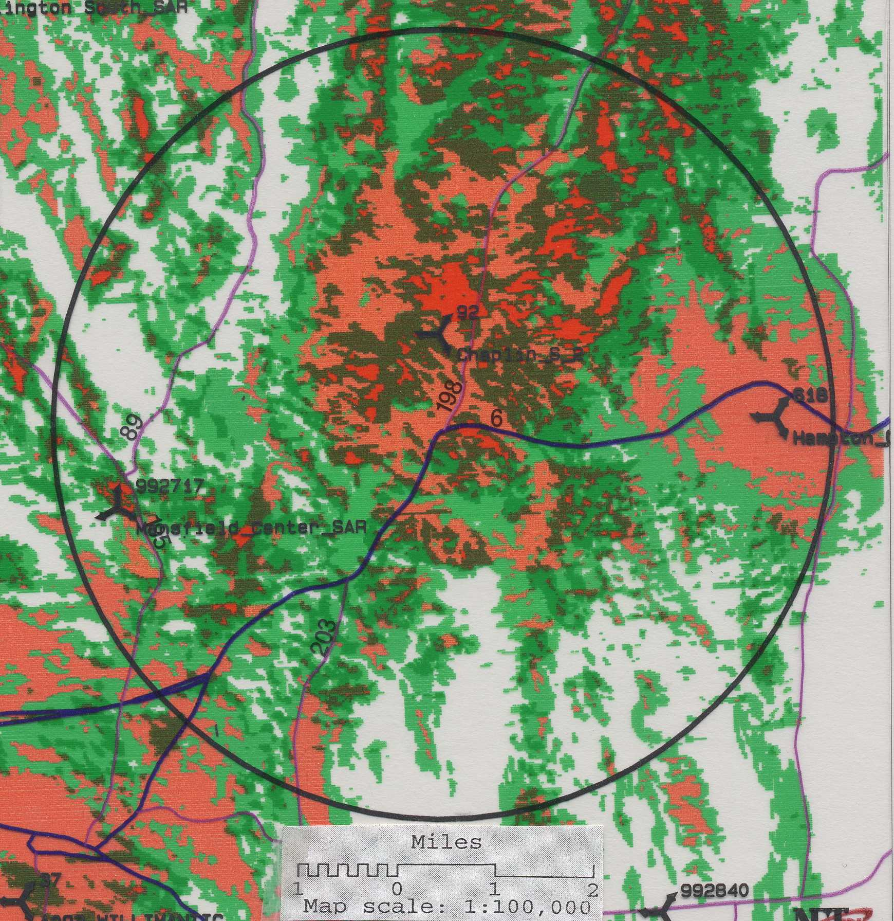
(Applicant 5, PHQ 6, map)

- Placing Cellco antennas on the existing 175-foot SBA tower on Davis Road in Chaplin at 150 feet AGL, in combination with existing and proposed coverage from surrounding Cellco sites would leave the following gaps within approximately a four-mile radius of the intersection of Route 6 and Route 198 in Chaplin as follows:
Gaps
(approximate miles)
Route <-90 dbm

198 1.5
6 0.1
203 0.0
89 0.0
195 0.0
1.6 miles total gaps

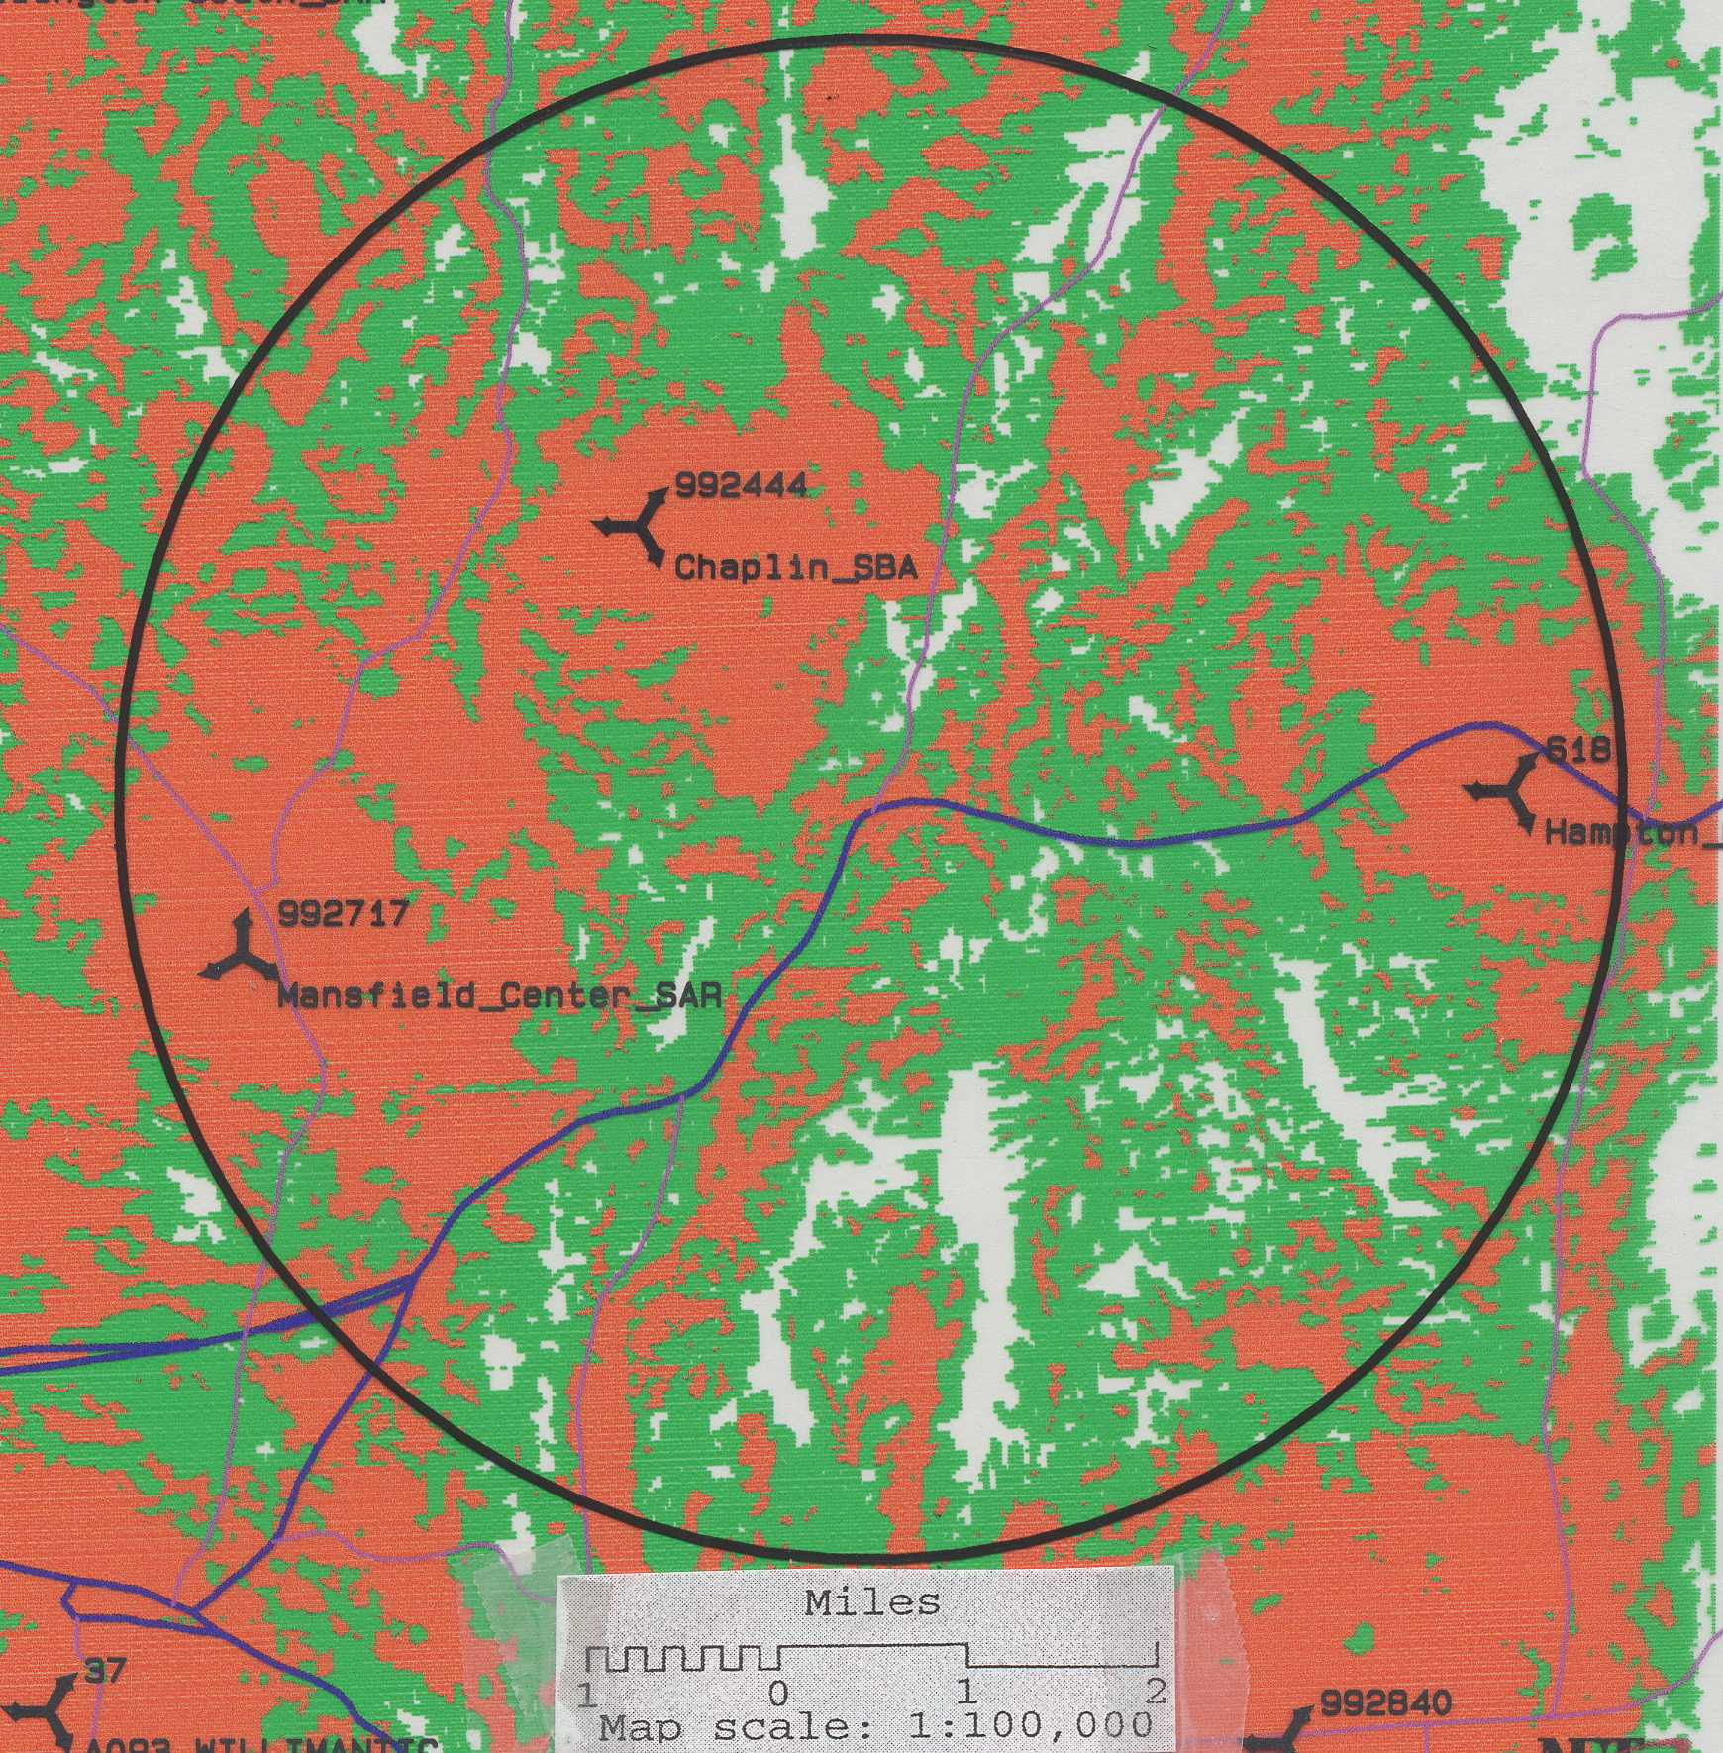
(Tr. 1, pp. 24-26; Cellco 6, maps)

- Sprint currently has antennas mounted at the 162.5-foot level of the existing 175-foot SBA tower off of Davis Road in Chaplin, approximately 1.5 miles from proposed site number one. Nextel has antennas at the 175-foot level of this tower. Existing Sprint coverage and gaps, defined as areas receiving <-90 dbm coverage, on State routes within approximately a four-mile radius of the intersection of Route 6 and Route 198 in Chaplin are as follows:

Gaps
(approximate miles)
Route <-90 dbm

198 3.2
6 1.6
- 1.2
89 0.0
195 0.3
6.3 miles total gaps

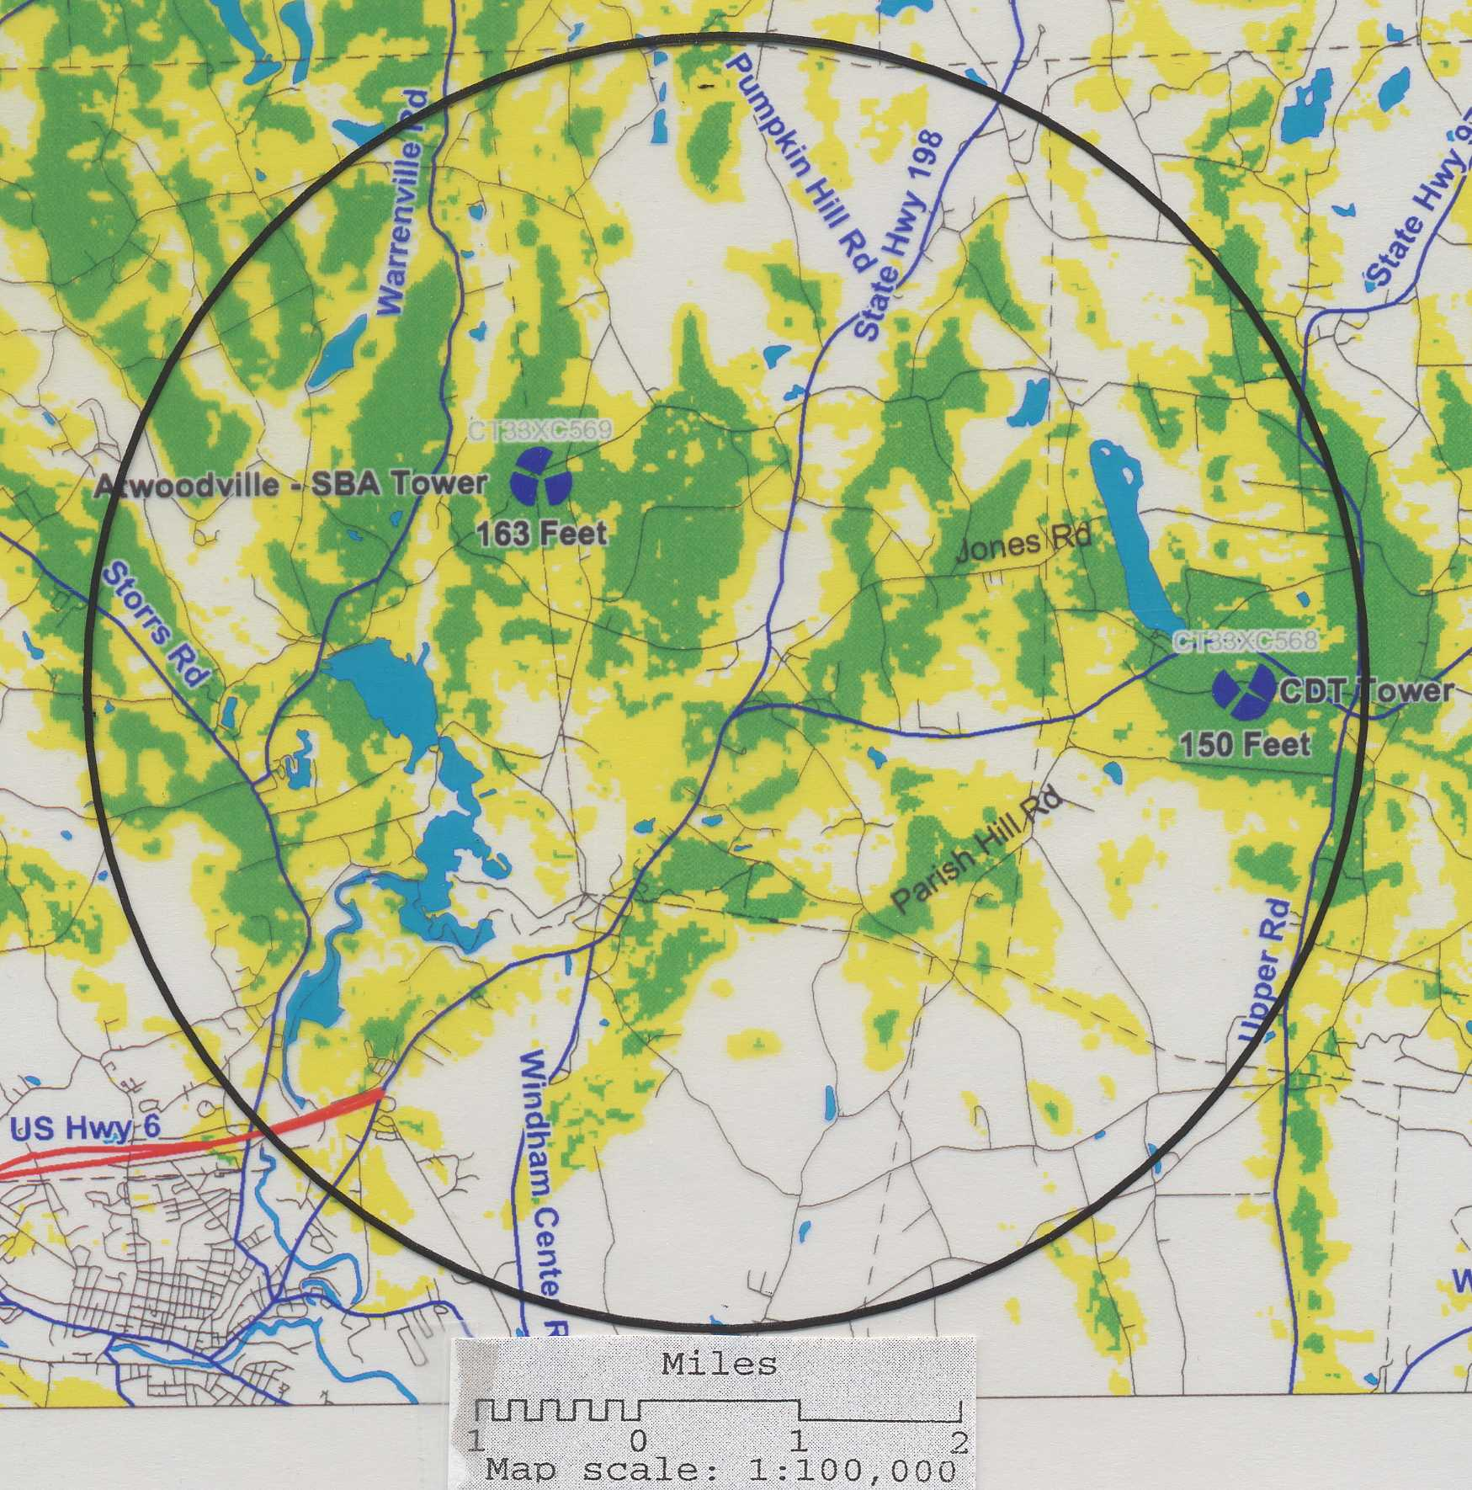
(Tr. 2, p. 67; Sprint 1 PHQ 1, Ex. B)
- The minimum height AGL required for Sprint to achieve its coverage objectives in the Chaplin area is 120-feet AGL on either proposed tower. Placing Sprint antennas 120 feet AGL on the proposed site number one tower combined with existing Sprint coverage would leave the following coverage gaps within approximately a four-mile radius of the intersections of Route 6 and Route 198 in Chaplin as follows:
Gaps
(approximate miles)
Route <-90 dbm

198 0.0
- 0.2
203 0.0
89 0.0
195 0.0
0.2 miles total gaps

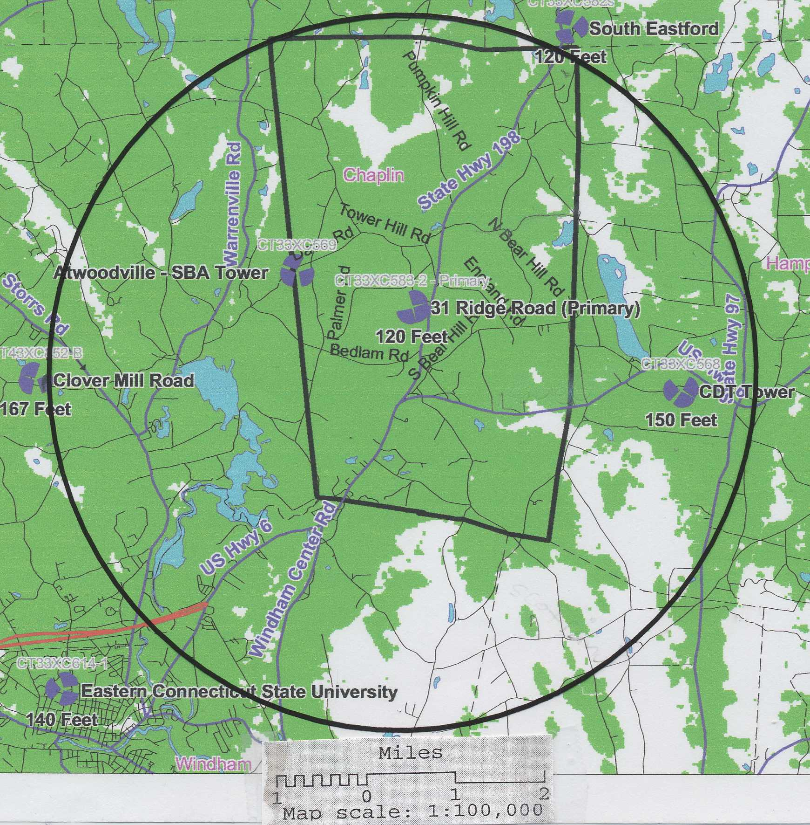
(Sprint 3, map; Tr. 2, pp. 61-62; p. 68)

- Placing Sprint antennas on the proposed number two tower at 120 feet AGL combined with existing Sprint coverage would leave the following coverage gaps within approximately a four-mile radius of the intersection of Route 6 and Route 198 in Chaplin as follows:
Gaps
(approximate miles)
Route <-90 dbm

- 0.0
6 0.2
203 0.0
89 0.0
195 0.0
0.2 miles total gaps

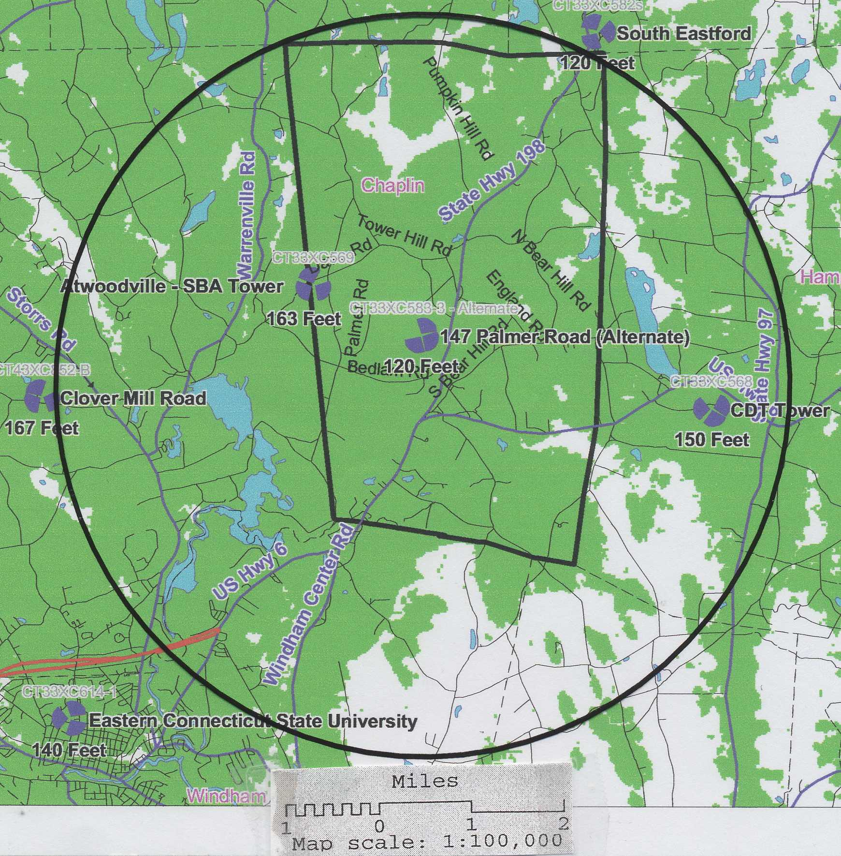
(Sprint 4, map)

- Sprint had considered development of a 175-foot tower on Middle Road in Chaplin, but withdrew the application from the Chaplin Zoning Commission. Sprint determined it could meet its coverage needs in Chaplin by using either of the proposed Crown towers in this application. If one of the proposed Crown sites is approved, Sprint would not pursue development of the Middle Road site. (Tr. 2, pp. 65-67)

