DOCKET NO 207 - James E. Dwyer Co., Inc. application for a Certificate of Environmental Compatibility and Public Need for the construction, maintenance and operation of a cellular telecommunications facility at 500 Moose Hill Road, Monroe, Connecticut. | }  }  }  } | Connecticut  Siting  Council  March 21, 2002

Findings of Fact
Introduction

- James E. Dwyer Co., Inc. (Dwyer) is in the business of construction and maintenance of wireless telecommunications facilities, and is not a licensed carrier. Dwyer has submitted applications to the Town of Monroe under the name Connecticut Architectural Towers, L.L.C. This application is filed by Dwyer in accordance with provisions of General Statute §§ 16-50g through 16-50aa to the Connecticut Siting Council (Council) on July 16, 2001, for the construction, operation, and maintenance of a cellular telecommunications facility in Monroe, Connecticut, to provide PCS coverage within the Metropolitan Trading Area (MTA) #1 (New York), and the Basic Trading Area (BTA) #321 (which includes Fairfield County, Connecticut). The proposed site is located at 500 Moose Hill Road, Monroe, Connecticut. (Dwyer 1, pp. 1, 2, 6 & 14; Dwyer 5, Q. 30)

- The party in this proceeding is the applicant. (Tr. 10/16/01, p. 4)

- Pursuant to General Statutes § 16-50m, the Council, after giving due notice thereof, held a public hearing on October 16, 2001, beginning at 7:00 p.m. in the Council Chambers of the Monroe Town Hall, 7 Fan Hill Road, Monroe, Connecticut. (Tr. 10/16/01, p. 2)

- The Council and its staff made inspections of the proposed site on October 16, 2001. During the field inspection, the applicant flew a balloon at the proposed site to simulate the height of the tower proposed at this location. The applicant released an additional 21 feet of tether to a height of 201 feet to allow for wind drift. (Tr. 10/16/01, p. 30)

- On November 29, 2001 the Council voted to reopen the record for this docket to resolve potential due process error in that the 300-foot relocation of the proposed tower may affect the rights of the surrounding residents. The Council held a hearing on December 17, 2001 beginning at 10:00 a.m. at 10 Franklin Square, New Britain, Connecticut. (Hearing Notice dated December 5, 2001; Tr. 10/16/01, p. 2)

Municipal Action

- On January 25, 2001, the Monroe Planning and Zoning Commission denied an application for the development of a wireless telecommunications facility at 500 Moose Hill Road (St. John’s Cemetery) proposed by Connecticut Architectural Towers, L.L.C. (CAT), a subsidiary of Dwyer. CAT proposed a 130-foot camouflaged wireless facility for the site designed as a church and steeple, which would accommodate at least five carriers, with the option of choosing a monopole design as an alternative. The Town of Monroe stated that the applicant failed to demonstrate that the proposal met the purpose and intent, and the requirements and design criteria of the Zoning Regulations. The Town cited that the applicant could not be considered a provider and therefore could not yield propagation specific to any wireless carrier. (Dwyer 1, pp. 6-7, 17; Section 6)

- During the discussions regarding the Connecticut Architectural Towers, L.L.C. application to the Town of Monroe, the Planning and Zoning Commission expressed concern that a “stealth” facility would be more obtrusive than a conventional monopole. The Planning and Zoning Commission stated that if they were to approve a wireless facility within the town that it would have to be a monopole that is the maximum allowable height without necessitating Federal Aviation Administration marking or lighting. (Dwyer 1, p. 7)

- The Monroe Fire Department has submitted a proposal to the Planning and Zoning Commission for a public safety communications tower that could also be used as a wireless telecommunications tower. The Monroe Fire Department is located on the corner of Moose Hill Road and Route 110. The Town of Monroe has publicly supported the Fire Department application. Dwyer rejected the firehouse site as a potential alternative to the St. John’s Cemetery site because it is located in close proximity to residential homes, and is directly across the street from the Monroe Historic District boundary. Three carriers have indicated interest in locating antennas on the proposed Fire Department tower, including Cingular, Verizon, and Sprint. (Dwyer 1, p. 10-11; Dwyer 3, Supplement to Application dated August 23, 2001; Dwyer 4, Q. 1; Tr. 12/17/01, p. 35)

Need

- Dwyer located the proposed facility to facilitate the provision of wireless telecommunications service to southeastern Monroe, western Shelton, and northeastern Trumbull. Currently there is not adequate coverage in this area for any of the 7 wireless providers licensed to serve this region. Dwyer investigated existing structures within a search area and found that none of these structures would provide adequate coverage to the area. (Dwyer 1, p. 9-10)

- In issuing cellular licenses, the Federal government has preempted the determination of public need for cellular service by the states, and has established design standards to ensure technical integrity and nationwide compatibility among all systems. (Council Admin. Notice, no. 7, Telecom. Act 1996)

- In 1996, the United States Congress recognized a nationwide need for high quality wireless telecommunications services, including cellular telephone service. Through the Federal Telecommunications Act of 1996, Congress seeks to promote competition, encourage technical innovations, and foster lower prices for telecommunications services. (Dwyer 1, p. 2; Council Admin. Notice, no. 7, Telecom Act 1996)

Site Search

- Dwyer identified nine existing communications towers located within approximately three miles of the site search area: a 130-foot tower owned by Sprint, located on Birdseye Road, Shelton; a 200-foot tower owned by AT&T, located on Booth Hill Road, Monroe; a 195-foot tower owned by Sprint, located near the intersection of Routes 59 and 25, Monroe; a 250-foot tower owned by Telemedia; a 150-foot tower owned by Sprint, located on Route 25 at the Monroe/Newtown line; a 150-foot tower owned by Sprint, located on Five Mile Hill, Oxford; a 150-foot tower owned by Sprint, located on Routes 67 and 42, Oxford; a 180-foot tower owned by Crown, located on Routes 84 and 34, Monroe; and a 240-foot tower owned by SNET, located on Guinea Road, Monroe. Three proposed towers were also identified within 3-miles of the search area including: a 195-foot tower located on Indian Ledge, Monroe, a 195-foot tower located at Stepney Fire House, Monroe, and a 195-foot tower located at Marian Heights. These towers would not provide adequate coverage to areas within southeastern Monroe. (Dwyer 1, Section 1; Dwyer 4, Q. 12)

- Dwyer identified and investigated eight potential sites, including the proposed site, within or near a 0.8-mile radius in Monroe. Dwyer investigated a commercial property adjacent to 575 Monroe Turnpike, which was rejected because it would not provide adequate coverage from a 180-foot tower. A site at Whitney Farms Golf Course was rejected due to a small coverage area from a 180-foot tower. The use of two church steeples on the Monroe Green was rejected because of the small area of coverage area that would come from these locations. Use of the Bridgeport Hydraulic Water Tank on Route 110 was rejected due to small coverage area that would come from that site. Vacant land within the Monroe Historic District was rejected because of significant adverse visual impact on the district as well as public opposition to a tower within that area. The existing police tower at the Monroe Town Hall was rejected because it is not structurally capable of supporting any more equipment and the replacement of that tower would result in impact on the historic district. A site at the Monroe Fire Department on Route 110 and Moose Hill Road was rejected because available land is limited, it is in close proximity to residential properties, it would visually impact the historic district, and it would provide less coverage to the area than a tower at St. John’s Cemetery. (Dwyer 1, pp. 12-13, Section 2; Dwyer 4, Q. 12)

Proposed Site

- The proposed site would be located on an approximately 50-acre parcel owned by St. John’s Greek Catholic Cemetery Association. There is no vegetative screening immediately adjacent to the proposed compound; however, continuous bands of deciduous vegetation are present along the surrounding roads. The tallest trees within this area are approximately 60 feet above ground level (AGL). The surrounding landscape consists of partially wooded, undeveloped land. The proposed site is located 629 feet above mean sea level (AMSL). (Dwyer 1, p. 1, 6, 16; Dwyer 4, Q. 7, 9; DEP comments dated August 31, 2001)

- The proposed site is within a Residential zone (RC). According to the Town of Monroe Plan of Development and Conservation, the site is within an area designated as “Existing Open Space”, with the area surrounding the parcel designated as “Suburban Low Density”. The Town’s Zoning Regulations express that the location of a tower above 80 feet in height within a residential area is the least desirable option for the location of antennas. (Dwyer 4, Q. 4; Dwyer Admin. Notice 1, Exhibit 19, Article XXV; Town of Monroe Future Land Use Plan)

- There are 23 homes within a 1000-foot radius of the proposed site, the nearest of which is approximately 600 feet to the east. (Dwyer 1, p. 11; Dwyer 5, Q. 28)

- The proposed site would include a 100-foot by 80-foot leased parcel on which Dwyer would develop a facility compound of the same size. The proposed tower and equipment compound would be enclosed by an 8-foot high wooden fence. A gravel surface would be established within the tower compound and access road. Two 20-foot by 30-foot equipment buildings and two equipment pads would be constructed to accommodate the carriers. (Dwyer 1, p. 16, Dwyer 4, Q. 3, 14, 18)

- Dwyer proposes to construct a 180-foot monopole, which is designed to accommodate six carriers with a 10-foot center-to-center vertical separation, at the proposed site. The tower is anticipated to be approximately 5-feet 6-inches in width at the base and 1-foot 4-inches in width at the top. Dwyer expects that if the Town of Monroe decides to use the facility they will locate a whip antenna at the top of the tower, which would have the ability to share a level with an antenna platform without causing interference due to the different frequencies used for public safety and wireless carriers. (Dwyer 1, p. 1; Dwyer 4, Q. 15; Tr. 10/16/01, p. 46-47)

- AT&T has committed to locating antennas at the 180-foot level on the proposed tower. Verizon, Nextel, Cingular, and Voicestream have expressed interest in locating equipment at the proposed facility. (Dwyer 4, Q. 11; Q. 26)

- The fall zone of the proposed tower would be contained within the lessor’s property. There are no existing or planned structures within the fall zone of the tower. (Dwyer 4, Q. 16)

- Access into the site would be a twelve-foot wide access road extending from Moose Hill Road along an existing driveway for 560 feet, then continuing to the site for an additional 500 feet. (Dwyer 1, Section 3, site plans; Dwyer 4, Q. 17)

- The approximate costs of construction to Dwyer for the proposed site are estimated as follows:

Gravel Access Road | $ 15,000
Compound Area Sitework | 25,000
180’ monopole and foundation | 135,000
Equipment Shelters | 120,000
Emergency Generator | 35,000
Fencing | 8,000
Utility Ductbank | 40,000
Electrical/Telephone Service | 25,000
Total Costs | $ 403,000
(Dwyer 1, Section 12)

- Dwyer stated that the tower height could be reduced by 30 feet to a height of 150 feet while still providing adequate coverage for six carriers. Antennas located at the 90-foot level should provide coverage to the design service area. (Dwyer 4, Q. 8; Tr. 10/16/01, p. 33-34, 65)

- Dwyer would be willing to construct a 130-foot architecturally treated stealth tower such as a church and steeple instead of the proposed monopole. Five to six carriers would be accommodated by this structure. (Dwyer 1, p. 17; Dwyer 4, Q. 6; Tr. 10/16/01, p. 47)

Revised Proposed Site

- At the Council hearing held on October 16, 2001, it was discovered that two abutting cemeteries did not receive notice of the proposed project. The applicant then notified these two adjacent congregations, Rodeph Sholom and B’Nai Israel. Rodeph Sholom did not object to the proposed project. B’Nai Israel requested that the proposed facility be moved farther away from their property. (Tr. 12/17/01, p. 10)

- The applicant submitted a revised site plan relocating the proposed facility 300 feet to the north. B’Nai Israel and the property owner, St. John’s Cemetery, have no objection to this relocation. The revised site is in an area of the cemetery that would not be used for at least 50 years. (Tr. 12/17/01, p. 11, 23)

- The revised site would provide wireless coverage similar to the originally proposed site. The elevation of the revised site is 617 feet amsl. (Dwyer 4, Q. 29; Dwyer 8, Q. 5)

Environmental Considerations

- The proposed site contains no known existing populations of Federal or State Endangered, Threatened or Special Concern Species. (DEP letter dated August 31, 2001)

- No wetlands or watercourses would be impacted during the construction of the proposed site. (Dwyer 1, Section 6, Letter from Town of Monroe Conservation and Water Resources Commission/Inland Wetland Commission dated August 29, 2001)

- The State Historic Preservation Office (SHPO) has determined that construction of the proposed site would have no effect on historic, architectural, or archaeological resources listed on or eligible for the National Register of Historic Places. (Dwyer 2, letter from the Connecticut Historical Commission dated July 3, 2001)

- Clearing of approximately 16 trees with diameters of six inches or greater at breast height would be required to construct the proposed site and access road. There would be no additional clearing of trees for the construction of the revised proposed site. (Dwyer 4, Q. 18; Tr. 12/17/01, p. 14)

- Erosion and sediment controls would be established as required by the State of Connecticut Department of Environmental Protection and the Town of Monroe Conservation Commission. Silt fencing would be placed immediately down slope of the project area, and an anti-tracking pad would be installed at the start of the proposed access road. (Dwyer 4; Q. 18)

- Analysis of the site performed by the Airspace Safety Analysis Corporation determined that the proposed site does not have to be registered with the Federal Aviation Administration (FAA). Analysis was done for a tower height of 130 feet AGL. At 180 feet AGL the proposed tower does not have to be registered with the FAA because it would be less than 200 feet AGL. (Dwyer 1, p. 17)

- The electromagnetic radiofrequency power densities, calculated using the FCC Office of Engineering and Technology Bulletin 65, August 1997, using conservative worst-case approximation of radiofrequency power density levels at the base of each tower, with all AT&T antennas transmitting simultaneously on all channels at full power would be 9.78 μW/cm² (0.98 percent of the American National Standards Institute (ANSI) Standard for the maximum permissible exposure) for the proposed AT&T antennas mounted 180 feet AGL. (Dwyer 1, p. 19, Section 5)

Visibility

- The visibility of the proposed tower from various locations in the area would be as follows:

Visibility of Proposed 180-foot Tower

Location | Visibility | Approx. Distance (ft.) and direction
Route 111 | Yes | 4200 W
Elm Street (to west of site) | No | 5300 W
Elm Street (to north of site) | Yes | 6900 N
Walnut Street | Yes | 4200 E
Route 110 | Yes | 4700 E
Masuk High School | Yes | 11,000 E
Walnut Tree Hill (Shelton) | No | 8700 S
(Dwyer 1, Section 8)

- Visibility of a 180-foot tower at the revised site to adjacent residents would be slightly increased through the trees. Visibility to farther locations would be similar to a 180-foot tower at the originally proposed site. Landscaping would be provided around the base of the equipment compound of the revised site. A wooden stockade fence would be installed around the equipment compound to minimize the visual effects of the equipment. (Dwyer 1, Tab 8; Dwyer 8, Q. 1; Tr. 12/17/01, p. 13, 14)

Coverage Needs

- Existing facilities in Monroe, Shelton (to the east), Seymour (to the northeast) and Oxford (to the north-northeast) leave gaps in cellular coverage in the Monroe area. Gaps are defined as areas receiving less than –90 dbm coverage. The primary purpose of this application is to provide coverage to these gaps within eastern Monroe. (Dwyer 1, p. 1; Section 4; Dwyer 4, Q. 9 & 10)

- Existing wireless coverage, at 1900 mhz, within a three mile radius of the proposed site is as follows:

Existing Coverage

(see Figure 1)

Route | Existing Gaps (miles)  < -90 dbm | Total Road  Miles
110 | 1.8 | 3.5
111 | 4.7 | 6.5
Total | 6.5 miles | 10.0 miles
(Dwyer 5, Q. 29)

- Existing coverage combined with antennas on the proposed site tower at the listed heights above ground level, both at 1900 mhz, would leave the following gaps within a three mile radius of the proposed site as follows:

Proposed Tower at 180-Feet AGL

(see Figure 2)

Route | Gaps (miles)  < -90 dbm | Total Road  Miles
110 | 0 | 3.5
111 | 0.7 | 6.5
Total | 0.7 miles | 10.0 miles

(Dwyer 5, Q. 29)

Proposed Tower at 140-Feet AGL

(see Figure 3)

Route | Gaps (miles)  < -90 dbm | Total Road  Miles
110 | 0 | 3.5
111 | 0.8 | 6.5
Total | 0.8 miles | 10.0 miles

(Dwyer 5, Q. 29)

Proposed Tower at 100-Feet AGL

(see Figure 4)

Route | Gaps (miles)  < -90 dbm | Total Road  Miles
110 | 0 | 3.5
111 | 1.0 | 6.5
Total | 1.0 miles | 10.0 miles

(Dwyer 5, Q. 29)

- Dwyer provided propagation analysis information based on a Personal Communication Service (PCS) system; however there is evidence that cellular carriers such as Cingular Wireless and Verizon Wireless have a need for location of antennas in this area of town. (Tr. 10/16/01, p. 37-38)

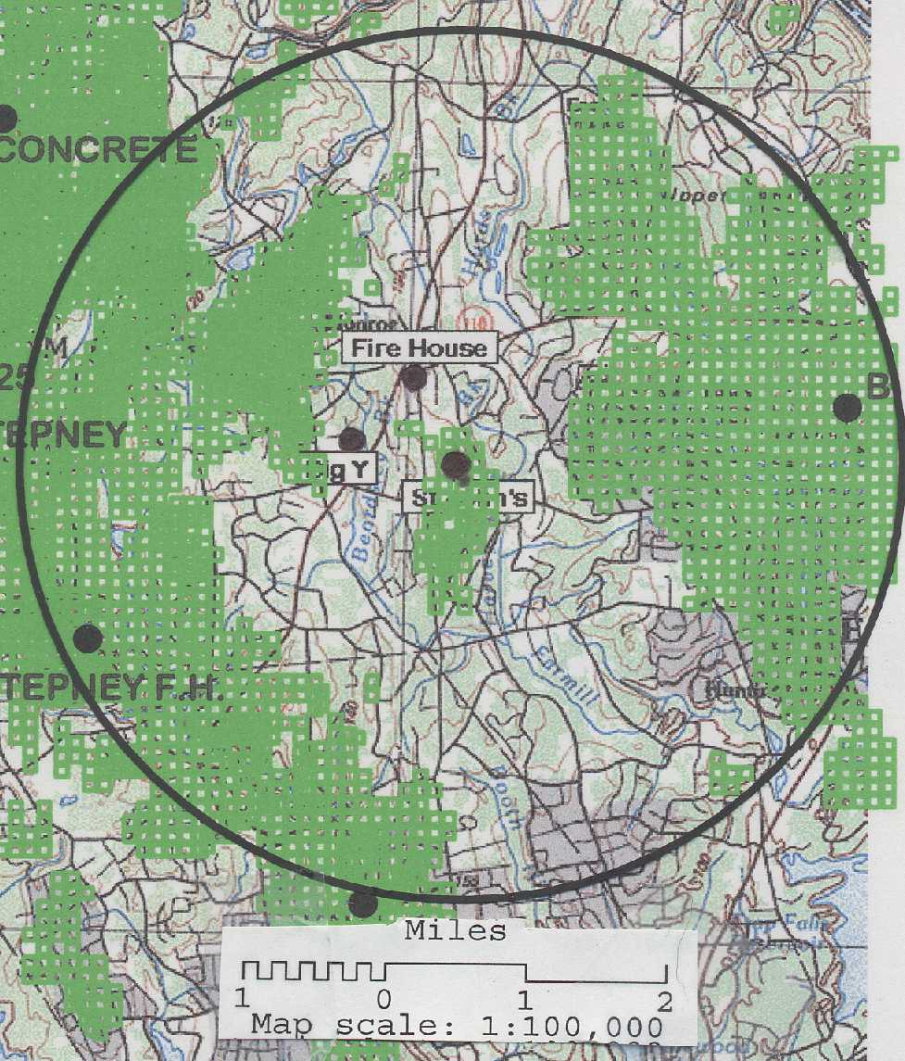
Figure 1. Existing coverage at 1900 mhz.

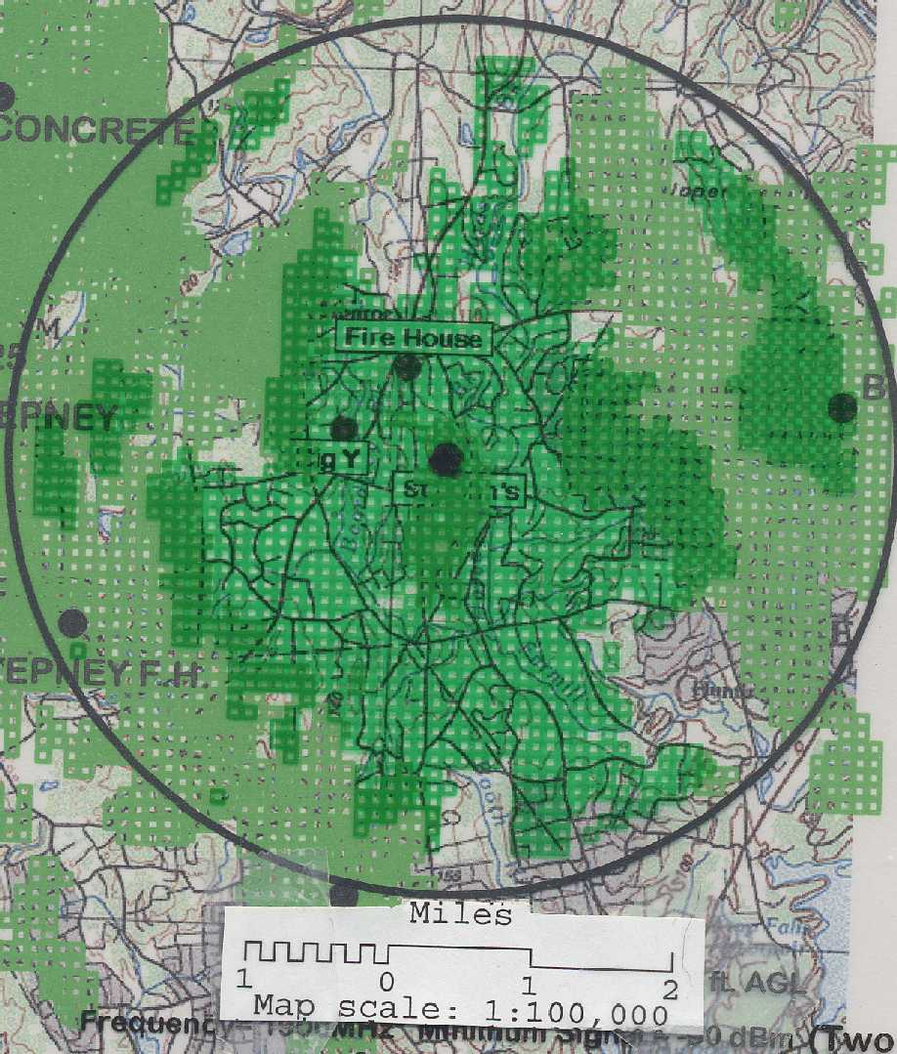
Figure 2. Existing coverage with coverage from the proposed site at
180-feet AGL (1900 mhz).

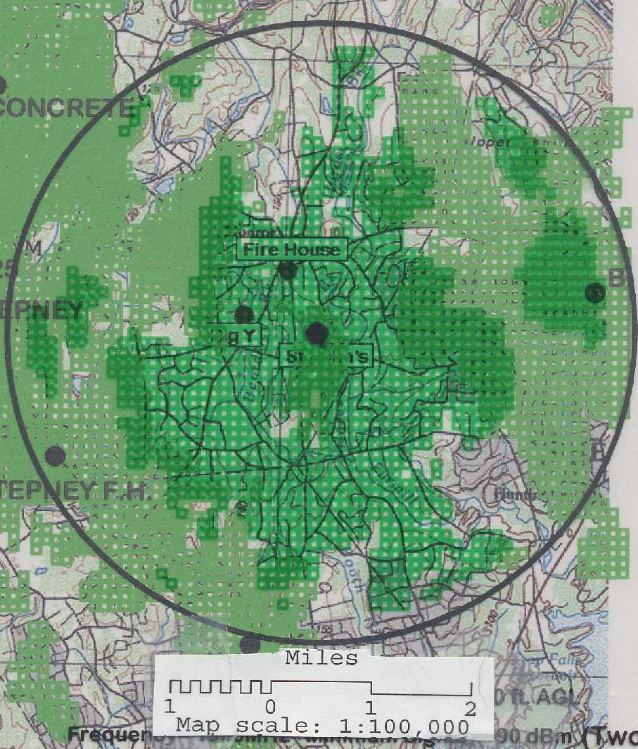
Figure 3. Existing coverage with coverage from the proposed site at
140-feet AGL (1900 mhz).

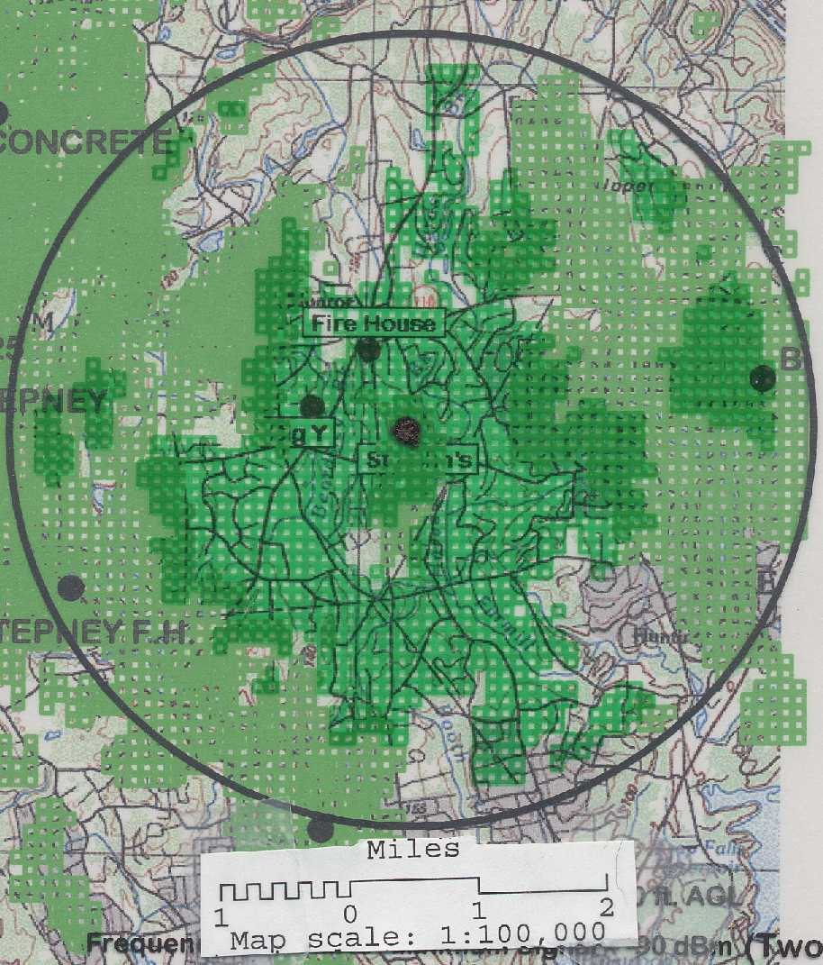
Figure 4. Existing coverage with coverage from the proposed site at
100-feet AGL (1900 mhz).

