DOCKET NO. 182A - Sprint Spectrum, L.P. d/b/a Sprint PCS and Litchfield Acquisition Corporation d/b/a AT&T Wireless Services amendment to the Certificate of Environmental Compatibility and Public Need for the existing telecommunications facility located 31 New Hartford Road (access via Rust Road), Barkhamsted, Connecticut. | }  }  }  } | Connecticut  Siting  Council  May 7, 2002

Findings of Fact

Introduction

- Sprint Spectrum L. P. d/b/a Sprint PCS (Sprint) and Litchfield Acquisition Corporation d/b/a AT&T Wireless Services (AT&T) in accordance with provisions of General Statutes §§ 16-50g through 16-50aa applied to the Connecticut Siting Council (Council) on November 8, 2001, for an amendment to the Certificate of Environmental Compatibility and Public Need (Certificate) to an existing telecommunications facility on 31 New Hartford Road (access via Rust Road), Barkhamsted, Connecticut. On June 25, 1998, the Council issued a Certificate for construction of a 120-foot tower, that was extended to 124 feet above ground level (agl) for attachment of branching to be camouflaged as a tree and equipment compound that accommodates AT&T, Nextel, and SNET. Sprint proposes to increase the height of this existing monopole tower camouflaged as a tree to a tota1 height of 148 feet above ground level. The purpose of the proposed facility is to provide personal communications service (PCS) to sections of U.S. Route 44 and State Routes 181, 219, and 318 in the Town of Barkhamsted, Litchfield County, Connecticut. (Sprint 1, pp. 1,2 and 5, and Revision December 14, 2001; Transcript (Tr.) dated January 24, 2001, 7:00 p.m., pp. 7, 12, 13, 15)

- The party in this proceeding is the applicant. The Federal Communications Commission (FCC) licenses Sprint as the “B block” “Wideband PCS” license holder for the two-gigahertz PCS frequencies for the greater New York City area, which includes the entire state of Connecticut. (Sprint 1, p. 1; Tr. pp. 5, 44, and 45)

- Public notice of the application, as required by General Statutes § 16-50l (b), was published in The Hartford Courant and in the Register Citizen. (Sprint 1, p. 3)

- As required by General Statute § 16-50l (e), Sprint provided the Town of Barkhamsted technical material on August 21, 2001 for the proposed increase in height of an existing tower to locate Sprint’s antennas, and relocate existing antennas of AT&T, SNET and Nextel to accommodate future collocation. Since the existing site is within 2,500 feet of an adjoining municipality, Sprint provided the Town of New Hartford technical material on September 5, 2001. (Sprint 1, p. 21 and Exhibits Q and S)

- Pursuant to General Statutes § 16-50m, the Council, after giving due notice thereof, held a public hearing on January 24, 2002, beginning at 7:00 p.m. in the cafeteria of the Barkhamsted Elementary School, 63 Ripley Hill Road, Barkhamsted, Connecticut. (Tr., p. 3)

- The Council and its staff made inspections of the existing tower site on January 24, 2002. During this field inspection, the applicant flew a balloon at the site to simulate the height of the proposed extension. (Sprint 1 p. 19; Council Pre-hearing Conference Notice dated December 20, 2001)

PCS Service Design

- Personal communications service (PCS) consists of low power transmitter/receiver stations known as cell sites. The system design allows for a configuration of cell sites so that the same frequencies can be used at the same time in different cells (frequency reuse) and to provide uninterrupted service throughout a service area (hand-off). (Docket No. 182, Finding of Fact No. 11)

- The location of cell sites is based upon key factors such as traffic demand, topography, site height, site availability, building density, and foliage. (Sprint 1, p. 8, Tab H; Docket No. 182 Finding of Fact No. 18)

- Sprint requires a minimum acceptable signal strength threshold of -94 decibels (dbm) to provide coverage in the Barkhamsted area. Signal strength thresholds lower than -94 dbm may create coverage gaps within a cell’s coverage area that may prevent the establishment of a call or cause a call to be disconnected. Presently, a gap in coverage exists along Route 44 in Barkhamsted and surrounding areas. (Sprint 1, p. 7, Exhibits E and H)

- Adjacent Sprint facilities that would hand off traffic with the proposed facility are as follows:

Location | Distance and Direction from proposed facility | Status
Greenwood Industrial Park, New Hartford | 1.70 mi./east southeast | Operating
Old North Road, Barkhamsted | 2.30 mi./northwest | Proposed
Oakdale Avenue, Winchester | 3.42 mi./northwest | Operating
20 Antolini Road, New Hartford | 4.63 mi./south | Proposed facility in Council Docket No. 184A
96 Powder Mill Road, Canton | 5.22 mi./southeast | Operating
1925-1930 East Main Street, Torrington | 6.40 mi./west | Operating
South of Route 202, New Hartford | 4.0 mi./south southeast | Proposed
Torrington | 9.0 mi./west | Proposed

(Sprint 1, Exhibit N and Revised Exhibits F and H; Sprint 3, Qs. 6 and 14, Tr. pp. 19-20)

Site Search

- In its search for a cell site in the Barkhamsted area, Sprint identified and investigated 4 potential sites, including the proposed site in the application. The remaining sites were rejected because a property owner was not interested in leasing property, another site did not provide adequate coverage, and a raw land site was not pursued due to the existing facility’s availability. The other alternative would be construction of a new tower. (Sprint 1, p. 16; Sprint 4, Timothy Keator Testimony)

Need and Coverage

- In 1996, the United States Congress recognized a nationwide need for high quality wireless telecommunications services, including cellular telephone service. The Federal Telecommunications Act of 1996 seeks to promote competition, encourage technical innovations, and foster lower prices for telecommunications services. Furthermore, the Federal government has preempted the determination of public need for wireless service by the states, and has established design standards to ensure technical integrity and nationwide compatibility among all systems. (Sprint 1, pp. 6-7; Telecommunications Act of 1996, Definition of Act, Sections 256, and 704)

- Coverage from existing and proposed facilities (see Finding of Fact # 8) within a two-mile radius of the Route 181 and Route 44 intersection indicates the following coverage gaps. Gaps are defined as areas receiving less than -94 dbm coverage. The primary purpose of this application is to provide service to these gaps in coverage and provide hand-off capability to adjacent sites.

Existing Coverage
(See Appendix A)

Route | Gaps (miles)  < -94 dbm | Total Road  Miles
44 | 1.75 | 4.50
181 | 2.25 | 2.25
219 | 0.0 | 3.75
318 | 1.50 | 2.75

(Sprint 1, Revised Exhibit E coverage model)

- Existing and proposed coverage combined with Sprint antennas on the proposed tower at a centerline height of 144 feet AGL within a two-mile radius of the Route 181 and Route 44 intersection as follows:

Proposed Tower at a centerline height of 144 feet AGL
(See Appendix B)

Route | Gaps (miles)  < -94 dbm | Total Road  Miles
44 | 0.13 | 4.50
181 | 0.0 | 2.50
219 | 0.0 | 3.75
318 | 0.13 | 2.75

(Sprint 1, Revised Exhibit F coverage model)

- Existing and proposed coverage combined with Sprint antennas on the proposed tower at a centerline height of 130 feet AGL within a two-mile radius of the Route 181 and Route 44 intersection as follows:

Proposed Tower at a centerline height of 130 feet AGL
(See Appendix C)

Route | Gaps (miles)  < -94 dbm | Total Road  Miles
44 | 0.13 | 4.50
181 | 0.0 | 2.50
219 | 0.0 | 3.75
318 | 0.13 | 2.75

As capacity increases in the Route 44 area of Barkhamsted and New Hartford, the issue in providing coverage begins to change with increased use. While a 130-foot and 140-foot tower provides similar coverage, future demand may cause coverage from a 130-foot tower to be inadequate.
(Sprint 3, Q. 2 coverage model; Tr. 1, pp. 26-29)

- Alternatives to monopole technology include microcell and repeater sites. A microcell is a small version of a cell site. A repeater is a low power system that borrows a channel from a nearby cell site and rebroadcasts it to a target area. These alternatives fulfill small coverage gaps or provide service to a building but would not be applicable in the Barkhamsted area due to the large coverage gaps and the necessary height to place antennas would not alleviate the need for a tower. (Sprint 1 pp. 15 and 16; Sprint 4, Anthony Wells Testimony)

Proposed site

- The proposed site is an existing telecommunications facility owned and operated by AT&T Wireless Services and consists of a 120-foot monopole tower camouflaged as a pine tree and three equipment buildings at the base of the tower within a 50-foot by 50-foot fenced compound. An additional four-foot extension on this tower supports artificial tree branching for a total height of 124 feet. (Sprint 1, p. 5; Sprint 3, Q. 7; Sprint 4, Alitz Abadjian Testimony; Tr. p.13)

- AT&T has a lease for a 75-foot by 75-foot area within an approximately 98-acre parcel of land owned by the Regional Refuse Disposal District (RRDD) No. 1. This site is located approximately 180 feet east from the end of Rust Road with an elevation of 780 feet above mean sea level. The RRDD property is zoned Restricted Industrial (I-1). The Barkhamsted Zoning Regulations, by special permit, allows use of communications towers in I-1 and I-2 zones. (Sprint 1, pp. 4, 5 and 13, Exhibit D; Sprint 1a Barkhamsted Zoning Regulations)

- Land north and west of the RRDD property is zoned residential (RA-1). Land to the north contains residences. Land west and south is wooded, and contains no homes. The RRDD transfer station and buildings are located to the east. U.S. Route 44 borders the RRDD east property boundary. The RRDD western property boundary fronts an unimproved road (Rust Road) for approximately 1300 feet to the Barkhamsted and New Hartford town boundary. (Sprint 1, pp. 4, 5 and 13, Docket No 182 Finding of Fact No. 28)

- Sprint would use an existing 12-foot wide by 170-foot long gravel covered access road. (Sprint 1, p. 8 and Revised Exhibit D; Sprint 4, Alitz Abadjian Testimony)

- Electric and telephone utilities exist at the facility and are underground. No permanent backup electrical system is proposed; however, Sprint relies on batteries for backup power and for outages lasting longer than 4 hours Sprint may use a portable electric generator. Each carrier may have a generator for its own use. (Sprint 1, p. 8 and Revised Exhibit D; Tr. pp. 29-30)

- No trees would be removed for the proposed extension of the tower or for the proposed placement of Sprint’s equipment within the existing fenced compound. (Tr. p. 18)

- There are no wetland areas within the existing leased parcel. (Sprint p. 9)

- There are seven homes on Rust Road of which four would be within a 1000-foot radius of the existing tower. The nearest residential structure would be approximately 600 feet north of the existing tower. (Sprint 1, pp. 11 and 13 and Exhibit I)

- The 148-foot tower radius would remain within the lessor’s property. The facility site equipment buildings would be the only structures within the tower radius. (Sprint 1, Exhibit D)

- The estimated cost of construction for the proposed modifications to the facility would be:

Monopine extension with branches $55,630
New platforms for all carriers $18,000
Installation of platforms, antennas, and branching $44,000
Ground site work $21,000
PCS radio equipment $126,000

Total $264,630
(Sprint 1, p. 19; Tr. P. 52)

Facility Specifications

- Sprint proposes to extend the existing 124-foot monopole to a total height of 148 feet above ground level (agl) and would maintain the tower as a camouflaged tree. Sprint proposes to install 12 panel type directional antennas, four per sector, at a centerline height of 144 feet agl. An additional four-foot extension for artificial tree branching would be installed above the antennas. A global positioning system antenna would be mounted at the 50-foot level of the tower. (Sprint 1, Revised Exhibit D; Sprint 5; Tr. p. 13-18)

- Sprint would install an 8.5-foot by 20-foot concrete foundation within the fenced compound for equipment, a main power cabinet, secondary power cabinet, battery backup cabinet, and primary radio cabinet. The foundation would accommodate three additional cabinets in the future. (Sprint 1, pp. 5 and 6; Sprint 4, Alitz Abadjian Testimony)

- AT&T proposes to relocate its 12 panel antennas on a 12-foot wide platform from its centerline height of 120 feet agl to an antenna centerline height of 134 feet agl. AT&T holds a PCS license for Litchfield County, Connecticut and proposes to provide data services. AT&T would operate six antennas at the 1900 MHz frequency and six antennas at the 850 MHz frequency. No modification to its equipment building is proposed. (Sprint 1, p. 6 and Revised Exhibit D; EM-AT&T-005-018-031-055-068-092-111-125-153-162-168-011121, Edwards and Kelsey d/b/o AT&T Wireless Services)

- Nextel currently has three omni directional whip antennas (14 feet long by 3 inches in diameter) at the top of the proposed tower with a centerline of radiation of 127 feet agl. Nextel proposes to remove these whip antennas and replace them with panel antennas on a platform at a centerline of radiation 124 feet. No modification to its equipment building is proposed. (Sprint 1, p. 6 and Revised Exhibit D)

- SNET proposes to relocate its 12 panel antennas on a 12-foot wide platform from its centerline height of 110 feet agl to an antenna centerline height of 114 feet agl. No modification to its equipment building is proposed. (Sprint 5; Tr. p.12)

- The existing 124-foot tower and its foundation is capable of being extended to a total height of 158 feet, camouflaged as a tree, and accommodate up to six carriers. This 158-foot tower would be designed to withstand pressures equivalent to a 69-mph wind with one-half inch solid ice accumulation. Elevations for future carriers would be available at the 104-foot and 94-foot levels of the proposed 144-foot tower. (Sprint 1, p. 5 and Revised Exhibit D; Sprint 3, Q. 7; Sprint 4, Alitz Abadjian Testimony)

- The existing tower did not have any air navigation marking and or lighting nor does Sprint propose any air navigation marking and or lighting consistent with Federal Aviation Administration (FAA) criteria. (Sprint 1, Exhibit K; Docket No. 182, Finding of Fact No. 43)

Environmental Considerations

- There are no known or existing populations of federal or State endangered, threatened or special concern species occurring at the proposed site. (Sprint 1, p. 12 and Exhibit K; Docket No. 182 Findings of Fact No. 49)

- The State Historic Preservation Officer determined that the proposed extension of the existing tower would have no effect with respect to historic, architectural, or archeological resources listed on or eligible for the national or State register of historic places. (Sprint 1, pp. 12-13 and Exhibit M)

- Noise associated with construction would be temporary. After construction, noise would be from a portable emergency generator used during extended power outages. (Sprint 1, p. 11; Tr. 30-33)

- A small amount of traffic would occur during construction. After construction, Sprint would make monthly visits for inspection and maintenance. (Sprint 1, p. 11)

- State Route 181 is designated a State scenic road from the intersection with Route 44 to the intersection of Route 318 including portions of Route 318 across Saville Dam and Route 219 bordering the east shore of Lake McDonough in the Town of Barkhamsted. (Docket No. 182 Finding of Fact No. 55)

- Visibility of proposed 148-foot tower camouflaged as a pine tree.

Location | Distance / Direction | Existing 124-foot Tower Visible? | Proposed tower with extension  Visible?
- Entrance to RRDD property off Route 44 | - 0.58 mi./west | - yes | - yes
- Hearthstone Drive | - 0.73 mi./southeast | - yes | - yes
- Miner Lane and Holcomb Hill Road intersection | - 1.21 mi./west | - yes | - yes
- Farmington River access off Route 318 | - 1.26 mi./southwest | - yes | - yes
- Barkhamsted Town Hall parking lot | - 1.32mi./southwest | - yes | - yes
- State Route 181/318 intersection | - 1.38 mi./southwest | - yes | - yes
- Vista from Tunis Trail on Ratlum Mountain | - 2.34 mi./west | - no | - no
- Saville Dam on Route 318 | - 2.50 mi./southwest | - no | - no

(Sprint 1, p. 11 and Exhibit L; Sprint 3, Qs. 10, 11, and 12; Docket No. 182 Finding of Fact 57 and 59)

- The cumulative worst-case electromagnetic radio frequency power densities for all carriers at the base of the proposed tower would be 22.45 percent of the 1992 American National Standards Institute (ANSI) standard as adopted by the FCC and the Connecticut Department of Environmental Protection General Statutes § 22a-162. (Sprint 1, Revised Exhibit P; OET Bulletin No. 65, Evaluating Compliance with FCC Guidelines for Human Exposure to Radio Frequency Electromagnetic Fields, FCC, Office of Engineering and Technology, August 1997; IEEE Standard for Safety Levels with Respect to Human Exposure to Radio Frequency Electromagnetic Fields, 3 kHz to 300 Ghz, approved by the American National Standards Institute, November 18, 1992; Guidelines for Evaluating the Environmental Effects of Radiofrequency Radiation, Federal Communications Commission’s Report and Order, adopted August 1, 1996)

Appendix A
Existing Coverage

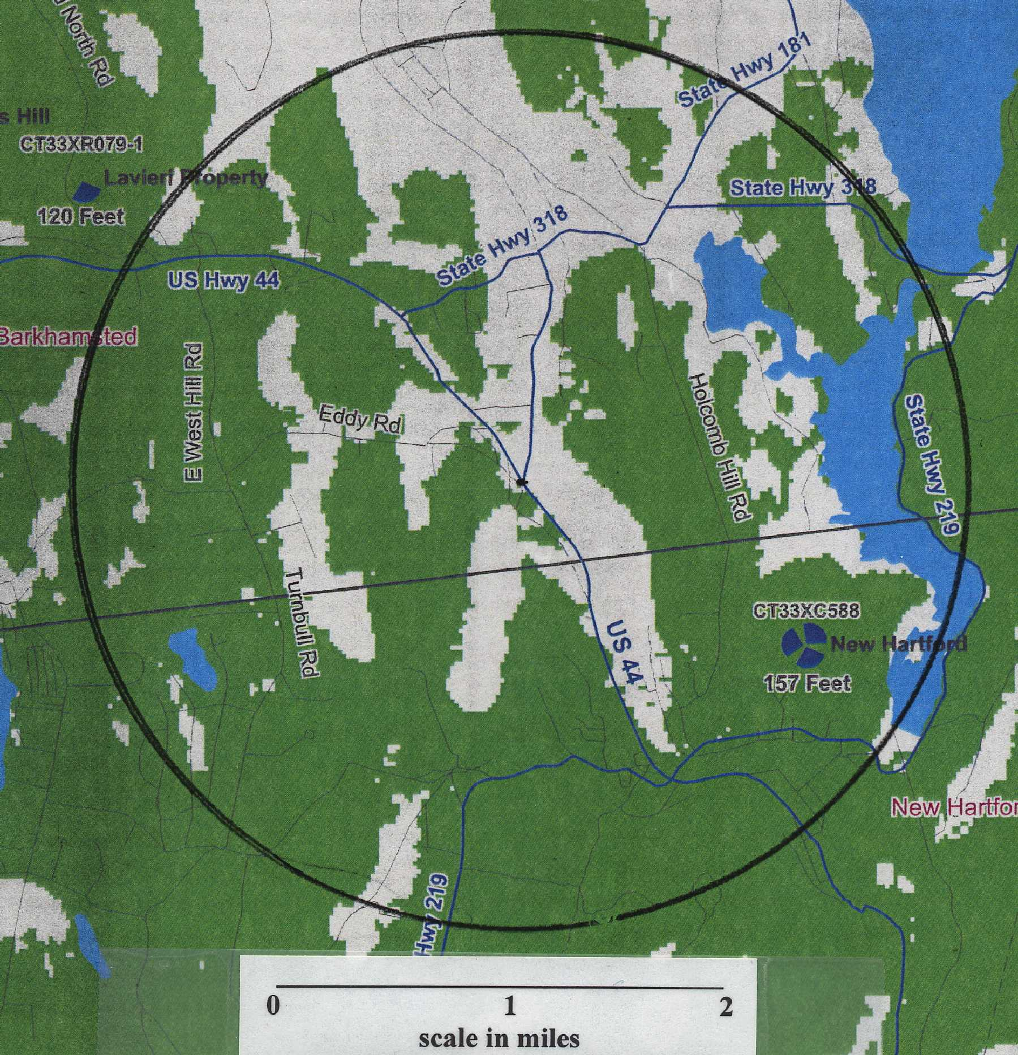

Green equates to coverage at -94 dbm or greater and white areas equate to no coverage.
(Sprint 1, Revised Exhibit E)
Appendix B
Proposed Tower at a centerline height of 144 feet AGL

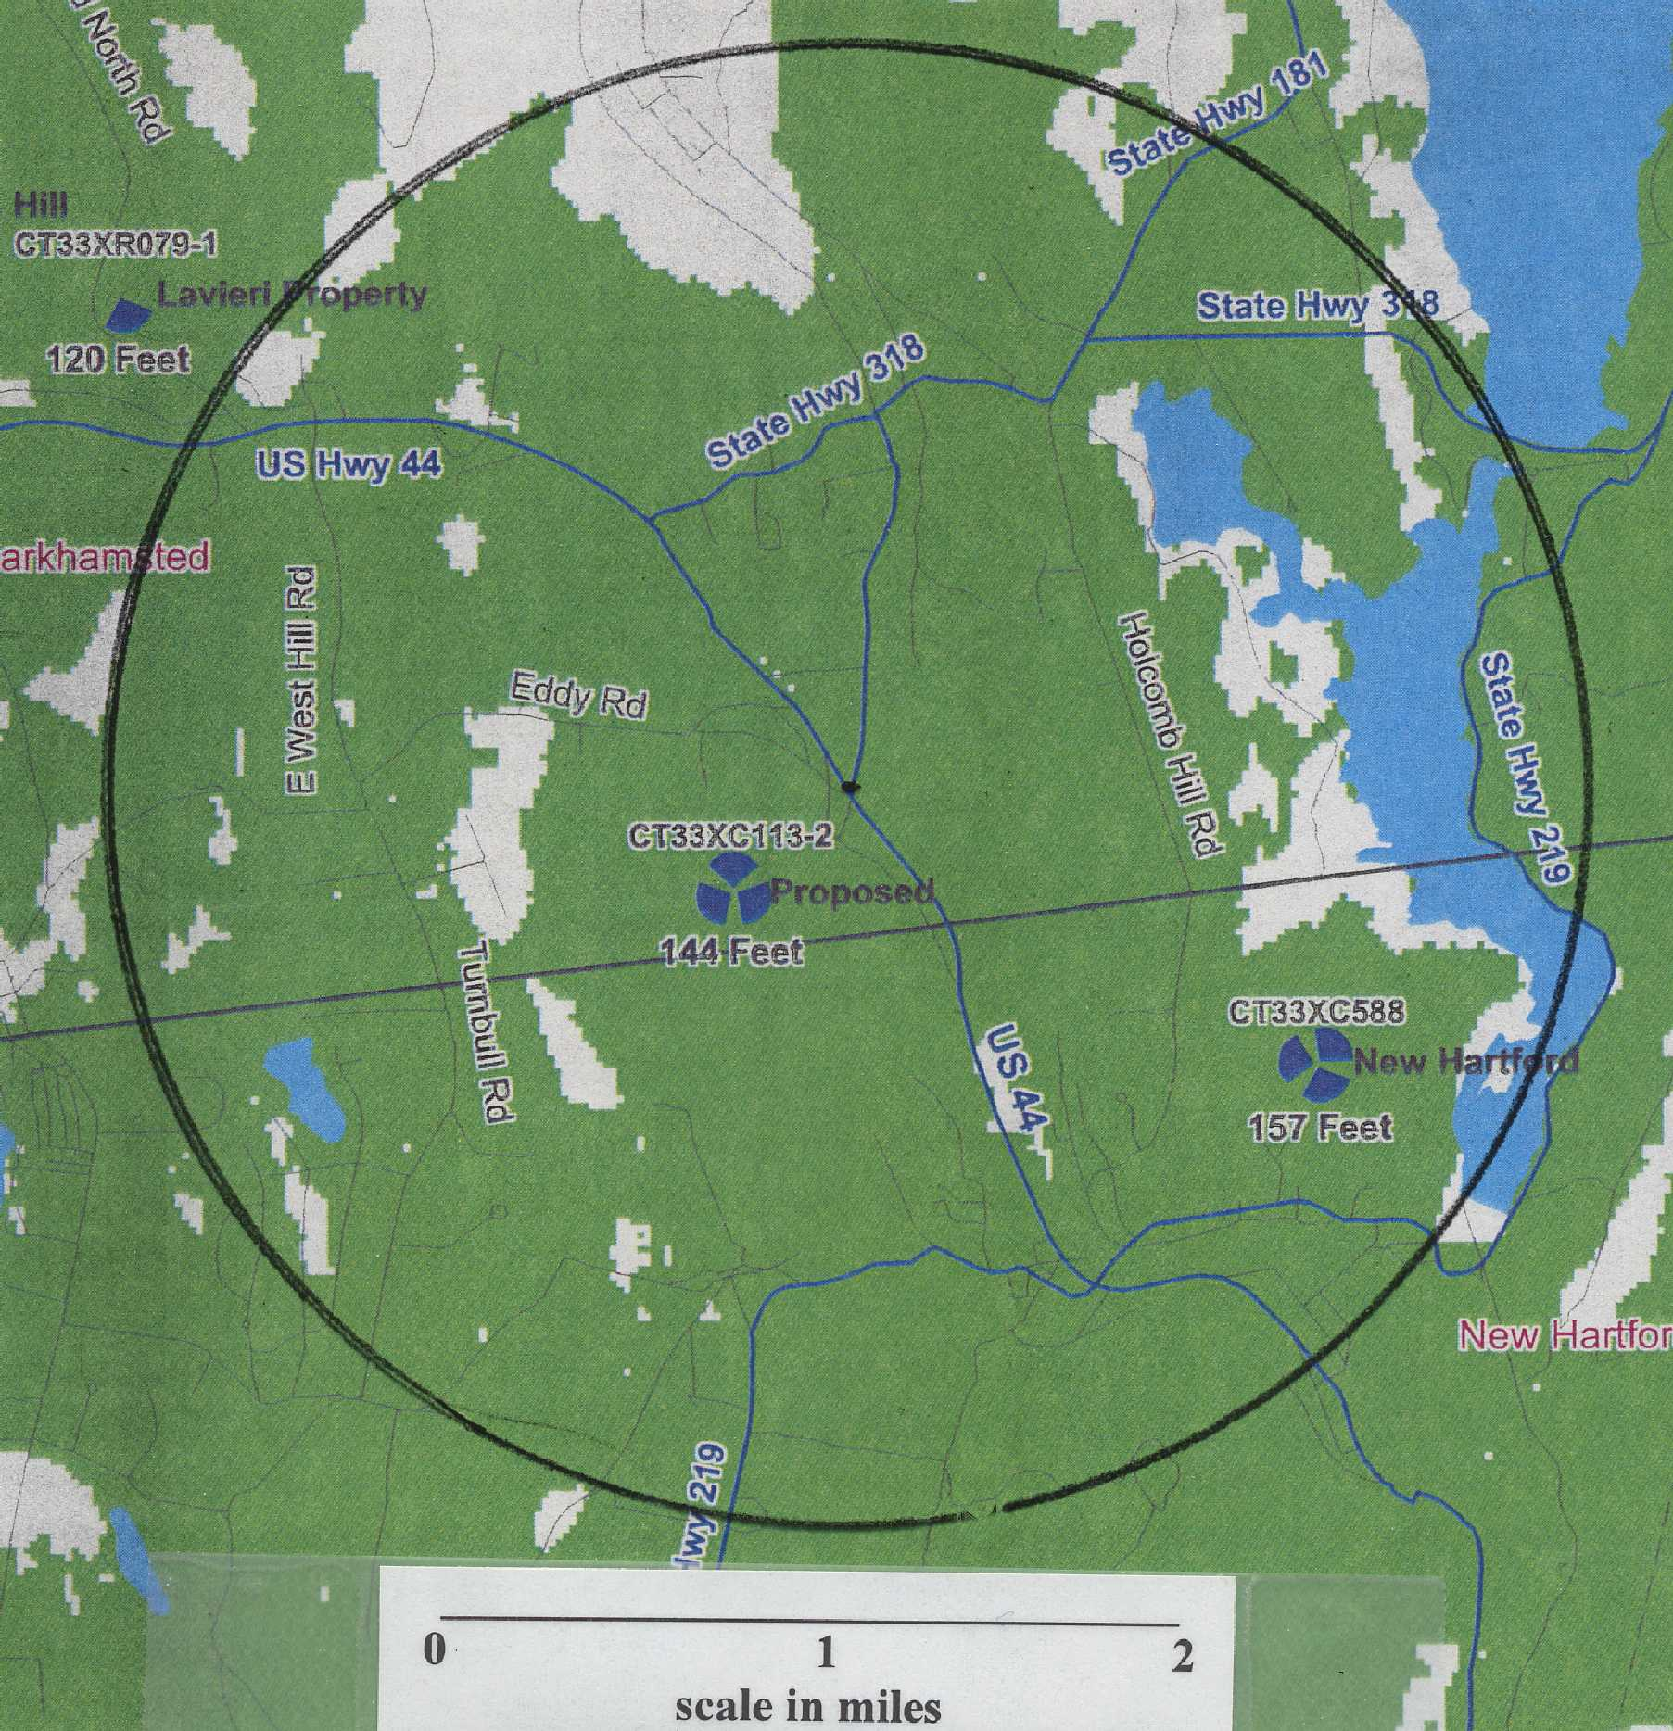

Green equates to coverage at -94 dbm or greater and white areas equate to no coverage.
(Sprint 1, Revised Exhibit F)
Appendix C
Proposed Tower at a centerline height of 130 feet AGL

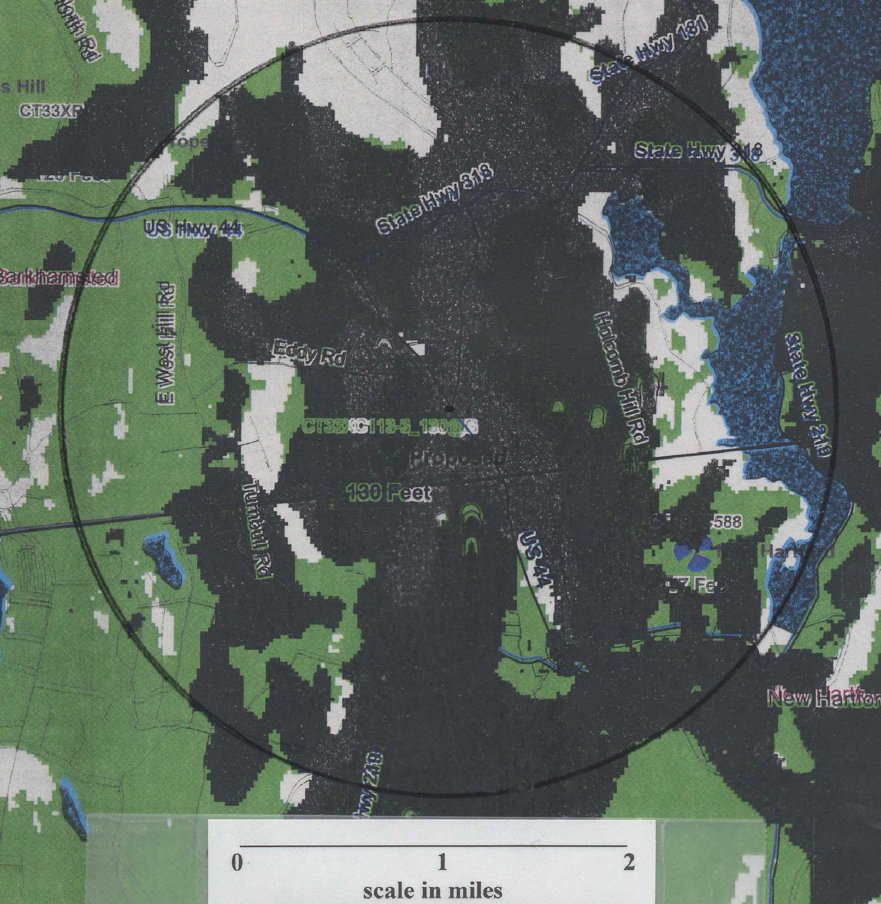

Green and black equates to coverage at -94 dbm or greater and white areas equate to no coverage.
(Sprint 3, Q. 2)

