Middletown State Veterans Cemetery
Headstone Application – Dependent (Front)
Phone (860) 616-3688 or Fax (860) 616-3561
oaa-cms.dva@ct.gov
Marble Headstone Inscription Instructions. You may use this form to write-out the inscription you would like on the headstone. Please provide the information to the cemetery prior to the date of the burial. You can email, or fax the application using the information listed above.
EXAMPLE

ELIZABETH R
JOHNSON
MAY 2 1931
JUN 26 2020
WIFE OF
LCDR (SS) ROBERT
JOHNSON USN
BELOVED WIFE
MOM AND NANA
LOVED BY ALL
LUKE 20:36
There are 11 lines of inscription available on an upright marble headstone. Each block below represents a letter, number or the space between words and numbers. The individual’s name is inscribed on the first two or three lines. The first two lines allow a maximum of 13 characters, including spaces. All other lines have a maximum of 15 characters including spaces. *Items in bold are mandatory on VA headstones. All other items are optional.
When the mandatory portion of the inscription is complete, you may use the remaining lines (9 – 11) to include a personalized additional inscription of your choice, provided it is consistent with our mission to honor Veterans and their families.
** If you use Line 1 for the First Name and Middle Initial in place of the Full Middle Name on Line 2, you may use an extra line at the bottom for Additional Inscription of your choice.
Emblem of Belief (Optional) |  |  |  | Emblems of Belief (EOB) currently offered for inscription at the top of the headstone are depicted on the back of this form. If you wish to add an EOB, please enter the number associated with the EOB.
* 1. | First name w/Middle Initial:  (or use line 2 for full middle name)
2. | ** Full Middle Name:
* 3. | Last Name:
* 4. | Month (1st three ltrs)/Day/*Year of Birth:
* 5. | Month (1st three ltrs)/Day/*Year of Death:
* 6. | Relationship Line:
(As depicted in the EXAMPLE photo above; Husband of, Wife of, Spouse of, Son of, Daughter of, etc.)
* 7. | Veteran’s Highest Rank and  First Name and MI or Middle Name
* 8. | Veteran’s Last Name  & *Branch of Service (*Abbreviated)
9. | Additional Inscription:
10. | Additional Inscription:
11. | Additional Inscription:
** Extra line for Additional Inscription:
(This line may only be used if Line 2,
Full Middle Name, is NOT used.)
Next of Kin Signature: |  |  |  |  |  |  |  |  |  |  |  |  | Date:

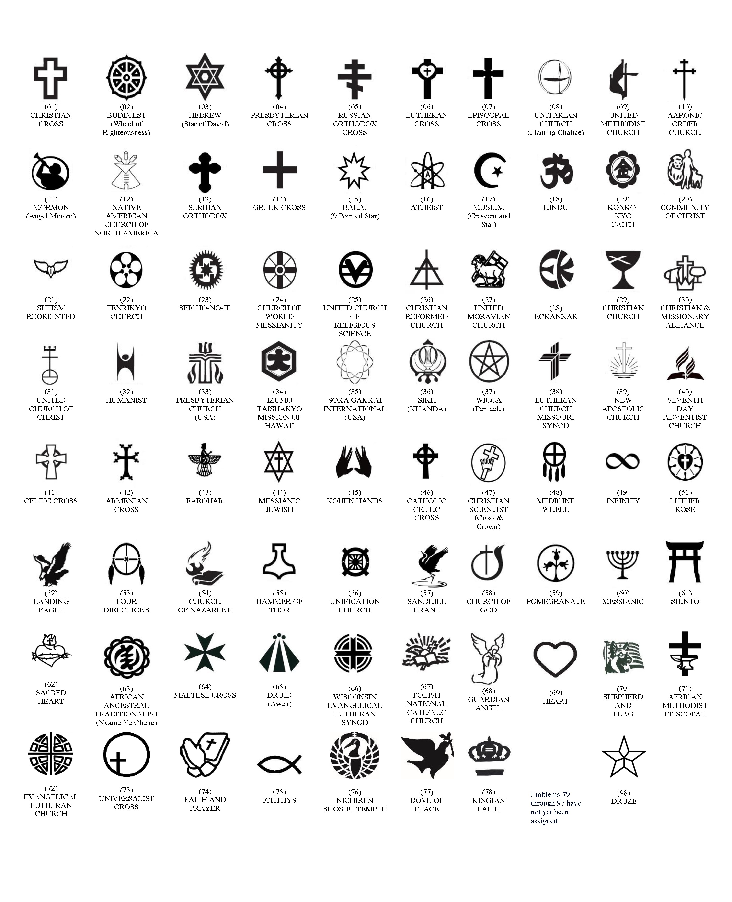
AVAILABLE EMBLEMS OF BELIEF FOR PLACEMENT ON GOVERNMENT HEADSTONES AND MARKERS (As of August, 2022)

