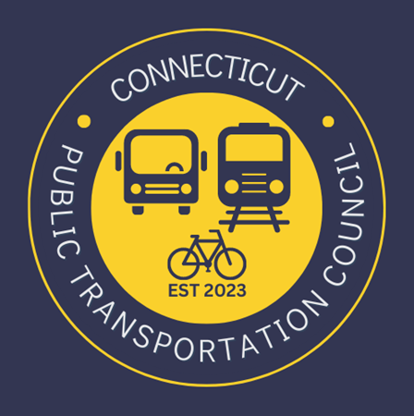

Connecticut Public Transportation Council

Minutes: Wednesday September 18, 2024 6:00 p.m.

Attendance and Meeting Introduction
Jim Gildea called the meeting to order at 6:05.
Council members in attendance were: Jim, Gildea Julia McGrath, Doug Hausladen, Marcellus Edwards, Kate Rozen, Al Sylvestre, Chance Carter and Phillip A. Magalnick
Benjamin Limmer introduced the following CDOT representation: Lisa Rivers, Elise Greenberg, Tyler Roth, Katie Hedberg, and Cortni Desir introduce themselves.
Public Comment
Miriam Grossman discusses issues with vending machines at Grand Central, including out-of-order soda machines and high prices at Hudson News. She also mentioned bus bunching and the need for improved kiosks in New Haven. Finally, she emphasized the need for more affordable and accessible vending options.
Honorata Kazmierczak raised concerns about accessible information fixtures and audible announcements at bus stations. In addition, she raised concerns about the proper staging order of trains at the Hartford Train station. Finally, she emphasized the importance of accessible information for blind and low vision individuals.
Shoreline East Train Restoration
- Benjamin Limmer explains the $5 million appropriation from the state legislature and the plan to implement additional service next month.
- Benjamin Limmer details the new service, including one additional train in the morning and evening, and through service to Stanford from New London.
Accessible Information Fixtures and Audible Announcements
- Phil Magalnick raises concerns about the status of fixing audible information fixtures and tactile information at bus stations in Stanford.
- Lisa Rivers, CDOT discussed the need for audible announcements and the challenges of maintaining them.
- Phil Magalnick reinforced the importance of accessible information for blind and low vision individuals.
- Lisa Rivers committed to investigating the issues and working with signage and audible announcements.
- Ben Limmer recommended scheduling a separate follow up meeting between HNS and Phillip Magalnick to discuss accessible seating issues
CT Rails and Shoreline East Survey Results
- Cortni Desir, CDOT presentesd the CT Rails, Shoreline East, Hartford Line, and New Haven Line survey results.
- The CT transit customer satisfaction survey reached 9,500 customers, with 75% feeling safe and 86% feeling operators drive safely.
- The survey highlights the need for better bus and shelter cleanliness, accessibility, and connectivity.
- The CT transit team implemented the largest service update in decades, focusing on increasing frequency, express services, and connections.
CT Fast Track and Customer Experience Action Plan
- Cortni Desir, CDOT discussed the CT Fast Track's $38.9 million grant to convert to an all-electric fleet.
- The customer experience action plan received recognition with an America's Transportation Award for quality of life and community.
- The tap and ride pilot for open payments on board busses is set to start, allowing riders to use their cell phones to pay.
- Amtrak held a groundbreaking event for the Connecticut River Bridge Project, a $1.3 billion project to replace the oldest bridge on the Shoreline East.

Strategic Plan and Mission Statement
- Benjamin Limmer introduced the Bureau's strategic plan, focusing on delivering on the CX action plan and top priorities from the governor's office.
- The new mission statement for the Bureau is "Improving lives through transportation by keeping Connecticut moving with accessible, safe, and reliable multimodal services across our state and beyond."
- The strategic goals include developing a dynamic workforce, optimizing the organization for delivery
excellence, fortifying strategic partnerships, and promoting long-term viability.

Data Ecosystem and Reporting Challenges
- Tyler Roth, CDOT discusses the challenges and opportunities in the data ecosystem, including the lack of uniformity across different service providers.
- The Bureau is working on standardizing data across providers and developing a public transit dashboard using Power BI.
- The dashboard will include monthly stats for bus, rail, and ferry services, with the goal of making data more transparent and accessible.
- The dashboard will be shared publicly by spring of next year, with feedback from the Bureau and service providers incorporated.
Questions and Feedback on Data Reporting
- Chance Carter asked about the possibility of breaking down data by route for better route-level analysis.
- Tyler Roth acknowledges the need for more granular data and will explore creating additional dashboards for route-level information.
- Phillip Magalnick raises concerns about the accessibility of interactive data charts for screen readers.
- Tyler Roth commits to investigating voice-assisted capabilities for the dashboard and ensuring data is accessible to all users.
A motion was made to adjourn by Al Sylvestre and seconded by Kare Rozen to adjourn at 8:35.

