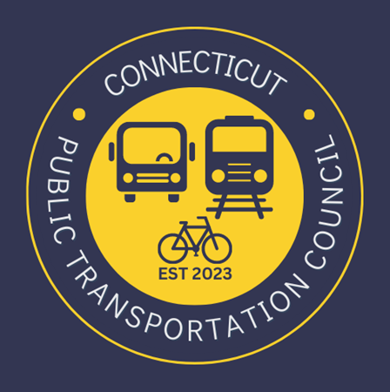
Connecticut Public Transportation Council

Minutes: Wednesday January 17, 2024 at 7:00pm

Virtual via Zoom

The following Councilmembers were in attendance: Jim Gildea, Zell Steever, Julia McGrath, Kate Rozen, Marcellus Edwards, Douglas Hausladen, Alan Sylvestre, Blaize Levitan, Chance Carter, and Vesta Bortey-Fio.

Also in attendance:
MNRR Representatives and CT DOT Representatives.

Council Business:
Chair Jim Gildea called the meeting to order at 7:06pm.
Zell Steever made a motion to approve the September 2023 meeting minutes. Second by Doug Hausladen. Motion approved unanimously.

Zell Steever made a motion to approve the December 2023 meeting minutes. Second by Julia McGrath. Motion approved unanimously.

Chair Gildea introduced the newest appointees Chance Carter and Vesta Bortey-Fio. The Council did a full welcome and introductions of the full team. Chair Gildea is working closely with the Legislature and Governor’s Office for remaining vacancies. The CTPC has submitted recommendations to fill all vacancies.

Chair Gildea also introduced representatives from CT Rides. They plan to attend more meetings and help partner on how we can advertise their benefits.

Public Comments:
There was no public comment, however Chair Gildea presented written comment submitted by Miriam Grossman

Legislative Update for 2024 Session
Kate Rozen provided the legislative update for the upcoming 2024 short session. The CTPC Working Group identified key priorities to advocate for this legislative cycle. See attached.

Meeting Schedule for 2024
Kate Rozen presented the proposed meeting schedule for CTPC for 2024. Blaize Levitan made a motion to approve. Zell Steever seconded. Motion approved. The meeting schedule is posted on our website.

Election of CPTC Officers
Chair Gildea opened the floor for nominations for Chair of the CPTC, which is a new Council from the Commuter Rail Council. Kate Rozen nominated Jim Gildea and Blaize Levitan seconded. Motion approved.

Chair Gildea nominated Kate Rozen to be the Vice Chair. Blaize Levitan seconded. Motion approved.

Chair Gildea nominated Blaize Levitan to be Secretary. Zell Steever seconded. Motion approved.

Chair Gildea said we will nominate a bus-transit user once we have the remaining vacancies appointed. It would be good to have rail-focused and bus-transit focused Vice Chair positions.

Hartford Line and Transportation Committee Meeting
Chair Gildea has been in close contact with State Senator Christine Cohen, Chair of the Transportation Committee. She has agreed to have the Council present for 2 hours in a public hearing on February 21st. We will present our legislative priorities. At conclusion, we will go to Union Station for our Hartford Line meeting in-person.

Operations Report Review
The Council reviewed the operations report provided by CT DOT. Timing of the report is in transition and the bus transit data is a work in progress. The report is still missing most key data points. Chair Gildea will work with CT DOT to ensure basic performance data is provided.

Chair Gildea will also notify the Transportation Committee that the Council’s very basic data requests from April 2022 still have not been filled. This is after numerous attempts and repeated promises from CT DOT and MNRR. The Council asked for: on-time performance data by major station in CT (Stamford even only was ok), ridership by station, and basic safety data by station. It has been very disturbing that there is no entity tracking on-time performance for the CT Commuter.

Adjournment
Zell Steever made a motion to adjourn. Julia McGrath seconded the motion. Meeting was adjourned by unanimous vote.

Respectfully submitted,

Blaize Levitan, Secretary

