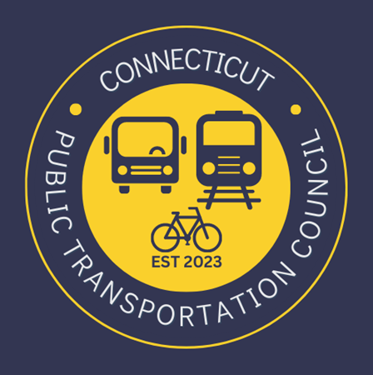
Connecticut Public Transportation Council

Minutes: Wednesday December 13, 2023 at 6:00pm

Virtual via Zoom

The following Councilmembers were in attendance: Jim Gildea, Zell Steever, Julia McGrath, Kate Rozen, Marcellus Edwards, Douglas Hausladen, Alan Sylvestre, and Blaize Levitan.

Also in attendance:
MNRR Representatives and CT DOT Representatives.

Council Business:
Chair Jim Gildea called the meeting to order at 6:05pm.
The November minutes were not ready for approval.

Chair Gildea introduced the newest appointee Alan Sylvestre, a bus transit user. He mentioned that we hoped to have full staffing for our first quarterly CT DOT meeting under the new model; he is working closely with Connecticut General Assembly leadership to appoint the transit user vacancies. He is confident we will have a full council soon. The CTPC has submitted recommendations to fill all vacancies.

Public Comments:
Miriam Grossman provided public comment.

Transit System Overview
Doug Holcomb, Executive Director of the Greater Bridgeport Transit District, provided a detailed presentation on the structure of the transit system, as well as GBTD current services and possible expansion. He offered to return to the Council and looks forward to working together. See attached presentation. There was a Q&A session afterwards.

Quarterly Update
CT DOT’s Public Transportation Bureau Chief Ben Limmer provided a quarterly update on major projects and initiatives of CT DOT. See attached presentation. There was a Q&A session afterwards.

Update on Micro-transit Pilot
Mark Goodale of the Connecticut Department of Transportation provided a presentation on the State’s grant-funded Micro-transit pilot program. There are 9 awardees in the program, which is currently wrapping up public bidding and contract execution. The program will launch Spring/Summer 2024. See attached presentation. There was a Q&A session afterwards.

Update on Transit App and Integration Efforts
SMART Grant (CT Integrated Transit Mobility Project)
Dan Baker of CT DOT provided an update and presentation on enhancing the digital customer experience. The CT DOT is looking to consolidate the user experience in a one-stop-shop mobile app, as well as improve payment options and experience. See attached presentation. There was a Q&A session afterwards.

Operations Report and Timing
Alicia Leite of CT DOT explained that the timing of the reports has been adjusted to the start of the month in which the meeting occurs. This will allow for better reporting from the rail and bus operations. It will also provide the Council with a report that is one more month current and will reduce the time burden on CT DOT staff.

Rail Operations Report Review
The Council reviewed the monthly rail report. Chair Gildea asked Ben Cornelius of MNRR when we could meet to receive on-time performance data for even the Stamford Station, a request originally made in April 2022. Alicia Leite of CT DOT offered to be the intermediary and would coordinate offline to setup a meeting with Chair Gildea, Blaize Levitan, Alicia Leite, and Ben Cornelius.

Bus Operations Report Review
CT DOT presented the first-ever operations report on Bus performance. This will be a work in progress as we collect data and work to ensure we are using consistent definitions. Alicia Leite cautioned about on-time performance data and that it cannot be compared to rail on-time performance.

Hartford and TC Meeting
Chair Gildea is working with the Transportation Committee leadership. With Senator Christine Cohen, the CTPC will be invited for a two-hour public discussion with the Transportation Committee. Our regular monthly meeting will follow, in person, in Hartford at Union Station. The monthly meeting will be 6PM start.

Old Business / New Business
None.

Adjournment
Zell Steever made a motion to adjourn. Marcellus Edwards seconded the motion. Meeting was adjourned by unanimous vote.

Respectfully submitted,

Blaize Levitan, Secretary

