

AGENDA
Wednesday April 17, 2024 7:00 p.m. via Zoom

1. | Welcome and Introductions | Chair | 7:00 p.m.
2. | Approval of September and December Minutes | CPTC | 7:02 p.m.
3. | Public Comment | Public | 7:04 p.m.

Council Business:
1. | New Member Introductions | CPTC |  | 7:15 p.m.
2. | 2024 Goals Check In | CPTC |  | 7:25 p.m.
3. | Review of 2024 Meeting Dates/Proposed Site Visits | CPTC |  | 7:55 p.m.
4. | Review of Legislative Priorities | CPTC |  | 8:00 p.m.
5. | June DOT Meeting Agenda | CPTC |  | 8:15 p.m.
6. | Legislative Updates | CPTC |  | 8:20 p.m
6. | Operations Report Review | CPTC |  | 8:30 p.m.
7. | Old Business / New Business | CPTC |  | 8:35 p.m.
8. | Adjourn | CPTC |  | 8:40 p.m.
Join Zoom Meeting
https://us02web.zoom.us/j/82727517048
Meeting ID: 827 2751 7048
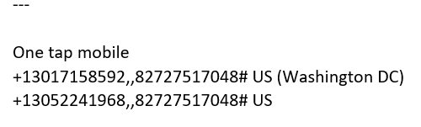

Next Meeting
May 15 - Tentatively Metro North Meeting in NYC with 6pm start

