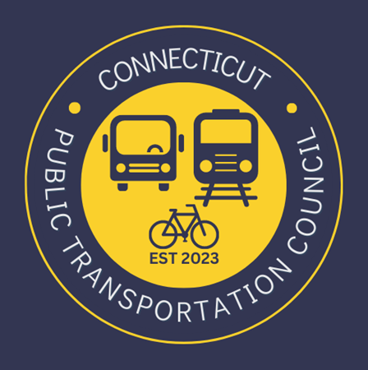

AGENDA
Wednesday December 13, 2023 6:00 p.m. via Zoom

1. | Welcome and Introductions | Chair | 6:00 p.m.
2. | Approval of November Minutes | CPTC | 6:02 p.m.
3. | Public Comment | Public | 6:04 p.m.

Council Business:
1. | Transit System Overview – Doug Holcomb E.D. GBTD | GBTD | 6:10 p.m.
2. | Quarterly Update- Ben Limmer | CDOT | 6:30 p.m.
3. | Update on Microtransit Pilot- Mark Goodale | CDOT | 6:50 p.m.
4. | Update on Transit App and integration efforts and Update on SMART Grant (CT Integrated Transit Mobility Project) – Dan Baker | CDOT | 7:10 p.m.
5. | Operations Report and Timing – Alicia Leite | CDOT | 7:40 p.m.
6. | Rail Operations Report Review | CDOT | 7:55 p.m.
7. | Bus Operations Report Review | CDOT | 8:05 p.m.
8. | Hartford and TC Meeting | CPTC | 8:15 p.m.
9. | Old Business / New Business | CPTC | 8:25 p.m..
10. | Adjourn | CPTC | 8:40 p.m.

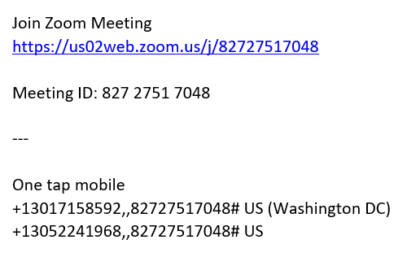
Next Meeting
January 17, 2023
T.B.D.

