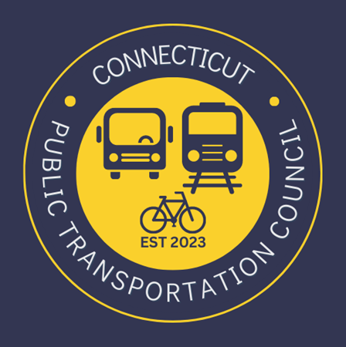

AGENDA
Wednesday May 28, 2025 6:00 p.m. Hybrid- In Person & Zoom
Metro North Conference Room Graybar Building
Grand Central Terminal
420 Lexington Avenue
New York, NY

1. | Welcome | Chair | 6:00 p.m.
2. | Approval of Meeting Minutes | CPTC | 6:02 p.m.
3. | Public Comment | Public | 6:05 p.m.

Council Business:
1. | Metro North Leadership Introductions | Metro North |  | 6:10 p.m.
2. | Fall Ridership Survey Results | Metro North |  | 6:20 p.m.
3. | 2024 Main Line Ridership | Metro North |  | 6:35 p.m.
4. | 2024 Branch Line Ridership | Metro North |  | 6:50 p.m.
5. | McKinsey Ridership Projects Update | Metro North |  | 7:05 p.m.
6. | Express Train Ridership Levels | Metro North |  | 7:20 p.m.
7. | Quiet car restoration discussion | Metro North |  | 7:30 p.m.
8. | Old Business / New Business | CPTC |  | 7:40 p.m.
9. | Adjourn | CPTC |  | 7:45 p.m.
Microsoft Teams
Join the meeting now
Meeting ID: 237 542 100 01
Passcode: nH9gm7SY

Next Meeting
June 25, 2025 - VTD

