

AGENDA
Wednesday February 21, 2024 6:00 p.m. via Hybrid- In Person & Zoom

1. | Welcome and Introductions | Chair | 6:00 p.m.
2. | Approval of September and December Minutes | CPTC | 6:02 p.m.
3. | Public Comment | Public | 6:04 p.m.

Council Business:
1. | Governor’s Initiatives on Transportation | Governor’s Office |  | 6:15 p.m.
2. | Greater Hartford Transit District Overview | GHTD |  | 6:35 p.m.
3. | Transportation Committee Update | CPTC |  | 6:55 p.m.
4. | Review of Legislative Priorities | CPTC |  | 7:00 p.m.
5. | Update on CTDOT March Meeting/Operational Review & Metrics | CPTC |  | 7:15 p.m.
6. | Operations Report Review | CPTC |  | 7:20 p.m.
7. | Old Business / New Business | CPTC |  | 7:25 p.m.
8. | Adjourn | CPTC |  | 7:30 p.m.
Join Zoom Meeting
https://us02web.zoom.us/j/82727517048
Meeting ID: 827 2751 7048
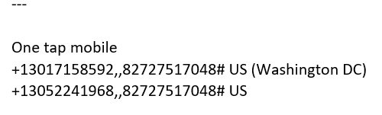

Next Meeting
March 20 - Quarterly CTDOT meeting - SLE focus to be held in New London

