Camp Quinebaug

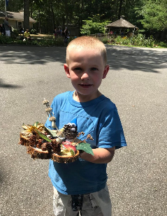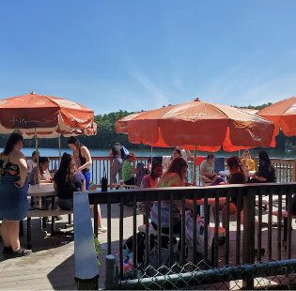

About Camp Quinebaug...
Camp Quinebaug, affectionately known as “Camp Q”, is a summer day Camp for youth with disabilities in Killingly, Connecticut. Camp Q is operated by The State of Connecticut, Department of Developmental Services, in conjunction with The Friends of Camp Quinebaug (non-profit board of directors), and in partnership with local schools and communities.
Camp Quinebaug was established in 1972 to provide a unique summer camp experience for school age children with disabilities in northeastern Connecticut. The camp is located on the Wauregan Reservoir (aka Quinebaug Pond) in Killingly. Camp Q, the reservoir, and surrounding wooded areas make up for approximately 11 acres of land. Our swimming area has the only beach on this waterway. Swimming, boating, fishing, nature enrichment, arts and crafts, sports and games highlight the busy camp schedule. Approximately 90-120 campers per season enjoy the benefits of this 6 week, fully accessible camp environment.
In addition to the State of Ct DDS oversite, Camp Q is licensed annually through the Office of Early Childhood (OEC) – Division of Youth Camps. Licensed Youth Camps in CT require strict adherence to rules, regulations and requirements around ensuring the health and safety of all campers, at all times, with a high emphasis on the training and certification of staff employed by the Camp and a safe camping environment.
Who can come to camp?
Camp Quinebaug Summer Camp is open to children ages four to twenty-two who are:
- Eligible for services from the Department of Developmental Services (DDS)*
- Enrolled in school, register for camp on established registration dates, and meet all requirements to be approved to attend camp
- Planning on attending camp with their own staff supports if they are needed
- Able to spend a considerable amount of time outdoors
- Able to participate in group settings

* If a child is not eligible for services from the DDS, and has a documented disability, they may be able to attend camp provided they: (1) meet all other above criteria, (2) have their own supervising staff who are with them at all times and who have met Camp Q staff training requirements and, (3) have been approved to attend by Camp Q administrative and managerial staff.
Alumni Camp:
A one week, day camp is available for individuals who formerly attended Camp Q, who have developmental disabilities, and have recently exited high school. This is held during the week prior to the official start of the six-week summer camp program. Registration requirements are the same for all campers, including Alumni.

