Enter the Individual’s First Name & Last Name, DDS#, Case Manager’s Name and the Meeting Date:
Da Person Centered Plan DDS # 12345
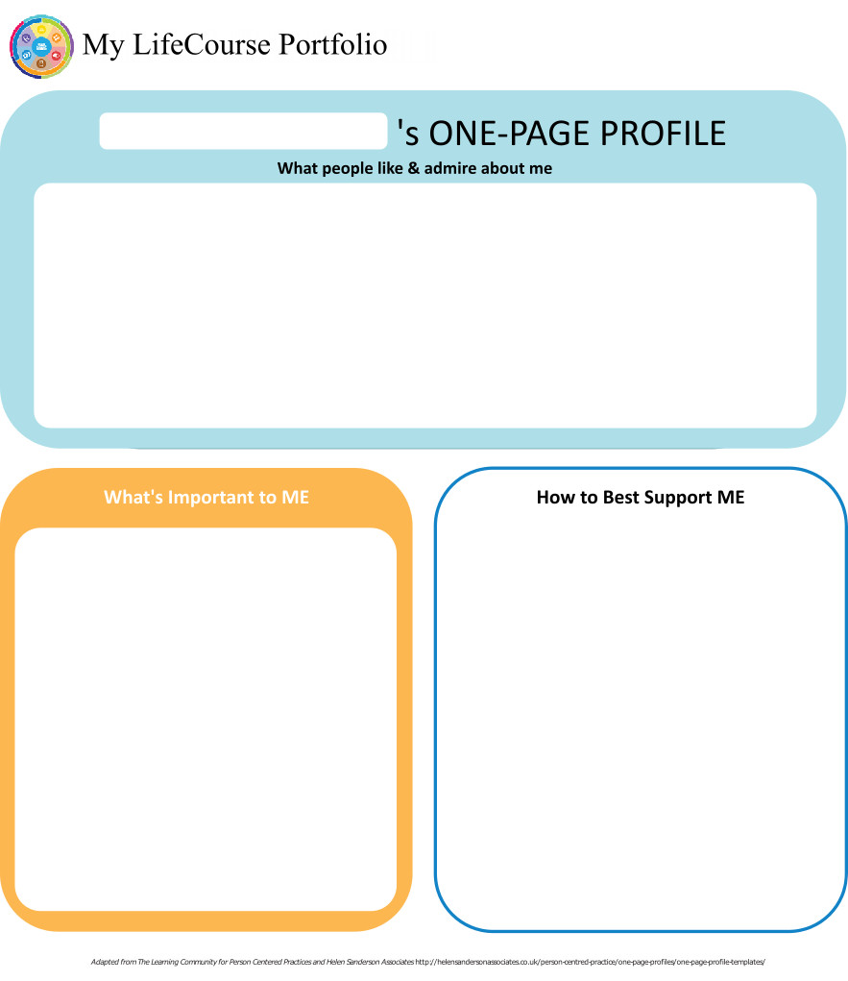
Case Manager: Meeting Date: 3/19/19

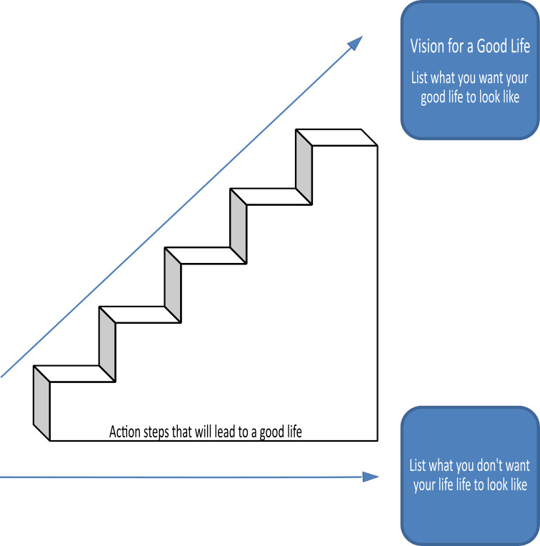

Home Life
Current Status Please include schedule, supports received, supervision needs, LON Risk areas, and accomplishments: Should be brief summaries and concise information on how the person is doing in their current residential situation. This may be a place to note how specific LON risk areas are being addressed (i.e. level of supervision, behavior plan). Not an area to rewrite or insert large amounts from other reports. Reports should be sent to team members and reviewed prior to the meeting - reports can be discussed at the meeting and attached to the IP. Include individual's schedule, supports that they receive, and supervision needs.

- What I want my Home to be like How do you like to spend your time at home: Is there something that you want to learn to do at home? Do you want to change anything about your home/bedroom? What do you like to do when you're home? What would you like your home environment to be like (i.e. quiet, busy, active, low-key, etc)? Are there things that your staff person/roommate/parent do that you don't like? Or are there things that they do that you do like?

- Would you like to live anywhere else, what’s your vision? Does this answer reflect what was stated for Vision of a Good Life on page 2? If you couldn't live where you are now, where would you want to live? With who? This is an opportunity to draw from the answers provided (i.e. "live in Florida", "Why?", "I like the beach and go to Disney World and visit my mom" - right there are 3 things that supports can assist person with).

- What Supports do you need to help with this? If needed, team members can offer suggestions of supports that will assist person with getting closer to their future vision. Elaborate on supports needed to assist the person with the WHY they have their vision of living anywhere else. Do you required training in an a specific area(s) to get closer to your vision? What are some steps that you can make to move closer to your vision? Who/what can help you with this? How can you incorporate some of your desires into your current home? Are there LON issues that can be noted here that would need supports?

- Do you need support with your finances?
Providers please include financial assessment and report if applicable. Do you have a representative payee? Please list.

Who is your rep payee? Is this person at risk of financial exploitation without support and why? What is being done to minimize risk? What kind of support do you receive for managing finances/making purchases? Financial assessment completed? Team may provide input here.
- You are required to obtain and maintain Medicaid benefits. Do you require help maintaining
Medicaid?
- If yes, who is responsible to help you? Who completes your T19 redetermination? CM is responsible for verifying a person's continuing eligibility for Medicaid. Do you have an on-line account with DSS?

- Financial Information:
- Earned Income Individual may be as detailed as they would like depending on the support they are receiving. Identified team members may have more knowledge and ensure assets meet eligibility criteria.
- Benefits Income (list programs and amounts) SSI, SSDI, SNAP, Rent subsidy, etc
- Bank Accounts Provide bank name(s) and balance(s) if possible.
- Burial/Funeral Account? Is there one? Where? Status of this (i.e. paid in full?)
- Total assets: Are they at risk of losing benefits based on assets?
- Are you satisfied with the supports you are receiving at home?
Describe: Include individual's response and guaridan's response - some may not be comfortable answering in front of the team. CM should f/u after meeting if necessary.

- Emergency contact: Who is the ¹st person to contact in the event of an emergency? Is there a secondary contact?

- Emergency Back-Up Plan:
An Emergency Back-Up plan must be completed for individuals who receive waiver services and live in their own home, family home or other settings where staff might not be continuously available, and who receive personal care and/or supervision supports and the failure of those supports to be available would lead to an immediate risk to the individual’s health and/or safety.

Need a plan if failure of support would lead to IMMEDIATE risk to the individual's health and safety.

Work, Day, Retirement or School
Current Status Description/schedule of what the individual is doing, level of support and supervision needed, identify any LON Risk areas, modes of transportation, accomplishments: Brief summary of present status, important points from reports, updates from family and providers, progress or accomplishments made this year, etc.. This is not an area to rewrite or insert full reports or data as they should be attached and discussed at IP meeting.

- Do you like the job you have or the activities you do during the day? "Yes" or "No" is okay for response as anything person wants to add can be added in question 2.
- What do you like about it, what would you like to change? Should be in person's own words. Team may need to assist the person if they are having difficulty in identifying specific items.
- What new skills, education or activities would you like to learn or take part in this year? Is there something new you would like to learn or try? Are there plans to try anything new? Were there items in the trajectory (the steps) that can go here? ¹st step toward the "dream job" from Vision?
- What are your career goals? Vision for the future? Were there any items related to work/daily activities in the Vision for a Good Life? Do you have a career objective/goal? Do you have a "dream" job? If you no longer work, what activities do you enjoy and how do you envision your future?

- What supports do you need during work or activities? What supports do you need to progress toward your most desired setting or activity? Do you need training in certain areas? Do you have a job coach? How do they help you? What works best for you or doesn't work for you? Team may offer input on this. Ideas or steps generated should be incorporated in the person's Action Plan. How would LON risks be supported?

- Do you have Transportation to get you to and from work on time?

Describe: What are the transportation arrangements? Is it working? Are you satisfied with this? Team may offer input on this.
- Do you make minimum wage or better? "Yes" or "No" response is sufficient, but open to discussion of current minimum wage. Many don't know what the minimum wage is. This may give them a prespective on their earnings. Current minimum wage is $10.10/hr. May write "N/A" for those who do not have any earned income.

- Are you satisfied with your wages?

Describe: "Yes" or "No" response is sufficient. If "no", may describe why, however may be discussed in questions 9 and 10.
- Do you make enough money to do the things you want? Can you pay your bills on time? Can you afford to live on your own or do you require living with others? Can you afford to do the things that you like to do? Or buy what you want to buy?

- What can you do this year to make more money? Does the person want to make more money this year? If so, team should discuss options to accomplish this.

- Are you satisfied with the supports you are receiving?
Describe: Answered in Yes or No, some may not be comfortable answering in front of the team. CM should f/u after meeting if necessary.

Health and Wellness
Current Status: How is your health? What supports are you receiving? What activities do you do to stay healthy? Please include current medications, diagnosis, doctor’s orders, dental, last physical, known allergies, adaptive equipment, brief overview of health history unless noted in Nursing Report, attach Nursing Report to plan if available. Is there a behavior plan in place? Please attach.
Reports should come to team members prior to the meeting so they can take the time to read and process the information outside of the meeting. Reports can be referred to, attached to the IP and only key points noted in this section, including diagnosis, known allergies, current orders, updates on addressing LON risk areas, brief overview of health or behavior history unless noted in submitted reports. For those without DDS funded nursing or behavior supports, include relevant history here or as an attachment.
- What’s Important to me about my health and safety Any areas you want or need to work on? This is entirely the person’s point of view. Teams may not agree with the person but it is important to hear what they think about their health. Some individuals may need some assistance in communicating their opinions to this question. How do you feel about yourself? Are you in good health? What do you do on a daily basis that keeps you healthy and safe (may refer to diets, behavior plans, etc)? Do you like doing these things?
2. Are you up to date on routine medical tests and visits?
Are you able to follow recommended health guidelines? List any deferrals.
Explain: If no, explain what is missing and why. List any deferrals and efforts made. Refer to/provide Minimal Preventive Care Guideline for Persons with Intellectual/Developmental Disabilities if needed.
3. What supports do you need to improve your health and safety? Please include a plan to support any health risk identified in your LON. Teams may need to assist the individual with identifying supports currently in place. Teams will discuss needs and develop strategies on addressing any health and safety risks identified in the LON. These strategies can be outlined here or in the Action Plan.
4. Are you satisfied with the supports you are receiving?
Describe: Answered in Yes or No, some may not be comfortable answering in front of the team. CM should f/u after meeting if necessary. "Supports" include anything used to keep them safe and healthy (i.e. medication, behavior plan, family, transportation).

Friendships, Relationships and Activities

- Who do you enjoy spending time with? Family, friends, co-workers, acquaintances? Any special relationships? Who are your friends? Who do you like hanging out with? Is there anyone you would like to get to know better? Teams should assist non-verbal people by showing them pictures of activities they enjoyed, or giving examples of their expressions during certain activites.

- What are your interests and hobbies? list current interests/hobbies. What do you have fun doing? Do you want to learn something new? Are there things you wish you can do? Have you heard of other people doing things that you would like to do? for those who can't express themselves show them pictures they can use to idenitfiy some things they might like.

- Do you participate in any Groups? Are you a member of a group now and do you enjoy it (i.e. Special Olympics, Self-Advocacy, place of worship, etc)? Do you want to get more involved? Are you interested in looking into some new groups? What would you find enjoyable? The team should bring examples for the person to discuss or learn about.

- Would you like to increase the time you spend with family, friends or doing hobbies or favorite activities? Are you happy with the amount of time you get out? Are you happy with the amount of time you spend with your friends/family, etc? If individual indicates "yes", team should discuss further for more details. Can the team provide examples or show pictures of the person enjoying something? Share with the individual and try to get their feedback or reactions?

- What help do you need to accomplish this? How can we help you with this? Directly related to #4 and is where the team can help the individual identify the supports needed and develop an action plan for this year and the future.



Action Plan
Desired Outcome  (What Do You Hope to Accomplish?) | Why is this Important to you? | Actions and Steps | Responsible Person(s) | Date to be  Completed or  Time frame monitored
- What can be done this year to help the person make progress toward their Future Vision? What do you hope to accomplish? What does the person want/need? | - What does this mean to the person? Will it help make more money? Develop more friendships? Improve health? Gain independence? | 1A:List steps needed to achieve desired outcome. | Who is going to assist the person with this step? Is the indivdiual responsible for a part? Who is accountable? | Does this step have a specific date for completion? Something that needs to be monitored "daily", "monthly" - list frequency of monitoring or a date - not "on-going" or "when needed".
 |  | 1B:Steps should be measurable - either in a Met/Unmet measurement or with more detailed progress or data measurement.
 |  | 1C: In some cases, steps can refer to another written plan (i.e. Nursing, behavior plan, eating guideline). Those steps do not need to be rewritten here.
 |  | 1D:

- Not all LON risks require a specific action step if a response to it has already been included in informational sections of the IP. |  | 2A:
 |  | 2B:
 |  | 2C:
 |  | 2D:

- As a guideline, any need that warrants a protocol, guidleines, program or paid supports need to be reflected in some way in an action step. |  | 3A:
 |  | 3B:
 |  | 3C:
 |  | 3D:

- Avoid generalized statements that do not clearly state the real intent of the desired outcome. |  | 4A:
 |  | 4B:
 |  | 4C:
 |  | 4D:

5A:
5B:
5C:
5D:

6A:
6B:
6C:
6D:

7A:
7B:
7C:
7D:

Summary of Supports and Services:
Agency/individual/Vendor | Type of Support/Service  (identify all including HCBS Waiver Services, non-waiver services and any other supports) | Amount of Support/Service  Hours per week/month/year
This section must include DDS Funded supports (waiver services and state funded), Medicaid state plan services, generic resources, and natural supports provided to address the needs identified in the Action Plan. The information documented in the plan must include the agency or individual who will provide supprt, type of service or support, and the amount of service or support. | IPs that include waiver services will specify which waiver service(s) are to be provided (i.e. Personal Support, IHS, etc)  It is of upmost importance that the information on the provider, supports/services and amount of supports/services for funded support listed here match the DDS authorization for those supports.  There may be changes in the supports or budgets that will require an update in the plan's Summary of Supports and Services or in the Individual Budget IP6 system and must be shared with team members.
 | For waiver services that are inclusive, such as Residential Habilitation (CLA), do not need to list on a separate line each support included with that waiver service (i.e. OT, Nursing)….different major services need to have their own separate line even if provided by the same agency (i.e. RES, DAY and transportation).
 | For those who self-direct, the Summary of Supports and Services does not have to include specific costs associated with hiring staff such as background checks or workers comp
 | If a provider has not been identified at the time of the meeting, the plan may indicate that a provider will be selected within a time frame. Team should indicate the type of provider to furnish the service and describe the activities to support the selection in the action plan. Once selection is made, CM shall ensure information is incorporated into the final IP and is distributed to all team members.
 | CMs and providers may need to confer with RMs to make sure details in this section (including the information on the Placement screen in eCamris) match
DDS | Case Management | Quarterly contact and as needed

For Extension Purposes Only
Plan remains appropriate and Team agreed to extend plan as per DDS extension procedure on:
Case Manager Signature:

Summary of Representation, Participation & Plan Monitoring

Choice and Decision Making
Would you like the assistance of a guardian (in some or many areas) or an advocate in making important decisions in your life? Does your team feel this assistance may be needed? Team should note steps to be taken in this area.

Document individual's desire for assistance of a guardian/decision maker and the team's evaluation of the individual's understanding and capacity to make important decisions/choices, accept assistance from others, and possible need for guardian/advocate/legal or personal representative. Should be discussed every year. Questions: Is the current guardianship status appropriate? Have there been any changes in their ability to make decisions? Team shall consider ways that greater involvement in self-advocacy may benefit the person or review whether they would like the assistance of a self-advocate IP Buddy, advocate, or legal/personal representative.

Individual’s Participation in Planning Process
Were you part of the planning for your meeting and the development of this plan? How can the team assist you with improving your participation in the future? Please identify those steps for next year’s meeting.

Document the person's actual participation in the planning process, team's efforts to involve the person in planning and planned effort to enhance person's future participation in planning. What steps are needed to assist the person with participation? Consider the time of the meeting - is this a good time for the individual? Does the location need to be more accommodating for the person for physical or pyschological reasons? Are there behavioral challenges that need to be considered? Are there thing that need to be worked on throughout the upcoming year? Teams should not assume that because the person has not participated in the past that they shouldn't participate in the future….develop a plan with the individual as needed to enhance participation….critical part of the plan…..not only right of the individual to be a part of their planning but also a requirement of CMS waivered services.

Representative’s Participation in Planning Process
Did your family/guardian/advocate/legal or personal representative take part in the planning process and meeting? Are you satisfied with their level of participation? Team should note steps to be taken in this area for any increased participation.

Document the person's family, guardian, advocate, legal or personal representative participation in the planning process, the team's effort to involve the person's family….or personal representative and efforts to enhance participation in the future. Were there scheduling problems? Was the location difficult for the representive to attend? Could teleconferencing or video conferencing be considered?

Monitoring and Evaluation of the Plan
Contact your case manager with any concerns or progress updates throughout the year. Providers will complete and distribute an Individual Progress Review every six months. Your case manager will conduct a Quality Service Review with you once a year.

Teams can note any additional steps for monitoring and evaluation here as well

Aquatic Activity Screening Individual Plan and Individual Short Plan Addendum
Name: Da | DDS#: 12345 | Date: 3/19/19
An individual’s aquatic activity screening* is effective for one year from the date on this form as part of the IP or for up to three years for an individual with an IP Short Form. Request for any changes or updates to this form shall be made through the Planning and Support Team process.
*For individuals without an IP and assigned case manager, this form shall be completed by the Helpline Case Manager and the individual’s family when access to aquatic activities at DDS-funded sites or with DDS-funded staff are planned (i.e., camp, respite centers, family support).
SECTION 1 SCREENING FOR PRESENCE AND PARTICIPATION IN AQUATIC ACTIVITIES
Definitions:
- “Aquatic Activities” means all water-related activities including swimming, boating, fishing, hot tubs, water parks and those activities that take place near to water.
- “Near To Water” means aquatic activities at any location where there is a body of water at the intended destination that is open and accessible to individuals. This means that there are no barriers to prevent access such as secure fencing or padlocked gates. Contact with the water may, or may not be intended. Bodies of water include, but are not limited to, streams, creeks, oceans, lakes, ponds, pools, hot tubs, wading pools, or natural or man-made water areas. Near to water activities include, but are not limited to, picnics in a park where there is water, feeding ducks at a pond, unrestricted access to backyard wading or swimming pools or hot tubs, or walks on the beach.
- “Shallow Water” means water at or below the height of the individual’s chest.
- “Deep Water” means water above the height of the individual’s chest.
The Planning and Support Team should assign an Aquatic Activity Code “0” to “6”for the individual Aquatic Activity Code
0 = Individual does not swim or participate in any aquatic activities.
If coded as “0”, Section 2 should have “NO” checked for all activities listed.
1= Near to Water Activities Only and Must Be With Staff
Individual participates only in activities near to water.
2 = Shallow Water Only Individual has limited or no swimming skills and does not respond to verbal redirection and may not recognize dangerous situations.
3 = Shallow Water Only Individual has limited or no swimming skills but usually responds to verbal redirection and may or may not recognize dangerous situations.
4 = Deep Water Swimmer Individual can swim in deep water with staff supervision (Comments in Section 2 may define supervision type).
5 = Aquatic Activity Level Not Known. Individual is approved only for aquatic activities as permitted in Section 2 and must be in a One-to-One enhanced staff-to-individual ratio at all of these activities until aquatic activity code is determined and approved.
6 = Independently Accesses Aquatic Activities Individual requires no supervision for aquatic activities. Do not complete Section 2.
SECTION 2 AQUATIC ACTIVITIES - SUPERVISION NEEDS
Complete this section for individuals with an Aquatic Activity Code of “0” to “5”only.
NOTE: If you check off ‘yes’ for any of the activities below, there must be a “staff-to-individual” ratio included. These ratios are for staff to ensure they provide adequate supervision. Safe staff ratios cannot exceed 1 staff to 7 individuals for any of the activities listed. If supervision needs are unknown due to lack of previous participation, the individual must be in a 1:1 staff to individual ratio at all aquatic activities, until a safe appropriate ratio can be determined and approved.
AQUATIC ACTIVITY | ABLE TO  PARTICIPATE | SUPERVISION NEEDS | COMMENTS (arms-length, line of sight, seizures, lifejacket, etc.)
Activities Near to Water |  | # staff to # individuals
Boating: follow site directions for life jacket use. |  | # staff to # individuals
Swimming |  | # staff to # individuals
Water Parks |  | # staff to # individuals
Hot Tub Use |  | # staff to # individuals

Individual’s Name: Da DDS # 12345

Provider: Submitted By:

Case Manager: Date: Period Covered: to

Six Month Annual Other: Date of next Review Meeting :

Are there any significant updates or changes regarding the person’s status in any of the following areas?

What’s important to me? Vision for a Good Life Home Life Finances Work, Day, Retirement or School
Health and Wellness Friendships, Relationships and Activities Integrated Support Star

Updates/Changes:

Copies should be sent to: Individual/Family/Guardian, Case Manager, Residential Provider, Day Provider
Waiver Service(s) (from Summary of Supports and Services):

#1 Desired Outcome: What can be done this year to help the person make progress toward their Future Vision? What do you hope to accomplish? What does the person want/need?
Progress made towards Actions and Steps Yes No Outcome not addressed (must comment below)
Include information about progress, whether steps should continue or be modified.
A: List steps needed to achieve desired outcome.
B: Steps should be measurable - either in a Met/Unmet measurement or with more detailed progress or data measurement.
C: In some cases, steps can refer to another written plan (i.e. Nursing, behavior plan, eating guideline). Those steps do not need to be rewritten here.
D:

See Attached

Concerns/Comments/Recommendations:
Waiver Service(s) (from Summary of Supports and Services):

#2 Desired Outcome: Not all LON risks require a specific action step if a response to it has already been included in informational sections of the IP.
Progress made towards Actions and Steps Yes No Outcome not addressed (must comment below)
Include information about progress, whether steps should continue or be modified.
A:
B:
C:
D:

See Attached
Concerns/Comments/Recommendations:

Individual’s Name: Da DDS # 12345
Waiver Service(s) (from Summary of Supports and Services):

#3Desired Outcome: As a guideline, any need that warrants a protocol, guidleines, program or paid supports need to be reflected in some way in an action step.
Progress made towards Actions and Steps Yes No Outcome not addressed (must comment below)
Include information about progress, whether steps should continue or be modified.
A:
B:
C:
D:

See Attached
Concerns/Comments/Recommendations:
Waiver Service(s) (from Summary of Supports and Services):

#4 Desired Outcome: Avoid generalized statements that do not clearly state the real intent of the desired outcome.
Progress made towards Actions and Steps Yes No Outcome not addressed (must comment below)
Include information about progress, whether steps should continue or be modified.
A:
B:
C:
D:

See Attached
Concerns/Comments/Recommendations:

Waiver Service(s) (from Summary of Supports and Services):

#5 Desired Outcome:
Progress made towards Actions and Steps Yes No Outcome not addressed (must comment below)
Include information about progress, whether steps should continue or be modified.
A:
B:
C:
D:

See Attached
Concerns/Comments/Recommendations:

Individual’s Name: Da DDS # 12345
Waiver Service(s) (from Summary of Supports and Services):

#6 Desired Outcome:
Progress made towards Actions and Steps Yes No Outcome not addressed (must comment below)
Include information about progress, whether steps should continue or be modified.
A:
B:
C:
D:

See Attached
Concerns/Comments/Recommendations:
Waiver Service(s) (from Summary of Supports and Services):

#7 Desired Outcome:
Progress made towards Actions and Steps Yes No Outcome not addressed (must comment below)
Include information about progress, whether steps should continue or be modified.
A:
B:
C:
D:

See Attached
Concerns/Comments/Recommendations:

