**BED & SIDE RAIL SAFETY AUDIT**

**DDS Public Programs**  **Southbury Training School**

**DDS Qualified Provider**      _______________________________________________

**(agency name)**

**Individual:**       **Date of Review:**

**Address:**

**Bed Serial Number:**       **Location of Serial Number:**      

**Type of Bed (check one):**

Fully electric hospital bed  Semi electric hospital bed  Manual hospital bed

Standard bed with added equipment  Other:

**Circle the diagram that best indicates the Rail Configuration on the bed being assessed.**

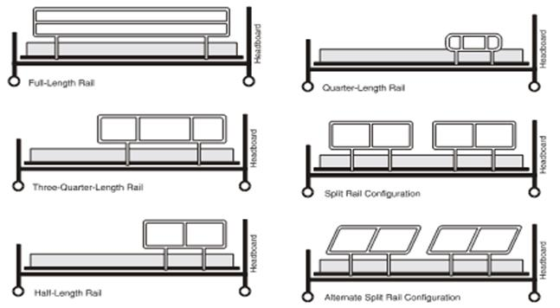

1. **Bed Operations:** Remove all sheets, blankets, bolsters, air mattresses, etc., before proceeding
2. **Semi-electric or manual beds:**

Cranks smoothly Yes  No  Comment:

Head/foot/gatch Yes  No  Comment:

Trendelenburg Yes  No  Comment:

Hi-Lo Yes  No  Comment:

Manual crank backup Yes  No  Comment:

1. **Fully electric beds:**

Cranks smoothly Yes  No  Comment:

Head/foot/gatch Yes  No  Comment:

Trendelenburg Yes  No  Comment:

Hi-Lo Yes  No  Comment:

1. **Semi-electric or fully electric beds:**

Cords/plugs free of damage Yes  No  Comment:

Cords secured properly Yes  No  Comment:

Controls work properly Yes  No  Comment:

(e.g., buttons/switches)

Grounded prong plug on bed Yes  No  Comment:

Grounded wall outlet available Yes  No  Comment:

1. **All beds**

Wheels operate smoothly Yes  No  Comment:

Wheel locks work Yes  No  Comment:

Headboard secured properly Yes  No  Comment:

Footboard secured properly Yes  No  Comment:

Rust Yes  No  Comment:

Dents Yes  No  Comment:

Sharp edges Yes  No  Comment:

Finish is intact Yes  No  Comment:

Surface is smooth Yes  No  Comment:

1. **Mattress:**
2. **General:**

Type

Intact Yes  No  Comment:

Stains Yes  No  Comment:

Odor Yes  No  Comment:

Fits properly Yes  No  Comment:

Is there a gel overlay Yes  No  Comment:

Other overlay Yes  No  Comment:

**Replace all sheets, blankets, bolsters, air mattresses, etc., before proceeding.**

1. **Observe and identify equipment present:**

To keep mattress up and in place (top to bottom):

Bracket Yes  No  Comment:

In proper position? Yes  No  Comment:

Blankets Yes  No  Comment:

Bolsters Yes  No  Comment:

Pillows Yes  No  Comment:

Other Yes  No  Comment:

To fill in gaps between mattress and side rails (Zone 3 – gap to measure 2 inches or less)

Blankets Yes  No  Comment:

Bolsters Yes  No  Comment:

Pillows Yes  No  Comment:

Other Yes  No  Comment:

Measurements: (right or left side of the bed is identified by standing at the head of the bed and facing the footboard)

Gap (if any) between mattress and each side rail (Zone 3):

Left rail       / Right rail       (If greater than 2 inches then bolster is required)

Gap (if any) between mattress and headboard and/or footboard (Zone 7):

Headboard       / Footboard       (Assess need for bolster if greater than 3 inches)

Distance from top of mattress to top of bed rail:

(**Please note**, there is no standard measurement for the distance from the top of the mattress to the top of the bed rail. However, it is important to understand that whenever the mattress that came with the bed is replaced with a different mattress or other equipment such as an air mattress, foam, egg crate, etc. designed to be placed on top of the mattress, this raises the level of the individual lying on the bed and may pose a risk of the individual falling over the bed rail.)

Is the height of the mattress alone or with any additional equipment lower than the top of the rail and low enough to prevent the individual from falling over the rail? Yes  No

If no, specify what measures have been taken to correct this issue:

1. **Bed Side Rails:**

Present Yes  No  Comment:

Type Single  Full  Split rail

Side rails and bed from same Yes  No  Unknown  Comment:

manufacturer

If no, are they compatible Yes  No  Comment:

Side rails operate correctly Yes  No  Comment:

Play detected (loose) Yes  No  Comment:

Bowed or warped Yes  No  Comment:

Side rail pads (if present):

Intact Yes  No  Comment:

Stains Yes  No  Comment:

Odor Yes  No  Comment:

Fits properly Yes  No  Comment:

Measurements:

Equal distance headboard to Yes  No  Comment:       (Zone 6)

footboard (If greater than 3 inches then action needed)

Equal Distance side to side Yes  No  Comment:       (Zone 3)

Distance within the rails (Zone 1)

Left rail       / Right rail       (If greater than 4¾ inches then action needed)

Distance between the mattress and the base of the rails with HOB elevated to approximately 30 degrees (Zone 2)

Left rail       / Right rail       (If greater than 3 inches then action needed)

Distance between the split between the hemi rails (Zone 5)

Left side       Right side       (If greater than 12.5 inches then action needed)

**Conclusion/Recommendations:**

**The safety and operating conditions of this bed, side rails, and related equipment is consistent with FDA guidance to reduce entrapment in bedrails.** Yes  No  Comment:

[**https://www.fda.gov/medical-devices/consumer-products/bed-rail-safety**](https://www.fda.gov/medical-devices/consumer-products/bed-rail-safety)

[**https://www.fda.gov/medical-devices/bed-rail-safety/recommendations-health-care-providers-about-bed-rails**](https://www.fda.gov/medical-devices/bed-rail-safety/recommendations-health-care-providers-about-bed-rails)

**The following changes are required to make the bed and side rails consistent with FDA guidance standards to reduce entrapment in bedrails.**

**Audit team members:**

|  |  |  |
| --- | --- | --- |
| **First Name** | **Last Name** | **Date** |
|  |  |  |
|  |  |  |
|  |  |  |
|  |  |  |

**(The following review is to be completed only if entrapment risks are identified)**

**Follow-up review of Bed and Side Rail Safety Audit.**

**Date of Review:**

**The audit team members have reviewed the changes made to this bed, as outlined in the recommendations above. All recommendations have been satisfactorily completed.**

**Audit team members:**

|  |  |  |
| --- | --- | --- |
| **First Name** | **Last Name** | **Date** |
|  |  |  |
|  |  |  |
|  |  |  |
|  |  |  |

**See Appendix A: Potential Entrapment Zones as Identified by FDA Guidance below.**

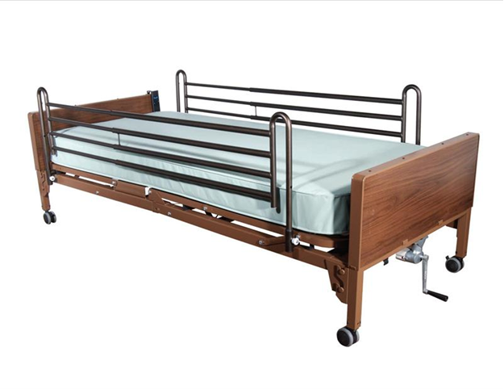 **Appendix A**

**Zone 3** Entrapment between the rail and the mattress

**Zone 6** Entrapment between the end of the rail and the side edge of the head or foot board

**Zone 7** Entrapment between head or foot board and the mattress end

**Zone 6** Entrapment between the end of the rail and the side edge of the head or foot board

**Zone 3** Entrapment between the rail and the mattress

**Zone 2** Entrapment under the rail, between the rail supports or next to a single rail support

**Zone 6** Entrapment between the end of the rail and the side edge of the head or foot board

**Zone 7** Entrapment between head or foot board and the mattress end

**Zone 6** Entrapment between the end of the rail and the side edge of the head or foot board

**Potential Entrapment Zones**

**as Identified by FDA Guidance Standards**

**Potential Entrapment Zones as Identified by FDA Guidance Standards**

**Zone 1 – Entrapment within the rail Zone 2 – Entrapment under the rail, between the rail supports or next to a single**

**rail support**

 

**Zone 3 – Entrapment between the rail and the mattress**



**Zone 4 – Entrapment under the rail, at end of rail**



**Zone 5 – Entrapment between split bed rails**



**Zone 6 – Entrapment between the end of the rail and the side edge of the head or foot board**



**Zone 7 – Entrapment between head or foot board and the mattress end**

