FORM SCG-2010.INST
Instruction Manual for the Public School Construction Cost Database (PSCCD)
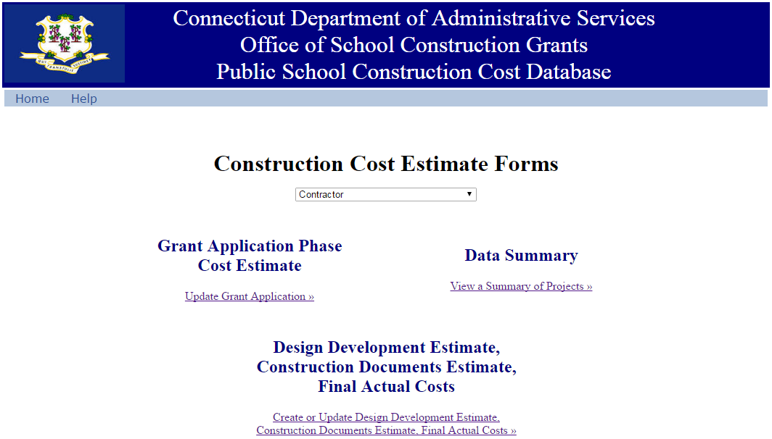

Version 1.2-2017-04-24

As part of the implementation of UNIFORMAT reporting of cost estimates and actual construction costs on school building project, the state Department of Administrative Services (DAS) has implemented a new “Public School Construction Cost Database” (PSCCD) web form. This new web interface allows Local Education Agencies (LEAs) and their school construction design firms to report the required cost estimates online. This manual provides instructions on how to use the PSCCD website.
The new website functions differently for different types of users, based on their role in the School Construction Grant process. Only users with appropriate permissions will have access to the website. This manual is organized into parts, with a part dedicated to the two basic classes of users:
Part 1 - Architecture/Engineering (A/E) Design firms working for LEAs on school construction projects
Part 2 - School Superintendents
The numbers used to identify “steps” in this manual are numbered within each of the two parts referred to above. Therefore step numbers in Part 1, for Architecture/Engineering Design firms, are different than those for Part 2, for School Superintendents.
Please note that, in this manual, all references to A/E Design consultants and professional also apply to professional cost estimators and other professionals authorized under DAS policy to create the cost reports.

Table of Contents
Part 1. Use by Architecture/Engineering Design firms 4
1. SCG authorizes A/E Design firm’s BizNet account. 4
2. Accessing the website. 4
3. Filling out a Grant Application Phase Cost Estimate 7
4. Filling out a Design Development estimate 10
5. Filling out a Construction Documents Estimate 12
6. Filling out Final Actual Costs report 14
Part 2. Use by Superintendents 16
1. Accessing the website. 16
2. Superintendent control of A/E Design consultant access. 19
3. Filing a Grant Application Phase Cost Estimate 19
4. Filing the Design Development estimate 21
5. Filing a Construction Documents Estimate 22
6. Filing a Final Actual Costs report 23
Part 3. Data generated 24
1. The Data Summary page 24
2. Header Summaries 24
3. Project Closeout and removal of A/E Design firms 25
Questions 26

Part 1. Use by Architecture/Engineering Design firms
In the new Cost Reporting procedures, A/E Design firms have the responsibility to prepare and submit professional, accurate construction cost estimates and actual construction costs.
- For projects classified as New Construction (N) or Approved Renovation (RNV), and projects greater than $5 million classified as Extension (E) or Extension/Alteration (EA), all steps are to be followed.
- For all other projects, LEAs and A/E Design consultants have, under DAS policy, the option of submitting reports prior to final actual costs in a form other than UNIFORMAT II. Therefore, for these projects, users are only required to complete step 3 up to step 3.d, plus step 3.e.ii. These users may skip steps 3.f to 3.l and steps 4 and 5, and they are then required to complete step 6.
Here are the steps to utilizing the PSCCD for an A/E Design firm:
- SCG authorizes A/E Design firm’s BizNet account. An A/E Design firm on a construction project for an LEA must first obtain authorization, from the LEA superintendent, to access the PSCCD records for that particular construction project. PSCCD is accessed through BizNet. If the A/E Design firm already has a BizNet account, the A/E Design firm will provide the superintendent with the email address for that BizNet account, and the Superintendent will ask SCG to grant authorization to that account. If the A/E firm does not yet have a BizNet account the A/E firm user provides the Superintendent with the email address that will later be used to create a BizNet account. SCG is able to pre-authorize that email address, which will have access to the project in question when the BizNet account is created.
- Accessing the website. Users access this website https://www.biznet.ct.gov/DCS_CostEstimate/Default.aspx,
  - bringing users to the following page: 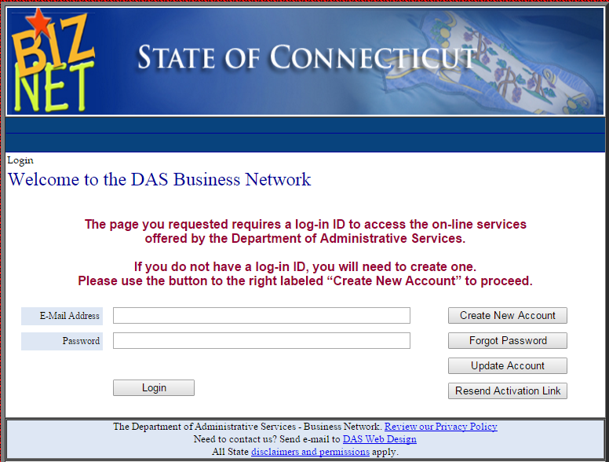
  - If the user has a BizNet account already, the user enters the email address and password for that account, and may skip to step 2.g, below. If the user does not have a BizNet account, the user clicks the button labeled “Create New Account”.
  - After clicking “Create New Account”, users are brought to this screen: 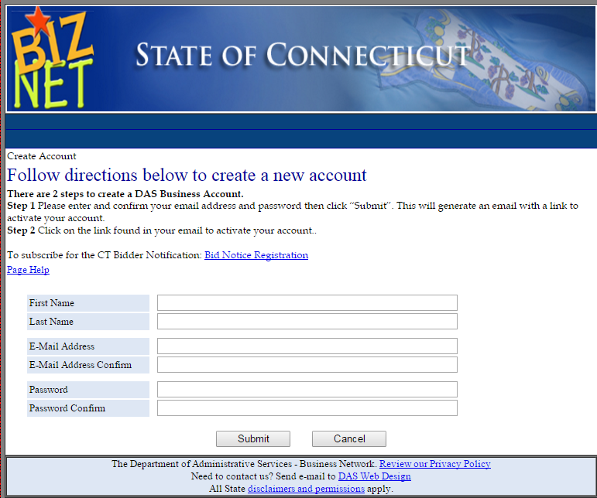
  - The user enter the requested information. Please ensure that the email address entered is the one given to Superintendent under step 1, above. When this is complete, click “Submit”.
  - The user will then receive a confirmation email. Click on the link in the email, as indicated. Then close all browsers and tabs for the PSCCD.
  - The user then re-opens the PSCCD website at https://www.biznet.ct.gov/DCS_CostEstimate/Default.aspx. That brings the user back to the login page, where the user enters their newly established login information:

  - After BizNet login, users are brought to the PSCCD main page: 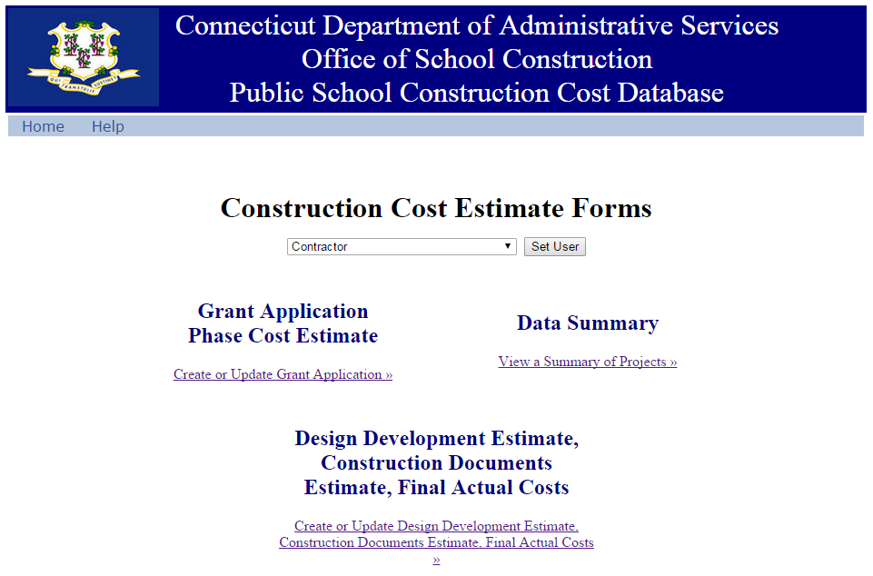

- Filling out a Grant Application Phase Cost Estimate:
  - By the time an A/E Design consultant reaches this point, the LEA superintendent will have filed an SCG-049 for the construction project in question and SCG will have assigned that consultant’s BizNet account to that project.
  - The user clicks on the “Grant Application Phase Cost Estimate” link, to reach this page: 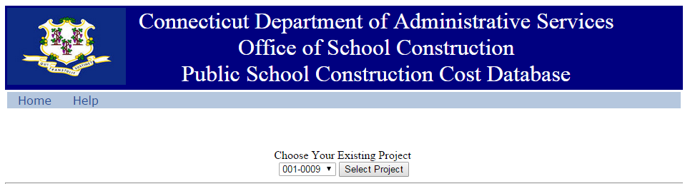
  - Under the words “Choose Your Existing Project”, the user hovers over the number to the left to activate a pull-down menu. The user selects the appropriate project number from this menu. (If the A/E Design user cannot select the project in question, they should contact their LEA and ask them to request that SCG assign the A/E Design firm to the project.)The user then clicks the “Select Project” button, to reach page for the “Grant Application Phase Cost Estimate”, which is to be filled out by the A/E Design consultant: 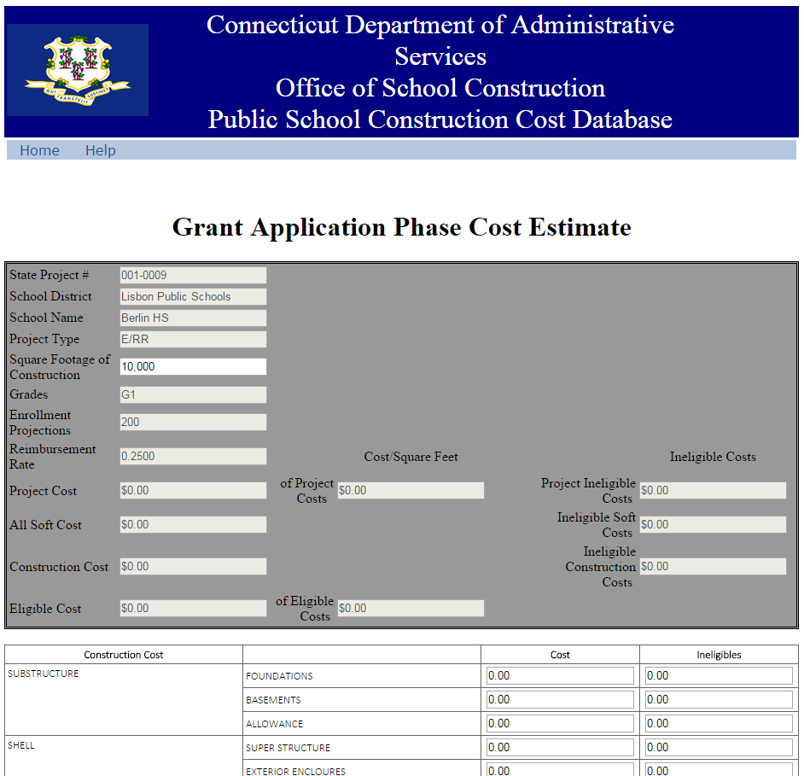
  - On this page, the A/E Design user must enter the appropriate “Square Footage of Construction”, where indicated. The A/E Design user must enter this square footage amount regardless of which level of reporting is required under 3.e, below.
  - At this point:
    - For projects classified as New Construction (N) or Approved Renovation (RNV), and projects greater than $5 million classified as Extension (E) or Extension/Alteration (EA), the A/E Design user then enters the appropriate UNIFORMAT II, Level 2 cost estimates associated with the FORM SCG-049 application submitted by the LEA. Costs, including both those eligible and ineligible for School Construction Grant reimbursement, should be entered in the column labeled “Cost” and the portion of the costs that are ineligible for reimbursement shall be entered in the column labeled “Ineligibles”. These cost estimates are an official filing and are filled out by A/E Design professional with the merit of their professional credentials.
    - For projects not required to do UNIFORMAT II reporting until the Final Actual Costs report, the A/E Design user may click the “Submit” button at the bottom of the web form, leaving all of the cost estimate fields blank. Please note that, even in these cases, the “Square Footage of Construction” must still be completed prior to clicking “Submit”.
  - Below the “Construction Costs” section of the report, there is another section, labeled “Soft Costs”: 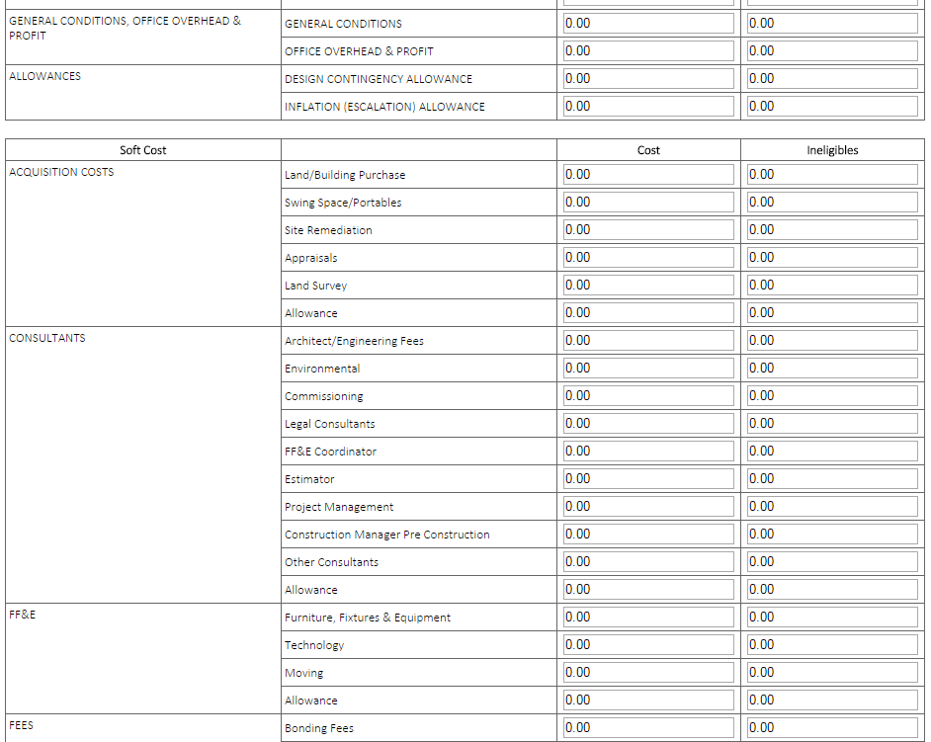
  - In the Soft Costs section, A/E Design users shall enter the indicated costs, using the same “Cost”/”Ineligibles” format as for the “Construction Costs” section.
  - At the bottom of the page, there is a “Save…and Continue” button. When this button is pressed, the data entered by the user is saved into the PSCCD system and the user may continue entering data. It is highly recommended that users save their data frequently.
  - Also at the bottom of the page, there is a “Save…and Exit” button. After this button is pressed, the user entered data is saved and the user is brought to the “Data Summary” page, which will show the A/E Design consultant a current summary of their projects: 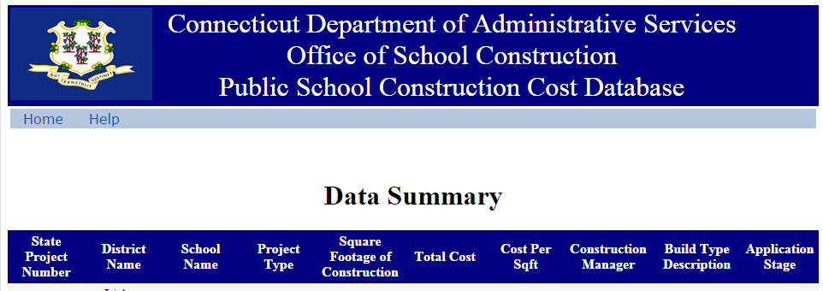

  - The user may return to the page at a later time. The data entered will be present and can be edited, prior to its official submission. (Please note that calculated fields in the header of each data entry web form will only be shown calculated or updated after a user saves and then returns to the form.)

  - When the A/E Design consultant has completed the data report, they should inform the LEA. The LEA superintendent may, then, review the estimates entered. They are not able to change any of the cost estimates or the project square footage. Any changes noted by the LEA must be entered by the A/E Design firm.

  - The A/E Design consultant may, then, click on the “Signoff and Submit” button and cause the report to be officially submitted to SCG. After this form has been submitted, it cannot be edited by the A/E Design consultant.

- Filling out a Design Development estimate:
  - When a project has reached the point wherein the LEA is prepared for a Design Development Review, the A/E Design consultant begins the process of entering the Design Development cost estimate by entering the PSCCD website following step 2, above, bringing the user to the following page.
  - Users click on the link for “Design Development Estimate, Construction Documents Estimate, Final Actual Costs”, bringing them to the following page. 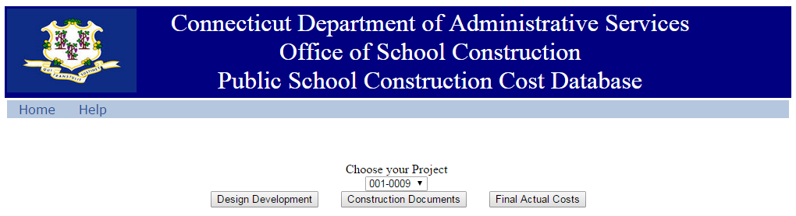
  - Users click on the pull-down menu below the words “Choose your Project”, and select the appropriate project number.
  - Users then click the button labeled, “Design Development”, bringing them to the following page. 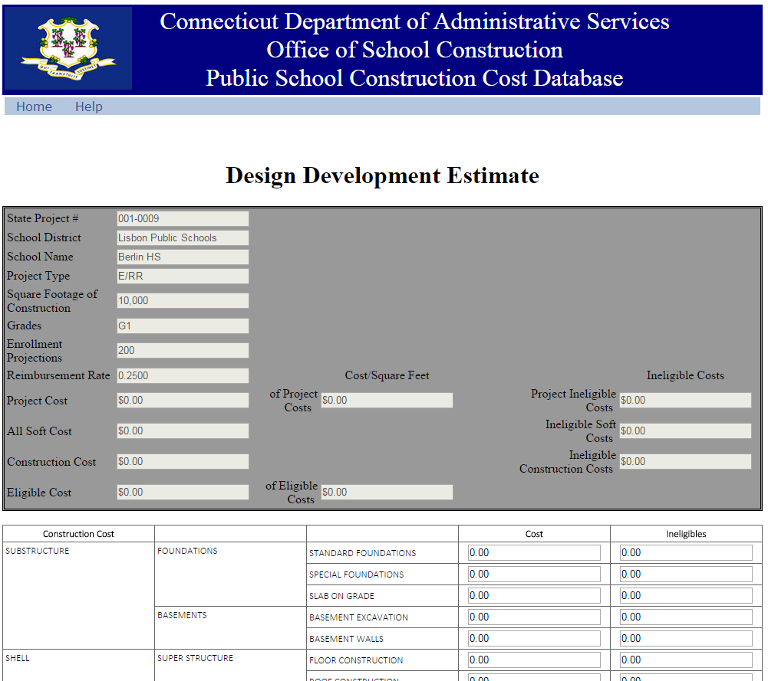

  - Users then follow the same procedures for entering and saving data as was used in step 3, with the exception that square footage cannot be changed at this stage and that the data, in accordance with DAS policy, must be to UNIFORMAT II, Level 3.

- Filling out a Construction Documents Estimate:
  - When a project has reached the point wherein the LEA is prepared to apply for authorization to go to bid, the A/E Design consultant begins the process of entering the Construction Documents cost estimate by following the process as in steps 4.a to 4.c, above.
  - Users then click on the button labeled, “Construction Documents”, bringing them to the following page. 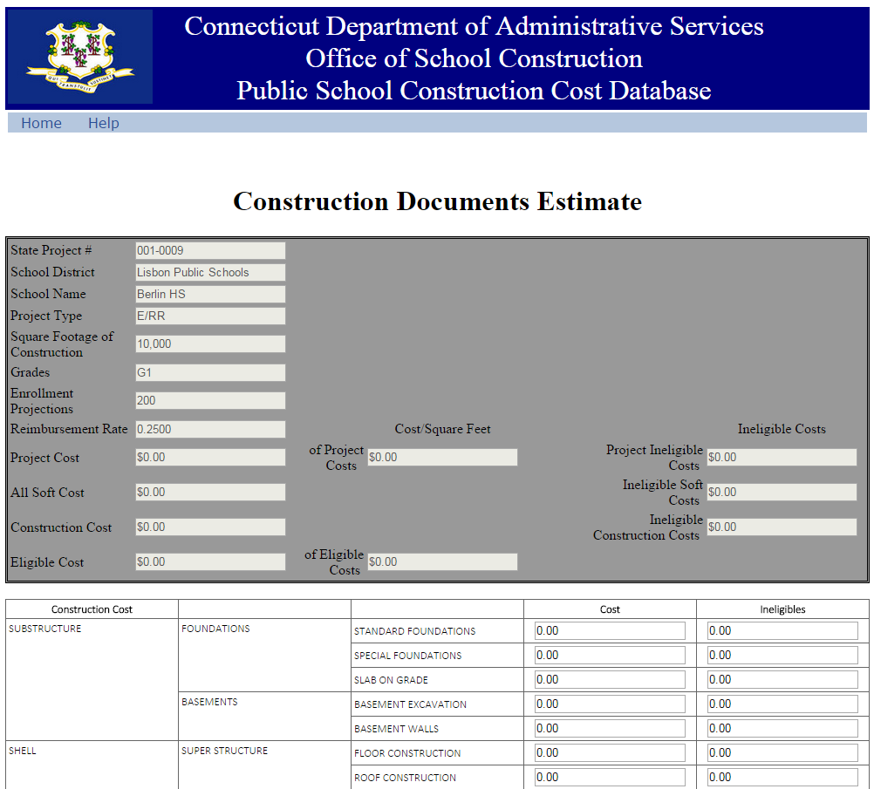
  - Users then follow the same procedures for entering and saving data as was used in step 4, entering data to UNIFORMAT II, Level 3.
  - If the project is a single phase project, when the A/E Design user clicks the “Signoff and Submit” button, it is the final Construction Documents Estimate submission.
  - If the project has more than one phase, the A/E Design user clicks the “Signoff and Submit” to file for each project stage. The A/E Design user should inform SCG when the LEA is prepared to submit a request to file for authorization to go to bid on a second or subsequent phase. Even though the first phase may only be for a portion of the project costs, the report filed for the first phase, and each subsequent phase, shall include the total estimated costs, in each line, for the entire project, not just the costs for that particular phase.
  - In the case of a second or subsequent phase, SCG will then unlock the Construction Documents Estimate form. The A/E Design user is then to re-open the form and make any changes to their earlier Construction Documents costs estimate that are needed due to updated estimates at the second or subsequent phase. Again, the estimated costs reported are to be for the entire project, just for the current phase.
  - In the case of a second or subsequent phase, when the A/E Design consultant has completed changes to the Construction Documents Estimate for that phase, they should inform the LEA superintendent, who may, then, review it and the A/E Design user may re-submit by clicking on the “Signoff and Submit” button.
- Filling out Final Actual Costs report:
  - After project substantial completion, the A/E Design consultant is to begin the process of entering the final actual costs of the project by following the process as in steps 4.a to 4.c, above.
  - Users then click on the button labeled, “Final Actual Costs”, bringing them to the following page. 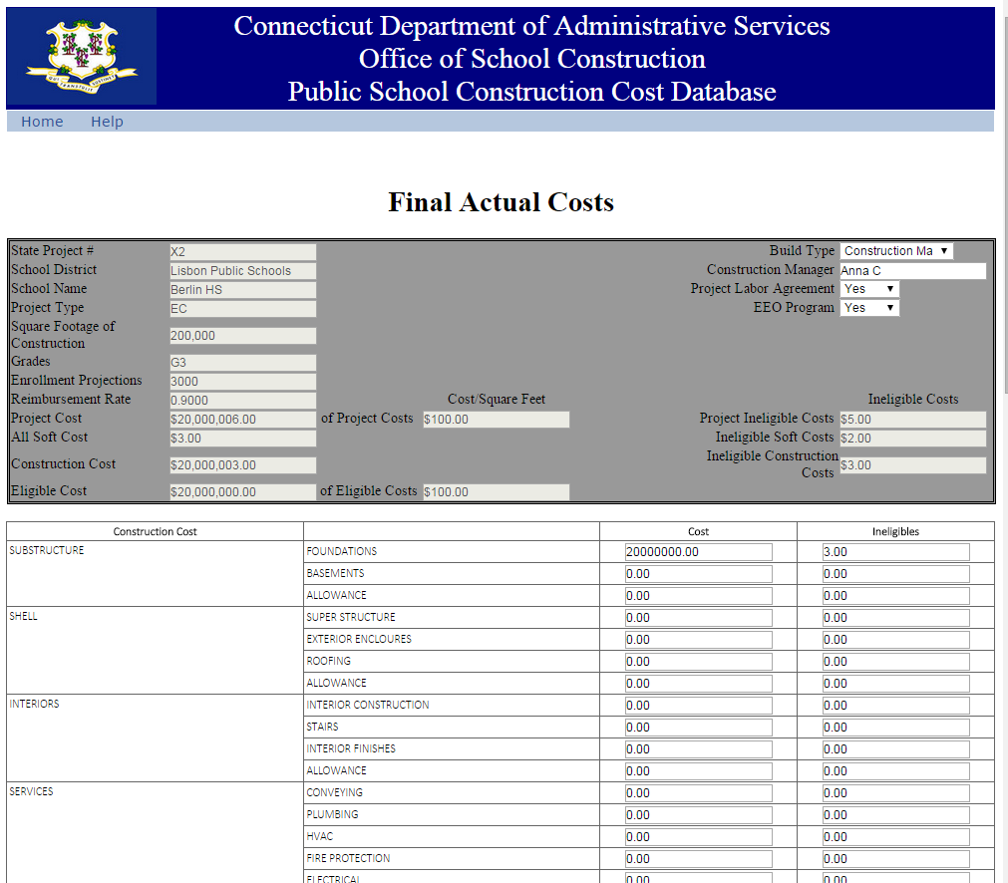

  - Users then follow the same procedures for entering as was used in step 4.
  - The Final Actual Costs form also contains additional information for the A/E Design consultant to enter. 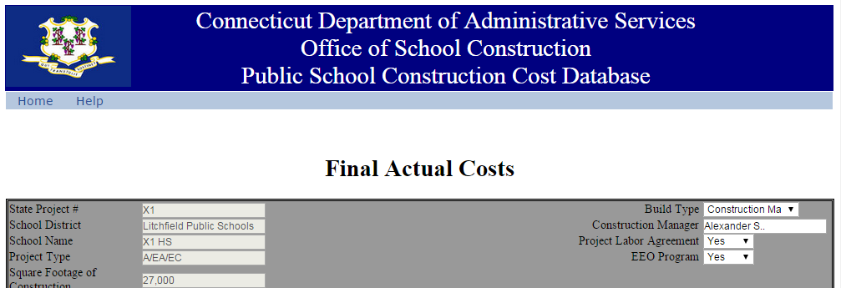

    - Next to the label, “Build Type”, click the pull down menu to select from the appropriate option between “General Contractor”, “Construction Manager At Risk” or “Construction Manager Agency”.

    - Next to the label, “Construction Manager”, enter the Construction Manager, if applicable.

    - Next to the label, “Project Labor Agreement”, click the pull down menu to select from the appropriate option between “Yes” or “No”.

    - Next to the label, “EEO Program”, click the pull down menu to select from the appropriate option between “Yes” or “No”.

  - Users then follow the same procedures for entering as was used in step 4 to save the data.

Part 2. Use by Superintendents
In the new Cost Reporting procedures, while A/E Design firms have the responsibility to prepare and submit professional, accurate construction cost estimates and actual construction costs, superintendents are responsible for these reports in the form of selecting qualified A/E Design professionals and reviewing reports prepared by their A/E Design professionals. The functioning of the PSCCD reflects this role.
- For projects classified as New Construction (N) or Approved Renovation (RNV), and projects greater than $5 million classified as Extension (E) or Extension/Alteration (E/A), all steps are to be followed.
- For all other projects, LEAs and A/E Design consultants have, under DAS policy, the option of submitting reports prior to final actual costs in a form other than UNIFORMAT II. Therefore, for these projects, users are only required to compete step 3 to submit reported project square footage, users may skip steps 4 and 5 and users are required to complete step 6.
The following are the steps for a superintendent to utilize the PSCCD:
- Accessing the website. Users access this website at https://www.biznet.ct.gov/DCS_CostEstimate/Default.aspx,
  - bringing users to the following page:

  - If the user has a BizNet account already, the user enters the email address and password for that account, and may skip to step 2.g, below. If the user does not have a BizNet account, the user clicks the button labeled “Create New Account”.
  - After clicking “Create New Account”, users are brought to this screen:

  - Users enter the requested information. Please ensure that the email address entered is the one given to Superintendent under step 1, above. When this is complete, click “Submit”.

  - Users will then receive a confirmation email. Click on the link in the email, as indicated. Then close all browsers and tabs for the PSCCD.

  - The user then re-opens the PSCCD website at https://www.biznet.ct.gov/DCS_CostEstimate/Default.aspx. That brings the user back to the login page, where the user enters their newly established login information:

  - After BizNet login, users are brought to the PSCCD main page:

  - The superintendent user then informs SCG about the email address for this BizNet account, and SCG staff will assign that account to the superintendent’s LEA information.
- Superintendent control of A/E Design consultant access. Project cost data and square footage must be entered by a qualified professional (herein referred to as the “A/E Design consultant”). For an A/E Design consultant on a construction project for an LEA to perform this function, they must first obtain authorization, from the LEA superintendent, to access the PSCCD records for that particular construction project.

  - PSCCD is accessed through BizNet.

  - If the A/E firm already has a BizNet account, the A/E Design firm will provide the superintendent with the email address for that BizNet account, and the superintendent is to then ask SCG to grant authorization to that account.

  - The superintendent must give SCG the email address that is or will be used for the A/E Design firm’s PSCCD BizNet access, as well as the specific project for which this A/E Design user will need access.

  - If the A/E firm does not yet have a BizNet account, the A/E firm user provides the email address that will later be used to create a BizNet account. At the superintendent’s request, SCG is able to pre-authorize that email address, which will have access to the project in question when the BizNet account is created.

- Filing a Grant Application Phase Cost Estimate:

  - Prior to any cost reporting on a project, the LEA must have first filed an online FORM SCG-049. The Grant Application Stage Cost Estimate in PSCCD is a part of the LEA’s School Construction Grant application, but PSCCD requires a project number generated from submission of the SCG-049 form. After submission of FORM SCG-049, the LEA superintendent informs SCG that their A/E Design consultant is prepared to file the Application Stage Cost Estimate, and SCG will prepare the project number in the PSCCD.

  - After completing step 3.a, above, the LEA then instructs their A/E Design consultant to log into PSCCD to enter their professional cost estimate in accordance with the DAS policies for grant Application stage cost estimates. The A/E Design user then enters the appropriate project square footage and any required UNIFORMAT II, Level 2 cost estimates associated with the FORM SCG-049 application submitted by the LEA. All costs, whether eligible or ineligible for School Construction Grant reimbursement, should be entered in the column labeled “Cost” and the portion of the costs that are ineligible for reimbursement shall be entered in the column labeled “Ineligibles”. In addition to the UNIFORMAT II cost categories, the A/E Design consultant also enters the “Soft Costs”, as indicated on the form. These cost estimates are an official filing and are filled out by the A/E Design professional with the merit of their professional credentials.

  - When the A/E Design consultant has completed and saved the data report, they should inform the LEA. The superintendent then navigates to the page as show in step 1.g, and clicks on the link labeled, “Create or Update Grant Application”, directing the superintendent to the page, shown as follows: 
  - The superintendent then clicks the pull down menu under the title, “Choose Your Existing Project”, which leads to the page where the project square footage and cost estimates are filled-in by the A/E Design consultant, as follows: 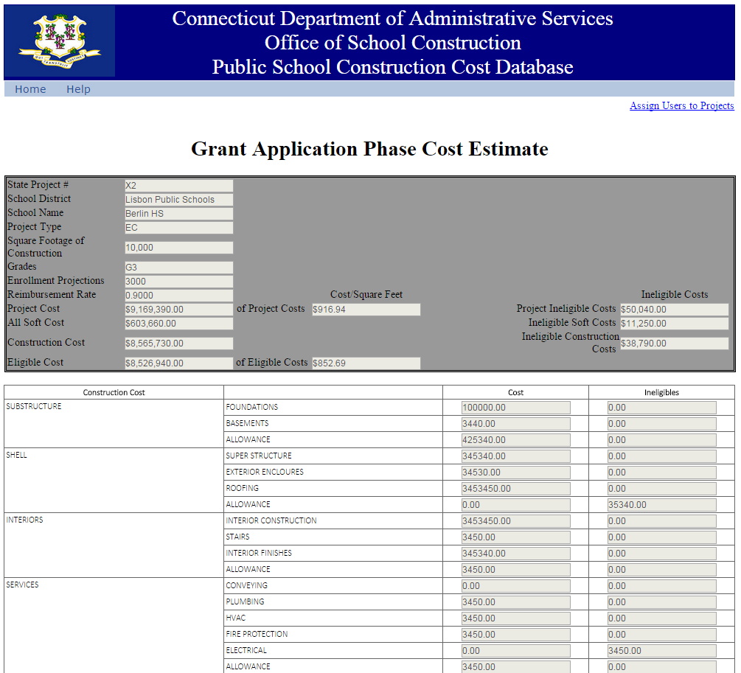

  - The superintendent then reviews the estimates entered, but cannot change any of the cost estimates or the project square footage.
  - If the superintendent finds errors, the LEA should contact the A/E Design consultant, who may correct the errors, if they concur.
  - If the superintendent finds the cost reports to be ready for filing, the superintendent informs their A/E Design consultant that the report is ready for the A/E Design consultant to be officially submitted.
- Filing the Design Development estimate:
  - When a project has reached the point wherein the LEA is prepared for a Design Development Review, the LEA should inform their A/E Design consultant to enter the Design Development cost estimate in the PSCCD.
  - Once the A/E Design consultant has informed the LEA that this is complete, the superintendent navigates to the page shown in step 1.g, and clicks on the link for “Design Development Estimate, Construction Documents Estimate, Final Actual Costs”. This brings them to the following page:
  - Then superintendent then clicks on the pull-down menu below the words “Choose your Project”, and select the appropriate project number.
  - Users then click the button labeled, “Design Development”, bringing them to the following page: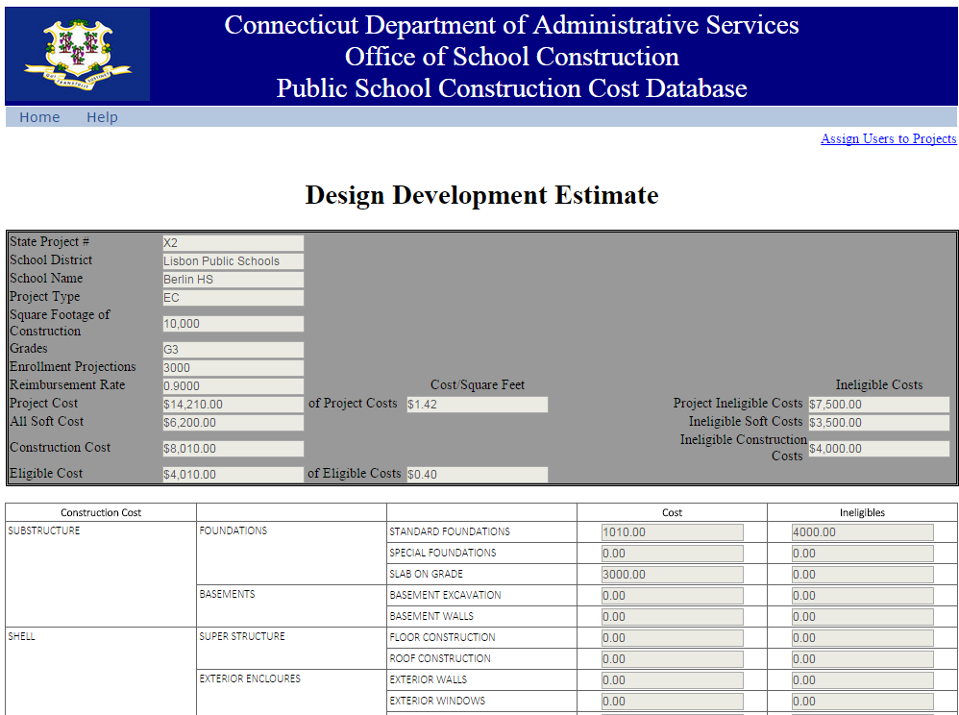
  - The superintendent then follow the same procedures for reviewing as described in step 0 to 3.g, above.
- Filing a Construction Documents Estimate:
  - When a project has reached the point wherein the LEA is prepared to apply for authorization to go to bid, the LEA should inform their A/E Design consultant to enter the Construction Documents cost estimate in the PSCCD.
  - Once the A/E Design consultant has informed the LEA that this is complete, the superintendent navigates to the page shown in steps 4.b to 4.c, above, and clicks, the button labeled, “Construction Documents”, as in step 4.d, above.
  - The superintendent then reviews and approves as in step 4.e.
  - If the project is a single phase project, when the A/E Design consultant completes submission of the data, it is the final Construction Documents Estimate submission.
  - If the project has more than one phase, the LEA’s Design consultant should inform SCG when they are prepared to submit a request to file for authorization to go to bid on a second or subsequent phase.
  - In the case of a second or subsequent phase, SCG will then unlock the Construction Documents Estimate form. The A/E Design consultant is then to re-enter the form and make any changes to their earlier Construction Documents costs estimate that are needed due to the second or subsequent phase.
  - For each such phase, the superintendent then follows the same procedures for reviewing as described in step 0 to 3.g, above.

- Filing a Final Actual Costs report:
  - After project substantial completion, the A/E Design consult must enter the final actual costs of the project into the PSCCD.
  - This report will be the full UNIFORMAT II Level 2 report, shown as follows:

  - After the A/E has entered the cost reporting data in the appropriate of these two forms, the superintendent then follow the same procedures for reviewing as described in step 0 to 3.g, above.

Part 3. Data generated and Miscellaneous
- The Data Summary page. This page can be accessed by clicking the link labeled “View a Summary of Projects” on the PSCCD home page. It is also the landing page from other site actions. The Data Summary page appears as follows: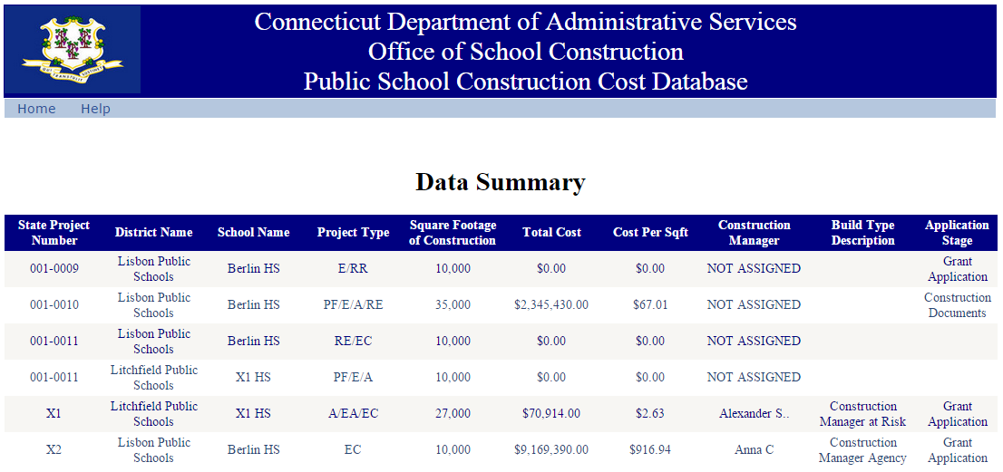
  - Users will only be able to view projects listed on this page that are applicable to them. Superintendents will only be able to view projects for their own district and A/E Design consultants will only be able to view projects assigned to them.
  - The “Total Cost” “Cost Per Sqft” data in this page are generated from the “Project Cost” data that appears in the Header Summaries, at the top of the cost reporting data pages. (See 2, below.)

- Header Summaries. At the top of each cost reporting page in the PSCCD (see below), there is gray data block. Different data pages look different. The example below is the Final Actual Costs page. 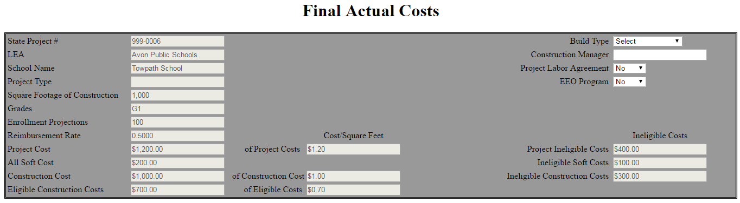
  - The data in these “Header Summaries” are updated when data is saved. Therefore, changes to the data on each page can only be viewed by re-accessing the page after it has been saved.
  - Data in Header Summaries calculated from PSCCD data pertain to the data in the report on that specific page. For example, the cost per square foot data on the Final Actual Costs page come from the Final Actual Costs report, rather than the Construction Documents report.
  - “Square Footage of Construction” is the square footage of the construction project reported by A/E Design consultant on the project in the Application Phase Cost Estimate.

  - “Project Ineligible Costs” is the sum of all ineligible costs, whether construction or soft costs, that are reported on that page.

  - “Ineligible Soft Costs” is the sum of only the ineligible soft costs reported on that page. Soft costs, for these purposes, are cost that are presented in the Cost Reporting forms under a separate section, labeled, “Soft Costs”.

  - “Ineligible Construction Costs” is the sum of only the ineligible construction costs reported on that page.

  - “Project Cost” is the sum of all costs reported on that page, whether the reported costs are eligible or ineligible costs or are construction or soft costs.

  - The “Cost Square Feet” “of Project Costs” is Project Cost, divided by the “Square Footage of Construction” reported as described above.

  - “All Soft Costs” is the sum of all reported soft costs, whether eligible or ineligible.

  - “Construction Costs”, for these purposes are the costs falling into the Construction Cost section, and is calculated here as is Project Costs, minus All Soft Costs.

  - The “Cost Square Feet” “of Construction Costs” is Construction Costs, divided by the “Square Footage of Construction” reported as described above.

  - “Eligible Construction Costs” is Construction Costs, minus Ineligible Construction Costs.

  - “Cost Square Feet” “of Eligible Costs” is Eligible Costs, divided by the “Square Footage of Construction” reported as described above.

  - “Build Type”, “Construction Manager”, “Project Labor Agreement” and “EEO Program” are entered on the Final Actual Costs page by the A/E Design consultant.

  - All other of the data reported are populated from other data.

- Project Closeout and removal of A/E Design firms. When an LEA is no longer using an A/E Design firm for a project, the superintendent must inform the SCG to have that A/E Design firm’s access to the project be removed.

Questions

If you have any questions on completing required reports in the PSCCD, please call:
the DAS Office of School Construction Grants and Review (OSCG&R) at 860-713-6490.
For technical issues with the PSCCD, please call 860-713-5882.

