State of Connecticut

MICROFILM LAND RECORD CERTIFICATION
 | 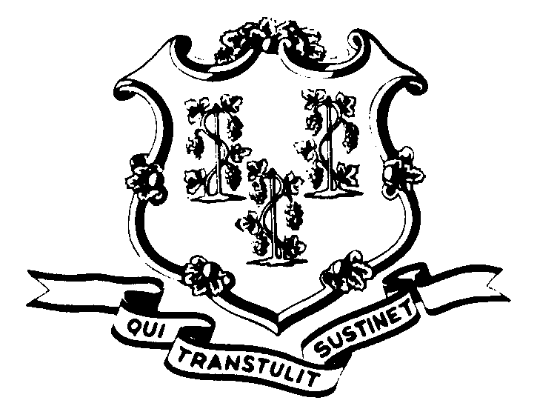  Use this certificate as a target on microfilm to certify authenticity |  | I, the undersigned, do certify that the microfilm images on this reel of microfilm of the land records of the below-listed Municipality are true copies of the original records left with the town clerk for record as accumulated during the regular course of business.  It is the established policy and practice of this municipality to microfilm these records for permanent retention.
 | Name of Municipality
 | Address of Municipality
Town Clerk

_________________________________ _______________________________________ _______________
Name (type or print) Signature Date

Connecticut State Library
Office of the Public Records Administrator

