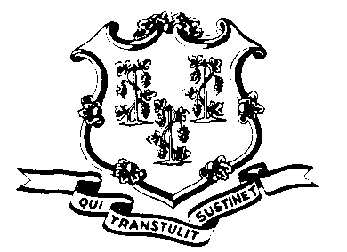
STATE OF CONNECTICUT
Records Retention and Disposition Policy
Acknowledgment of Receipt
Pursuant to §1-240 and §53-153 of the General Statutes of Connecticut, unauthorized removal or destruction of public records, as defined in §1-200(5), is a misdemeanor or a felony offense and is punishable by fine or imprisonment.
 | I, |  | , have received a copy of the State of Connecticut Public
 |  | (Type or print full name)
 | Records Policy 05: Disposition of Public Records.
 | Signature |  |  |  | Date
Records Retention and Disposition Policy Acknowledgement of Receipt (Form RC-001) issued by the Connecticut State Library, Office of the Public Records Administrator (revised 12/2013)

