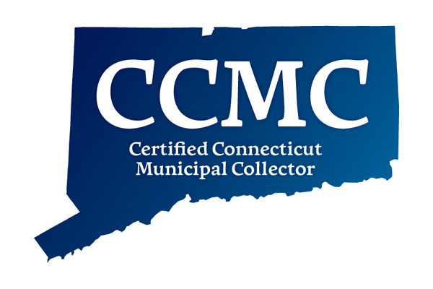
CERTIFIED CONNECTICUT MUNICIPAL
COLLECTORS’ COMMITTEE

John Rainaldi, CCMC, CCMA II, Ellington
Lisa A. Biagiarelli, CCMC, Norwalk
David Kluczwski, CCMC, Fairfield
Lisa Madden, CCMC, Windham
Beth Hamel, CCMC, Harwinton
Launa Goslee, CCMC, Torrington
Martin L. Heft, OPM Undersecretary

(Page 1 of 2)
C.C.M.C. CERTIFICATE REQUEST
DATE OF APPLICATION: _________________________________________________________
NAME: ________________________________________________________________________
Please PRINT name the way it should appear on certificate

COMPLETE MAILING ADDRESS: ______________________________________________________________________________ ______________________________________________________________________________ ______________________________________________________________________________
TOWN you currently work for:
EMAIL ADDRESS: _______________________________________________________________
POSITION/TITLE: _______________________________________________________________
ORIGINAL DATE (MM/DD/YYYY), AND TOWN of hire in a Connecticut Tax Office:
_____________________________________________________________________________
By signing below, I, the applicant, hereby attest that I have successfully completed the written course of study by achieving a passing grade in each of the four qualifying courses; that I have achieved a passing grade on the comprehensive written final examination; that I have been employed in a Connecticut Tax Collectors Office or an Office of Revenue for at least three years, meeting the experience requirements; and, that to the best of my knowledge and belief, I am eligible to receive the C.C.M.C. designation under Conn. Gen. Stat. 12-130a.
1. Sewer use, WPCA or fire district collections may be considered the equivalent of tax collections if the applicant’s work for the taxing authority is his/her principal job function and not merely ancillary.
2. “Three years” is defined as working three years from date of hire.
3. Work in any other municipal department does not meet the criteria for experience.

Additional explanation is necessary concerning how you have met the experience requirement when having worked in multiple municipalities. Documentation must be submitted with this application. (i.e. Corresponding HR documentation showing the town, department, length of service)

(Page 2 of 2)

I/We understand that false or misleading statements on my/our part on this affidavit or otherwise will result in an unfavorable recommendation from the Certification Committee and may disqualify the applicant from consideration for Certification in the future.

APPLICANT SIGNATURE _____________________________________ DATE: ____________
PRINT NAME OF ATTESTING OFFICIAL: _________________________ POSITION: ___________________
SIGNATURE OF ATTESTING OFFICIAL: ____________________________________
PLEASE RETURN THIS FORM TO: Lisa Madden, C.C.M.C. Committee, c/o Town of Windham, PO Box 195, Willimantic, CT. 06226-0195, lisamaddenccmc@gmail.com

