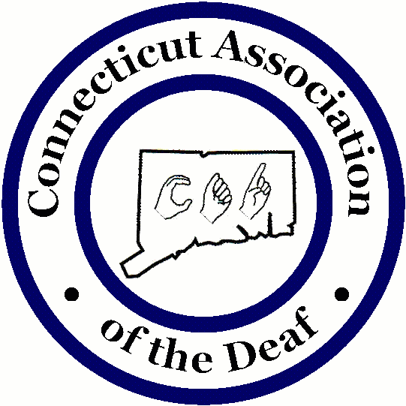

Mental Health Providers for the Deaf and Hard of Hearing in CT and Out of State

Holly Miller, Psy. D., NCSP
Psychological evaluations, and school consultation;
Accepts Husky, and will see all ages.
Phone: 860-841-2251
Email: drhollymiller18@gmail.com

Capitol Region Mental Health Center
Deaf and Hard of Hearing Program
Contact Person: Melissa Dennis, LPC
Deaf and Hard of Hearing Program Director
Phone: 860-293-6345
Videophone: 860-856-6121
Cell Phone: 959-710-9635
Fax: 860-297-0915
Email: Melissa.Dennis@ct.gov

Capitol Region Mental Health Center
Deaf and Hard of Hearing Program
Contact Person: Elizabeth P. Cote, L.C.S.W.
51 Coventry Street
Hartford, CT 06112
Phone: 860-297-0811 or 860-297-0957
Videophone: 860-899-1849
Fax: 860-297-0915
Text: 959-239-4652
Email: Elizabeth.Cote@ct.gov

Capitol Region Mental Health Center
Deaf and Hard of Hearing Program
Clinician: Vacant
51 Coventry Street
Hartford, CT 06112

State of Connecticut-Department of Mental Health and Addiction Services (DMHAS)
Southwest Connecticut Mental Health System
Deaf and Hard of Hearing Unit
Contact Person: Glenn Alleman, Jr. LMSW
Clinical Social Worker
1635 Central Ave.
Bridgeport, CT 06610
Phone: 203-551-7400 (Building Number)
Videophone: 203-416-8177 (Primary Contact Number)
Fax: 203-551-7690
Mobile/Text:959-895-6878
Email: Glenn.Allenman@ct.gov

State of Connecticut-Department of Mental Health and Addiction Services (DMHAS)
Community Mental Health Center (CMHC)
Deaf and Hard of Hearing Unit
Dana Jacquemin, LMSW
Clinician of the Deaf and Hard of Hearing
Deaf and Hard of Hearing Services
Cell Phone/Facetime: 203-974-7212
Videophone: 203-361-3370
Fax: 203-974-7322
Email: Dana.jacquemin@ct.gov
Hours: Monday to Friday, 8:30am-5:00pm
Note: Services are person-centered and recovery-oriented services that are culturally and linguistically affirmative for Deaf, Deaf Blind, and Hard-of-Hearing adults, who are eighteen (18) and older with persistent mental illness and/or substance use problems.

State of Connecticut- Department of Aging and Disability Services
Deaf and Hard of Hearing Counseling Unit: Sue Shatney
Income Guideline: Household Income within 150% of federal poverty level
VP: 860-899-1648
Email: Susan.shatney@ct.gov

Franciscan Life Center
Contact Person: Sister Mary Elizabeth
Phone: 203-237-8084
Email: flc@flcenter.org
http://www.flcenter.org

Gretchen Brandt MA, LMFT, Southport, CT:
Phone: 203-257-4171
Email: gretchenbrandttherapy@gmail.com
Note: Anthem, Aetna, Husky, and is willing to do case agreements if needed. She’s also willing to do periodic home visits and will occasionally interpret an AA meeting.
Tele health is available

Meghan Geary Strenk, LCSW, LLC
Psychotherapist
Virtual appointments can be scheduled by contacting via phone/text/FaceTime
Phone: 203-525-7429
Email: mgslcswct@gmail.com
https://meghan-geary-strenk.clientsecure.me

Mental Health Connecticut, Inc: http://www.mhconn.org

Paul J Shaker, LCSW, M. Div., Bloomfield, CT:
Phone: 203-525-8358
E mail: PJShake@yahoo.com
www.pauljshaker.com
Note: Most Private Insurances, EAP Programs, Medicare, and Husky/Medicaid accepted. Willing to do single case agreements with insurance companies with whom he is not yet paneled. Speaks Spanish

Suzanne Guerrucci, LCSW, Shelton, CT:
https://www.psychologytoday.com/us/therapists/suzanne-guerrucci-shelton-ct/160373
Phone: 203-816-6288 (VP) and/or 203-864-1220
Email: suzanneguerrucci@gmail.com
Note: Only accept 21 years and over.
Accept-Medicare, Medicaid (Husky), Anthem, Aetna, Cigna, United Health Care, Optum. Telehealth available

True Places Counseling, PLLC
Allison B. Wetmur, DSW, LCSW
New London, CT 06320
Phone: 860-501-4048 Videophone: 860-398-5719
Fax: 860-469-2937
Email: Alison@trueplacescounseling.com
Note: Private Insurance, Medicaid, Medicare

Dr. Lisa Kuntz
Women’s Center for Psychotherapy (NOT for women only)
www.womens-center.com
Practice phone number 860-523-4450 x 7 (Voice only)
Note: Private insurance. Also provides psychological evaluations for agencies like DCF, Courts and school districts when there is a deaf person needing services.
Email: dr.lisakuntz@gmail.com
Deaf person-best to contact Dr. Lisa is through email.
Sees men, women, couples, children, LGBTQ

Living Awareness, LLC
Teressa Cohen, LMFT
Contemplative Psychotherapist
2437 Albany Ave, Suite 202
West Hartford CT, 06117
Text: 860-860-8560
Videophone: 860-337-4242
Email: info@livingawarenesstherapy.com
Website: livingawarenesstherapy.com
Serving adults, couples and families
In-Person and Telehealth
Private pay, reduced fee, pro bono

Liz Citron, LCSW, LLC Phone: 860-463- 4045 Email: ecitronlcsw@gmail.com Available via Virtual/Telehealth session. Accepts CT Medicaid only. Serving children, families, and adults.

Community Guidance for Central Connecticut
Outpatient Mental Health Therapy
Contact person: Mariah Santana, AMFT
Marriage and Family Therapy Associate
Accepting Husky/Medicaid and Anthem.
Accepting children, adolescents, adults, couples, and families.
In-person and Telehealth are available.
Psychiatry is available.
Address: 384 Pratt St, Meriden, CT 06450
Phone: 203-235-5767 Ex. 3370
Video Phone: 860-378-8106
Fax: 203-238-2010
Email: msantana@cgccentralct.org
Website: https://www.cgccentralct.org/

Rosa M. Guzman, LICSW
Psychotherapy with Rosa Guzman, LICSW, LLC.
Types of Therapy offered: Individual Counseling, Couples Counseling, Depression, Anxiety, Bipolar, PTSD, Victims of Domestic Violence-Physical, verbal, psychological, sexual and emotional abuse, Lesbian, Gay, Transgendered individuals/couples, low self-esteem, Schizophrenia.
Accepting:
HUSKY Health (Connecticut)
Quest Behavioral Health (both Connecticut & Massachusetts)
Aetna (both Connecticut & Massachusetts)
Blue Cross/Blue Shield of Massachusetts (Virtual Network)
Anthem Blue Cross/Blue Shield of Connecticut
Horizon Blue Cross/Blue Shield of New Jersey
Independence Blue Cross/Pennsylvania (Virtual network in CT)
Carelon Behavioral Health (both Connecticut & Massachusetts)
Cigna (both Connecticut & Massachusetts)
Oxford (Optum) -- (both Connecticut & Massachusetts)
Oscar (Optum) (both Connecticut & Massachusetts)
Blue Cross/Blue Shield of Rhode Island (In Connecticut)
United Health Care (Optum in Connecticut & Massachusetts)
United Health Care Medicare Advantage in (both Connecticut & Massachusetts)
Blue Cross/Blue Shield of Rhode Island/Medicare Advantage in Connecticut
Point32 Healthcare in Massachusetts
Blue Cross/Blue Shield of MA/Medicare Advantage in Massachusetts
Office Video Phone: (413) 206-4660
Email: Rosa@RosaGuzmanlicsw.com
Website: https://rosaguzmanlicsw.com/home

Deaf Counseling Center
Contact Person: Dr. Candace A. McCullough and Sharon Duchesneau, LCPC
Phone 240-280- 2577
Email: frontdesk@deafcounseling.com
Text: 240-701-5155
www.deafcounseling.com
Note: Accepts many insurance plans (PPO, AETNA, Beacon, Kaiser, UHC, Optum, etc.) For Federal employees with PPO, no copayment. Willing to do single case agreements for insurance companies not paneled with. All of our therapists are Deaf and use ASL. Sessions available in person and teletherapy. Have support groups. LGBT-friendly

