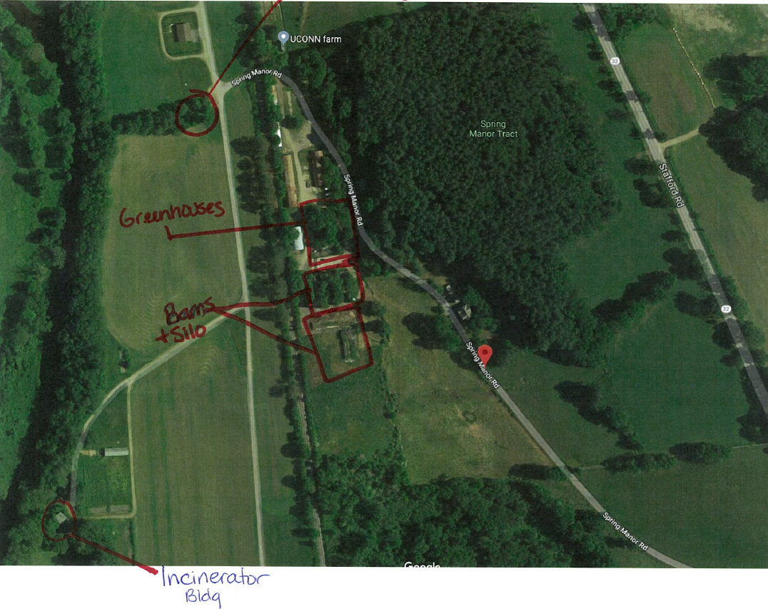
Slaughter House
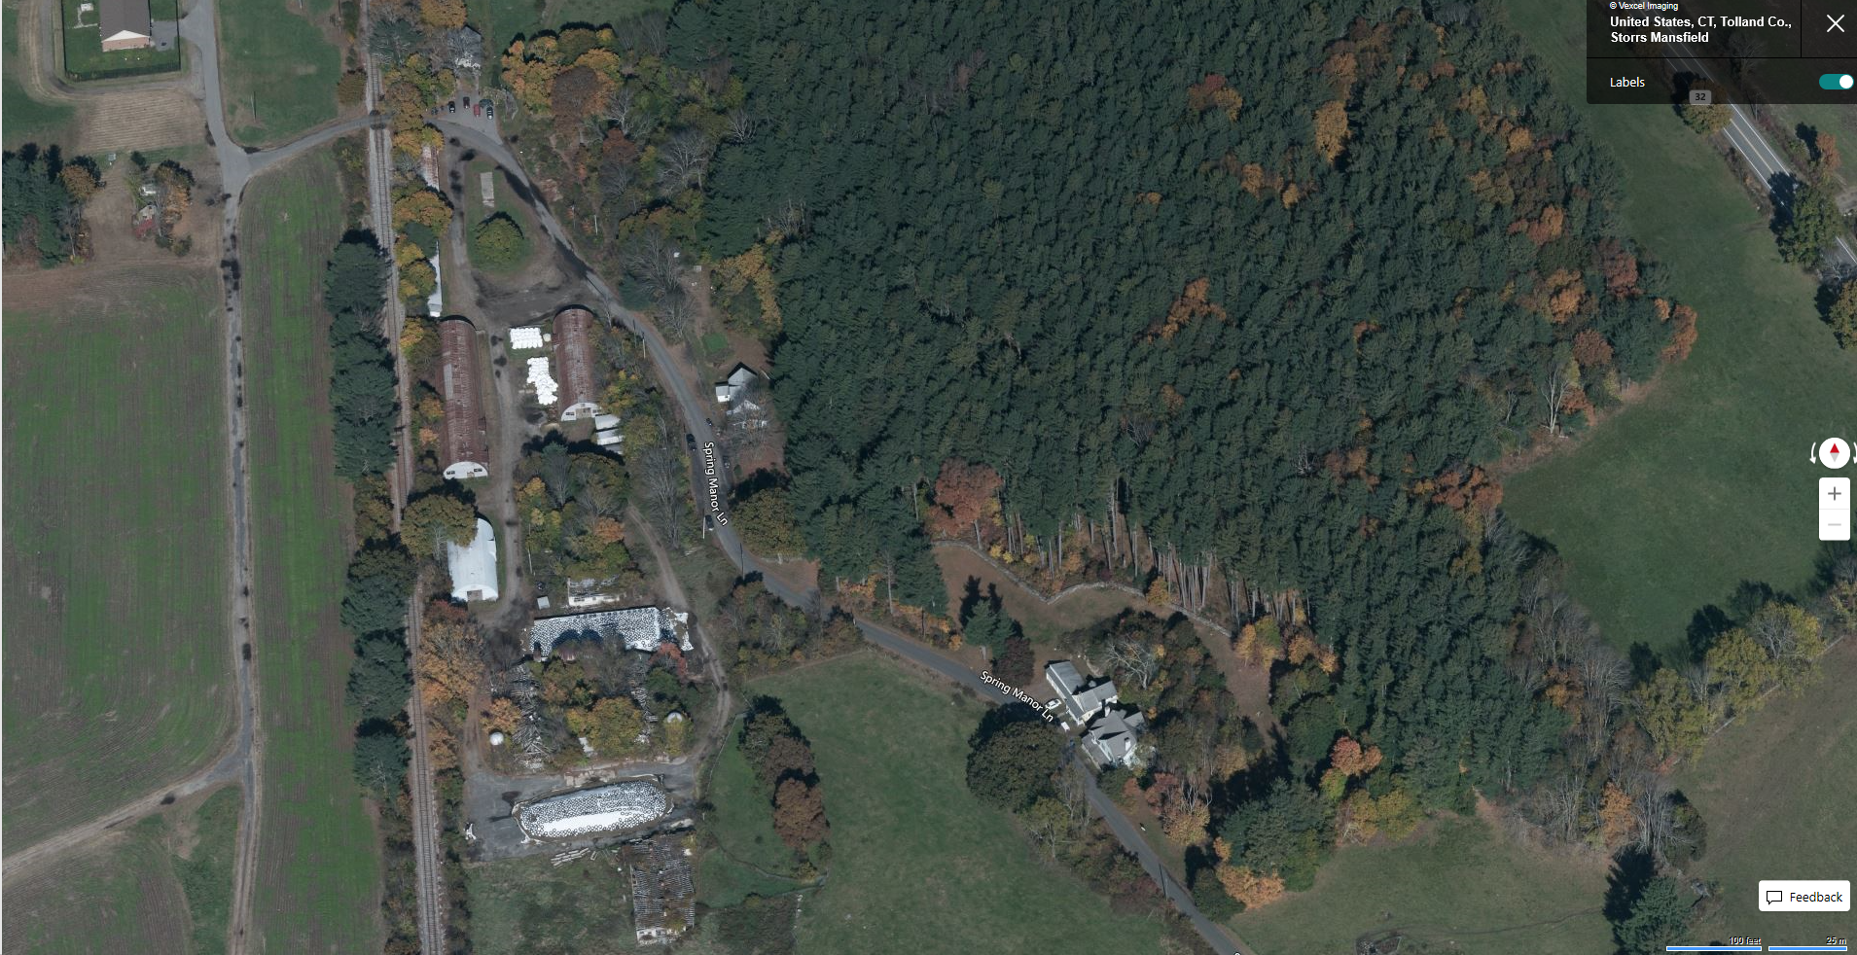

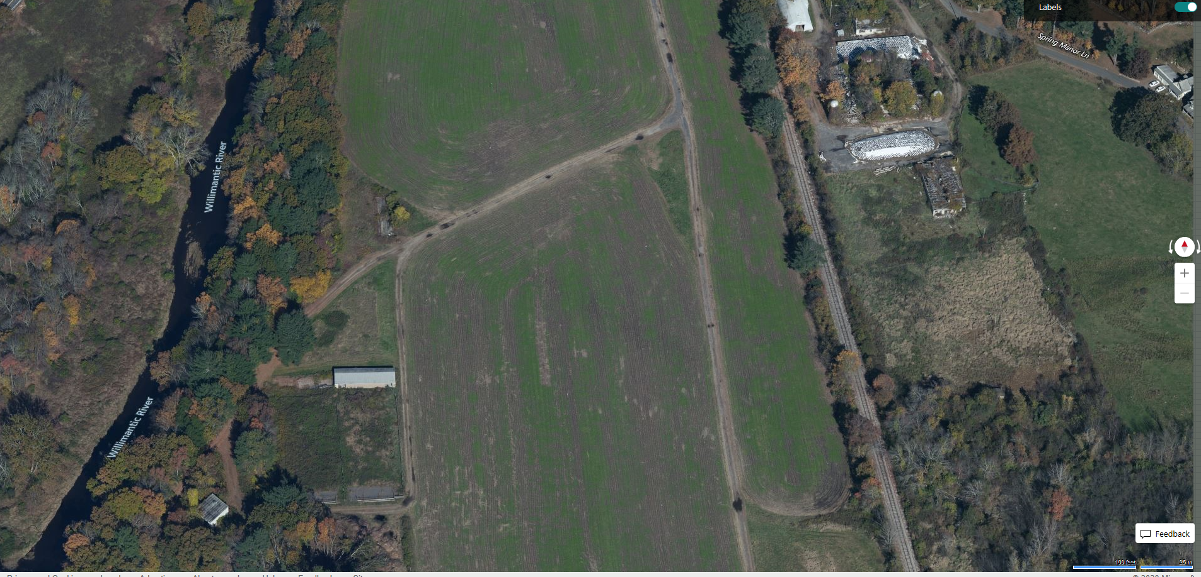
THE SMALL METAL SHED SHOWN ON THE NEXT PAGE IS FURTHER DOWN THIS DIRT ROAD

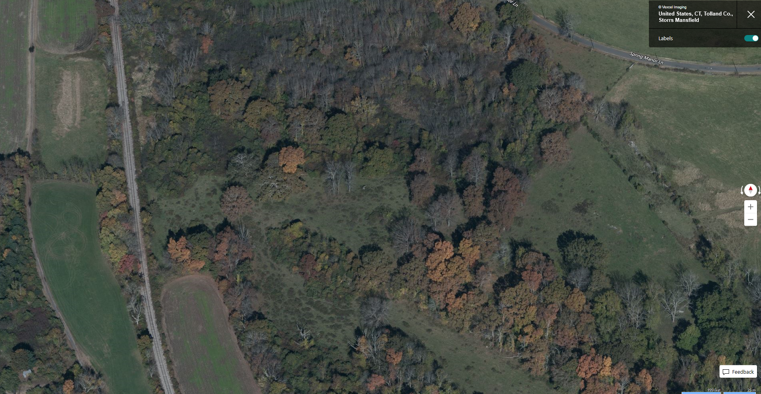
SMALL METAL SHED

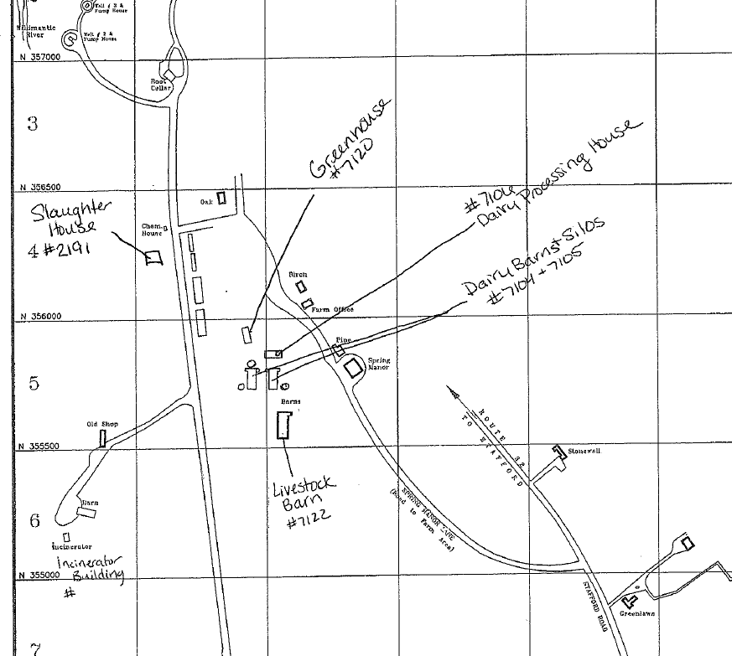
SMALL METAL SHED LOCATED DOWN THIS DIRT ROAD NOT SHOWN ON THIS MAP

