Module 1: Approve/Reject Content Page Submissions via email

Classroom Exercise 1

Reject a Content Page Submission

- Open your work email to receive content page submission email.
  - Select the hyperlink from the email to review the page.
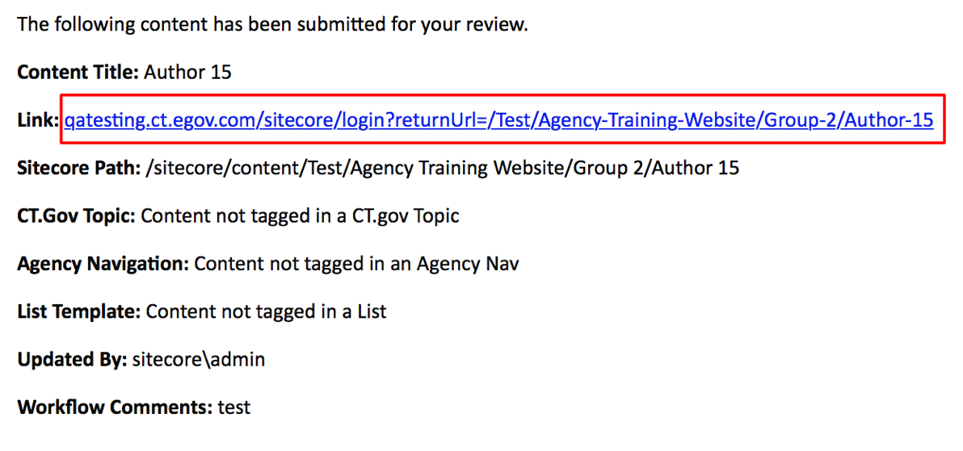
- Log in to Sitecore.
- Select the Reject link from the blue message bar.
- Enter in a comment.
- Select OK.

The content page is placed back into Draft mode for the Content Author to modify.

NOTE: The Content Approver can make modifications to the content page and save them prior to Rejecting the page. Remember to check the page back in (Unlock icon).

Classroom Exercise 2

Approve a Content Page Submission

- Open your work email to receive content page submission email.
  - Select the hyperlink from the email to review the page.
- Log in to Sitecore.
- Select the Approve link from the blue message bar.
- Enter in a comment.
- Select OK.

Depending upon the workflow settings, the content page will publish once approved.

NOTE: The Content Approver can make modifications to the content page and save them prior to Approving the page. Remember to check the page back in (Unlock icon).

Module 1: Approve/Reject Content Page Submissions via Workbox

Classroom Exercise 3

Accept or Reject Content Page Submissions from Workbox

- Log in to Sitecore.
- Select the Workbox icon on the Sitecore Ribbon from the Home Tab.
- Check that you have your Agency Group Workflow(s) checked to display them.
  - Example: Default State Workflow
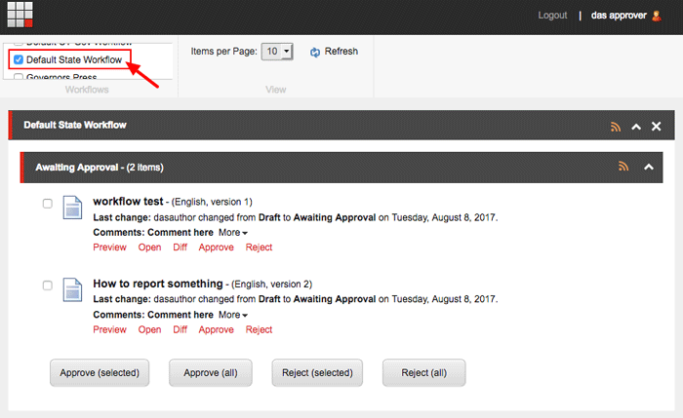

There are a couple ways to Approve/Reject pages:
- Select the Preview link. Opens a preview of the draft page awaiting approval in a new browser window from the Experience Editor.
  - Select the Edit icon to edit the page then Approve it.
  - Enter in a comment for the Content Author to receive.
  - Select OK.

  - Open - Opens the page in the Content Editor mode.
(NOT RECOMMENDED)
  - To edit the page, select the Publish tab on the Ribbon and click on the Experience Editor icon.
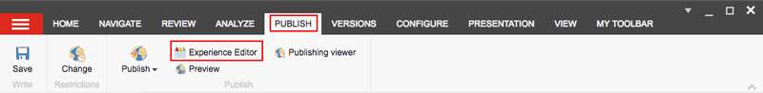
  - Diff - Compares the differences between two versions of the same page.
(NOT RECOMMENDED)
  - In the Compare Versions dialog box, select the two versions that you want to compare and whether to compare them in one field or side by side in two columns.
- Select the Approve link. Moves the workflow state to Approved and publishes the page.
- Select the Reject link. Moves the state back to Draft and reassigns it to the Content Author
- Enter a comment and select OK.
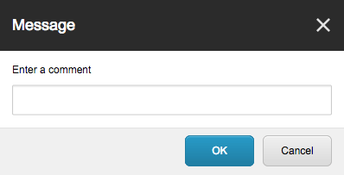

Approve/Reject Multiple Pages
You can Approve or Reject multiple or all pages awaiting approval by:
- Checking multiple pages from the list and selecting the Approve (selected) button or Reject (selected) button.
- Approve/Reject All pages from the list by selecting the Approve (selected) button or Reject (selected) button.

