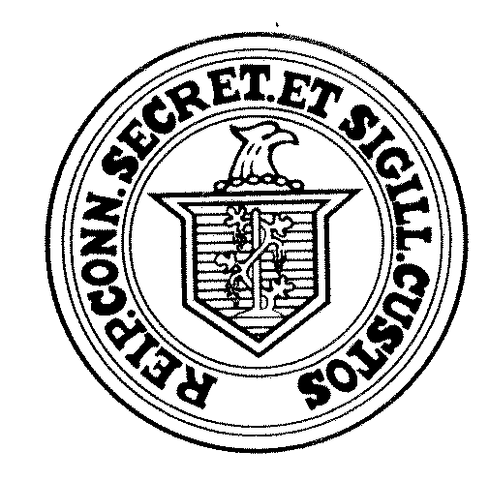
OFFICE OF THE SECRETARY OF THE STATE
Certificate of Endorsement Procedure
To maintain social distancing, the Secretary of the State is allowing for the receipt of scanned copies of the Certificate of Endorsement.
No endorsement is valid unless it is certified to the Secretary of the State Properly and On Time. The Secretary of the State must receive the Certificate of Endorsement by 4:00pm on the fourteenth (14) day after the close of the convention.

- A Major political party will hold their conventions or caucuses pursuant to the processes established by each State Central Committee, i.e. in person, virtually, by telephone.

- Secretary of the State will accept Certificate of Endorsements that are scanned and e-mailed by the appropriate deadline with original to follow by regular mail.
  - The subject line in e-mail shall include Party, Office and District
    - Example: Wig Party, State Representative, Assembly District 3

- Secretary of the State will accept multiple pages of the Certificate of Endorsement if, when taken together, complete the entire Certificate of Endorsement.
  - Example: Page one includes the signature of the presiding officer of the convention with information regarding the convention (date, time, location); Page two includes the name, address and signature of the candidate

The Certificate of Endorsement shall be scanned and e-mailed to:
Heather.Augeri@ct.gov
or
Moriah.Moriarty@ct.gov

If a receipt of the email is desired, please request a read/receipt when sending the email.

Additionally, after sending the virtual copy, please MAIL your form with original signatures to:

Legislation and Elections Administration Division
Attn: Heather Augeri
165 Capitol Avenue, Suite 1000
Hartford, CT 06106

- The Certificate of Endorsement must be signed by either the permanent chair or the permanent secretary of the convention and provided to the endorsed candidate.

- The candidate must also sign the form and designate their name as they authorize it to appear on the ballot. The candidate is responsible for ensuring both the virtual and physical Certificates of Endorsement are completed and filed by the fourteenth day after the convention deadline with the Secretary of the State.

- The 15% Eligibility for Primary Certificate should be handled the same way as above – signed by both the candidate and either the permanent chairman or secretary of the convention.

- There will be ONE form used for all types of endorsements. This SINGLE form will be used for multi-town endorsements, 15% challengers in multi-town districts, and single town districts as well.

- THERE IS NO 15% PRIMARY OPTION FOR SINGLE TOWN DISTRICT OFFICES. IGNORE THIS OPTION ON THE CERTIFICATE OF ENDORSEMENT
IMPORTANT!
It is important to note that the failure to endorse or the failure to properly file an endorsement does not create a vacancy that may be filLed LATER. THE FAILURE WILL result in a non-endorsement. A vacancy is created only when a candidate withdraws from A PROPERLY MADE endorsement or nomination.

