Connecticut State Department of Education
Academic Office

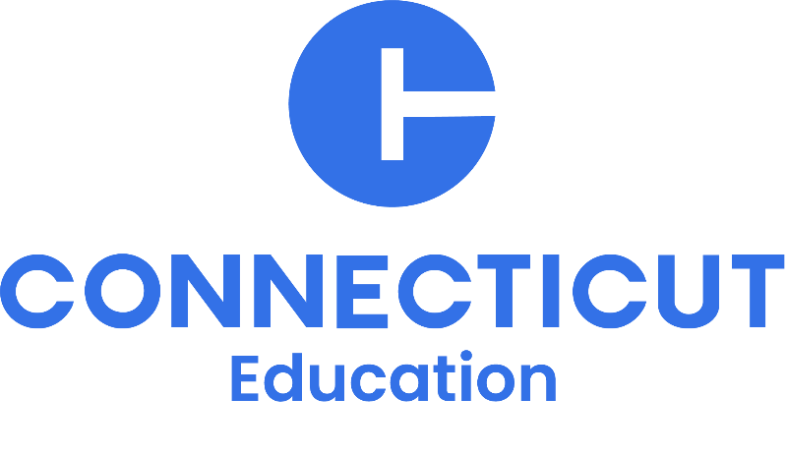

Connecticut High Dosage Tutoring (HDT) Providers

Request for Information
RFI #008

Charlene M. Russell-Tucker
Commissioner of Education

The Connecticut State Department of Education is committed to a policy of equal opportunity/affirmative action for all qualified persons. The Connecticut Department of Education does not discriminate in any employment practice, education program, or educational activity on the basis of: race; color; religious creed; age; sex; pregnancy; sexual orientation; workplace hazards to reproductive systems; gender identity or expression; marital status; national origin; ancestry; retaliation for previously opposed discrimination or coercion; intellectual disability; genetic information; learning disability; physical disability (including, but not limited to, blindness); mental disability (past/present history thereof); military or veteran status; status as a victim of domestic violence; or criminal record in state employment, in accordance with applicable statutes unless there is a bona fide occupational qualification excluding persons in any of the aforementioned protected classes. Inquiries regarding the Connecticut State Department of Education’s nondiscrimination policies should be directed to: Attorney Louis Todisco, Connecticut State Department of Education, by mail 450 Columbus Boulevard, Hartford, CT 06103-1841; or by telephone 860-713-6594; or by email louis.todisco@ct.gov.

The Connecticut State Department of Education is an Affirmative Action/Equal Opportunity Employer.
Contents
Part I. Information 4
Legal Authority: 4
Contact Information: 4
Schedule: 5
Freedom of Information: 5
Part II. Request for Information 5
Background: 5
Scope: 6
Responses to the RFI: 7
Part III. Informational Documentation Requirements: 8
Submission Information: 8
Part IV. Definitions 8

Part I. Information

The Connecticut State Department of Education (CSDE) is committed to advancing universal access to high-quality mathematics instruction through the strategic implementation of High-Dosage Tutoring (HDT). Grounded in evidence-based practices, HDT provides consistent, targeted, and relationship-centered support that accelerates student learning and addresses unfinished learning in mathematics. The CSDE prioritizes this approach as a key component of a comprehensive strategy to improve math outcomes, close opportunity gaps, and ensure all learners develop the critical thinking and problem-solving skills necessary for long-term success. Through strong partnerships, ongoing evaluation, and continuous improvement, the CSDE will support districts in scaling and sustaining high-impact tutoring models that meet the needs of Connecticut learners.

Legal Authority:
Connecticut General Statute Section 17b-28, as amended by Section 340 of Public Act No. 25-166 appropriated from the General Fund for the annual period of fiscal year (FY27) for High Dosage Tutoring Grants.

Contact Information:
Questions concerning this Request for Information (RFI) may be directed to the CSDE Academic Office, Irene Parisi, Chief Academic Officer (Irene.Parisi@ct.gov or 860-713-6852).

Schedule:
Task | Organization/  Agent | Required Action | Date
Issue RFI | CSDE | Post the RFI on the Department of Administrative Services (DAS) State Contracting Portal and the CSDE Website. | May 13, 2026
Receive Questions from Prospective RFI Respondents | Prospective RFI Respondents | Review the RFI and submit any questions via email to Irene.Parisi@ct.gov. | May 14 - 20, 2026
Amend the RFI and Answer Submitted Questions | CSDE | Post addendum to the DAS page: https://portal.ct.gov/DAS/CTSource/BidBoard  and the CSDE RFP page: 2026 RFPs. | May 21, 2026
Submit Information | RFI Respondents | Submit information to the CSDE by email to Irene.Parisi@ct.gov. | June 5, 2026

Freedom of Information:
Pursuant to Connecticut General Statutes (C.G.S.) Sections 1-210 et seq. (FOIA), all questions and responses to this RFI are considered public records and every person shall have the right to (1) inspect such records promptly during regular office or business hours; (2) copy such records in accordance with C.G.S. Section 1-212(g); or (3) receive a copy of such records in accordance with C.G.S. Section 1-212.

Part II. Request for Information

Background:
The vision of the CSDE and HDT program is to provide high-quality, evidence-based, rigorous instruction to accelerate and transform mathematics learning for Connecticut students.
Essential elements of HDT include well-trained tutors working consistently with small groups of students during the school day, using high-quality materials and LEA curricula aligned to state standards. Connecticut HDT’s design draws extensively on research and school-based models with a demonstrable record of success. Tutoring sessions will prioritize grade-level content and mastery of prerequisite concepts and skills required for continued academic success during tutoring and in class.
The CSDE requests information from interested parties who may provide services and support for the implementation of the State’s HDT program, a state funded program that aims to improve mathematics achievement amongst students in Grades 6-10.

The HDT program is an ongoing state initiative that aims to implement a research-based model to accelerate learning for priority students in Grades 6-10 in SY2027. Recognizing the challenge of recruiting and training individuals to provide tutoring services in middle- and high-school, the CSDE invites organizations to submit information that can be shared with local education agencies participating in the HDT program.

This RFI is being issued solely for informational and planning purposes and does not constitute a solicitation to contract with the CSDE.

Scope:
Through this RFI the CSDE is seeking to identify providers of HDT services and support in education to Local Education Agencies (LEAs) participating in the Connecticut HDT program. RFI Respondents must abide by all student data privacy laws and regulations (FERPA, CIPA, COPPA) and provide tutoring services to LEAs on school campus and or virtual through an instructional model that aligns with Tier 1 instruction and Connecticut Core Standards for Mathematics.

Information provided by RFI respondents pursuant to this Request for Information may be included in guidance documents developed by the CSDE for distribution to each local and regional board of education and/or posted on the CSDE portal. The CSDE reserves the right to synthesize information provided by Respondents and include or not information provided pursuant to this Request for Information in the CSDE’s sole discretion. By responding to this RFI, a RFI Respondent grants permission to the CSDE to publish any information provided in guidance documents developed by the CSDE for distribution and/or published on the CSDE portal. A local or regional board of education will not receive funding for services provided by an organization unless the organization is included in the guidance documents developed by the CSDE.

The CSDE may also recommend use of the supports and resources specified in the RFI responses as part of the Connecticut’s HDT program.

Responses to the RFI:
To be included in HDT program guidance documents developed by the CSDE for distribution, each RFI respondent must address all elements of this RFI delineated below. Clear and thorough responses should include but are not limited to explanations of the following range of descriptions, experiences, and services:

- description of organization, including its mission, leadership, years of operation, number of students served, and other notable points;
- an overview of the tutoring services your organization provides, including grade levels, time of day, content areas, frequency, teacher-student ratio, and instructional model, including in-person or virtual;
- description of the curriculum, digital tools/online platforms (including how students access the platform), and instructional materials your organization uses and how they align to Tier 1 instruction and Connecticut Core Standards. Please also include middle and high school math programs your organization/tutors are familiar with;
- description of the tutors your organization employs, the training they receive (including pre-service and in-service training, cultural-competency training, and bilingual competencies, especially related to supporting Spanish-speaking students), and their experience working with high-needs students (students with disabilities, students receiving Free- or Reduced-Priced Meals, and English Language Learners). Are your tutors experienced in leading tutoring sessions without the supervision of school staff;
- explanation of how your organization uses data-driven instruction, formative assessments, formative assessment practices during the tutoring sessions, and other tools to gauge student learning and growth;
- Description of how your tutors collaborate and communicate with teachers, families, and school officials to maximize the impact of tutoring and student learning outside of regular tutoring sessions;
- Description of any relevant experience working in Connecticut public school districts;
- If available, provide any data or evaluations of your tutoring model as evidence of the program’s overall effectiveness. Data showcasing progress made in middle and/or high school math is of particular value to this project;
- Provide an estimate of your organization's cost per pupil;
- Provide list of Connecticut districts currently under contract with your organization;
- Provide list of other organizations out of state currently under contract with your organization; and
- Compliance with student data privacy Laws.

In addition to the required information, respondents may include any additional information that will help to better assess the proposed services. Attach all supporting documentation as appendices that should be referenced in the body of the responses.

Part III. Informational Documentation Requirements

Submission Information:
- By June 5, 2026, 4:00 p.m. EST, submit a response in narrative form by email to Irene.Parisi@ct.gov containing a complete application that addresses the sections and subtopics noted in the Response to RFI section.

The response must be provided in an electronic document. Text should be formatted using a readable font (12 -point). The response should follow the format and order outlined on Pages 6-7 of this RFI.

- Label the submission using the following information.
Request for Information: Connecticut High-Dosage Tutoring Program Providers
  - RFI #008
  - Vendor or business name, primary contact information, website link
  - Include the following title in the subject line of the submission email: Connecticut High Dosage Tutoring Program Providers RFI Submission

Part IV. Definitions

High-Dosage Tutoring: According to contemporary research, HDT is an effective strategy to accelerate learning and provide equity in accessing tutoring for all students. The intensity and frequency of HDT has been shown to accelerate learning more than any other academic intervention. An exemplary HDT model is made accessible intentionally, embedding small-group and/or individual instruction during the school day. Instructed by highly-qualified tutors, every session focuses on students’ identified needs in English Language Arts (ELA) and/or mathematics, with standards-based content aligned to the LEA’s curriculum, grade level performance goals, and high school course requirements.
CIPA: Children’s Internet Protection Act is a Federal law that requires schools and libraries receiving federal funding for internet access to implement internet safety policies. These policies must block or filter harmful content, such as obscene material, and protect minors from inappropriate online content.
COPPA: The Children's Online Privacy Protection Act is a Federal law enacted to protect the privacy of children under 13 by regulating how online services and websites collect, use, and disclose their personal information. It requires companies to obtain parental consent before collecting data from children and mandates certain privacy policies and practices.
FERPA: Family Educational Rights and Privacy Act Is a Federal law that provides rights for parents regarding their children’s education records. This Act provides general information on a parent’s rights under FERPA.
Request for Information: A document that an organization uses to request and obtain information about a product or service from suppliers. In this structured manner, an organization can learn about the possible solutions for the scope of work as indicated in the request for information.

RFI Respondent: A supplier (e.g., publisher, organization) that provides a written response to a request for information, providing details about the possible solutions for the scope of work as indicated in the request.

