Connecticut State Department of Education
Academic Office

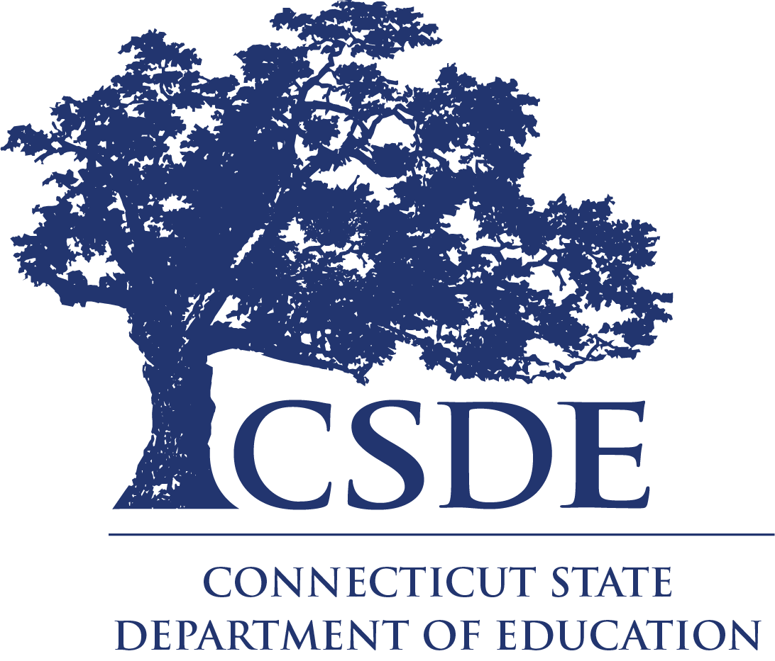

Charlene M. Russell-Tucker
Commissioner of Education

Request for Information
RFI # 005

Instructional Resources, Materials and Professional Learning Models
to Support Connecticut State Department of EducationK-8 Social Studies Model Curriculum

The Connecticut State Department of Education is committed to a policy of equal opportunity/affirmative action for all qualified persons. The Connecticut Department of Education does not discriminate in any employment practice, education program, or educational activity on the basis of race; color; religious creed; age; sex; pregnancy; sexual orientation; workplace hazards to reproductive systems; gender identity or expression; marital status; national origin; ancestry; retaliation for previously opposed discrimination or coercion; intellectual disability; genetic information; learning disability; physical disability (including, but not limited to, blindness); mental disability (past/present history thereof); military or veteran status; status as a victim of domestic violence; or criminal record in state employment, unless there is a bona fide occupational qualification excluding persons in any of the aforementioned protected classes. Inquiries regarding the Connecticut State Department of Education’s nondiscrimination policies should be directed to: Attorney Louis Todisco, Connecticut State Department of Education, by mail 450 Columbus Boulevard, Hartford, CT 06103-1841; or by telephone 860-713-6594; or by email louis.todisco@ct.gov.

The Connecticut State Department of Education is an Affirmative Action/Equal Opportunity Employer.
Contents
Part I. Information 4
Legal Authority: 4
Contact Information: 5
Schedule: 5
Freedom of Information: 6
Part II. Request for Information 6
Background: 6
Scope: 6
Responses to the RFI: 7
Part III. Informational Documentation Requirements 8
Submission Information: 8

Part I. Information

Legal Authority:

Sec. 374. (NEW) (Effective July 1, 2021) states that (a) Not later than January 1, 2023, the Department of Education, in collaboration with the State Education Resource Center, shall develop a model curriculum for grades kindergarten to grade eight, inclusive, that may be used by local and regional boards of education. June Sp. Sess., Public Act No. 21-2 Senate Bill No. 1202 (b) The content of the model curriculum shall (1) be rigorous, age appropriate, aligned with curriculum guidelines approved by the State Board of Education and in accordance with the state-wide subject matter content standards, adopted by the state board pursuant to section 10-4 of the general statutes, (2) be in accordance with the program of instruction and subject matter requirements prescribed in section 10-16b of the general statutes, and (3) include and integrate throughout such model curriculum at least the following: (A) The subject matter prescribed in section 10-16b of the general statutes, (B) Native American studies, (C) Asian American and Pacific Islander studies, (D) lesbian, gay, bisexual, transgender, queer and other sexual orientations and gender identities studies, (E) climate change, (F) personal financial management and financial literacy, (G) the military service and experience of American veterans, (H) civics and citizenship, including instruction in digital citizenship and media literacy that provides students with the knowledge and skills necessary to safely, ethically, responsibly and effectively use digital technologies to create and consume digital content, communicate with others and participate in social and civic activities, (I) the principles of social-emotional learning, and (J) racism. (c) In developing the model curriculum, the Department of Education and State Education Resource Center (1) shall consult with persons and organizations with subject matter expertise in developing the model curriculum, and (2) may utilize existing and appropriate public or private materials, personnel and other resources, and accept gifts, grants and donations, including in-kind donations, designated for the development of the model curriculum under this section. (d) The Department of Education shall make the model curriculum available to local and regional boards of education and on the department's Internet web site.

Public Act No. 21-2 states that Sec. 377 of <PUBLIC ACT>. (Effective July 1, 2021) (a) For the school year commencing July 1, 2023, and each school year thereafter, each local and regional board of education shall include Native American studies as part of the social studies curriculum for the school district, pursuant to section 10-16b of the general statutes. Such Native American studies curriculum shall include, but need not be limited to, a focus on the Northeastern Woodland Native American Tribes of Connecticut. In developing and implementing the Native American studies curriculum, the board may utilize the curriculum materials made available by the State Board of Education pursuant to subsection (d) of section 10-16b of the general statutes, or other existing and appropriate public or private materials, personnel, and resources, provided such curriculum is in accordance with the state-wide subject matter content standards.

Contact Information:
Questions concerning this Request for Information (RFI) may be directed to the CSDE Academic Office, Stephen Armstrong, Social Studies Education Consultant at stephen.armstrong@ct.govor 860-713-6706.

Schedule:
Task | Organization/Agent | Required Action | Date
Issue RFI | CSDE | Post the RFI on the Department of Administrative Services (DAS) State Contracting Portal and the CSDE Website. | July 1, 2024
Receive Questions from Prospective RFI Respondents | Prospective RFI Respondents | Review the RFI and submit any questions via email to stephen.armstrong@ct.gov | July 3 – July 10, 2024
Amend the RFI and Answer Submitted Questions | CSDE | Post addendum to the DAS page: https://portal.ct.gov/DAS/CTSource/BidBoard  and the CSDE RFP page: https://portal.ct.gov/SDE/RFP/Request-for-Proposals/2024-RFPs | July 15, 2024
Submit Information | RFI Respondents | Submit information to the CSDE by email to stephen.armstrong@ct.gov | July 24, 2024

Freedom of Information:
This RFI is being issued solely for informational planning purposes and does not constitute a solicitation. Pursuant to Connecticut General Statutes (C.G.S.). Sections 1-210 et seq. (FOIA), all questions and responses to this RFI are considered public records and every person shall have the right to (1) inspect such records promptly during regular office or business hours; (2) copy such records in accordance with C.G.S. Section 1-212(g); or (3) receive a copy of such records in accordance with C.G.S. Section 1-212.

Part II. Request for Information

Background:
The CSDE requests information from interested parties who may provide instructional resources, supplemental instructional materials, and or professional learning opportunities for district leaders and educators that are aligned to the Connecticut Social Studies Elementary and Secondary Social Studies Standards and will support the implementation of kindergarten through grade eight Social Studies Model Curricula located on GoOpenCT. This RFI is not an offer, and no contract will be awarded as a result. This RFI is not an offer, and no contract will be awarded as a result.

Scope:
The purpose of this RFI project is to identify instructional resources, supplemental instructional materials, and or professional learning opportunities that a. amplifies the rich Social Studies content in the Connecticut Elementary and Secondary Social Studies Standards and b. Integrates topics such as Native American studies, Asian American/ Pacific Islander studies, Lesbian, Gay, Bisexual, Transgender, Queer and Gender Identities studies, Veteran studies, and other topics which are components of the CSDE Social Studies model curriculum. These resources should also help enhance inquiry instruction in Social Studies and connect students to culturally responsive materials.

Information provided pursuant to this Request for Information may be included in guidance documents developed by the CSDE for distribution to each local and regional board of education and or posted on the CSDE portal. The CSDE reserves the right to synthesize information provided by the respondents and/or to include information provided pursuant to this request for Information.

To be included in guidance documents developed by the CSDE for distribution, each respondent must address all elements of this RFI, delineated below:

Responses to the RFI:
Clear and thorough responses should include but are not limited to explanations of the following:
The vendor’s business practices who desire or wish to support educators to:
  - Utilize the instructional resources that align to the Connecticut Elementary and Secondary Social Studies Standards.
  - Implement the CSDE Social Studies Model Curriculum units.
  - Understand and utilize culturally responsive instructional materials.
  - Understand and utilize the Inquiry Arc outlined in the College, Career, and Civic Life (C3 Framework).
  - Include and integrate legislated topics such as Native American studies, Asian American and Pacific Islander studies, lesbian, gay, bisexual, transgender, queer, and other sexual orientations and gender identities studies, the military service and experience of American veterans, civics, and citizenship, including instruction in digital citizenship and media literacy, and racism.
- The vendor’s evidence-based products and resources that would enhance the ability of students to:
  - Utilize instructional texts, videos, and other content materials to develop questions and plan inquiries into 1. Social Studies content and topics 2. think like a historian, economist, geographer, political scientist 3. evaluate sources, use evidence, communicate conclusions 4. take informed action.
  - Engage in inquiry and project-based activities/ materials.
  - Engage with culturally relevant materials for history, economics, geography, and civics.
  - Explore legislated topics.
- Materials for use by students to demonstrate their understanding of the content (e.g., workbooks, texts, diagrams, maps, primary sources, artifacts, digital platforms).
- Recommendations for working with students who have diverse learning needs.
- Professional learning topics for administrators and teachers that include:
- the purpose for utilizing inquiry-based instruction in Social Studies.
- describing how culturally responsive, inclusive, and inquiry based social studies curriculum contributes to a high-quality Social Studies learning experience and is essential for developing students for college career and civic life; and
- instructional rigor, explicit instruction, student engagement, and flexibility of delivery of Social Studies Instruction.
- Product literature, specifications, and photos that adequately describe the available services and products.
- Optional - Respondents may provide a list of Connecticut districts or schools currently using their resources.

In addition to the required information, respondents may include any additional information that will help to better assess the proposed services. Attach all supporting documentation as appendices that should be referenced in the body of the responses.

Part III. Informational Documentation Requirements

Submission Information:
- By July 24, 2024, 4:00 p.m., submit a response in narrative form by email to stephen.armstrong@ct.gov containing a complete description of the grades kindergarten to grade eight Social Studies curriculum/resources, and associated professional learning supports as specified in the Scope section of this document.
- Label the submission using the following information.
- Request for Information: K-8 Social Studies Model Curriculum: Inclusive and Inquiry-based Resources/ Materials and Professional Learning Supports
- RFI # 005
- Vendor or business name, primary contact information, website link
- Include the following title in the subject line of the submission email: K-8 Social Studies Model Curriculum Inclusive and Inquiry-based Resources/ Materials and Professional Learning Supports

